**PROJECT SCREENS**

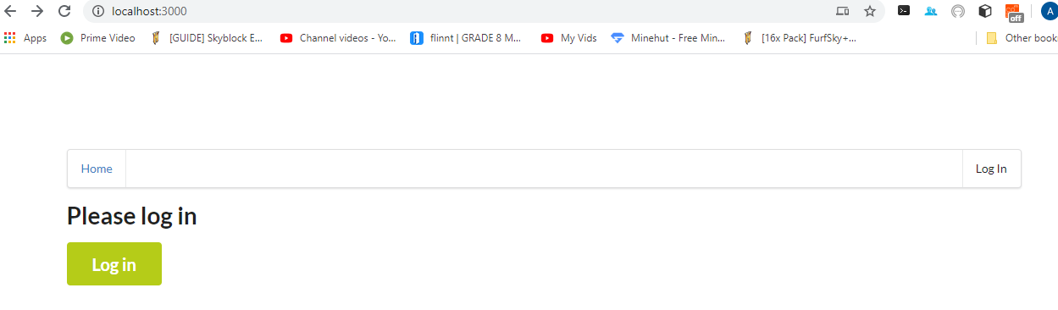

**AUTH0 DETAILS**

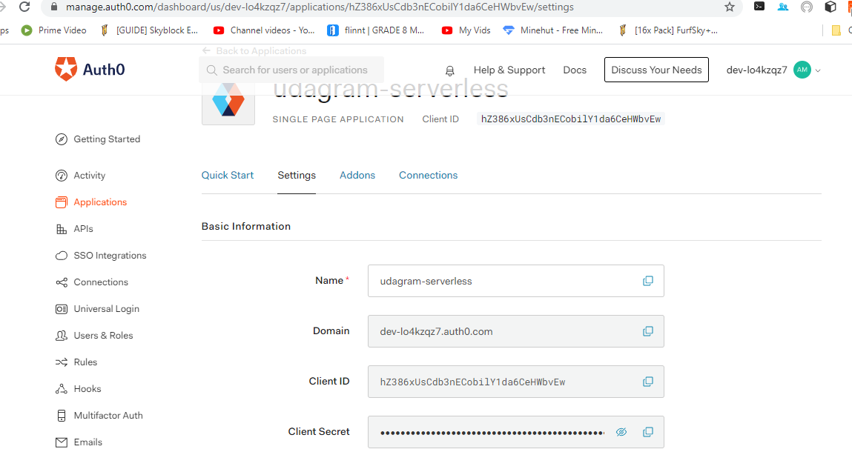

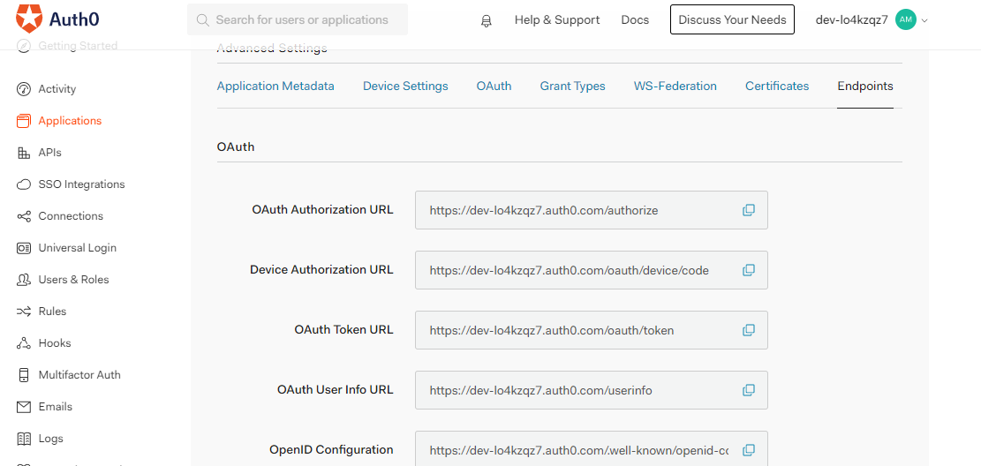

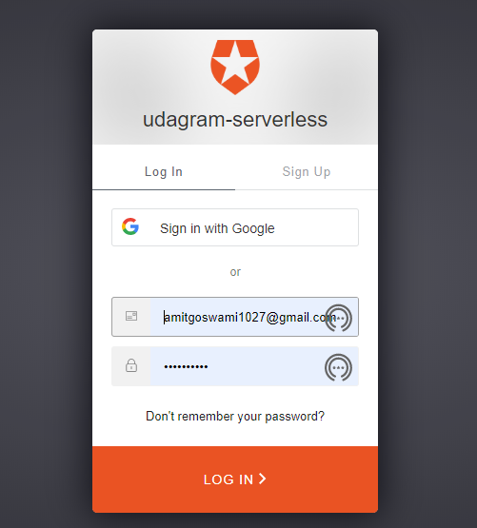

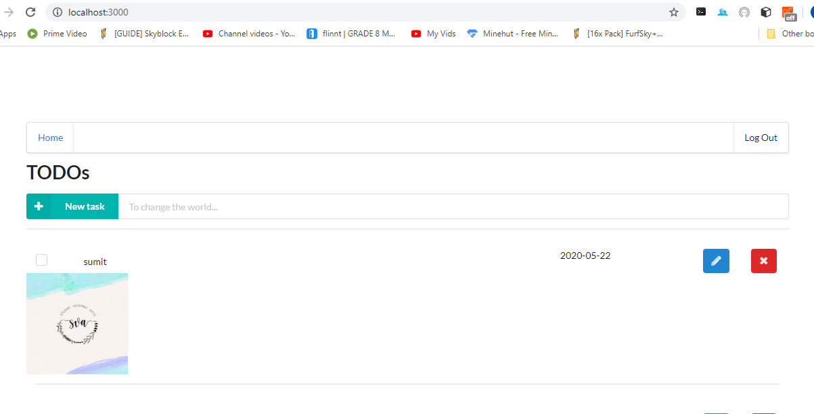

**DEPLOYMENT SCREENS**

**API ENDPOINT DEPLOYMENT DETAILS**

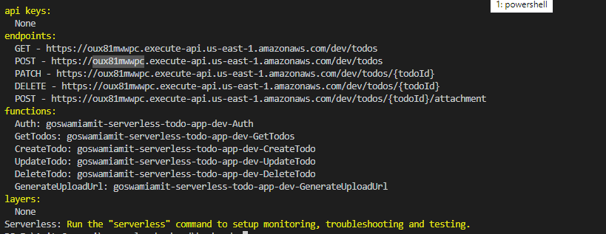

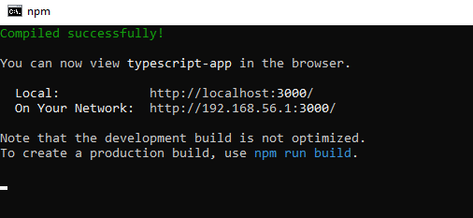

**AWS DEPLOYMENT DETAILS**

**CLOUD FOUNDATION**

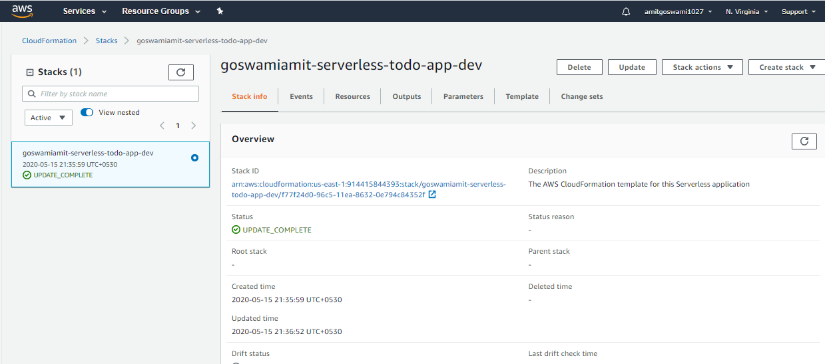

**DYNAMO DB**

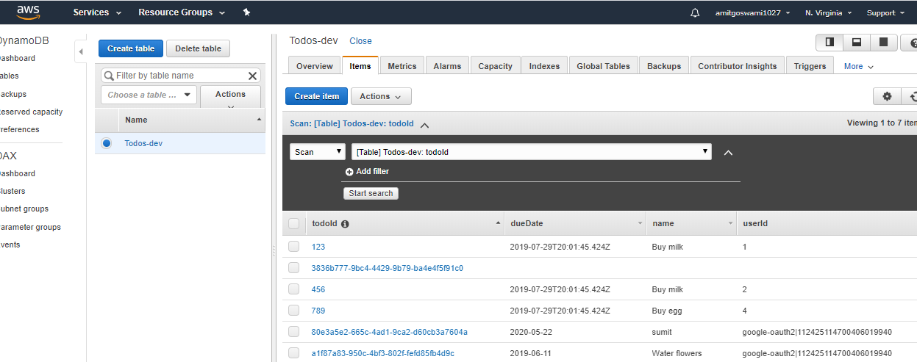

**API GATEWAY**

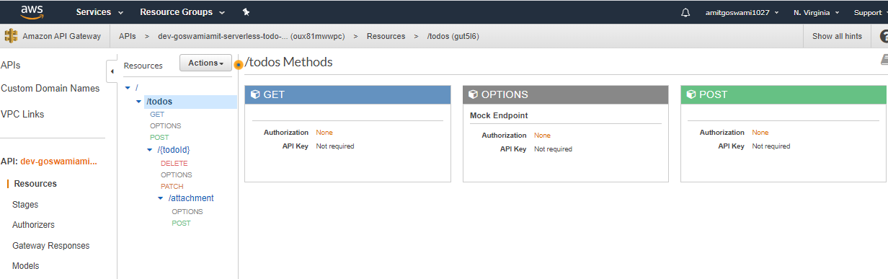

**LAMBDA FUNCTIONS**

