**Udagram Image Filtering Microservice**

1. Setup Node Environment - **Done**

You'll need to create a new node server. Open a new terminal within the   
 project directory and run:

* Initialize a new project: npm i
* run the development server with npm run dev

### Create a new endpoint in the server.ts file - **Done**

* The starter code has a task for you to complete an endpoint in ./src/server.ts which uses query parameter to download an image from a public URL, filter the image, and return the result.

We've included a few helper functions to handle some of these concepts and   
 we're importing it for you at the top of the ./src/server.ts file.

import {filterImageFromURL, deleteLocalFiles} from './util/util';

### Deploying your system - **Done**

Follow the process described in the course to eb init a new application   
 and eb create a new environment to deploy your image-filter service! Don't   
 forget you can use eb deploy to push changes.

**Test elastic beanstalk Deployment** :

Use the following URL:

http://udagram.us-east-1.elasticbeanstalk.com/filteredimage?image_url=https://blog.hubspot.com/hubfs/parts-url.jpg

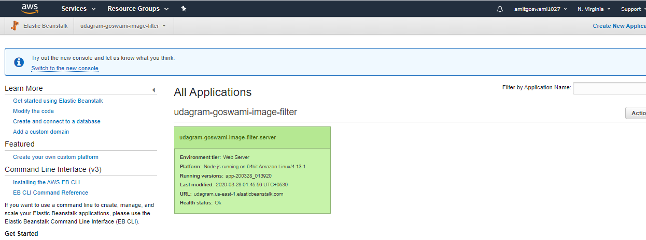

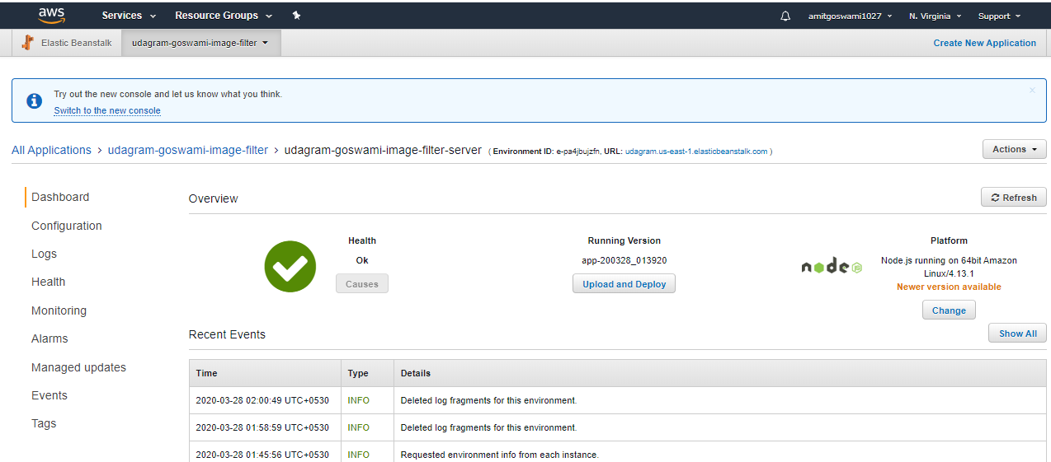

Output – POSTMAN

