<https://labs.play-with-docker.com/p/d3gvtss69qi000e9ag9g#d3gvtss6_d3gvu00l2o9000c9dk40>  
amitgoyal11  
<https://docs.docker.com/>

<https://hub.docker.com/_/hello-world>

cmd

1.install docker

2. docker

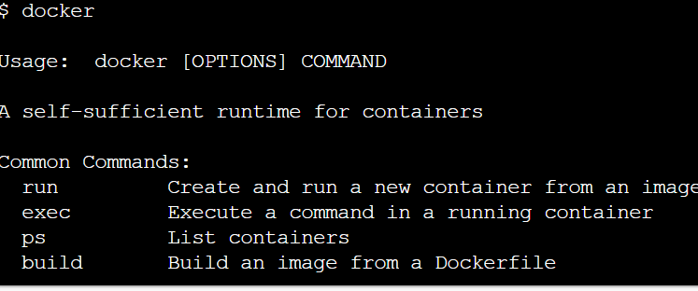

3. docker –version  


4. docker start

5. docker info

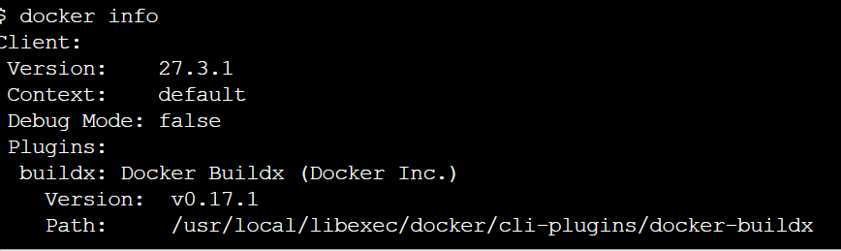

6. docker images  


7. docker ps ----list out all running containers

8. docker ps -a ----list out all running container with id  
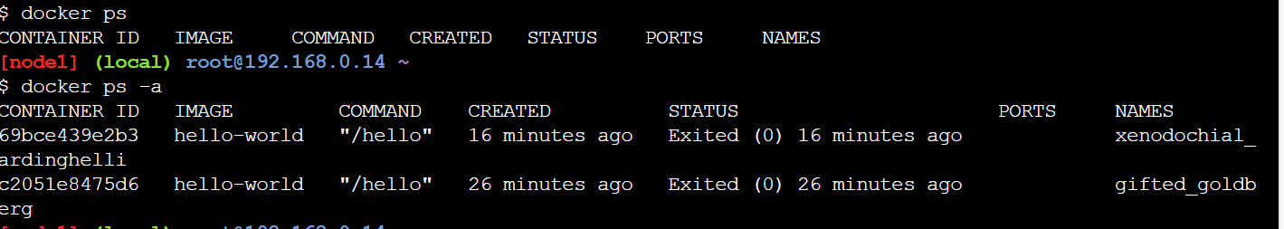

9. docker pull <image>  
 docker run hello-world (image name) if exist then run other wise download  
- Run a container from an image

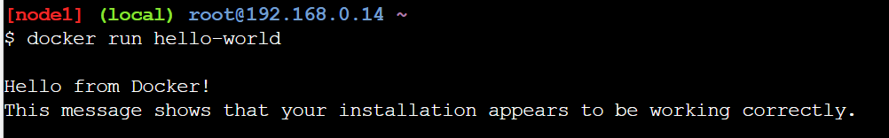

10 docker stop container id  
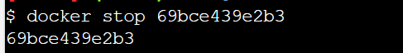

11.  
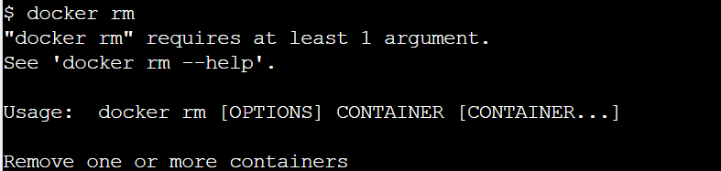

|  |  |
| --- | --- |
| docker run <image> | Run a container from an image |

|  |  |
| --- | --- |
| docker run -it <image> bash | Run interactively with a bash shell |

|  |  |
| --- | --- |
| docker run -d <image> | Run container in background (detached) |

|  |  |
| --- | --- |
| docker run -p 8080:80 <image> | Map port 80 inside container to 8080 on host |

|  |  |
| --- | --- |
| docker ps | List running containers |

|  |  |
| --- | --- |
| docker ps -a | List **all** containers |

|  |  |
| --- | --- |
| docker stop <container> | Stop a running container |

|  |  |
| --- | --- |
| docker start <container> | Start a stopped container |

|  |  |
| --- | --- |
| docker rm <container> | Remove a container |

|  |  |
| --- | --- |
| docker exec -it <container> bash | Run a command in a running container |

|  |  |
| --- | --- |
| docker logs <container> | View logs from a container |

