Plant Disease Classification And Weed Detection

SAI PRASHEEL MANDALA  
*VIT University Chennai, Tamil Nadu, India*  mandalasai.prasheel2018@vitstudent.ac.in

SURESH MADDU  
*VIT University Chennai, Tamil Nadu, India*  maddusuresh2018@vitstudent.ac.in

SAJJA AMITH  
*VIT University Chennai, Tamil Nadu, India*  sajja.amith2018@vitstudent.ac.in

VENKATESH

*VIT University Chennai, Tamil Nadu, India*

venkatesh2018@vitstudent.ac.in

NIKHIL KUMAR  
*VIT University Chennai, Tamil Nadu, India*  nikhil.kumar2018@vitstudent.ac.in

*Abstract*—**Early disease detection is critical for improved crop yield and quality. Disease Plants can cause substantial economic losses to individual farmers by lowering the quality of agricultural products. In a country like India, where agriculture is the main source of income, it is critical to detect disease at an early stage.Weeding and pest control are both critical aspects of plant maintenance. Farmers need alternatives for weed control due to the desire to reduce chemicals used in farming. However, conventional mechanical cultivation cannot selectively remove weeds and there are no selective herbicides for some weed situations. Since hand labor is costly, an automated weed control system could be feasible.**

Keywords — plant disease,weeds,chemicals,algorithm,image processing,convolution networks.

# Introduction

Because to technological breakthroughs, people can now provide proper health and food to fulfil the demands of the world's growing population. When it comes to India, it is undeniable that 70% of the population is directly or indirectly associated to cultivating area, which remains the country's largest region. If we look at it from a different angle, According to study, overall yield creation might grow by at least 50% by 2050. Half pushing and half developing Sector by adding weight on the inside and outside. Farmers constitute the vast bulk of the population. Poor and disinterested in development, which may result in higher troubles due to pets and plant diseases. The most common and essential agricultural products are vegetables and fruits. The high material content found in the ground, air, and water is a result of our reliance on synthetic pesticides, as well as, astonishingly, in our bodies.

Plant infections are currently unable to be defined using the traditional method of visual assessment in humans. Computer vision models have advanced to the point where they can now provide quick, standardised, and accurate responses to these issues. During the preparation process, classifiers can also be delivered as attachments. All you require is a web browser, as well as a telephone with a camera. Business applications that are well-known Naturalist and Plant are two words that come to mind as a naturalist with a snap, Demonstrate how this is achievable. Both apps succeed at both sharing skills with clients and creating intuitive interfaces on social networks.

Deep Learning has lately produced amazing achievements in image identification, audio recognition, and natural language processing, among other fields. In the topic of Plant Disease Detection, the Convolutional Neural Network provided great results. The Convolutional Neural Network is the most effective approach for object recognition. We consider the Neural Architecture, which includes faster Region-Based Convolutional Neural Networks (Faster R-CNN), Region-Based Convolutional Neural Networks (R-FCN), and single-shot Multi box detectors (SSD). Each Neural Architecture should be able to be paired with any feature exactor dependent on the software program's scenario. Data preparation is crucial for models to operate correctly. Several infections (viral or fungal) may be difficult to identify since their symptoms frequently overlap.

# problem statement

Our goal is to boost agricultural productivity while reducing the usage of toxic pesticides to control weeds and diseases. Farmers can save money on pesticides and save the environment by detecting illnesses and weeds early on in the field. It also helps them make money.

We must ensure that agricultural sector challenges are resolved so that farmers' lifestyles are not affected. Farmers' working circumstances should likewise be addressed.

Our objective is to detect weeds using image processing and to develop a deep learning model based on an architectural convolution network to detect plant illnesses using pictures of healthy or sick plant leaves, which can assist enhance yields.

There has been a surge in interest in deploying automation in agriculture and other industries in recent years. One of the areas that need automation is weed management and plant disease detection. Herbicides are sprayed equally throughout the field in traditional methods. Aside from the detrimental effects on plants, soil, and underground aquifers, a considerable quantity of herbicides will be wasted because only a portion of fields are weed-free. A smart weed management technology should be used to avoid these problems from occurring. These systems must be capable of identifying weeds in the field and instructing herbicide sprayers to spray directly on the required places.

# motivation

Agriculture in India is burdened with so many issues. These issues have an immediate and indirect impact on the life of a farmer. Farming procedures and other agricultural operations demand a farmer's time as well as his or her efforts.

We have grains on hand and eat meals all year. However, we seldom consider the hard labour and devotion of farmers involved in agricultural production. These food crops are grown to contribute to the general expansion of the agricultural industry. Nonetheless, farmers' issues go undetected throughout the whole process of extracting food and harvesting crops. Farmers are unfamiliar with sophisticated farming techniques. This prevents them from employing appropriate technological resources in farming and other disciplines. Farmers should be trained on the use of large labour equipment in order to lessen their issues. Farmers can reduce pests if they get familiar with the mechanisms of technical instruments.

If farmers get familiar with the information related to advanced agricultural procedures and the required safety measures, they can get rid of various problems.

Even though farmers do their best to generate their income and earn their livelihoods, we need to reflect on agricultural problems and solutions. Responsible consumption of resources is among one of the most important sustainable development goals. Which made us think that we should make sure that the problems of the agriculture sector are eradicated so that the lives of farmers are not hampered. And working conditions of farmers should also be improved.

# literature survey

This article[1] emphasizes the crucial importance of developing chemical-free agricultural goods to secure food security and long-term agricultural growth. This study was carried out to learn about the various weed control approaches utilised by different researchers and how they may be applied in agricultural activity. Many self-propelled and tractor-drawn weeding equipment have been created for medium and large farms, but little research has been conducted for small and marginal farmers. As a result, an effective weeding equipment for small and marginal farmers is required.

Image processing was utilized in this study[2] for this aim. In the future, image processing techniques will be used to detect weeds in crops. The purpose of this research is to conduct a survey of weed identification strategies employing image processing techniques. This research gives a survey on weed detection in agricultural settings using image processing techniques. To examine crop photos, procedures such as segmentation, feature extraction, and clustering can be applied. There is a requirement to choose the most.

In this paper[3,] they adopted certain ways to limit the use of herbicides by spraying them solely in weed-infested regions. In this research, we used MATLAB image processing to detect weed regions in a picture taken from the fields. They have devised a way for detecting weed utilizing image processing in this system. We can detect and segregate weed-affected regions from agricultural plants by using our method. The goal of creating such a system is to detect and reuse weed-infested regions for future sowing. This specific location can be considered for further weed control activities, which will result in increased yield.

This article [4] presents a novel approach for classifying leaves based on the CNN model and creates two models using Google Net to vary network depth. The degree of discoloration or leaf damage determined the effectiveness of each model. Even if 30% of the leaves are damaged, the identification rate is more than 94%. In the future, we will undertake research to recognize leaves related to branches in order to build a visual system that can recreate the leaves linked to branches. Plant species are identified using a number of ways by humans.

This publication [5] also explores several ways for recognizing plant diseases and defining the kind of affected leaves. For prediction, we're using a Convolution Neural Network (CNN) with many levels. That The complete procedure is explained based on the photos used for training and pre-treatment. Following that, there is a CNN deep and optimizer training approach, as well as testing and image enhancement. Make use of the images provided below. We can precisely identify the processing technique and discriminate between various plant ailments.

# proposed work

## Plant Disease Detection Using CNN

The plant dataset includes 70000 healthy and diseased leaf scans separated into 38 species and disease groups. We looked at over 70,000 photos of plant leaves with labels spread over 38 classes to see whether we could predict which disease class they belonged to. On this compressed picture, we apply optimization and model predictions after resizing it to 256 256 pixels.

*Data processing and augmentation :*

When it comes to creating an effective image classifier, picture augmentation is crucial. Despite the fact that datasets might contain hundreds to thousands of training samples, the diversity may not be adequate to develop an appropriate model. Flipping the image vertically/horizontally, rotating the image via various angles, and scaling the image are just a few of the many image augmentation choices. These enhancements assist to boost the amount of meaningful data in a dataset. Each picture in the Plant Village collection has a resolution of 256 by 256 pixels. The Keras deep-learning framework is used for data processing and picture enhancement.

The following are the training enhancement options:

• Rotation - Rotate a training image in a random direction.

• Shear - Adjust the shearing angle.

• Brightness - Assists the model in adapting to changes in illumination

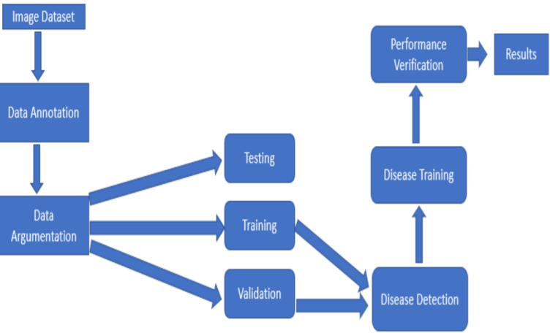

A pre-trained model has already been trained on a dataset and has weight values that represent the properties of the dataset on which it was trained. Characteristics learned are typically transferable to fresh data. A model constructed on a large dataset of bird pictures, for example, would have learned properties like edges and horizontal lines that you may transfer to your dataset collection.

Pre-trained models are useful for a number of reasons. Using a pre-trained model saves time. Someone else has already made the effort to learn a huge number of attributes, and model will undoubtedly benefit from it.

There are three major steps:

1.Image preprocessing is the first phase.

2.Image Segmentation preprocessing involves image segmentation, image enhancement, and colour space conversion.First, the digital image is improved with a filter.

Then, for each image, create an array.

3.The third is Model Construction. CNN classifiers are taught to identify illnesses in each plant type using CNN.

Essentially, a CNN model is made up of two parts: the feature extraction part and the classification part.

The feature extraction is done by the convolution + pooling layers.

The Input Layer

This layer is where the model receives input. At this early stage of the neural network, the number of neurons and the number of features are both the same. In the case of a photograph, the total number of features is equal to the number of pixels. The input data is divided into two divisions for training and testing the model. The majority of the data is utilised for training, with the remaining used for testing.

Hidden Layer

This layer receives the output of the input layer. It is influenced by both the model and the volume of data. Each buried layer may have a different number of neurons.

Output Layer

A logistic function is used to process the data from the hidden layer. The probability score for each class is computed by processing each class's output by a logistic function.

By constructing networks, the convolution layers learn such complicated properties. (stacked on top of each other) As an example, the initial layers detect edges, the subsequent layers combine them to detect shapes, and the subsequent levels combine this information to identify significant characteristics. Finally, the fully connected layers learn how to use the convolutional features to accurately identify the pictures.

VGG models are a type of CNN Architecture.These are models, which are networks with many parameters ( A Case in point is VGG16, which has 138 Million Parameters).Training such a network takes time and resources.VGG19 is a VGG model variation of 19 layers (16 convolution layers, 3 fully linked layers, 5 MaxPool layers, and 1 SoftMax layer).

## Weed Detection using Image Processing

RGB to Grayscale: Color is seen by humans via cones, which are wavelength-sensitive sensory cells. Cones are classified into three categories, each having a unique sensitivity to electromagnetic radiation (light) of varying wavelengths. One form of cone is mostly sensitive to red light, another to green light, and yet another to blue light. We can make practically any perceptible hue by generating a regulated mix of these three fundamental colours (red, green, and blue) and thereby activating the three types of cones at will. This is why colour pictures are frequently saved as three independent image matrices: one holding the amount of red (R) in each pixel, one storing the amount of green (G), and one storing the amount of blue (B). Such colour pictures are referred to as RGB images..

When converting an RGB image to grayscale, we must take the RGB values for each pixel and produce a single value indicating that pixel's brightness. One method is to take the average of each channel's contribution: (R+B+C)/3. However, because perceived brightness is frequently dominated by the green component, a different, more "human-oriented" way is to take a weighted average, such as 0.3R + 0.59G + 0.11B.

Grayscale To Binary: A binary image is a computer image with just two potential values for each pixel. A binary picture is often composed of two colours: black and white. The colour used in the image for the object(s) is the foreground colour, whereas the remainder of the image is the background colour. This is referred described as "bi-tonal" in the document-scanning business.

Image Sharpening: The selection of the high-pass filtering operation is critical in the effective sharpening procedure. Traditionally, linear filters have been employed to create the high-pass filter; however, if the source picture is polluted by noise, linear approaches can provide undesirable results. If a weighted median filter with proper weights is utilised, a compromise between noise attenuation and edge highlighting can be attained. To demonstrate, imagine a WM filter applied to a grayscale picture using the following filter mask.

*Global Thresholding*: Global thresholding entails setting an intensity value (threshold) such that all voxels with intensity values less than the threshold belong to one phase and the rest to the other. Global thresholding is only as good as the degree of intensity separation between the image's two peaks. It is an uncomplicated segmentation option.

In 3DMA, the global thresholding option allows the user to choose a single global threshold for a 3D picture or distinct thresholds for each 2D slice in the image. Some experimental options are also supplied to allow automatic threshold selection by conducting a binormal fit to the two-peak histogram and establishing a threshold at the interpeak minimum obtained by the normal fits.

Area thresholding is an excellent method for obtaining important information stored in pixels while reducing background noise. This is achieved by using a feedback loop to refine the threshold value prior to converting the original grayscale picture to binary.

The concept is to divide the image into two parts: backdrop and foreground.

1. Determine the starting threshold value, which is usually the mean 8-bit value of the original picture.

2. Split the original image into two parts: 1. Pixel values less than or equal to the threshold; and 2. Background.

2. Pixel values over the threshold; foreground

3. Determine the mean average of the two new photos.

4. Averaging the two means, compute the new threshold.

5. If the difference between the previous and new threshold values is less than a defined limit, you are completed. Otherwise, apply the modified threshold to the original image and continue experimenting.

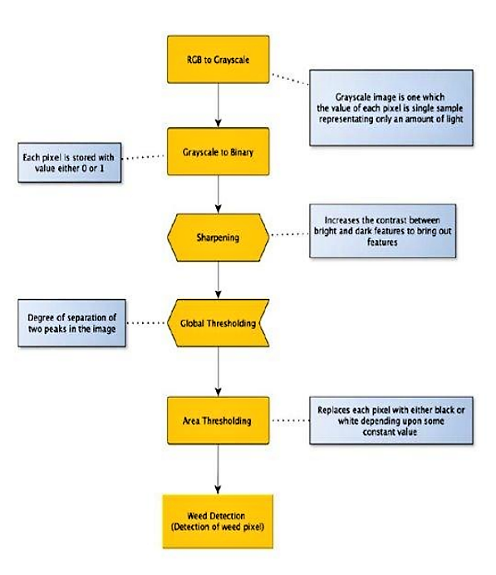

# experimental setup

## Dataset

The plant dataset contains 70000 leaf scans of healthy and diseased leaves divided into 38 species and disease classes. We examined over 70,000 pictures of plant leaves with labels from 38 different disease classes to see whether we could determine which disease class they belonged to. We apply optimization and model predictions on this compressed image after enlarging it to 256 256 pixels..

## Software Requirements

1. Python
2. Google CoLab
3. MatLab
4. Ngrok Server
5. Streamlit Framework

## Machine Learning Model

## VGG-19 is a 19-layer deep convolutional neural network. A pretrained version of the network trained on over a million photos from the ImageNet database may be loaded. The pretrained network can categorise photos into 1000 different object categories, including keyboards, mice, pencils, and a variety of animals. As a consequence, the network has learnt detailed feature representations for a diverse set of pictures. The network accepts images with a resolution of 224 by 224.

ARCHITECTURE

This network was fed a fixed size (224 * 224) RGB picture as input, implying that the matrix was of shape (224,224,3). The only preprocessing done was to remove the mean RGB value from each pixel over the whole training set. They used kernels of (3 * 3) size with a stride size of 1 pixel to cover the entire visual concept.To keep the image's spatial resolution, spatial padding was applied.Sride 2 was used to conduct max pooling across a 2* 2 pixel window.

This was followed by the Rectified linear unit (ReLu) to bring non-linearity into the model in order to enhance classification and computing time, since prior models employed tanh or sigmoid functions, which proved significantly better than those.

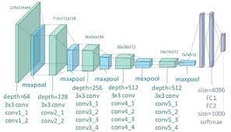

Uses of the VGG Neural Network

The VGG net was built primarily to win the ILSVRC, but it has been utilised in a variety of other ways as well.

Used simply as a suitable classification architecture for many additional datasets, and because the authors made the models public, they may be used as is or with modifications for other comparable jobs as well.

Transfer learning: This method may also be utilised for facial recognition applications.

Weights are easily available in other frameworks like as Keras and may be tinkered with and utilised as desired.

The VGG-19 network is used to reduce content and style loss.

At the end, Streamlit is used to deploy plant disease detection model online.It is an app framework to deploy machine learning apps built using Python. It is an open-source framework.There is no need to write a backend, define different routes or handle HTTP requests. It is easy to deploy and manage. Using Streamlit, we can quickly create web apps and effortlessly deploy them. Streamlit enables you to develop an app in the same manner that you would write Python code. Working on the interactive cycle of coding and monitoring outcome.

# results

From each folder, only 400 photographs were picked. For each image, an array is formed. Furthermore, we scaled the data points in the input file from [0, 255] (the minimum and maximum RGB values in the image) to [0, 1].

The dataset was then separated into two parts: the training set and the validation set of photos. Picture generator objects execute random rotations, movements, inversions, civilizations, and portions of our image set.

We use Adam's Hard Optimizer for our model. The model is the starting point for our network. match the generating function Our objective is to increase the amount of data, train-test data, and epochs to train. In this project, we used a number of 50 for epochs.

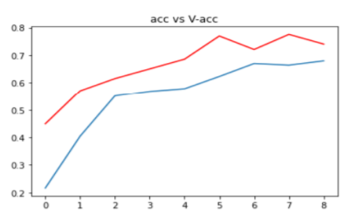

The accuracy of the model is = 82.10790157318115 %

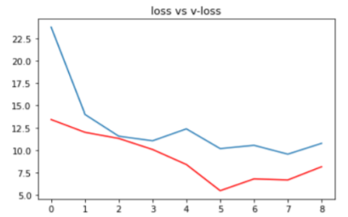

Log-loss is indicative of how close the prediction probability is to the corresponding actual/true value

Plant Disease Classification Web App





Weed Detection

From the proposed content the entire prototype of the Weed Detection Robot was successful. The algorithms gave reliable accuracy to detect the presence or absence of weed cover. The prototype was able to move to a nearby farm and take the images Successfully.

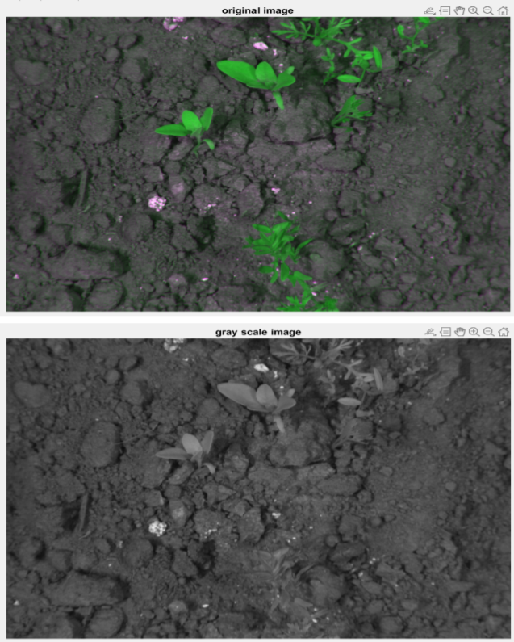

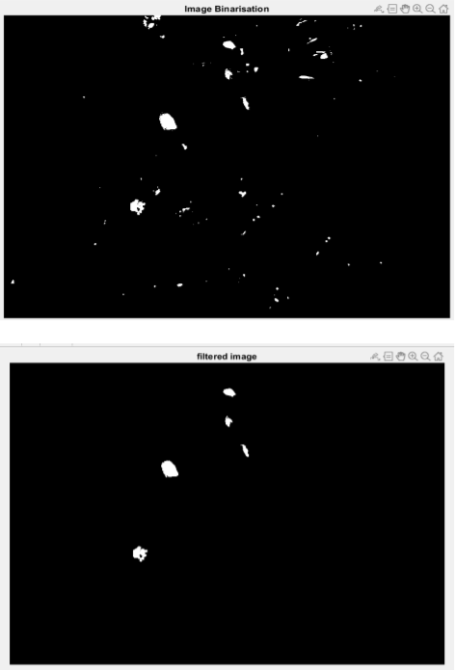

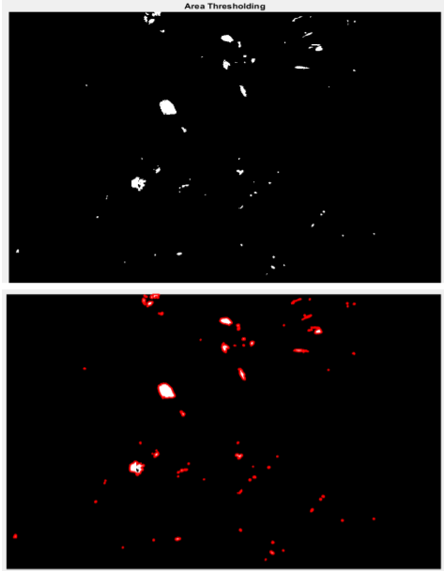

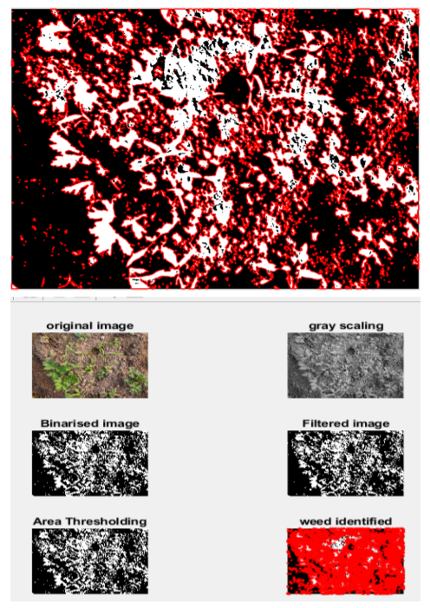

# conclusion

Here, we have successfully created a method for detecting weed plants in fields among agricultural plants. The image analysis for weed detection may be improved further by splitting the image into more areas and having as many nozzles as needed to spray the chemicals and pesticides needed to control or stop the development of the weed. By inserting a memory module, it may be transformed into an extremely resilient closed loop system. The image processing algorithm may be improved so that detection becomes more general. We can construct a closed loop system vehicle with high accuracy GPS (RTK), encoders, compass, and tilt sensors to position itself and follow waypoints for high precision detection. Also, the GPS-equipped truck can assist us in mapping the region where the weed is most concentrated as well as studying the area for soil and weeds.

Keeping crops safe in organic farming is a difficult task. This necessitates a thorough knowledge of the crop in issue, as well as any pests, illnesses, or weeds that may be present. In our system, we created a specific deep learning model based on a distinctive architectural convolution network to diagnose plant ailments using pictures of healthy or sick plant leaves. The previously described technology might be upgraded to a real-time video entry system that allows for unattended plant maintenance. An intelligent system that detects and cures problems can also be integrated into specialised systems. In research, plant disease control has been proven to increase yields.

##### References

[1] A review on weed detection using ground-based machine vision and image processing techniques

Aichen Wang,Wen Zhang,Xinhua Wei.

[2] Design and Development of Automatic Weed Detection and Smart Herbicide Sprayer Robot, Aravind R, Daman, M Kariyappa B S Professor Department of Electronics and Communication R V College of Engineering Bengaluru, India.

[3] Plant Disease Classification: A Comparative Evaluation of Convolutional Neural Networks and Deep Learning Optimizers.

[4] K. Elangovan , S. Nalini “Plant Disease Classification Using Image Segmentation and SVM Techniques” IJCIRV ISSN 0973-1873 Volume 13.

[5] Sonal P Patel. Mr. Arun Kumar Dewangan “A Comparative Study on Various Plant Leaf Diseases Detection and Classification” (IJSRET), ISSN 2278 – 0882