IRS Login.gov-Style IAM Demo
EC2 Deployment Runbook
PostgreSQL + ZITADEL + NGINX + FastAPI
Two-part installation and configuration guide for the IAM demo environment.

Architecture Overview
Internet
| HTTPS
v
NGINX
+--> auth.etelligent-group.dev --> ZITADEL :8083 --> PostgreSQL :5432
+--> etelligent-group.dev/iam-demo/ --> FastAPI :8088
|
+---- OIDC ----> ZITADEL
Simple analogy: PostgreSQL is ZITADEL's memory, ZITADEL is the identity/security desk, FastAPI is the IRS application, and NGINX is the front door that routes traffic.

SECTION 1 - Install PostgreSQL, ZITADEL, and Start the ZITADEL UI

1. Connect to EC2
ssh -i your-key.pem ec2-user@<EC2-PUBLIC-IP>
sudo dnf update -y

2. Install PostgreSQL
sudo dnf list postgresql*
sudo dnf install postgresql15 postgresql15-server -y
psql --version

3. Initialize and start PostgreSQL
sudo postgresql-setup --initdb
sudo systemctl start postgresql
sudo systemctl enable postgresql
sudo systemctl status postgresql

4. Create the ZITADEL database and database user
sudo -u postgres psql
CREATE USER zitadel WITH PASSWORD '<STRONG-ZITADEL-DB-PASSWORD>';
CREATE DATABASE zitadel OWNER zitadel;
GRANT ALL PRIVILEGES ON DATABASE zitadel TO zitadel;
\du
\l
\q
Use a long unique database password. Do not commit it to Git.

5. Test PostgreSQL connectivity
psql "postgresql://zitadel:<PASSWORD>@localhost:5432/zitadel"
SELECT current_database(), current_user;
\q

6. Install ZITADEL v3.4.15 binary
cd /tmp
wget https://github.com/zitadel/zitadel/releases/download/v3.4.15/zitadel-linux-amd64.tar.gz
tar -xzf zitadel-linux-amd64.tar.gz
find . -name zitadel -type f
sudo mv zitadel-linux-amd64/zitadel /usr/local/bin/zitadel
sudo chmod +x /usr/local/bin/zitadel
zitadel version

7. Create ZITADEL database configuration and master key
Create a strong 32-character ZITADEL master key and keep it outside Git.
sudo mkdir -p /etc/zitadel
sudo nano /etc/zitadel/zitadel.env
ZITADEL_DATABASE_POSTGRES_DSN=postgresql://zitadel:<DB_PASSWORD>@127.0.0.1:5432/zitadel?sslmode=disable
ZITADEL_EXTERNALSECURE=true
sudo chmod 600 /etc/zitadel/zitadel.env

8. Initialize and start ZITADEL
export ZITADEL_DATABASE_POSTGRES_DSN='postgresql://zitadel:<DB_PASSWORD>@127.0.0.1:5432/zitadel?sslmode=disable'
nohup zitadel start-from-init \
--masterkey '<YOUR-32-CHAR-MASTER-KEY>' \
--tlsMode disabled \
> /home/ec2-user/zitadel.log 2>&1 &
ps -ef | grep zitadel
tail -f /home/ec2-user/zitadel.log
ss -lntp | grep 8083
curl http://127.0.0.1:8083/debug/healthz

9. Install and start NGINX
sudo dnf install nginx -y
sudo systemctl enable nginx
sudo systemctl start nginx
sudo nginx -t
sudo systemctl status nginx

10. Create a dedicated public hostname for ZITADEL
Recommended public ZITADEL address: auth.etelligent-group.dev. Create an A record pointing auth.etelligent-group.dev to the EC2 public IP. Keep the FastAPI application at https://etelligent-group.dev/iam-demo/.

11. Configure NGINX for the ZITADEL UI/API
sudo nano /etc/nginx/conf.d/zitadel.conf
server {
listen 443 ssl http2;
server_name auth.etelligent-group.dev;
ssl_certificate /etc/letsencrypt/live/auth.etelligent-group.dev/fullchain.pem;
ssl_certificate_key /etc/letsencrypt/live/auth.etelligent-group.dev/privkey.pem;
location / {
grpc_pass grpc://127.0.0.1:8083;
grpc_set_header Host $host;
grpc_set_header X-Forwarded-Proto https;
}
}

12. Configure HTTPS
sudo dnf install certbot python3-certbot-nginx -y
sudo certbot --nginx -d auth.etelligent-group.dev
sudo nginx -t
sudo systemctl reload nginx

13. Open the ZITADEL console
https://auth.etelligent-group.dev/ui/console/
- Log in with the administrator created during initialization.
- Change the initial administrator password.
- Create a backup administrator/recovery path.

ZITADEL Configuration for the IRS IAM Demo

14. Create the organization
Organization: Federal Services

Switch to login.gov orginaztion
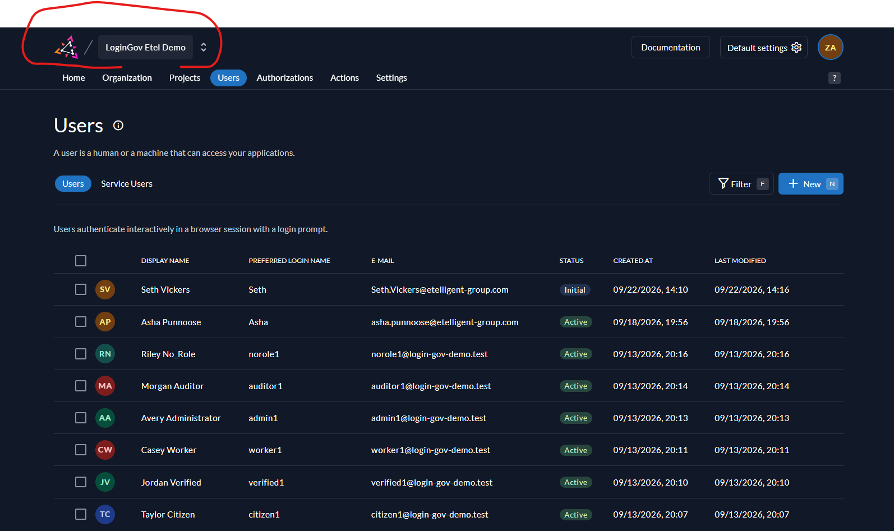

15. Create the project
Project: Federal Services IAM Demo

16. Create project roles
Role Key | Purpose
citizen | Regular public user
verified_user | Identity-verified user
case_worker | Agency/IRS case worker
agency_admin | Application administrator
security_auditor | Read-only security/audit reviewer

Create action to assign citizen role to new registered users.

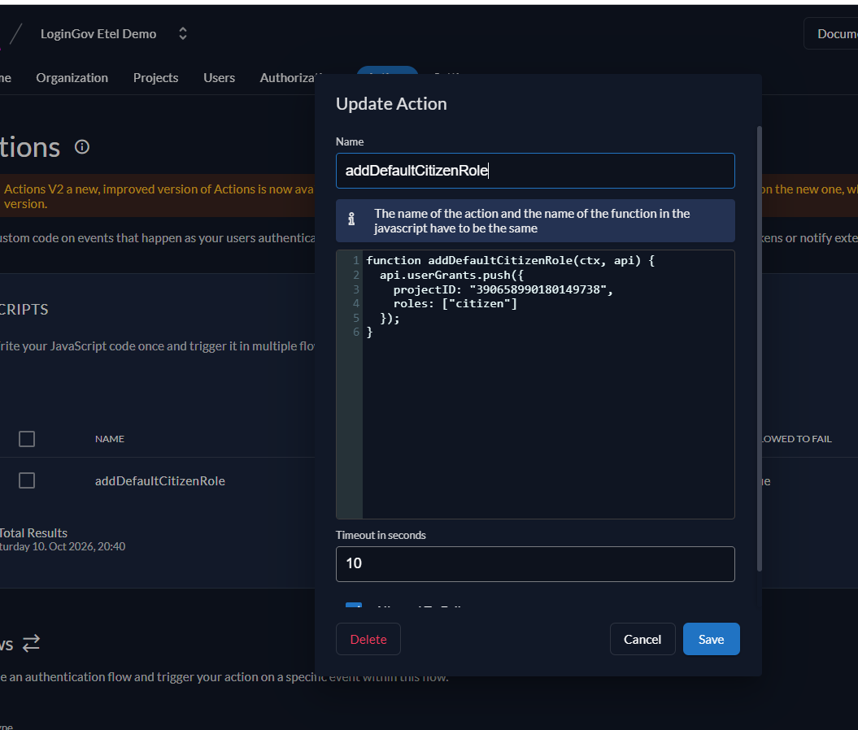

2. Create the Action

Navigate to:

Organization → Actions → Actions → New

Use:

Name

addDefaultCitizenRole

Script

function addDefaultCitizenRole(ctx, api) {

api.userGrants.push({

projectID: "YOUR_PROJECT_ID",

roles: ["citizen"]

});

}

Replace:

YOUR_PROJECT_ID

with the actual ZITADEL Project ID.

Example:

function addDefaultCitizenRole(ctx, api) {

api.userGrants.push({

projectID: "324567890123456789",

roles: ["citizen"]

});

}

The function name must exactly match the Action name.

3. Connect the Action to registration

Go to:

Organization → Actions → Flows → New

Configure:
Setting | Value
Flow type | Internal Authentication
Trigger | Post Creation
Action | addDefaultCitizenRole

Then save the flow.

Because your users register with ZITADEL username/password, they use the Internal Authentication flow. ZITADEL documents Post Creation with api.userGrants.push() as the mechanism for assigning roles to newly created users.

17. Configure project role behavior
- Enable Assert Roles on Authentication so the application can receive project roles.
- For the no-role demo, leave role-assignment enforcement off if you want norole1 to authenticate successfully and then be denied by FastAPI authorization.

18. Create the OIDC web application
Application: IRS Login.gov Demo
Type: Web
Protocol: OIDC
Flow: Authorization Code

19. Configure redirect and logout URIs
Redirect URI:
https://etelligent-group.dev/iam-demo/auth/callback
Post Logout Redirect URI:
https://etelligent-group.dev/iam-demo/
The redirect URI must match exactly, including any trailing slash. Use production HTTPS and keep Development Mode off.

20. Record the Client ID and configure token roles
Current Client ID to verify in ZITADEL: 390659814679718378
If the application is recreated, use the new Client ID. Enable the required token/role settings so FastAPI can inspect roles.

21. Configure MFA and passkeys
Passwordless: Allowed
MFA methods: TOTP + WebAuthn/Passkey

22. Create test users and assign roles
User | Role | Authentication
citizen1 | citizen | Password + TOTP
verified1 | verified_user | Passkey
worker1 | case_worker | Password + TOTP
admin1 | agency_admin | Password + Passkey
norole1 | No role | Password only
auditor1 (optional) | security_auditor | Configured MFA
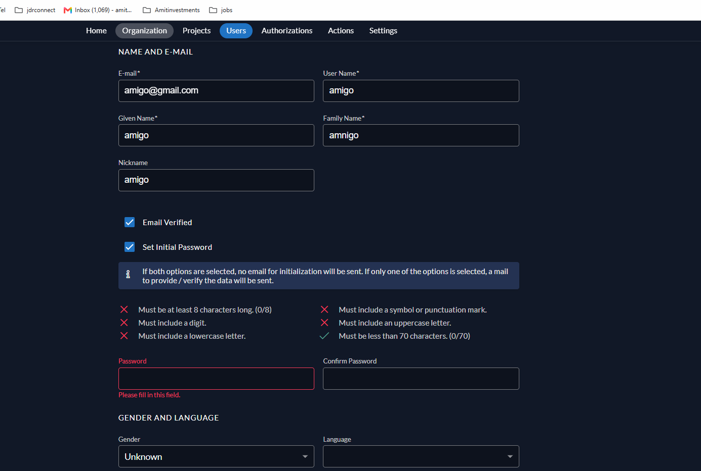

SECTION 2 - Deploy and Start the FastAPI Application

1. Clone the application from Git
cd /home/ec2-user
git clone https://git-codecommit.us-east-1.amazonaws.com/v1/repos/IRS_LoginGov
cd IRS_LoginGov

2. Create the Python virtual environment
python3 -m venv .venv
source .venv/bin/activate
python -m pip install --upgrade pip
pip install -r requirements.txt

3. Create the application .env file
nano /home/ec2-user/IRS_LoginGov/.env
OIDC_ISSUER=https://auth.etelligent-group.dev
OIDC_CLIENT_ID=390659814679718378
OIDC_REDIRECT_URI=https://etelligent-group.dev/iam-demo/auth/callback
OIDC_POST_LOGOUT_URI=https://etelligent-group.dev/iam-demo/
SESSION_SECRET=<GENERATE-A-NEW-LONG-RANDOM-SECRET>
APP_HOST=127.0.0.1
APP_PORT=8088
APP_ROOT_PATH=/iam-demo
SESSION_HTTPS_ONLY=true
chmod 600 .env
grep '.env' .gitignore || echo '.env' >> .gitignore

4. Validate application configuration
source .venv/bin/activate
python -c "from app.config import APP_PORT, APP_ROOT_PATH, OIDC_REDIRECT_URI, OIDC_POST_LOGOUT_URI; print(APP_PORT); print(APP_ROOT_PATH); print(OIDC_REDIRECT_URI); print(OIDC_POST_LOGOUT_URI)"
Expected:
8088
/iam-demo
https://etelligent-group.dev/iam-demo/auth/callback
https://etelligent-group.dev/iam-demo/

5. Verify OIDC discovery before starting FastAPI
curl https://auth.etelligent-group.dev/.well-known/openid-configuration
Confirm that the response contains issuer, authorization_endpoint, token_endpoint, userinfo_endpoint, jwks_uri, and end_session_endpoint.

6. Start FastAPI with nohup
cd /home/ec2-user/IRS_LoginGov
source .venv/bin/activate
mkdir -p logs
nohup python3 -m uvicorn app.main:app --host 127.0.0.1 --port 8088 > /home/ec2-user/IRS_LoginGov/logs/uvicorn.log 2>&1 &

7. Check FastAPI locally
ps -ef | grep uvicorn
ss -lntp | grep 8088
curl http://127.0.0.1:8088/
tail -f /home/ec2-user/IRS_LoginGov/logs/uvicorn.log

8. Create the FastAPI NGINX configuration
sudo nano /etc/nginx/conf.d/irs-login-gov.conf
server {
listen 80;
server_name etelligent-group.dev;
return 301 https://$host$request_uri;
}
server {
listen 443 ssl http2;
server_name etelligent-group.dev;
ssl_certificate /etc/letsencrypt/live/etelligent-group.dev/fullchain.pem;
ssl_certificate_key /etc/letsencrypt/live/etelligent-group.dev/privkey.pem;
location /iam-demo/ {
proxy_pass http://127.0.0.1:8088/;
proxy_set_header Host $host;
proxy_set_header X-Real-IP $remote_addr;
proxy_set_header X-Forwarded-For $proxy_add_x_forwarded_for;
proxy_set_header X-Forwarded-Proto https;
}
}

9. Test and reload NGINX
sudo nginx -t
sudo systemctl reload nginx
sudo systemctl status nginx

10. Open and test the application
https://etelligent-group.dev/iam-demo/
Expected flow: FastAPI -> ZITADEL login -> MFA/passkey -> authorization code -> callback -> token validation -> role check -> permitted dashboard.

11. Test all user scenarios
- citizen1 -> citizen page
- verified1 -> verified-user page
- worker1 -> case-worker page
- admin1 -> admin page
- norole1 -> access denied
- auditor1 -> audit page, if configured
Use separate browsers or Incognito windows to avoid cookie/session overlap.

12. Verify the no-role test
norole1 -> correct credentials -> authentication succeeds -> no project role -> FastAPI authorization check -> 403 / Access Denied
This demonstrates that authentication (who you are) is different from authorization (what you are allowed to do).

13. Verify logout
FastAPI session -> ZITADEL end_session endpoint -> session ends -> https://etelligent-group.dev/iam-demo/

14. Update application code later
cd /home/ec2-user/IRS_LoginGov
git pull origin main
source .venv/bin/activate
pip install -r requirements.txt
pkill -f "uvicorn app.main:app"
nohup python3 -m uvicorn app.main:app --host 127.0.0.1 --port 8088 > logs/uvicorn.log 2>&1 &

15. Daily status and recovery commands
PostgreSQL:
sudo systemctl status postgresql
ZITADEL:
ps -ef | grep zitadel
ss -lntp | grep 8083
tail -100 /home/ec2-user/zitadel.log
FastAPI:
ps -ef | grep uvicorn
ss -lntp | grep 8088
tail -100 /home/ec2-user/IRS_LoginGov/logs/uvicorn.log
NGINX:
sudo nginx -t
sudo systemctl status nginx
sudo tail -100 /var/log/nginx/error.log

Final Environment Checklist
- PostgreSQL is running and the zitadel database/user works.
- ZITADEL is running locally and reachable through auth.etelligent-group.dev.
- Organization, project, application, roles, users, MFA, redirect URI and logout URI are configured.
- FastAPI runs on 127.0.0.1:8088 with nohup.
- NGINX routes /iam-demo/ to FastAPI.
- OIDC discovery works from EC2.
- All role scenarios and the no-role denial scenario have been tested.
- Secrets are not committed to Git.

