
PROJECT REPORT

ON

BANKING
SYSTEM

SUBMITTED TO
SYED TAWHID IMAM
SENIOR LECTURER
UNIVERSITY OF BRAHMANBARIA

SUBMITTED BY
NAIMA AKTER MITHILA
JAID HASSAN
M.R.AMIT HASAN

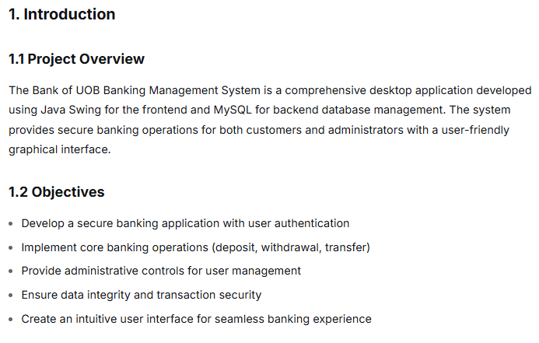
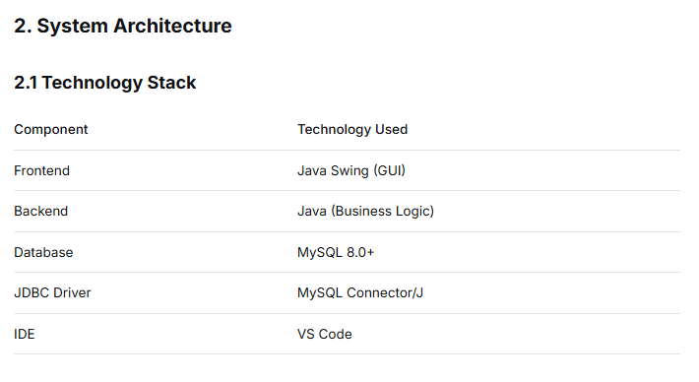
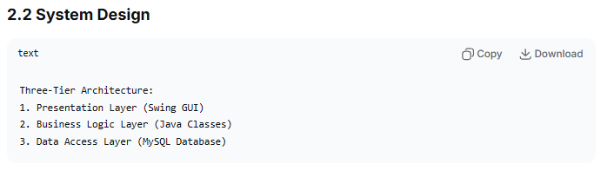
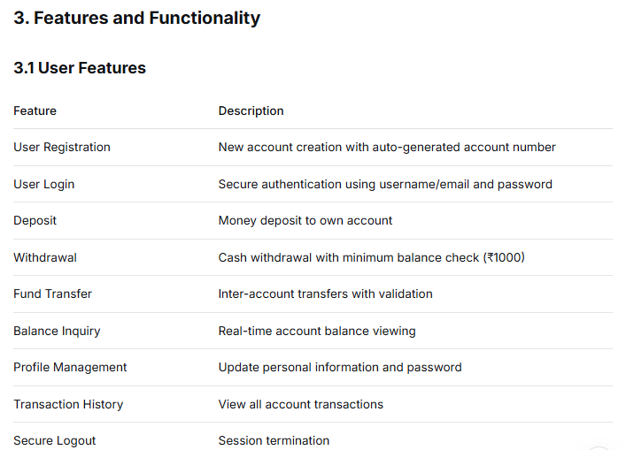
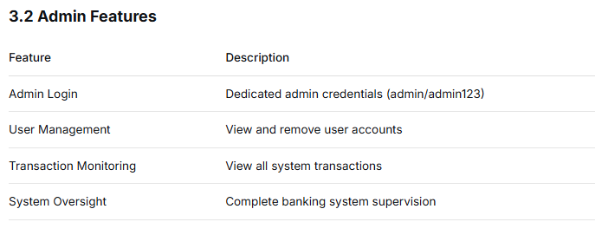
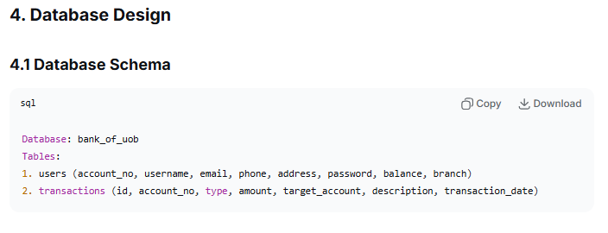
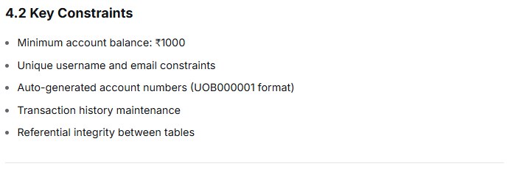
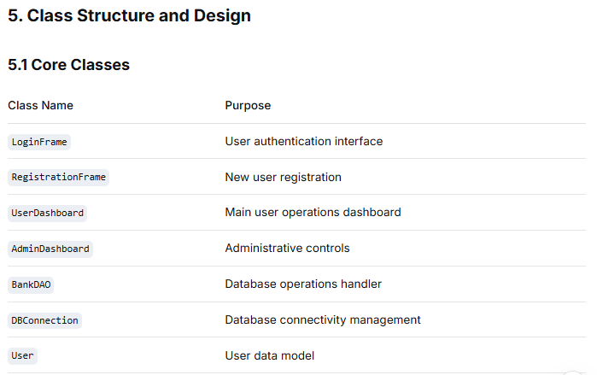
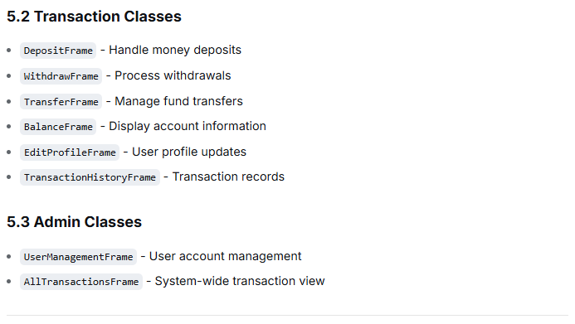
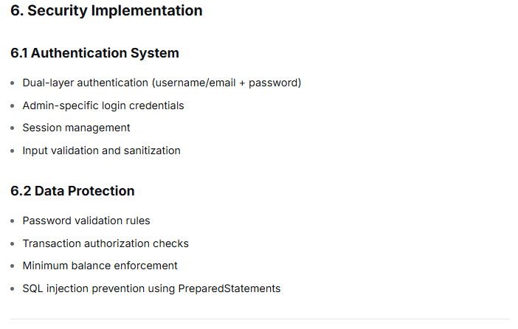
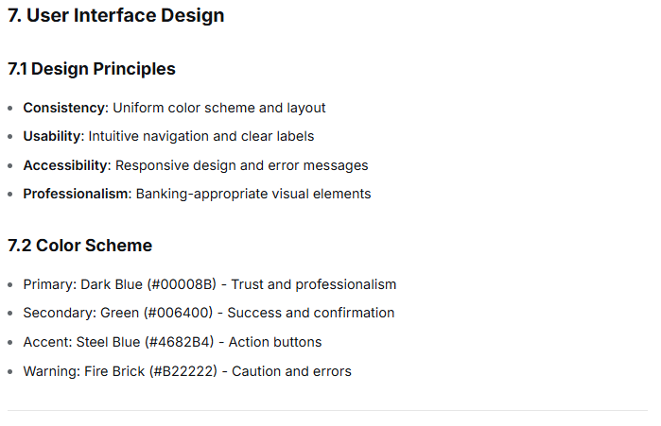
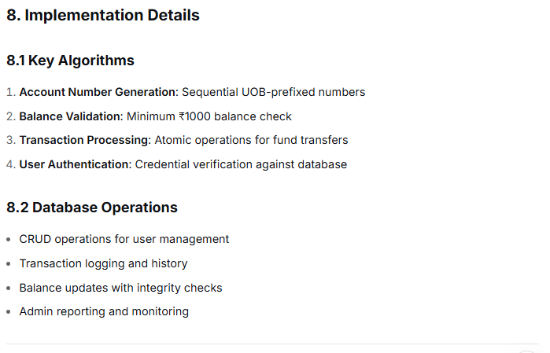
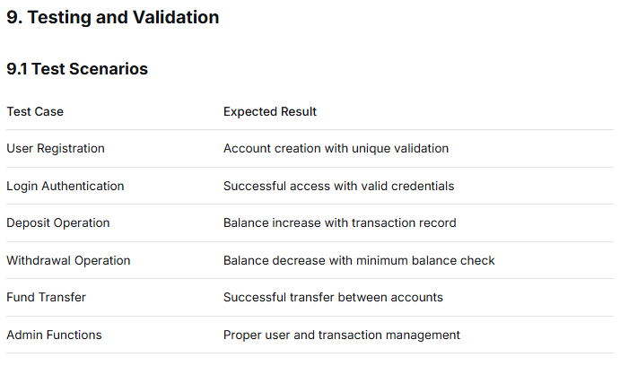
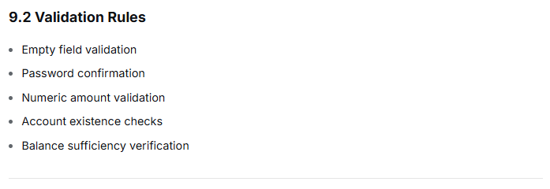
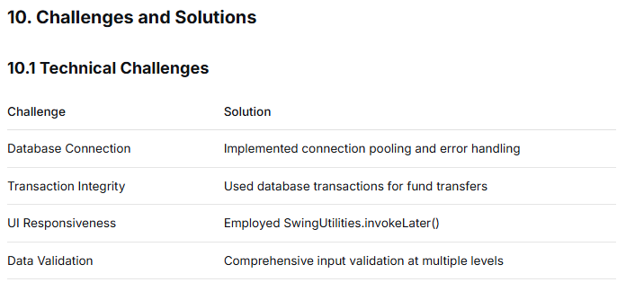
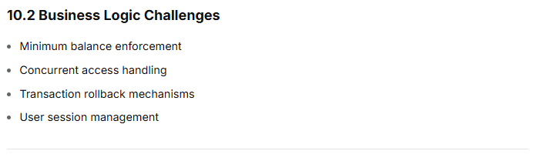
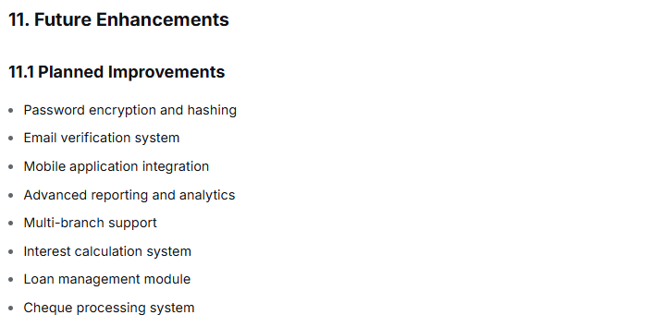
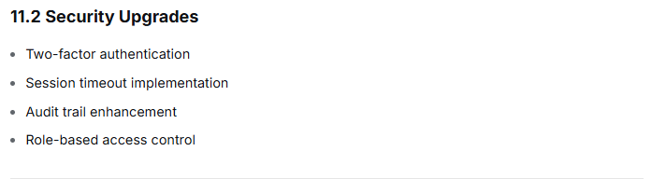

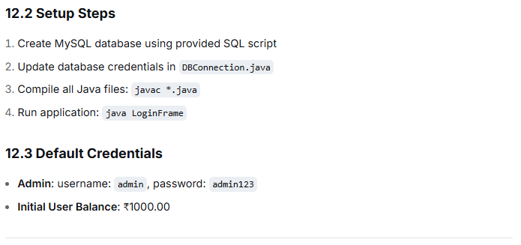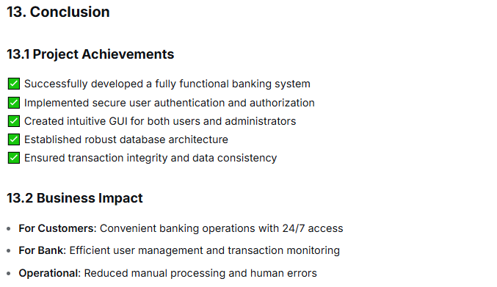
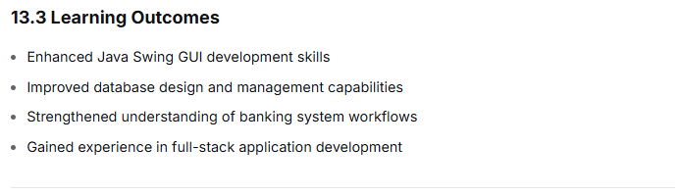
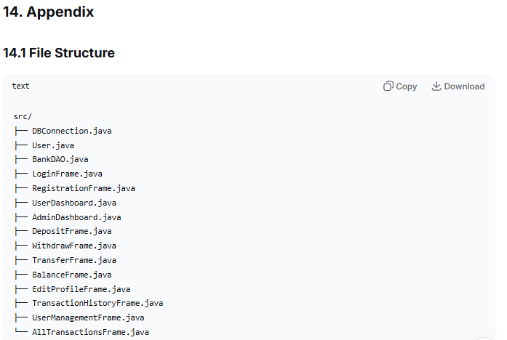
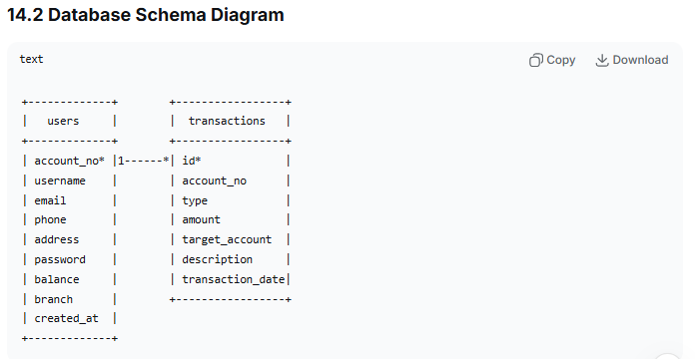

14.3 ER Diagram
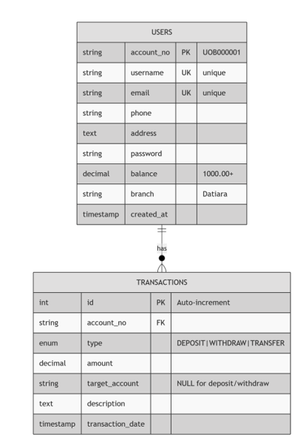

14.4 Data Flow Diagram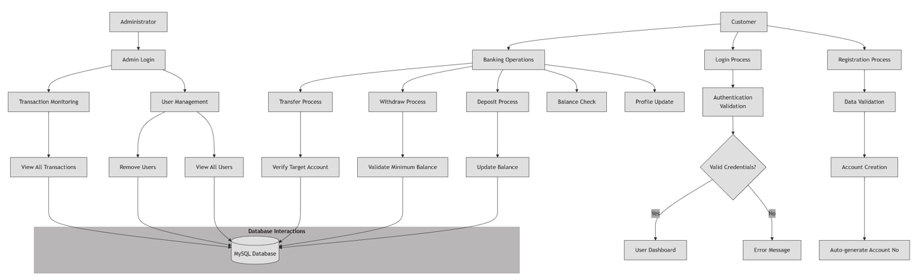
14.5 Use Case Diagram

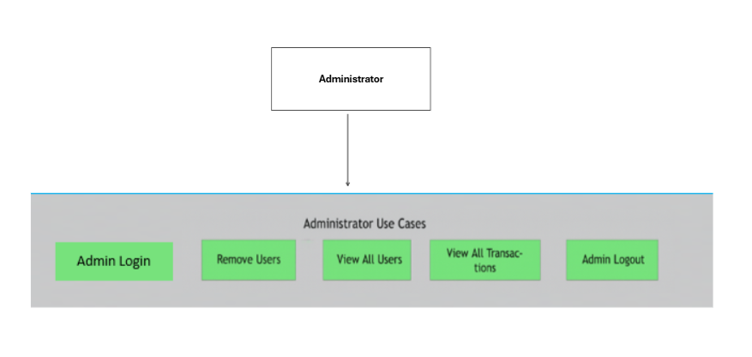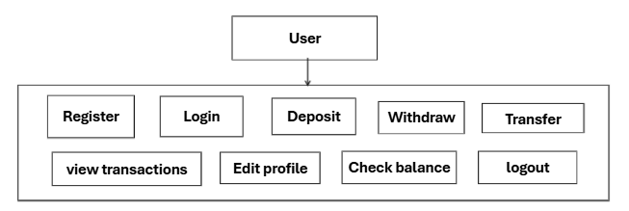

15.Team Roles
Jaid Hassan: Frontend Developer & UI Designer
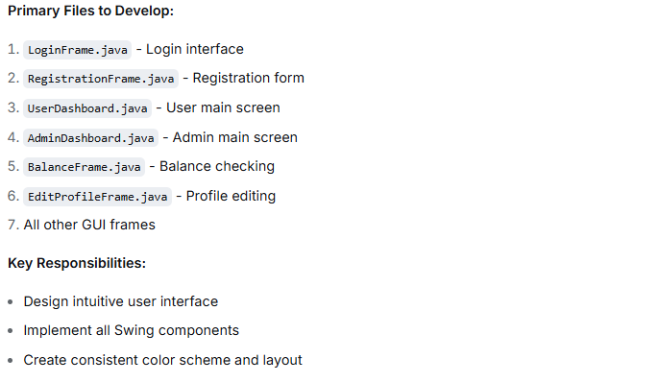
M.R. Amit Hassan: Team Lead & Backend Developer
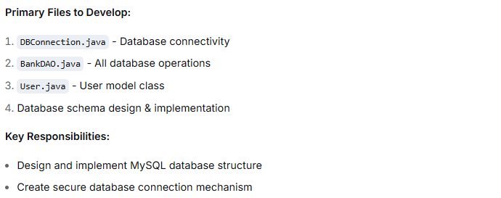

Naima Akter Mithila: Quality Analyst & Documentation
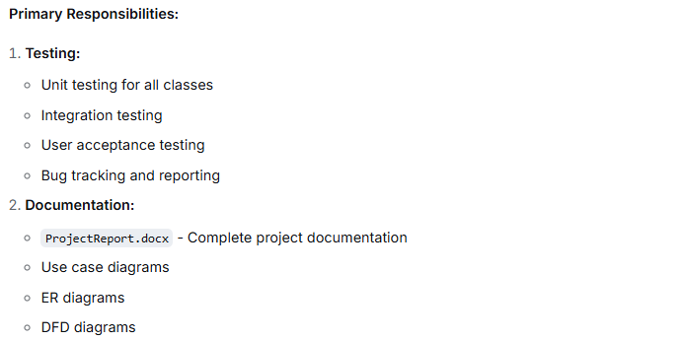

16. References
https://venngage.com/templates/diagrams/green-banking-system-er-diagram-169efd12-812f-43fa-b123-f195b4aa3d5a
https://online.visual-paradigm.com/diagrams/templates/data-flow-diagram/data-flow-diagram-example-bank-system/;VPSESSIONID=FC1ABEDBCB2E1D6D7DB0CD0F009876F3
https://venngage.com/templates/diagrams/light-banking-business-use-case-ac674046-d4af-43e1-a864-55e48ad61a3b

