The seeker scheduling system – A very rough draft.
Definitions
Performance States: Each DVFS configuration is given a performance state number with 0 being the one with the lowest clock-speed. This is usually denoted as P_{n} .
T – The total number of performance states supported by the system
N – The total processors on line.
C_{i} – The i'th processor.
P_{i} – The i'th performance state. P₀ is the one with the lowest clock speed and power consumption, and P_{T-1} is the one with the highest clock speed and power consumption. Note that this is the exact opposite when compared to P-State provided in processor manuals.
Delta: The total changes in Performance states on a global basis. For example if C₀ changes from P₂ to P₄, and C₁ changes from P₃ to P₀, while all other CPU’s are held at their existing performance state, then the delta of this mutation is said to be |4-2| + |0-3| = 5.
Mutation: The act of changing the performance states of the CPUs in the system.
Mutation Interval: The interval between two consecutive mutations.
Scheduling Quanta: Interval on which scheduling decisions are made. Usually every 1-10ms per processor and depends on the OS configuration.
Layout: The scheduling is done in a hierarchical fashion. A task is given a performance state to execute with which implies a set of processors which are running at that particular performance state. The layout L as seen by the scheduler and the mutator is:
(scheduler) where is the set of processors executing in P_{i}.
(mutator) where is the performance state at which C_{i} is currently executing with.
For example with T=5, N=4, and C₀, C₁ in state P₀, C₂ in state P₄ and finally C₃ in state P₁,
(scheduler)
(mutator)
The indices's are used every time an arithmetic operation has to be performed on the members. For example from the mutator's view, L = [0,0,4,1].
Demand: Number of requests from the previous mutation for each state in the system. It is represented as D = [D₀,D₁,D₂,…]. For example, demand is D = [0,8,8,4,0] implies that from the last mutation, P₀ and P₄ were never requested, P₁ was requested 8 times, P₂ was requested 8 times, P₃ was requested 4 times.
Introduction
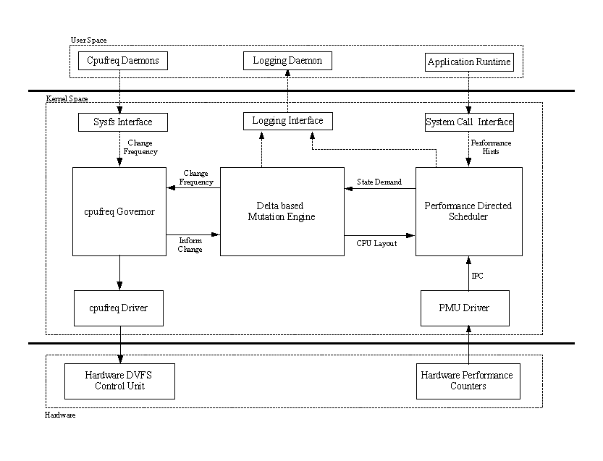
Figure 1: Seeker Scheduler System Architecture.
The performance directed scheduler (PDS) is invoked every scheduling quanta for each and every on line processor and makes decisions of what performance state a task must execute with based on its current performance (derived by reading from the PMU Driver). The information of available states and their comprising CPUs’ (Layout, L) are read in from the Mutation engine. Upon every invocation, the PDS updates the demand array, D with the requested state, and schedules the task on the closest available performance state.
The Delta based Mutation Engine (Mutator), reads in the demand array, based off of which makes decisions on what the new layout must be. The mutator is constrained by delta. If a frequency change is required, the mutator instructs the governor to change and finally, clears the demand array and updates the layout array.
Performance Directed Scheduler:
The performance Directed Scheduler (PDS) is invoked every time a task switch is requested. On a moderately loaded system, this is on an average, every scheduling quanta (1-10ms). Upon invocation, the Instructions per clock (IPC) is computed for the task being switched out from the running state. This is used to make decisions on what performance state the task should execute on. Figure 2 describes the decision diagram. The value chosen for H and L is 0.875 and 0.625 respectively.
All operations performed on the current performance state is adjusted to keep it within bounds [0,T) where T is the total number of states supported by the system. For example, the test machine used for the experiments supports a total of 5 states as shown in Table 1, allowing operations on P to be adjusted to be within [0,5). That is additions performed on P are not allowed to be greater than 4 (T-1) and subtractions are not allowed to be lesser than 0.
State | Frequency | Power Single-Plane | Power - Dual Plane
P₀ | 1100 | 75 | 64.6
P₁ | 1400 | 85.2 | 75.6
P₂ | 1700 | 95.4 | 88.8
P₃ | 2000 | 106.6 | 108.2
P₄ | 2200 | 114.1 | 115
Table 1: State characteristics for the AMD Opteron 8354
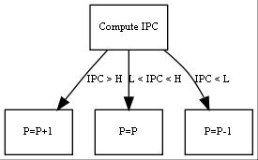
Figure 2: Decision diagram for PDS
This is a simple decision to request for a state one higher than the current state if the IPC was greater than H, by one less than the current state if IPC were less than L. The current state is maintained if the IPC is in the interval (L,H). More information about the procedure used is provided in Figure 3 below.
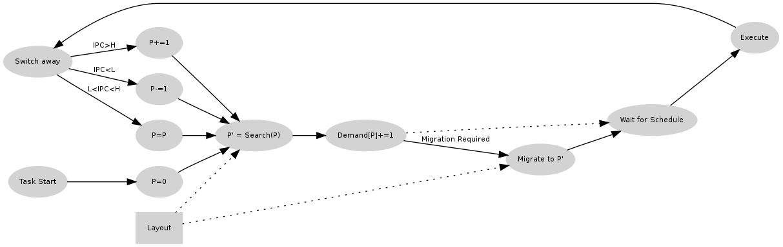
Figure 3: Scheduling methodology
Example:
Layout chosen by the mutator = [(C₀,C₁),(),(),(C₂),(C₃)] (Core 0,1 are in State 0, Core 2 in State 3 and Core 3 in state 4.
Task starts off and runs with an IPC > H, is currently executing with state P₀.
Now it requests with state P₁ (the left decision arc). But the scheduler notices the layout and that there are no processors currently at P₁. Hence it schedules it on the closest P₃, and the task migrates to C₂. The demand vector is updated to increment the demand for state P₁. Note that the demand is updated for the requested state, and not the given state.
On the next reschedule, task has an L < IPC < H, and hence the scheduler requests for the current state P₃, and hence continues to execute on C₂, and the demand for P₃ is incremented.
On the next reschedule, the task has changed phases, and is now executing with an IPC < L, as per the right arc of the decision tree, requests for a state P₂ (Incrementing the demand for P₂). Upon inspection of the layout, the scheduler chooses P₀. And hence migrates to C₀ or C₁ based on what is loaded the least. Note that PDS does not make decisions on choosing between C₀ or C₁. That decision is made my the Linux load balancer.
This can be improved by using a delayed adaptive step algorithm shown in figure 3.
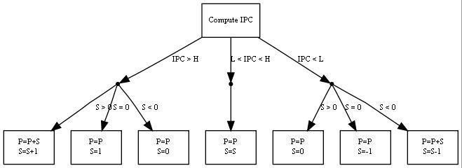
Figure 4: Decision Diagram for the adaptive step PDS
Here S is the step size with which the state transition can happen. Thus if S = 2, P = 1 (Current state is P₁) and IPC > H, then P = 3 (P₃) will be requested while assigning a value of 4 to S.
After the request, an available and unloaded state closest to the requested state is searched in the layout and the task is scheduled on one of the processors executing with the corresponding state. The demand vector is also updated for the requested state.
Note that, the state given to a task and the state requested by a task is dependent on the current layout.
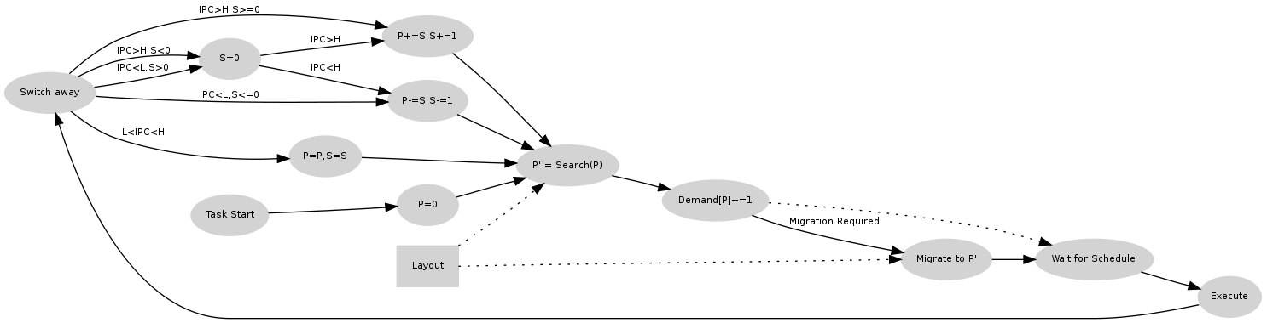
Figure 5: Adaptive Step Scheduling Methodology.

Example. Using the same example, L = [(C₀,C₁),(),(),(C₂),(C₃)]
Task starts off executing on P₀. The step parameter is currently 0.
First reschedule: IPC > H, PDS requests for state 0 + 0 = P₀, (The step is 0). and continues in the same state. The step is updated to be 1. (Second from the left).
Next, IPC > H, Step, S = 1, PDS requests for state 0 + 1 = P₁. (Step is 1), and step is updated to be 2. as there are no cpus with P₁, task migrates to P₃. This is the first decision from the left.
Next IPC > H, State, P₃, Step S = 2, PDS requests for state 4 (3 + 2 >= 5, and 4 is the max state number) and finally migrates to P4.
The same goes for all decisions.
Delta constrained Mutation:
Constraint: The total change should be less than or equal to delta.
Optimize: The system tries its best to attain the demand.
Compute Transition Direction
Compute State Matrix
Compute state weight
Pick Winning State
Winning State
chooses Processor
Mark Processor as assigned
Adjust Delta
Delta > 0
Start
End

Figure 6: Delta Constrained Mutation Process.
Each of the subprocesses are described below
Compute Transition Direction, and prerequisites
Demand vector D updated by the scheduler, is used to compute the number of processors required by each state P_{i} giving a transformed demand vector d using the Load the system experienced in the elapsed mutation interval.

Example, if D = [0,12,0,0,8], and the load is 3.0 (3 active processors were used), then d = [0,2,0,0,1] (Make note of the rounded division).
The direction of transition is an indication for the state matrix on what is the general trend.

Z_{R} The required Performance

Z_{P} the present Performance

The direction of the transition.
Essentially if Direction is 1, then a higher performance is demanded out of the system. -1 implies that a lower performance is required out of the system and a value of 0 indicates that things are fine the way they are.
And the Poison Matrix X (N x T matrix) is set to false.
Compute State Matrix:
The information in the state matrix represents the delta constraint and hence mobility allowed for each processor and the preferred direction of transition. Thus as C₀ is in state P₀, then,with delta = 1, C₀ can at most change to P₁. In general, this allows a processor to have a preference to stay in its current state or move minimally under the control of the delta constraint.
Based on the current layout and direction, a state matrix is constructed with each row corresponding to each and every on-line processor, Each column corresponds to each and every available performance state. Essentially, the state matrix M is a N x T matrix. For a system with 4 cores (C₀ through C₃) and 5 states (P₀ through P₄), a matrix shown below is constructed. If C_{i} is currently in P_{j},then it is given a max value of 2T (10 as per this example) which tapers off on either side (Based on direction)for delta number of columns. Beyond which a value of 0 is assigned to the cell expressed by Equation 1-3. L is a vector describing the state each processor is in. So, if C₀ through C₃ are in states 0,1,2,3, then L = [0,1,2,3]. The state matrix for each direction possible is shown below. M₀₀ corresponds to processor 0 and state 0. The state matrix M differs based on the direction required and is shown in equation 1-3 below.

Equation 1: Mutation Matrix
Example matrices for L = [0,1,2,3] with each required direction is shown below (delta = 1):

It can be observed that the tapering off is symmetric for M⁰ while being biased for M⁺¹ where the right leg has a larger value and M⁻¹ where the left leg has a larger value.
Compute state weight:
Elements along each column of matrices M (M⁺¹, M⁻¹ or M⁰ based on the required direction) are summed and an element by element product with the demand vector d is taken to get the weight vector W. For example, d = [0,2,0,0,1] for state 1, and an upward direction (direction = +1) W₂ = 2 x (0+9+10+4)

Equation 5

Pick winning state:
The highest value in W is chosen to be the winning state, a. In this case P₁ (a = 1) wins with a value of 46.
Pick Processor:
The processor, b, with the highest value in the state matrix and whose value in the poison matrix X_{a,i} is false. (In the example is is picked and X_{a,b} is set to true. In this case C₁ is chosen. Now as C₁ was already in P₁, delta does not need any adjustments. Finally the demand vector d is adjusted to decrement its demand by 1: d_{a} = d_{a} -1. Note that if C₁ was not in P₁, then delta must be reduced appropriately for the next iteration. The process is repeated again, re-computing the state matrix with the new delta.
Break condition:
The entire process is repeated for a maximum of Load (Number of cores/processors) times or till delta = 0 or the value of the winning state is 0. Unassigned processors are requested to go into a deeper sleep state and are not available for the scheduler.
Once completed, a new layout is decided and the demand vector D is reset and the cpufreq governor is requested for frequency changes if required.
The process is repeated every mutation interval.

