Orion Admin — Project Brief
Quarterly planning document · Q3 2026

1. Overview
This brief describes the goals for the next release. It uses bold, italic, underlined and struck-through text, red text, a highlighted phrase, E = mc² and a link to the project website.

Goals
- Ship the media package with zero dependencies
  - Carousel, gallery and lightbox
  - Players and document viewer
- Reach WCAG 2.2 AA on every component
- Keep the bundle under 250 KB gzip

Milestones
- Design review
- Implementation
  - Core components
  - Documentation
- Public beta
“Simplicity is prerequisite for reliability.” — Edsger W. Dijkstra

Budget
Team | Q1 | Q2 | Total
Engineering | $120,000 | $135,000 | $255,000
Engineering | $18,000 | $22,000 | $40,000
Design | $42,000 | $38,000 | $80,000
Shared services (merged across quarters) | $64,000 per half |  | $128,000
Grand total |  |  | $503,000
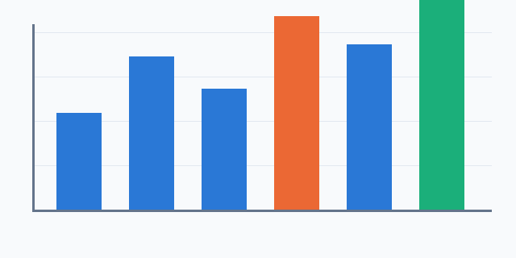
Figure 1. Monthly revenue

2. Timeline
Phase one starts in October. Phase two follows in December.
Centered paragraph for the sign-off section.
Right-aligned — Project Office

Risks
Browser support for inline PDF differs on mobile; the viewer falls back to a download card.

