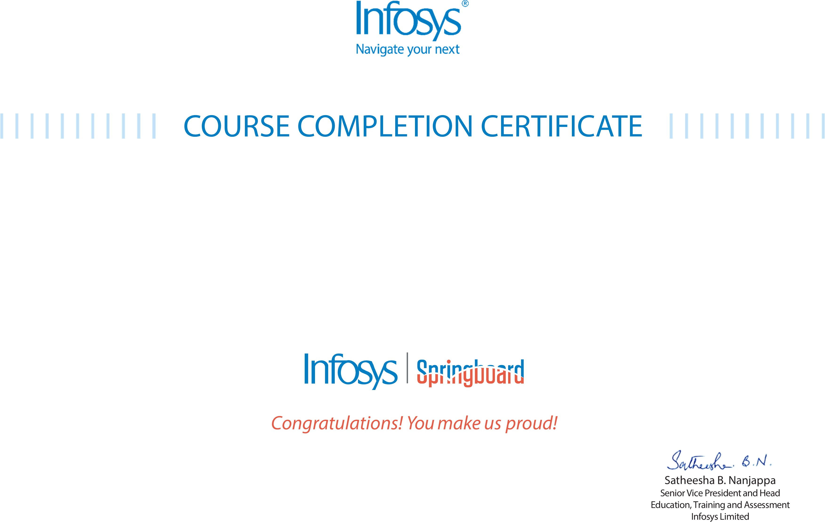
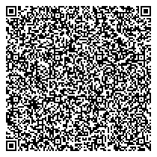

The certificate is awarded to

Amateppa Ambigar
for successfully completing the course

JavaScript
on September 3, 2026

Issued on: Thursday, September 3, 2026
To verify, scan the QR code at https://verify.onwingspan.com

