There are two methods to rank the subjects in order of difficulty

Method1 :

In method1 ranks of difficulty is based on the majority score in that particular subject. An histogram of each subject is obtained and based on the majority score (at what range of marks does the peak lye). If the peak position is present LEFT(lower marks range), then that subject is difficult for majority of students. If the peak is present more towards RIGHT(higher marks range), then that subject is easy for majority of students. So based on the peak position the subjects are arranged accordingly.

Implementation (Using MATLAB)

1. The excel file containing marks of students is in the form of a matrix (students X subject marks, in our case 45 students X 6 subjects) is imported to a matrix ‘marks’ using xlsread() command.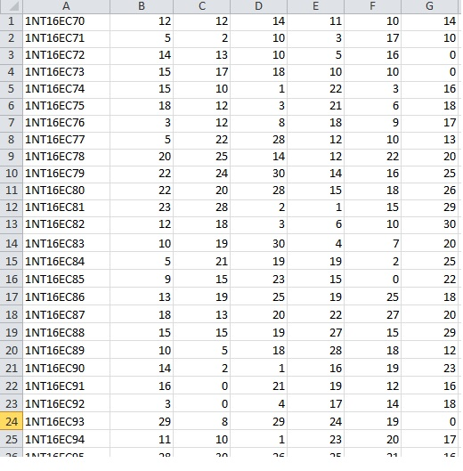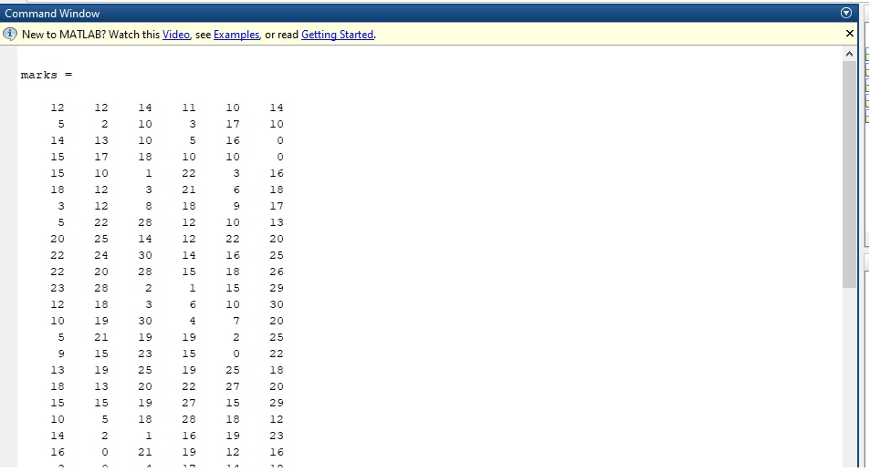
2. A histogram for each subject is obtained based on the marks of all the students in that subject. In MATLAB, by using the hist() command we can obtain the histogram. The hist() command returns two things, first is a graph(histogram), the second is a matrix that represents the Y value of the histogram for each division of X). 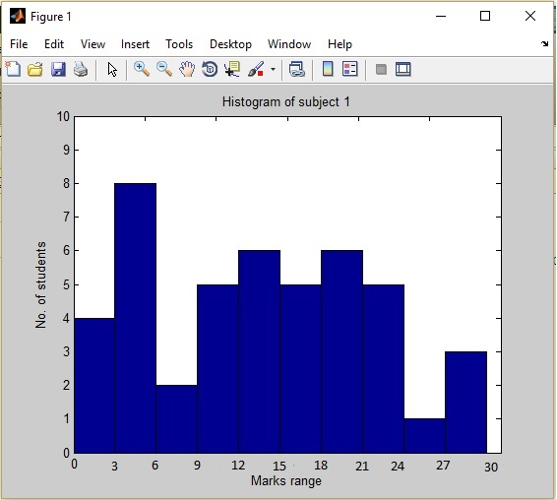

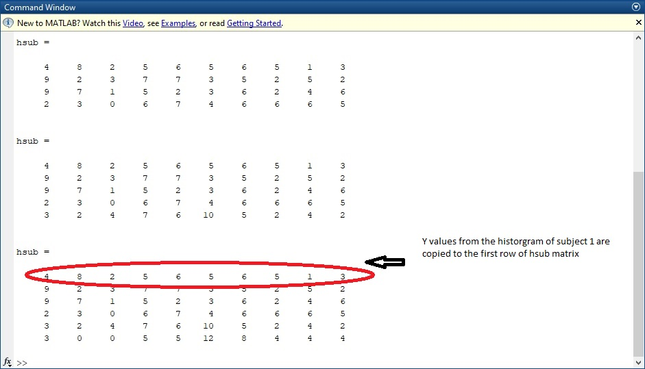

1. The hsub matrix represents the histogram values for each subject. Row -> subject1,2,3…. And column -> No. of students in the range 0-3,3-6,6-9….so on. At this step the peak positions are calculated for each subject. 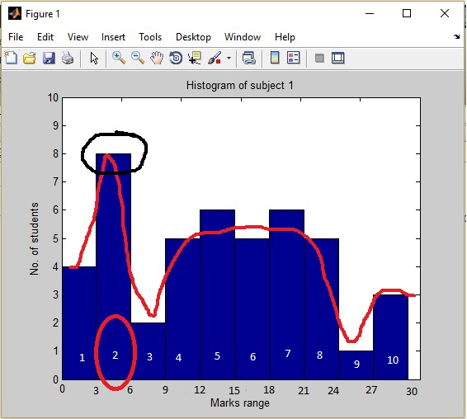

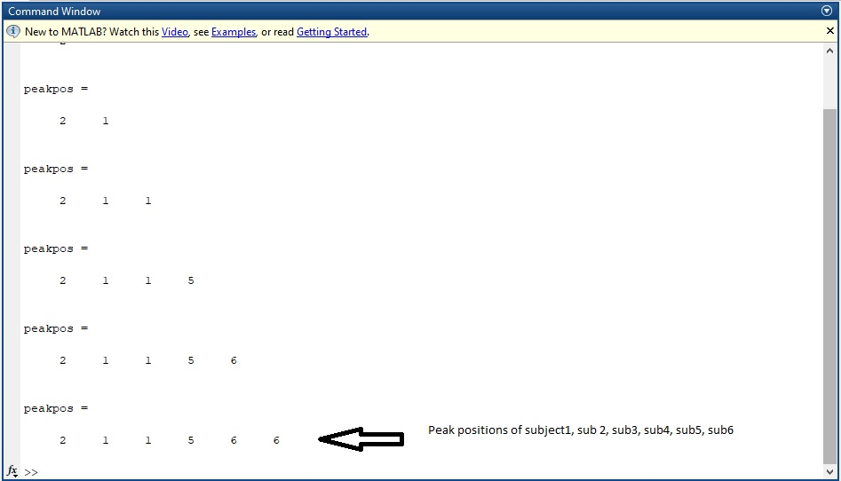

1. Once the peak position is found for each subject, the rank matrix is formed. The rank matrix represents the subject index, in decreasing order of difficulty. The first element of the rank matrix is the index of the MOST DIFFICULT subject. And the last element of the rank matrix represents the index of the EASIEST subject. For example, Say rank = [ 3 2 6 4 1 5], what this means is, here 3 is the first index(MOST DIFFICULT) so here 3 means ‘Sujbect3’ and 5 is the last element(EASIEST), so 5 means ‘Subject5’.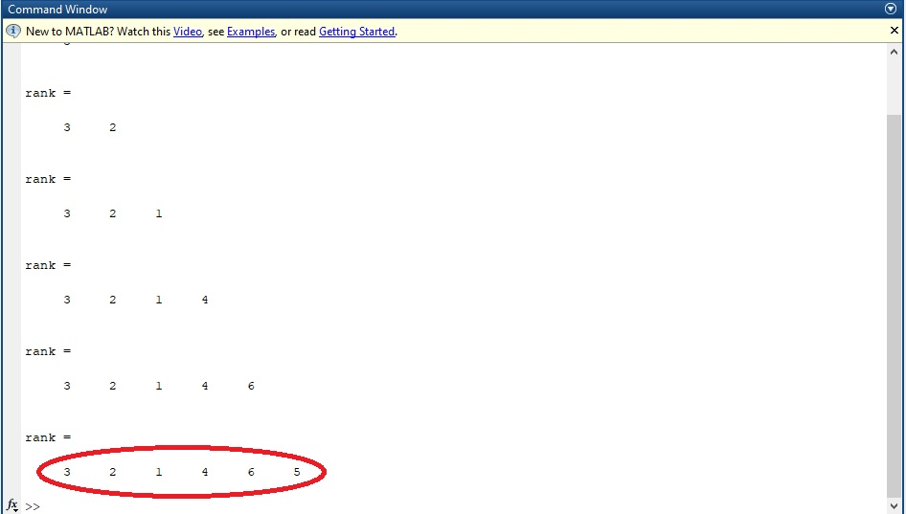

In our case, subject3 is the most difficult and subject5 is the easiest. By verifying the histograms of each subject manually, we can come to this conclusion.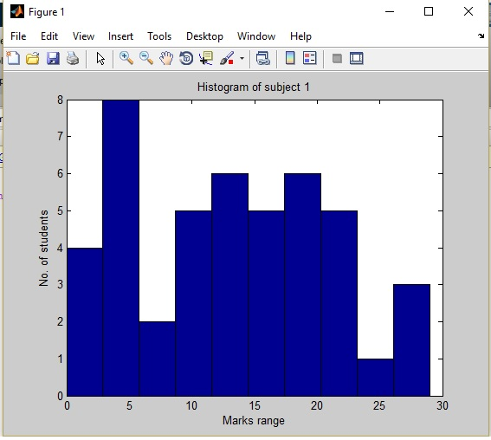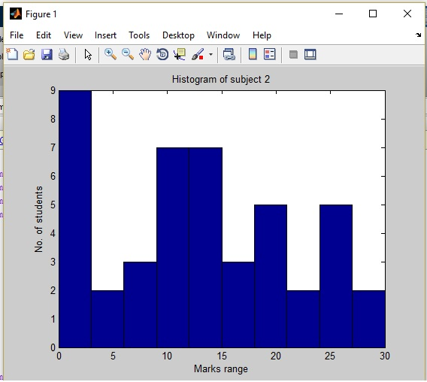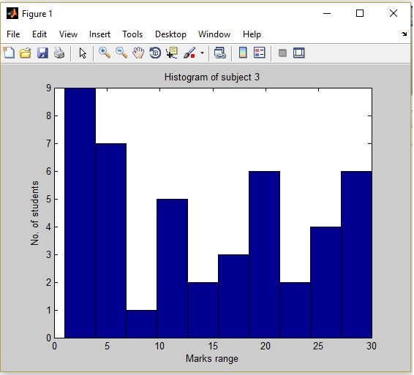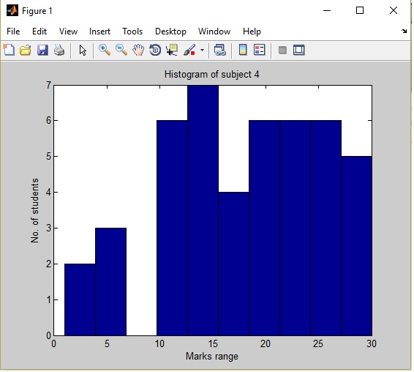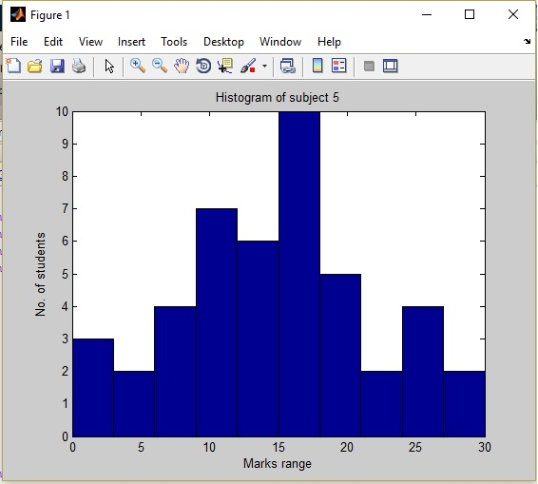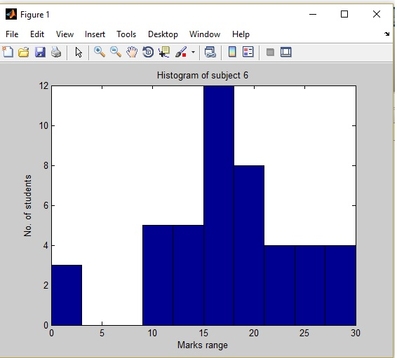

Finally based on method1 the timetable can be set as follows.

|  |  |
| --- | --- |
| Subject3 | Subject4 |
| Subject2 | Subject6 |
| Subject1 | Subject5 |

Method2:

In method2 there are two stages.

In 1st stage we consider each student and arrange the subjects in decreasing order of difficulty based of highest,2nd ,3rd , 4th highest… and so on. A matrix named ‘rank is formed’ and each row of the rank matrix is dedicated to a particular student. In each row, the first element represents the index of the difficult subject and last element represents the easiest subject **for that particular student**. So this process is done for all the students and the rank matrix is formed.

In the 2nd stage we consider the columns of rank matrix, the columns of the rank matrix represents what is the relative difficulty of that subject for that particular student. Suppose the 2nd row of the rank matrix has elements as such.

Rank(2,:) = 3 6 1 2 5 4

What this means is

Subject 1 is 3rd difficult  
Subject 2 is 6th difficult  
Subject 3 is 1st difficult  
Subject 4 is 2nd difficult  
Subject 5 is 5th difficult  
Subject 6 is 4th difficult

**NOTE**: Here index represents the subject and the value represents the rank of difficulty.  
  
  
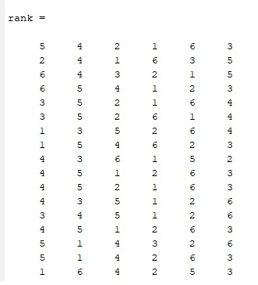

In 2nd stage, we consider this rank matrix and plot a histogram, this histogram represents ‘How many students find this subject difficult at scale from 1 to 6.

