**Business Report**

**Project – FRA Project(Milestone-1)**

**Predicting Credit Risk for Company data**

**Created by Amit Jain**

Contents

List of Figure 2

Credit Risk Dataset : Introduction 3

Problem statement : 3

Read the data as Dataframe in python and analyze the data. 4

Fixing messy column names (containing spaces) for ease of use : 5

Data dictionary : 6

Create dependent variable: 9

Data types of all variables: 10

Dropping unnecessary columns: 11

NULL Checks: 12

Treat missing values: 14

Outlier detection: 14

Outlier Treatment: 15

Univariate analysis: 16

Distinct Value Counts of each field: 16

Correlation heatmap 18

Model building using stats model: 19

Stats Model definitions: 19

Partitioning the data into train and test: 20

Start with the model 20

# **List of Figure**

Figure 1 HeatMap 14

Figure 2 BoxPlot for all data elements 15

Figure 3 ScatterPlot 19

# **Credit Risk Dataset : Introduction**

This report explains the business requirements and provide the detailed solution based on the data provided for each problem statement. given in the assignment. Also, the purpose of this exercise is to execute Stats Model supervised learning techniques on the given data, combine all predictions and find out the model with best prediction or accuracy. In supervised learning techniques, there are clearly defined X and Y variables. Supervised Learning is used to predict either a continuous response (as in regression) or a categorical response (as in classification). These are machine learning models for combining predictions from multiple separate models. Both regression and classification can be done using Ensemble Learning. Combining all the individual predictions can be done using either voting or averaging.

# **Problem statement :**

Businesses or companies can fall prey to default if they are not able to keep up their debt obligations. Defaults will lead to a lower credit rating for the company which in turn reduces its chances of getting credit in the future and may have to pay higher interests on existing debts as well as any new obligations. From an investor's point of view, he would want to invest in a company if it is capable of handling its financial obligations, can grow quickly, and is able to manage the growth scale.

A balance sheet is a financial statement of a company that provides a snapshot of what a company owns, owes, and the amount invested by the shareholders. Thus, it is an important tool that helps evaluate the performance of a business.

Data that is available includes information from the financial statement of the companies for the previous year (2015). Also, information about the Networth of the company in the following year (2016) is provided which can be used to drive the labeled field.

**Dataset for Problem 1: Company_Data2015-1.xlsx**

To understand the problem, for Credit risk checking company has given sample of 3586 Company records collected data in the Company_Data2015-1.xlsx , which have financial information of the companies for previous year 3025 and we need to predict Company status based on next Year Networth.

**Dependent variable -** We need to create a default variable that should take the value of 1 when net worth next year is negative & 0 when net worth next year is positive.

**Assumption:**

Assume that the data follows a normal distribution. In reality, the normality assumption may not always hold if the sample size is small.

Step of understanding the data:

Import the data: Imported the data using Python notebooks and analyzed the effects of Education and Occupations over salary field.

# **Read the data as Dataframe in python and analyze the data.**

This is how the data look like:

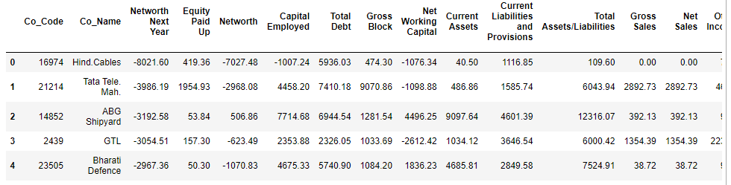

Shape of the data:

The number of rows (observations) is 3586

The number of columns (variables) is 67

Insights:

1. There are only 3586 Rows in sample, data , which are Companies previous year financial statements
2. We have given total 67 different fields for the data, so good amount of observation points.
3. Column names of the data:

'Co_Code', 'Co_Name', 'Networth Next Year', 'Equity Paid Up',, 'Networth', 'Capital Employed', 'Total Debt', 'Gross Block ',, 'Net Working Capital ', 'Current Assets ',, 'Current Liabilities and Provisions ', 'Total Assets/Liabilities ',, 'Gross Sales', 'Net Sales', 'Other Income', 'Value Of Output',, 'Cost of Production', 'Selling Cost', 'PBIDT', 'PBDT', 'PBIT', 'PBT',, 'PAT', 'Adjusted PAT', 'CP', 'Revenue earnings in forex',, 'Revenue expenses in forex', 'Capital expenses in forex',, 'Book Value (Unit Curr)', 'Book Value (Adj.) (Unit Curr)',, 'Market Capitalisation', 'CEPS (annualised) (Unit Curr)',, 'Cash Flow From Operating Activities',, 'Cash Flow From Investing Activities',, 'Cash Flow From Financing Activities', 'ROG-Net Worth (%)',, 'ROG-Capital Employed (%)', 'ROG-Gross Block (%)',, 'ROG-Gross Sales (%)', 'ROG-Net Sales (%)',, 'ROG-Cost of Production (%)', 'ROG-Total Assets (%)', 'ROG-PBIDT (%)',, 'ROG-PBDT (%)', 'ROG-PBIT (%)', 'ROG-PBT (%)', 'ROG-PAT (%)',, 'ROG-CP (%)', 'ROG-Revenue earnings in forex (%)',, 'ROG-Revenue expenses in forex (%)', 'ROG-Market Capitalisation (%)',, 'Current Ratio[Latest]', 'Fixed Assets Ratio[Latest]',, 'Inventory Ratio[Latest]', 'Debtors Ratio[Latest]',, 'Total Asset Turnover Ratio[Latest]', 'Interest Cover Ratio[Latest]',, 'PBIDTM (%)[Latest]', 'PBITM (%)[Latest]', 'PBDTM (%)[Latest]',, 'CPM (%)[Latest]', 'APATM (%)[Latest]', 'Debtors Velocity (Days)',, 'Creditors Velocity (Days)', 'Inventory Velocity (Days)',, 'Value of Output/Total Assets', 'Value of Output/Gross Block'

# **Fixing messy column names (containing spaces) for ease of use :**

We can also observe that above listed column names have multiple Special characters in it , example [, (, ], ), %, - white space etc.

In order to start analyzing them in out Python tool, we need to clear this clutter and modify Column names only.

After fixing column names, this is how the Column names look like:

'Co_Code', 'Co_Name', 'Networth_Next_Year', 'Equity_Paid_Up', 'Networth', 'Capital_Employed', 'Total_Debt', 'Gross_Block', 'Net_Working_Capital', 'Current_Assets', 'Current_Liabilities_and_Provisions', 'Total_Assets_by_Liabilities', 'Gross_Sales', 'Net_Sales', 'Other_Income', 'Value_Of_Output', 'Cost_of_Production', 'Selling_Cost', 'PBIDT', 'PBDT', 'PBIT', 'PBT', 'PAT', 'Adjusted_PAT', 'CP', 'Revenue_earnings_in_forex', 'Revenue_expenses_in_forex', 'Capital_expenses_in_forex', 'Book_Value_Unit_Curr', 'Book_Value_Adj_Unit_Curr', 'Market_Capitalisation', 'CEPS_annualised_Unit_Curr', 'Cash_Flow_From_Operating_Activities', 'Cash_Flow_From_Investing_Activities', 'Cash_Flow_From_Financing_Activities', 'ROG_Net_Worth_perc', 'ROG_Capital_Employed_perc', 'ROG_Gross_Block_perc', 'ROG_Gross_Sales_perc', 'ROG_Net_Sales_perc', 'ROG_Cost_of_Production_perc', 'ROG_Total_Assets_perc', 'ROG_PBIDT_perc', 'ROG_PBDT_perc', 'ROG_PBIT_perc', 'ROG_PBT_perc', 'ROG_PAT_perc', 'ROG_CP_perc', 'ROG_Revenue_earnings_in_forex_perc', 'ROG_Revenue_expenses_in_forex_perc', 'ROG_Market_Capitalisation_perc', 'Current_RatioLatest', 'Fixed_Assets_RatioLatest', 'Inventory_RatioLatest', 'Debtors_RatioLatest', 'Total_Asset_Turnover_RatioLatest', 'Interest_Cover_RatioLatest', 'PBIDTM_percLatest', 'PBITM_percLatest', 'PBDTM_percLatest', 'CPM_percLatest', 'APATM_percLatest', 'Debtors_Velocity_Days', 'Creditors_Velocity_Days', 'Inventory_Velocity_Days', 'Value_of_Output_by_Total_Assets', 'Value_of_Output_by_Gross_Block'

# **Data dictionary :**

|  |  |  |  |
| --- | --- | --- | --- |
| **#** | **Field Name** | **Description** | **New Field Name** |
| 1 | Co_Code | Company Code | Co_Code |
| 2 | Co_Name | Company Name | Co_Name |
| 3 | Networth Next Year | Value of a company as on 2016 – Next Year(difference between the value of total assets and total liabilities) | Networth_Next_Year |
| 4 | Equity Paid Up | Amount that has been received by the company through the issue of shares to the shareholders | Equity_Paid_Up |
| 5 | Networth | Value of a company as on 2015 – Current Year | Networth |
| 6 | Capital Employed | Total amount of capital used for the acquisition of profits by a company | Capital_Employed |
| 7 | Total Debt | The sum of money borrowed by the company and is due to be paid | Total_Debt |
| 8 | Gross Block | Total value of all of the assets that a company owns | Gross_Block |
| 9 | Net Working Capital | The difference between a company’s current assets (cash, accounts receivable, inventories of raw materials and finished goods) and its current liabilities (accounts payable). | Net_Working_Capital |
| 10 | Current Assets | All the assets of a company that are expected to be sold or used as a result of standard business operations over the next year. | Curr_Assets |
| 11 | Current Liabilities and Provisions | Short-term financial obligations that are due within one year (includes amount that is set aside cover a future liability) | Curr_Liab_and_Prov |
| 12 | Total Assets/Liabilities | Ratio of total assets to liabailities of the company | Total_Assets_to_Liab |
| 13 | Gross Sales | The grand total of sale transactions within the accounting period | Gross_Sales |
| 14 | Net Sales | Gross sales minus returns, allowances, and discounts | Net_Sales |
| 15 | Other Income | Income realized from non-business activities (e.g. sale of long term asset) | Other_Income |
| 16 | Value Of Output | Product of physical output of goods and services produced by company and its market price | Value_Of_Output |
| 17 | Cost of Production | Costs incurred by a business from manufacturing a product or providing a service | Cost_of_Prod |
| 18 | Selling Cost | Costs which are made to create the demand for the product (advertising expenditures, packaging and styling, salaries, commissions and travelling expenses of sales personnel, and the cost of shops and showrooms) | Selling_Cost |
| 19 | PBIDT | Profit Before Interest, Depreciation & Taxes | PBIDT |
| 20 | PBDT | Profit Before Depreciation and Tax | PBDT |
| 21 | PBIT | Profit before interest and taxes | PBIT |
| 22 | PBT | Profit before tax | PBT |
| 23 | PAT | Profit After Tax | PAT |
| 24 | Adjusted PAT | Adjusted profit is the best estimate of the true profit | Adjusted_PAT |
| 26 | CP | Commercial paper , a short-term debt instrument to meet short-term liabilities. | CP |
| 27 | Revenue earnings in forex | Revenue earned in foreign currency | Rev_earn_in_forex |
| 28 | Revenue expenses in forex | Expenses due to foreign currency transactions | Rev_exp_in_forex |
| 29 | Capital expenses in forex | Long term investment in forex | Capital_exp_in_forex |
| 30 | Book Value (Unit Curr) | Net asset value | Book_Value_Unit_Curr |
| 31 | Book Value (Adj.) (Unit Curr) | Book value adjusted to reflect asset’s true fair market value | Book_Value_Adj_Unit_Curr |
| 32 | Market Capitalisation | Product of the total number of a company’s outstanding shares and the current market price of one share | Market_Capitalisation |
| 33 | CEPS (nnualized) (Unit Curr) | Cash Earnings per Share, profitability ratio that measures the financial performance of a company by calculating cash flows on a per share basis | CEPS_annualised_Unit_Curr |
| 34 | Cash Flow From Operating Activities | Use of cash from ongoing regular business activities | Cash_Flow_From_Opr |
| 35 | Cash Flow From Investing Activities | Cash used in the purchase of non-current assets–or long-term assets– that will deliver value in the future | Cash_Flow_From_Inv |
| 36 | Cash Flow From Financing Activities | Net flows of cash that are used to fund the company (transactions involving debt, equity, and dividends) | Cash_Flow_From_Fin |
| 37 | ROG-Net Worth (%) | Rate of Growth – Networth | ROG_Net_Worth_perc |
| 38 | ROG-Capital Employed (%) | Rate of Growth – Capital Employed | ROG_Capital_Employed_perc |
| 39 | ROG-Gross Block (%) | Rate of Growth – Gross Block | ROG_Gross_Block_perc |
| 40 | ROG-Gross Sales (%) | Rate of Growth – Gross Sales | ROG_Gross_Sales_perc |
| 41 | ROG-Net Sales (%) | Rate of Growth – Net Sales | ROG_Net_Sales_perc |
| 42 | ROG-Cost of Production (%) | Rate of Growth - Cost of Production | ROG_Cost_of_Prod_perc |
| 43 | ROG-Total Assets (%) | Rate of Growth – Total Assets | ROG_Total_Assets_perc |
| 44 | ROG-PBIDT (%) | Rate of Growth- PBIDT | ROG_PBIDT_perc |
| 45 | ROG-PBDT (%) | Rate of Growth- PBDT | ROG_PBDT_perc |
| 46 | ROG-PBIT (%) | Rate of Growth- PBIT | ROG_PBIT_perc |
| 47 | ROG-PBT (%) | Rate of Growth- PBT | ROG_PBT_perc |
| 48 | ROG-PAT (%) | Rate of Growth- PAT | ROG_PAT_perc |
| 49 | ROG-CP (%) | Rate of Growth- CP | ROG_CP_perc |
| 50 | ROG-Revenue earnings in forex (%) | Rate of Growth - Revenue earnings in forex | ROG_Rev_earn_in_forex_perc |
| 51 | ROG-Revenue expenses in forex (%) | Rate of Growth - Revenue expenses in forex | ROG_Rev_exp_in_forex_perc |
| 52 | ROG-Market Capitalisation (%) | Rate of Growth – Market Capitalisation | ROG_Market_Capitalisation_perc |
| 53 | Current Ratio[Latest] | Liquidity ratio, company’s ability to pay short-term obligations or those due within one year | Curr_Ratio_Latest |
| 54 | Fixed Assets Ratio[Latest] | Solvency ratio, the capacity of a company to discharge its obligations towards long-term lenders indicating | Fixed_Assets_Ratio_Latest |
| 55 | Inventory Ratio[Latest] | Activity ratio, specifies the number of times the stock or inventory has been replaced and sold by the company | Inventory_Ratio_Latest |
| 56 | Debtors Ratio[Latest] | Measures how quickly cash debtors are paying back to the company | Debtors_Ratio_Latest |
| 57 | Total Asset Turnover Ratio[Latest] | The value of a company’s revenues relative to the value of its assets | Total_Asset_Turnover_Ratio_Latest |
| 58 | Interest Cover Ratio[Latest] | Determines how easily a company can pay interest on its outstanding debt | Interest_Cover_Ratio_Latest |
| 59 | PBIDTM (%)[Latest] | Profit before Interest Depreciation and Tax Margin | PBIDTM_perc_Latest |
| 60 | PBITM (%)[Latest] | Profit Before Interest Tax Margin | PBITM_perc_Latest |
| 61 | PBDTM (%)[Latest] | Profit Before Depreciation Tax Margin | PBDTM_perc_Latest |
| 62 | CPM (%)[Latest] | Cost per thousand (advertising cost) | CPM_perc_Latest |
| 63 | APATM (%)[Latest] | After tax profit margin | APATM_perc_Latest |
| 64 | Debtors Velocity (Days) | Average days required for receiving the payments | Debtors_Vel_Days |
| 65 | Creditors Velocity (Days) | Average number of days company takes to pay suppliers | Creditors_Vel_Days |
| 66 | Inventory Velocity (Days) | Average number of days the company needs to turn its inventory into sales | Inventory_Vel_Days |
| 67 | Value of Output/Total Assets | Ratio of Value of Output (market value) to Total Assets | Value_of_Output_to_Total_Assets |
| 68 | Value of Output/Gross Block | Ratio of Value of Output (market value) to Gross Block | Value_of_Output_to_Gross_Block |

**Description of the data elements:**

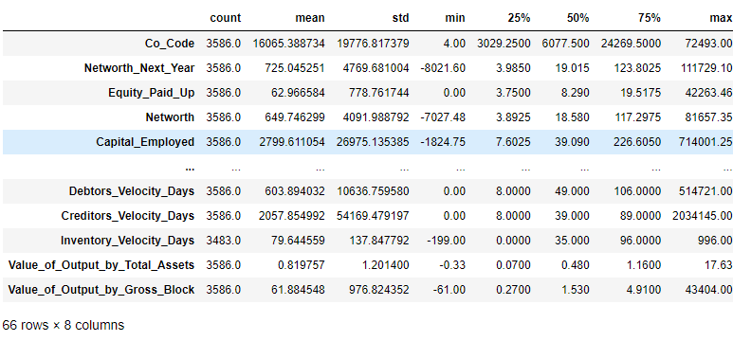

Insights:

1. We can clearly see that data have different range of Min, max and Median.
2. We can Scale the data, based on our what prediction method we are using.

# **Create dependent variable:**

Dependent variable – We need to create a default variable that should take the value of 1 when net worth next year is negative & 0 when net worth next year is positive.

Lets check for the proportion of the data:

1. 3198
2. 388

Now lets check for the summary of the “default” target data :

count 3586.000000

mean 0.108199

std 0.310674

min 0.000000

25% 0.000000

50% 0.000000

75% 0.000000

max 1.000000

Name: default, dtype: float64

Insights:

1. Target variable is 1, which denotes the Default companies
2. Value 0 denotes, non default company
3. Default companies data is very less as compare to Non-default company.
4. Ratio of the target variable is 10.8%

# **Data types of all variables:**

Data columns (total 68 columns):

# Column Non-Null Count Dtype

--- ------ -------------- -----

0 Co_Code 3586 non-null int64

1 Co_Name 3586 non-null object

2 Networth_Next_Year 3586 non-null float64

3 Equity_Paid_Up 3586 non-null float64

4 Networth 3586 non-null float64

5 Capital_Employed 3586 non-null float64

6 Total_Debt 3586 non-null float64

7 Gross_Block 3586 non-null float64

8 Net_Working_Capital 3586 non-null float64

9 Current_Assets 3586 non-null float64

10 Current_Liabilities_and_Provisions 3586 non-null float64

11 Total_Assets_by_Liabilities 3586 non-null float64

12 Gross_Sales 3586 non-null float64

13 Net_Sales 3586 non-null float64

14 Other_Income 3586 non-null float64

15 Value_Of_Output 3586 non-null float64

16 Cost_of_Production 3586 non-null float64

17 Selling_Cost 3586 non-null float64

18 PBIDT 3586 non-null float64

19 PBDT 3586 non-null float64

20 PBIT 3586 non-null float64

21 PBT 3586 non-null float64

22 PAT 3586 non-null float64

23 Adjusted_PAT 3586 non-null float64

24 CP 3586 non-null float64

25 Revenue_earnings_in_forex 3586 non-null float64

26 Revenue_expenses_in_forex 3586 non-null float64

27 Capital_expenses_in_forex 3586 non-null float64

28 Book_Value_Unit_Curr 3586 non-null float64

29 Book_Value_Adj_Unit_Curr 3582 non-null float64

30 Market_Capitalisation 3586 non-null float64

31 CEPS_annualised_Unit_Curr 3586 non-null float64

32 Cash_Flow_From_Operating_Activities 3586 non-null float64

33 Cash_Flow_From_Investing_Activities 3586 non-null float64

34 Cash_Flow_From_Financing_Activities 3586 non-null float64

35 ROG_Net_Worth_perc 3586 non-null float64

36 ROG_Capital_Employed_perc 3586 non-null float64

37 ROG_Gross_Block_perc 3586 non-null float64

38 ROG_Gross_Sales_perc 3586 non-null float64

39 ROG_Net_Sales_perc 3586 non-null float64

40 ROG_Cost_of_Production_perc 3586 non-null float64

41 ROG_Total_Assets_perc 3586 non-null float64

42 ROG_PBIDT_perc 3586 non-null float64

43 ROG_PBDT_perc 3586 non-null float64

44 ROG_PBIT_perc 3586 non-null float64

45 ROG_PBT_perc 3586 non-null float64

46 ROG_PAT_perc 3586 non-null float64

47 ROG_CP_perc 3586 non-null float64

48 ROG_Revenue_earnings_in_forex_perc 3586 non-null float64

49 ROG_Revenue_expenses_in_forex_perc 3586 non-null float64

50 ROG_Market_Capitalisation_perc 3586 non-null float64

51 Current_RatioLatest 3585 non-null float64

52 Fixed_Assets_RatioLatest 3585 non-null float64

53 Inventory_RatioLatest 3585 non-null float64

54 Debtors_RatioLatest 3585 non-null float64

55 Total_Asset_Turnover_RatioLatest 3585 non-null float64

56 Interest_Cover_RatioLatest 3585 non-null float64

57 PBIDTM_percLatest 3585 non-null float64

58 PBITM_percLatest 3585 non-null float64

59 PBDTM_percLatest 3585 non-null float64

60 CPM_percLatest 3585 non-null float64

61 APATM_percLatest 3585 non-null float64

62 Debtors_Velocity_Days 3586 non-null int64

63 Creditors_Velocity_Days 3586 non-null int64

64 Inventory_Velocity_Days 3483 non-null float64

65 Value_of_Output_by_Total_Assets 3586 non-null float64

66 Value_of_Output_by_Gross_Block 3586 non-null float64

67 default 3586 non-null int32

dtypes: float64(63), int32(1), int64(3), object(1)

Insights:

1. All of the data is in Numeric Format, except Co_Code and Co_Name, and these 2 fields are not required , so looks good to me.

# **Dropping unnecessary columns:**

Drop the fields CO_Code and CO_name , since these are not required for our model. Also Drop column Networth_Next_Year, because we used this field to build the Dependent Field "default"

# **NULL Checks:**

Equity_Paid_Up 0

Networth 0

Capital_Employed 0

Total_Debt 0

Gross_Block 0

...

Creditors_Velocity_Days 0

Inventory_Velocity_Days 103

Value_of_Output_by_Total_Assets 0

Value_of_Output_by_Gross_Block 0

default 0

Insights:

1. We checked that data have NULL values in all of these positional columns:

(array([26, 48, 49, 50, 51, 52, 53, 54, 55, 56, 57, 58, 61], dtype=int64),)

1. Total NULL values in data set are : 103
2. Let’s check how many percentage values are missing in each columns.

if there are more than 30% of the values are missing, we will drop them

Inventory_Velocity_Days 0.028723

Book_Value_Adj_Unit_Curr 0.001115

Total_Asset_Turnover_RatioLatest 0.000279

CPM_percLatest 0.000279

PBDTM_percLatest 0.000279

...

ROG_Net_Worth_perc 0.000000

Networth 0.000000

PBIDT 0.000000

Capital_Employed 0.000000

default 0.000000

No Column have values more than 30%, so we are good in this case, and no need to drop any field because of Missing values. Let's visually inspect the missing values in our data

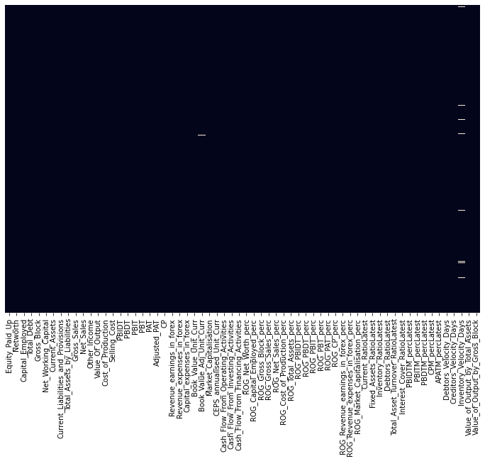

Figure 1 HeatMap

Insights:

1. We can see that data have NULL values in a few columns only, and that is spotted in white dashes in the data . This data is too less. And we can impute them
2. We can see that maximum percentage of missing are 2.8% in Column **Inventory_Velocity_Days**

# **Treat missing values:**

There are many ways to Treat Missing values.

1. Either Replace them with Median
2. Impute them with any imputer

We will use both methods and analyze them separately . First of all we will impute missing values with Median value of that column:

Replace NULL with Median and this is how the data look like :

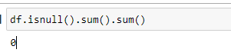

# **Outlier detection:**

Plot all data n box plot:

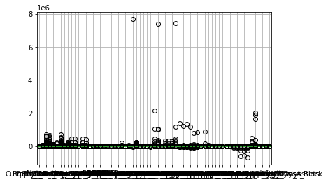

Figure 2 BoxPlot for all data elements

**Insights:**

1. **Also individual box plot can not be draw in this document, as there are 65 box plot to draw, which wont fit into page.**
2. **But we can clearly see some bubbles in the above graph , which is depicting outliers in the data**

# **Outlier Treatment:**

**We have created a function for checking upper and lower limit of the data and we will use that function for calculating, total no of records in each field, which are beyond this range.**

**List the total no of values in each column, which are above upper limit or less than lower limit of that column.**

Equity_Paid_Up 905

Networth 1342

Capital_Employed 1220

Total_Debt 1247

Gross_Block 1236

...

Debtors_Velocity_Days 738

Creditors_Velocity_Days 770

Inventory_Velocity_Days 719

Value_of_Output_by_Total_Assets 633

Value_of_Output_by_Gross_Block 984

Length: 64, dtype: int64

**Insights:**

1. **There are total of 76984 records, which have values beyond upper and lower range of the value in that field.**
2. **There are many ways we can Treat Outliers ,** 
   1. **Either we can replace Higher values to Upper Limit or very less value to Lower limit of outliers**
   2. **Or we can impute them to K Nearest neighbor Method.**
   3. **In our Case, we dont know Company Segmentations, and Companies can have different levels of Revenue, Profits and all can be Valid at same time. So we should Treat them with K nearest neighbor method , and Treat them same as we did for Missing values.**
   4. **Still I will be using both method for KNN as well as replacing higher values with Upper/lower values**

**First of all, we would replace the outlier data with upper and lower value.**

**Again , since data fields are too large, we can display the Box plot in the Business report.**

# **Univariate analysis:**

# **Distinct Value Counts of each field:**

Equity_Paid_Up:1586

Networth:2334

Capital_Employed:2512

Total_Debt:1557

Gross_Block:1877

Net_Working_Capital:2078

Current_Assets:2199

Current_Liabilities_and_Provisions:1698

Total_Assets_by_Liabilities:2565

Gross_Sales:2081

Net_Sales:2079

Other_Income:545

Value_Of_Output:2097

Cost_of_Production:1975

Selling_Cost:531

PBIDT:1418

PBDT:1179

PBIT:1327

PBT:969

PAT:885

Adjusted_PAT:883

CP:1129

Revenue_earnings_in_forex:431

Revenue_expenses_in_forex:528

Capital_expenses_in_forex:1

Book_Value_Unit_Curr:2540

Book_Value_Adj_Unit_Curr:2483

Market_Capitalisation:1469

CEPS_annualised_Unit_Curr:1315

Cash_Flow_From_Operating_Activities:1340

Cash_Flow_From_Investing_Activities:922

Cash_Flow_From_Financing_Activities:989

ROG_Net_Worth_perc:1725

ROG_Capital_Employed_perc:1972

ROG_Gross_Block_perc:1103

ROG_Gross_Sales_perc:2084

ROG_Net_Sales_perc:2085

ROG_Cost_of_Production_perc:2069

ROG_Total_Assets_perc:2107

ROG_PBIDT_perc:2208

ROG_PBDT_perc:2201

ROG_PBIT_perc:2216

ROG_PBT_perc:2150

ROG_PAT_perc:2097

ROG_CP_perc:2175

ROG_Revenue_earnings_in_forex_perc:1

ROG_Revenue_expenses_in_forex_perc:1

ROG_Market_Capitalisation_perc:1600

Current_RatioLatest:455

Fixed_Assets_RatioLatest:741

Inventory_RatioLatest:1134

Debtors_RatioLatest:1161

Total_Asset_Turnover_RatioLatest:352

Interest_Cover_RatioLatest:776

PBIDTM_percLatest:1835

PBITM_percLatest:1654

PBDTM_percLatest:1707

CPM_percLatest:1551

APATM_percLatest:1268

Debtors_Velocity_Days:241

Creditors_Velocity_Days:203

Inventory_Velocity_Days:225

Value_of_Output_by_Total_Assets:283

Value_of_Output_by_Gross_Block:764

default:2

insights:

1. These fields have distinct count of value as only 1

Column name is Capital_expenses_in_forex and its unique value count is : 1

Column name is ROG_Revenue_earnings_in_forex_perc and its unique value count is : 1

Column name is ROG_Revenue_expenses_in_forex_perc and its unique value count is : 1

1. Since these columns have only 1 value in it, we can not use it for our Predictions. So we should Drop these fields, as they are not going to contribute anything in Target variable prediction.
2. Individual Box plot and distribution of the data . Please refer Notebook for the diagram.
3. Data Skewness :

Equity_Paid_Up 1.141900

Networth 0.903328

Capital_Employed 1.137131

Total_Debt 1.197970

Gross_Block 1.228742

...

Creditors_Velocity_Days 1.143302

Inventory_Velocity_Days 1.206446

Value_of_Output_by_Total_Assets 1.110709

Value_of_Output_by_Gross_Block 1.183618

default 2.523672

1. Data is not normally distributed and it is Right skewed and left skewed in both directions for many fields.
2. Checking proportion of default

0 0.891801

1 0.108199

# **Correlation heatmap**

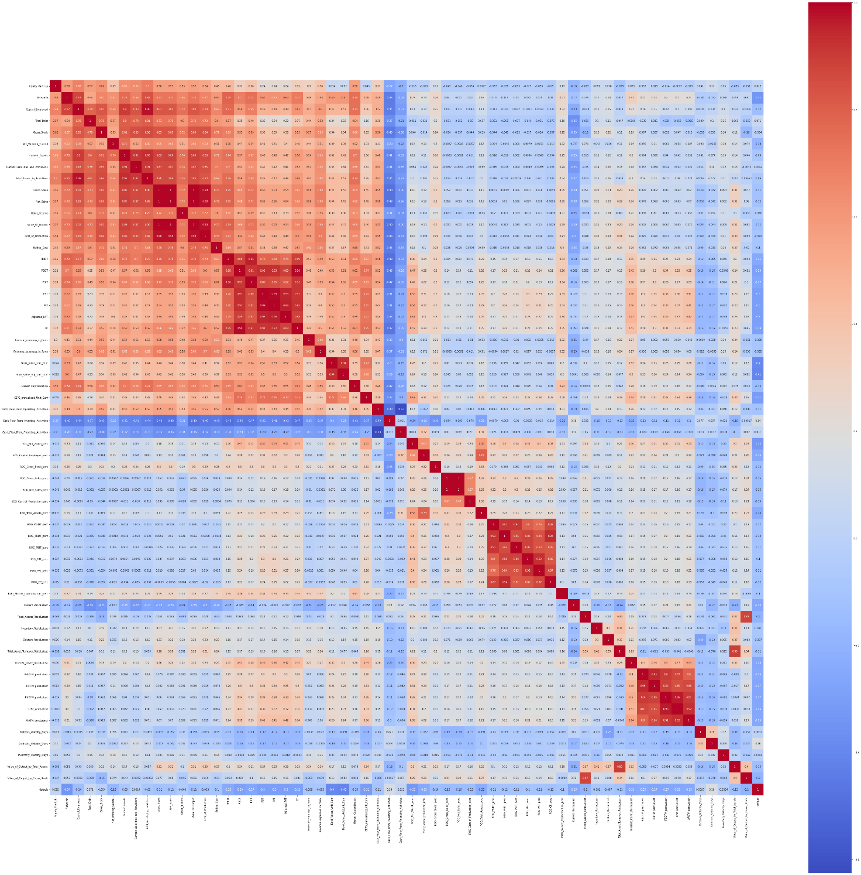

Figure 3 ScatterPlot

Insights:

1. We don’t need to look at the Score of co-relation for each column, we can just look at the color coding and Dark Red and Dark Blue showing Strong Positive and negative co-relations, among fields. We can clearly see that there are many fields, which can be avoided for analyzing and building prediction models, because they have co-relation between them,

# **Model building using stats model:**

# **Stats Model definitions:**

We will use statsmodels module to implement Ordinary Least Squares(OLS) method of linear regression for predicting “Default “ Companies based on the data provided for us.

Introduction : 

A linear regression model establishes the relation between a dependent variable(y) and at least one independent variable(x) as:



In OLS method, we have to choose the values of bi and b0 such that, the total sum of squares of the difference between the calculated and observed values of y, is minimized.   
Formula for OLS:



Where,   
= predicted value for the ith observation   
= actual value for the ith observation   
= error/residual for the ith observation   
n = total number of observations  
To get the values of  b0 and b1 which minimize S, we can take a partial derivative for each coefficient and equate it to zero.

**Approach :**

First of all we define the variables **x** and **y**. In the example below, the variables are read from a csv file using pandas.   
 Next, We need to add the constant b0 to the equation using the **add_constant()** method.

The OLS() function of the statsmodels.api module is used to perform OLS regression. It returns an OLS object. Then fit() method is called on this object for fitting the regression line to the data.

The summary() method is used to obtain a table which gives an extensive description about the regression results

# **Partitioning the data into train and test:**

We divided the data into train and Test data set. With given parameters:

test_size = 0.33, random_state = 42, stratify = y

**Test Size specify**, what should be the size of train and test data set, in our case, train set will have 66 % of data and test will have about 33% of data elements

**Random state** given as 42.

Check the shape of the data :

Train size: (2402, 61)

Test Size : (1184, 61)

**Why stratify = y?**

Please note, because this data is highly imbalanced and could possibly result into different proportions in the y variable between train and test set.

# **Start with the model**

This is how the final data looks like :

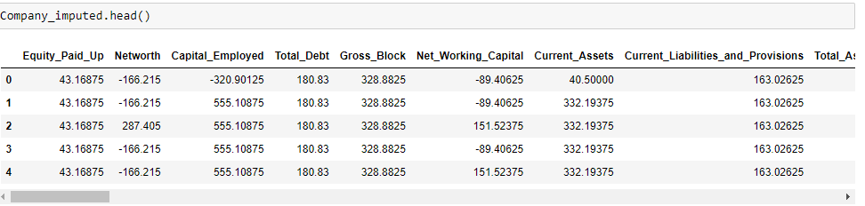

Once the data is split into 4 parts : X_train, X_test, y_train, y_test

We need to Concatenate train data (X_train, y_train) with name as TRAIN and test data (X_test, y_test) as TEST separately, because Stats model work on Complete data, it does need Separation of independent variables into 2 form of train and test.

After concatenation of data, we have got these list of fields in Train data , which are all fields and all rows of independent variables:

Index(['Equity_Paid_Up', 'Networth', 'Capital_Employed', 'Total_Debt',

'Gross_Block', 'Net_Working_Capital', 'Current_Assets',

'Current_Liabilities_and_Provisions', 'Total_Assets_by_Liabilities',

'Gross_Sales', 'Net_Sales', 'Other_Income', 'Value_Of_Output',

'Cost_of_Production', 'Selling_Cost', 'PBIDT', 'PBDT', 'PBIT', 'PBT',

'PAT', 'Adjusted_PAT', 'CP', 'Revenue_earnings_in_forex',

'Revenue_expenses_in_forex', 'Book_Value_Unit_Curr',

'Book_Value_Adj_Unit_Curr', 'Market_Capitalisation',

'CEPS_annualised_Unit_Curr', 'Cash_Flow_From_Operating_Activities',

'Cash_Flow_From_Investing_Activities',

'Cash_Flow_From_Financing_Activities', 'ROG_Net_Worth_perc',

'ROG_Capital_Employed_perc', 'ROG_Gross_Block_perc',

'ROG_Gross_Sales_perc', 'ROG_Net_Sales_perc',

'ROG_Cost_of_Production_perc', 'ROG_Total_Assets_perc',

'ROG_PBIDT_perc', 'ROG_PBDT_perc', 'ROG_PBIT_perc', 'ROG_PBT_perc',

'ROG_PAT_perc', 'ROG_CP_perc', 'ROG_Market_Capitalisation_perc',

'Current_RatioLatest', 'Fixed_Assets_RatioLatest',

'Inventory_RatioLatest', 'Debtors_RatioLatest',

'Total_Asset_Turnover_RatioLatest', 'Interest_Cover_RatioLatest',

'PBIDTM_percLatest', 'PBITM_percLatest', 'PBDTM_percLatest',

'CPM_percLatest', 'APATM_percLatest', 'Debtors_Velocity_Days',

'Creditors_Velocity_Days', 'Inventory_Velocity_Days',

'Value_of_Output_by_Total_Assets', 'Value_of_Output_by_Gross_Block',

'default'],

And similar fields will be part of Test data as well.

**Model 1 (With all columns ):**

We have used all of the fields listed above and build our first model.

And this is the final result for our first model:

|  |  |  |  |
| --- | --- | --- | --- |
| Logit Regression Results | | | |
| **Dep. Variable:** | default | **No. Observations:** | 2402 |
| **Model:** | Logit | **Df Residuals:** | 2340 |
| **Method:** | MLE | **Df Model:** | 61 |
| **Date:** | Tue, 15 Nov 2022 | **Pseudo R-squ.:** | 0.6745 |
| **Time:** | 18:07:50 | **Log-Likelihood:** | -268.02 |
| **converged:** | True | **LL-Null:** | -823.47 |
| **Covariance Type:** | nonrobust | **LLR p-value:** | 1.198e-192 |

|  |  |  |  |  |  |  |
| --- | --- | --- | --- | --- | --- | --- |
|  | **coef** | **std err** | **z** | **P>|z|** | **[0.025** | **0.975]** |
| **Intercept** | -0.1885 | 0.258 | -0.732 | 0.464 | -0.693 | 0.316 |
| **Equity_Paid_Up** | -0.0079 | 0.014 | -0.585 | 0.559 | -0.035 | 0.019 |
| **Networth** | -0.0056 | 0.005 | -1.215 | 0.224 | -0.015 | 0.003 |
| **Capital_Employed** | -0.0124 | 0.010 | -1.294 | 0.196 | -0.031 | 0.006 |
| **Total_Debt** | 0.0213 | 0.007 | 3.008 | 0.003 | 0.007 | 0.035 |
| **Gross_Block** | 0.0012 | 0.004 | 0.288 | 0.773 | -0.007 | 0.009 |
| **Net_Working_Capital** | -0.0040 | 0.010 | -0.400 | 0.689 | -0.023 | 0.015 |
| **Current_Assets** | 0.0053 | 0.008 | 0.640 | 0.522 | -0.011 | 0.022 |
| **Current_Liabilities_and_Provisions** | 0.0010 | 0.013 | 0.081 | 0.935 | -0.024 | 0.026 |
| **Total_Assets_by_Liabilities** | 0.0065 | 0.008 | 0.795 | 0.427 | -0.010 | 0.023 |
| **Gross_Sales** | -0.0114 | 0.010 | -1.113 | 0.266 | -0.031 | 0.009 |
| **Net_Sales** | 0.0203 | 0.022 | 0.939 | 0.348 | -0.022 | 0.063 |
| **Other_Income** | -0.0076 | 0.079 | -0.097 | 0.923 | -0.162 | 0.147 |
| **Value_Of_Output** | -0.0188 | 0.014 | -1.348 | 0.178 | -0.046 | 0.009 |
| **Cost_of_Production** | 0.0065 | 0.013 | 0.510 | 0.610 | -0.018 | 0.031 |
| **Selling_Cost** | -0.0350 | 0.103 | -0.340 | 0.734 | -0.237 | 0.167 |
| **PBIDT** | -0.0177 | 0.040 | -0.438 | 0.661 | -0.097 | 0.062 |
| **PBDT** | -0.1551 | 0.145 | -1.069 | 0.285 | -0.440 | 0.129 |
| **PBIT** | 0.0184 | 0.050 | 0.368 | 0.713 | -0.080 | 0.117 |
| **PBT** | 0.0480 | 0.212 | 0.226 | 0.821 | -0.368 | 0.464 |
| **PAT** | -0.0803 | 0.247 | -0.325 | 0.745 | -0.565 | 0.404 |
| **Adjusted_PAT** | 0.0038 | 0.077 | 0.050 | 0.960 | -0.147 | 0.155 |
| **CP** | 0.1585 | 0.154 | 1.028 | 0.304 | -0.144 | 0.461 |
| **Revenue_earnings_in_forex** | -0.0277 | 0.037 | -0.754 | 0.451 | -0.100 | 0.044 |
| **Revenue_expenses_in_forex** | 0.0533 | 0.038 | 1.414 | 0.157 | -0.021 | 0.127 |
| **Book_Value_Unit_Curr** | -0.0215 | 0.035 | -0.622 | 0.534 | -0.089 | 0.046 |
| **Book_Value_Adj_Unit_Curr** | -0.0684 | 0.036 | -1.878 | 0.060 | -0.140 | 0.003 |
| **Market_Capitalisation** | -0.0043 | 0.004 | -1.205 | 0.228 | -0.011 | 0.003 |
| **CEPS_annualised_Unit_Curr** | -0.0612 | 0.050 | -1.218 | 0.223 | -0.160 | 0.037 |
| **Cash_Flow_From_Operating_Activities** | 0.0100 | 0.027 | 0.375 | 0.707 | -0.042 | 0.062 |
| **Cash_Flow_From_Investing_Activities** | -0.0427 | 0.051 | -0.834 | 0.404 | -0.143 | 0.058 |
| **Cash_Flow_From_Financing_Activities** | 0.0023 | 0.043 | 0.053 | 0.958 | -0.083 | 0.087 |
| **ROG_Net_Worth_perc** | -0.0236 | 0.012 | -1.899 | 0.058 | -0.048 | 0.001 |
| **ROG_Capital_Employed_perc** | 0.0237 | 0.011 | 2.224 | 0.026 | 0.003 | 0.045 |
| **ROG_Gross_Block_perc** | -0.0316 | 0.021 | -1.476 | 0.140 | -0.074 | 0.010 |
| **ROG_Gross_Sales_perc** | 0.0896 | 0.120 | 0.748 | 0.454 | -0.145 | 0.325 |
| **ROG_Net_Sales_perc** | -0.0914 | 0.119 | -0.766 | 0.444 | -0.325 | 0.143 |
| **ROG_Cost_of_Production_perc** | -0.0060 | 0.004 | -1.432 | 0.152 | -0.014 | 0.002 |
| **ROG_Total_Assets_perc** | -0.0256 | 0.010 | -2.519 | 0.012 | -0.046 | -0.006 |
| **ROG_PBIDT_perc** | -0.0058 | 0.006 | -1.016 | 0.310 | -0.017 | 0.005 |
| **ROG_PBDT_perc** | 0.0064 | 0.006 | 1.148 | 0.251 | -0.005 | 0.017 |
| **ROG_PBIT_perc** | 0.0049 | 0.005 | 0.954 | 0.340 | -0.005 | 0.015 |
| **ROG_PBT_perc** | -0.0021 | 0.005 | -0.435 | 0.663 | -0.012 | 0.008 |
| **ROG_PAT_perc** | 0.0014 | 0.004 | 0.351 | 0.726 | -0.006 | 0.009 |
| **ROG_CP_perc** | -0.0042 | 0.004 | -0.928 | 0.353 | -0.013 | 0.005 |
| **ROG_Market_Capitalisation_perc** | -0.0024 | 0.003 | -0.799 | 0.424 | -0.008 | 0.003 |
| **Current_RatioLatest** | -0.5445 | 0.094 | -5.763 | 0.000 | -0.730 | -0.359 |
| **Fixed_Assets_RatioLatest** | -0.0015 | 0.112 | -0.014 | 0.989 | -0.221 | 0.218 |
| **Inventory_RatioLatest** | -0.0678 | 0.026 | -2.561 | 0.010 | -0.120 | -0.016 |
| **Debtors_RatioLatest** | -0.0396 | 0.026 | -1.523 | 0.128 | -0.091 | 0.011 |
| **Total_Asset_Turnover_RatioLatest** | -0.0678 | 0.207 | -0.328 | 0.743 | -0.473 | 0.337 |
| **Interest_Cover_RatioLatest** | -0.1067 | 0.053 | -2.023 | 0.043 | -0.210 | -0.003 |
| **PBIDTM_percLatest** | 0.0133 | 0.032 | 0.419 | 0.675 | -0.049 | 0.076 |
| **PBITM_percLatest** | -0.0783 | 0.040 | -1.943 | 0.052 | -0.157 | 0.001 |
| **PBDTM_percLatest** | 0.0095 | 0.054 | 0.177 | 0.859 | -0.096 | 0.115 |
| **CPM_percLatest** | -0.0490 | 0.068 | -0.723 | 0.470 | -0.182 | 0.084 |
| **APATM_percLatest** | 0.1252 | 0.069 | 1.802 | 0.072 | -0.011 | 0.261 |
| **Debtors_Velocity_Days** | -0.0042 | 0.002 | -2.771 | 0.006 | -0.007 | -0.001 |
| **Creditors_Velocity_Days** | 0.0011 | 0.002 | 0.676 | 0.499 | -0.002 | 0.004 |
| **Inventory_Velocity_Days** | 0.0015 | 0.002 | 0.827 | 0.408 | -0.002 | 0.005 |
| **Value_of_Output_by_Total_Assets** | 0.7860 | 0.358 | 2.196 | 0.028 | 0.085 | 1.487 |
| **Value_of_Output_by_Gross_Block** | -0.0875 | 0.111 | -0.790 | 0.430 | -0.305 | 0.130 |

Insights:

1. We can clearly see that results from our 1st Model have all 61 columns,,after removing unnecessary fields of Co_num, next_year_networth etc.
2. There are many columns with more than 0.05 P value, which denotes those fields are not required for predicting the Target field.
3. As per initial Heatmap, we already know, that data have multi collinearity in the data, so we don’t need all of the columns for predicting target values

**Removing multicollinearity using VIF:**

**What is VIF:**

The Variance Inflation Factor (VIF) measures the severity of multicollinearity in regression analysis. It is a statistical concept that indicates the increase in the variance of a regression coefficient as a result of collinearity.

In ordinary least square (OLS) regression analysis, multicollinearity exists when two or more of the independent variables demonstrate a linear relationship between them. VIF can be calculated by the formula below:

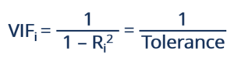

Where **Ri2**represents the unadjusted coefficient of determination for regressing the ith independent variable on the remaining ones. The reciprocal of VIF is known as **tolerance**. Either VIF or tolerance can be used to detect multicollinearity, depending on personal preference.

**Interpreting the Variance Inflation Factor**

Variance inflation factors range from 1 upwards. The numerical value for VIF tells you (in decimal form) what percentage the variance (i.e. the standard error squared) is inflated for each coefficient. For example, a VIF of 1.9 tells you that the variance of a particular coefficient is 90% bigger than what you would expect if there was no multicollinearity — if there was no correlation with other predictors.  
A **rule of thumb** for interpreting the variance inflation factor:

* 1 = not correlated.
* Between 1 and 5 = moderately correlated.
* Greater than 5 = highly correlated.

Exactly how large a VIF has to be before it causes issues is a subject of debate. What is known is that the more your VIF increases, the less reliable your regression results are going to be. In general, a VIF above 10 indicates high correlation and is cause for concern. Some authors suggest a more conservative level of 2.5 or above.

**Summary:**

* Variance inflation factor (VIF) is used to detect the severity of multicollinearity in the ordinary least square (OLS) regression analysis.
* Multicollinearity inflates the variance and type II error. It makes the coefficient of a variable consistent but unreliable.
* VIF measures the number of inflated variances caused by multicollinearity.
* Eliminate fields with Greater than 5 , which means there is highly correlated. We should do it one by one for each field.

**Model 2 with VIF threshold 4:**

To Notice, since we have lot of independent fields, we should go and check for each single columns and check VIF multiple times.

Rather we have used a Loop function, its checking VIF in Iterations and remove one column in one iteration and calculate VIF again. This loop will run until we get all the fields with lesser value of VIF than threshold limit.

For this testing we will keep VIF threshold value as 5.

Keep VIF threshold value as 5:

After executing Loop function, we received 34 columns and about half of the fields are eliminated, which had very high co-relation in it.

Remained fields are:

Index(['Total_Debt', 'Net_Working_Capital', 'Other_Income', 'Selling_Cost',

'Adjusted_PAT', 'Revenue_earnings_in_forex',

'Revenue_expenses_in_forex', 'Book_Value_Adj_Unit_Curr',

'Market_Capitalisation', 'CEPS_annualised_Unit_Curr',

'Cash_Flow_From_Operating_Activities',

'Cash_Flow_From_Investing_Activities',

'Cash_Flow_From_Financing_Activities', 'ROG_Net_Worth_perc',

'ROG_Capital_Employed_perc', 'ROG_Gross_Block_perc',

'ROG_Net_Sales_perc', 'ROG_Cost_of_Production_perc',

'ROG_Total_Assets_perc', 'ROG_PBIT_perc', 'ROG_CP_perc',

'ROG_Market_Capitalisation_perc', 'Current_RatioLatest',

'Inventory_RatioLatest', 'Debtors_RatioLatest',

'Total_Asset_Turnover_RatioLatest', 'Interest_Cover_RatioLatest',

'PBITM_percLatest', 'CPM_percLatest', 'Debtors_Velocity_Days',

'Creditors_Velocity_Days', 'Inventory_Velocity_Days',

'Value_of_Output_by_Gross_Block', 'default'],

We ran the stats Model on above listed field, and this is the Stats summary for same:

|  |  |  |  |
| --- | --- | --- | --- |
| **Dep. Variable:** | default | **No. Observations:** | 2402 |
| **Model:** | Logit | **Df Residuals:** | 2368 |
| **Method:** | MLE | **Df Model:** | 33 |
| **Date:** | Tue, 15 Nov 2022 | **Pseudo R-squ.:** | 0.6546 |
| **Time:** | 18:08:40 | **Log-Likelihood:** | -284.41 |
| **converged:** | True | **LL-Null:** | -823.47 |
| **Covariance Type:** | nonrobust | **LLR p-value:** | 3.364e-205 |

|  |  |  |  |  |  |  |
| --- | --- | --- | --- | --- | --- | --- |
|  | **coef** | **std err** | **z** | **P>|z|** | **[0.025** | **0.975]** |
| **Intercept** | -0.2422 | 0.226 | -1.072 | 0.284 | -0.685 | 0.201 |
| **Total_Debt** | 0.0157 | 0.004 | 3.831 | 0.000 | 0.008 | 0.024 |
| **Net_Working_Capital** | -0.0067 | 0.004 | -1.643 | 0.100 | -0.015 | 0.001 |
| **Other_Income** | -0.0227 | 0.066 | -0.341 | 0.733 | -0.153 | 0.108 |
| **Selling_Cost** | -0.0587 | 0.081 | -0.725 | 0.469 | -0.218 | 0.100 |
| **Adjusted_PAT** | -0.0126 | 0.049 | -0.259 | 0.796 | -0.108 | 0.083 |
| **Revenue_earnings_in_forex** | -0.0358 | 0.033 | -1.084 | 0.278 | -0.101 | 0.029 |
| **Revenue_expenses_in_forex** | 0.0480 | 0.034 | 1.433 | 0.152 | -0.018 | 0.114 |
| **Book_Value_Adj_Unit_Curr** | -0.1004 | 0.010 | -10.195 | 0.000 | -0.120 | -0.081 |
| **Market_Capitalisation** | -0.0081 | 0.003 | -3.015 | 0.003 | -0.013 | -0.003 |
| **CEPS_annualised_Unit_Curr** | -0.0670 | 0.037 | -1.820 | 0.069 | -0.139 | 0.005 |
| **Cash_Flow_From_Operating_Activities** | 0.0037 | 0.022 | 0.169 | 0.866 | -0.039 | 0.047 |
| **Cash_Flow_From_Investing_Activities** | -0.0143 | 0.041 | -0.346 | 0.730 | -0.095 | 0.067 |
| **Cash_Flow_From_Financing_Activities** | 0.0071 | 0.038 | 0.186 | 0.853 | -0.067 | 0.082 |
| **ROG_Net_Worth_perc** | -0.0267 | 0.012 | -2.317 | 0.021 | -0.049 | -0.004 |
| **ROG_Capital_Employed_perc** | 0.0220 | 0.010 | 2.230 | 0.026 | 0.003 | 0.041 |
| **ROG_Gross_Block_perc** | -0.0308 | 0.020 | -1.512 | 0.131 | -0.071 | 0.009 |
| **ROG_Net_Sales_perc** | -0.0020 | 0.004 | -0.474 | 0.636 | -0.010 | 0.006 |
| **ROG_Cost_of_Production_perc** | -0.0062 | 0.004 | -1.551 | 0.121 | -0.014 | 0.002 |
| **ROG_Total_Assets_perc** | -0.0216 | 0.010 | -2.231 | 0.026 | -0.041 | -0.003 |
| **ROG_PBIT_perc** | 0.0028 | 0.002 | 1.188 | 0.235 | -0.002 | 0.008 |
| **ROG_CP_perc** | -0.0016 | 0.002 | -0.716 | 0.474 | -0.006 | 0.003 |
| **ROG_Market_Capitalisation_perc** | -0.0008 | 0.003 | -0.290 | 0.772 | -0.006 | 0.005 |
| **Current_RatioLatest** | -0.5418 | 0.091 | -5.931 | 0.000 | -0.721 | -0.363 |
| **Inventory_RatioLatest** | -0.0537 | 0.023 | -2.382 | 0.017 | -0.098 | -0.010 |
| **Debtors_RatioLatest** | -0.0274 | 0.023 | -1.186 | 0.236 | -0.073 | 0.018 |
| **Total_Asset_Turnover_RatioLatest** | 0.2183 | 0.132 | 1.648 | 0.099 | -0.041 | 0.478 |
| **Interest_Cover_RatioLatest** | -0.0728 | 0.047 | -1.547 | 0.122 | -0.165 | 0.019 |
| **PBITM_percLatest** | -0.0307 | 0.015 | -2.040 | 0.041 | -0.060 | -0.001 |
| **CPM_percLatest** | 0.0044 | 0.017 | 0.251 | 0.802 | -0.030 | 0.038 |
| **Debtors_Velocity_Days** | -0.0042 | 0.001 | -2.909 | 0.004 | -0.007 | -0.001 |
| **Creditors_Velocity_Days** | 0.0011 | 0.002 | 0.735 | 0.462 | -0.002 | 0.004 |
| **Inventory_Velocity_Days** | 0.0011 | 0.002 | 0.689 | 0.491 | -0.002 | 0.004 |
| **Value_of_Output_by_Gross_Block** | -0.0515 | 0.044 | -1.157 | 0.247 | -0.139 | 0.036 |

Still we see lot of Columns have P value more than 0.05, so lets run VIF function one more time, and eliminate fields , which have VIF more than 4

**Model 3 with VIF threshold 4:**

After adjusting threshold limit to 4 , we were successfully able to eliminate 3 more fields. Which means we have now below listed fields for our Third model:

Index(['Total_Debt', 'Net_Working_Capital', 'Other_Income', 'Adjusted_PAT',

'Revenue_earnings_in_forex', 'Revenue_expenses_in_forex',

'Book_Value_Adj_Unit_Curr', 'Market_Capitalisation',

'Cash_Flow_From_Operating_Activities',

'Cash_Flow_From_Investing_Activities',

'Cash_Flow_From_Financing_Activities', 'ROG_Net_Worth_perc',

'ROG_Capital_Employed_perc', 'ROG_Gross_Block_perc',

'ROG_Net_Sales_perc', 'ROG_Cost_of_Production_perc',

'ROG_Total_Assets_perc', 'ROG_PBIT_perc', 'ROG_CP_perc',

'ROG_Market_Capitalisation_perc', 'Current_RatioLatest',

'Inventory_RatioLatest', 'Debtors_RatioLatest',

'Total_Asset_Turnover_RatioLatest', 'Interest_Cover_RatioLatest',

'CPM_percLatest', 'Debtors_Velocity_Days', 'Creditors_Velocity_Days',

'Inventory_Velocity_Days', 'Value_of_Output_by_Gross_Block', 'default']

Again, run the stats model on top of above listed columns.

|  |  |  |  |
| --- | --- | --- | --- |
| **Dep. Variable:** | default | **No. Observations:** | 2402 |
| **Model:** | Logit | **Df Residuals:** | 2371 |
| **Method:** | MLE | **Df Model:** | 30 |
| **Date:** | Tue, 15 Nov 2022 | **Pseudo R-squ.:** | 0.6501 |
| **Time:** | 18:08:42 | **Log-Likelihood:** | -288.13 |
| **converged:** | True | **LL-Null:** | -823.47 |
| **Covariance Type:** | nonrobust | **LLR p-value:** | 5.990e-206 |

|  |  |  |  |  |  |  |
| --- | --- | --- | --- | --- | --- | --- |
|  | **coef** | **std err** | **z** | **P>|z|** | **[0.025** | **0.975]** |
| **Intercept** | -0.2233 | 0.225 | -0.993 | 0.321 | -0.664 | 0.218 |
| **Total_Debt** | 0.0143 | 0.004 | 3.595 | 0.000 | 0.006 | 0.022 |
| **Net_Working_Capital** | -0.0064 | 0.004 | -1.687 | 0.092 | -0.014 | 0.001 |
| **Other_Income** | -0.0546 | 0.065 | -0.843 | 0.399 | -0.182 | 0.072 |
| **Adjusted_PAT** | -0.0448 | 0.044 | -1.021 | 0.307 | -0.131 | 0.041 |
| **Revenue_earnings_in_forex** | -0.0454 | 0.031 | -1.457 | 0.145 | -0.106 | 0.016 |
| **Revenue_expenses_in_forex** | 0.0477 | 0.033 | 1.463 | 0.143 | -0.016 | 0.112 |
| **Book_Value_Adj_Unit_Curr** | -0.1006 | 0.010 | -10.439 | 0.000 | -0.120 | -0.082 |
| **Market_Capitalisation** | -0.0079 | 0.003 | -3.007 | 0.003 | -0.013 | -0.003 |
| **Cash_Flow_From_Operating_Activities** | -0.0026 | 0.022 | -0.119 | 0.905 | -0.045 | 0.040 |
| **Cash_Flow_From_Investing_Activities** | -0.0153 | 0.039 | -0.388 | 0.698 | -0.092 | 0.062 |
| **Cash_Flow_From_Financing_Activities** | 0.0049 | 0.037 | 0.132 | 0.895 | -0.068 | 0.078 |
| **ROG_Net_Worth_perc** | -0.0284 | 0.011 | -2.531 | 0.011 | -0.050 | -0.006 |
| **ROG_Capital_Employed_perc** | 0.0197 | 0.010 | 2.033 | 0.042 | 0.001 | 0.039 |
| **ROG_Gross_Block_perc** | -0.0265 | 0.020 | -1.310 | 0.190 | -0.066 | 0.013 |
| **ROG_Net_Sales_perc** | -0.0022 | 0.004 | -0.537 | 0.591 | -0.010 | 0.006 |
| **ROG_Cost_of_Production_perc** | -0.0060 | 0.004 | -1.519 | 0.129 | -0.014 | 0.002 |
| **ROG_Total_Assets_perc** | -0.0229 | 0.010 | -2.372 | 0.018 | -0.042 | -0.004 |
| **ROG_PBIT_perc** | 0.0025 | 0.002 | 1.049 | 0.294 | -0.002 | 0.007 |
| **ROG_CP_perc** | -0.0017 | 0.002 | -0.769 | 0.442 | -0.006 | 0.003 |
| **ROG_Market_Capitalisation_perc** | -0.0008 | 0.003 | -0.304 | 0.761 | -0.006 | 0.005 |
| **Current_RatioLatest** | -0.5498 | 0.091 | -6.054 | 0.000 | -0.728 | -0.372 |
| **Inventory_RatioLatest** | -0.0503 | 0.023 | -2.224 | 0.026 | -0.095 | -0.006 |
| **Debtors_RatioLatest** | -0.0281 | 0.023 | -1.224 | 0.221 | -0.073 | 0.017 |
| **Total_Asset_Turnover_RatioLatest** | 0.1895 | 0.130 | 1.458 | 0.145 | -0.065 | 0.444 |
| **Interest_Cover_RatioLatest** | -0.0896 | 0.047 | -1.902 | 0.057 | -0.182 | 0.003 |
| **CPM_percLatest** | -0.0253 | 0.011 | -2.345 | 0.019 | -0.046 | -0.004 |
| **Debtors_Velocity_Days** | -0.0037 | 0.001 | -2.616 | 0.009 | -0.006 | -0.001 |
| **Creditors_Velocity_Days** | 0.0010 | 0.001 | 0.689 | 0.491 | -0.002 | 0.004 |
| **Inventory_Velocity_Days** | 0.0011 | 0.002 | 0.659 | 0.510 | -0.002 | 0.004 |
| **Value_of_Output_by_Gross_Block** | -0.0611 | 0.044 | -1.392 | 0.164 | -0.147 | 0.025 |

Check for VIF for all the fields in this model :

|  | **variables** | **VIF** |
| --- | --- | --- |
| **8** | Cash_Flow_From_Operating_Activities | 3.804148 |
| **7** | Market_Capitalisation | 3.769023 |
| **12** | ROG_Capital_Employed_perc | 3.671089 |
| **0** | Total_Debt | 3.620201 |
| **2** | Other_Income | 3.483271 |
| **5** | Revenue_expenses_in_forex | 3.418506 |
| **18** | ROG_CP_perc | 3.262816 |
| **17** | ROG_PBIT_perc | 3.251599 |
| **23** | Total_Asset_Turnover_RatioLatest | 3.135009 |
| **16** | ROG_Total_Assets_perc | 3.108078 |
| **3** | Adjusted_PAT | 3.033204 |
| **1** | Net_Working_Capital | 2.902452 |
| **4** | Revenue_earnings_in_forex | 2.872264 |
| **10** | Cash_Flow_From_Financing_Activities | 2.863477 |
| **11** | ROG_Net_Worth_perc | 2.719630 |
| **9** | Cash_Flow_From_Investing_Activities | 2.503964 |
| **6** | Book_Value_Adj_Unit_Curr | 2.460811 |
| **22** | Debtors_RatioLatest | 2.346833 |
| **26** | Debtors_Velocity_Days | 2.345360 |
| **29** | Value_of_Output_by_Gross_Block | 2.316941 |
| **24** | Interest_Cover_RatioLatest | 2.250516 |
| **21** | Inventory_RatioLatest | 2.221555 |
| **27** | Creditors_Velocity_Days | 2.180764 |
| **20** | Current_RatioLatest | 2.175016 |
| **14** | ROG_Net_Sales_perc | 2.081818 |
| **15** | ROG_Cost_of_Production_perc | 1.995917 |
| **28** | Inventory_Velocity_Days | 1.860591 |
| **25** | CPM_percLatest | 1.744019 |
| **19** | ROG_Market_Capitalisation_perc | 1.621405 |
| **13** | ROG_Gross_Block_perc | 1.477094 |
| **30** | default | 1.397951 |

We can see that all of the fields have less than 4 VIF value for this.

#### **Validating the model on train set**

Confusion Matrix for train data:

[[2112 30]

[ 74 186]]

Calculate Recall and other matrix:

precision recall f1-score support

0 0.97 0.99 0.98 2142

1 0.86 0.72 0.78 260

accuracy 0.96 2402

macro avg 0.91 0.85 0.88 2402

weighted avg 0.95 0.96 0.95 2402

#### **Validating the model on test set**

Confusion Matrix for train data:

[[1035 21]

[ 38 90]]

Calculate Recall and other matrix:

precision recall f1-score support

0 0.96 0.98 0.97 1056

1 0.81 0.70 0.75 128

accuracy 0.95 1184

macro avg 0.89 0.84 0.86 1184

weighted avg 0.95 0.95 0.95 1184

Insights:

1. We are more interested in RECALL value as it denotes, how much “default” value or Targeted value we are predicting correctly.
2. Recall value for train data and test data are 78% and 75% in sequence, which is not bad
3. Still data is imbalanced, because our targeted values are very less in Sample data.

**Model 4 - Balance data using SMOTE and threshold VIF as 4:**

We will be using SMOTE functionality to generate data for target values, and we will upscaling the data for this case.

Steps:

1. Again, we will perform Smote on full sample data , so total fields are 62
2. Upscale data using imblearn.over_sampling library
3. We also run VIF function to check best features, which can be used for Stats model, after executing VIF calculation function, we found 31 fields and we kept threshold limit as 4 for eliminating features with High co-relation.
4. We generated the Stats model technique and following is the result for Stats model:

|  |  |  |  |
| --- | --- | --- | --- |
| **Dep. Variable:** | default | **No. Observations:** | 3748 |
| **Model:** | Logit | **Df Residuals:** | 3717 |
| **Method:** | MLE | **Df Model:** | 30 |
| **Date:** | Tue, 15 Nov 2022 | **Pseudo R-squ.:** | 0.7452 |
| **Time:** | 18:08:45 | **Log-Likelihood:** | -652.27 |
| **converged:** | True | **LL-Null:** | -2559.5 |
| **Covariance Type:** | nonrobust | **LLR p-value:** | 0.000 |

|  |  |  |  |  |  |  |
| --- | --- | --- | --- | --- | --- | --- |
|  | **coef** | **std err** | **z** | **P>|z|** | **[0.025** | **0.975]** |
| **Intercept** | 1.6931 | 0.162 | 10.462 | 0.000 | 1.376 | 2.010 |
| **Total_Debt** | 0.0240 | 0.003 | 7.305 | 0.000 | 0.018 | 0.030 |
| **Net_Working_Capital** | -0.0053 | 0.003 | -1.782 | 0.075 | -0.011 | 0.001 |
| **Other_Income** | -0.1006 | 0.050 | -2.028 | 0.043 | -0.198 | -0.003 |
| **Adjusted_PAT** | -0.0177 | 0.029 | -0.602 | 0.547 | -0.075 | 0.040 |
| **Revenue_earnings_in_forex** | -0.0699 | 0.024 | -2.966 | 0.003 | -0.116 | -0.024 |
| **Revenue_expenses_in_forex** | 0.0389 | 0.024 | 1.609 | 0.108 | -0.008 | 0.086 |
| **Book_Value_Adj_Unit_Curr** | -0.1220 | 0.007 | -17.710 | 0.000 | -0.135 | -0.108 |
| **Market_Capitalisation** | -0.0097 | 0.002 | -4.788 | 0.000 | -0.014 | -0.006 |
| **Cash_Flow_From_Operating_Activities** | -0.0262 | 0.016 | -1.620 | 0.105 | -0.058 | 0.006 |
| **Cash_Flow_From_Investing_Activities** | -0.0400 | 0.031 | -1.305 | 0.192 | -0.100 | 0.020 |
| **Cash_Flow_From_Financing_Activities** | -0.0079 | 0.028 | -0.283 | 0.777 | -0.062 | 0.047 |
| **ROG_Net_Worth_perc** | -0.0340 | 0.008 | -4.402 | 0.000 | -0.049 | -0.019 |
| **ROG_Capital_Employed_perc** | 0.0231 | 0.007 | 3.354 | 0.001 | 0.010 | 0.037 |
| **ROG_Gross_Block_perc** | -0.0330 | 0.015 | -2.201 | 0.028 | -0.062 | -0.004 |
| **ROG_Net_Sales_perc** | -0.0058 | 0.003 | -1.793 | 0.073 | -0.012 | 0.001 |
| **ROG_Cost_of_Production_perc** | -0.0070 | 0.003 | -2.447 | 0.014 | -0.013 | -0.001 |
| **ROG_Total_Assets_perc** | -0.0314 | 0.007 | -4.631 | 0.000 | -0.045 | -0.018 |
| **ROG_PBIT_perc** | 0.0043 | 0.002 | 2.548 | 0.011 | 0.001 | 0.008 |
| **ROG_CP_perc** | -0.0021 | 0.002 | -1.300 | 0.194 | -0.005 | 0.001 |
| **ROG_Market_Capitalisation_perc** | -0.0027 | 0.002 | -1.358 | 0.174 | -0.007 | 0.001 |
| **Current_RatioLatest** | -0.6289 | 0.056 | -11.244 | 0.000 | -0.739 | -0.519 |
| **Inventory_RatioLatest** | -0.0543 | 0.014 | -3.784 | 0.000 | -0.082 | -0.026 |
| **Debtors_RatioLatest** | -0.0576 | 0.016 | -3.514 | 0.000 | -0.090 | -0.025 |
| **Total_Asset_Turnover_RatioLatest** | 0.3287 | 0.089 | 3.707 | 0.000 | 0.155 | 0.503 |
| **Interest_Cover_RatioLatest** | -0.0856 | 0.034 | -2.515 | 0.012 | -0.152 | -0.019 |
| **CPM_percLatest** | -0.0507 | 0.008 | -6.185 | 0.000 | -0.067 | -0.035 |
| **Debtors_Velocity_Days** | -0.0059 | 0.001 | -5.662 | 0.000 | -0.008 | -0.004 |
| **Creditors_Velocity_Days** | 0.0010 | 0.001 | 0.909 | 0.363 | -0.001 | 0.003 |
| **Inventory_Velocity_Days** | 0.0005 | 0.001 | 0.414 | 0.679 | -0.002 | 0.003 |
| **Value_of_Output_by_Gross_Block** | -0.0945 | 0.028 | -3.384 | 0.001 | -0.149 | -0.040 |

#### **Validating the model on train set**

Confusion Matrix for train data:

[[2009 133]

[ 84 1522]]

Calculate Recall and other matrix:

precision recall f1-score support

0 0.96 0.94 0.95 2142

1 0.92 0.95 0.93 1606

accuracy 0.94 3748

macro avg 0.94 0.94 0.94 3748

weighted avg 0.94 0.94 0.94 3748

#### **Validating the model on test set**

Confusion Matrix for train data:

[[972 84]

[ 11 117]]

Calculate Recall and other matrix:

precision recall f1-score support

0 0.99 0.92 0.95 1056

1 0.58 0.91 0.71 128

accuracy 0.92 1184

macro avg 0.79 0.92 0.83 1184

weighted avg 0.94 0.92 0.93 1184

Insights:

1. We are more interested in RECALL value as it denotes, how much “default” value or Targeted value we are predicting correctly.
2. Recall value for train data and test data are 95% and 91% in sequence, which is very good.
3. Accuracy on Train and Test data is also very good which is more than 92% with both train and test data.
4. Precision is Bad after SMOTE is implemented, because data was imbalanced, and we had to upscale data using SMOTE.

**Conclusion and Recommendations:**

1. Sample data had 3586 rows and 67 columns; total number of column values were not bad.
2. We have not given Company types, like Mid-Size, Small Size or Large capital companies.
3. We have not given revenue of the companies , so that we can segregate companies based on their revenue
4. We have not given industry type of companies like, IT, Manufacturing, Retail , Pharma, etc . We consider them all of same type and not taken any action based on what type company it is
5. Data have about 100+ NULL values in sample data, which we imputed by taking median.
6. Data was very large number of outliers , and for our modelling purpose, we treated outliers, using bringing them back to Normal Upper and Lower limits
7. Data was very imbalanced , and we upscale data using SMOTE feature
8. In the Final model , we have used 31 columns for deciding “DEFAULT” nature of companies, and there were total 67 features, were given.
9. There are other method also available for classification model, but for this exercise purpose, we have used only stats model .
10. NULL Values and Outlier treatment:

Following methods were used in this exercise for treating NULL and outlier values:

* 1. Impute NULL with Median and Impute Outlier by bringing them back to Normal range. This Method is used for this project submission, because it has the best RECALL and Accuracy score.
  2. I have also tested NULL values and Outlier treatment with KNN method of data imputations, but recall values and precision are very less in this case , so I switch back to above point a only . Following attached is notebook, where I have tested using KNN model as well, but RECALL values are very less. This is just for reference purpose.:



This is a Notebook file, in this Notebook, I have tested KNN treatment and calculated RECALL after KNN treatment of Missing values and Outliers.