**Business Report**

**Capstone Project**

**LI_BFSI_01+Life+Insurance+Sales**

**2nd Submission**

**Date: 25-Dec-2022**

**Created by Amit Jain**

Table of Contents

List of Figure 4

1. Introduction of the business Problem 5

1.1 Defining Problem Statement: 5

1.2 Need of the study/project: 5

1.3 Understanding business/social opportunity: 5

2. Data Export : 6

2.1 Visual inspection of data (rows, columns, descriptive details): 6

2.2 Understanding of attributes: 7

3. Data Preparation 9

3.1 Encoding: 9

3.2 Data Split: Split the data into train and test (70:30) 11

4. Model building and interpretation : 12

4.1 SKLearn Linear Model: 12

4.1.1 Definition: 12

4.1.2 Action: 13

4.1.3 Equation: 13

4.1.4 Understanding Model: 14

4.1.5 Performance parameters: 15

4.1.6 Feature importance 15

4.2 Building Stats Model: 16

4.2.1 Definition: 16

4.2.2 Action: 16

4.2.3 Performance parameters: 18

4.2.4 Feature Importance: 18

4.3 Building Multiple Stats Model to eliminate non affecting fields : 19

4.3.1 Stats Model for fields with lower value of VIF : 19

4.3.1.1 How to interpret a given VIF value?: 19

4.3.1.2 Action: 20

4.3.1.3 Performance parameters: 21

4.3.1.4 Stats Model for fields with Lower P value and remove other fields: 22

4.3.1.5 Action: 22

4.3.1.6 Performance parameters: 24

4.3.1.7 Equation and interpretation: 24

4.4 Decision Tree Model 25

4.4.1 Definition: 25

4.4.2 Action: 25

4.4.3 Feature Importance : 26

4.4.4 Performance parameters: 26

4.5 Random Forest Regressor Model 27

4.5.1 Definition : 27

4.5.2 Action: 27

4.5.3 Feature Importance : 28

4.5.4 Performance parameters: 28

4.6 Artificial Neural Network Regressor 29

4.6.1 Definition: 29

4.6.2 Action: 30

4.6.3 Feature Importance : 30

4.6.4 Performance parameters: 30

5. Model Tuning and business implication 31

5.1 Bagging Regressor (Random Forest should be applied for Bagging) 31

5.1.1 Definition : 31

5.1.2 Action: 32

5.1.3 Feature Importance : 32

5.1.4 Performance parameters: 32

5.2 Hyper parameter tuning for random forest 33

5.2.1 Definition: 33

5.2.2 Action: 34

5.2.3 Feature Importance : 34

5.2.4 Performance parameters: 35

5.3 Hyper parameter tuning for Decision Tree Regressor 35

5.3.1 Definition: 35

5.3.2 Action: 36

5.3.3 Feature Importance : 37

5.3.4 Performance parameters: 37

6. Interpretation of the most optimum model and its implication on the business 38

6.1 Performance Parameters List : 38

6.2 Gather Matrix from all Models: 39

# **List of Figure**

Figure 1 Scatter plot for Prediction on Test data Figure 2 Scatter plot for Prediction on Train data 15

Figure 3Scatter Plot for Predicted values on Test data set 18

Figure 4 Example for Decision tree 25

Figure 5 Decision Tree Feature Importance 26

Figure 6 Example for Random Forest 27

Figure 7Random Forest Feature Importance 28

Figure 8 Example for ANN Model 29

Figure 9 Explain Bagging 31

Figure 10 Explain Bootstrapping 32

Figure 11 Best Param Random Forest Feature Importance 35

Figure 12 Sort performance matrixes with Lowest RMSE 41

Figure 13Sort Performance matrixes with lowest MAPE value 42

# **Introduction of the business Problem**

Introduction: This report explains the business requirements and provide the detailed solution based on the data provided for each problem statement. given in the assignment.

# **Defining Problem Statement:**

*“The dataset belongs to a leading life insurance company. The company wants to predict the bonus for its agents so that it may design appropriate engagement activity for their high performing agents and upskill programs for low performing agents are most important.”*

Dataset for Problem : **Sales.xlsx**

To understand the problem, Life insurance Company has given randomly collected sample of 4520 Customer records data in the sales.xlsx file, which have pattern of the Customer information about, their purchased Insurance Plans, their tenure with Insurance company, Sum insured and some more information about customer. Company has also given information about AgentBonus given to insurance company Agents who made customer purchase their plans.

Insurance company wants to analyze this sample data and Predict Bonus for their agents, based on past sample data , so that they can understand more about internal Agents, who bring sell to the Company. Company also want to know, if there are any low performing Agents, which requires any special training to increase growth or if they need any assistance. Company also want to build environment to encourage Agents, who are very good in selling plans, and motivate others by example of giving rewards to good performing Agents.

# **Need of the study/project:**

It is very important for any company to know their Customers, at the same time its equally important to know their own employees, who serve end Customers. This is a very generic problem as well as requirement, specially in Insurance and Sales sectors to know their own employees, identifying good performing Agents/Sales person and low performing employees. So that they can know own capacity and can plan for the future growth. And based on this analysis, they can deploy their good performing Agents/Sales person in tough market and plan for good trainings to up scaling low performing employees.

# **Understanding business/social opportunity:**

This kind of analysis for knowing own Agents/Sales person gives a good opportunity for any company to grow. They build a good healthy environment to encouraging good agents and upscaling and providing trainings assistance to not so good employees. It will also give a proper benchmark , to motivate other gents. By looking at the formula, management can understand, what parameters give more weightage for getting good compensation and good bonus amount. And it will remove partiality and bad judgement of the top level management.

# **Data Export :**

We have been given Sample data from Insurance Company . We have performed following steps as part of 1st submissions :

1. Column name correction
2. Duplicate checks
3. NULL values treatments
4. Outlier treatments
5. Add new fields
6. Dropped un-necessary fields
7. Merging similar Categories of any column
8. Univariate analysis
9. Bivariate analysis
10. Multi variate analysis

We have exported all corrected data as part of our 1st assignments and again Imported that data for this report submission.

# **Visual inspection of data (rows, columns, descriptive details):**

Import the data: Imported the data using Python notebooks and analyzed the effects of Education and Occupations over salary field.

This is how the data look like:

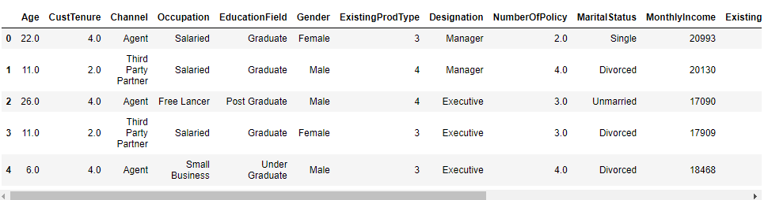

**Data dictionary:**

**AgentBonus_per_policy** => Average Bonus amount given to each agents in last month per Policy

**Age** =>Age of customer

**CustTenure** =>Tenure of customer in organization

**Channel** =>Channel through which acquisition of customer is done

**Occupation** =>Occupation of customer

**EducationField** =>Field of education of customer

**Gender** =>Gender of customer

**ExistingProdType** =>Existing product type of customer

**Designation** =>Designation of customer in their organization

**NumberOfPolicy** =>Total number of existing policy of a customer

**MaritalStatus** =>Marital status of customer

**MonthlyIncome** =>Gross monthly income of customer

**ExistingPolicyTenure** =>Max tenure in all existing policies of customer

**SumAssured_per_policy** => Average sum assured in all existing policies of customer per policy

**Zone** =>Customer belongs to which zone in India. Like East, West, North and South

**PaymentMethod** =>Frequency of payment selected by customer like Monthly, quarterly, half yearly and yearly

# **Understanding of attributes:**

**Data description:**

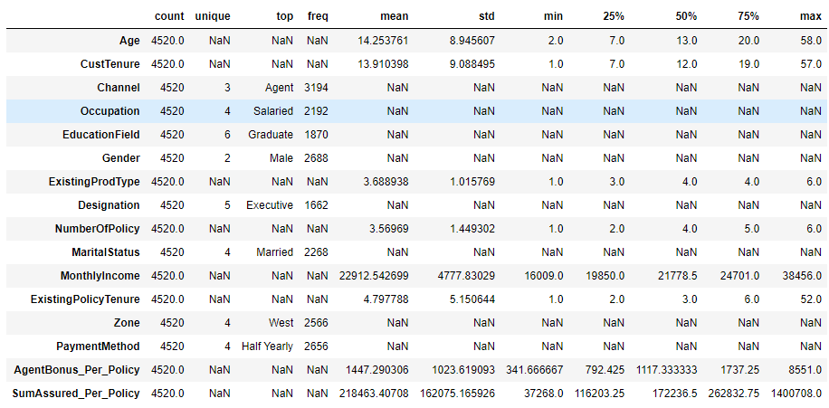

**Insights:**

1. Agent Bonus per policy: Bonus given to Agents, as well as Target variable. Minimum bonus given as 341 and Max is 8551

2. Age: Customers of all age group from 2 years to 58 years.

3. Customer Tenure: Many customers associated with Company from their Birth

4. Existing Prod Type : There are only 6 insurance products

5. Number of Policy: Customer can have multiple policies, from insurance company , for their family members or Self.

6. Monthly income Ranging between about 16K to 38K.

**Data info:**

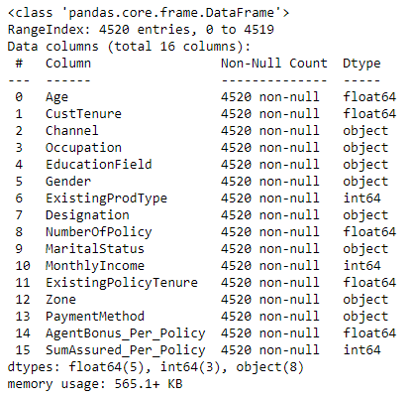

**List of the columns:**

Index(['Age', 'CustTenure', 'Channel', 'Occupation', 'EducationField',

'Gender', 'ExistingProdType', 'Designation', 'NumberOfPolicy',

'MaritalStatus', 'MonthlyIncome', 'ExistingPolicyTenure', 'Zone',

'PaymentMethod', 'AgentBonus_Per_Policy', 'SumAssured_Per_Policy'],

dtype='object')

# **Data Preparation**

# **Encoding:**

In machine learning, we usually deal with datasets that contain multiple labels in one or more than one column. These labels can be in the form of words or numbers. To make the data understandable or in human-readable form, the training data is often labelled in words.

Label Encoding refers to converting the labels into a numeric form so as to convert them into the machine-readable form. Machine learning algorithms can then decide in a better way how those labels must be operated. It is an important pre-processing step for the structured dataset in supervised learning.

**Limitation of label Encoding :**

Label encoding converts the data in machine-readable form, but it assigns a unique number(starting from 0) to each class of data. This may lead to the generation of priority issues in the training of data sets. A label with a high value may be considered to have high priority than a label having a lower value.

**Example:**

An attribute having output classes Mexico, Paris, Dubai. On Label Encoding, this column lets Mexico is replaced with 0, Paris is replaced with 1, and Dubai is replaced with 2. With this, it can be interpreted that Dubai has high priority than Mexico and Paris while training the model, But actually, there is no such priority relation between these cities here.

After performing Encoding . this is how the data looks like for categorical fields :

Columns is : Channel

['Agent', 'Third Party Partner', 'Online']

Categories (3, object): ['Agent', 'Online', 'Third Party Partner']

[0 2 1]

Columns is : Occupation

['Salaried', 'Free Lancer', 'Small Business', 'Large Business']

Categories (4, object): ['Free Lancer', 'Large Business', 'Salaried', 'Small Business']

[2 0 3 1]

Columns is : EducationField

['Graduate', 'Post Graduate', 'Under Graduate', 'Engineer', 'Diploma', 'MBA']

Categories (6, object): ['Diploma', 'Engineer', 'Graduate', 'MBA', 'Post Graduate', 'Under Graduate']

[2 4 5 1 0 3]

Columns is : Gender

['Female', 'Male']

Categories (2, object): ['Female', 'Male']

[0 1]

Columns is : Designation

['Manager', 'Executive', 'VP', 'AVP', 'Senior Manager']

Categories (5, object): ['AVP', 'Executive', 'Manager', 'Senior Manager', 'VP']

[2 1 4 0 3]

Columns is : MaritalStatus

['Single', 'Divorced', 'Unmarried', 'Married']

Categories (4, object): ['Divorced', 'Married', 'Single', 'Unmarried']

[2 0 3 1]

Columns is : Zone

['North', 'West', 'East', 'South']

Categories (4, object): ['East', 'North', 'South', 'West']

[1 3 0 2]

Columns is : PaymentMethod

['Half Yearly', 'Yearly', 'Quarterly', 'Monthly']

Categories (4, object): ['Half Yearly', 'Monthly', 'Quarterly', 'Yearly']

[0 3 2 1]

Sample looks like this :

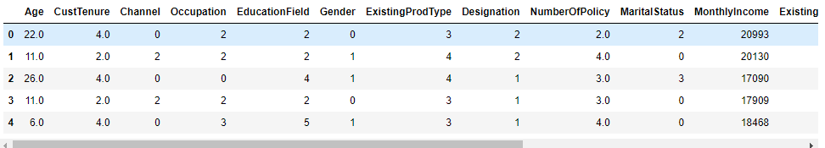

**Data Info :**

<class 'pandas.core.frame.DataFrame'>

RangeIndex: 4520 entries, 0 to 4519

Data columns (total 16 columns):

# Column Non-Null Count Dtype

--- ------ -------------- -----

0 Age 4520 non-null float64

1 CustTenure 4520 non-null float64

2 Channel 4520 non-null int8

3 Occupation 4520 non-null int8

4 EducationField 4520 non-null int8

5 Gender 4520 non-null int8

6 ExistingProdType 4520 non-null int64

7 Designation 4520 non-null int8

8 NumberOfPolicy 4520 non-null float64

9 MaritalStatus 4520 non-null int8

10 MonthlyIncome 4520 non-null int64

11 ExistingPolicyTenure 4520 non-null float64

12 Zone 4520 non-null int8

13 PaymentMethod 4520 non-null int8

14 AgentBonus_Per_Policy 4520 non-null float64

15 SumAssured_Per_Policy 4520 non-null int64

# **Data Split: Split the data into train and test (70:30)**

The train-test split is used to estimate the performance of machine learning algorithms that are applicable for prediction-based Algorithms/Applications. This method is a fast and easy procedure to perform such that we can compare our own machine learning model results to machine results. By default, the Test set is split into 30 % of actual data and the training set is split into 70% of the actual data.

We need to split a dataset into train and test sets to evaluate how well our machine learning model performs. The train set is used to fit the model, and the statistics of the train set are known. The second set is called the test data set, this set is solely used for predictions.

**Dataset Splitting:**

Scikit-learn alias sklearn is the most useful and robust library for machine learning in Python. The scikit-learn library provides us with the model_selection module in which we have the splitter function train_test_split().

Dependent variable : **AgentBonus_Per_Policy**

After performing train test split , We have got 4 parts :

Shape for X_train is (3164, 15)

Shape for X_test is (1356, 15)

Shape for y_train is (3164, 1)

Shape for y_test is (1356, 1)

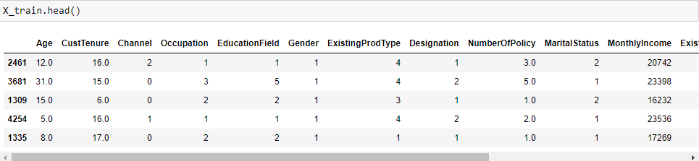

# **Model building and interpretation :**

# **SKLearn Linear Model:**

# **Definition:**

Linear regression is defined as the process of determining the straight line that best fits a set of dispersed data points.

Linear regression is a simple and common type of predictive analysis. Linear regression attempts to model the relationship between two (or more) variables by fitting a straight line to the data. Put simply, linear regression attempts to predict the value of one variable, based on the value of another (or multiple other variables).

We can recall from high-school math that the equation for a linear relationship is: y = m(x) + b. In machine learning, m is often referred to as the weight of a relationship and b is referred to as the bias.

This relationship is referred to as a univariate linear regression because there is only a single independent variable. In many cases, our models won’t actually be able to be predicted by a single independent variable. In these cases, there will be multiple independent variables influencing the dependent variable.

When working with scikit-linear learn's regression approach, we will encounter the following concepts:

* Best Fit - The straight line in a plot that minimizes the divergence between related dispersed data points
* Coefficient - Also known as a parameter, is the factor that is multiplied by a variable. A coefficient in linear regression represents changes in a Response Variable
* Coefficient of Determination - It is the correlation coefficient. In a regression, this term is used to define the precision or degree of fit
* Correlation - the measurable intensity and degree of association between two variables, often known as the 'degree of correlation.' The values range from -1.0 to 1.0
* Dependent Feature - A variable represented as y in the slope equation y=ax+b. Also referred to as an Output or a Response
* Estimated Regression Line - the straight line that best fits a set of randomly distributed data points
* Independent Feature - a variable represented by the letter x in the slope equation y=ax+b. Also referred to as an Input or a predictor
* Intercept - It is the point at where the slope intersects the Y-axis, indicated by the letter b in the slope equation y=ax+b
* Least Squares - a method for calculating the best fit to data by minimizing the sum of the squares of the discrepancies between observed and estimated values
* Mean - an average of a group of numbers; nevertheless, in linear regression, Mean is represented by a linear function
* Residual - the vertical distance between a data point and the regression line
* Regression - is an assessment of a variable's predicted change in relation to changes in other variables
* Regression Model - The optimum formula for approximating a regression
* Response Variables - This category covers both the Predicted Response (the value predicted by the regression) and the Actual Response (the actual value of the data point)
* Slope - the steepness of a regression line. The linear relationship between two variables may be defined using slope and intercept: y=ax+b

# **Action:**

We have performed linear regression techniques from Sklearn LinearRegression library .

Following is co-efficient of Determination :

The coefficient for Age is 4.789430368850247

The coefficient for CustTenure is 4.759701081772676

The coefficient for Channel is -8.882960541752864

The coefficient for Occupation is 7.510211001225475

The coefficient for EducationField is -5.507046975671935

The coefficient for Gender is 2.1343057926728486

The coefficient for ExistingProdType is -15.273396744099568

The coefficient for Designation is 4.737994566790387

The coefficient for NumberOfPolicy is -159.7092491616902

The coefficient for MaritalStatus is 14.788341883378328

The coefficient for MonthlyIncome is 0.008683193446440198

The coefficient for ExistingPolicyTenure is 2.6087386706276594

The coefficient for Zone is -5.627466691687209

The coefficient for PaymentMethod is 1.6127186348940015

The coefficient for SumAssured_Per_Policy is 0.004765571407328226

# **Equation:**

**AgentBonus_per_policy** = Age * 4.789430368850247 + CustTenure * 4.759701081772676 + Channel * -8.882960541752864 + Occupation * 7.510211001225475 + EducationField * -5.507046975671935 + Gender * 2.1343057926728486 + ExistingProdType * -15.273396744099568 + Designation * 4.737994566790387 + NumberOfPolicy * -159.7092491616902 + MaritalStatus * 14.788341883378328 + MonthlyIncome * 0.008683193446440198 + ExistingPolicyTenure * 2.6087386706276594 + Zone * -5.627466691687209 + PaymentMethod * 1.6127186348940015 + SumAssured_Per_Policy * 0.004765571407328226 + 671.7150861205953

**The intercept for the model is 671.7150861205953**

Intercept is the point on Y Axis , when all values of X are Zero. basically when we say, what should be the value of Y when all params are Zero

The coefficient of determination, denoted as 𝑅², tells you which amount of variation in 𝑦 can be explained by the dependence on 𝐱, using the particular regression model. A larger 𝑅² indicates a better fit and means that the model can better explain the variation of the output with different inputs.

The value 𝑅² = 1 corresponds to SSR = 0. That’s the perfect fit, since the values of predicted and actual responses fit completely to each other.

R-Squared: R2 is a statistic that will give some information about the goodness of fit of a model. It ranges from 0 to 1. Exxample: if the value of R-squared is 0.745 so it explains 74% of variance is explained by the model.

for this Model , we have R-Squared as 0.896, which means, model is 89.6% of variance is explained by the model.

**The coefficient of determination R^2 of the prediction on Train set 0.906776344656819**

**The coefficient of determination R^2 of the prediction on Test set 0.8964948926865645**

# **Understanding Model:**

One way to assess how well a regression model fits a dataset is to calculate the root mean square error, which is a metric that tells us the average distance between the predicted values from the model and the actual values in the dataset.

The lower the RMSE, the better a given model is able to “fit” a dataset.

The formula to find the root mean square error, often abbreviated RMSE, is as follows:

RMSE = Square root of ( sum(Pi – Oi)**2 / n)

where:

Σ is a fancy symbol that means “sum”

Pi is the predicted value for the ith observation in the dataset

Oi is the observed value for the ith observation in the dataset

n is the sample size

This means that the RMSE represents the square root of the variance of the residuals.

suppose we want to build a regression model to predict the exam score of students and we want to find the best possible model among several potential models. Suppose we fit three different regression models and find their corresponding RMSE values:

RMSE of Model 1: 14.5

RMSE of Model 2: 16.7

RMSE of Model 3: 9.8

Model 3 has the lowest RMSE, which tells us that it’s able to fit the dataset the best out of the three potential models.

**The Root Mean Square Error (RMSE) of the model is for Train set is 317.48346002535106**

**The Root Mean Square Error (RMSE) of the model is for Train set is 316.6349977188605**

This is how data points look like for predicted variables:

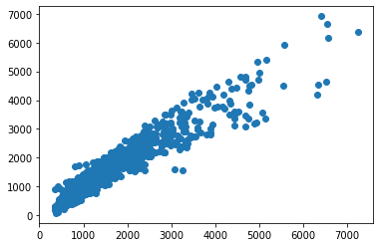 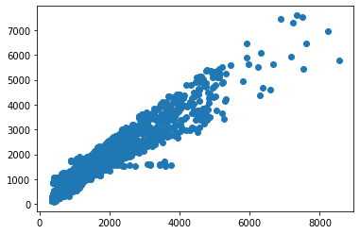

Figure 1 Scatter plot for Prediction on Test data Figure 2 Scatter plot for Prediction on Train data

# **Performance parameters:**

Train data matrix:

The MAE is: 220.32100694973653

The MSE is: 100795.7473896687

The MAPE is 0.1707241803718864

The EVS is 0.9067763446568196

The RMSE 316.6349977188605

Test data matrix:

The MAE for Test data is: 222.5194900195983

The MSE for Test data is: 100257.72178042283

The MAPE for Test data is 0.17126532112977724

The EVS for Test data is 0.8964952272518002

The RMSE 317.48346002535106

# **Feature importance**

Feature importance refers to a class of techniques for assigning scores to input features to a predictive model that indicates the relative importance of each feature when making a prediction.

We fit a LinearRegression model on the regression dataset and retrieve the *coeff_* property that contains the coefficients found for each input variable. These coefficients can provide the basis for a crude feature importance score. This assumes that the input variables have the same scale or have been scaled prior to fitting a model.

In regression analysis, the magnitude of coefficients is not necessarily 100% related to their importance. The most common criteria to determine the importance of independent variables in regression analysis are **p-values**.

Small p-values imply high levels of importance, whereas high p-values mean that a variable is not statistically significant.

We can only use the magnitude of coefficients as a measure for feature importance when our model is penalizing variables. **sklearn does not report p-values though.**

# **Building Stats Model:**

# **Definition:**

Linear regression statsmodel is the model that helps us to predict and is used for fitting up the scenario where one parameter is directly dependent on the other parameter. Here, we have one variable that is dependent and the other one which is independent. Depending on the change in the value of the independent parameter, we need to predict the change in the dependent variable.

Ordinary least squares (OLS) regression is a [statistical method](https://www.encyclopedia.com/earth-and-environment/ecology-and-environmentalism/environmental-studies/statistical-method) of analysis that estimates the relationship between one or more independent variables and a dependent variable; the method estimates the relationship by minimizing the sum of the squares in the difference between the observed and predicted values of the dependent variable configured as a straight line.

# **Action:**

OLS model works on only train and Test data set, it does not need separation of Dependent and Independent variables . We just need to specify during model building , which variable is Dependent . but Sample data don’t need a separation in it.

So, we have merged X and Y variables and built separate Train and Test data set .

**Field names for both train and test data set are:**

Index(['Age', 'CustTenure', 'Channel', 'Occupation', 'EducationField',

'Gender', 'ExistingProdType', 'Designation', 'NumberOfPolicy',

'MaritalStatus', 'MonthlyIncome', 'ExistingPolicyTenure', 'Zone',

'PaymentMethod', 'SumAssured_Per_Policy', 'AgentBonus_Per_Policy'])

**Data Info :**

# Column Non-Null Count Dtype

--- ------ -------------- -----

0 Age 3164 non-null float64

1 CustTenure 3164 non-null float64

2 Channel 3164 non-null int8

3 Occupation 3164 non-null int8

4 EducationField 3164 non-null int8

5 Gender 3164 non-null int8

6 ExistingProdType 3164 non-null int64

7 Designation 3164 non-null int8

8 NumberOfPolicy 3164 non-null float64

9 MaritalStatus 3164 non-null int8

10 MonthlyIncome 3164 non-null int64

11 ExistingPolicyTenure 3164 non-null float64

12 Zone 3164 non-null int8

13 PaymentMethod 3164 non-null int8

14 SumAssured_Per_Policy 3164 non-null int64

15 AgentBonus_Per_Policy 3164 non-null float64

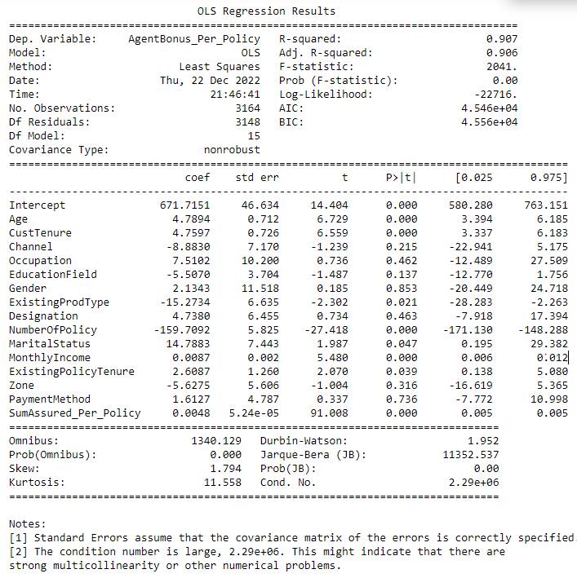

After building OLS Model , this is the co-efficient of determinations:

Intercept 671.715086

Age 4.789430

CustTenure 4.759701

Channel -8.882961

Occupation 7.510211

EducationField -5.507047

Gender 2.134306

ExistingProdType -15.273397

Designation 4.737995

NumberOfPolicy -159.709249

MaritalStatus 14.788342

MonthlyIncome 0.008683

ExistingPolicyTenure 2.608739

Zone -5.627467

PaymentMethod 1.612719

SumAssured_Per_Policy 0.004766

# **Performance parameters:**

Train data matrix:

The MAE is: 220.32100694970435

The MSE is: 100795.74738966869

The MAPE is 0.17072418037186507

The EVS is 0.9067763446568196

The RMSE 316.63499771886285

Test data matrix:

The MAE for Test data is: 222.5194900195671

The MSE for Test data is: 100257.7217804241

The MAPE for Test data is 0.17126532112975362

The EVS for Test data is 0.8964952272517993

The RMSE 317.48346002535055



Figure 3Scatter Plot for Predicted values on Test data set

# **Feature Importance:**

In regression analysis, the magnitude of coefficients is not necessarily 100% related to their importance. The most common criteria to determine the importance of independent variables in regression analysis are **p-values**.

Small p-values imply high levels of importance, whereas high p-values mean that a variable is not statistically significant.

We can only use the magnitude of coefficients as a measure for feature importance when our model is penalizing variables. **sklearn does not report p-values though.** But Stats model does give **p-values** .

From Stats model summary , we can see that there are high P value for many of the fields from our data set.

|  |  |  |
| --- | --- | --- |
|  | coef | P>|t| |
| Intercept | 671.7151 | 0 |
| Age | 4.7894 | 0 |
| CustTenure | 4.7597 | 0 |
| Channel | -8.883 | 0.215 |
| Occupation | 7.5102 | 0.462 |
| EducationField | -5.507 | 0.137 |
| Gender | 2.1343 | 0.853 |
| ExistingProdType | -15.2734 | 0.021 |
| Designation | 4.738 | 0.463 |
| NumberOfPolicy - | 159.7092 | 0 |
| MaritalStatus | 14.7883 | 0.047 |
| MonthlyIncome | 0.0087 | 0 |
| ExistingPolicyTenure | 2.6087 | 0.039 |
| Zone | -5.6275 | 0.316 |
| PaymentMethod | 1.6127 | 0.736 |
| SumAssured_Per_Policy | 0.0048 | 0 |

**So we can consider High Importance features are :**

Age , CustomerTenure, NumberofPolicy, MonthlyIncome and SumAssured_Per_Policy

And less affecting features are :

PaymentMethod , Gender, Occupation, Designation etc.

# **Building Multiple Stats Model to eliminate non affecting fields :**

# **Stats Model for fields with lower value of VIF :**

Calculate VIF for each Field and based on VIF value we decide, which column can be eliminated.

VIF (variance inflation factor) is used for checking multicollinearity in regression Model. its Values can range between 1 to Infinite.

# **How to interpret a given VIF value?:**

Consider the following linear regression model: **Y = β0 + β1 × X1 + β2 × X2 + β3 × X3 + ε**

For each of the independent variables X1, X2 and X3 we can calculate the variance inflation factor (VIF) in order to determine if we have a multicollinearity problem.

Here’s the formula for calculating the VIF for X1: **VIF1 = 1 / (1 - R**2)**

VIF (variance inflating factor) formula for the first variable in the model.

R2 in this formula is the coefficient of determination from the linear regression model which has:

X1 as dependent variable

X2 and X3 as independent variables

In other words, R2 comes from the following linear regression model:

X1 = β0 + β1 × X2 + β2 × X3 + ε

And because R2 is a number between 0 and 1:

When R2 is close to 1 (i.e. X2 and X3 are highly predictive of X1): the VIF will be very large

When R2 is close to 0 (i.e. X2 and X3 are not related to X1): the VIF will be close to 1

Therefore the range of VIF is between 1 and infinity.

# **Action:**

We have checked VIF for each field, and taken threshold to 5. Fields with more than value of 5, can be consider to eliminate that field . We have done this exercise in a For Loop,

Out of 16 fields, we have consider only these 10 fields, which have VIF value less than 5 :

Index(['CustTenure', 'Channel', 'EducationField', 'Gender', 'Designation',

'MaritalStatus', 'ExistingPolicyTenure', 'Zone', 'PaymentMethod',

'SumAssured_Per_Policy'],

VIF Values for all of above fields are :

VIF for CustTenure --> 3.7649121302806456

VIF for Channel --> 1.351814184733024

VIF for EducationField --> 3.013828674898219

VIF for Gender --> 2.23880673655966

VIF for Designation --> 3.6622884417664836

VIF for MaritalStatus --> 2.9365604234253677

VIF for ExistingPolicyTenure --> 2.182083152055937

VIF for Zone --> 4.306208853382339

VIF for PaymentMethod --> 1.5613624945213813

VIF for SumAssured_Per_Policy --> 2.890013748992411

**Co-efficient of determination :**

Intercept 97.578366

CustTenure 2.490252

Channel -5.525502

EducationField -3.716762

Gender 12.087670

Designation 9.399802

MaritalStatus 16.199391

ExistingPolicyTenure 2.282474

Zone 1.504290

PaymentMethod -5.626124

SumAssured_Per_Policy 0.005840

dtype: float64

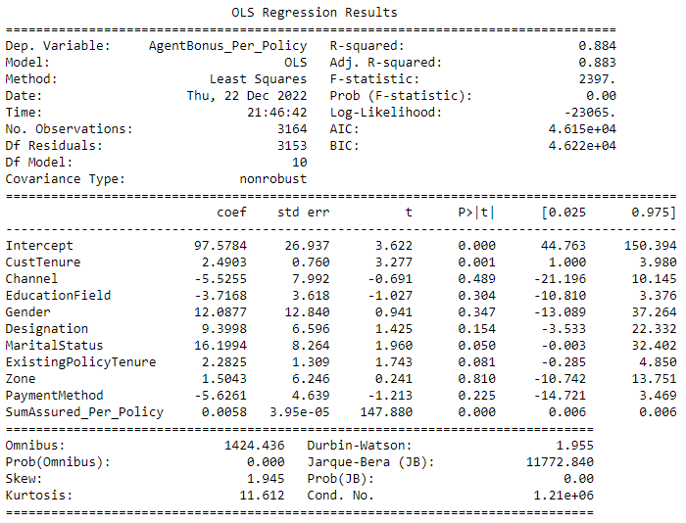

# **Performance parameters:**

Train data matrix:

The MAE is: 238.54187545716903

The MSE is: 125701.42525909047

The MAPE is 0.17557448996078645

The EVS is 0.8837416592666577

The RMSE 353.56277958413546

Test data matrix:

The MAE for Test data is: 244.14186309381338

The MSE for Test data is: 125006.63910726018

The MAPE for Test data is 0.1796778764535846

The EVS for Test data is 0.8709648906909357

The RMSE 354.54396801961036

# **Stats Model for fields with Lower P value and remove other fields:**

Based on the OLS Summary, form above model, we have come to this conclusion that,, there are many fields, with High P -value, the Higher the P Value, Lower the chance it will affect the Predictions. This is the list of P value for all the fields:

|  |  |  |
| --- | --- | --- |
|  | coef | P>|t| |
| Intercept | 97.5784 | 0 |
| CustTenure | 2.4903 | 0.001 |
| Channel | -5.5255 | 0.489 |
| EducationField | -3.7168 | 0.304 |
| Gender | 12.0877 | 0.347 |
| Designation | 9.3998 | 0.154 |
| MaritalStatus | 16.1994 | 0.05 |
| ExistingPolicyTenure | 2.2825 | 0.081 |
| Zone | 1.5043 | 0.81 |
| PaymentMethod | -5.6261 | 0.225 |
| SumAssured_Per_Policy | 0.0058 | 0 |

# **Action:**

We have removed fields one by one and re-generated OLS model and checked P values for fields again and again, until each field importance came below 0.05.

We started with these fields:

* 1. Model Build by removing field name “**Zone**” : Since Zone has Highest P-Value , so we dropped this field and Built our Model, on top of Step 4.3.1 , where we eliminated fields with higher VIF.

After building Model without field “Zone”, We still saw that there were many fields with High P-Value .

* 1. Model Build by removing field name “**Channel**”: Since Channel , has Highest P-Value , so we dropped this field and Built our Model on top of above model. We still saw that there were many fields with High P-Value .
  2. Model Build by removing field name “**Gender**”: Since Gender, has Highest P-Value , so we dropped this field and Built our Model on top of above model. We still saw that there were many fields with High P-Value .
  3. Model Build by removing field name “**EducationField**”: Since **EducationField**, has Highest P-Value , so we dropped this field and Built our Model on top of above model. We still saw that there were many fields with High P-Value .
  4. Model Build by removing field name “**PaymentMethod**”: Since **PaymentMethod** , has Highest P-Value , so we dropped this field and Built our Model on top of above model. We still saw that there were many fields with High P-Value .
  5. Model Build by removing field name “**Designation**”: Since **Designation**, has Highest P-Value , so we dropped this field and Built our Model on top of above model. We still saw that there were many fields with High P-Value .
  6. Model Build by removing field name “**MaritalStatus**”: Since **MaritalStatus**, has Highest P-Value , so we dropped this field and Built our Model on top of above model. We still saw that there were many fields with High P-Value .

After dropping **MaritalStatus ,** we Built our Final Stats Model with these features:

No Field have VIF value more than 5

No field have higher p-Value than 0.05

And we are left with only these 3 fields, which are most important feature to determine the targeted values:

CustTenure

ExistingPolicyTenure

SumAssured_per_policy

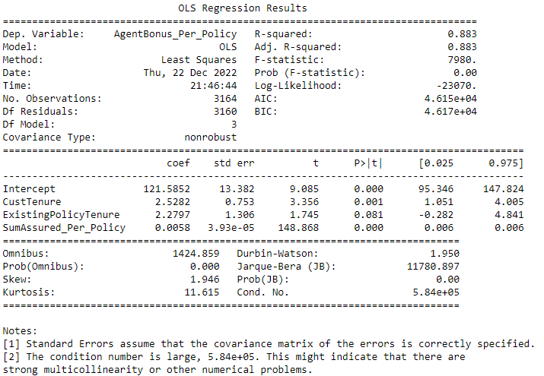

# **Performance parameters:**

Train data matrix:

The MAE is: 238.6871961437201

The MSE is: 126072.974963021

The MAPE is 0.17554253326507824

The EVS is 0.8833980215394808

The RMSE 352.60212402026525

Test data matrix:

The MAE for Test data is: 243.29840734002366

The MSE for Test data is: 124328.25786360275

The MAPE for Test data is 0.1787555654744601

The EVS for Test data is 0.8716758974028127

The RMSE 355.0675639410347

# **Equation and interpretation:**

We can use below formula for determining the targeted value:

**AgentBonus_per_policy = (121.59) + (2.53) * CustTenure +**

**(2.28) * ExistingPolicyTenure + (0.01) * SumAssured_Per_Policy**

We can see from the equation, if all of the Independent parameters are Zero, then also Agent will receive a Bonus of

Rs 121.59 , which is very good.

Also there is clear that 1% of total amount of SumAssured goes into Agent Bonus, because co-efficient is 0.01

# **Decision Tree Model**

# **Definition:**

Decision Tree is a decision-making tool that uses a flowchart-like tree structure or is a model of decisions and all of their possible results, including outcomes, input costs, and utility. Decision-tree algorithm falls under the category of supervised learning algorithms. It works for both continuous as well as categorical output variables.

The branches/edges represent the result of the node and the nodes have either:

Conditions [Decision Nodes]

Result [End Nodes]

The branches/edges represent the truth/falsity of the statement and take makes a decision based on that in the example below which shows a decision tree that evaluates the smallest of three numbers:

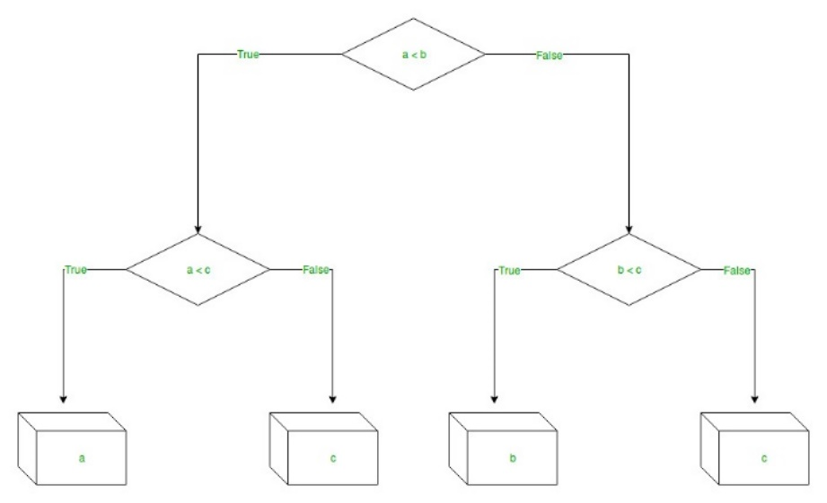

Figure 4 Example for Decision tree

**Decision Tree Regression:**   
Decision tree regression observes features of an object and trains a model in the structure of a tree to predict data in the future to produce meaningful continuous output. Continuous output means that the output/result is not discrete, i.e., it is not represented just by a discrete, known set of numbers or values.

**Discrete output example:** A weather prediction model that predicts whether or not there’ll be rain on a particular day.   
**Continuous output example:** A profit prediction model that states the probable profit that can be generated from the sale of a product.

# **Action:**

Again, decision tree works on Separate group of dependent variable and independent variables of train and test data. So we will use our Old sub groups of train and test split data set:

After performing train test split , we have got 4 parts :

Shape for X_train is (3164, 15)

Shape for X_test is (1356, 15)

Shape for y_train is (3164, 1)

Shape for y_test is (1356, 1)

We have used Sklearn DecisionTreeRegressor library for our model building and created Model .

# **Feature Importance :**

After building decision tree Model, this is the list of features with their importance weightage

SumAssured_Per_Policy 0.879796

NumberOfPolicy 0.041685

MonthlyIncome 0.023623

Age 0.018812

CustTenure 0.014237

ExistingPolicyTenure 0.008178

Designation 0.002733

MaritalStatus 0.001986

Occupation 0.001936

ExistingProdType 0.001746

EducationField 0.001732

Zone 0.000928

PaymentMethod 0.000918

Gender 0.000906

Channel 0.000786

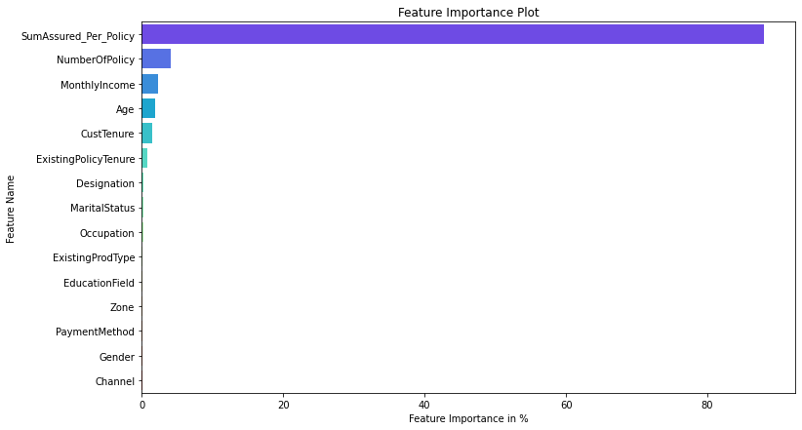

Figure 5 Decision Tree Feature Importance

# **Performance parameters:**

Train data matrix:

The MAE is: 0.0

The MSE is: 0.0

The MAPE is 0.0

The EVS is 1.0

The RMSE is:0.00

Test data matrix:

The MAE for Test data is: 239.35693215339234

The MSE for Test data is: 136407.9355465421

The MAPE for Test data is 0.17331057475482273

The EVS for Test data is 0.8592843399780032

The RMSE is:369.33

Decision Tree model always give a clear separation on Train data set, that’s why it gives value of 0 for all the performance parameters, When we checked for test data, then actual errors comes, and RMSE for DTree is 369.33

# **Random Forest Regressor Model**

# **Definition :**

Every decision tree has high variance, but when we combine all of them together in parallel then the resultant variance is low as each decision tree gets perfectly trained on that particular sample data, and hence the output doesn’t depend on one decision tree but on multiple decision trees. In the case of a classification problem, the final output is taken by using the majority voting classifier. In the case of a regression problem, the final output is the mean of all the outputs. This part is called **Aggregation**.

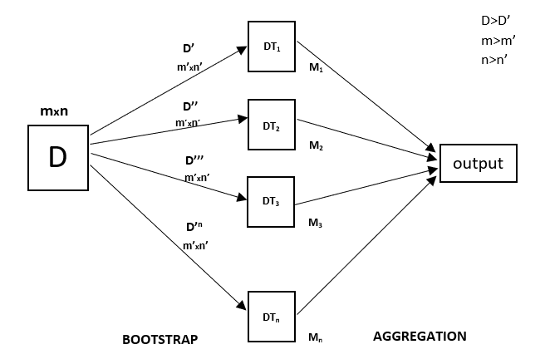

Figure 6 Example for Random Forest

Random Forest is an ensemble technique capable of performing both regression and classification tasks with the use of multiple decision trees and a technique called Bootstrap and Aggregation, commonly known as **bagging**. The basic idea behind this is to combine multiple decision trees in determining the final output rather than relying on individual decision trees.   
Random Forest has multiple decision trees as base learning models. We randomly perform row sampling and feature sampling from the dataset forming sample datasets for every model. This part is called Bootstrap.

We need to approach the Random Forest regression technique like any other machine learning technique

# **Action:**

Random forest is similar to decision tree, which works on Separate group of dependent variable and independent variables of train and test data. So we will use our Old sub groups of train and test split data set:

After performing train test split , we have got 4 parts :

Shape for X_train is (3164, 15)

Shape for X_test is (1356, 15)

Shape for y_train is (3164, 1)

Shape for y_test is (1356, 1)

We have used Sklearn RandomForestRegressor library for our model building and created Model .

# **Feature Importance :**

After building Renadom Forest Model, this is the list of features with their importance weightage

SumAssured_Per_Policy 0.891987

NumberOfPolicy 0.038844

Age 0.016303

MonthlyIncome 0.015429

CustTenure 0.014407

ExistingPolicyTenure 0.008537

EducationField 0.002414

Designation 0.002192

ExistingProdType 0.001839

MaritalStatus 0.001773

Occupation 0.001504

Gender 0.001254

Channel 0.001195

PaymentMethod 0.001186

Zone 0.001135

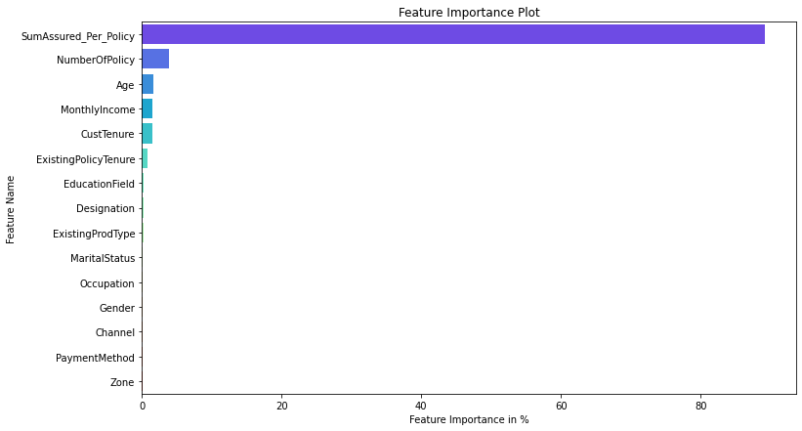

Figure 7Random Forest Feature Importance

# **Performance parameters:**

Train data matrix:

The MAE is: 65.69539559629162

The MSE is: 10394.932540860822

The MAPE is 0.04768645807947594

The EVS is 0.9903860465401678

The RMSE is:101.96

Test data matrix:

The MAE for Test data is: 178.33922976073418

The MSE for Test data is: 73391.11692993417

The MAPE for Test data is 0.1282120366478216

The EVS for Test data is 0.9242322882676777

The RMSE is:270.91

# **Artificial Neural Network Regressor**

The purpose of using Artificial Neural Networks for Regression over Linear Regression is that the linear regression can only learn the linear relationship between the features and target and therefore cannot learn the complex non-linear relationship. In order to learn the complex non-linear relationship between the features and target, we are in need of other techniques. One of those techniques is to use Artificial Neural Networks. Artificial Neural Networks have the ability to learn the complex relationship between the features and target due to the presence of activation function in each layer. Let’s look at what are Artificial Neural Networks and how do they work.

# **Definition:**

Artificial Neural Networks are one of the deep learning algorithms that simulate the workings of neurons in the human brain. There are many types of Artificial Neural Networks, Vanilla Neural Networks, Recurrent Neural Networks, and Convolutional Neural Networks. The Vanilla Neural Networks have the ability to handle structured data only, whereas the Recurrent Neural Networks and Convolutional Neural Networks have the ability to handle unstructured data very well.

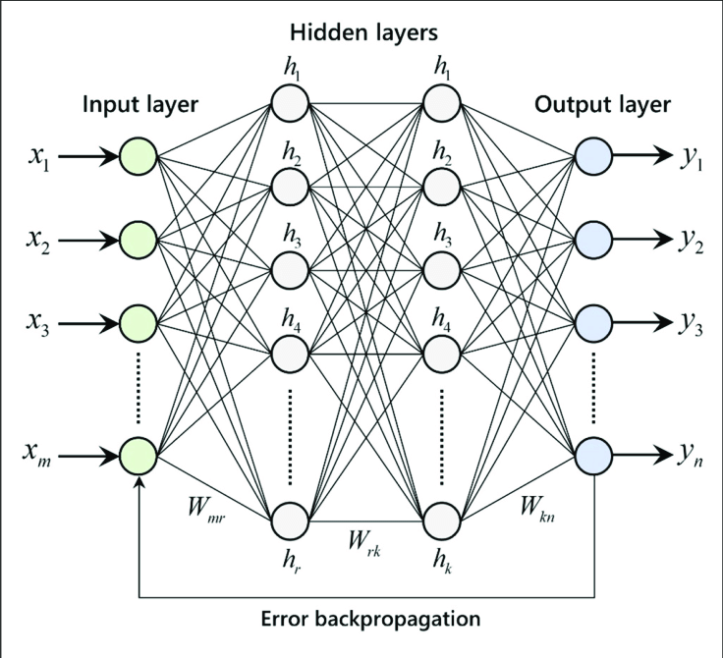

Figure 8 Example for ANN Model

The Artificial Neural Networks consists of the Input layer, Hidden layers, Output layer. The hidden layer can be more than one in number. Each layer consists of n number of neurons. Each layer will be having an Activation Function associated with each of the neurons. The activation function is the function that is responsible for introducing non-linearity in the relationship. In our case, the output layer must contain a linear activation function. Each layer can also have regularizers associated with it. Regularizers are responsible for preventing overfitting.

The functionality of ANN can be explained in below 5 simple steps:

1. Read the input data
2. Produce the predictive model (A mathematical function)
3. Measure the error in the predictive model
4. Inform and implement necessary corrections to the model repeatedly until a model with least error is found
5. Use this model for predicting the unknown

# **Action:**

We have used Grid search to find the best parameters used in our prediction model. We have used following params for grid search:

param_grid = { 'hidden_layer_sizes': [50,100],

'activation':['logistic','relu'],

'max_iter': [250,],

'solver': ['adam','sgd'],

'tol': [0.1,0.01], }

We want our Model to check between 50 and 100 hidden layers, the more number of hidden layers you apply, more time it will take to execute.

The activation function generates an output based on input signals. Logistic/Segmoid are same

After using grid search these are the Parameters, we have received :

{'activation': 'logistic',

'hidden_layer_sizes': 100,

'max_iter': 250,

'solver': 'sgd',

'tol': 0.1}

sigmoid/logistic activation function is one of the most widely used functions:

* It is commonly used for models where we have to predict the probability as an output. Since probability of anything exists only between the range of 0 and 1, sigmoid is the right choice because of its range.
* The function is differentiable and provides a smooth gradient, i.e., preventing jumps in output values. This is represented by an S-shape of the sigmoid activation function.

# **Feature Importance :**

We cannot get the values of list of best parameters used for prediction Model , because it all comes under Hidden layers.

# **Performance parameters:**

Train data matrix:

The MAE is: 4972.297786270588

The MSE is: 25833654.247346397

The MAPE is 5.255688936394857

The EVS is -0.09295335197465215

The RMSE is:5082.68

Test data matrix:

The MAE for Test data is: 4990.048298012509

The MSE for Test data is: 25943347.914660286

The MAPE for Test data is 5.291987651047779

The EVS for Test data is -0.09990145029430497

The RMSE is:5093.46

# **Model Tuning and business implication**

There are many ways we can Tune our Model :

1. We can use bagging/Boosting regressors
2. We can Tune and search for best Hyper parameters.
3. We can KFold our data and do testing

I have used above methods and built following models :

# **Bagging Regressor (Random Forest should be applied for Bagging)**

# **Definition :**

Bagging, also known as Bootstrap aggregating, is an ensemble learning technique that helps to improve the performance and accuracy of machine learning algorithms. It is used to deal with bias-variance trade-offs and reduces the variance of a prediction model. Bagging avoids overfitting of data and is used for both regression and classification models, specifically for decision tree algorithms.

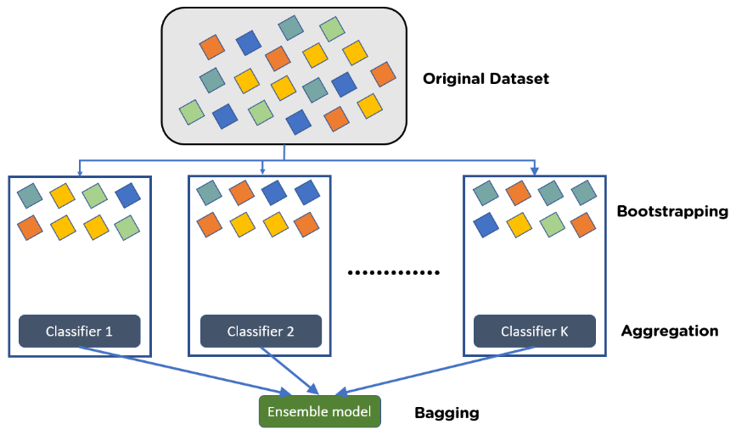

Figure 9 Explain Bagging

Bootstrapping is the method of randomly creating samples of data out of a population with replacement to estimate a population parameter.

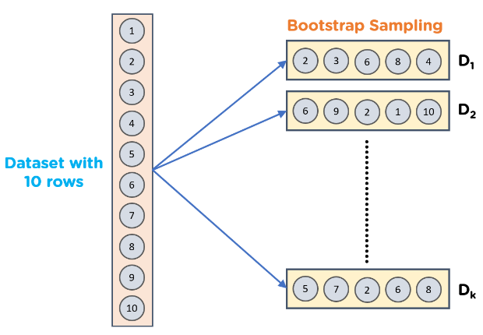

Figure 10 Explain Bootstrapping

**Steps to Perform Bagging:**

* Consider there are n observations and m features in the training set. You need to select a random sample from the training dataset without replacement
* A subset of m features is chosen randomly to create a model using sample observations
* The feature offering the best split out of the lot is used to split the nodes
* The tree is grown, so you have the best root nodes
* The above steps are repeated n times. It aggregates the output of individual decision trees to give the best prediction

# **Action:**

I have used Random Forest regressor for base_estimator and then used base_estimator parameters of Random Forest into Bagging Algorithm.

I have used Sklearn BaggingRegressor library for our model building.

# **Feature Importance :**

Bagging don’t give List of best features. 'BaggingRegressor' object has no attribute 'feature_importances_'

So we cannot say, which Attribute of Sample data set is more contributing in prediction model

# **Performance parameters:**

Train data matrix:

The MAE is: 106.47556038137378

The MSE is: 24820.70796807343

The MAPE is 0.07690297993131891

The EVS is 0.9770456925867458

The RMSE is:157.55

Test data matrix:

The MAE for Test data is: 180.50244943952802

The MSE for Test data is: 72519.03619748793

The MAPE for Test data is 0.12940358828836765

The EVS for Test data is 0.9251368574731786

The RMSE is:269.29

This model is Overfit, because train results are giving very good numbers but Test RMSE value is very large as compared to Train results.

# **Hyper parameter tuning for random forest**

# **Definition:**

Hyperparameters are configurations that cannot be learnt from the regular data that we provide to the algorithm; these are inbuilt to the algorithm and each algorithm has its own predefined set of hyperparameters.  Hyperparameters are often tuned for increasing model accuracy, and we can use various methods such as GridSearchCV, RandomizedSearchCV .

List of some of inbuilt hyperparameters are as follows:

* n_estimators: We know that a random forest is nothing but a group of many decision trees, the n_estimator parameter controls the number of trees inside the classifier. We may think that using many trees to fit a model will help us to get a more generalized result, The default number of estimators is 100 in scikit-learn.
* max_depth: It governs the maximum height upto which the trees inside the forest can grow. It is one of the most important hyperparameters when it comes to increasing the accuracy of the model, as we increase the depth of the tree the model accuracy increases upto a certain limit but then it will start to decrease gradually because of overfitting in the model.
* min_samples_split: It specifies the minimum amount of samples an internal node must hold in order to split into further nodes. If we have a very low value of min_samples_splits then, in this case, our tree will continue to grow and start overfitting. By increasing the value of min_samples_splits we can decrease the total number of splits thus limiting the number of parameters in the model and thus can aid in reducing the overfitting in the model. However, the value should not be kept very large that a number of parameters drop extremely causing the model to underfit. We generally keep min_samples_split value between 2 and 6. However, the default value is set to 2.
* min_samples_leaf:  It specifies the minimum amount of samples that a node must hold after getting split. It also helps to reduce overfitting when we have ample amount of parameters. Less number of parameters can lead to overfitting also, we should keep in mind that increasing the value to a large number can lead to less number of parameters and in this case model can underfit also. The default value is set to 1.
* max_features: Random forest takes random subsets of features and tries to find the best split.  max_features helps to find the number of features to take into account in order to make the best split. It can take four values “auto“, “sqrt“, “log2” and None.
  + In case of auto: considers max_features = sqrt(n_features)
  + In case of sqrt: considers max_features = sqrt(n_features), it is same as auto
  + In case of log2: considers max_features = log2(n_features)
  + In case of None: considers max_features = n_features
* max_leaf_nodes: It sets a limit on the splitting of the node and thus helps to reduce the depth of the tree, and effectively helps in reducing overfitting. If the value is set to None, the tree continues to grow infinitely.
* max_samples: This hyperparameter helps to choose maximum number of samples from the training dataset to train each individual tree.

These are the major hyperparameters that are present implicitly in the random forest classifier which is required to be tuned in order to increase the accuracy of our training model.

# **Action:**

We have used following parameters and tested in gridSearch algorithm .

param_grid = {

'max_depth': [8,10,12],

'max_features': [3,4,5],

'max_depth': [8,10],

'min_samples_leaf': [30,60,90], ## 1-3% of training data set

'min_samples_split': [100,180,250], ## 3 times of min sample leaf

'n_estimators': [100,200]

}

Final List of parameters after testing:

{'max_depth': 10,

'max_features': 5,

'min_samples_leaf': 30,

'min_samples_split': 100,

'n_estimators': 200}

# **Feature Importance :**

Imp

1. SumAssured_Per_Policy 0.541611
2. NumberOfPolicy 0.376927
3. CustTenure 0.024193
4. Age 0.021406
5. MonthlyIncome 0.015970
6. ExistingPolicyTenure 0.010595
7. Designation 0.003730
8. ExistingProdType 0.003584
9. MaritalStatus 0.000875
10. PaymentMethod 0.000409
11. Zone 0.000235
12. EducationField 0.000172
13. Gender 0.000128
14. Occupation 0.000099
15. Channel 0.000066

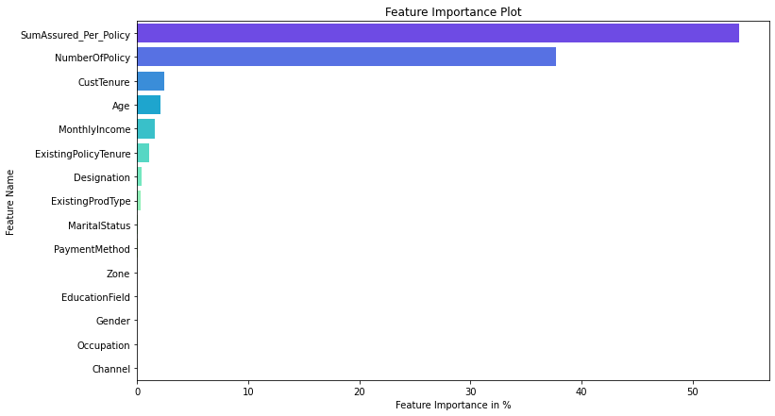

Figure 11 Best Param Random Forest Feature Importance

# **Performance parameters:**

Train data matrix:

The MAE is: 106.47556038137378

The MSE is: 24820.70796807343

The MAPE is 0.07690297993131891

The EVS is 0.9770456925867458

The RMSE is:157.55

Test data matrix:

The MAE for Test data is: 180.50244943952802

The MSE for Test data is: 72519.03619748793

The MAPE for Test data is 0.12940358828836765

The EVS for Test data is 0.9251368574731786

The RMSE is:269.29

This model is Overfit, because train results are giving very good numbers but Test RMSE value is very large as compared to Train results.

# **Hyper parameter tuning for Decision Tree Regressor**

# **Definition:**

The process of reducing overfitting. Regularization is done differently in regression models. But for a decision tree classifier, we should perform regularization by providing additional arguments accepted by DecisionTreeClassifier. These arguments provided by us to revamp our model are called HyperParameters.

**Hyperparameter and parameters:**

Parameters are the model features that the model learns from the data. Whereas, Hyperparameters are arguments accepted by a model-making function and can be modified to reduce overfitting, leading to a better generalization of the model.

**Hyperparameter List for Decision Trees:**

Some of the important hyperparameters:

* Max Depth: This argument represents the maximum depth of a tree. If not specified, the tree is expanded until the last leaf nodes contain a single value. Hence by reducing this meter, we can preclude the tree from learning all training samples thereby, preventing over-fitting.
* Max leaf nodes: As the name suggests, this hyperparameter caps the number of leaf nodes in a decision tree. It will allow the branches of a tree to have varying depths, another way to control the model’s complexity.
* n_estimators: This argument limits the number of decision trees in random forests. By default, its value is calibrated to 100, but in the case of larger datasets, 100 can prove to be a meager quantity. Hence, it’s better to try a higher number of estimators.
* min_samples_split: Minimum samples split decides or hold the value for the minimum number of samples necessary to split a nonterminal node. By default, the decision tree tries to split every node that has two or more rows of data inside it. This can again cause memorization of training data, resulting in a lesser generalized model.
* min_samples_leaf: Minimum sample leaf may sound like minimum sample split and is somewhat similar too. But in this case, we are talking about the minimum number of samples required to be left at the leaf node. A split will only be considered if there are at least min_samples_leaf samples on the left and right branches.

# **Action:**

We have used following parameters and tested in gridSearch algorithm .

param_grid = {

'criterion': ['squared_error', 'friedman_mse', 'absolute_error'],

'max_depth': [8,10,12],

'min_samples_leaf': [100,150,200],

'min_samples_split': [300,450,600],

}

Final List of parameters after testing:

DecisionTreeRegressor(max_depth=8,

min_samples_leaf=100,

min_samples_split=300,

random_state=1)

# **Feature Importance :**

Imp

SumAssured_Per_Policy 0.973447

NumberOfPolicy 0.026164

MonthlyIncome 0.000388

Age 0.000000

CustTenure 0.000000

Channel 0.000000

Occupation 0.000000

EducationField 0.000000

Gender 0.000000

ExistingProdType 0.000000

Designation 0.000000

MaritalStatus 0.000000

ExistingPolicyTenure 0.000000

Zone 0.000000

PaymentMethod 0.000000

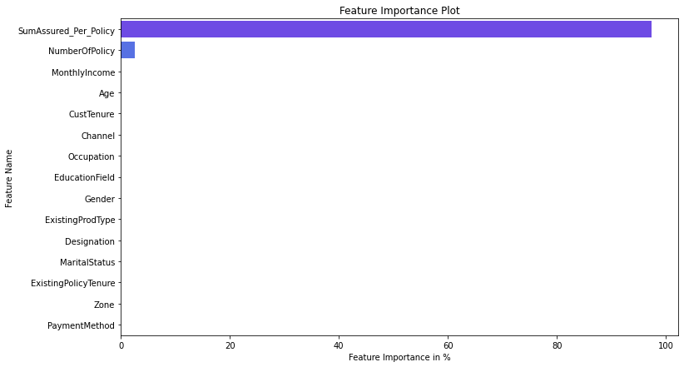

We can clearly see that except 3 fields, there is no contribution by any other fields. Those important fields are :

SumAssured_Per_Policy 0.973447

NumberOfPolicy 0.026164

MonthlyIncome 0.000388

# **Performance parameters:**

Train data matrix:

The MAE is: 199.28413409118212

The MSE is: 109990.86396354134

The MAPE is 0.14767656097815846

The EVS is 0.8982721849779248

The RMSE is:331.65

Test data matrix:

The MAE for Test data is: 211.17181273772886

The MSE for Test data is: 108965.47420328196

The MAPE for Test data is 0.1564641747663458

The EVS for Test data is 0.8875324431646422

The RMSE is:330.10

This model is Perfect fit, because Train and Test result RMSE values are and all other parameters are in about same

range. This is a sign of good modelling .

# **Interpretation of the most optimum model and its implication on the business**

# **Performance Parameters List :**

We have created multiple models, and Tunned them as well by gridSearch mechanism. We have considered these performance matrixes after our model generations :

1. **MAE : Mean Absolute error :**

Absolute Error is the amount of error in your measurements. It is the difference between the measured value and “true” value. For example, if a scale states 90 pounds but you know your true weight is 89 pounds, then the scale has an absolute error of 90 lbs – 89 lbs = 1 lbs. And Mean Absolute Error(MAE) is the average of all absolute errors. The formula is:

[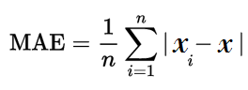](https://www.statisticshowto.com/wp-content/uploads/2016/10/MAE.png)  
Where:

n = the number of errors,

Σ = summation symbol (which means “add them all up”),

|xi – x| = the absolute errors.

1. **MSE (Mean squared error):**

Mean squared error (MSE) measures the amount of error in statistical models. It assesses the average squared difference between the observed and predicted values. When a model has no error, the MSE equals zero. As model error increases, its value increases The formula for MSE is the following.

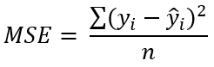

Where :

yi is the ith observed value.

ŷi is the corresponding predicted value.

n = the number of observations.

1. **MAPE (mean absolute percentage error):**

The mean absolute percentage error (MAPE) measures accuracy of a forecast system. It measures this [accuracy](https://www.statisticshowto.com/accuracy-and-precision/) as a

[percentage](https://www.statisticshowto.com/statistics-basics/calculate-percentages/), and can be calculated as the average absolute percent error for each time period minus actual values

divided by actual values.

The mean absolute percentage error (MAPE) is the most common measure used to forecast error, probably because the variable’s units are scaled to percentage units, which makes it easier to understand . It works best if there are no

extremes to the data (and no zeros). It is often used as a loss function in [regression analysis](https://www.statisticshowto.com/probability-and-statistics/regression-analysis/) and model evaluation.

Formula for Mean Absolute Percentage Error

[Mean absolute percentage error (MAPE)](https://www.statisticshowto.com/wp-content/uploads/2017/09/mape.jpeg)  
  
Where:

n is the number of fitted points,

At is the actual value,

Ft is the forecast value.

Σ is [summation notation](https://www.statisticshowto.com/calculus-definitions/summation-notation-sigma-function/) (the absolute value is summed for every forecasted point in time).

1. **EVS (Explained variance):**

Explained variance (sometimes called “explained variation”) refers to the variance in the response variable in a model

that can be explained by the predictor variable(s) in the model. The higher the explained variance of a model, the more the model is able to explain the variation in the data.

1. **RMSE (Root Mean Square Error ):**

Root Mean Square Error (RMSE) is the standard deviation of the [residuals](https://www.statisticshowto.com/probability-and-statistics/statistics-definitions/residual/) (prediction errors). Residuals are a measure of how far from the regression line data points are; RMSE is a measure of how spread out these residuals are. In other

words, it tells you how concentrated the data is around the line of best fit. Root mean square error is commonly used in climatology, forecasting, and regression analysis to verify experimental results.

The formula is:  
[rmse](https://www.statisticshowto.com/wp-content/uploads/2016/10/rmse.png)  
Where:

f = forecasts (expected values or unknown results),

o = observed values (known results).

# **Gather Matrix from all Models:**

We have built multiple models . List of all of these models are:

* Linear regression
* Stats Model
* Stats model Reduced parameters after VIF score and Higher P-Value
* Decision tree Model
* Random forest Model
* Random Forest Model with Bagging regressor
* Hyper parameters tuning for decision tree
* Hyper parameters tuning for Random forest

We have captured multiple performance matrix parameters, mentioned above in section 6.1 like

MAE

MAE ( Mean Absolute error)

MSE (Mean squared error)

MAPE (mean absolute percentage error)

EVS (Explained variance)

RMSE (Root Mean Square Error )

And we have gathered all performance parameters from all the models and put it in a data frame .

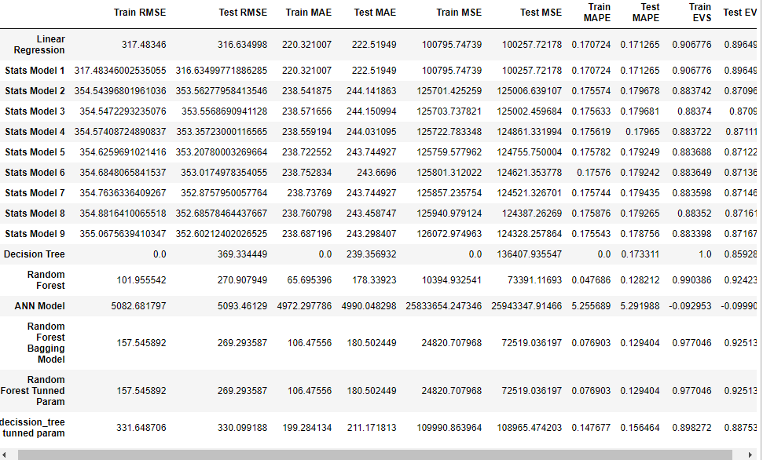

**Comparison:**

There are multiple ways we can compare our models. I have done comparison with Lowest RMSE values and Lower

MAPE values.

RMSE gives us Error in the model and MAPE gives good result in percentage wise.

**Lowest RMSE:**

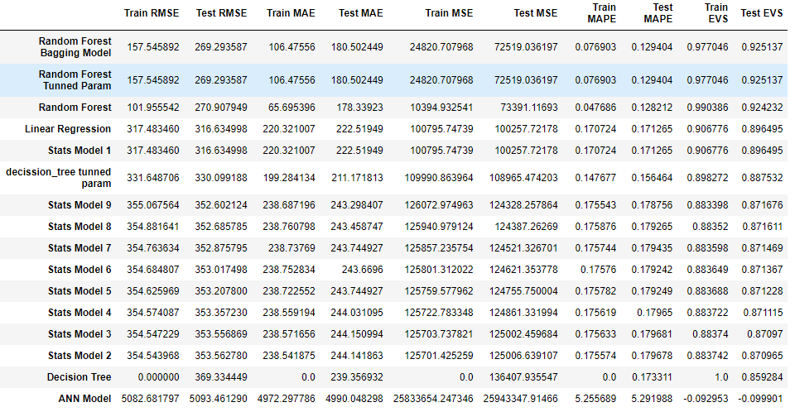

Figure 12 Sort performance matrixes with Lowest RMSE

**Insights:** With Lowest RMSE Random forest Model with Bagging regressor and Random forest model with Tunned Hyper Parameters, both giving same results. But there are big difference in train and test values of RMSE, which indicates overfitting of the model. In this case, we will consider 4th Lowest RMSE Model is the best one, which is “Linear Regression” Model. It has about same values of RMSE value

**Lowest MAPE:**

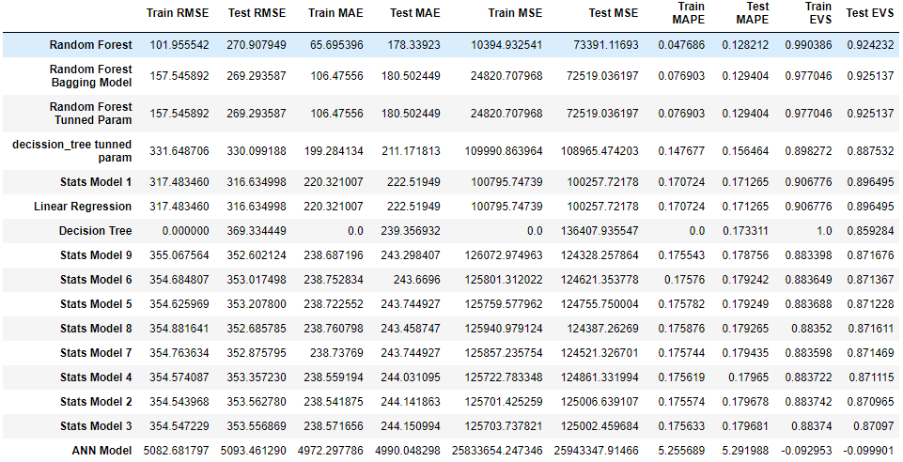

Figure 13Sort Performance matrixes with lowest MAPE value

Insights:

Random forest related all 3 models have lowest MAPE model. But again, those seems over fitting the model, because train and test values have big difference.

Whereas Decision tree with tunned hyper parameters , Linear Regression and Stats Model seems best model among all , which are giving similar results for both train and test data set. Giving 14.7% for decision tree and 17 % for Linear and stats model of MAPE value.