**Business Report**

**Capstone Project**

**LI_BFSI_01+Life+Insurance+Sales**

**Final Report submission**

**Date: 20-Jan-2023**

**Created by Amit Jain**

Table of Contents

List of Figure 3

1. Introduction of the business Problem 4

1.1 Defining Problem Statement: 4

1.2 Need of the study/project: 4

2. Data Export : 4

2.1 Visual inspection of data (rows, columns, descriptive details): 4

2.2 Understanding of attributes (variable info, renaming if required): 5

3. Exploratory data analysis 6

3.1 Addition of new variables (if required) 6

3.2 Missing Value treatment (if applicable) 6

3.3 Duplicate checks: 7

3.4 Removal of unwanted variables (if applicable) 7

3.5 Outlier removal (if applicable): 8

3.6 Univariate Analysis 9

3.6.1 Taking counts for each Categorical field : 9

3.6.2 Merge similar categorical values: 10

3.6.3 Check data skewness : 11

3.6.4 Generate Histogram and Boxplot for Sample data: 12

3.7 Bivariate Analysis 13

3.8 Multivariate Analysis 17

4. Data Preparation (Variable transformation / Split the data ) 18

4.1 Numeric Variable Transformation: 19

4.2 Categorical Variable Transformation (Encoding) 19

4.3 Data Split: Split the data into train and test (70:30) 20

5. Model building and interpretation : 20

5.1 SKLearn Linear Model: 20

5.2 Building Linear Model with Scaled parameters : 21

5.3 Building Stats Model: 22

5.4 Building Multiple Stats Model to eliminate non affecting fields : 24

5.4.1 Stats Model for fields with lower value of VIF : 24

5.4.2 Stats Model for fields with Lower P value and remove other fields: 25

5.5 Decision Tree Model 27

5.6 Random Forest Regressor Model 28

5.7 Artificial Neural Network Regressor 29

6. Model Tuning and business implication 29

6.1 Bagging Regressor (Random Forest should be applied for Bagging) 30

6.2 Hyper parameter tuning for random forest 30

6.3 Hyper parameter tuning for Decision Tree Regressor 31

7. Interpretation of the most optimum model and its implication on the business 32

8. Business insights , Recommendations 33

8.1 Business insights from EDA 34

8.2 Business benefits: 34

8.3 Improvement Area and recommendations: 34

# **List of Figure**

Figure 1 Boxplot 8

Figure 2 : Histogram and Boxplot 12

Figure 3 Mean, Count and Sum graph for categorical fields 13

Figure 4 heat Map 17

Figure 5 pair plot against AgentBonus per policy 18

Figure 6 Scatter plot for Prediction on Test data Figure 7 Scatter plot for Prediction on Train data 21

Figure 8 Scatter plot for Prediction on Scaled Test data Figure 9 Scatter plot for Prediction on Scaled train data 22

Figure 10 Scatter Plot for Predicted values on Test data set 23

Figure 11 Decision Tree Feature Importance 27

Figure 12 Random Forest Feature Importance 28

Figure 13 Best Param Random Forest Feature Importance 30

Figure 14 Best feature Decision Tree Tunned Param 31

# **Introduction of the business Problem**

Introduction: This report explains the business requirements and provide the detailed solution based on the data provided for each problem statement. given in the assignment.

# **Defining Problem Statement:**

*“The dataset belongs to a leading life insurance company. The company wants to predict the bonus for its agents so that it may design appropriate engagement activity for their high performing agents and upskill programs for low performing agents are most important.”* Dataset for Problem : **Sales.xlsx**

To understand the problem, Life insurance Company has given randomly collected sample of 4520 Customer records data in the sales.xlsx file, which have pattern of the Customer information about, their purchased Insurance Plans, their tenure with Insurance company, Sum insured and some more information about customer. Company has also given information about AgentBonus given to insurance company Agents who made customer purchase their plans.

Insurance company wants to analyze this sample data and Predict Bonus for their agents, based on past sample data , so that they can understand more about internal Agents, who bring sell to the Company. Company also want to know, if there are any low performing Agents, which requires any special training to increase growth or if they need any assistance. Company also want to build environment to encourage Agents, who are very good in selling plans, and motivate others by example of giving rewards to good performing Agents.

# **Need of the study/project:**

It is very important for any company to know their Customers, at the same time its equally important to know their own employees, who serve end Customers. This is a very generic problem as well as requirement, specially in Insurance and Sales sectors to know their own employees, identifying good performing Agents/Sales person and low performing employees. So that they can know own capacity and can plan for the future growth. And based on this analysis, they can deploy their good performing Agents/Sales person in tough market and plan for good trainings to up scaling low performing employees.

# **Data Export :**

# **Visual inspection of data (rows, columns, descriptive details):**

Import the data: Imported the data using Python notebooks and analyzed the effects of Education and Occupations over salary field. This is how the data look like:

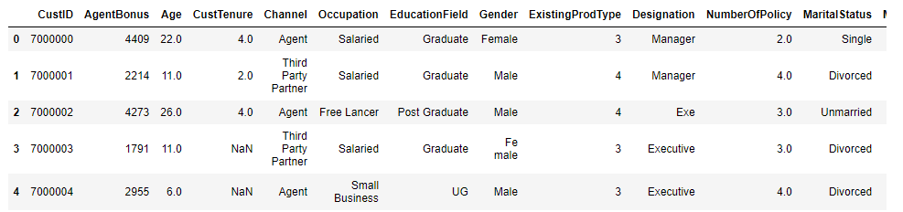

**Data dictionary:**

**CustID** =>Unique customer ID

**AgentBonus** =>Bonus amount given to each agents in last month

**Age** =>Age of customer

**CustTenure** =>Tenure of customer in organization

**Channel** =>Channel through which acquisition of customer is done

**Occupation** =>Occupation of customer

**EducationField** =>Field of education of customer

**Gender** =>Gender of customer

**ExistingProdType** =>Existing product type of customer

**Designation** =>Designation of customer in their organization

**NumberOfPolicy** =>Total number of existing policy of a customer

**MaritalStatus** =>Marital status of customer

**MonthlyIncome** =>Gross monthly income of customer

**Complaint** =>Indicator of complaint registered in last one month by customer

**ExistingPolicyTenure** =>Max tenure in all existing policies of customer

**SumAssured** =>Max of sum assured in all existing policies of customer

**Zone** =>Customer belongs to which zone in India. Like East, West, North and South

**PaymentMethod** =>Frequency of payment selected by customer like Monthly, quarterly, half yearly and yearly

**LastMonthCalls** =>Total calls attempted by company to a customer for cross sell

**CustCareScore** =>Customer satisfaction score given by customer in previous service call

# **Understanding of attributes (variable info, renaming if required):**

**Data description:**

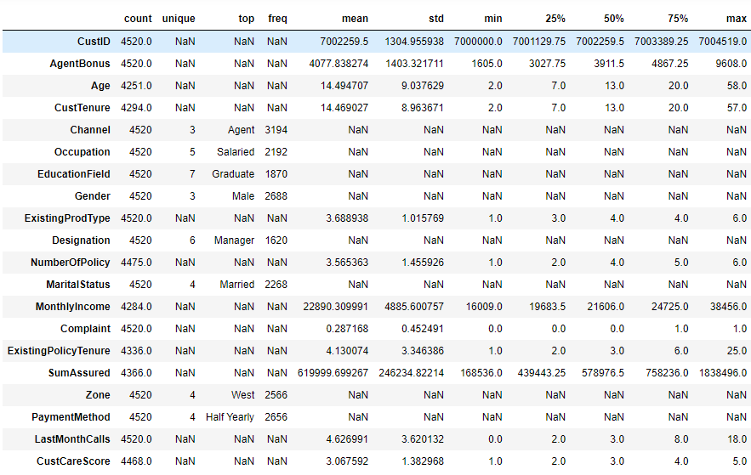

**Insights:**

1. Agent Bonus : Bonus given to Agents, as well as Target variable. Minimum bonus given as 1605 and Max is 9608

2. Age: Customers of all age group from 2 years to 58 years, there are also customers with 0 Age, needs to be corrected

3. Customer Tenure: Many customers associated with Company from their Birth

4. Existing Prod Type : There are only 6 insurance products

5. Number of Policy: Customer can have multiple policies, from insurance company , for their family members or Self , if it is blank, that needs to be corrected

6. Monthly income Ranging between about 16K to 38K , if it is blank, needs to be corrected

7. Complaint: 0 to 1 complaint in last one month

8. Gender showing as 3 ,: this needs to be corrected

9. Occupation : Different Occupations, there can be multiple business with same name, needs to be corrected

10. Education : can have similar names of degrees, needs to be corrected

11. Designation: can be duplicate

12. existing Policy tenure. if it is blank needs to be corrected

13. Sum Assured : if it is blank needs to be corrected

14. Customer care score. needs to be corrected if it is blank

15. Customer id can be removed from data, as it will not be required for Bonus prediction

16. Channel , occupation, Education, Gender, Designation , Marital Status and all other Object type fields should be converted to Numeric format in order to use it in prediction Model.

# **Exploratory data analysis**

# **Addition of new variables (if required)**

**AgentBonus** is the amount of Bonus given to Insurance agents based, what policy he/she has sold to customers, and what profit Company might have taken. Since one customer can buy multiple policies together, so it will not be fare to Compare AgentBonus amount of one agent with another. May be AgentBonus for one agent is more (because hist Customer bought 5 policies together). but Average of per policy of that bonus amount can be lower than Single Policy of bigger SumAssured.

* So lets create additional Field, "AgentBonus_Per_Policy", which should be calculated by:

AgentBonus_Per_Policy = AgentBonus/NumberOfPolicy

* Also lets create a new field called SumAssured_Per_Policy, which should be calculated by :

SumAssured_Per_Policy = SumAssured/NumberOfPolicy

Now we have got this list of fields, which in new data set:

Index(['CustID', 'AgentBonus', 'Age', 'CustTenure', 'Channel', 'Occupation',

'EducationField', 'Gender', 'ExistingProdType', 'Designation',

'NumberOfPolicy', 'MaritalStatus', 'MonthlyIncome', 'Complaint',

'ExistingPolicyTenure', 'SumAssured', 'Zone', 'PaymentMethod',

'LastMonthCalls', 'CustCareScore', **'AgentBonus_Per_Policy',**

**'SumAssured_Per_Policy'**],

dtype='object')

# **Missing Value treatment (if applicable)**

We have taken NULL counts for all of our attributes and NULL value counts are as follows:

CustID 0

AgentBonus 0

Age 269

CustTenure 226

Channel 0

Occupation 0

EducationField 0

Gender 0

ExistingProdType 0

Designation 0

NumberOfPolicy 45

MaritalStatus 0

MonthlyIncome 236

Complaint 0

ExistingPolicyTenure 184

SumAssured 154

Zone 0

PaymentMethod 0

LastMonthCalls 0

CustCareScore 52

AgentBonus_Per_Policy 45

SumAssured_Per_Policy 199

Total NULL values in data : 1410

Total data elements in Sample data are: 99440

1410 is the total Null counts, which includes NULL counts for our 2 newly created fields as well, which are :

AgentBonus_Per_Policy 45

SumAssured_Per_Policy 199

If we subtract this count, then actual total number of missing values count is 1166

**NULL Treatment one by one for each NULL field:**

* **Treating NULL Age:** Age should be Greater than or Equals to Customer Tenure as well as Existing Policy Tenure. So let’s give first preference to Customer Tenure and then existing Policy Tenure for correcting NULL “**Age**” . There were total 269 NULL records in Age field. We will consider Policy Started , as child gets Birth and Age should be replaced with “CustomerTenure “ and then “ExistingPolicyTenure”.
* **Treating NULL CustomerTenure:** We will replace NULL “CustomerTenure “ field with “ExistingPolicyTenure” and if “ExistingPolicyTenure” is also not available then we should replace “CustomerTenure “ with “Age” field.
* **Treating “Existing Policy tenure”:** Similarly, if Cust “Existing Policy tenure” is NULL, then replace it with “Customer Tenure” and second preference will be to replace it with “Age”
* **Treating “NumberOfPolicy”:** Best way to Treat this field is to replace NULL with Mode.
* **Treating NULLs for "AgentBonus_Per_Policy”:** Since we have already computed NumberOfPolicy Field, then for treating missing values for "AgentBonus_Per_Policy”, we will again use our formula for this field.

**df2['AgentBonus_Per_Policy']=df2['AgentBonus']/df2['NumberOfPolicy']**

and NULL has been treated.

* **Treating NULL for "MonthlyIncome" and "SumAssured":** Best way to Treat this field is to use KNN Imputers for missing NULL values. I have used KNNImputer from SKLearn library and used this method for imputing missing values for **"MonthlyIncome" and "SumAssured".**
* **Treating NULL for "CustCareScore":** I have used Median for this value and treating missing values for "CustCareScore".

Now we are left with only SumAssured field , which have NULL values, but we will impute this, as we are using SumAssured_per_policy field instead, which we have already corrected and we are going to drop field SumAssured in our next Step.

# **Duplicate checks:**

We checked duplicity in CustID field, and we did not find any Duplicate records. Total Count for Duplicate records are : 0

# **Removal of unwanted variables (if applicable)**

Since We have used AgentBonus and SumAssured for building our new field, so we don’t need them any more for our analysis, Also We dont need field CustId for our analysis, as it will not add any benefits in our analysis. So we will drop these 3 fields from our data: **AgentBonus , SumAssured , CustID**

And we have added these 2 fields in our data : **AgentBonus_per_policy , SumAssured_per_policy**

We will also check for co-relations, in further sections and if we find that any field don’t have relation with Target field , then we will drop those fields as well.

|  |  |  |  |
| --- | --- | --- | --- |
|  | Complaint | LastMonthCalls | CustCareScore |
| Age | 0.019496 | 0.123837 | 0.029853 |
| CustTenure | 0.00685 | 0.142982 | 0.013919 |
| ExistingProdType | -0.003486 | 0.033191 | 0.00411 |
| NumberOfPolicy | -0.016014 | 0.075138 | -0.001005 |
| MonthlyIncome | -0.004815 | 0.34393 | 0.035751 |
| Complaint | 1 | -0.02632 | -0.003814 |
| ExistingPolicyTenure | -0.005082 | 0.126951 | 0.013532 |
| LastMonthCalls | -0.02632 | 1 | 0.006386 |
| CustCareScore | -0.003814 | 0.006386 | 1 |
| AgentBonus_Per_Policy | 0.025091 | 0.038717 | -0.005319 |
| SumAssured_Per_Policy | 0.023838 | 0.03474 | -0.013488 |

We have built co-relation matrix for all the fields and checked it’s relation with Targeted field. This is co-relation with AgentBonus:

Complaint : 0.025091

LastMonthCalls: 0.038717

CustCareScore: -0.005319

we have checked that following fields have very minute impact on targeted fields and these can be dropped as well:

# **Outlier removal (if applicable):**

We have analyzed data from the boxplot:

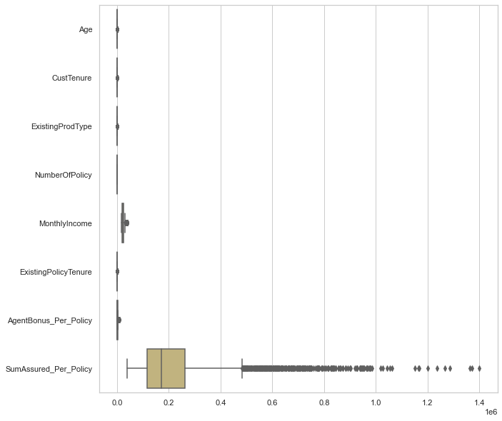

Figure 1 Boxplot

Action : We do see outliers in about each of the field of sample data, but data scales are different,

Example: Age have limited discrete values, AgentBonus will be always lesser than SumAssured and it will be just a fraction of percentage of SumAssured . Customer Tenure, Existing Policy tenure, and other Age type fields are also discrete in nature. So I would not like to treat outliers, as People have different income slaves and can take multiple or Single Policy as well. **And I really want to understand nature of other fields, how they are affecting our target field, AgentBonus , so we will not treat the outliers**

# **Univariate Analysis**

# **Taking counts for each Categorical field :**

We have taken counts for all the Categorical fields in Sample data set and this is the result for it :

Field name is CHANNEL : and Count for this categories are 3

Online 468

Third Party Partner 858

Agent 3194

Field name is OCCUPATION : and Count for this categories are 5

Free Lancer 2

Laarge Business 153

Large Business 255

Small Business 1918

Salaried 2192

Field name is EDUCATIONFIELD : and Count for this categories are 7

MBA 74

UG 230

Post Graduate 252

Engineer 408

Diploma 496

Under Graduate 1190

Graduate 1870

Field name is GENDER : and Count for this categories are 3

Fe male 325

Female 1507

Male 2688

Field name is DESIGNATION : and Count for this categories are 6

Exe 127

VP 226

AVP 336

Senior Manager 676

Executive 1535

Manager 1620

Field name is MARITALSTATUS : and Count for this categories are 4

Unmarried 194

Divorced 804

Single 1254

Married 2268

Field name is ZONE : and Count for this categories are 4

South 6

East 64

North 1884

West 2566

Field name is PAYMENTMETHOD : and Count for this categories are 4

Quarterly 76

Monthly 354

Yearly 1434

Half Yearly 2656

Insights:

1. Channel as "Agent" has maximum count of 3194, and least no of channel is Online. with 468

2. OCCUPATION : Maximum Policy Holder are Salaried Employees, where as free Lancer and Large business people are very less in Insurance .

3. OCCUPATION : "Laarge Business" and "Large Business" are same, it needs to be merged.

4. EDUCATIONFIELD: "UG" and "Under Graduate" are same category and needs to merged.

5: EDUCATIONFIELD: Highest Policy holders are Graduate and Least are MBA degree Holder.

6: GENDER : "Fe male" and "Female" are same, and needs to merge into one category

7. Maximum policy Holders are male with 2688 Count.

8. DESIGNATION : Exe and Executive are same and can be merge into one Category.

9. South Zone and followed by east zone have very less number of customers , need to work in that area

10. Customers like to pay half yearly and yearly payments method most for the payment of their premiums.

# **Merge similar categorical values:**

From taking counts of each Categorical field, we have seen that , there are some values, which we can merge into Single value. Example:

OCCUPATION : "Laarge Business" and "Large Business can be merged into Single field “Large business”

EDUCATIONFIELD: "UG" and "Under Graduate" can be merged into “Under graduate”

GENDER : "Fe male" and "Female" are same and should be merged into “Female”

DESIGNATION : Exe and Executive are same and should be merged into “Executive”

Taking counts for each Categorical fields after merging similar values:

Field name is CHANNEL : and Count for this categories are 3

Online 468

Third Party Partner 858

Agent 3194

Name: Channel, dtype: int64

Field name is OCCUPATION : and Count for this categories are 4

Free Lancer 2

Large Business 408

Small Business 1918

Salaried 2192

Field name is EDUCATIONFIELD : and Count for this categories are 6

MBA 74

Post Graduate 252

Engineer 408

Diploma 496

Under Graduate 1420

Graduate 1870

Field name is GENDER : and Count for this categories are 2

Female 1832

Male 2688

Field name is DESIGNATION : and Count for this categories are 5

VP 226

AVP 336

Senior Manager 676

Manager 1620

Executive 1662

Field name is MARITALSTATUS : and Count for this categories are 4

Unmarried 194

Divorced 804

Single 1254

Married 2268

Field name is ZONE : and Count for this categories are 4

South 6

East 64

North 1884

West 2566

Field name is PAYMENTMETHOD : and Count for this categories are 4

Quarterly 76

Monthly 354

Yearly 1434

Half Yearly 2656

Insights:

1. Maximum number of policies sold by Agents and very less policies sold by Online channel.
2. Maximum number of policy holders are Salaried with count of 2192 records and least number of Policy holders are free Lancer.
3. Maximum number of policy holders are Graduate in Education with count of 1870 records, and MBA holders are least with no of 74.
4. Male are Maximum number of policy holders as compared to female records.
5. Married people are Maximum number of policy holders whereas unmarried people don’t prefer taking Insurance policy.
6. There are maximum policies sold in West region of the country, whereas South reason have very less 6 policies sold.
7. Maximum number of policy holders prefer to pay Half yearly premiums .

# **Check data skewness :**

Age 0.960101

CustTenure 0.928995

ExistingProdType -0.401100

NumberOfPolicy -0.108161

MonthlyIncome 1.373508

ExistingPolicyTenure 3.440053

AgentBonus_Per_Policy 2.144651

SumAssured_Per_Policy 2.373659

dtype: float64

Insights:

1. data is not 100% Normally distributed.
2. About all data have Outliers, and which is possible because , insurance Policies , can be different for many customers, depending on their Need , worth and sum insured.
3. All data is Slightly Right Skewed .

# **Generate Histogram and Boxplot for Sample data:**

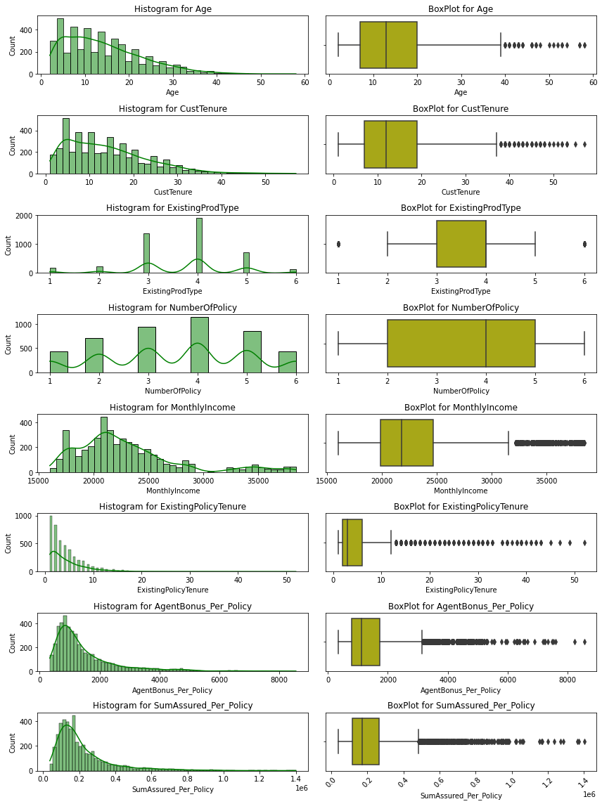

Figure 2 : Histogram and Boxplot

Insights:

* Age: we can have any range of Age for customer, maximum Age is 58 years in data, which is valid.
* CustomerTenure is about similar to Age field, Customertenure can also range from 1 year to Maximum of Age limit of the customer.
* Number of Policy is a discrete field, which have 6 possible values in it, maximum customers have taken 4 policies.
* Monthly Income field is a continuous field, and its ranging from 15K to about 40k , which is normal. Data is right Skewed.
* Existing Policy tenure shows maximum Customer are part of under 10 years and there are a very few customers from 10 to 58 years of existing Policies.
* AgentBonus_per_policy and SumAssured_per_policy is Continuous fields, and have similar distribution of data , this data is also right skewed.
* About all the fields have some outliers.

# **Bivariate Analysis**

Figure 3 Mean, Count and Sum graph for categorical fields

I have performed, Bivariate analysis of all other the fields, with respect to Agent Bonus per policy as this is our target variable, and take Mean, Counts and Sum of Categorical fields.

Field name is CHANNEL : and Distinct Count for this Column is 3

and it's distinct categories are ['Agent' 'Third Party Partner' 'Online']

Average AgentBonus for each categories of this Column are:

Third Party Partner 1419.576690

Agent 1453.390106

Online 1456.468768

Total sum value of AgentBonus for each category for Column are : Channel

Online 6.816274e+05

Third Party Partner 1.217997e+06

Agent 4.642128e+06

Field name is OCCUPATION : and Distinct Count for this Column is 4

and it's distinct categories are ['Salaried' 'Free Lancer' 'Small Business' 'Large Business']

Average AgentBonus for each categories of this Column are: Occupation

Free Lancer 1174.416667

Large Business 1337.526348

Small Business 1426.108568

Salaried 1486.503817

Total sum value of AgentBonus for each category for Column are : Occupation

Free Lancer 2.348833e+03

Large Business 5.457107e+05

Small Business 2.735276e+06

Salaried 3.258416e+06

Field name is EDUCATIONFIELD : and Distinct Count for this Column is 6

and it's distinct categories are ['Graduate' 'Post Graduate' 'Under Graduate' 'Engineer' 'Diploma' 'MBA']

Average AgentBonus for each categories of this Column are: EducationField

Engineer 1306.026511

Under Graduate 1416.263650

MBA 1432.172297

Diploma 1454.777688

Graduate 1491.099947

Post Graduate 1515.442857

Total sum value of AgentBonus for each category for Column are : EducationField

MBA 1.059808e+05

Post Graduate 3.818916e+05

Engineer 5.328588e+05

Diploma 7.215697e+05

Under Graduate 2.011094e+06

Graduate 2.788357e+06

Field name is GENDER : and Distinct Count for this Column is 2

and it's distinct categories are ['Female' 'Male']

Average AgentBonus for each categories of this Column are: Gender

Female 1432.857442

Male 1457.126990

Total sum value of AgentBonus for each category for Column are : Gender

Female 2.624995e+06

Male 3.916757e+06

Field name is DESIGNATION : and Distinct Count for this Column is 5

and it's distinct categories are ['Manager' 'Executive' 'VP' 'AVP''Senior Manager']

Average AgentBonus for each categories of this Column are: Designation

Executive 1234.364811

Manager 1405.986770

Senior Manager 1607.296031

AVP 1897.170685

VP 2161.760324

Total sum value of AgentBonus for each category for Column are : Designation

VP 4.885578e+05

AVP 6.374494e+05

Senior Manager 1.086532e+06

Executive 2.051514e+06

Manager 2.277699e+06

Field name is MARITALSTATUS : and Distinct Count for this Column is 4

and it's distinct categories are ['Single' 'Divorced' 'Unmarried' 'Married']

Average AgentBonus for each categories of this Column are: MaritalStatus

Divorced 1213.452177

Unmarried 1348.409622

Single 1452.517145

Married 1535.753380

Total sum value of AgentBonus for each category for Column are : MaritalStatus

Unmarried 2.615915e+05

Divorced 9.756155e+05

Single 1.821456e+06

Married 3.483089e+06

Field name is ZONE : and Distinct Count for this Column is 4

and it's distinct categories are ['North' 'West' 'East' 'South']

Average AgentBonus for each categories of this Column are: Zone

South 1337.038889

North 1423.996665

East 1427.593229

West 1465.141959

Total sum value of AgentBonus for each category for Column are : Zone

South 8.022233e+03

East 9.136597e+04

North 2.682810e+06

West 3.759554e+06

Field name is PAYMENTMETHOD : and Distinct Count for this Column is 4

and it's distinct categories are ['Half Yearly' 'Yearly' 'Quarterly' 'Monthly']

Average AgentBonus for each categories of this Column are: PaymentMethod

Quarterly 1148.781579

Yearly 1438.049361

Monthly 1443.254661

Half Yearly 1461.359130

Total sum value of AgentBonus for each category for Column are : PaymentMethod

Quarterly 8.730740e+04

Monthly 5.109121e+05

Yearly 2.062163e+06

Half Yearly 3.881370e+06

Insights:

Based on the Above counts and unique values of Different Categorical fields of the data, we can come to this conclusion:

1. Field name is CHANNEL : and Distinct Count for this Column is 3
   * and it's distinct categories are ['Agent' 'Third Party Partner' 'Online']
   * There are maximum no of insurance taken from Agents with no of 3194 , and least no of insurance taken by online channel with count of 468.
   * On an average all three type of channels receiving about similar bonus, there is very slight difference in Bonus amount, if channel is different.
   * maximum total Bonus received by Agents Categories and Online policy giving agents get least amount of Bonus.
2. Field name is OCCUPATION : and Distinct Count for this Column is 4
   * it's distinct categories are ['Salaried' 'Free Lancer' 'Small Business' 'Large Business']
   * Salaried person are among highest Insurance holder with count of 2192, whereas Free lancer taken very less insurance of only 2 records in sample data
   * Again, on an average Bonus remain about same for all agents, who sold policies to any occupation of customer, though Bonus is highest for Salaries Customer.
   * Undouble Total bonus for Agents, who sold policy to Salaried Customers are maximum, because Salaried person are maximum in numbers as well.
3. Field name is EDUCATIONFIELD : and Distinct Count for this Column is 6
   * and it's distinct categories are ['Graduate' 'Post Graduate' 'Under Graduate' 'Engineer' 'Diploma' 'MBA']
   * there are maximum Customers are Graduate, whereas MBA holder are least.
4. Field name is GENDER : and Distinct Count for this Column is 2
   * and it's distinct categories are ['Female' 'Male']
   * Maximum Customers are Male
5. Field name is DESIGNATION : and Distinct Count for this Column is 5
   * and it's distinct categories are ['Manager' 'Executive' 'VP' 'AVP' 'Senior Manager']
   * Counts are each categories of this column are :
   * maximum customers are Executives and least customers are on VP post, this is obvious data.
6. Maximum Average bonus given to Agents, who sold policies to VP, it seems, VP takes most Sum insured, thats why Bonus is high for them.
7. Field name is MARITALSTATUS : and Distinct Count for this Column is 4
   * and it's distinct categories are ['Single' 'Divorced' 'Unmarried' 'Married']
   * Counts are each categories of this column are :
   * Married person baught maximum policies.
8. Field name is ZONE : and Distinct Count for this Column is 4
   * and it's distinct categories are ['North' 'West' 'East' 'South']
   * Counts are each categories of this column are :
   * maximum customers belong to West region of Country with the count of 2566, whereas there are only 6 customers from South region, this is interesting data to analyze, why we have very less customers from south. Also customers from east region are also very less with no of 64.
9. Field name is PAYMENTMETHOD : and Distinct Count for this Column is 4
   * and it's distinct categories are ['Half Yearly' 'Yearly' 'Quarterly' 'Monthly']
   * Counts are each categories of this column are :
   * Customers like to give EMI for policy maximum is half yearly and then yearly.

# **Multivariate Analysis**

**Heat Map:**

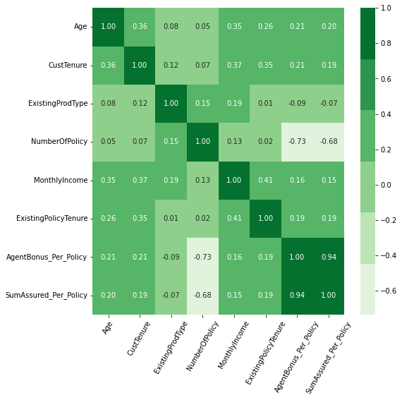

Figure 4 heat Map

Co-relation Matrix: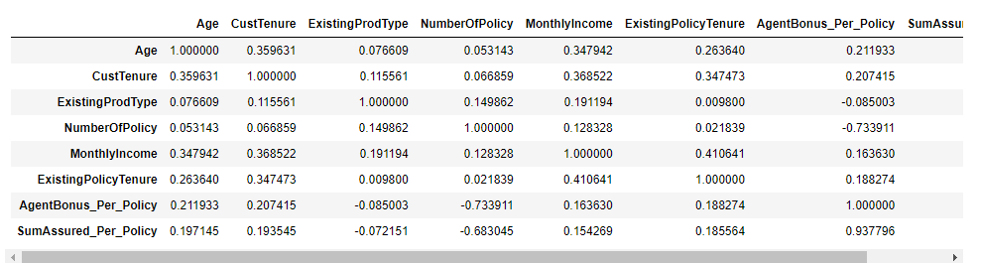

Insights:

1. AgentBonus_Per_Policy have very strong relationship with about all of the other fields
2. As Sum insured of the Customer increases, Bonus also increases.
3. Bonus increased with the experience of the Age of the Customer, Customer tenure, Monthly income of the Customer, as well as Existing policy tenure,
4. There is very minute positive relationship between Agent Bonus with Existing Prod type, Number of Policies, and Customer care Score.
5. CustCareScore, LastMonthCalls and Compaint dont have any relation with any other field, its almost 0 co-relation with every other field. So we have dropped them in initial steps

**Pair plot:**

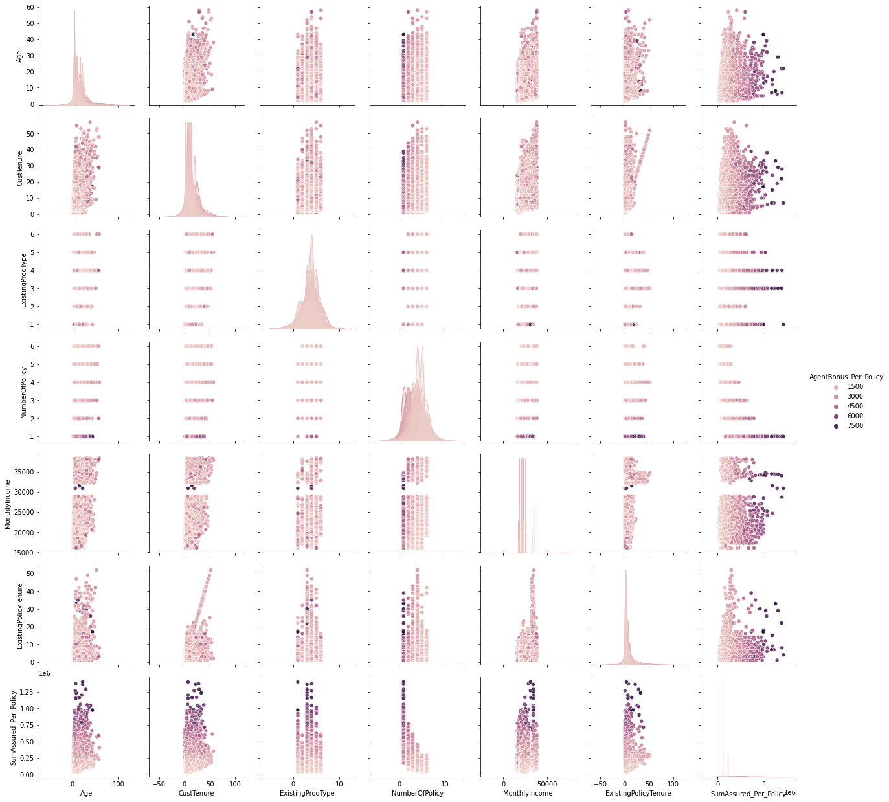

Figure 5 pair plot against AgentBonus per policy

insights:

1. there is clear separation of Bonus for Agents, as all variables increasing, Bonus also increasing.

# **Data Preparation (Variable transformation / Split the data )**

We have seen the scale from data description, that data have different kind of Scales for fields in the data set. So, in order to build a Linear Regression Model, we can Scale the variables using different methods available . Variable transformation is a way to make the data work better in your model. Data variables can have two types of form: numeric variable and categorical variable, and their transformation should have different approaches.

# **Numeric Variable Transformation:**

Numeric Variable Transformation is turning a numeric variable to another numeric variable. Typically it is meant to change the scale of values and/or to adjust the skewed data distribution to Gaussian-like distribution through some “monotonic transformation”.

There are many ways, we can achieve Numeric variable transformation or Scale them : Min-max scaling , Logarithmic transformation, Standardization, RankGauss etc.

In our Model , we have built 2 separate data set:

**df_scaled** for Transformed numeric fields

**df_new** for another data set for Non transformation of existing Numeric fields, basically use as is.

I have used z-score from Sklearn libraries for transforming all Numeric fields. And once this is done, we will us it in Linear transformation, and we will check , if transformation is reducing noise from the Model or not.

# **Categorical Variable Transformation (Encoding)**

Categorical variable transformation  is turning a categorical variable to a numeric variable. Categorical variable transformation is mandatory for most of the machine learning models because they can handle only numeric values. It is also called encoding,

In machine learning, we usually deal with datasets that contain multiple labels in one or more than one column. These labels can be in the form of words or numbers. To make the data understandable or in human-readable form, the training data is often labelled in words.

Label Encoding refers to converting the labels into a numeric form so as to convert them into the machine-readable form. Machine learning algorithms can then decide in a better way how those labels must be operated. It is an important pre-processing step for the structured dataset in supervised learning. After performing Encoding . this is how the data looks like for categorical fields:

Columns is : Channel

['Agent', 'Third Party Partner', 'Online']

Categories (3, object): [0 2 1]

Columns is : Occupation

['Salaried', 'Free Lancer', 'Small Business', 'Large Business']

Categories (4, object): [2 0 3 1]

Columns is : EducationField

['Graduate', 'Post Graduate', 'Under Graduate', 'Engineer', 'Diploma', 'MBA']

Categories (6, object): [2 4 5 1 0 3]

Columns is : Gender ['Female', 'Male']

Categories (2, object): [0 1]

Columns is : Designation ['Manager', 'Executive', 'VP', 'AVP', 'Senior Manager']

Categories (5, object): [2 1 4 0 3]

Columns is : MaritalStatus ['Single', 'Divorced', 'Unmarried', 'Married']

Categories (4, object): [2 0 3 1]

Columns is : Zone ['North', 'West', 'East', 'South']

Categories (4, object): [1 3 0 2]

Columns is : PaymentMethod ['Half Yearly', 'Yearly', 'Quarterly', 'Monthly']

Categories (4, object): [0 3 2 1]

Sample looks like this :

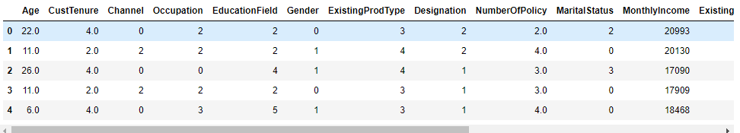

# **Data Split: Split the data into train and test (70:30)**

We need to split a dataset into train and test sets to evaluate how well our machine learning model performs. The train set is used to fit the model, and the statistics of the train set are known. The second set is called the test data set, this set is solely used for predictions.

**Dependent variable : AgentBonus_Per_Policy** After performing train test split , We have got 4 parts :

Shape for X_train is (3164, 15)

Shape for X_test is (1356, 15)

Shape for y_train is (3164, 1)

Shape for y_test is (1356, 1)

# **Model building and interpretation :**

# **SKLearn Linear Model:**

**Action:** We have performed linear regression techniques from Sklearn LinearRegression library .

Following is co-efficient of Determination :

The coefficient for Age is 4.789430368850247

The coefficient for CustTenure is 4.759701081772676

The coefficient for Channel is -8.882960541752864

The coefficient for Occupation is 7.510211001225475

The coefficient for EducationField is -5.507046975671935

The coefficient for Gender is 2.1343057926728486

The coefficient for ExistingProdType is -15.273396744099568

The coefficient for Designation is 4.737994566790387

The coefficient for NumberOfPolicy is -159.7092491616902

The coefficient for MaritalStatus is 14.788341883378328

The coefficient for MonthlyIncome is 0.008683193446440198

The coefficient for ExistingPolicyTenure is 2.6087386706276594

The coefficient for Zone is -5.627466691687209

The coefficient for PaymentMethod is 1.6127186348940015

The coefficient for SumAssured_Per_Policy is 0.004765571407328226

**Equation:**

**AgentBonus_per_policy** = Age * 4.789430368850247 + CustTenure * 4.759701081772676 + Channel * -8.882960541752864 + Occupation * 7.510211001225475 + EducationField * -5.507046975671935 + Gender * 2.1343057926728486 + ExistingProdType * -15.273396744099568 + Designation * 4.737994566790387 + NumberOfPolicy * -159.7092491616902 + MaritalStatus * 14.788341883378328 + MonthlyIncome * 0.008683193446440198 + ExistingPolicyTenure * 2.6087386706276594 + Zone * -5.627466691687209 + PaymentMethod * 1.6127186348940015 + SumAssured_Per_Policy * 0.004765571407328226 + 671.7150861205953

The intercept for the model is 671.7150861205953 . Intercept is the point on Y Axis , when all values of X are Zero. basically when we say, what should be the value of Y when all params are Zero

**Performance parameters:**

|  |  |  |
| --- | --- | --- |
| **performance Param** | **Train Data** | **test Data** |
| MAE | 220.3210069 | 222.51949 |
| MSE | 100795.7474 | 100257.7218 |
| MAPE | 0.17072418 | 0.171265321 |
| EVS | 0.906776345 | 0.896495227 |
| RMSE | 316.6349977 | 317.48346 |

This is how data points look like for predicted variables:

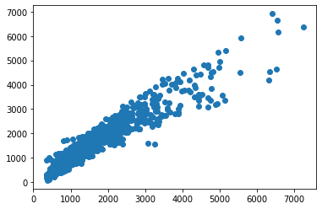 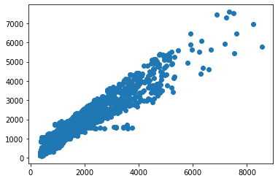

Figure 6 Scatter plot for Prediction on Test data Figure 7 Scatter plot for Prediction on Train data

**Feature importance :** We fit a LinearRegression model on the regression dataset and retrieve the coeff_ property that contains the coefficients found for each input variable. These coefficients can provide the basis for a crude feature importance score. This assumes that the input variables have the same scale or have been scaled prior to fitting a model.

In regression analysis, the magnitude of coefficients is not necessarily 100% related to their importance. The most common criteria to determine the importance of independent variables in regression analysis are **p-values.**

Small p-values imply high levels of importance, whereas high p-values mean that a variable is not statistically significant.

**We can only use the magnitude of coefficients as a measure for feature importance when our model is penalizing variables. sklearn does not report p-values though.**

# **Building Linear Model with Scaled parameters :**

We have Scaled numeric fields from Sklearn’s z-score library and built new data frame df_scaled. We used this new data frame for building Linear regression model and will check, how the model performs.

Decision tree-based models are less sensitive to scale and skew than these techniques may not contribute a lot, but for other models (e.g. neural net, SVM, linear model etc.), they could be a game changer, or for some cases even mandatory, such as the case you use penalization terms with L1/L2 norm.

**Action:** We have performed linear regression techniques from Sklearn LinearRegression library .

Following is co-efficient of Determination :

The coefficient for Age is 42.83962224334871

The coefficient for CustTenure is 43.253731727586946

The coefficient for Channel is -7.047067651864262

The coefficient for Occupation is 4.781586127409858

The coefficient for EducationField is -9.566226806308082

The coefficient for Gender is 1.047841452593378

The coefficient for ExistingProdType is -15.512531622244383

The coefficient for Designation is 4.601985548114451

The coefficient for NumberOfPolicy is -231.44126984310716

The coefficient for MaritalStatus is 11.3843211448863

The coefficient for MonthlyIncome is 41.482235158809694

The coefficient for ExistingPolicyTenure is 13.43519903309641

The coefficient for Zone is -5.700509672207306

The coefficient for PaymentMethod is 2.205000719314816

The coefficient for SumAssured_Per_Policy is 772.295331497455

**Equation:**

Age * 42.83962224334871 + CustTenure * 43.253731727586946 + Channel * -7.047067651864262 + Occupation * 4.781586127409858 + EducationField * -9.566226806308082 + Gender * 1.047841452593378 + ExistingProdType * -15.512531622244383 + Designation * 4.601985548114451 + NumberOfPolicy * -231.44126984310716 + MaritalStatus * 11.3843211448863 + MonthlyIncome * 41.482235158809694 + ExistingPolicyTenure * 13.43519903309641 + Zone * -5.700509672207306 + PaymentMethod * 2.205000719314816 + SumAssured_Per_Policy * 772.295331497455 + 1447.1195249943657

**Performance parameters:**

The coefficient of determination R^2 of the prediction on Train set 0.9067763446568196

The coefficient of determination R^2 of the prediction on Test set 0.8964948926865648

The intercept for the model is 1447.1195249943657



Figure 8 Scatter plot for Prediction on Scaled Test data Figure 9 Scatter plot for Prediction on Scaled train data

|  |  |  |
| --- | --- | --- |
| **performance Param** | **Train Data** | **test Data** |
| MAE | 220.3210069 | 222.51949 |
| MSE | 100795.7474 | 100257.7218 |
| MAPE | 0.17072418 | 0.171265321 |
| EVS | 0.906776345 | 0.896495227 |
| RMSE | 317.48346 | 316.6349977 |

# **Building Stats Model:**

**Action:**

OLS model works on only train and Test data set, it does not need separation of Dependent and Independent variables . We just need to specify during model building , which variable is Dependent . but Sample data don’t need a separation in it. So, we have merged X and Y variables and built separate Train and Test data set .

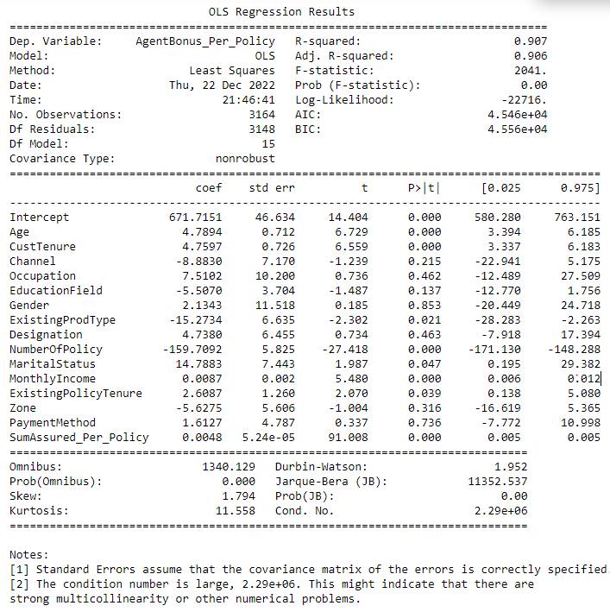

After building OLS Model , this is the co-efficient of determinations:

Intercept 671.715086

Age 4.789430

CustTenure 4.759701

Channel -8.882961

Occupation 7.510211

EducationField -5.507047

Gender 2.134306

ExistingProdType -15.273397

Designation 4.737995

NumberOfPolicy -159.709249

MaritalStatus 14.788342

****MonthlyIncome 0.008683

ExistingPolicyTenure 2.608739

Zone -5.627467

PaymentMethod 1.612719

SumAssured_Per_Policy 0.004766

**Performance parameters:**

|  |  |  |
| --- | --- | --- |
| **performance Param** | **Train Data** | **test Data** |
| MAE | 220.3210069 | 222.51949 |
| MSE | 100795.7474 | 100257.7218 |
| MAPE | 0.17072418 | 0.171265321 |
| EVS | 0.906776345 | 0.896495227 |
| RMSE | 316.6349977 | 317.48346 |

Figure 10 Scatter Plot for Predicted values on Test data set

**Feature Importance:**

In regression analysis, the magnitude of coefficients is not necessarily 100% related to their importance. The most common criteria to determine the importance of independent variables in regression analysis are p-values.

Small p-values imply high levels of importance, whereas high p-values mean that a variable is not statistically significant. We can only use the magnitude of coefficients as a measure for feature importance when our model is penalizing variables. sklearn does not report p-values though. But Stats model does give p-values .

From Stats model summary , we can see that there are high P value for many of the fields from our data set. So we can consider High Importance features are :

Age , CustomerTenure, NumberofPolicy, MonthlyIncome and SumAssured_Per_Policy

And less affecting features are : PaymentMethod , Gender, Occupation, Designation etc.

# **Building Multiple Stats Model to eliminate non affecting fields :**

# **Stats Model for fields with lower value of VIF :**

With the help of calculating VIF for each Field and based on VIF value, we decide, which column can be eliminated. VIF (variance inflation factor) is used for checking multicollinearity in regression Model. its Values can range between 1 to Infinite.

We have checked VIF for each field, and taken threshold to 5. Fields with more than value of 5, can be consider to eliminate that field . We have done this exercise in a For Loop, Out of 16 fields, we have consider only these 10 fields, which have VIF value less than 5 : Index(['CustTenure', 'Channel', 'EducationField', 'Gender', 'Designation', 'MaritalStatus', 'ExistingPolicyTenure', 'Zone', 'PaymentMethod', 'SumAssured_Per_Policy'],

VIF Values for all of above fields are :

VIF for CustTenure --> 3.7649121302806456

VIF for Channel --> 1.351814184733024

VIF for EducationField --> 3.013828674898219

VIF for Gender --> 2.23880673655966

VIF for Designation --> 3.6622884417664836

VIF for MaritalStatus --> 2.9365604234253677

VIF for ExistingPolicyTenure --> 2.182083152055937

VIF for Zone --> 4.306208853382339

VIF for PaymentMethod --> 1.5613624945213813

VIF for SumAssured_Per_Policy --> 2.890013748992411

**Co-efficient of determination :**

Intercept 97.578366

CustTenure 2.490252

Channel -5.525502

EducationField -3.716762

Gender 12.087670

Designation 9.399802

MaritalStatus 16.199391

ExistingPolicyTenure 2.282474

Zone 1.504290

PaymentMethod -5.626124

SumAssured_Per_Policy 0.005840

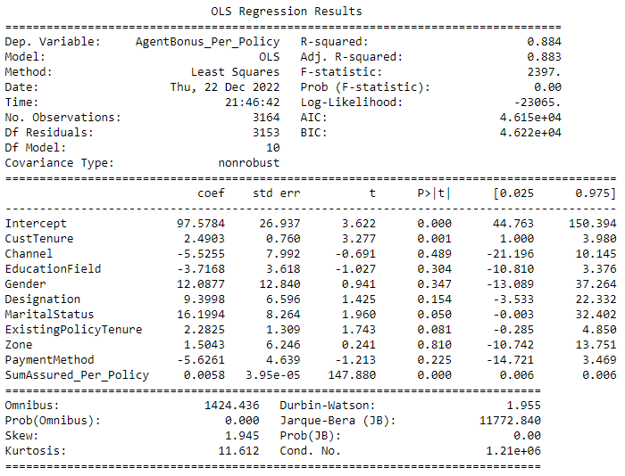

**Performance parameters:**

|  |  |  |
| --- | --- | --- |
| **performance Param** | **Train Data** | **test Data** |
| MAE | 238.5418755 | 244.1418631 |
| MSE | 125701.4253 | 125006.6391 |
| MAPE | 0.17557449 | 0.179677876 |
| EVS | 0.883741659 | 0.870964891 |
| RMSE | 353.5627796 | 354.543968 |

# **Stats Model for fields with Lower P value and remove other fields:**

Based on the OLS Summary, form above model, we have come to this conclusion that,, there are many fields, with High P -value, the Higher the P Value, Lower the chance it will affect the Predictions. This is the list of P value for all the fields:

|  |  |  |
| --- | --- | --- |
|  | coef | P>|t| |
| Intercept | 97.5784 | 0 |
| CustTenure | 2.4903 | 0.001 |
| Channel | -5.5255 | 0.489 |
| EducationField | -3.7168 | 0.304 |
| Gender | 12.0877 | 0.347 |
| Designation | 9.3998 | 0.154 |
| MaritalStatus | 16.1994 | 0.05 |
| ExistingPolicyTenure | 2.2825 | 0.081 |
| Zone | 1.5043 | 0.81 |
| PaymentMethod | -5.6261 | 0.225 |
| SumAssured_Per_Policy | 0.0058 | 0 |

**Action:**

We have removed fields one by one and re-generated OLS model and checked P values for fields again and again, until each field importance came below 0.05.

We started with these fields:

* + Model Build by removing field name “**Zone**” : Since Zone has Highest P-Value , so we dropped this field and Built our Model, on top of Step 4.3.1 , where we eliminated fields with higher VIF.

After building Model without field “Zone”, We still saw that there were many fields with High P-Value .

* + Model Build by removing field name “**Channel**”: Since Channel , has Highest P-Value , so we dropped this field and Built our Model on top of above model. We still saw that there were many fields with High P-Value .
  + Model Build by removing field name “**Gender**”: Since Gender, has Highest P-Value , so we dropped this field and Built our Model on top of above model. We still saw that there were many fields with High P-Value .
  + Model Build by removing field name “**EducationField**”: Since **EducationField**, has Highest P-Value , so we dropped this field and Built our Model on top of above model. We still saw that there were many fields with High P-Value .
  + Model Build by removing field name “**PaymentMethod**”: Since **PaymentMethod** , has Highest P-Value , so we dropped this field and Built our Model on top of above model. We still saw that there were many fields with High P-Value .
  + Model Build by removing field name “**Designation**”: Since **Designation**, has Highest P-Value , so we dropped this field and Built our Model on top of above model. We still saw that there were many fields with High P-Value .
  + Model Build by removing field name “**MaritalStatus**”: Since **MaritalStatus**, has Highest P-Value , so we dropped this field and Built our Model on top of above model. We still saw that there were many fields with High P-Value .

After dropping **MaritalStatus ,** we Built our Final Stats Model with these features:

No Field have VIF value more than 5

No field have higher p-Value than 0.05

And we are left with only these 3 fields, which are most important feature to determine the targeted values:

CustTenure , ExistingPolicyTenure and SumAssured_per_policy

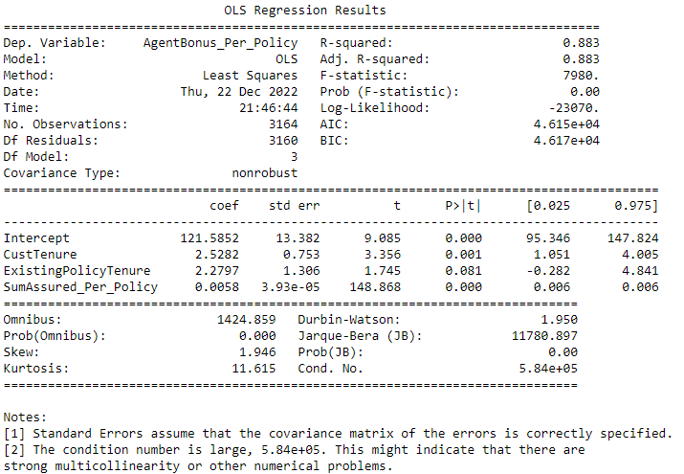

# 

**Performance parameters:**

|  |  |  |
| --- | --- | --- |
| **performance Param** | **Train Data** | **test Data** |
| MAE | 238.6871961 | 243.2984073 |
| MSE | 126072.975 | 124328.2579 |
| MAPE | 0.175542533 | 0.178755565 |
| EVS | 0.883398022 | 0.871675897 |
| RMSE | 352.602124 | 355.0675639 |

**Equation and interpretation:**

We can use below formula for determining the targeted value:

**AgentBonus_per_policy = (121.59) + (2.53) * CustTenure +**

**2.28) * ExistingPolicyTenure + (0.01) * SumAssured_Per_Policy**

We can see from the equation, if all of the Independent parameters are Zero, then also Agent will receive a Bonus of Rs 121.59 , which is very good. Also there is clear that 1% of total amount of SumAssured goes into Agent Bonus, because co-efficient is 0.01

# **Decision Tree Model**

**Action:**

Again, decision tree works on Separate group of dependent variable and independent variables of train and test data. So we will use our Old sub groups of train and test split data set: After performing train test split , we have got 4 parts :

Shape for X_train is (3164, 15)

Shape for X_test is (1356, 15)

Shape for y_train is (3164, 1)

Shape for y_test is (1356, 1)

We have used Sklearn DecisionTreeRegressor library for our model building and created Model .

**Feature Importance :**

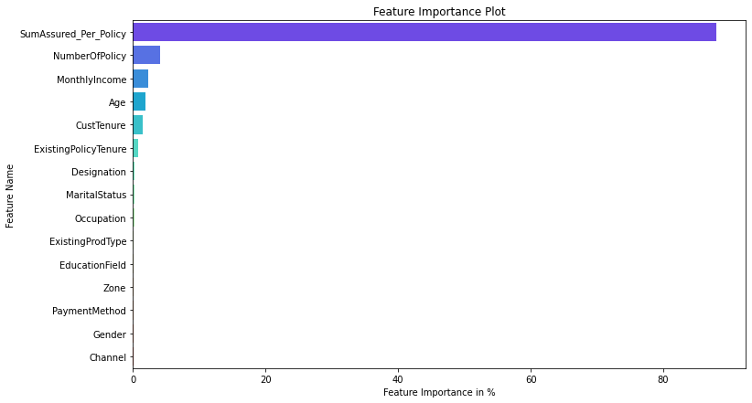After building decision tree Model, this is the list of features with their importance weightage

SumAssured_Per_Policy 0.879796

NumberOfPolicy 0.041685

MonthlyIncome 0.023623

Age 0.018812

CustTenure 0.014237

ExistingPolicyTenure 0.008178

Designation 0.002733

MaritalStatus 0.001986

Occupation 0.001936

ExistingProdType 0.001746

EducationField 0.001732

Zone 0.000928

PaymentMethod 0.000918

Gender 0.000906

Channel 0.000786

Figure 11 Decision Tree Feature Importance

**Performance parameters:**

|  |  |  |
| --- | --- | --- |
| **performance Param** | **Train Data** | **test Data** |
| MAE | 0 | 239.3569322 |
| MSE | 0 | 136407.9355 |
| MAPE | 0 | 0.173310575 |
| EVS | 1 | 0.85928434 |
| RMSE | 0 | 369.33 |

Decision Tree model always give a clear separation on Train data set, that’s why it gives value of 0 for all the performance parameters, When we checked for test data, then actual errors comes, and RMSE for DTree is 369.33

# **Random Forest Regressor Model**

**Action:**

Random forest is similar to decision tree, which works on Separate group of dependent variable and independent variables of train and test data. So we will use our Old sub groups of train and test split data set: After performing train test split , we have got 4 parts :

Shape for X_train is (3164, 15)

Shape for X_test is (1356, 15)

Shape for y_train is (3164, 1)

Shape for y_test is (1356, 1)

We have used Sklearn RandomForestRegressor library for our model building and created Model .

**Feature Importance :**

After building Renadom Forest Model, this is the list of features with their importance weightage

SumAssured_Per_Policy 0.891987

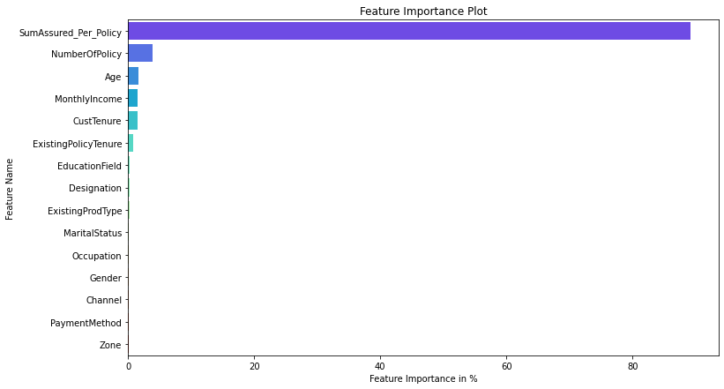NumberOfPolicy 0.038844

Age 0.016303

MonthlyIncome 0.015429

CustTenure 0.014407

ExistingPolicyTenure 0.008537

EducationField 0.002414

Designation 0.002192

ExistingProdType 0.001839

MaritalStatus 0.001773

Occupation 0.001504

Gender 0.001254

Channel 0.001195

PaymentMethod 0.001186

Zone 0.001135

Figure 12 Random Forest Feature Importance

**Performance parameters:**

|  |  |  |
| --- | --- | --- |
| **performance Param** | **Train Data** | **test Data** |
| MAE | 65.6953956 | 178.3392298 |
| MSE | 10394.93254 | 73391.11693 |
| MAPE | 0.047686458 | 0.128212037 |
| EVS | 0.990386047 | 0.924232288 |
| RMSE | 101.96 | 270.91 |

# **Artificial Neural Network Regressor**

**Action:**

We have used Grid search to find the best parameters used in our prediction model. We have used following params for grid search:

param_grid = { 'hidden_layer_sizes': [50,100], 'activation':['logistic','relu'], 'max_iter': [250,],

'solver': ['adam','sgd'], 'tol': [0.1,0.01], }

We want our Model to check between 50 and 100 hidden layers, the more number of hidden layers you apply, more time it will take to execute. The activation function generates an output based on input signals. Logistic/Segmoid are same . After using grid search these are the Parameters, we have received :

{'activation': 'logistic', 'hidden_layer_sizes': 100, 'max_iter': 250,

'solver': 'sgd', 'tol': 0.1}

**Feature Importance :** We cannot get the values of list of best parameters used for prediction Model , because it all comes under Hidden layers.

**Performance parameters:**

|  |  |  |
| --- | --- | --- |
| **performance Param** | **Train Data** | **test Data** |
| MAE | 4972.297786 | 4990.048298 |
| MSE | 25833654.25 | 25943347.91 |
| MAPE | 5.255688936 | 5.291987651 |
| EVS | -0.09295335 | -0.09990145 |
| RMSE | 5082.68 | 5093.46 |

# **Model Tuning and business implication**

There are many ways we can Tune our Model :

1. We can use bagging/Boosting regressors
2. We can Tune and search for best Hyper parameters.
3. We can KFold our data and do testing

I have used above methods and built following models :

# **Bagging Regressor (Random Forest should be applied for Bagging)**

**Action:** I have used Random Forest regressor for base_estimator and then used base_estimator parameters of Random Forest into Bagging Algorithm. I have used Sklearn BaggingRegressor library for our model building.

**Feature Importance :** Bagging don’t give List of best features. 'BaggingRegressor' object has no attribute 'feature_importances_'

So we cannot say, which Attribute of Sample data set is more contributing in prediction model

**Performance parameters:**

|  |  |  |
| --- | --- | --- |
| **performance Param** | **Train Data** | **test Data** |
| MAE | 106.4755604 | 180.5024494 |
| MSE | 24820.70797 | 72519.0362 |
| MAPE | 0.07690298 | 0.129403588 |
| EVS | 0.977045693 | 0.925136857 |
| RMSE | 157.55 | 269.29 |

This model is Overfit, because train results are giving very good numbers but Test RMSE value is very large as compared to Train results.

# **Hyper parameter tuning for random forest**

**Action:** We have used following parameters and tested in gridSearch algorithm .

param_grid = { 'max_depth': [8,10,12], 'max_features': [3,4,5],

'min_samples_leaf': [30,60,90], 'min_samples_split': [100,180,250], 'n_estimators': [100,200] }

Final List of parameters after testing:

{'max_depth': 10, 'max_features': 5, 'min_samples_leaf': 30,

'min_samples_split': 100, 'n_estimators': 200}

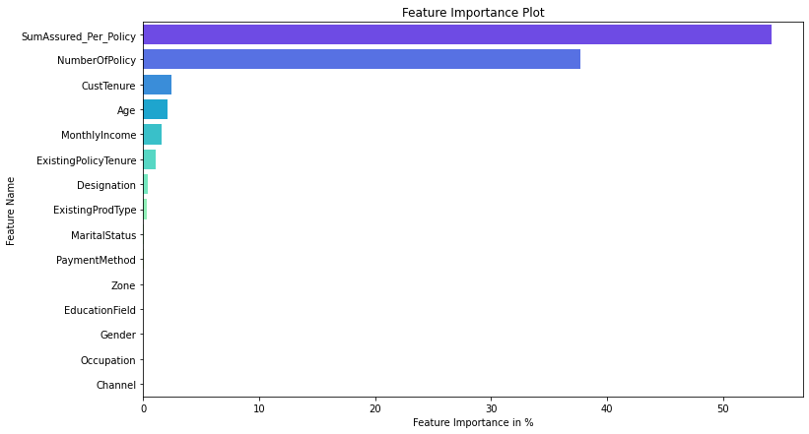**Feature Importance :**

SumAssured_Per_Policy 0.541611

NumberOfPolicy 0.376927

CustTenure 0.024193

Age 0.021406

MonthlyIncome 0.015970

ExistingPolicyTenure 0.010595

Designation 0.003730

ExistingProdType 0.003584

MaritalStatus 0.000875

PaymentMethod 0.000409

Zone 0.000235

EducationField 0.000172

Gender 0.000128

Occupation 0.000099

Channel 0.000066

Figure 13 Best Param Random Forest Feature Importance

**Performance parameters:**

|  |  |  |
| --- | --- | --- |
| **performance Param** | **Train Data** | **test Data** |
| MAE | 106.4755604 | 180.5024494 |
| MSE | 24820.70797 | 72519.0362 |
| MAPE | 0.07690298 | 0.129403588 |
| EVS | 0.977045693 | 0.925136857 |
| RMSE | 157.55 | 269.29 |

This model is Overfit, because train results are giving very good numbers but Test RMSE value is very large as compared to Train results.

# **Hyper parameter tuning for Decision Tree Regressor**

**Action:** We have used following parameters and tested in gridSearch algorithm .

param_grid = { 'criterion': ['squared_error', 'friedman_mse', 'absolute_error'], 'max_depth': [8,10,12],

'min_samples_leaf': [100,150,200], 'min_samples_split': [300,450,600], }

Final List of parameters after testing:

DecisionTreeRegressor(max_depth=8, min_samples_leaf=100,

min_samples_split=300, random_state=1)

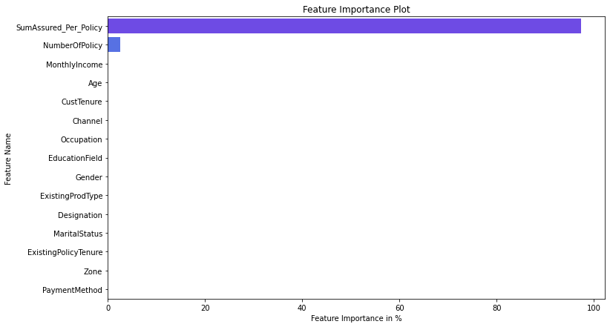

**Feature Importance :**

Imp

SumAssured_Per_Policy 0.973447

NumberOfPolicy 0.026164

MonthlyIncome 0.000388

Age 0.000000

CustTenure 0.000000

Channel 0.000000

Occupation 0.000000

EducationField 0.000000

Gender 0.000000

ExistingProdType 0.000000

Designation 0.000000

MaritalStatus 0.000000

ExistingPolicyTenure 0.000000

Zone 0.000000

PaymentMethod 0.000000

Figure 14 Best feature Decision Tree Tunned Param

We can clearly see that except 3 fields, there is no contribution by any other fields. Those important fields are :

SumAssured_Per_Policy 0.973447

NumberOfPolicy 0.026164

MonthlyIncome 0.000388

**Performance parameters:**

|  |  |  |
| --- | --- | --- |
| **performance Param** | **Train Data** | **test Data** |
| MAE | 199.2841341 | 211.1718127 |
| MSE | 109990.864 | 108965.4742 |
| MAPE | 0.147676561 | 0.156464175 |
| EVS | 0.898272185 | 0.887532443 |
| RMSE | 331.65 | 330.1 |

This model is Perfect fit, because Train and Test result RMSE values are and all other parameters are in about same

range. This is a sign of good modelling .

# **Interpretation of the most optimum model and its implication on the business**

We have built multiple models . List of all of these models are:

* Linear regression
* Stats Model And Stats model with Reduced parameters after VIF score and Higher P-Value
* Decision tree Model And Hyper parameters tuning for decision tree
* Random forest Model And Hyper parameters tuning for Random forest
* Random Forest Model with Bagging regressor

We have captured multiple performance matrix parameters:

* MAE ( Mean Absolute error)
* MSE (Mean squared error)
* MAPE (mean absolute percentage error)
* EVS (Explained variance)
* RMSE (Root Mean Square Error )

And we have gathered all performance parameters from all the models and put it in a data frame

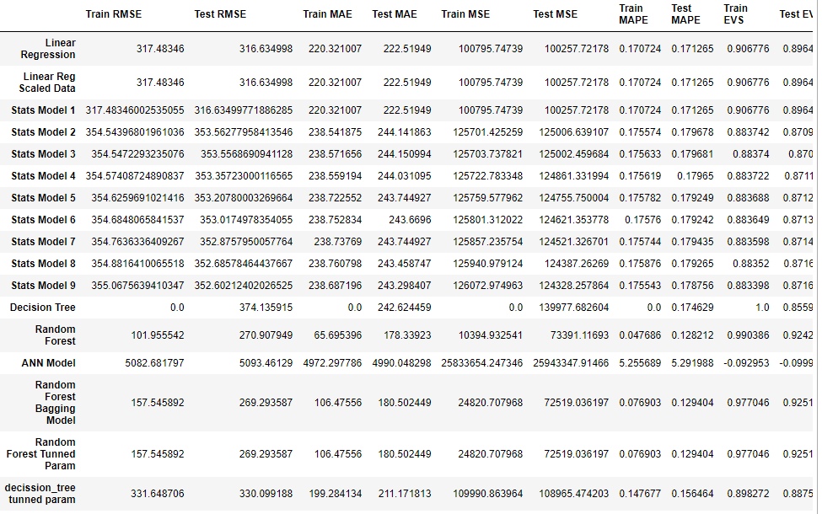

**Comparison:**

There are multiple ways we can compare our models. I have done comparison with Lowest RMSE values and Lower

MAPE values. RMSE gives us Error in the model and MAPE gives good result in percentage wise.

**Lowest RMSE:**

With Lowest RMSE Random forest Model with Bagging regressor and Random forest model with Tunned Hyper Parameters, both giving same results. But there are big difference in train and test values of RMSE, which indicates overfitting of the model. In this case, we will consider 4th Lowest RMSE Model is the best one, which is “Linear Regression” Model. It has about same values of RMSE value

**Lowest MAPE:** Random forest related all 3 models have lowest MAPE model. But again, those seems over fitting the model, because train and test values have big difference. Whereas Decision tree with tunned hyper parameters , Linear Regression , Linear Regression with scaled data and Stats Model seems best model among all , which are giving similar results for both train and test data set. Giving 14.7% for decision tree and 17 % for Linear and stats model of MAPE value.

# **Business insights , Recommendations**

We have given data set with Agent Bonus for Total SumAssured for N number of policies purchases by any csutomers, so for building good prediction model, we have created 2 new fields , which are

AgentBonus_per_policy

SumAssured_per_Policy

And we have used NumberOfPolicy field for generating above fields.

**Some of requirements of doing this are as follows:**

* This is very important to know what is Bonus given for each Customers, irrespective of how many policies Customer purchased.
* We need to know, how is SumAssured affected AgenBonus, but if we not created new field SumAsuured_per_policy (This is actually a average of Totsl SumAssured / Number of Policy), Our model wont be able to understand, this relations.
* For an example , if Customer purchased 4 policy of total 1000 Rs, and AgentBonus is 400 Rs, which means Bonus is 1000/(400*4) = 6.25% per policy Bonus

And for any other Customer purchased Single Policy of amount 1000 and his Agent get 250 Rs Bonus, which means, he received 1000/250 = 40% Bonus,

so for making them all on same Scale, we need to create above listed both variable to know Average of AgentBonus per Policy as well as Average of SumAssured per policy.

* We have also checked for the co-relation between all the fields and targeted field, which is AgentBonus and we found that their co-relation coefficient was very low and we dropped those fields.

Complaint : 0.025091

LastMonthCalls: 0.038717

CustCareScore: -0.005319

we have checked that following fields have very minute impact on targeted fields and these can be dropped.

# **Business insights from EDA**

We performed following actions on our data :

* Added new fields, dropped not-necessary fields. Imputed NULLs, Univariate, Bi-variate and Multivariate Analysis.
* Checked individual column’s distribution, their counts, in it’s category, mean and Sum of values. Checked outliers, distribution and checked normality of data.
* I have also done Co-relation check, data skewness and checked distribution of all the fields against target variable.

Based on above analysis , following are business insights:

* We can see clear co-relation between SumAssured_per_policy and AgentBonus_per_policy field with co-relation of 0.94 , which means, as Sumassured increases, AgentBonus also increases.
* AgentBonus also have good positive co-relation with field Age, CustomerTenure and existingPolicyTenure of with Positive 0.2 with each field mentioned.
* AgentBonus have very minute relation with fields Complaint and LastMonthCalls, which makes sense.

# **Business benefits:**

* Company would know strength of their own employees.
* They can easily segregate good Salesperson and low performing Agents.
* Company can give clear criteria, by informing Salesperson, how they can achieve good incentives.
* It will remove partiality and bad judgements of the top-level managements
* It will create good environment among all employees for fare justifications of the Bonus amounts.
* Company can encourage good performing Sales-persons
* Company can also provide Trainings or build any special program to assist bad Agents.
* Additional steps can be taken by Company by accompanying good Agent with low performing Agents, so that they can learn from good resources.

# **Improvement Area and recommendations:**

* South Zone have least number of Customers, so good salesperson should deploy to tough market
* There can be some discount offer or Less policy premium campaign can be run in South and East regions, where policy Holders are very less.
* There is good opportunity to attract more Large business holders, they have deep pockets and Company can make good money from them.
* Maximum number of policies sold by Agents and very less policies sold by Online channel. So we can provide some sort of discounts and promotions for Online Agents, in order for making good online business, Online channels are very powerful nowadays and it has reach to every single customers, so make it powerful.
* Maximum number of policy holders are Salaried with count of 2192 records and least number of Policy holders are free Lancer. Insurance company can reach to more and more Free Lancing Customers, as they are very less from the Sample customers.
* Maximum number of policy holders are Graduate in Education with count of 1870 records, and MBA holders are least with no of 74. Insurance company can reach to more and more MBA professionals as they very less from the Sample customers.
* Insurance company can reach to more female customers for buying policies and do not and give some promotions to women. As Male are Maximum number of policy holders as compared to female records.
* Married people are Maximum number of policy holders whereas unmarried people don’t prefer taking Insurance policy. So Company can run campaign and encourage more youths for knowing about policies and how important is insurance nowadays.