FAQ’s

# **What is the mode of Hackathon?**

Online, do it from home.

**Where can I register myself?**

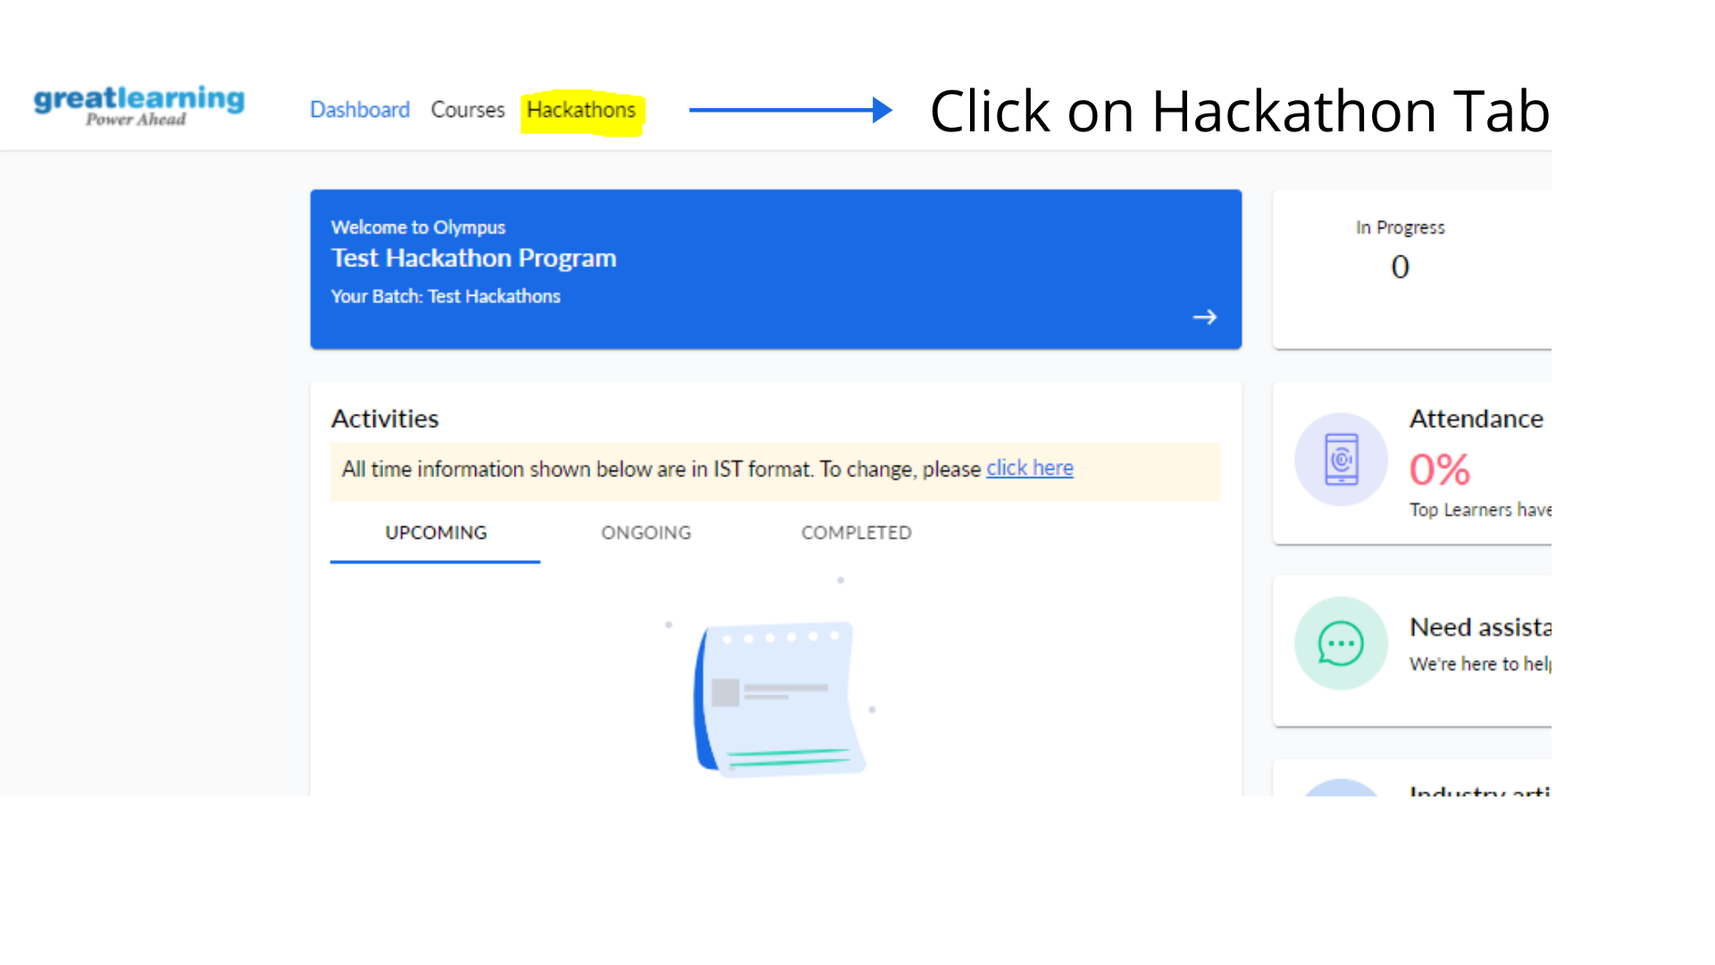

**How do I register myself for this event?**

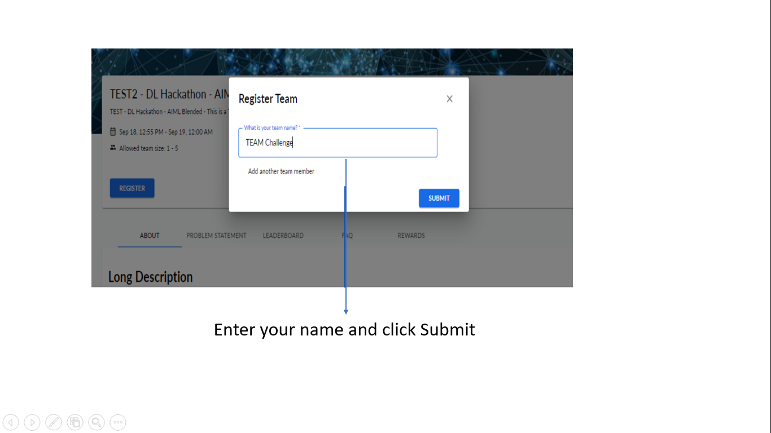

# **How do I make a submission?**

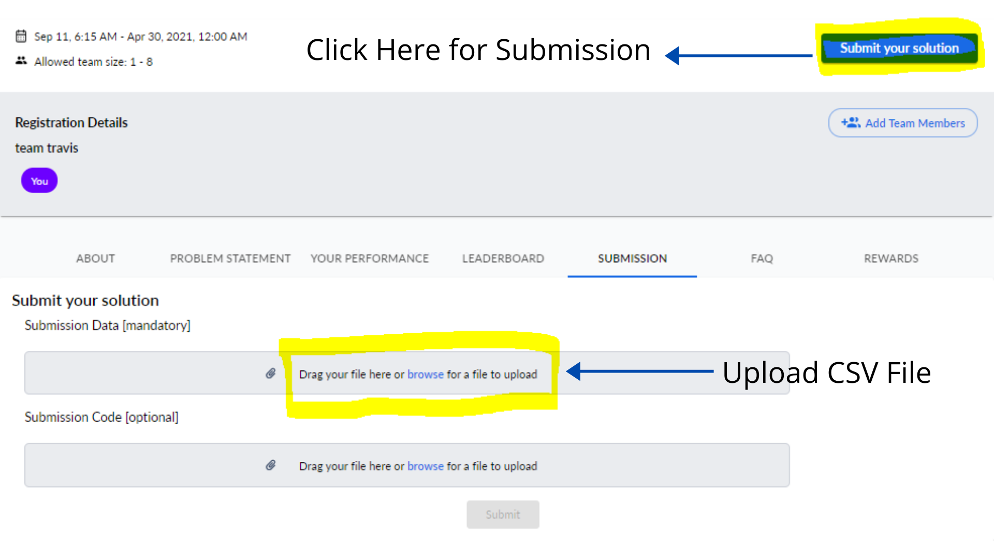

## Is there any restriction on the number of submissions?

Ans: No. There is no limit on number of submissions

## Will you provide any support in problem solving?

Ans: As it is a competition, no help related to the given problem or coding will be given from Great Learning

## What is the ideal solution to the problem?

Ans: In hackathon, you build the capability to come up with multiple approaches to the same problem. In this scenario, there is no ideal solution. The game is to get to the top by getting the best model accuracy. There might be scenarios where the model is not the best in terms of implementation in business scenarios because of overfitting. The ideal solution of this Hackathon will be the one with the best accuracy.

## What techniques can I use while working with the problem?

Ans: You can use any suitable technique that you are aware of. There are no restrictions as far as any techniques or tools are concerned.

## Will I get model solution once the Hackathon is over?

Ans: No. No solutions to the problem will be provided

## Do I have to submit the code file for the submissions?

Ans: Yes, you need to submit the code file which has the highest accuracy.

**Note:** In-case you have any other query apart from above FAQs please discuss it with your Program Manager.

# **RULE-**

**Plagiarism -** Copying from your friend’s notebook or any similar activity of copying code from the internet is strictly prohibited. If any instance of plagiarism is found, it will lead to disqualification of the candidate from the hackathon.