**Distribution of Loan Terms**

Machine generated alternative text:
400000 
350000 
300000 
250000 
200000 
150000 
100000 
50000 
Loan Term 

Maximum loans are for 3 year duration compared to 5 year duration

**Distribution of Interest Rates**

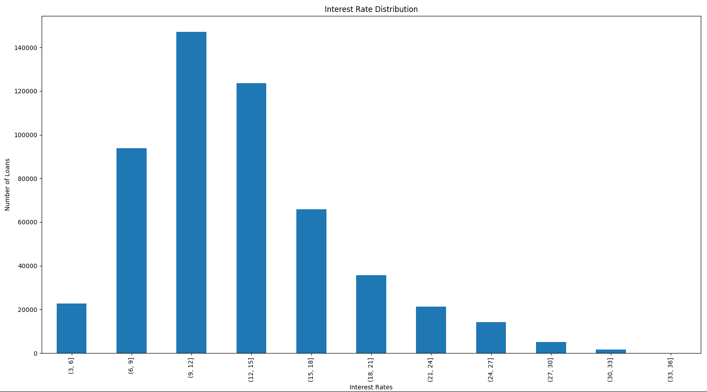

Maximum loans disbursed are in the range of 9 - 15 %. But it is extremely right skewed. There are significant number of loans upwards of 24 %. These high interest loans shall require further analysis as they could be potential candidates for defaulting.

**Distribution of Grades**

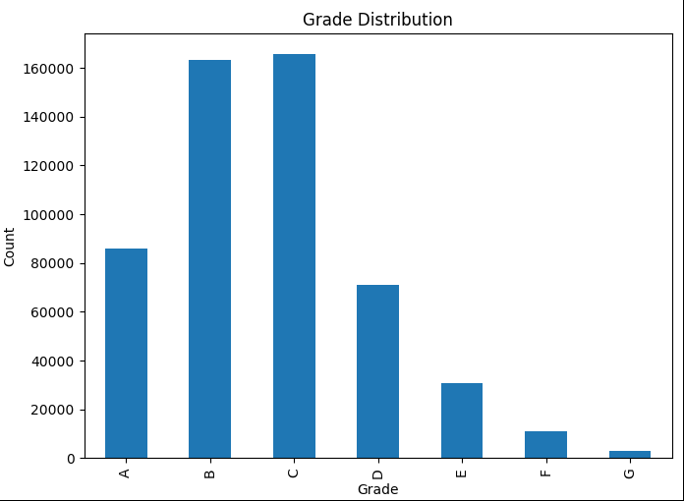

Maximum loans disbursed are Grade B and C. The distribution is right skewed.