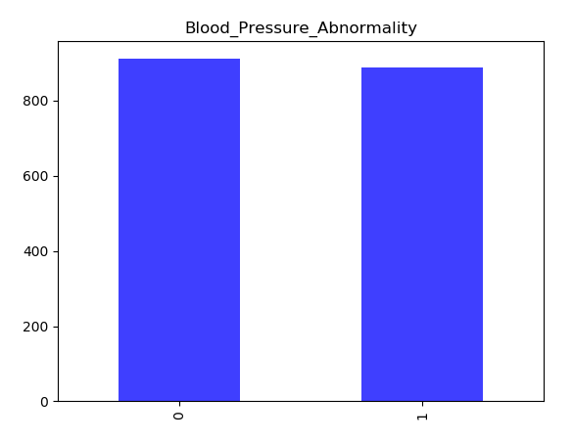

Observation : Histogram of Blood_Pressure_Abnormality

* Data is evenly distributed

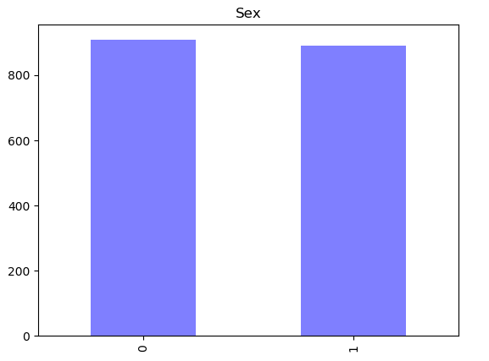

Observation : Histogram of Sex

* Data is evenly distributed between Male and Female subjects
* 0 : Male
* 1 : Female

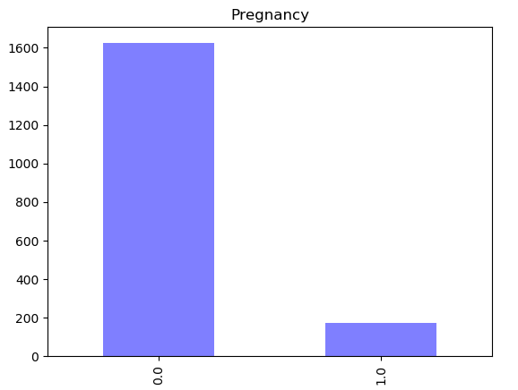

Observation : Histogram of Pregnancy

* As expected number of non pregnant subjects are much more than Pregnant subjects
* 0 : Non Pregnant
* 1 : Pregnant

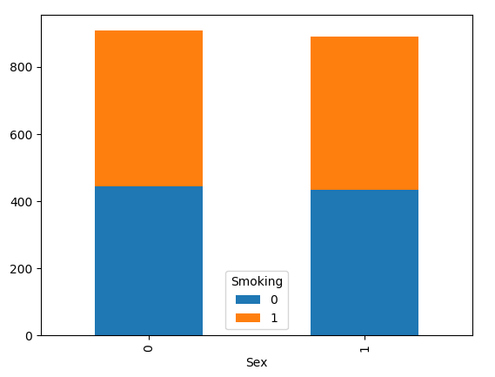

Observation : Distribution of Smoking column group by Sex

* Data is quite evenly distributed between Smoking and non-Smoking subjects even within each Sex

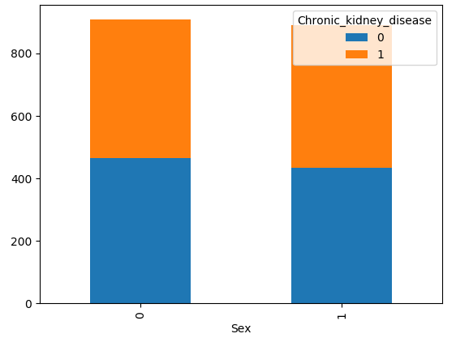

Observation : Distribution of subjects having Chronic_Kidney_Disease grouped by Sex

* Data is quite evenly distributed between subjects having Chronic Kidney disease vs the subjects not having Chronic Kidney disease even within each Sex type

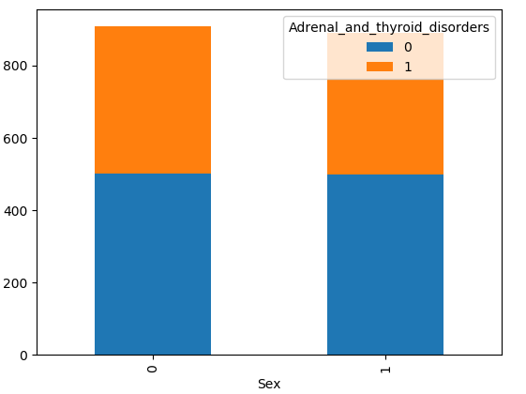

Observation : Distribution of subjects having Adrenal_and_thyroid_disorders grouped by Sex

* Data is quite evenly distributed between subjects having Adrenal and thyroid disordervs the subjects not having Adrenal and thyroid disorder even within each Sex type

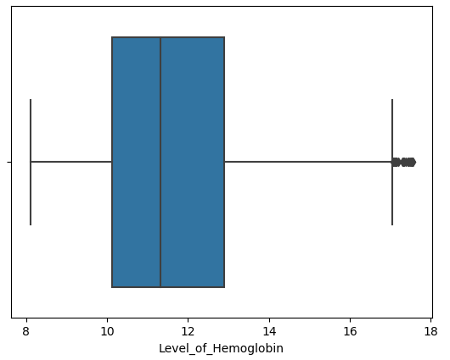

Observation : Boxplot of Hemoglobin levels for the whole group

* The median is around 11.2 – 11.3 which seems normal. Some subjects showing very high hemoglobin level (Above 17) which is not abnormal if the subject is of good health

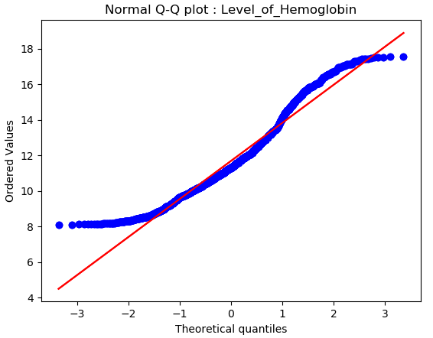

Observation : Quantile-Quantile plot of Hemoglobin levels for the whole group

* As evident from the box plot also, data is quite normal baring some outliers. Although data is not perfectly bell shaped but nothing abnormal

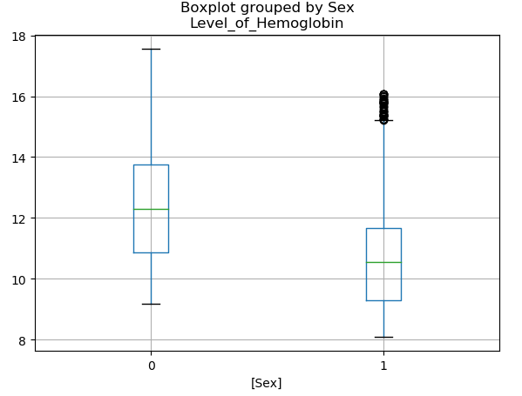

Observation : Boxplot of Hemoglobin levels for each sex group

* Hemoglobin levels of Male subjects seem perfectly normal. Some Female subjects however, show very high Hemoglobin level.

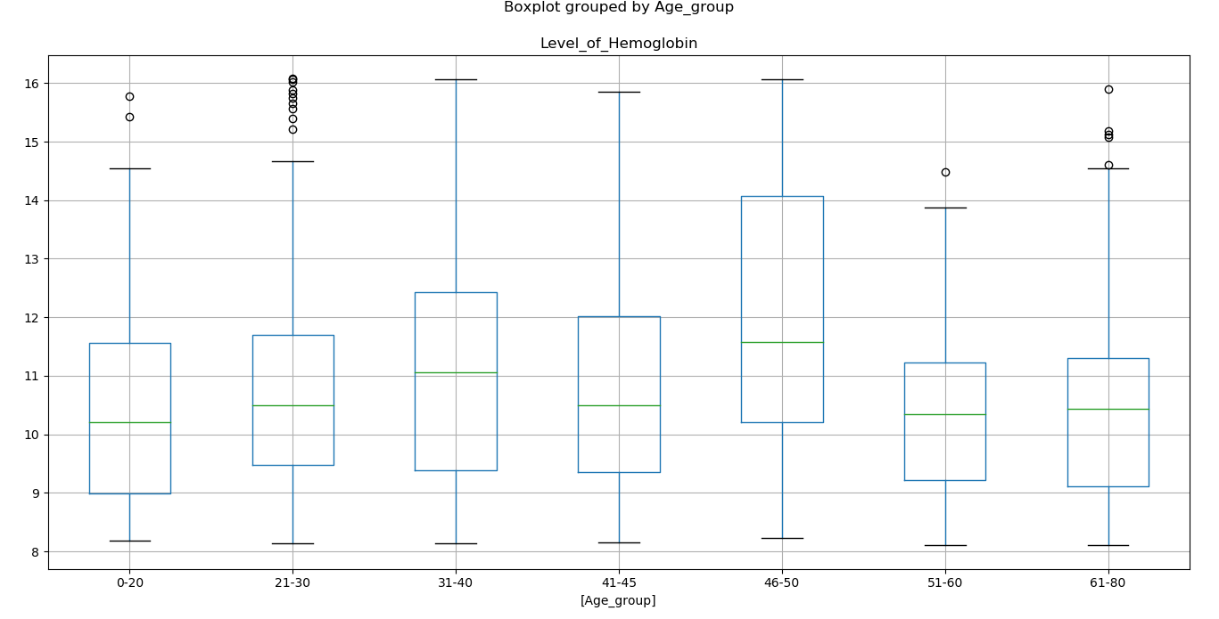Observation : Boxplot analysis of Hemoglobin Levels of Female Subjects across various Age groups

* Outliers are observed within Age groups 0-20, 21-30,61-80 in Female sujects.
* The most evident outliers in Hemoglobin levels is in the age group of 21-30. Which could possibly be due to Good Health of female subjects in that age.
* There is a sudden spike in Hemoglobin levels in the age group of 46-50, which could be attributed to the sudden stoppage of Menstrual cycles in women during this period
* In the age group 61-80, health of subjects can vary drastically depending on their lifestyle which would show up as drastic differences in their hemoglobin levels.

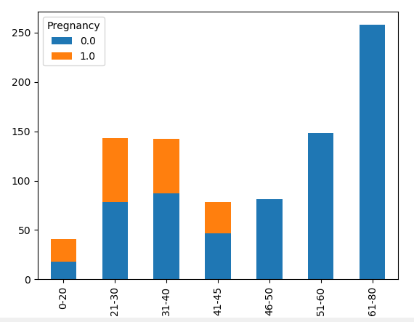

Observation : Histogram of Pregnancy counts of Female Subjects across various Age groups

* Quite evidently there are large number of subjects who are found pregnant in the first four age groups which would suggest low hemoglobin levels in these age group as can be evidenced in the boxplot analysis above.

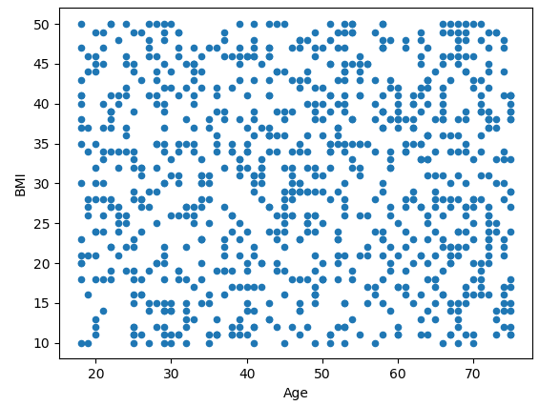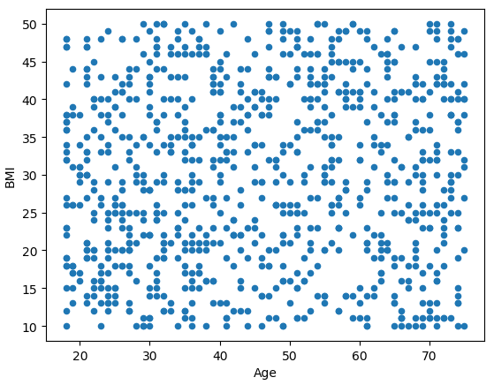

Observation : Scatter Plot of Age Vs BMI of Male and Female Subjects respectively

* Homogenous plot. No inferences can be drawn.

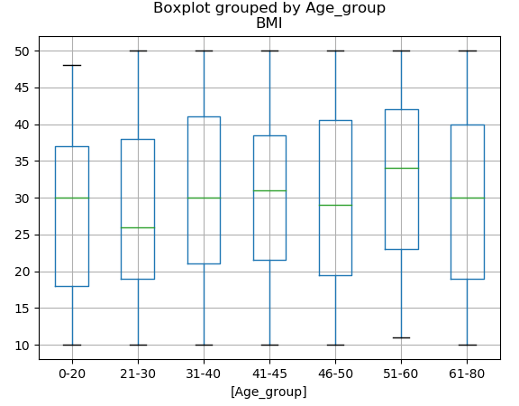

Observation : Box Plot of BMI of Male subjects grouped by Age.

* Commonly accepted **BMI** ranges are underweight: under 18.5 kg/m2, normal weight: 18.5 to 25, overweight: 25 to 30, obese: over 30..

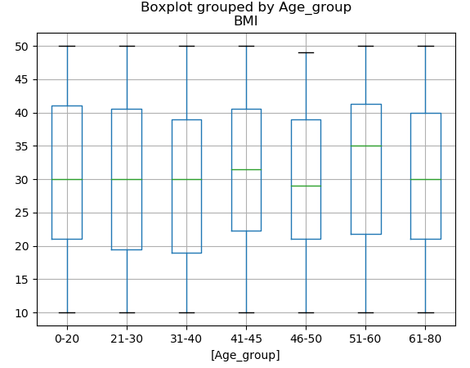

Observation : Box Plot of BMI of Female subjects grouped by Age.

* Sex does not seem to have any impact on the BMI values across all age groups
* The median BMI of all the subjects whether Male or Female is either overweight or slightly obese across all the age groups.

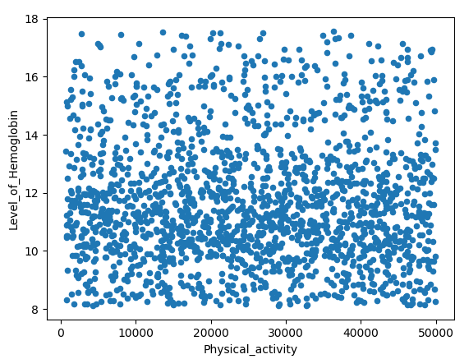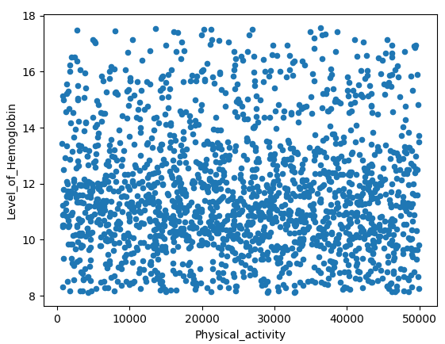

Observation : Scatter Plot of Physical Activity Vs Level of Hemoglobin for Male and Female subjects.

* Physical Activity seem to have no impact on Level of Hemoglobin

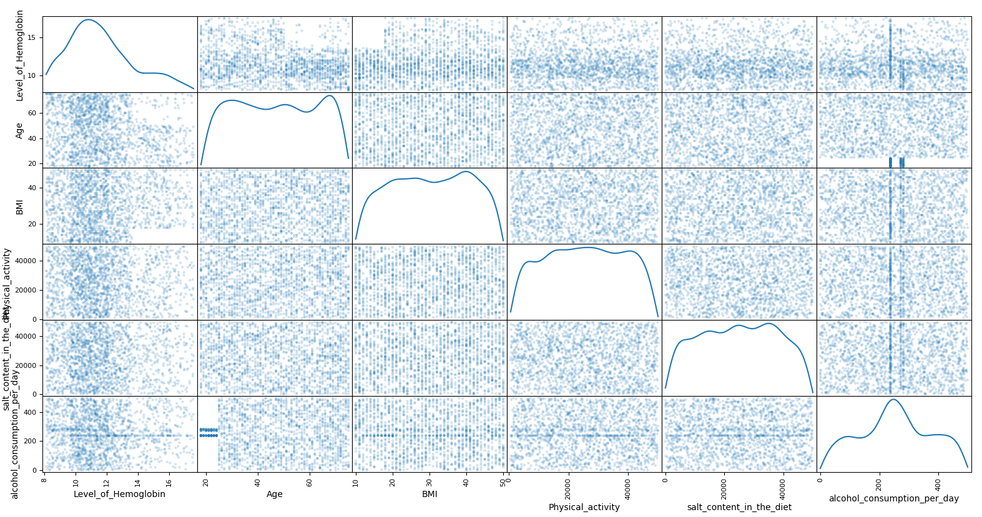

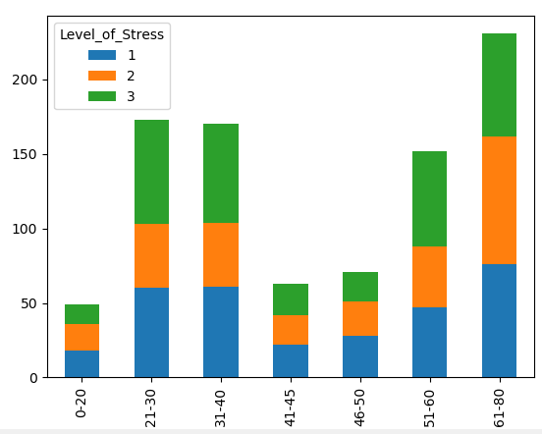

Observation : Histogram of Level of Stress of Male subjects across Age groups.

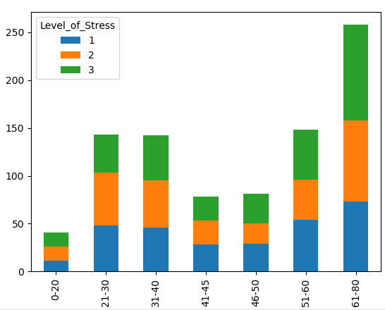

Observation : Histogram of Level of Stress of Female subjects across Age groups.

* Whereas more Male subjects have higher stress levels in the age groups 21 to 40 years, Females show higher tendency of stress in older age i.e. above 60.

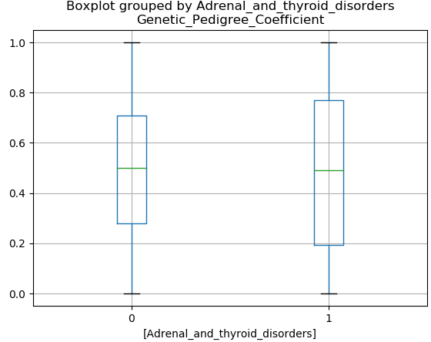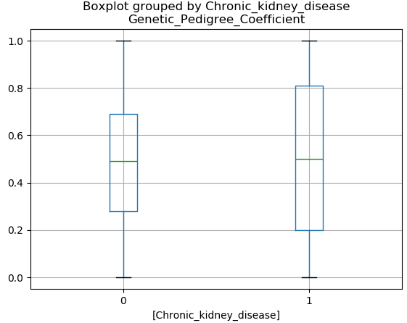

Observation : Boxplot of Genetic_Pedigree_coefficient for patients separated by Chronic Kidney disease and Adrenal_and_thyroid_disorders.

* 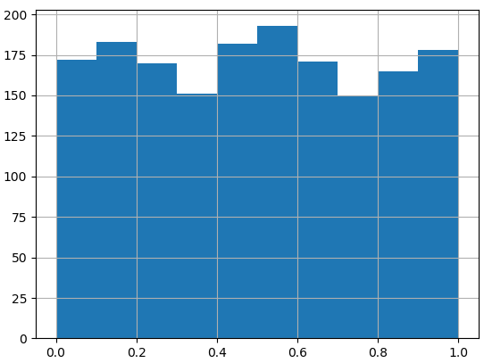The median for both the groups is around 0.5

Distribution of Genetic Pedigree Coefficient

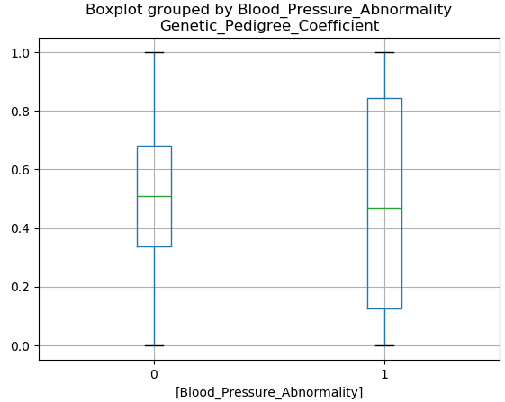

Distribution of Genetic Pedigree Coefficient

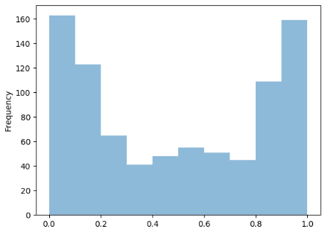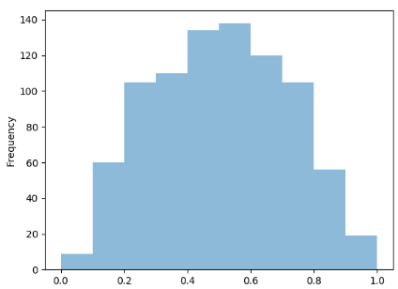

when Blood Pressure Abnormality = 0 when Blood Pressure Abnormality = 1

Distribution of Genetic Pedigree Coefficient

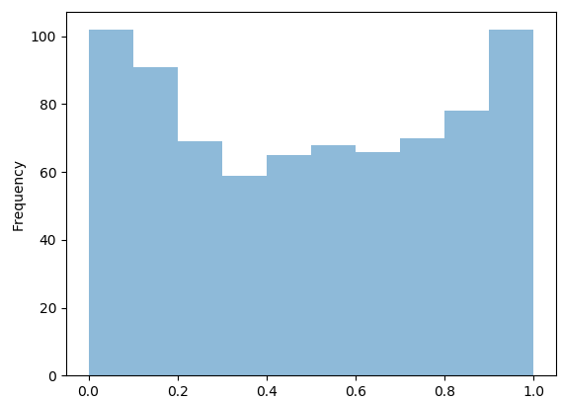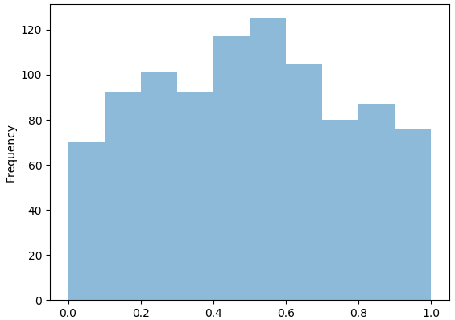

when Adrenal and Thyroid Disorder = 0 when Adrenal and Thyroid Disorder = 1

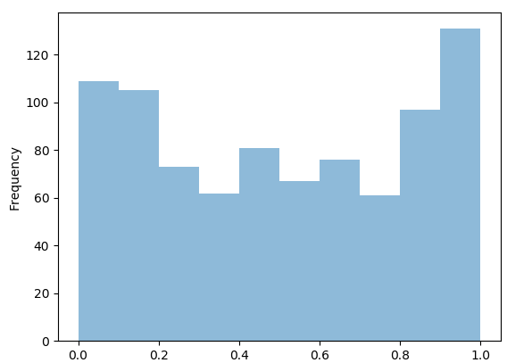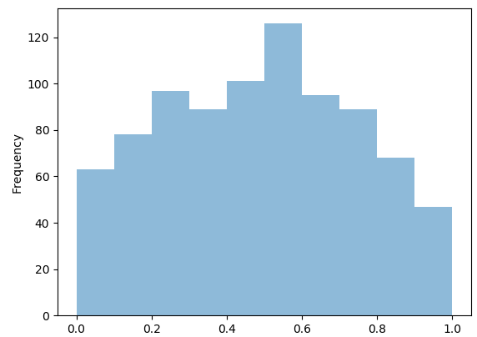

when Chronic Kidney Disorder = 0 when Chronic Kidney Disorder = 1