**ARDUINO PROJECT EMBEDDED SYSTEM**

*PROJECT REPORT SUBMITTED*

By

Pranavi (20198054)

Pranav Rastogi (20198100)

Rishank Barua (20198089)

Rohit Kumar Sah (20195146)

Saksham Saxena (20198055)

Sakshi Sihag (20198093)



**DEPARTMENT OF COMPUTER SCIENCE AND ENGINEERING**

**MOTILAL NEHRU NATIONAL INSTITUTE OF TECHNOLOGY ALLAHABAD**

**PRAYAGRAJ, INDIA- 211004**

**Design and implementation of Smart Irrigation System using Arduino**

**Abstract:** In the present world, food and water scarcity is primarily caused by population growth; therefore, agriculture must be promoted in order to avoid this. A lot of water resources are wasting in the agricultural field. We use an automated plant monitoring system based on Arduino to eliminate this problem. This technology detects the moisture content of the soil and adjusts the water supply accordingly. This system also features crop growth tracking and water level detection in the tank. As a result, when the soil is dry, the pump will automatically water the fields, and when the soil is wet, the pump will automatically stop, eliminating the need for people and saving time.

**Problem Statement**

Agriculture uses 85 percent of the world's available freshwater resources, according to data. It is critical to develop methods for sustainable water usage that are based on research and technology. We can manage water flow and so reduce irrigation waste by using a microcontroller, some sensors, and a relay. As a result, our solution may significantly improve water utilization and productivity. Our method is created to reduce wasteful water flow into agricultural fields and to irrigate crops as needed. When the soil moisture measurement exceeds or falls below the specified limit, the relay attached to the Arduino microcontroller activates or deactivates the motor.

It is a simple project more useful in watering plants automatically without any human interference. We know that people do not pour the water on to the plant in their gardens/farms when they are not around. As a result, there is a chance to get the plants damaged. This project is an excellent solution for such kind of problems.

**Proposed Solution**

Smart irrigation system using Arduino uno, this system includes the multi sensors. The multi sensor is a soil sensor.

The aim of this study is to build a system that helps the process of regulating water by measuring the humidity ratio. The grounded sensors all around the land area will give notice about the need for water and likewise, it will be provided. At the same time arranged a mechanized approach for the water tanker to be filled when it is empty. This system considered to sense dryness of the soil in the end switch on the electric pump to begin the supply of water and switch off the pump on every occasion enough water provided.

An automated irrigation system has taken the place of the outdated irrigation system. There have been numerous smart irrigation systems developed. In contrast to traditional irrigation methods, a smart irrigation system adjusts the water supply based on the demands of the fields and crops. A temperature sensor serves as the smart irrigation system's feedback mechanism. This temperature sensor is installed on the irrigation field at a precise spot. Water is pumped to the corresponding location based on its value for a predetermined time. The transmitter and receiver sections will be able to communicate using wireless communication technologies. This will eliminate the need for a large number of cables in the field. Otherwise, it could cause a slew of issues with plowing, harvesting, and other tasks.

**COMPONENTS REQUIRED FOR AUTOMATIC IRRIGATION SYTEM**

* Arduino Uno
* Moisture Sensor(FC-28)
* 16*12 LCD Display
* 5v Relay Module
* 5v Water Pump with small Pipe
* Resistors
* 9v Battery

**THEORY**

**Arduino**

Arduino is a free and open-source platform where we can get I/O pin to connect different sensors, actuators. It include 14 digital pins(0-13) and 6 analogue pins(A0-A5). It consist of an ATmega328 microcontroller which can be programmed through Arduino ide software according to our requirements.

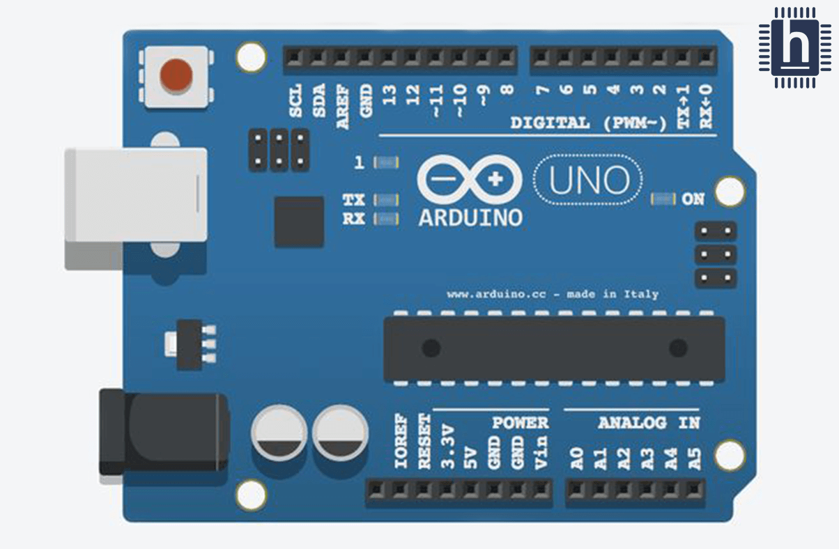

**Soil moisture sensor (FC-28)**

Soil moisture sensor have two probes are utilized to measure the moisture level of soil. The current flows through these two probes through soil, and moisture level is measure with the varies in the resistance value of the probes due to water content in the soil. When the water level is maximum in the soil, it conducts electrical signal in the probes and the resistance of the probes decreases and hence send signal to the arduino. When water level is minimum, it poorly conduct electricity and the resistance in the probes increases.

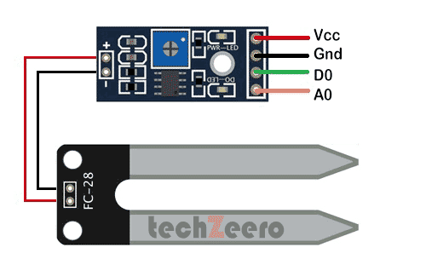

**LCD**

LCD stands for liquid crystal display which is a electrical module. The 16*2 LCD display is a relatively basic module that is typically used to display letters and numbers. The command and data registers are found on a 16*2 LCD. Switching from one register to another is done with the register select. The command register has the value RS=0, while the data register has the value RS=1. Command register stores the command instructions of LCD. A command tells the LCD to perform a certain activity, such as initializing it, clearing its screen, setting the data register. The ASCII value of the character to be shown is the cursor location, managing the display, and so on.

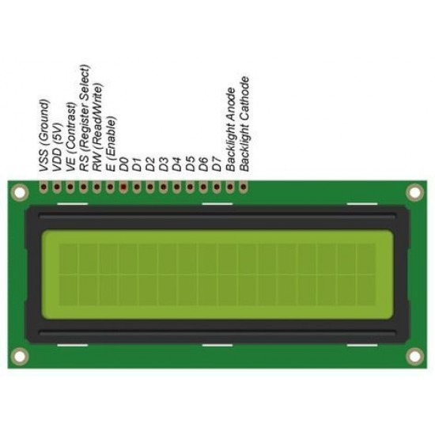

It is employed in this project to pump water from the main water tank through pipelines for irrigation. This pump can be used for a variety of purposes in the home, including cleaning, bathing, space heating, and water flowering. This pump was chosen for this project because it offers a number of benefits. It is lightweight, for example. It also has a modest size, making it simple to install and replace. It also has sufficient efficiency to pump water for irrigation. It requires less electricity because it runs on 12 volts. Furthermore, the noise level of this pump is extremely low. Finally, the price of this pump is really low.

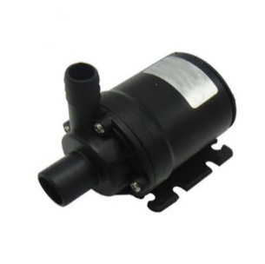

**RELAY MODULE**

A relay is an electromagnetic device that connects two circuits magnetically. They are used for switching the circuit from one to another. They are used to connect with a low voltage circuit to high voltage electrical circuit.

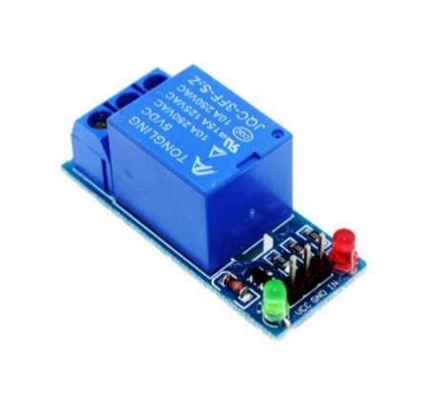

**Prototype Circuit**

Arduino is being used to interface all the sensors. Arduino is powered with 5v adapter. Moisture sensor sense the moisture level present in the soil and send output to the Arduino. If the moisture level is below 30%, motor will be on and motor starts pumping water in the soil. And if the moisture level is above 30%, the motor will be off that means there is no need of irrigation. The value of moisture reading will be shown on the LCD so that the farmer will be able know the current situation of surrounding. The motor is connected to a 12V battery and inductor. Here we can change the moisture value using a POT-HG manually. In pin 6, Relay is connected to the motor which will either start or stop irrigation based on the information passed by Arduino which it is getting from the moisture sensor.

In the below figure, moisture value is displayed in the lcd and value is 24%. It is less than 30%, so motor is on showing irrigation has started.

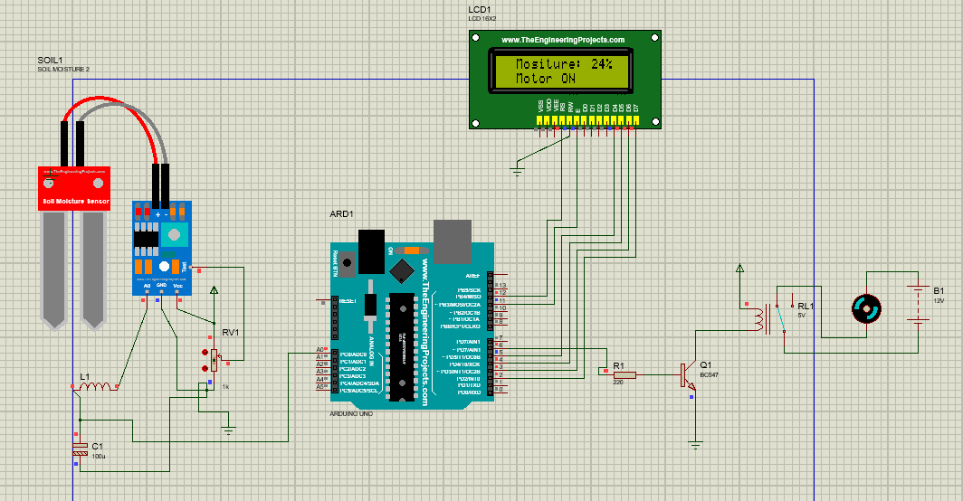

Fig: System Circuit with motor on

In the below figure, moisture value is displayed in the lcd and value is 32%. It is greater than 30%, so motor is off showing irrigation has been completed or don’t need it right now.

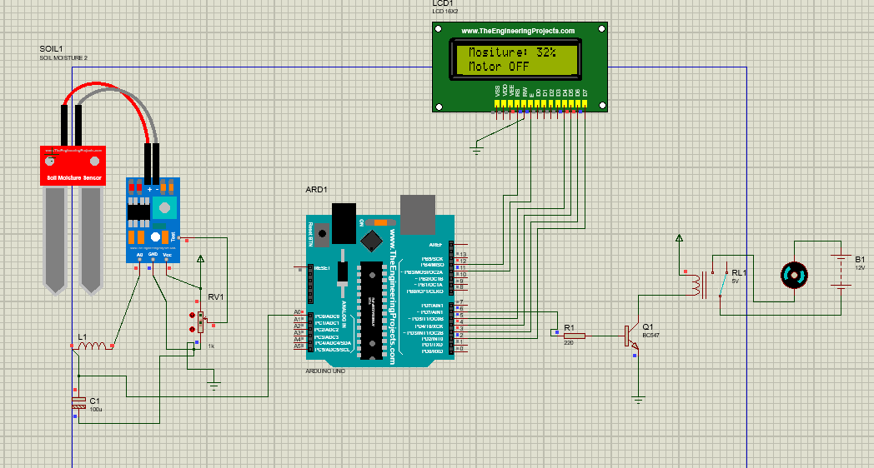

**RESULTS AND CONCLUSION**

We can adjust the moisture content of cultivated land soils thanks to this research. Water pumping moto turned on or off automatically through relay according to on soil wetness. This conserves water while allowing the water level to be achieved at a favored area of the plant, enhancing crop output. Servo motors from vegetation water are uniformly disseminated in water to guarantee optimal absorption through utilization. There is extremely little water waste, and the system can give water to the plant when it is needed based on the type of plant, soil moisture, and temperature. We can adjust the moisture content of cultivated land soils thanks to this research. Water pumping moto turned on or off automatically through relay according to soil wetness. This conserves water while allowing the water level to be achieved at a favored area of the plant, enhancing crop output. Servo motors from vegetation water are uniformly disseminated in water to guarantee optimal absorption through utilization. There is extremely little water waste, and the system can give water to the plant when it is needed based on the type of plant, soil moisture, and temperature.

**References:**

1. [Arduino Reference - Arduino Reference](https://www.arduino.cc/reference/en/)
2. [How to Use a Soil Moisture Sensor - Arduino Project Hub](https://create.arduino.cc/projecthub/MisterBotBreak/how-to-use-a-soil-moisture-sensor-ce769b)
3. [Guide for Relay Module with Arduino | Random Nerd Tutorials](https://randomnerdtutorials.com/guide-for-relay-module-with-arduino/)