ISO 20022
Target2-Securities - Billing

Message Definition Report Part 1
Approved by the Securities SEG on 20 November 2025 and the Payments SEG on 01 December 2025, under the lead of the Securities SEG.
This document provides information about the use of the candidate messages for Billing and includes, for example, business transactions and examples.
December 2025

Table of Contents
Table of Contents 2
1 Introduction 4
1.1 Terms and Definitions 4
1.2 Abbreviations and Acronyms 4
1.3 Document Scope and Objectives 5
1.4 References 5
2 Scope and Functionality 6
2.1 Background 6
2.2 Scope 6
2.3 Groups of MessageDefinitions and Functionality 6
3 BusinessRoles and Participants 8
3.1 Participants and BusinessRoles Definitions 8
3.2 BusinessRoles and Participants Table 9
4 BusinessProcess Description 10
5 Description of BusinessActivities 11
5.1 Billing 11
6 BusinessTransactions 15
6.1 Query Billing Information 15
6.2 Billing Report 16
7 Business Examples 18
7.1 Billing 18
8 Revision Record 23
Preliminary Note
The Message Definition Report (MDR) is made of three parts:
MDR Part 1
This describes the contextual background required to understand the functionality of the proposed message set. Part 1 is produced by the submitting organization that developed or maintained the message set in line with an MDR Part 1 template provided by the ISO 20022 Registration Authority (RA) on www.iso20022.org.
MDR Part 2
This is the detailed description of each message definition of the message set. Part 2 is produced by the RA using the model developed by the submitting organization.
MDR Part 3
This is an extract if the ISO 20022 Business Model describing the business concepts used in the message set. Part 3 is an Excel document produced by the RA.

Introduction

Terms and Definitions
The following terms are reserved words defined in ISO 20022 Edition 2013 – Part1. When used in this document, the UpperCamelCase notation is followed.
Term | Definition
BusinessRole | Functional role played by a business actor in a particular BusinessProcess or BusinessTransaction.
Participant | Involvement of a BusinessRole in a BusinessTransaction.
BusinessProcess | Definition of the business activities undertaken by BusinessRoles within a BusinessArea whereby each BusinessProcess fulfils one type of business activity and whereby a BusinessProcess may include and extend other BusinessProcesses.
BusinessTransaction | Particular solution that meets the communication requirements and the interaction requirements of a particular BusinessProcess and BusinessArea.
MessageDefinition | Formal description of the structure of a message instance.
When a MessageDefinition or message identifier is specified, it should include the variant and version number. However, in this document (except in the business examples section, if present), variant and version numbers are not included. In order to know the correct variant and version number for a MessageDefinition, the related Message Definition Report Part 2 document should be consulted.

Abbreviations and Acronyms
The following is a list of abbreviations and acronyms used in the document.
Abbreviation/Acronyms | Definition
4CB | Banca d’Italia, Banque de France, Deutsche Bundesbank and Banco d’España
A2A | Application-to-Application mode. Defines a mode of technical communication that permits the exchange of information between software applications of T2S and a directly connected T2S actor.
ACH | Automated Clearing House
BAH/head.001 | Business Application Header
BIC | Business Identifier Code
CeBM | Central Bank Money
CSD | Central Securities Depository
ID | Identification
LCMM | Life Cycle Management and Matching Domain within T2S
LQMG | Liquidity Management Domain within T2S
MDR | Message Definition Report
NCB | National Central Bank
RTGS | Real-time gross settlement (RTGS) system.  A settlement system in which processing and settlement take place in real-time on a gross basis.
SEG | Standards Evaluation Group
T2S | TARGET2-Securities
TM | Technical Message. Messages which cover technical functions within T2S System
U2A | User-to-Application mode. Defines a mode of technical communication that permits the exchange of information between software applications of T2S and a T2S system user through a graphical user interface (GUI).
URD | T2S User Requirement Document
XML | eXtensible Mark-up language

Document Scope and Objectives
This document is the first part of the Billing Message Definition Report (MDR) that describes the BusinessTransactions and underlying message set. For the sake of completeness, the document may also describe BusinessActivities that are not in the scope of the business processes covered in this document.
This document describes the following:
- the BusinessProcess scope
- the BusinessRoles involved in these BusinessProcesses
The main objectives of this document are as follows:
- to provide information about the messages that support the business processes
- to explain the BusinessProcesses and BusinessActivities these messages have addressed
- to give a high level description of BusinessProcesses and the associated BusinessRoles
- to document the BusinessTransactions
- to provide business examples
The messages definitions are specified in Message Definition Report Part 2.

References
Document | Version | Date | Author
ISO 20022 Business Justification #042 – Securities settlement and reconciliation  ISO 20022 Business Justifications (RA ID: 042) | 2.0 |  | 4CB
T2S User Requirements (URD)  T2S User Requirements Document R2025.JUN (URD) | R2025.  JUN | 13MAR  2025 | ECB

Scope and Functionality

Background
This Message Definition Report covers a set of two MessageDefinitions developed by Banca d'Italia on behalf of 4CB in close collaboration with SWIFT and approved by the Securities SEG on 20 November 2025 and the Payments SEG on 01 December 2025, under the lead of the Securities SEG. These messages are specifically designed to support T2S Community for Billing and Invoice management. T2S (TARGET2-Securities) is a European securities settlement engine which offers centralised settlement in central bank money across all European securities markets. The fundamental objective of T2S is to integrate and harmonise the highly fragmented securities settlement infrastructure in Europe. It aims to reduce the costs of cross-border securities settlement and increase competition and choice among providers of post-trading services in Europe.
The Billing module (such as in T2S) provides the functionality to generate invoices for CSDs and NCBs to invoice their participants and customers respectively, based on the information that T2S provides and that CSDs and NCBs may complement with additional data. This module automatically produces monthly bills containing all billable events (e.g. events related to the lifecycle of an instruction), fixed and variable fees. At the end of a billing period, an invoice is sent and sums up all the relevant billing information per T2S Party. All invoices are stored electronically and are available for later inquiries.

Scope
As described in the ISO 20022 Business Justification, the scope covers the following communication flows described below.

Groups of MessageDefinitions and Functionality

These messages are to be used with the ISO 20022 Business Application Header (head.001). The schema and more information about the Business Application Header (BAH) can be found on the www.iso20022.org web site

Groups

Billing
This Billing message set consists of:

MessageDefinition | Message Identifier
Billing Report Request | camt.076
Billing Report | camt.077

Functionality
These Billing messages definitions are specifically designed to support the following technical functions:
- Billing Report Request: the camt.076 is sent to make the following types of queries:
- Cumulative Billing Data Query enabling the sender to request the billing data of an invoice, which consists of the aggregated information on the level of a System Member for a specified period for each offered functionality;
- Itemised Billing Data Query enabling the sender to request itemised billing data information which consists of the aggregated information on the level of a single securities account, cash account or party within a given period for each service item.
- Billing Report: the camt.077 is sent to provide with:
- the official invoice;
- status of a previously sent cancellation of the latest valid invoice;
- consumption data message (for NCBs only);
- response to a user query containing billing data.
The BillingReport message is sent in push mode (invoice, invoice cancellation and consumption message) or as response to the Billing Report Request camt.076 message, containing information on requested items (cumulative or itemised billing data) or business error reports.

See Message Definition Report Part 2 for the message and formats.

BusinessRoles and Participants
A BusinessRole represents an entity (or a class of entities) of the real world, physical or legal, a person, a group of persons, a corporation. Examples of BusinessRoles: “Financial Institution”, “Automated Clearing House”, “Central Securities Depository”.
A Participant is a functional role performed by a BusinessRole in a particular BusinessProcess or BusinessTransaction. Examples of Participants: the “user” of a system, “debtor”, “creditor”, “investor”.
The relationship between BusinessRoles and Participants is many-to-many. One BusinessRole can be involved as different Participants at different moments in time or at the same time. Examples of BusinessRoles: "user", "debtor”, "creditor", "investor". Different BusinessRoles can be involved as the same Participant.
In the context of Billing the high-level BusinessRoles and typical Participants can be represented as follows:

Participants and BusinessRoles Definitions
Participants
Description | Definition
Instructing Party | Party that instructs the executing/servicing party to process and monitor a transaction and receives reports and communications from executing/servicing party.
Executing / Servicing Party | Party that processes, monitors and reports on transactions received from the Instructing party and sends reports and communications to instructing party.
Business Roles
Description | Definition
Collateral Management System | System focused on management of eligible collateral used for credit operations.
National Central Bank | The principal monetary authority of a nation, a central bank performs several key functions, including issuing currency and regulating the supply of credit in the economy.
Payment Bank | A Payment Bank is either a central bank or a private bank used to settle the cash leg of securities settlements: it provides the cash account to support the settlement of the securities transactions of another financial institution in central bank money (CeBM).
Central Database System | System collecting data from different sources and providing them to other systems.
Central Securities Depository (CSD) | An infrastructure that, holds or controls, the holding of physical or dematerialised financial instruments belonging to all, or a large portion of, the investors in a securities market. This affects the centralised transfer of ownership of such securities by entries on its books and records.
Market Infrastructure | The party that provides, through common membership, services to create a fair and open process for the execution of transactions between trading parties, and the creation of settlement obligations. Example include an exchange.

BusinessRoles and Participants Table

BusinessRole | Participant  Account Servicer | Participant  Account Owner
Collateral Management System | X
National Central Bank | X
Payment Bank | X
Central Security Depository (CSD) | X
Market Infrastructure |  | X

BusinessProcess Description
This diagram represents the high level BusinessProcesses.

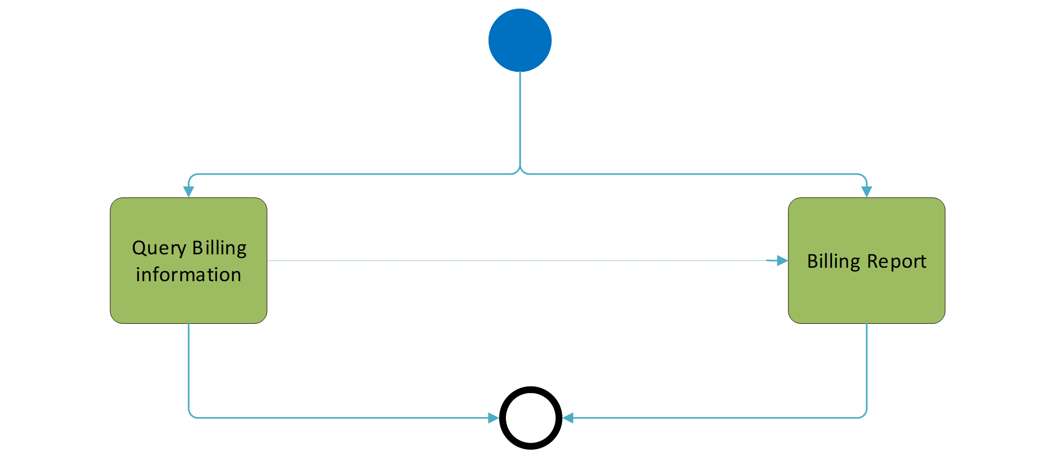

Billing Report
Item | Description
Definition | The Billing Report is sent by Central System as official invoice, status of a previously sent cancellation of the latest valid invoice, consumption data message or as a response of a System member query containing information backing the actual valid invoice. The latter is a query response to the query message, containing information on requested items (cumulative or itemised billing data) or business error reports.
Trigger | The process is triggered by an event within the Central system for the corresponding billing period or by a System member querying billing data information.
Pre-conditions | All generated invoice data (monthly or intra-month) are available for query purposes, no matter if they have the status "cancelled" or "not confirmed". However, the System Member can query for his Invoice Data by using the Billing Reference (Invoice Number) as a distinct search criterion to be sure that the returned data are active and confirmed.
Post-conditions | The acknowledgement of the billing report process
Role | Instructing/Servicing Party

Description of BusinessActivities
This section presents the different BusinessActivities within each BusinessProcess. The BusinessActivities of a process are described with activity diagrams.
Legend
Symbol | Name | Definition
 | Start Point | Shows where the lifecycle of the business process commences.
 | End Point | Shows where the lifecycle of the business process may ends.
 | Lozenge (or diamond) | Indicates that a choice between several actions can be made.
 | Bar | Indicates that several actions are initiated in parallel.

Billing

Query Billing Information
Notes: in the frame of the flow, System Transaction Administrator corresponds to the executing party, the System Member to the Instructing Party.

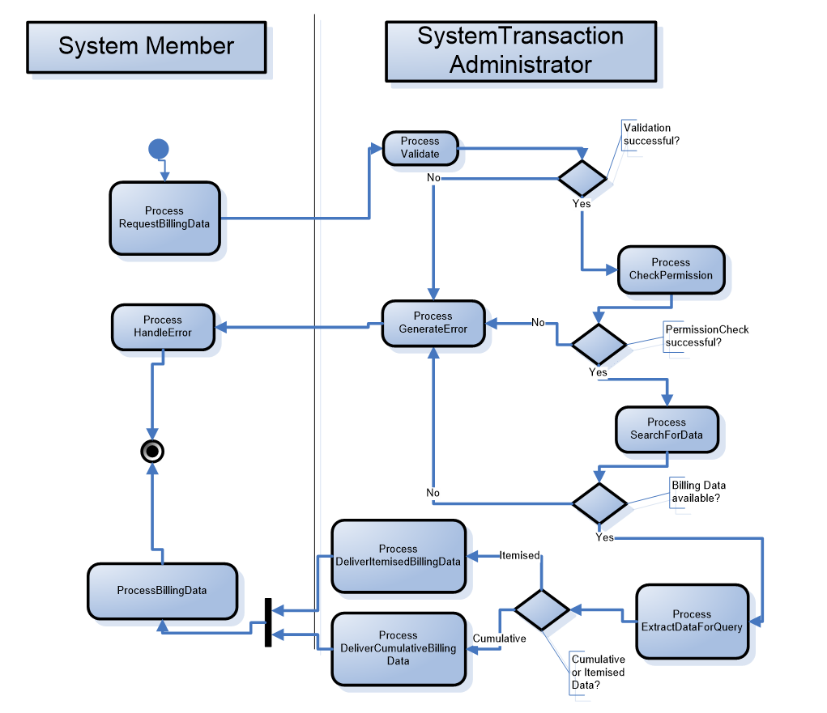
Step | Description | Initiator
Process Request Billing Data | Instruct the Executing/Servicing Party to return:  • Cumulative Billing Data  • Itemised Billing Data | Instructing Party
Validate | Executing/Servicing Party system checks if this instruction is a new occurrence or not.  It also checks if this instruction is already handled or not.  If validation of the message fails, a status message “REJECTED” will be sent including the related errors and reason information. | Executing/Servicing Party
Process | If the instruction is accepted, the Executing/Servicing Party processes the instruction and return the requested information to the Instructing Party. | Executing/Servicing Party
Process Generate Error | Executing/Servicing Party informs the Instructing Party that this instruction is rejected and why. | Executing/Servicing Party
Process Billing Data / Process Handle Error | Instructing Party monitors the status of the instruction. | Instructing Party

Billing Report
Notes: in the frame of the flow, Settlement Infrastructure corresponds to the executing party, the System Member to the Instructing Party.

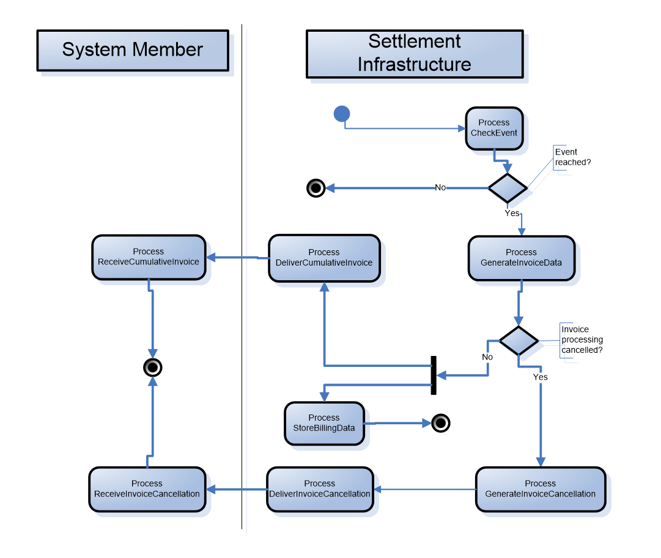
Step | Description | Initiator
Process Check Event | Executing/Servicing Party system checks if the event for the generation of billing data is reached. | Executing/Servicing Party
Process Generate Invoice, Generate Invoice Cancellation and Deliver | If the event is reached, the Executing/Servicing Party processes the invoice data and return the generated billing information to the Instructing Party.  This process is triggered periodically to return invoices to all subscribed Instructing Parties. | Executing/Servicing Party
Process Receive Invoice / Process Receive Invoice Cancellation | Instructing Party monitors the status of the generation of the invoice/invoice cancellation. | Instructing Party

BusinessTransactions
This section describes the message flows based on the activity diagrams documented above. It shows the typical exchanges of information in the context of a BusinessTransaction.

Query Billing Information

Positive Scenario
Applies when the query sent by the Instructing Party is processed and confirmed by the Executing/Servicing Party.


Query Process
Billing Report (camt.077): COMPLETED
Cumulative/Itemised Billing Report Request (camt.076)

Billing Report Request
The Instructing Party sends the query to the Executing/Servicing Party to obtain information about:
- Cumulative Billing Data
- Itemised Billing Data

This query contains information that clearly identifies a certain invoice, billing period or, in case of itemised queries, specific securities account, cash account or participant.
The Executing/Servicing Party informs the Instructing party that the Billing Report Query has been successfully processed (COMPLETED) by returning the requested information.

Negative Scenario
Applies when the query sent by the Instructing Party is rejected by the Executing/Servicing Party.

Query Process
Billing Report (camt.077): REJECTED
Cumulative/Itemised Billing Report Request (camt.076)

Billing Report Request
The Instructing Party sends the query to the Executing/Servicing Party to obtain information about:
- Cumulative Billing Data
- Itemised Billing Data

This query contains information that clearly identifies a certain invoice, billing period or, in case of itemised queries, specific securities account, cash account or participant.
The Executing/Servicing Party informs the Instructing party that the Billing Report Query has been rejected (REJECTED). The Executing/Servicing Party present to the Instructing Party the business or operational error which caused the rejection.

Billing Report
Applies when the report is sent by the Executing/Servicing Party.
Report Process
Invoice / Consumption Data / Cancellation Report (camt.077)

Billing Report
The Executing/Servicing Party sends the report to the Instructing Party to communicate:
- An official invoice
- Consumption data (for NCBs only)
whenever a specific event is reached in the business day.

The Executing/Servicing Party sends the report to the Instructing Party to communicate:
- the cancellation status of an invoice
At the end of the processing of a previously sent cancellation request submitted by the operator.

Business Examples
This section describes business examples of the use of the various candidate MessageDefinitions.

Billing

camt.076.001.01 CumulativeBillingDataQuery
Description
The CumulativeBillingDataQuery enables the sender to request the billing data of an invoice, which consists of the aggregated information for a specified period for each service item.
Message Instance
<BllgRptReq>
<MsgHdr>
<MsgId>NONREF</MsgId>
<ReqTp>
<Prtry>
<Id>CUMU</Id>
</Prtry>
</ReqTp>
</MsgHdr>
<SchCrit>
<Svc>
<SysId>
<MktInfrstrctrId>
<Prtry>T2</Prtry>
</MktInfrstrctrId>
</SysId>
</Svc>
<BllgId>BILLINGIDABC00001</BllgId>
<BllgPrd>
<FrDt>2019-01-01</FrDt>
<ToDt>2019-01-31</ToDt>
</BllgPrd>
<RspnsblPtyId>
<Id>
<AnyBIC>BITAITRRXXX</AnyBIC>
</Id>
</RspnsblPtyId>
</SchCrit>
</BllgRptReq>

camt.077 Invoice
Description
The Invoice message provides customer with the legal invoice.
Message Instance
<BllgRpt>
<MsgHdr>
<MsgId>NONREF</MsgId>
<ReqTp>
<Prtry>
<Id>INVC</Id>
</Prtry>
</ReqTp>
</MsgHdr>
<BllgRptOrErr>
<BllgRpt>
<RgltryData>
<Invcr>
<Nm>Invoicername</Nm>
<PstlAdr>
<StrtNm>Street</StrtNm>
<BldgNb>Buildingnumber</BldgNb>
<PstCd>Postcode</PstCd>
<TwnNm>Town</TwnNm>
<CtrySubDvsn>CountrySubDivision</CtrySubDvsn>
<Ctry>IT</Ctry>
</PstlAdr>
<CtctDtls>
<PhneNb>+39-123456789</PhneNb>
<EmailAdr>Invoicer(at)bill.eu</EmailAdr>
</CtctDtls>
</Invcr>
<Invcee>
<Nm>Invoiceename</Nm>
<PstlAdr>
<StrtNm>Street</StrtNm>
<BldgNb>Buildingnumber</BldgNb>
<PstCd>Postcode</PstCd>
<TwnNm>Town</TwnNm>
<CtrySubDvsn>CountrySubDivision</CtrySubDvsn>
<Ctry>IT</Ctry>
</PstlAdr>
</Invcee>
<InvcLglStmt>LEGAL STATEMENT</InvcLglStmt>
<PmtMtd>
<Prtry>PAYMENT METHOD</Prtry>
</PmtMtd>
</RgltryData>
<Svc>
<SysId>
<MktInfrstrctrId>
<Prtry>T2</Prtry>
</MktInfrstrctrId>
</SysId>
</Svc>
<InvcDt>2019-01-31</InvcDt>
<BllgId>BILLINGID00002</BllgId>
<BllgPrd>
<FrDt>2019-01-01</FrDt>
<ToDt>2019-01-31</ToDt>
</BllgPrd>
<RspnsblPtyId>
<Id>
<AnyBIC>BITAITRRXXX</AnyBIC>
</Id>
</RspnsblPtyId>
<PtyId>
<Id>
<AnyBIC>UNCRITMMXXX</AnyBIC>
</Id>
</PtyId>
<InvcTtls>
<Tax>
<Rate>10</Rate>
<Desc>VAT</Desc>
<TaxblAmt Ccy="EUR">60.00</TaxblAmt>
<Amt Ccy="EUR">6.00</Amt>
</Tax>
<TtlInvcAmt>
<Amt Ccy="EUR">66.00</Amt>
</TtlInvcAmt>
<PmtDueDt>2019-02-20</PmtDueDt>
</InvcTtls>
<SvcCtgyTtls>
<TtlInvcAmt>
<Amt Ccy="EUR">60.00</Amt>
</TtlInvcAmt>
<SvcCtgy>
<Cd>SETT</Cd>
</SvcCtgy>
<SvcItmTtls>
<ItmTp>0001</ItmTp>
<Qty>1000</Qty>
<UnitPric Ccy="EUR">0.03</UnitPric>
<TtlInvcAmt>
<Amt Ccy="EUR">30.00</Amt>
</TtlInvcAmt>
</SvcItmTtls>
<SvcItmTtls>
<ItmTp>0002</ItmTp>
<Qty>200</Qty>
<UnitPric Ccy="EUR">0.15</UnitPric>
<TtlInvcAmt>
<Amt Ccy="EUR">30.00</Amt>
</TtlInvcAmt>
</SvcItmTtls>
</SvcCtgyTtls>
</BllgRpt>
</BllgRptOrErr>
</BllgRpt>

Revision Record

Revision | Date | Author | Description | Sections affected
0.1 | 27-06-2025 | Coco/Del Vecchio/Mancini (BDI, 4CB) | First draft based on the available HLBR’s | all
0.2 | 25/07/2025 | Coco/Del Vecchio/Mancini (BDI, 4CB) | XML samples added | Section 7
1.0 | 01/08/2025 | ISO 20022 RA | Draft version for Evaluation | All sections
1.1 | 01/12/2025 | Coco/Del Vecchio/Mancini (BDI, 4CB) | Deletion of "T2S" in response to a Securities SEG comment | Section 5
2.0 | 22/12/2025 | ISO 20022 RA | Approved version | All sections

Disclaimer:
Although the Registration Authority has used all reasonable efforts to ensure accuracy of the contents of the iso20022.org website and the information published thereon, the Registration Authority assumes no liability whatsoever for any inadvertent errors or omissions that may appear thereon. Moreover, the information is provided on an "as is" basis. The Registration Authority disclaims all warranties and conditions, either express or implied, including but not limited to implied warranties of merchantability, title, non-infringement and fitness for a particular purpose.
The Registration Authority shall not be liable for any direct, indirect, special or consequential damages arising out of the use of the information published on the iso20022.org website, even if the Registration Authority has been advised of the possibility of such damages.

Intellectual Property Rights:
The ISO 20022 MessageDefinitions described in this document were contributed by Banca d’Italia and SWIFT for Target2-Securities. The ISO 20022 IPR policy is available at www.ISO20022.org > About ISO 20022 > Intellectual Property Rights.

