ISO 20022
Target2-Securities - Administration - Maintenance 2023 - 2024

Message Definition Report Part 1
Approved by the Securities and Payments SEG under the leadership of the Securities SEG on 15 February 2024

This document provides information about the use of the messages for Target2-Securities - Administration and includes, for example, business transactions and messages flows.

March 2024

Table of Contents
Table of Contents 2
1 Introduction 5
1.1 Terms and Definitions 5
1.2 Abbreviations and Acronyms 5
1.3 Document Scope and Objectives 6
1.4 References 6
2 Scope and Functionality 7
2.1 Background 7
2.2 Scope 7
2.3 Groups of MessageDefinitions and Functionality 7
3 BusinessRoles and Participants 9
3.1 Participants and BusinessRoles Definitions 11
3.2 BusinessRoles and Participants Table 12
4 BusinessProcess Description 13
4.1 Report Query Request 13
4.2 Resend Request 16
4.3 Receipt Acknowledgement 18
5 Description of BusinessActivities 21
5.1 Report Query Request (admi.005) 22
5.2 Resend Request (admi.006) 24
5.3 Receipt Acknowledgement (admi.007) 26
6 BusinessTransactions 29
6.1 Report Query Request Business Transaction (admi.005) 29
6.2 Resend Request Business Transaction (admi.006) 30
6.3 Receipt Acknowledgement Business Transaction (admi.007) 31
7 Examples 33
7.1 Report Query Request - admi.005.001 33
7.2 Resend Request - admi.006.001 34
7.3 Receipt Acknowledgement - admi.007.001 34
8 Revision Record 36

Preliminary Note
The Message Definition Report (MDR) is made of three parts:
MDR Part 1
This describes the contextual background required to understand the functionality of the proposed message set. Part 1 is produced by the submitting organization that developed or maintained the message set in line with an MDR Part 1 template provided by the ISO 20022 Registration Authority (RA) on www.iso20022.org.
MDR Part 2
This is the detailed description of each message definition of the message set. Part 2 is produced by the RA using the model developed by the submitting organization.
MDR Part 3
This is an extract if the ISO 20022 Business Model describing the business concepts used in the message set. Part 2 is an Excel document produced by the RA.

Introduction

Terms and Definitions
The following terms are reserved words defined in ISO 20022 Edition 2013 – Part1. When used in this document, the UpperCamelCase notation is followed.
Term | Definition
BusinessRole | Functional role played by a business actor in a particular BusinessProcess or BusinessTransaction.
Participant | Involvement of a BusinessRole in a BusinessTransaction.
BusinessProcess | Definition of the business activities undertaken by BusinessRoles within a BusinessArea whereby each BusinessProcess fulfils one type of business activity and whereby a BusinessProcess may include and extend other BusinessProcesses.
BusinessTransaction | Particular solution that meets the communication requirements and the interaction requirements of a particular BusinessProcess and BusinessArea.
MessageDefinition | Formal description of the structure of a message instance.
When a MessageDefinition or message identifier is specified, it should include the variant and version number. However, in this document (except in the business examples section, if present), variant and version numbers are not included. In order to know the correct variant and version number for a MessageDefinition, the related Message Definition Report Part 2 document should be consulted.

Abbreviations and Acronyms
The following is a list of abbreviations and acronyms used in the document.
Abbreviation/Acronyms | Definition
4CB | Banca d’Italia, Banque de France, Deutsche Bundesbank and Banco d’España
ACH | Automated Clearing House
A2A | Application-to-Application mode. Defines a mode of technical communication that permits the exchange of information between software applications of T2S and a directly connected T2S actor.
BAH/head.001 | Business Application Header
BIC | Business Identifier Code
CeBM | Central Bank Money
CSD | Central Securities Depository
ID | Identification
MDR | Message Definition Report
NCB | National Central Bank
RTGS | Real-time gross settlement (RTGS) system.  A settlement system in which processing and settlement take place in real-time on a gross basis.
SEG | Standards Evaluation Group
T2S | TARGET2-Securities
TM | Technical Message. Messages which cover technical functions within T2S System
U2A | User-to-Application mode. Defines a mode of technical communication that permits the exchange of information between software applications of T2S and a T2S system user through a graphical user interface (GUI).
URD | T2S User Requirement Document
XML | eXtensible Mark-up language

Document Scope and Objectives
This document is the first part of the Target2-Securities - Party Reference Data Message Definition Report (MDR) that describes the BusinessTransactions and underlying message set. For the sake of completeness, the document may also describe BusinessActivities that are not in the scope of the business processes covered in this document.
This document describes the following:
- the BusinessProcess scope
- the BusinessRoles involved in these BusinessProcesses
The main objectives of this document are as follows:
- to provide information about the messages that support the business processes
- to explain the BusinessProcesses and BusinessActivities these messages have addressed
- to give a high-level description of BusinessProcesses and the associated BusinessRoles
- to document the BusinessTransactions
- to provide business examples
The messages definitions are specified in Message Definition Report Part 2.

References
Document | Version | Date | Author
ISO 20022 Business Justification #042 – Securities settlement and reconciliation  Status of ISO 20022 submissions | ISO20022 (RA ID: 042) | 2.0 |  | 4CB
T2S User Requirements (URD)  https://www.ecb.europa.eu/paym/t2s/pdf/2016-08-01_urd_v5_05.pdf | 5.05 | 20 Aug 2016 | ECB
ISO 20022 Payments Maintenance 2023/2024 - Maintenance Change Request (Catalogue of change requests | ISO20022 – RA ID: MCR #234) | 2023 | Sep 2023 | Swift

Scope and Functionality

Background
This Message Definition Report covers a set of three candidate Administration Message Definitions developed by Deutsche Bundesbank, on behalf of 4CB in close collaboration with SWIFT, and approved by the Securities and Payments SEG (under the leadership of the Securities SEG) on 15 February 2024.
Originally, the messages have been designed to support the T2S community for Collateral management. T2S (TARGET2-Securities) is a European securities settlement engine which offers centralised settlement in central bank money across all European securities markets. The fundamental objective of T2S is to integrate and harmonise the highly fragmented securities settlement infrastructure in Europe. It aims to reduce the costs of cross-border securities settlement and increase competition and choice among providers of post-trading services in Europe.

Scope
These three MessageDefinitions (admi.005, admi.006 and admi.007) are specifically designed to support more technical, administrative, back-up and notification functions between a Central system and its participants. All of them support the monitoring and delivery of complete message/business information between a Central System and its participants. Therefore the messages assist a gapless reconciliation and documentation of post-trade processing.

Groups of MessageDefinitions and Functionality
These messages are to be used with the ISO 20022 Business Application Header (head.001). The schema and more information about the Business Application Header (BAH) can be found on the www.iso20022.org web site

Groups

Administration
This Administration message set consists of:
MessageDefinition | Message Identifier
ReportQueryRequest | admi.005
ResendRequest | admi.006
ReceiptAcknowledgement | admi.007

This Administration message set consists of the Report Query Request (admi.005) and Resend Request (admi.006) and Receipt Acknowledgement (admi.007). The Report Query Request and the Resend Request will be used with the ISO 20022 Business Application Header (head.001).
The ReceiptAcknowledgement message is in general sent by T2S without BAH. Only in case it is sent as response to the Report Query Request (admi.005) the BAH is attached.
The business scenarios for which a BAH is not provided are: Missing Authentication; Inbound Processing Rejections; Oversize and timeout scenarios and query queuing information.

The Business File Header (head.002) can be used to bundle multi messages within a file. A Business File can contain one or several business messages (Business Application & ISO message). In response to an incoming Business File a ReceiptAcknowledgement (admi.007) will be sent, to provide information on negative validation for a certain business message or the whole Business File.
See Message Definition Report Part 2 for the message and formats.

BusinessRoles and Participants
A BusinessRole represents an entity (or a class of entities) of the real world, physical or legal, a person, a group of persons, a corporation. Examples of BusinessRoles: “Financial Institution”, “Automated Clearing House”, “Central Securities Depository”.
A Participant is a functional role performed by a BusinessRole in a particular BusinessProcess or BusinessTransaction. Examples of Participants: the “user” of a system, “debtor”, “creditor”, “investor”.
The relationship between BusinessRoles and Participants is many-to-many. One BusinessRole can be involved as different Participants at different moments in time or at the same time. Examples of BusinessRoles: "user", "debtor”, "creditor", "investor". Different BusinessRoles can be involved as the same Participant.
A business actor represents an entity (or a class of entities) of the real world, physical or legal, a person, a group of persons, a corporation. E.g. of business actors: “Financial Institution”, “ACH”, “CSD”, NCB.
A business role is a role performed by a business actor in a specific business context and process: e.g. the “user” of a system, “debtor”, “creditor”, “investor” etc.
Relationship between business roles and actors is many-to-many. One business actor (i.e. a person) can play different roles at different moments in time or at the same time: "user", "debtor, "creditor", "investor" etc. One role can also be played by different actors.

In the context of Collateral Reporting, the high-level business roles and typical actors can be represented as follows, based on the hierarchy of Roles defined in T2S as a securities settlement engine:

T2S supports a hierarchical model of roles and access rights to ensure the segregation of both functions and data. The area of the slide shaded in grey represents the data set-up for T2S dedicated cash accounts required in the static data of T2S. An NCB, acting as a CSD in its home country and providing dedicated cash accounts in T2S, will have the role of NCB and CSD and will exist in T2S as both a CSD and an NCB.

Participants and BusinessRoles Definitions
Participants
Description | Definition
System Transaction Administrator | In a central system, the entity or neutral body, in charge of providing services to the system's members. It is in charge of performing specified tasks on behalf and under the responsibility of the system's direct members. It can be a matching engine, a settlement engine, or a financial institution. It also maintains accounts or netting balances for the direct members of the system, registers transactions, performs checks and validations, and manages the settlement cycle or other value added processes, as specified in the functional specifications of the system.
System Member | The party that is entitled to make full or partial use of the system transaction administrator, to make it perform business processes on its behalf. A member can submit transactions, and request and/or receive information. A member can be a direct or indirect member.
Business Roles
Description | Definition
Instructing Party | Party that instructs the executing/servicing party to process and monitor a transaction.
Executing/Servicing Party | Party that processes, monitors and reports on transactions received from an instructing party.
Settlement Infrastructure | The party that provides services to its members for the settlement of transactions and holding of assets (e. g. T2S, RTGS).
T2S operator | The T2S operator is the top level of the hierarchical role and access rights model. The T2S operator role classification includes all T2S system users of the entity, which will be responsible for the day-to-day operation and management of T2S. The T2S actors managed by this entity shall be CSDs and NCBs participating in T2S. At the highest level, the T2S operator shall have access to all data and functionality in the subordinate level.
Settlement Infrastructure Direct Participant | The party which is not a CSD and that is directly connected to the Settlement Infrastructure Platform. It could be a local custodian, a global custodian, a stock exchange, a central counterparty…
Executing / Servicing Party | Party that processes, monitors and reports on transactions received from the Instructing party.
Central Securities Depositories (CSD) | An infrastructure that, holds or controls, the holding of physical or dematerialised financial instruments belonging to all, or a large portion of, the investors in a securities market. This affects the centralised transfer of ownership of such securities by entries on its books and records.
National Central Bank (NCB) | The principal monetary authority of a nation, a central bank performs several key functions, including issuing currency and regulating the supply of credit in the economy.
System Member | The party that is entitled to make full or partial use of the system transaction administrator, to make it perform business processes on its behalf. A member can submit transactions, and request and/or receive information. A member can be a direct or indirect member.
Payment Bank | The payment bank role includes all T2S system users of payment banks that require access to the T2S dedicated cash account balances and postings of the T2S dedicated cash accounts they provide for the purpose of securities settlement.

BusinessRoles and Participants Table
BusinessRole | System Member | System Transaction Administrator
T2S operator | x
National Central Bank | x
Payment Bank | x
Settlement Infrastructure |  | x
Settlement Infrastructure Direct Participant | x
Instructing Party | x
Executing/Servicing Party | x | x

BusinessProcess Description

Report Query Request
The following diagram gives an overview of different types of queries used within Central System:
Settlement Instruction Queries:
Central System shall allow Central System Actors to perform queries on settlement instructions based on the actor’s roles and privileges. For example, for System Actors all instructions that have been sent by either the System Actor or by other Central System Actors that have been authorised by the System Actor to do so;
Securities Account Position Queries:
System users of CSD Participants, CSDs as well as payment banks and NCBs are allowed to send Securities Account Position and Securities Account Position History Queries.
Cash Related Queries:
Central System shall provide NCBs, settlement banks and payment banks, in accordance with their access rights, with the possibility to query e. g. the current balance of one or more Central System dedicated cash accounts.
Dynamic Data Queries:
The only query in this section is the “Report Query”, which provides a System user with the possibility to query the latest available report.
Static Data Queries:
Central System shall provide static data queries to all directly connected System actors. A System Actor shall be able to perform only those queries for which the actor has the necessary privileges. The queries shall return only those data for which the System actor has the necessary access right.
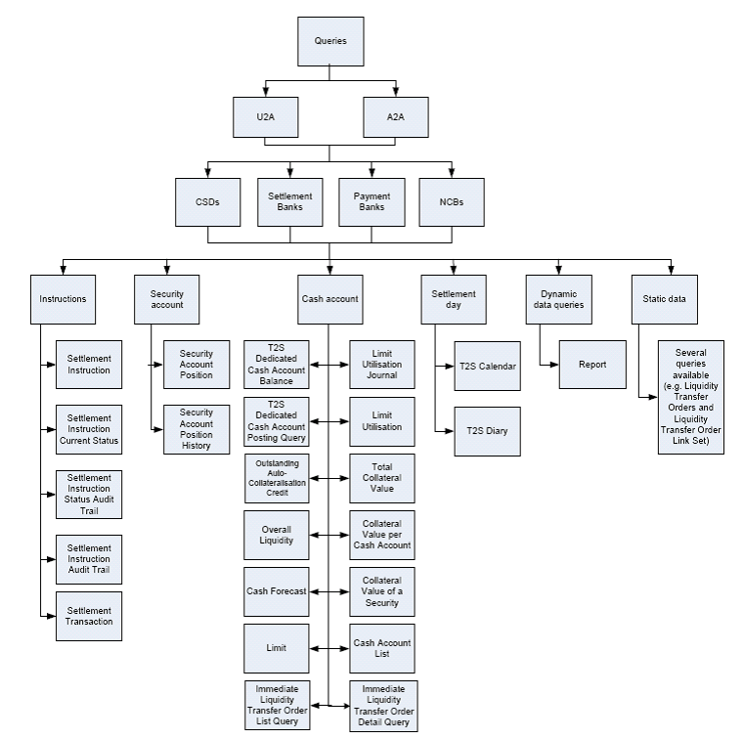

Report query process
Item | Description
Definition | The Report Query Request is sent by a CB, CSD or any party authorised by them to use the report query. It aims at querying the latest available report data of a specific report type. This message enables the sender to request a report (available and/or already sent) according to his access rights. The sender instructs Central System to send the latest available Report and uses the possible selection parameters to specify the report further.
Trigger | The process is triggered when a CB, CSD or any party authorised by them to use the report query, defines specific search criteria. If none or not all of these selection parameters are specified, Central System returns all reports available consistent with the access rights.
Pre-conditions | The System User has the respective privilege to obtain the requested report. The corresponding business data should be available and accessible.
Post-conditions | A Query Response Message for Business Data including requested business data is sent back to the requesting System Actor, i.e. either the retrieved data sets or a notification that the extraction returned a zero result. In case no business data is found a query response message for operational error is sent back to the requesting System Actor indicating the error(s) which occurred.
Role | System Member

Resend Request
This graph describes the inbound and outbound communication within Central System. The main processes are highlighted within the green box:

The following diagrams give an overview of Resend process used within Central System:
Resent Request Process
Item | Description
Definition | The Resend request enables directly connected CSDs, CBs or any parties authorized by them to request the resending of a message or a file (duplicate of the original message/file) supported by Central System. To instruct Central System for the resend of a message the technical address of the receiving party must be specified.
Trigger | The process is triggered when a CB, CSD or any party authorised by them to use the Resend by defining specific criteria, e. g. Business Date (optional field), Sequence number or Original Message Reference can be used to further specify the request: If no Business Date is specified the current Business Date is assumed
Pre-conditions | The System User has the respective privilege to obtain the requested report. The corresponding business data (T2S outbound messages or files) are already produced and accessible
Post-conditions | In response to the Resend Request message, Central System sends first a positive “Validation Result Resend” after the successful permission check. In parallel, the duplicate of the original message/file is sent. If an error occurs resulting from the processing of the Resend Request an error information is sent.
Role | System Member

Receipt Acknowledgement
The diagram below provides a high-level overview of the different functions available. The main processes are highlighted within the green box:
The graph below provides information about the different processes within Central System where a Receipt Acknowledgement is generated (highlighted within the green box):
Receipt Acknowledgement Process
Item | Description
Definition | Receipt Acknowledgement is generated by Central System and sent to a directly connected Participant to inform about a rejection of a message. It is generated only by the Central System. Within Central System this message is generated after a negative authentication process. It can be also sent as an error reporting response to a report query or resend request and as a validation result notification to a resend request.
Trigger | The process is triggered by Central System when a CB, CSD or any party authorised sends a message which leads to a rejection of the Central System platform.
Pre-conditions | This message is sent by Central System for the following reasons: Missing Authentication; Inbound Processing Rejections; Rejection Resend; Validation Result Resend; Oversize and timeout; Report Detail Query Response; Query Queuing Information.
Post-conditions | The Receipt Acknowledgement is sent by Central System not by any other party involved in the process.
Role | System Transaction Administrator

Description of BusinessActivities
This section presents the different BusinessActivities within each BusinessProcess. The BusinessActivities of a process are described with activity diagrams.
Legend
Symbol | Name | Definition
 | Start Point | Shows where the lifecycle of the business process commences.
 | End Point | Shows where the lifecycle of the business process may ends.
 | Lozenge (or diamond) | Indicates that a choice between several actions can be made.
 | Bar | Indicates that several actions are initiated in parallel.

Report Query Request (admi.005)
In the frame of Central System flow, instructing party corresponds to the direct participant, payment bank or CSD, the servicing/executing party or the receiving party is the settlement infrastructure who achieves the report query request.
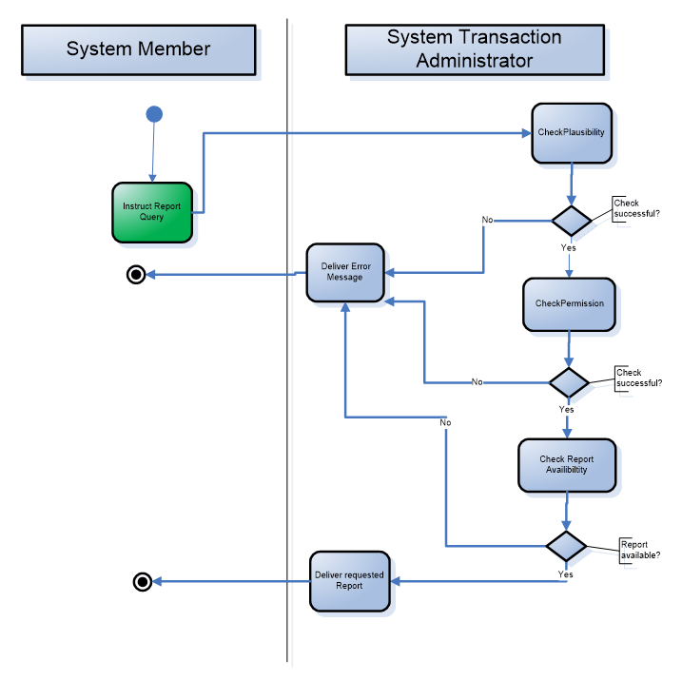
Step | Description | Initiator
Report Query Request | Request to receive a specified report | System Member
Rejection message | Informs the instruction party (by error and description) in case if the instruction of Report Query was not valid for processing.  There could be three different reasons for a rejection message:  - plausibility check not successful  - permission check not successful  - no existing report which can be provided to system member. | System Transaction Administrator
Response | Delivers the requested report (e. g. Statement of Holdings, Statement of Transactions etc.) to the requesting system member | System Transaction Administrator

Resend Request (admi.006)
In the frame of Central flow, instructing party corresponds to the direct participant or payment bank, the servicing/executing party or the receiving party is the settlement infrastructure who achieves the ResendRequest.
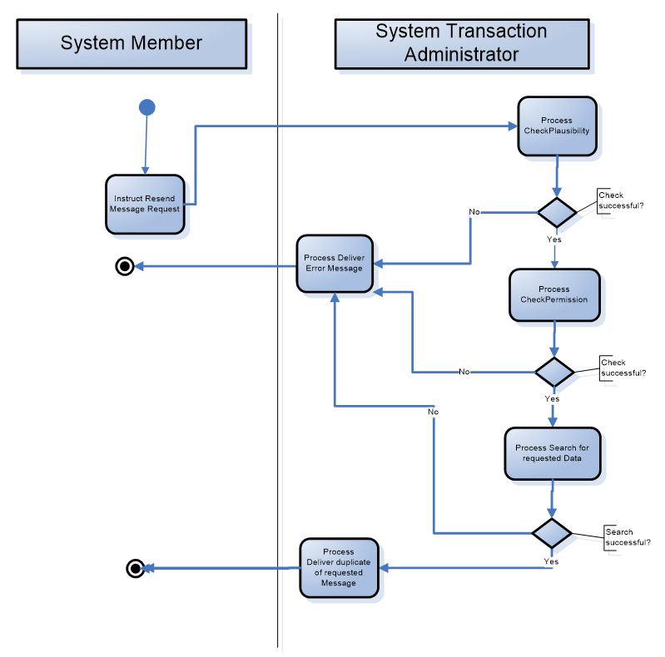

Step | Description | Initiator
Resend Request | Request to initiate the sending of a specified already sent message | System Member
Rejection message | Informs the instructing party (by error and description) in case if the instruction of Resend Message Request was not valid for processing.  There could be three different reasons for a rejection message:  - plausibility check not successful  - permission check not successful  - no existing message which can be provided to system member. | System Transaction Administrator
Response | Delivers the requested message (duplicate of the original) to the requesting system member | System Transaction Administrator

Receipt Acknowledgement (admi.007)
Note: In the frame of the Central System workflows, System Transaction Administrator corresponds to the settlement infrastructure, the System Member to the Central System-Participant.

Scenario 1a
The ReceiptAcknowledgement message can be used to provide a processing status of the initial message. In response the System Transaction Administrator can sent a rejection or an acknowledgement status message (as a kind of a successful receipt).
Step | Description | Initiator
Scenario 1a | Sending of an A2A-message (i.e. Query, Instruction etc.) | System Member
Receipt Acknowledgement | Informs the sending party about the successful receipt (ACK) or by error and description in case the received message was not suitable for processing (NAK). | System Transaction Administrator

Scenario 1b
The ReceiptAcknowledgement message can be used alternatively in case the processing of the message is not possible by the System Transaction Administrator for business reasons (a kind of neutral error report).
Step | Description | Initiator
Scenario 1b | Sending of an A2A-message (i.e. Query, Instruction etc.) | System Member
Receipt Acknowledgement | Informs the sending party why the original message was not suitable for processing, including error or status description. | System Transaction Administrator

BusinessTransactions
This section describes the message flows based on the activity diagrams documented above. It shows the typical exchanges of information in the context of a BusinessTransaction.

Report Query Request Business Transaction (admi.005)
As outlined above a CSD, NCB or directly connected Central System party sends a report query to the Central System (e. g.T2S platform) to request the latest available data of a specific report type. An overview of the communication flow and sequence diagram can be found below:

Resend Request Business Transaction (admi.006)

As outlined above CSDs, NCBs or any parties authorised by them send a Resend Request to the Central System to receive the requested message again. If the requested message is available a duplicate message will be sent by Central Systemin push mode. The description of the communication flow and sequence diagram see below (Duplicate indication is provided within the BAH as part of the business message):

Receipt Acknowledgement Business Transaction (admi.007)

Scenario 1: Receipt Acknowledgement sent by Central System e. g. T2S platform
The incoming A2A (Application to Application) messages/files are replied by the Receipt-Acknowledgement message, which acknowledges the receipt of a message (“ACK”) or works as a negative acknowledgement (“NAK”) in case of an error or for business reasons and provide information about the status (e.g. rejection, acceptance) of an instruction. This Receipt-ACK is generated by the Central system (e. g. T2S platform).

Examples
This section describes business examples of the use of the various MessageDefinitions for Report Query Request, Resend Request, and Receipt Acknowledgement Each example starts with a description of the example scenario followed by the actual Message Instance. All XML instances are embedded in the BAH, but the XML message instance provided below do only show the content of the pure business message.

Report Query Request - admi.005.001
Description
The Report Query Request message is sent by a System Member to a System Transaction Administrator. In this example a “Complete Statement of pending Amendment Instructions for Intra-Position Movements and Settlement Instruction report” identified via code “CPAP” dated 2017-08-13 is requested from Party “ACCTOWNRXXX” belonging to Parent BIC “ACCTSVCRXXX”.
Search criteria which are defined:
- Report Name: Complete Statement of pending Amendment Instructions …”CPAP”
- Party Identification via two BICs: “ACCTOWNRXXX” and “ACCTSVCRXXX”
- Date when the Report was produced: 2017-08-13
Message Instance

<RptQryReq>
<MsgHdr>
<MsgId>T2SREPORTQUERY01</MsgId>
</MsgHdr>
<RptQryCrit>
<SchCrit>
<RptNm>CPAP</RptNm>
<PtyId>
<Id>
<AnyBIC>ACCTOWNRXXX</AnyBIC>
</Id>
</PtyId>
<RspnsblPtyId>
<Id>
<AnyBIC>ACCTSVCRXXX</AnyBIC>
</Id>
</RspnsblPtyId>
<DtSch>
<EQDt>2017-08-13</EQDt>
</DtSch>
</SchCrit>
</RptQryCrit>
</RptQryReq>

Resend Request - admi.006.001
Description
The Resend Request message is sent by a System Member to the System Transaction Administrator to request the resending of an already sent message. In this example a Resend Request with the Message Identification RESENDREQUEST01 and the corresponding sequence number “1234567890111213” and the business date 2017.11.11 is sent to T2S.
Selection criteria chosen for the message resend request:
- Business Date: 2017-11-11
- Sequence Number: “1234567890111213“
- Date when the Report was produced: 2017-08-13
- Party Technical address to which the original messages was sent: cn=smith,ou= t2s-ops, o=bnkacctt
Message Instance
<RsndReq>
<MsgHdr>
<MsgId>RESENDREQUEST01</MsgId>
</MsgHdr>
<RsndSchCrit>
<BizDt>2017-11-11</BizDt>
<SeqNb>1234567890111213</SeqNb>
<Rcpt>
<Id>
<NmAndAdr>
<Nm>cn=smith,ou= t2s-ops, o=bnkacctt</Nm>
</NmAndAdr>
</Id>
</Rcpt>
</RsndSchCrit>
</RsndReq>

Receipt Acknowledgement - admi.007.001
Description 1
The Receipt Acknowledgement is used in this usage by T2S to inform a T2S Actor (Sender), that an incoming message has caused an error during its processing. It reports the error which occurred in an error code and, if available, in a textual description. In this example a Receipt Acknowledgement “Inbound Processing Rejection” referring to an incoming message with the ID INCOMINGMSG03 with error code “I012” and description “IICR001-The party technical 3 address does not exist” is sent to the corresponding party.
Message Instance 1

<RctAck>
<MsgId>
<MsgId>NONREF</MsgId>
</MsgId>
<Rpt>
<RltdRef>
<Ref>INCOMINGMSG03</Ref>
</RltdRef>
<ReqHdlg>
<StsCd>I012</StsCd>
<Desc>IICR001-The party technical address does not exist</Desc>
</ReqHdlg>
</Rpt>
</RctAck>
Description 2
The Receipt Acknowledgement Validation Result Resend message is used in this usage to inform the sender of a message that his request for resending a message could be successfully processed by T2S. It reports the positive status in a coded form.
In this example a Receipt Acknowledgement “Validation Result Resend” referring to an incoming message with the ID RESENDREQOK01 with status code “OK” is sent to the corresponding party.
Message Instance 2
<RctAck>
<MsgId>
<MsgId>NONREF</MsgId>
</MsgId>
<Rpt>
<RltdRef>
<Ref>RESENDREQOK01</Ref>
</RltdRef>
<ReqHdlg>
<StsCd>OK</StsCd>
</ReqHdlg>
</Rpt>
</RctAck>

Revision Record

Revision | Date | Author | Description | Sections affected
1.0 | Dec 2023 | 4CB and SWIFT | Draft version for SEG review, based on maintenance 2023/2024 | All
2.0 | March 2024 | ISO 20022 RA | Approved version | All

Disclaimer:
Although the Registration Authority has used all reasonable efforts to ensure accuracy of the contents of the iso20022.org website and the information published thereon, the Registration Authority assumes no liability whatsoever for any inadvertent errors or omissions that may appear thereon. Moreover, the information is provided on an "as is" basis. The Registration Authority disclaims all warranties and conditions, either express or implied, including but not limited to implied warranties of merchantability, title, non-infringement and fitness for a particular purpose.
The Registration Authority shall not be liable for any direct, indirect, special or consequential damages arising out of the use of the information published on the iso20022.org website, even if the Registration Authority has been advised of the possibility of such damages.

Intellectual Property Rights:
The ISO 20022 MessageDefinitions described in this document were contributed described in this document were contributed Deutsche Bundesbank on behalf of 4CB and SWIFT for Target2-Securites. The ISO 20022 IPR policy is available at www.ISO20022.org > About ISO 20022 > Intellectual Property Rights.

Sequence number which informs the recipient of the message about the business order of settlement status/notification messages in T2-Securities.

