ISO 20022

Authorities Financial Investigations
Maintenance 2023 - 2024

Message Definition Report Part 1
Approved by the Payments SEG on 18 January 2024
This document provides information about the use of the messages for Authorities Financial Investigations and includes, for example, business scenarios and messages flows.
February 2024

Table of Contents
Table of Contents 2
1 Introduction 5
1.1 Terms and Definitions 5
1.2 Abbreviations and Acronyms 5
1.3 Document Scope and Objectives 5
1.4 References 6
2 Scope and Functionality 7
2.1 Background 7
2.2 Scope 7
2.3 Groups of MessageDefinitions and Functionality 8
3 BusinessRoles and Participants 9
3.1 Participants and BusinessRoles Definitions 9
3.2 BusinessRoles and Participants Table 9
4 BusinessProcess Description 10
4.1 Business Use Case Diagram 10
4.2 Business Process Flows 12
5 Description of BusinessActivities 13
5.1 Financial Information Request Initiation, Validation and Processing 14
5.2 Financial Information Request Change of Status 15
6 BusinessTransactions 17
6.1 Scenario 1 - Response Status : Complete 17
6.2 Scenario 2 – Response status : Partially 17
6.3 Scenario 3 – Response status : No response 18
7 Revision Record 19

Preliminary Note
The Message Definition Report (MDR) is made of three parts:
MDR Part 1
This describes the contextual background required to understand the functionality of the proposed message set. Part 1 is produced by the submitting organisation that developed or maintained the message set in line with an MDR Part 1 template provided by the ISO 20022 Registration Authority (RA) on www.iso20022.org.
MDR Part 2
This is the detailed description of each message definition of the message set. Part 2 is produced by the RA using the model developed by the submitting organisation.
MDR Part 3
This is an extract if the ISO 20022 Business Model describing the business concepts used in the message set. Part 3 is an Excel document produced by the RA.

Introduction

Terms and Definitions
The following terms are reserved words defined in ISO 20022 Edition 2013 – Part1. When used in this document, the UpperCamelCase notation is followed.
Term | Definition
BusinessRole | Functional role played by a business actor in a particular BusinessProcess or BusinessTransaction.
Participant | Involvement of a BusinessRole in a BusinessTransaction.
BusinessProcess | Definition of the business activities undertaken by BusinessRoles within a BusinessArea whereby each BusinessProcess fulfils one type of business activity and whereby a BusinessProcess may include and extend other BusinessProcesses.
BusinessTransaction | Particular solution that meets the communication requirements and the interaction requirements of a particular BusinessProcess and BusinessArea.
MessageDefinition | Formal description of the structure of a message instance.
When a MessageDefinition or message identifier is specified, it should include the variant and version number. However, in this document (except in the business examples section, if present), variant and version numbers are not included. In order to know the correct variant and version number for a MessageDefinition, the related Message Definition Report Part 2 document should be consulted.

Abbreviations and Acronyms
The following is a list of abbreviations and acronyms used in the document.
Abbreviation/Acronyms | Definition
ACK | Acknowledgement
NAK | Negative Acknowledgement (reject)
FFI | Finance Finland
MCR | Maintenance Change Request
MDR | Message Definition Report
XML | eXtensible Mark-up Language

Document Scope and Objectives
This document is the first part of ISO 200222 Message Definition Report (MDR) that describes the BusinessTransactions and underlying message set. For the sake of completeness, the document may also describe BusinessActivities that are not in the scope of the business processes covered in this document.
This document describes the following:
- the BusinessProcess scope
- the BusinessRoles involved in these BusinessProcesses
The main objectives of this document are as follows:
- to provide information about the messages that support the BusinessProcesses
- to explain the BusinessProcesses and BusinessActivities these messages have addressed
- to give a high level description of BusinessProcesses and the associated BusinessRoles
- to document the BusinessTransactions
- to provide business examples
The MessageDefinitions are specified in Message Definition Report Part 2.

References
Document | Version | Date | Author
ISO 20022 Business Justification – Authorities Financial Investigation |  | 2011-10-28 | FFI, now
ISO 20022 Business Justification – Authorities Financial Investigation /  The MCR #234 – Payments Maintenance 2023/2024 |  | 2023-12-07 | Swift

Scope and Functionality

Background
This Message Definition Report covers a set of three ISO 20022 MessageDefinitions developed by Finance Finland and approved by ISO 20022 Payments Standards Evaluation Group (SEG) on 18 January 2024.
The set of Authorities Financial Investigations candidate message definitions described in this document is exchanged between Authorities who have a legal right to request account and other banking and financial instrument information to carry out their duties and the Financial Institutions to which they make these requests. Requested information can relate to accounts, their signatories and beneficiaries and co-owners as well as movements plus positions on these accounts. Additionally, this information can pertain to loans and guarantees..
These messages are specifically designed to support FFI members with the standardized messaging flows related to authorities’ financial investigations to fulfilling the Finnish government’s aims. In parallel, FFI has found that other countries have expressed interest in the standardization of these flows.

Scope
The scope of this Authorities Financial Investigations project addresses the messaging between Authorities who have a legal right to request account and other banking and financial instrument information to carry out their duties and the Financial Institutions to which they make these requests. Requested information can relate to accounts, their signatories and beneficiaries and co-owners as well as movements plus positions on these accounts. Additionally, this information can pertain to loans and guarantees.
Requests are underpinned by specific legal texts, each one determining a specific scope of response by the financial institutions.

Groups of MessageDefinitions and Functionality

Groups
Authorities Financial Investigations
A set of three investigations messages have been defined based on existing ISO 20022 transaction and reporting messagess.
The content of the messages provides for:
- Request account and other banking and financial information. Requested information can relate to accounts, their signatories and beneficiaries and co-owners as well as movements plus positions on these accounts Extensive invoice line item detail. This request is sent by authorities (police, customs, tax authorities, enforcement authorities) to a financial institution;
- Response to the request to provide a part or all of the requested information. The response is sent by the financial institution to the authorities (police, customs, tax authorities, enforcement authorities) to References to other documents such as purchase orders, including line item details;
- Notification sent by the authorities (police, customs, tax authorities, enforcement authorities) to a financial institution to inform the financial institution that the confidentiality status of the investigation has changed.
MessageDefinition | Message Identifier
InformationRequestOpening | auth.001
InformationRequestRespone | auth.002
InformationRequestStatusChangeNotification | auth.003

Functionality
See Message Definition Report Part 2 for the message scopes and formats.

BusinessRoles and Participants
A BusinessRole represents an entity (or a class of entities) of the real world, physical or legal, a person, a group of persons, a corporation. Examples of BusinessRoles: “Financial Institution”, “Automated Clearing House”, “Central Securities Depository”.
A Participant is a functional role performed by a BusinessRole in a particular BusinessProcess or BusinessTransaction. Examples of Participants: the “user” of a system, “debtor”, “creditor”, “investor”.
The relationship between BusinessRoles and Participants is many-to-many. One BusinessRole can be involved as different Participants at different moments in time or at the same time. Examples of BusinessRoles: "user", "debtor”, "creditor", "investor". Different BusinessRoles can be involved as the same Participant.
In the context of Stand-alone Remittance the high-level BusinessRoles and typical Participants can be represented as follows:

Participants and BusinessRoles Definitions
BusinessRoles
Description | Definition
Investigator | An organisation with authority granted by the government to perform financial investigations with the collaboration of Financial Institutions.
Account servicer | Party that manages the account on behalf of the account owner (that is, manages the registration and booking of entries on the account, calculates balances on the account and provides information about the account), or the party that has a contractual relationship with the owner (for example, market data provider).
Participants
Description | Definition
Authority | In the current scope of this project, the following organisations have been identified as authorities:  - Police,  - Customs,  - Tax authorities,  - Enforcement authorities  - Collection authorities.
Financial Institution | In the scope of this project, the Financial Institution is an organisation with a valid banking licence in the country of the Authority making the Financial Investigation related request

BusinessRoles and Participants Table
Participant | BusinessRole  Investigator | BusinessRole  Account servicer
Authority | X
Financial Institution |  | X

BusinessProcess Description

Business Use Case Diagram
This diagram represents the high level BusinessProcesses.
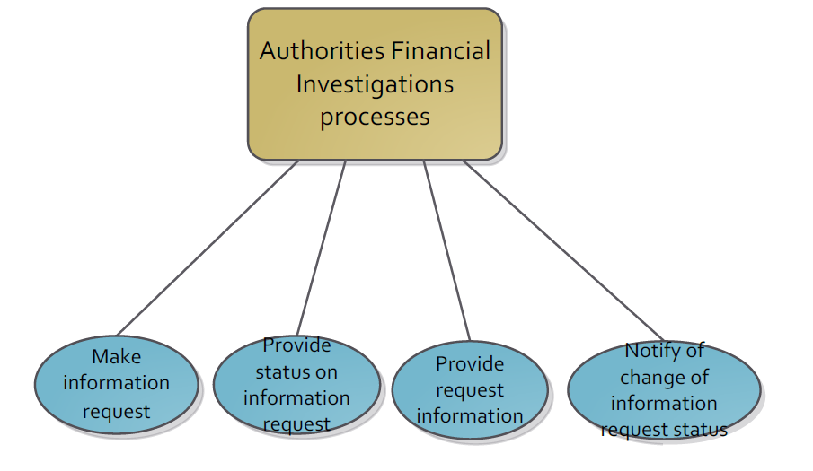
Make information request process
Item | Description
Definition | Process by which an Authority, on a specifically defined legal basis, and in the scope of a specific investigation, requests financial information from a Financial Institution, this information being related to an organisation, an account, its owner or another party related to the account (beneficiary, signatory, etc....).
Trigger | The process is triggered when Authorities are carrying out their duties.
Pre-conditions | The request has to be underpinned by specific legal texts.
Post-conditions | None.
Role | Investigator (Authority)

Provide status on information request process
Item | Description
Definition | Process by which a Financial Institution which has received a request for financial information in the scope of a financial investigation provides the Authority with the status of the request.
Trigger | the process is triggered when a request has been received.
Pre-conditions | None.
Post-conditions | None.
Role | Account Servicer

Provide request information
Item | Description
Definition | Process by which a Financial Institution which has received a request for financial information in the scope of a financial investigation provides the Authority with a part or all of the requested information.
Trigger | The process is triggered when a request has been received.
Pre-conditions | None.
Post-conditions | None.
Role | Account Servicer

Notify of change of information request status
Item | Description
Definition | Process by which an Authority, in the scope of a specific investigation, informs the Financial Institution that the status of the investigation has changed. The currently foreseen change of status to be informed by the Authority to the Financial Institution is the confidentiality status, i.e. whether or not the account owner or other party related to the account (beneficiary, signatory, etc...) can be informed of the existence of this investigation by the Financial Institution.
Trigger | Change of confidentiality status at the Authorities level.
Pre-conditions | None.
Post-conditions | None.
Role | Investigator (Authority)

Business Process Flows
The process flows hereafter describe a possible high level sequence of the processes defined in the previous chapter.
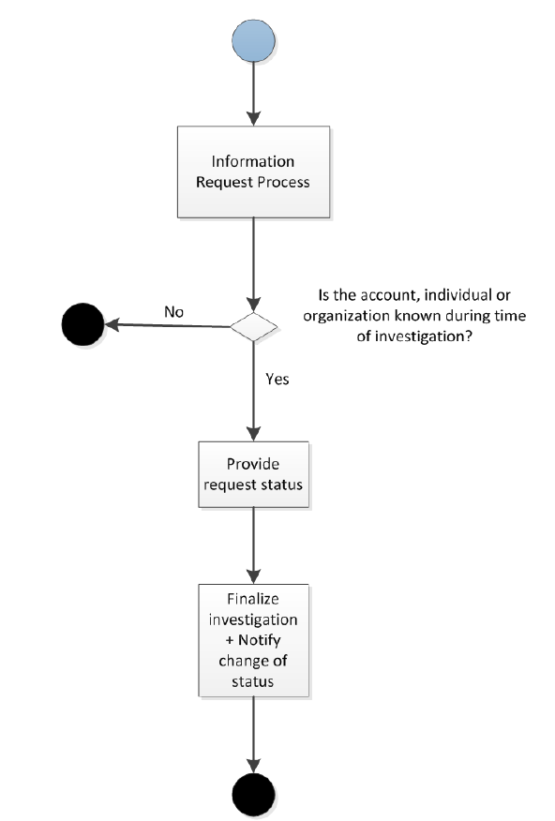

Description of BusinessActivities
This section presents the different BusinessActivities within each BusinessProcess. The BusinessActivities of a process are described with activity diagrams.
Legend
Symbol | Name | Definition
 | Start Point | Shows where the lifecycle of the business process commences.
 | End Point | Shows where the lifecycle of the business process may ends.
 | Lozenge (or diamond) | Indicates that a choice between several actions can be made.
 | Bar | Indicates that several actions are initiated in parallel.

Financial Information Request Initiation, Validation and Processing
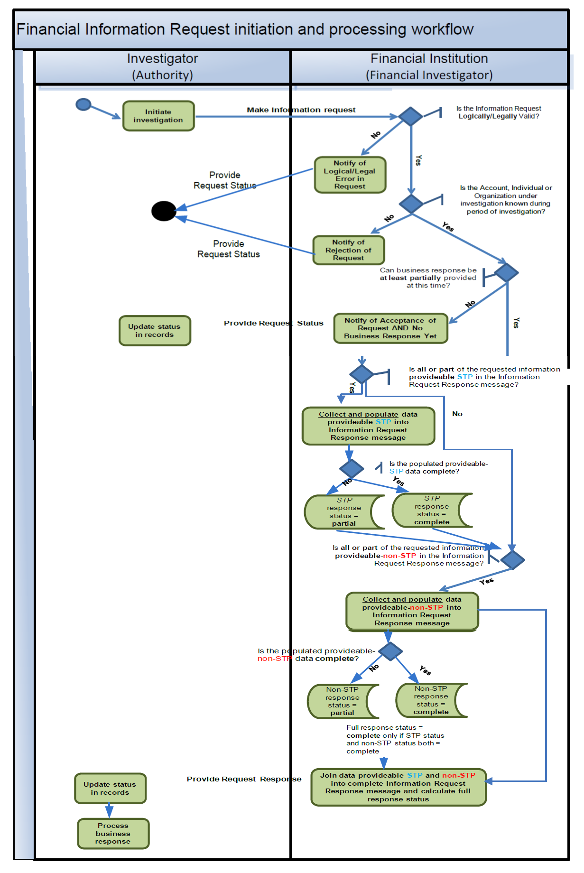

Step | Description | Initiator
Initiate Investigation | The authorities initiate an investigation of related to an account, their signatories and beneficiaries and co-owners as well as movements plus positions on these accounts. | Authorities
Check of Records for Account and Notify the Authorities | The queried Financial Institution checks whether the account, organisation or individual referred to in the investigation were/are known within the specified investigation dates.  If so, the Financial Institution must provide a business response to the Authority with the status of the response (complete, partial or response not provided yet).  If not, the Financial Institution must notify the Authority in rejecting the Information Request. | Financial Institution
Change of Status | If the confidentiality status of a specific request changes, the authorities will notify the financial institution | Authorities

Financial Information Request Change of Status
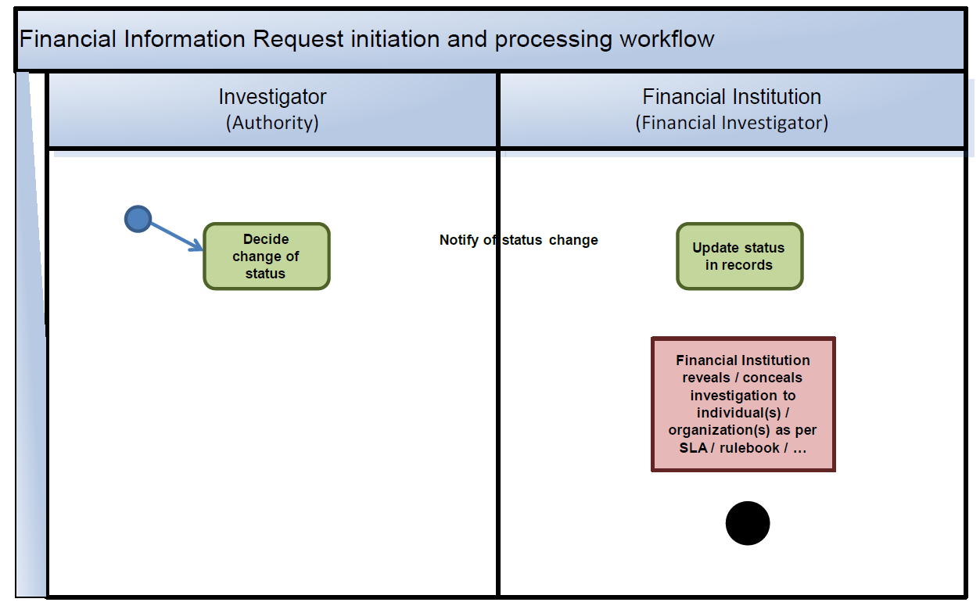

Step | Description | Initiator
Decide Change of Status | The change of status notification from the Authority to the Financial Institution is currently foreseen for the change of confidentiality of the investigation underlying the financial information request.  - Typically, the change will be from confidential to non-confidential.  - Additionally, the change may be from non-confidential to confidential following an incorrect initial description of the investigation in the initial Request message. | Authorities
OUT OF SCOPE | The Financial Institution that has been notified of a change to non-confidential is thereby allowed to notify the individual(s) or organisation(s) of the fact that they have been investigated by the Authority. | Financial Institution

BusinessTransactions
This section describes the message flows based on the activity diagrams documented above. It shows the typical exchanges of information in the context of a BusinessTransaction.
In black, the mandatory messages.
In dotted line, the optional/potential messages.

Scenario 1 - Response Status : Complete
The Authority sends an information request opening message to a financial institution. Subsequently the financial institution sends an information request response message with one of the following response status (complete, partially or no response yet).
In the case that the response status is complete, the communication flow stops here. If there is a status change related to this information request a last message could follow informing the financial institution.
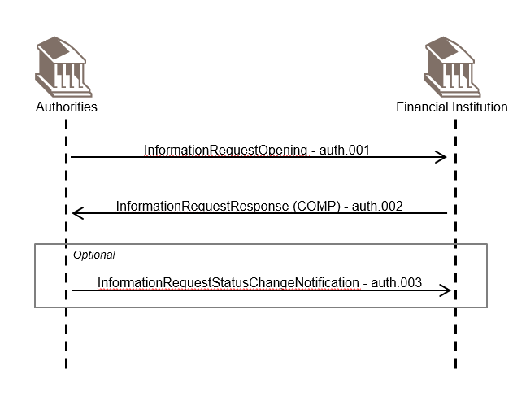

Scenario 2 – Response status : Partially
The Authority sends an information request opening message to a financial institution. Subsequently the financial institution sends an information request response message with the response status partially (PART).
In the case the response status is partially complete, at a later stage a second information request response message will follow with the response status complete. If there is a status change related to this information request a last message could follow informing the financial institution.

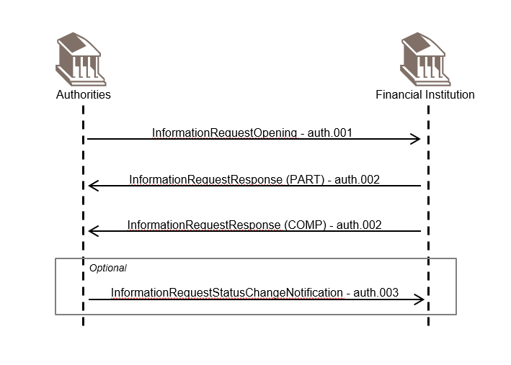

Scenario 3 – Response status : No response
The Authority sends an information request opening message to a financial institution. Subsequently the financial institution sends an information request response message with the response status no response (NRES).
In the case the response status is no response, a second information request response message will follow with the response information and the response status set to either complete or partially. Subsequently a third information request response message could follow with the full response and the response status set to complete. If there is a status change related to this information request a last message could follow informing the financial institution.
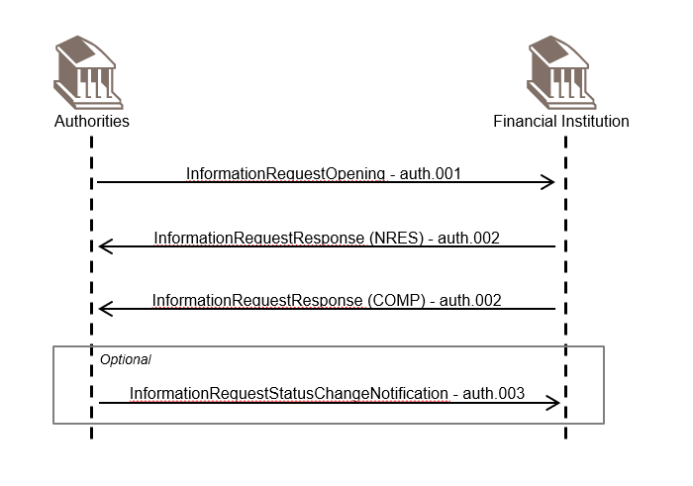

Revision Record

Revision | Date | Author | Description | Sections affected
1.0 | 07 December 2023 | Finance Finland | Draft version for SEG Review | All
2.0 | 18 January 2024 | RA | Approved version | Title, 2 and 7

Disclaimer:
Although the Registration Authority has used all reasonable efforts to ensure accuracy of the contents of the iso20022.org website and the information published thereon, the Registration Authority assumes no liability whatsoever for any inadvertent errors or omissions that may appear thereon. Moreover, the information is provided on an "as is" basis. The Registration Authority disclaims all warranties and conditions, either express or implied, including but not limited to implied warranties of merchantability, title, non-infringement and fitness for a particular purpose.
The Registration Authority shall not be liable for any direct, indirect, special or consequential damages arising out of the use of the information published on the iso20022.org website, even if the Registration Authority has been advised of the possibility of such damages.

Intellectual Property Rights:
The ISO 20022 MessageDefinitions described in this document were contributed by Finance Finland. The ISO 20022 IPR policy is available at www.ISO20022.org > About ISO 20022 > Intellectual Property Rights.

