ISO 20022
Charges Management - Maintenance 2023 - 2024

Message Definition Report Part 1
Approved by the Payments SEG on 8th January 2024
This document provides information about the use of the messages for Charges Management

March 2024

Table of Contents
Table of Contents 2
1 Introduction 5
1.1 Terms and Definitions 5
1.2 Abbreviations and Acronyms 5
1.3 Document Scope and Objectives 5
1.4 References 6
2 Scope and Functionality 7
2.1 Background 7
2.2 Scope 7
2.3 Groups of Message Definitions and Functionality 7
3 BusinessRoles and Participants 9
3.1 Participants and BusinessRoles Definitions 9
3.2 BusinessRoles and Participants Table 10
4 BusinessProcess Description 11
5 Description of BusinessActivities 12
5.1 Charges Payment Notification 12
5.2 Charges Payment Request 13
6 BusinessTransactions 14
6.1 Charges Payment Notification 14
6.2 Charges Payment Request 14
7 Business Examples 15
7.1 ChargesPaymentNotification camt.105.001.02 15
7.2 ChargesPaymentRequest camt.106.001.02 16
8 Revision Record 18

Preliminary Note
The Message Definition Report (MDR) is made of three parts:
MDR Part 1
This describes the contextual background required to understand the functionality of the proposed message set. Part 1 is produced by the submitting organisation that developed or maintained the message set in line with an MDR Part 1 template provided by the ISO 20022 Registration Authority (RA) on www.iso20022.org.
MDR Part 2
This is the detailed description of each message definition of the message set. Part 2 is produced by the RA using the model developed by the submitting organisation.
MDR Part 3
This is an extract if the ISO 20022 Business Model describing the business concepts used in the message set. Part 2 is an Excel document produced by the RA.

Introduction

Terms and Definitions
The following terms are reserved words defined in ISO 20022 Edition 2013 – Part1. When used in this document, the UpperCamelCase notation is followed.
Term | Definition
BusinessRole | Functional role played by a business actor in a particular BusinessProcess or BusinessTransaction.
Participant | Involvement of a BusinessRole in a BusinessTransaction.
BusinessProcess | Definition of the business activities undertaken by BusinessRoles within a BusinessArea whereby each BusinessProcess fulfils one type of business activity and whereby a BusinessProcess may include and extend other BusinessProcesses.
BusinessTransaction | Particular solution that meets the communication requirements and the interaction requirements of a particular BusinessProcess and BusinessArea.
MessageDefinition | Formal description of the structure of a message instance.
When a MessageDefinition or message identifier is specified, it should include the variant and version number. However, in this document (except in the business examples section, if present), variant and version numbers are not included. In order to know the correct variant and version number for a MessageDefinition, the related Message Definition Report Part 2 document should be consulted.

Abbreviations and Acronyms
The following is a list of abbreviations and acronyms used in the document.
Abbreviation/Acronyms | Definition
camt | ISO 20022 Cash Management business area

Document Scope and Objectives
This document is the first part of the Message Definition Report (MDR) that describes the BusinessTransactions and underlying message set. For the sake of completeness, the document may also describe BusinessActivities that are not in the scope of the business processes covered in this document.
This document describes the following:
- the BusinessProcess scope
- the BusinessRoles involved in these BusinessProcesses
The main objectives of this document are as follows:
- to provide information about the messages that support the business processes
- to explain the BusinessProcesses and BusinessActivities these messages have addressed
- to give a high level description of BusinessProcesses and the associated BusinessRoles
- to document the BusinessTransactions
- to provide business examples
The messages definitions are specified in Message Definition Report Part 2.

References
Document | Version | Date | Author
ISO20022BJ_SWIFT_ChequesCharges_v1.doc | 2020 | 2020-07-03 | SWIFT
ISO20022_MDRPart1_ExceptionsAndInvestigations_2019_2020_v2.docx | 2020 | 2020-01-09 | SWIFT
ISO 20022 Maintenance Change Request (MCR #217) document  (Fast Track Charge Maintenance) | 2023 | 2023-04-30 | SWIFT
ISO 20022 Maintenance Change Request (MCR #234) document (Payments Maintenance 2023/2024) | 2023 | 2023-08-31 | SWIFT

Scope and Functionality

Background
This Message Definition Report covers a set of two message definitions developed by SWIFT in close collaboration with payments market infrastructure and cash service providers and approved by the Payments Standards Evaluation Group (SEG) on 8th January 2024. These messages are specifically designed to support charge management.

Scope
The charge management messages facilitates the account servicing institution to notify and request charges payment.


Groups of Message Definitions and Functionality

These messages are to be used with the ISO 20022 Business Application Header (head.001). The schema and more information about the Business Application Header (BAH) can be found on the www.iso20022.org web site

Groups
The messages in this message set cover charge management.

Charge Management

MessageDefinition | Message Identifier
ChargesPaymentNotification | camt.105
ChargesPaymentRequest | camt.106

Related Messages
ChargesPaymentRequest is used to request charges for the cash management initiation and case management workflow.
MessageDefinition | Message Identifier
CustomerPaymentCancellationRequest | camt.055
FIToFIPaymentCancellationRequest | camt.056
RequestToModifyPayment | camt.087
ClaimNonReceipt | camt.027
UnableToApply | camt.026
ResolutionOfInvestigation | camt.029
NotificationOfCaseAssignment | camt.030
RequestForDuplicate | camt.033
Duplicate | camt.034
RejectInvestigation | camt.031
CancelCaseAssignment | camt.032
CaseStatusReportRequest | camt.038
CaseStatusReport | camt.039
DebitAuthorisationRequest | camt.037
DebitAuthorisationResponse | camt.036
AdditionalPaymentInformation | camt.028
ProprietaryFormatInvestigation | camt.035

Functionality
See Message Definition Report Part 2 for the message formats.

BusinessRoles and Participants
A BusinessRole represents an entity (or a class of entities) of the real world, physical or legal, a person, a group of persons, a corporation. Examples of BusinessRoles: “Financial Institution”, “Automated Clearing House”, “Central Securities Depository”.
A Participant is a functional role performed by a BusinessRole in a particular BusinessProcess or BusinessTransaction. Examples of Participants: the “user” of a system, “debtor”, “creditor”, “investor”.
The relationship between BusinessRoles and Participants is many-to-many. One BusinessRole can be involved as different Participants at different moments in time or at the same time. Examples of BusinessRoles: "user", "debtor”, "creditor", "investor". Different BusinessRoles can be involved as the same Participant.
In the context of Charge Management the high-level BusinessRoles and typical Participants can be represented as follows:
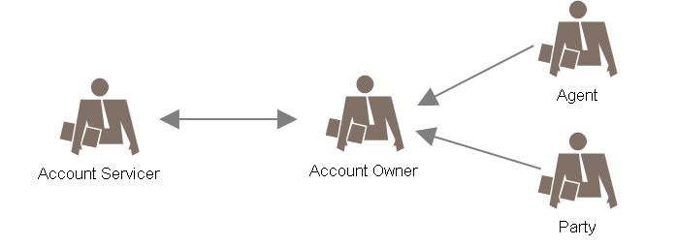

Participants and BusinessRoles Definitions
Participants
Description | Definition
Account Servicer | Agent, which can be a financial institution or a service provider, that provides account services.  Also named Account Servicing Institution
Account Owner | Party that legally owns the account with the account servicer.
Business Roles
Description | Definition
Agent | Organisation established primarily to provide financial services to the account owners.  An agent could also be the owner of an account with another account servicing institution
Party | Non-financial institution (organisation or person), owns an account with the account servicing institution

BusinessRoles and Participants Table
 | Participant
BusinessRole | Account Servicer | Account Owner
Agent | X | X
Party |  | X

BusinessProcess Description
This diagram represents the high level BusinessProcesses.
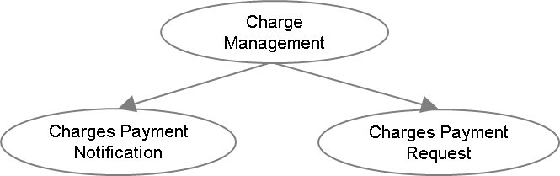
Charges Payment Notification
Item | Description
Definition | The account owner is notified by the account servicing institution about the charges, interest or other adjustments which have been debited or credited which are previously unknown to the account owner.
Trigger | Charges, interest or other adjustment payments
Pre-conditions | The charges, interest or other adjustments have been debited or credited to the account owner's account
Post-conditions | Successful notification of charges, interest or other adjustment payments
Role | Account servicing institution; account owner (financial institution or customer)
Charges Payment Request
Item | Description
Definition | The account servicing institution requests the account owner (financial institution) for the payment of charges, interest and other expenses that are previously unknown to the account owner.
Trigger | Charges, interest or other adjustment payments
Pre-conditions | Chargeable service availed by the account owner
Post-conditions | Successful charges, interest or other adjustment payments
Role | Account servicing institution, account owner (financial institution)

Description of BusinessActivities
This section presents the different BusinessActivities within each BusinessProcess. The BusinessActivities of a process are described with activity diagrams.
Legend
Symbol | Name | Definition
 | Start Point | Shows where the lifecycle of the business process commences.
 | End Point | Shows where the lifecycle of the business process may ends.
 | Lozenge (or diamond) | Indicates that a choice between several actions can be made.
 | Bar | Indicates that several actions are initiated in parallel.

Charges Payment Notification
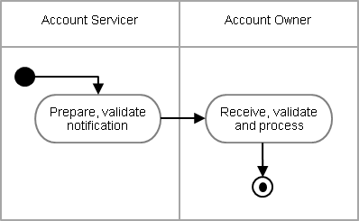

Step | Description | Initiator
Prepare, validate notification | The validated notification sent to the account owner. A single message can contain one or more sets of charges and payment details. . | Account Servicer
Receive, validate and process | The notification received, validated and processed. | Account Owner

Charges Payment Request
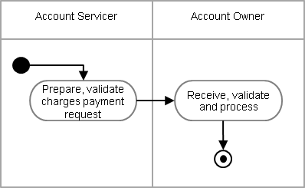

Step | Description | Initiator
Prepare, validate charges payment request | The validated charges payment request sent to the account owner. A single message can contain one or more sets of charges and payment details. | Account Servicer
Receive, validate and process | The charges payment message received, validated and processed. | Account Owner

BusinessTransactions
This section describes the message flows based on the activity diagrams documented above. It shows the typical exchanges of information in the context of a BusinessTransaction.

Charges Payment Notification
The account serving institution sends a ChargesPaymentNotification message to the account owner. These charges, interest or other adjustment details are previously unknown to the account owner. A single notification message can have one or many sets of charges information.
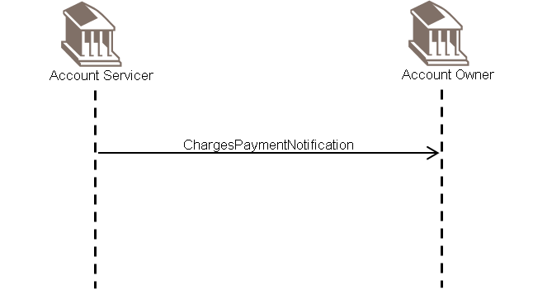

Charges Payment Request
The account serving institution sends a ChargesPaymentRequest message to the account owner. These charges, interest or other expenses are previously unknown to the account owner. A single charges payment request message can have one or many sets of charges information.
The charges payment request will be addressed through the Exception and Investigations message set.
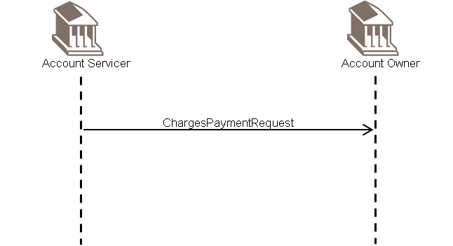

Business Examples
This section describes business examples of the use of the various MessageDefinitions.

ChargesPaymentNotification camt.105.001.02
Description
A ChargesPaymentNotification message is sent by an account service provider to the account owner, to advise charges that are previously unknown to the account owner.
Message Instance
XML | Comment
<ChrgsPmtNtfctn> | Charges Payment Notification
<GrpHdr> | Group Header
<MsgId>00301</MsgId> | Message Identification
<CreDtTm>2001-12-17T09:30:00</CreDtTm> | Creation Date Time
<TtlChrgs> | Total Charges
<NbOfChrgsRcrds>1</NbOfChrgsRcrds> | Number Of Charges Records
</TtlChrgs>
</GrpHdr>
<Chrgs> | Charges (one repetition)
<Sngl> | Single
<UndrlygTx> | Underlying Transaction
<MsgId>AAAA100628-123v</MsgId> | Message Identification
<ChqNb>210092979</ChqNb> | Cheque Number
</UndrlygTx>
<Amt Ccy="GBP">10</Amt> | Amount
<CdtDbtInd>DBIT</CdtDbtInd> | Credit Debit Indicator
<DbtrAgt>
<FinInstnId>
<BICFI>PEFIUS33LAX</BICFI> | Debtor Agent
</FinInstnId>
</DbtrAgt>
<ChrgsAcct>
<Id>
<IBAN>BE30001216371411</IBAN> | Charges Account
</Id>
</ChrgsAcct>
<Tp>
<Cd>COMM</Cd> | Commission
</Tp>
</Sngl>
</Chrgs>
</ChrgsPmtNtfctn>

ChargesPaymentRequest camt.106.001.02
Description
A ChargesPaymentRequest message is sent by an account service provider to the account owner, to request charges payment that are previously unknown to the account owner.
Message Instance
XML | Comment
<ChrgsPmtReq> | Charges Payment Request
<GrpHdr> | Group Header
<MsgId>00242</MsgId> | Message Identification
<CreDtTm>2001-12-17T09:30:00</CreDtTm> | Creation Date Time
<TtlChrgs> | Total Charges
<NbOfChrgsRcrds>1</NbOfChrgsRcrds> | Number Of Charges Records
</TtlChrgs>
</GrpHdr>
<Chrgs> | Charges
<Sngl> | Single
<UndrlygTx> | Underlying Transaction
<MsgId>AAAA102624-769</MsgId> | Message Identification
</UndrlygTx>
<Amt Ccy="GBP">10</Amt> | Amount
<DbtrAgt>
<FinInstnId>
<BICFI>PEFIUS45LAX</BICFI> | Debtor Agent
</FinInstnId>
</DbtrAgt>
<Tp>
<Cd>BRKF</Cd> | Brokerage Fee
</Tp>
</Sngl>
</Chrgs>
</ChrgsPmtReq>

Revision Record

Revision | Date | Author | Description | Sections affected
1.0 | December 2023 | SWIFT | Draft version for SEG review | All
2.0 | March 2024 | ISO 20022 RA | Approved version | All

Disclaimer:
Although the Registration Authority has used all reasonable efforts to ensure accuracy of the contents of the iso20022.org website and the information published thereon, the Registration Authority assumes no liability whatsoever for any inadvertent errors or omissions that may appear thereon. Moreover, the information is provided on an "as is" basis. The Registration Authority disclaims all warranties and conditions, either express or implied, including but not limited to implied warranties of merchantability, title, non-infringement and fitness for a particular purpose.
The Registration Authority shall not be liable for any direct, indirect, special or consequential damages arising out of the use of the information published on the iso20022.org website, even if the Registration Authority has been advised of the possibility of such damages.

Intellectual Property Rights:
The ISO 20022 MessageDefinitions described in this document were contributed by SWIFT. The ISO 20022 IPR policy is available at www.ISO20022.org > About ISO 20022 > Intellectual Property Rights.

