ISO 20022
Notification to Receive
Maintenance 2023-2024

Message Definition Report Part 1
Approved by the Payments SEG on 8th January 2024
This document provides information about the use for the Notification to Receive messages.
March 2024

Table of Contents
Table of Contents 2
1 Introduction 5
1.1 Terms and Definitions 5
1.2 Abbreviations and Acronyms 5
1.3 Document Scope and Objectives 5
1.4 References 6
2 Scope and Functionality 7
2.1 Background 7
2.2 Scope 7
2.3 Groups of MessageDefinitions and Functionality 7
3 BusinessRoles and Participants 9
3.1 Participants and BusinessRoles Definitions 9
3.2 BusinessRoles and Participants Table 10
4 BusinessProcess Description 11
5 Description of BusinessActivities 13
5.1 Notification To Receive 13
6 BusinessTransactions 15
6.1 Notification To Receive - Direct Successful 15
6.2 Notification To Receive - Direct successful with Discrepancies 15
6.3 Notification To Receive - Direct Unsuccessful 16
6.4 Notification To Receive - Direct Cancellation 18
6.5 Notification To Receive - Relay Successful 18
6.6 Notification To Receive - Relay Successful with Discrepancies 19
6.7 Notification To Receive - Relay Unsuccessful 20
6.8 Notification To Receive - Relay Cancellation 21
7 Revision Record 22

Preliminary Note
The Message Definition Report (MDR) is made of three parts:
MDR Part 1
This describes the contextual background required to understand the functionality of the proposed message set. Part 1 is produced by the submitting organisation that developed or maintained the message set in line with an MDR Part 1 template provided by the ISO 20022 Registration Authority (RA) on www.iso20022.org.
MDR Part 2
This is the detailed description of each message definition of the message set. Part 2 is produced by the RA using the model developed by the submitting organisation.
MDR Part 3
This is an extract if the ISO 20022 Business Model describing the business concepts used in the message set. Part 2 is an Excel document produced by the RA.

Introduction

Terms and Definitions
The following terms are reserved words defined in ISO 20022 Edition 2013 – Part1. When used in this document, the UpperCamelCase notation is followed.
Term | Definition
BusinessRole | Functional role played by a business actor in a particular BusinessProcess or BusinessTransaction.
Participant | Involvement of a BusinessRole in a BusinessTransaction.
BusinessProcess | Definition of the business activities undertaken by BusinessRoles within a BusinessArea whereby each BusinessProcess fulfils one type of business activity and whereby a BusinessProcess may include and extend other BusinessProcesses.
BusinessTransaction | Particular solution that meets the communication requirements and the interaction requirements of a particular BusinessProcess and BusinessArea.
MessageDefinition | Formal description of the structure of a message instance.
When a MessageDefinition or message identifier is specified, it should include the variant and version number. However, in this document (except in the business examples section, if present), variant and version numbers are not included. In order to know the correct variant and version number for a MessageDefinition, the related Message Definition Report Part 2 document should be consulted.

Abbreviations and Acronyms
The following is a list of abbreviations and acronyms used in the document.
Abbreviation/Acronyms | Definition
ISTH | International Standards Team Harmonisation
ISITC | International Securities Association for Institutional Trade Communication
IFX | Interactive Financial eXchange Forum
TWIST | Transaction Workflow Innovation Standards Team
OAGi | Open Application Group

Document Scope and Objectives
This document is the first part of the Notification To Receive Message Definition Report (MDR) that describes the BusinessTransactions and underlying message set. For the sake of completeness, the document may also describe BusinessActivities that are not in the scope of the business processes covered in this document.
This document describes the following:
- the BusinessProcess scope
- the BusinessRoles involved in these BusinessProcesses
The main objectives of this document are as follows:
- to provide information about the messages that support the BusinessProcesses
- to explain the BusinessProcesses and BusinessActivities these messages have addressed
- to give a high level description of BusinessProcesses and the associated BusinessRoles
- to document the BusinessTransactions
The MessageDefinitions are specified in Message Definition Report Part 2.

References
Document | Version | Date | Author
ISO 20022 Business Justification – Cash Account Reporting Request and Notification Messages |  | 2011-01-19 | SWIFT
ISO 20022 Maintenance Change Request (RA ID: 192) document (Payments Maintenance 2021/2022) | 2021 | 2021-10-01 | SWIFT
ISO 20022 Maintenance Change Request (MCR #234) document (Payments Maintenance 2023/2024) | 2023 | 2023-08-31 | SWIFT

Scope and Functionality

Background
This Message Definition Report covers a set of three MessageDefinitions developed by SWIFT and approved by the Payments SEG on 8th January 2024.
These messages are specifically designed to support reporting of cash transactions between an account servicer and its customer.

Scope
As described in the ISO 20022 Business Justification, the scope covers three reporting messages to complement the existing suite of ISO 20022 messages in the payments and cash management domain.
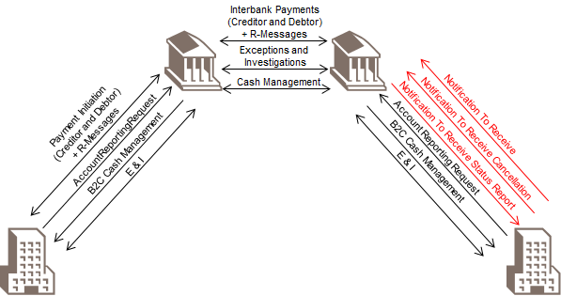

Groups of MessageDefinitions and Functionality
This message set contains the following three MessageDefinitions:
NotificationToReceive
This message is sent by an account owner or by a party acting on the account owner's behalf to one of the account owner's account servicing institutions.
NotificationToReceiveCancellationAdvice
This message is sent by an account owner or by a party acting on the account owner's behalf to one of the account owner's account servicing institutions.
NotificationToReceiveStatusReport
This message is sent in response to a NotificationToReceive message.
MessageDefinition | Message Identifier
NotificationToReceive | camt.057
NotificationToReceiveCancellationAdvice | camt.058
NotificationToReceiveStatusReport | camt.059

BusinessRoles and Participants
A BusinessRole represents an entity (or a class of entities) of the real world, physical or legal, a person, a group of persons, a corporation. Examples of BusinessRoles: “Financial Institution”, “Automated Clearing House”, “Central Securities Depository”.
A Participant is a functional role performed by a BusinessRole in a particular BusinessProcess or BusinessTransaction. Examples of Participants: the “user” of a system, “debtor”, “creditor”, “investor”.
The relationship between BusinessRoles and Participants is many-to-many. One BusinessRole can be involved as different Participants at different moments in time or at the same time. Different BusinessRoles can be involved as the same Participant.
In the context of Notification To Receive the high-level BusinessRoles and typical Participants can be represented as follows:
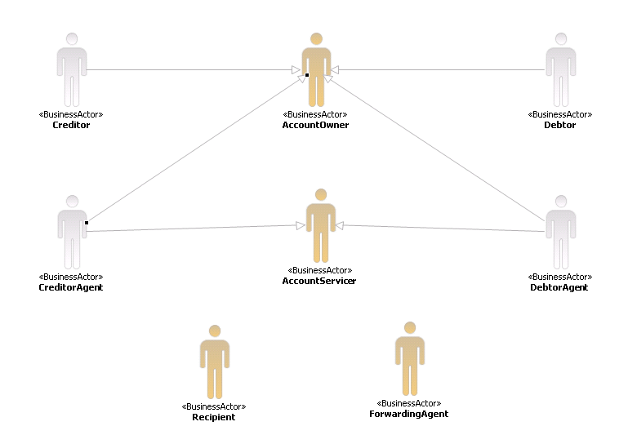

Participants and BusinessRoles Definitions
Participants
Description | Definition
Account Servicer | Party that manages the account on behalf of the account owner (that is, manages the registration and booking of entries on the account, calculates balances on the account and provides information about the account), or the party that has a contractual relationship with the owner (for example, market data provider).
Account Owner | Party that legally holds the account or the party in a contractual relationship with the servicer.
Recipient | Party authorised by the account owner to receive information about movements on the account.
Forwarding Agent | Financial institution that receives the instruction from the initiating party and forwards it to the next agent in the payment chain for execution.
BusinessRoles
Description | Definition
Creditor | Party to which an amount of money is due.
Debtor | Party that owes an amount of money to the (ultimate) creditor.
Creditor Agent | Financial institution servicing an account for the creditor.
Debtor Agent | Financial institution servicing an account for the debtor.
Market Infrastructure | Party that processes, monitors and reports on transaction within the system received from the system member.
System Member | Party that instructs the executing/servicing party to process and maintain a transactions in the system.

BusinessRoles and Participants Table
BusinessRole | Participant  Account Servicer | Participant  Account Owner | Participant  Recipient | Participant  Forwarding Agent
Creditor |  | X | X
Debtor |  | X | X
Creditor Agent | X |  | X | X
Debtor Agent | X |  | X | X
Market Infrastructure | X |  | X | X
System Member |  | X | X | X

BusinessProcess Description
This diagram represents the high level BusinessProcesses.
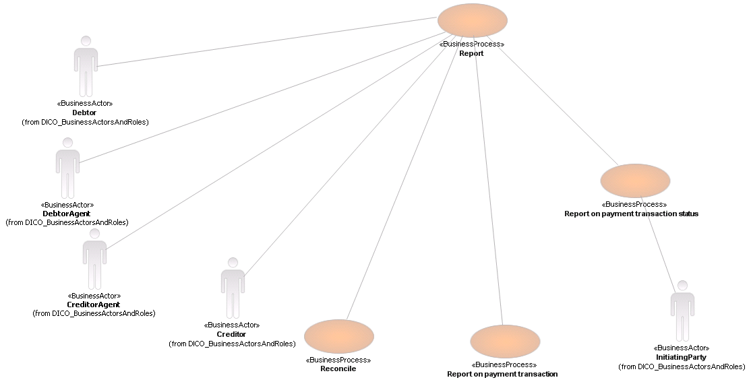
Reporting applies both to interbank reporting, for example, nostro account reporting, and bank-to-customer reporting. The definitions below apply to the bank-to-customer reporting. Regulatory reporting is described as a separate process.
Report
Item | Description
Definition | The process includes the financial impact reporting, the reporting on the payment transaction status and the reconciliation process. Further descriptions of these sub-processes are included below.
Trigger | Payment process is completed.
Pre-conditions | An agreement exists between the reporting party and the reported party to do a specific type of reporting, in order to meet legal requirements and business requirements agreed between the reporting and reported party.
Post-conditions | The payment transaction is reported on.
Role | Account Servicer (creditor agent)
Reconcile
Item | Description
Definition | The process includes the financial impact reporting, the reporting on the payment transaction status and the reconciliation process. Further descriptions of these sub-processes are included below.
Trigger | Payment process is completed.
Pre-conditions | An agreement exists between the reporting party and the reported party to do a specific type of reporting, in order to meet legal requirements and business requirements agreed between the reporting and reported party.
Post-conditions | The payment transaction is reported on.
Role | Account Owner (creditor)
Report on Payment Transaction
Item | Description
Definition | Reporting done by debtor agent to debtor or party authorised by the debtor to receive the report and reporting by creditor agent to creditor or party authorised by the creditor to receive the report on the financial impact of the processed transaction.  Examples of this type of reporting typically are debit advices, credit advices, intraday and end-of-day statements.
Trigger | Completion of the settlement process.
Pre-conditions | Debit or credit has been registered to the account.  (The term 'registered' is used, rather than the term 'booked', as an entry on an account can have three statuses, pending, future and booked, as defined in the cash management messages set.)
Post-conditions | The 'financial impact' report is delivered.
Role | Account Servicer (creditor agent)
Report on Payment Transaction Status
Item | Description
Definition | Report to initiating party by first or forwarding agent on negative (rejected) and/or positive status (accepted/repaired) of the payment transaction throughout the lifecycle of the transaction.
Trigger | Any change in status during the lifecycle of the transaction.
Pre-conditions | Transaction has been received by any agent in the chain.
Post-conditions | Status is delivered to the initiating party.
Role | Account Servicer (creditor agent)
Report on final execution status is the reporting done by the final agent to the initiating party when he has registered the item to the creditor's account. This reporting has to be conveyed to the initiating party, either through the chain of preceding agents in the original chain, or through means of investigation by, for example, forwarding or first agent.

Description of BusinessActivities
This section presents the different BusinessActivities within each BusinessProcess. The BusinessActivities of a process are described with activity diagrams.
Legend
Symbol | Name | Definition
 | Start Point | Shows where the lifecycle of the business process commences.
 | End Point | Shows where the lifecycle of the business process may ends.
 | Lozenge (or diamond) | Indicates that a choice between several actions can be made.
 | Bar | Indicates that several actions are initiated in parallel.

Notification To Receive
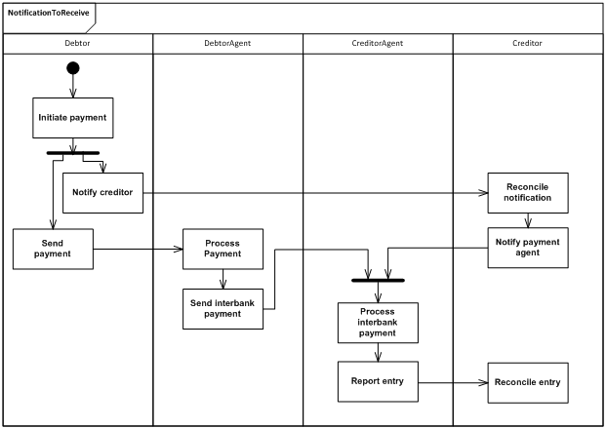
Step | Description | Initiator
Initiate payment | The debtor prepares the payment to close a payment obligation. | Debtor
Notify creditor | The details required for the full identification and reconciliation of the initiated payment are transmitted directly to the creditor. | Debtor
Send payment | The debtor sends the payment to its agent. | Debtor
Process payment | The debtor agent validates and processes the payment | Debtor Agent
Send interbank payment | Once validated, the debtor agent initiates an interbank message and sends it to the creditor through the settlement chain. | Debtor Agent
Process interbank payment | The creditor agent processes the receive payment and reconciles it with the notification received from the creditor. | Creditor Agent
Reconcile notification | The creditor receives the details of the payment from the debtor and reconciles the details against its own references. | Creditor
Notify payment agent | Once validated, the credit notifies its agent about an incoming payment, and provides all of the required details for the matching of the incoming payment with the creditor own references. | Creditor
Report entry | The creditor agent has booked the entry in the account of the creditor and report the entry in a reporting message. | Creditor Agent
Reconcile entry | The creditor receives the confirmation of the credit and books the entry in its own accounts. | Creditor

BusinessTransactions
This section describes the message flows based on the activity diagrams documented above. It shows the typical exchanges of information in the context of a BusinessTransaction.

Notification To Receive - Direct Successful
This scenario is the basic and most elementary scenario, in which an account owner is expecting funds from a counterparty and the account servicing institution is advised that funds are expected on the account of the account owner.
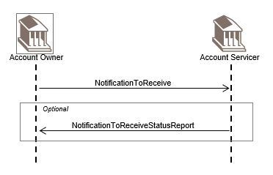
The account owner sends a NotificationToReceive message to the account servicing institution.
On due date the funds arrive as expected and the account servicing institution may send a NotificationToReceiveStatusReport message to the account owner to confirm receipt of the funds. This is optional.

Notification To Receive - Direct successful with Discrepancies
In this scenario, the account owner is expecting funds from a counterparty and the account servicing institution is advised that funds are expected on the account of the account owner. The funds arrive but with some discrepancies.
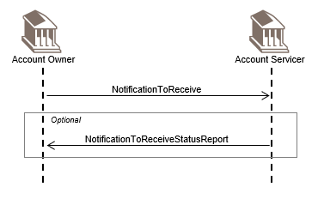
The account owner sends a NotificationToReceive message to its account servicing institution.
On due date the funds arrive but the account servicing institution identifies one or more discrepancies. The account servicing institution sends a NotificationToReceiveStatusReport message to advise the account owner of the receipt of the funds with discrepancies.
If the discrepancies are acceptable, no further action is required from the account owner.
Out of Scope
- If the account owner does not agree with the discrepancies, the account owner launches an investigation.

Notification To Receive - Direct Unsuccessful
In this scenario, the account owner is expecting funds from a counterparty and the account servicing institution is advised that funds are expected on the account of the account owner, but the funds do not arrive.
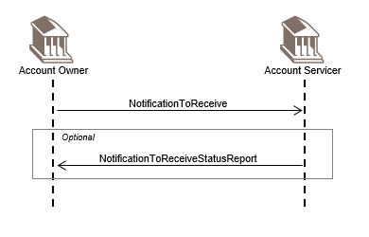
The account owner sends a NotificationToReceive message to its account servicing institution.
On due date, the funds do not arrive and the account servicing institution sends a NotificationToReceiveStatusReport message to advise the account owner of the non-receipt of the funds.
Out of Scope
- The account owner launches an investigation.

Notification To Receive - Direct Cancellation
An account owner is expecting funds from a counterparty and the account servicing institution is advised that funds are expected on the account of the account owner. Later the original transaction is cancelled and the account owner advises the account servicing institution that the funds will not arrive.
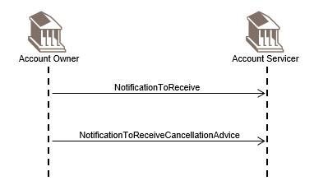
The account owner sends a NotificationToReceive message to the account servicing institution.
Later the account owner sends a NotificationToReceiveCancellationAdvice message.

Notification To Receive - Relay Successful
An account owner wishes to notify its account servicing institution that funds are expected on its account however, the account owner uses a forwarding agent for all its communication with the account servicing institution. The forwarding agent issues or forwards messages from the account owner to the account servicing institution and reports information from the account servicing institution to the account owner.
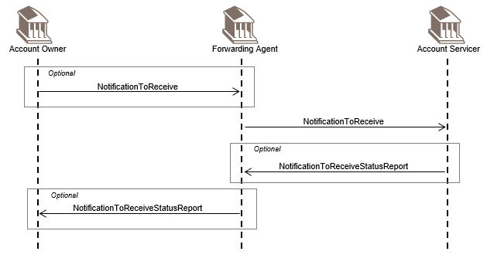
The account owner sends a NotificationToReceive message to a forwarding agent or requests the forwarding agent to issue a NotificationToReceive.
The forwarding agent issues or forwards the NotificationToReceive message to the account servicing institution.
On due date, the funds arrive in accordance with the NotificationToReceive message and the account servicing institution may send a NotificationToReceiveStatusReport message to confirm receipt of the funds to the forwarding agent. This is optional
If the NotificationToReceiveStatusReport message is received, the forwarding agent forwards the NotificationToReceiveStatusReport message or reports the details of the NotificationToReceiveStatusReport message to the account owner.

Notification To Receive - Relay Successful with Discrepancies
An account owner wishes to notify its account servicing institution that funds are expected on its account however, the account owner uses a forwarding agent for all its communication with the account servicing institution. The forwarding agent issues or forwards messages from the account owner to the account servicing institution and reports information from the account servicing institution to the account owner. In this scenario the funds arrive but with some discrepancies.
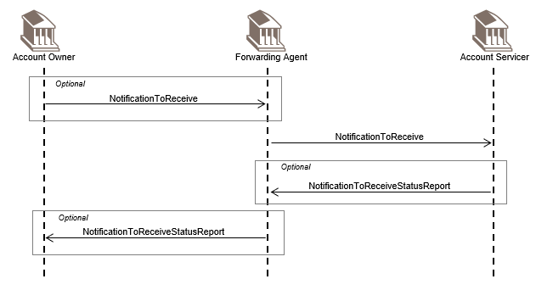
The account owner sends a NotificationToReceive message to a forwarding agent or requests a forwarding agent to issue a NotificationToReceive.
The forwarding agent forwards the NotificationToReceive message to the account servicing institution.
On due date the funds arrive but the account servicing institution identifies one or more discrepancies. The account servicing institution sends to the forwarding agent a NotificationToReceiveStatusReport message to advise the account owner of the receipt of the funds with discrepancies.
The forwarding agent forwards the NotificationToReceiveStatusReport message or reports the details of the NotificationToReceiveStatusReport message to the account owner.
Out of Scope
- If the account owner does not agree with the discrepancy, the account owner launches an investigation.

Notification To Receive - Relay Unsuccessful
An account owner wishes to notify its account servicing institution that funds are expected on its account; however, the account owner uses a forwarding agent for all its communication with the account servicing institution. The forwarding agent issues or forwards messages from the account owner to the account servicing institution and reports information from the account servicing institution to the account owner. In this scenario the funds do not arrive.
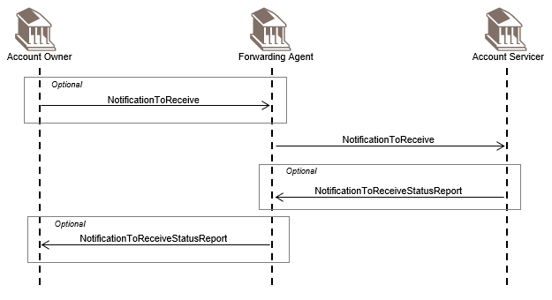
The account owner sends a NotificationToReceive message to a forwarding agent or requests the forwarding agent to issue a NotificationToReceive.
The forwarding agent issues or forwards the NotificationToReceive message to the account servicing institution.
On due date the funds do not arrive so the account servicing institution sends to the forwarding agent a NotificationToReceiveStatusReport message to advise the account owner of the non-receipt of the funds.
The forwarding agent forwards the NotificationToReceiveStatusReport message or reports the details of the NotificationToReceiveStatusReport message to the account owner.
Out of Scope
- The account owner launches an investigation.

Notification To Receive - Relay Cancellation
An account owner wishes to notify its account servicing institution that funds are expected on its account; however, the account owner uses a forwarding agent for all its communication with the account servicing institution. The forwarding agent issues or forwards messages from the account owner to the account servicing institution and reports information from the account servicing institution to the account owner. Later the original transaction is cancelled and the account owner advises the account servicing institution that the funds will not arrive.
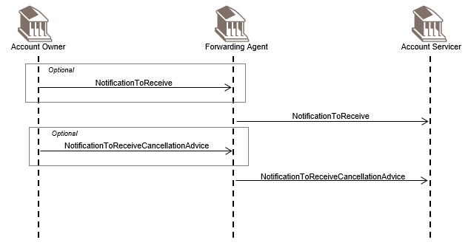
The account owner sends a NotificationToReceive message to the forwarding agent or requests the forwarding agent to issue a NotificationToReceive.
The forwarding agent issues or forwards the NotificationToReceive message to the account servicing institution.
Later the account owner sends a NotificationToReceiveCancellationAdvice message to the forwarding agent or requests the forwarding agent to issue a NotificationToReceiveCancellationAdvice message.
The forwarding agent issues or forwards the NotificationToReceiveCancellationAdvice message to the account servicing institution.

Revision Record

Revision | Date | Author | Description | Sections affected
1.0 | December 2023 | SWIFT | Draft version for SEG review | All
2.0 | January 2024 | SWIFT | Final version | All

Disclaimer:
Although the Registration Authority has used all reasonable efforts to ensure accuracy of the contents of the iso20022.org website and the information published thereon, the Registration Authority assumes no liability whatsoever for any inadvertent errors or omissions that may appear thereon. Moreover, the information is provided on an "as is" basis. The Registration Authority disclaims all warranties and conditions, either express or implied, including but not limited to implied warranties of merchantability, title, non-infringement and fitness for a particular purpose.
The Registration Authority shall not be liable for any direct, indirect, special or consequential damages arising out of the use of the information published on the iso20022.org website, even if the Registration Authority has been advised of the possibility of such damages.

Intellectual Property Rights:
The ISO 20022 MessageDefinitions described in this document were contributed by the SWIFT. The ISO 20022 IPR policy is available at www.ISO20022.org > About ISO 20022 > Intellectual Property Rights.

