PROJECT REPORT OF INDUSTRY ORIENTED HANDS ON EXPERIENCE (IOHE)
ON
Smart Campus
submitted in partial fulfilment of the requirements for the award of degree of

BACHELOR OF ENGINEERING
In
COMPUTER SCIENCE AND ENGINEERING

Submitted by: Supervised By:
Amit Kumar Sah (2210991253) Dr. Ajay Kumar
Ashish Ranjan (2210991402) Chitkara University
Adarsh Ranjan (2210991179)



DEPARTMENT OF COMPUTER SCIENCE AND ENGINEERING

CHITKARA UNIVERSITY INSTITUTE OF ENGINEERING AND TECHNOLOGY
CONTENTS

S no. | Title | Page no.
1. | Declaration and Acknowledgement | 3-4
2. | Abstract | 5
3. | Introduction | 6-7
4. | Methodology and System Design | 8-10
5. | Tools and Technologies | 11
6. | Implementation | 12
7. | Major Findings / Outcomes / Output / Results | 13
8. | Conclusion and Future Scope | 13
9. | References | 14
10. | Appendices | 15-23

DECLARATION

We hereby certify that the work which is being presented in the project report entitled “SmartSpace” in partial fulfilment of requirement for the award of the degree of Bachelor of Engineering (Computer Science and Engineering) submitted in the department of Computer Science and Engineering at Chitkara University Institute of Engineering and Technology, Chitkara University, Punjab, India, is an authentic record of my own work carried out under the supervision of < Dr. Ajay Kumar >. The matter presented in this project report has not been submitted in any other university/institute for the award of any degree.

Place: Rajpura (Amit Kumar Sah) (Ashish Ranjan) (Adarsh Ranjan)
Date: 14-05-2026 (2210991253) (2210991402) (2210991179)

This is to certify that the above statement made by the candidates is correct to the best of my knowledge and belief.

(Dr. Ajay Kumar)
<Head of IOHE>
Department of Computer Science and Engineering
Chitkara University Institute of Engineering and Technology,
Chitkara University, Punjab, India

ACKNOWLEDGEMENT

It is our pleasure to be indebted to various people, who directly or indirectly contributed in the development of this work and who influenced my thinking, behaviour and acts during the course of study.
We express our sincere gratitude to all for providing me an opportunity to undergo Integrated Project as the part of the curriculum. We are thankful to “Dr. Ajay Kumar” for his support, cooperation, and motivation provided to us during the training for constant inspiration, presence and blessings.
We also extend my sincere appreciation to Dr.Ajay Kumar who provided their valuable suggestions and precious time in accomplishing our IOHE project report.
Lastly, we would like to thank the almighty and our parents for their moral support and friends with whom we shared our day-to day experience and received lots of suggestions that improve our quality of work.
Amit Kumar Sah
2210991253
Ashish Ranjan
2210991402
Adarsh Ranjan
2210991179

ABSTRACT

SmartSpace — Shared Space Management Platform is a web-based system designed to help manage and make better use of shared university spaces like seminar halls, study rooms, and common areas. Traditional systems for managing these spaces often struggle with problems such as manual booking processes, no real-time info on availability, scheduling overlaps, inefficient use of resources, and poor tracking of facilities.

The new system offers a central platform where students and administrators can manage and book shared spaces in a clear and organized way. It includes real-time availability updates, time-based booking features, automatic room release, and role-specific dashboards for efficient monitoring and control.

The frontend of the system is built using React.js and Vite, while Node.js and Express.js are used for the backend. MongoDB handles the database, and JWT authentication is used to ensure secure login and control access based on user roles. The system aims to cut down on manual work, increase transparency, improve how resources are used, and make campus space management easier through a modern digital solution.

INTRODUCTION

2.1 Problem Background
In universities and other institutions, shared spaces such as seminar halls, study rooms, cafeterias, and common areas are frequently used by students and staff.However, the way these spaces are managed is still largely done by hand and lacks organization. People often don’t have up-to-date information on whether a room is available, which can cause booking mistakes, confusion, and wasted time.
In many cases, spaces stay occupied longer than they should because there are no clear time limits or systems in place to monitor usage.There is also no central place to keep track of how these spaces are being used or to make sure everyone has fair access. The current systems mostly just allow for basic booking and don’t include proper monitoring, transparency, or structured management. Because of this, the way resources are used isn’t efficient, and the overall experience for users suffers.

2.2 Objective of the Project
SmartSpace offers a single place where people can manage shared areas within an institution in a better organized and effective manner. The system lets users see when spaces are available in real time and book them for specific periods. It uses different access levels to ensure that everyone's involvement is clear and that management stays under control. Features like automatic booking and tracking help make things more open and honest, prevent overlaps in scheduling, and ensure that university resources are used fairly.

2.3 Proposed Solution / System Overview
SmartSpace is a central platform designed to help manage shared university spaces in a structured and efficient manner. Both students and administrators can see real-time availability of spaces and book them for specific time periods. The system uses different roles, like Community Head and Community Member, to ensure organized management and active participation. It also has automated booking features that stop unwanted use of spaces and help make sure resources are used fairly. The main aim is to improve transparency, reduce the need for manual tasks, and make campus space management more efficient.

2.4 Key Features or Functionality
SmartSpace offers a centralized way to manage spaces, track availability in real time, and handle bookings for shared university facilities.It provides different dashboards for Community Heads and Members, allowing controlled access and better organization. The system uses time-based booking rules to stop people from keeping spaces occupied for too long, which helps use resources more fairly. It also keeps records of all bookings and includes monitoring tools to increase transparency and make operations more efficient.

2.5 Technology / Method Used
React.js with Vite for frontend. Fast and responsive UI.
Node.js and Express.js for backend services and system logic.
MongoDB for database management and data storage.
JWT for secure authentication and role-based access.
REST APIs and client-server architecture for smooth communication and scalability.

2.6 Expected Outcome & Benefits
SmartSpace aims to cut down on the need for manual booking and reduce clashes when people try to book the same space.By showing real-time availability and having a clear booking process, it makes it easier to track who is using what and when. This helps make better use of resources. The system also allows control based on time, which stops spaces from being occupied when they’re not needed. Overall, the platform makes it easier to keep track of usage, saves time for staff, and leads to a more organized and efficient campus.

2.7 Original Contribution Statement
SmartSpace offers a central and organized way to handle shared spaces on a university campus. It includes real-time updates on space availability, access permissions based on user roles, and booking systems that have set time limits. This helps make space usage more transparent, ensures fair use of resources, and boosts the overall efficiency of managing campus areas
METHODOLOGY

3.1 Requirement Analysis
The project requirements were determined by looking at the issues in existing shared space management systems. Key features such as real-time availability tracking, online booking options, role-based access controls, and time-based booking restrictions were decided on.
3.2 System Design
The platform was built using a client-server setup. Different sections were made for handling user login, managing the community, booking spaces, monitoring activities, and controlling the dashboard.
3.3 Development
The fronted part was created with React.js and Vite, and the server side was built using Node.js and Express.js. MongoDB was used to handle the database, and JWT was included to make sure the system is secure and allows different levels of access based on user roles.
3.4 Testing
Tests were done on the main functions, the login system, and the user interface to find and correct issues during the development process.

SYSTEM DESIGN

4.1 Architecture
The SmartSpace OS platform follows a client–server architecture where the frontend communicates with backend services through REST APIs. The frontend built using React (Vite) handles user interaction, while the backend built using Node.js and Express manages business logic and database communication. MongoDB stores persistent data such as users, communities, spaces, and bookings.

4.2 Modules
- Authentication Module – Handles user login and registration.
- Community Management – Create and manage communities.

- Space Management – Add and manage spaces within communities.

- Space Booking – Allows users to book available spaces.

- Dashboard Module – Central interface for user interactions.
4.3 Data Flow
Level 0: User → SmartSpace System → Database
Level 1: Authentication → Dashboard → Community → Space → Booking

4.4 Use Cases
Actors:
- User
- Administrator
Use cases:
- Login/Register
- Create Community
- Add Space
- Book Space
- View Booking Status
4.5 ER (Entity Relationship)
Entities:
- User
- Community
- Space
- Booking

Relationships:
- User creates Community
- Community contains Space
- User books Space

TOOLS AND TECHNOLOGIES

SmartSpace uses advanced technologies to make sure the platform can grow easily, keep data safe, and manage shared spaces effectively.
- React.js (with Vite) is used to create a quick, responsive, and interactive user interface that gives a smooth experience when navigating through the dashboard.
- Node.js and Express.js are used for the back-end, handling tasks like booking spaces and managing the main functions of the system.
- MongoDB is used to store and manage data securely, including information about users, spaces, and booking details.
- REST APIs are used to allow the front-end and back-end to communicate efficiently while ensuring data is transferred securely.

IMPLEMENTATION

6.1 Technologies Used
- Frontend: React (Vite)
- Backend: Node.js, Express.js, MongoDB

- Authentication: JWT

6.2 Functionalities
- Community creation and management
- Space listing and booking

- Dashboard interface for navigation

- Booking status and availability tracking

6.3 Workflow
- User logs in
- Dashboard loads after authentication.

- User selects or creates a community.

- Spaces within the community are displayed.

- User books a space

RESULTS AND DISCUSSION

The system successfully:
- Improved transparency in space availability
- Reduced manual coordination between users and space managers
- Enhanced booking tracking and management
- Increased overall operational efficiency

CONCLUSION
SmartSpace OS is a scalable platform for efficient space management and booking. It improves transparency, reduces manual effort, and enhances efficiency through a centralized dashboard with support for future enhancements.

FUTURE SCOPE
- Real-time booking updates

- Mobile application development

- AI-based space recommendations for users

- Payment gateway integration

REFERENCES

- React.js (Official Documentation)
Meta. React – A JavaScript Library for Building User Interfaces.
https://react.dev
- Vite (Official Documentation)
Evan You. Vite – Next Generation Frontend Tooling.
https://vitejs.dev
- Node.js (Official Documentation)
OpenJS Foundation. Node.js – JavaScript Runtime Environment.
https://nodejs.org
- Express.js (Official Documentation)
OpenJS Foundation. Express – Fast, Unopinionated Web Framework for Node.js.
https://expressjs.com
- MongoDB (Official Documentation)
MongoDB Inc. MongoDB – NoSQL Database Platform.
https://www.mongodb.com/docs
- JWT Authentication
Auth0. JSON Web Tokens (JWT).
https://jwt.io/introduction
- Tailwind CSS (Official Documentation)
Tailwind Labs. Tailwind CSS – Utility-First CSS Framework.
https://tailwindcss.com/docs
- REST API Documentation
MDN Web Docs. REST APIs and Web Services.
https://developer.mozilla.org/en-US/docs/Glossary/REST
APPENDIX
Screenshots
- Figure 1: Main UI
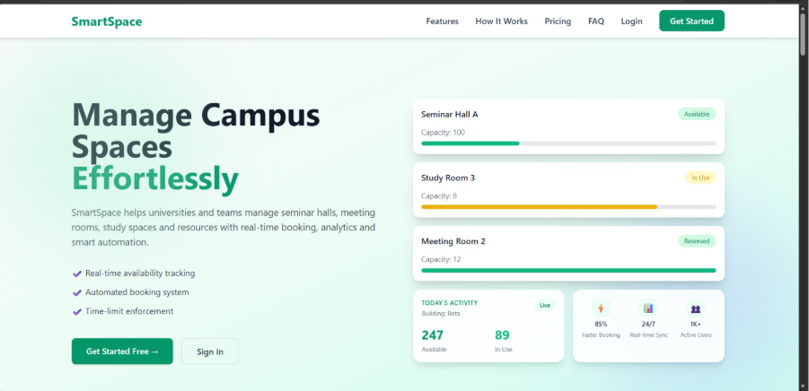

- Figure 2: DashBoard UI

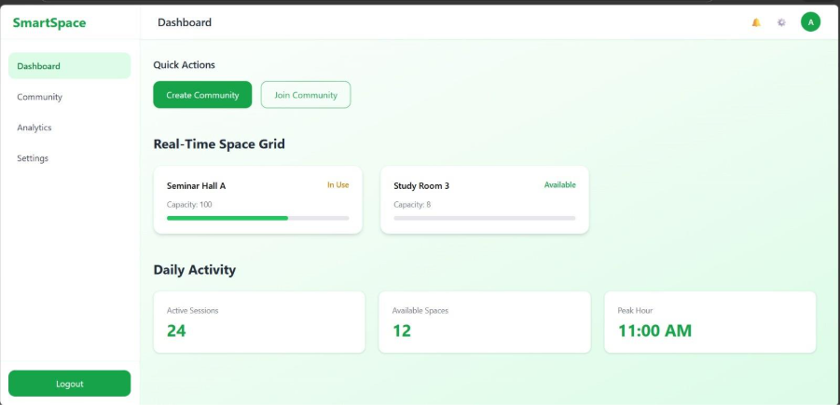

- Figure 3: Creating Space in Community UI
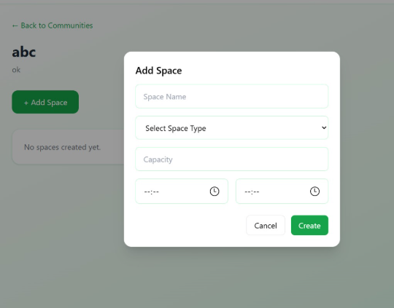

- Figure 4: Selecting space type
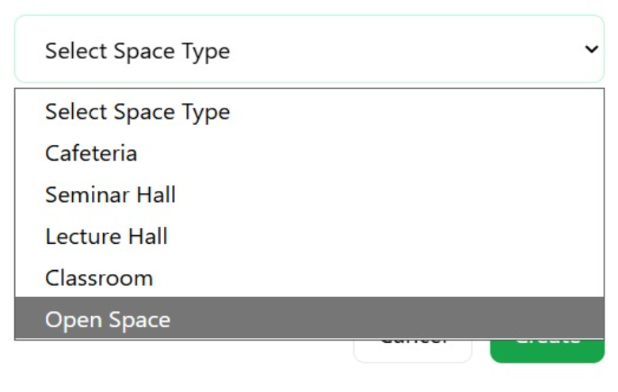

- Figure 5: Previous Booking Details
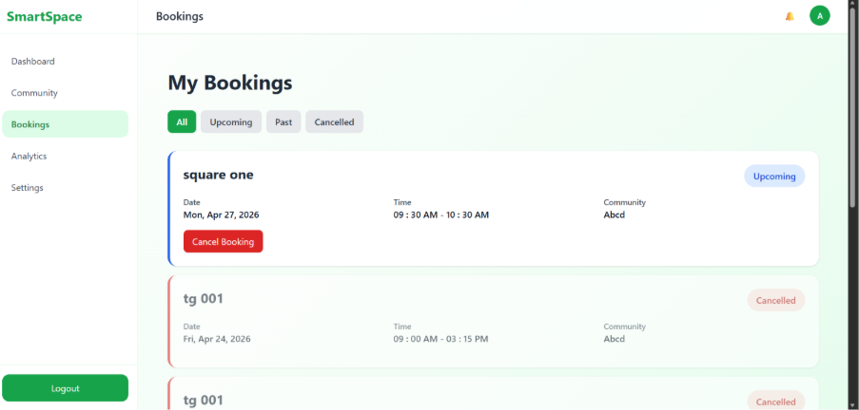

Figure 6: Uses Analytics

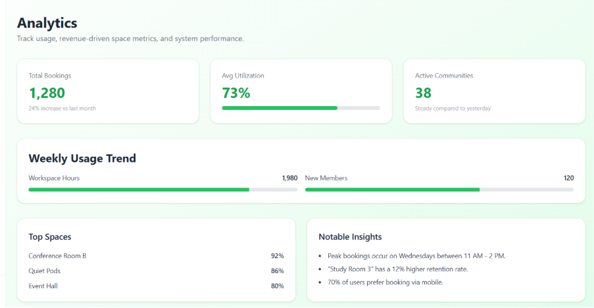

Diagrams
- Data Flow
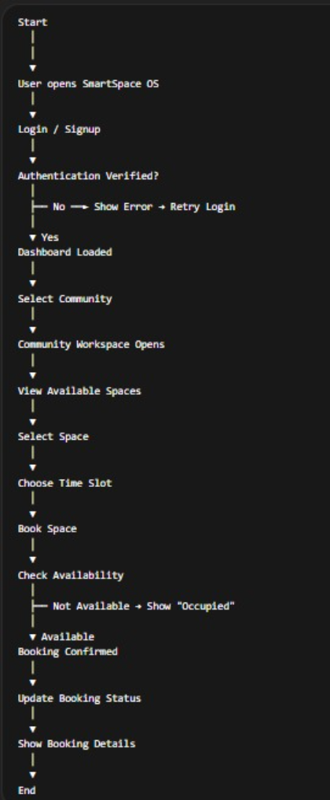

Code Implementation
