**Affairs Data Logistics Regression**

**Descriptive Statistics of the categorical variables is as follows:** 75% of people don’t have any affairs.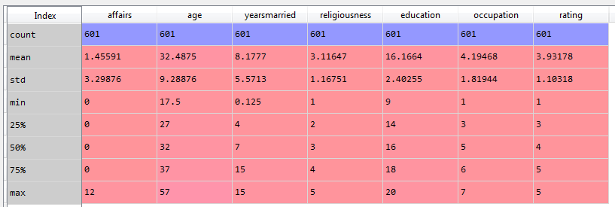

**Analysis of the categorical variables:**

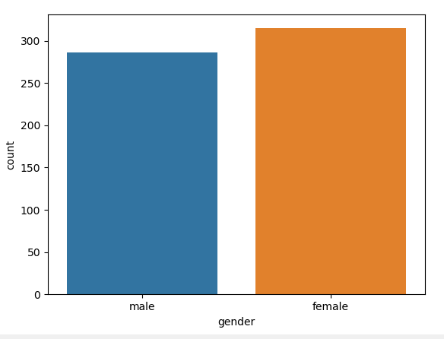

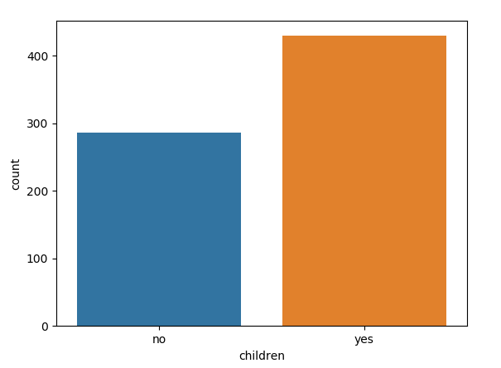

**The correlation of the continuous variables**

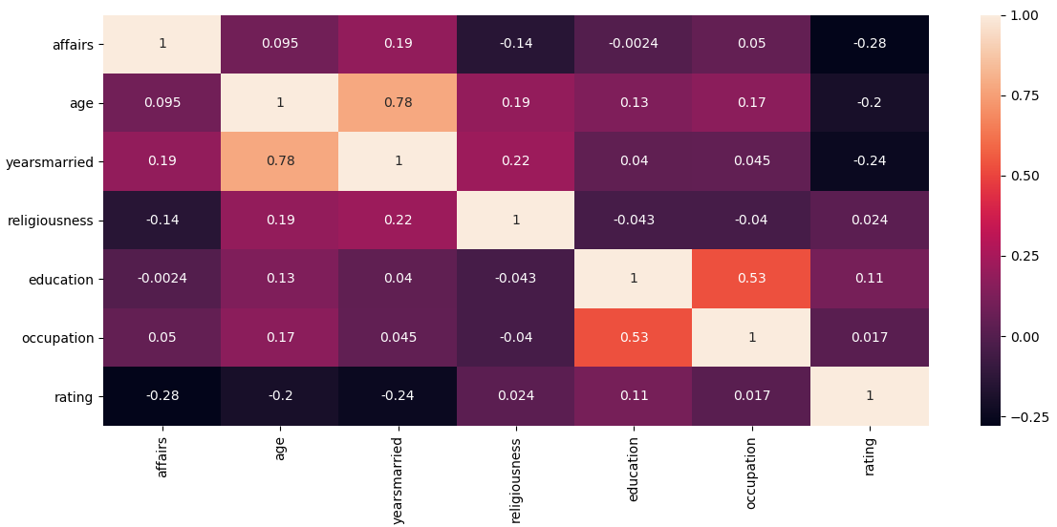

**The pair plot of the continuous variables**

