Screenshot1 – Junit Successful execution of all the test URL.

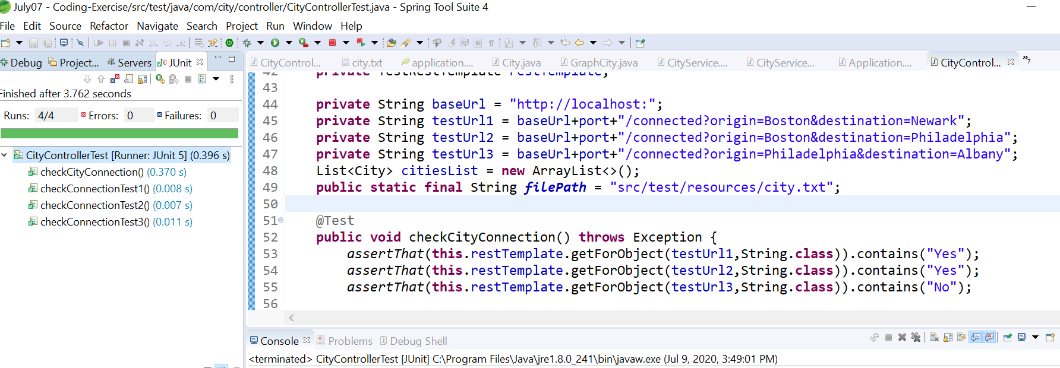

Screenshot 2 – From UI

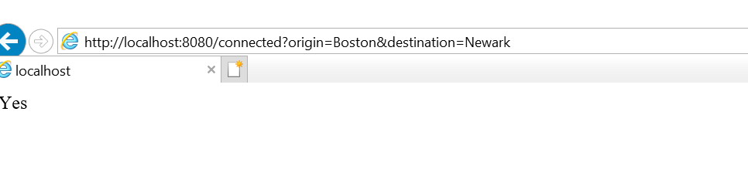

Screenshot 3 – From UI

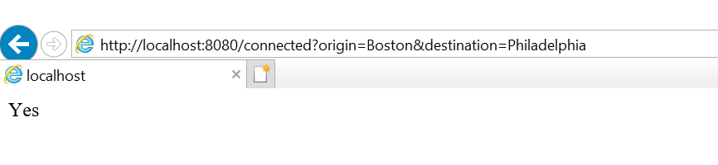

Screenshot 4 – From UI

