

Bangla Sahayata Kendra
Upanna, Ground Floor, 325, Sarat Chatterjee Road, Howrah, PIN: 711102
Visit: https://bsk.wb.gov.in | Email: bsk@wb.gov.in | Call: +91 33 2214 0080
Government of West Bengal
Transforming Citizen Service Delivery in
Bangla Sahayata Kendra (BSK)
through AI and ML Integration
Project Report
In Technical Collaboration with
Center of Excellence in DS & ML
Department of Information Technology, GoWB

Team Members

Name | Contact Number | Email
Aritra Chatterjee | 6290457661 | aritrac.cse.ug@jadavpuruniversity.in
Soumyadeep Basak | 9330116625 | basaksoumyadeep04@gmail.com
Adarsh Rounak | 9334792875 | adarshrounak79@gmail.com
Nilesh Ranjan Pal | 7001366080 | nileshpal530@gmail.com

Under Supervision of

Dr. Saptarsi Goswami  Mr. Kausik Halder | Dr. Arindam Ray  Mr. Manojit Baral
Table of Contents
1. Introduction 3
1.1. Background 3
1.2. Need for the Project (Existing Challenges in Current System and Scope of Solution 3
2. Problem Statement (Detailed Definition of the Problem) 3
3. Objectives 4
4. Data Collection & Preparation 4
4.1. Data Sources, Data Cleaning and Pre-processing Techniques 4
4.2. Dataset Description 4
5. System Overview / Methodology 6
5.1. Proposed System Architecture 6
5.2. Process Flow Diagram 7
5.3. Technologies / Tools / Frameworks Used 8
5.4. Detailed Explanation of Chosen AI/ML Models and components 9
5.5. Deployment Plan 11
5.6. Estimation of API Cost 12
6. Results & Discussion 13
6.1. Model Evaluation Strategy 13
6.2. Evaluation Results 13
7. Limitations 14
7.1. Identified Limitations of the Model/System 14
7.2. Possible Risks or Failures 15
8. Future Scope 15
8.1. Potential Improvements 15
9. Conclusion 16
10. References 16

- Introduction
  - Background

The Government of West Bengal have established Bangla Sahayata Kendras (BSKs) to enable citizens to easily access government services. BSKs act as a vital point of connection between the public and the government—they have effectively facilitated access to many services related to welfare, utilities, and document-assistance.

Although the BSKs have successfully provided a number of important services closer to communities, an important limitation has arisen in the way services are being consumed. While making their visits to BSKs, a number of citizens have sought a particular council service, leaving the majority ignorant of other services—related or not—that they are entitled to benefit from. Therefore, limited awareness of public entitlement is restricting the overall benefit of the BSK framework to the citizen.

  - Need for the Project (Existing Challenges in Current System and Scope of Solution)

BSK's present citizen service delivery model offers little to no personalization, and little to no intelligent service mapping. The following are the major constraints:

Limited Citizen Awareness: Visitors usually only know about a few services offered at BSKs and underuse the services available to them. Thus most services remain underused even though they could be helpful to a person coming to the BSK.

Missing Data-Driven Awareness/Assistance: There is no real-time, related recommendation capability available to the BSK Operator that would enable him to assist citizens with appropriate services based on citizens background/intent or needs.

- Problem Statement (Detailed Definition of the Problem)

There exists a significant gap in citizen awareness regarding the breadth of services offered through BSK. Citizens frequently access specific services without knowledge of other relevant or complementary offerings. For example, someone seeking a property mutation service may also be eligible for a new electricity connection, yet remains uninformed of such options.
- Objectives:
- Analyze Citizen Behavior & Service Usage Patterns
  - Study historical service usage and demographic profiles of BSK visitors.
  - Identify frequently availed services and common combinations.
- Design AI/ML-Based Recommendation System
  - Build models to suggest relevant additional services using demographic, geographic, and service usage data.
  - Apply filters for eligibility and recurrence to refine recommendations.
Impact:
This AI-driven system will enhance citizen experience by recommending complementary services at the point of delivery, reducing unnecessary repeat visits, and improving welfare outreach. It supports BSK’s transition to a smarter, citizen-centric, data-driven model.

- Data Collection & Preparation
4.1 Data Sources, Data Cleaning and Preprocessing Techniques

The dataset was provided as a PostgreSQL dump. Tables used include:

- ml_citizen_master, ml_citizen_master_v2

- ml_service_master, ml_provision

Preprocessing included:

- Concatenating citizen master tables

- Dropping duplicates and handling missing values

- Merging provision logs with citizen and service data

- Standardizing feature formats (districts, IDs)

4.2 Dataset Description

The dataset used in this project was obtained from an official PostgreSQL database dump provided by the BSK team. It included multiple interrelated tables containing information on citizens, service usage, services offered, and location metadata.

Primary Tables:

Table Name | Description | Number of Records
ml_citizen_master | Demographic data of citizens | 7,57,239
ml_citizen_master_v2 | Supplementary citizen data | 21,00,805
ml_service_master | Metadata of government services | 414
ml_provision | Citizen service usage logs | 51,29,590

Secondary Tables:

Table Name | Description | Number of Records
ml_district | District reference table | 25
ml_block_municipality | Block and municipality data | 343
ml_sub_division | Subdivision-level mapping | 67
ml_gp_ward_master | Gram Panchayat/Ward mapping | 3,545
ml_post_office_master | Post office data | 3,643
ml_deo_master | DEO-related metadata | 273
ml_bsk_master | BSK center records | 338

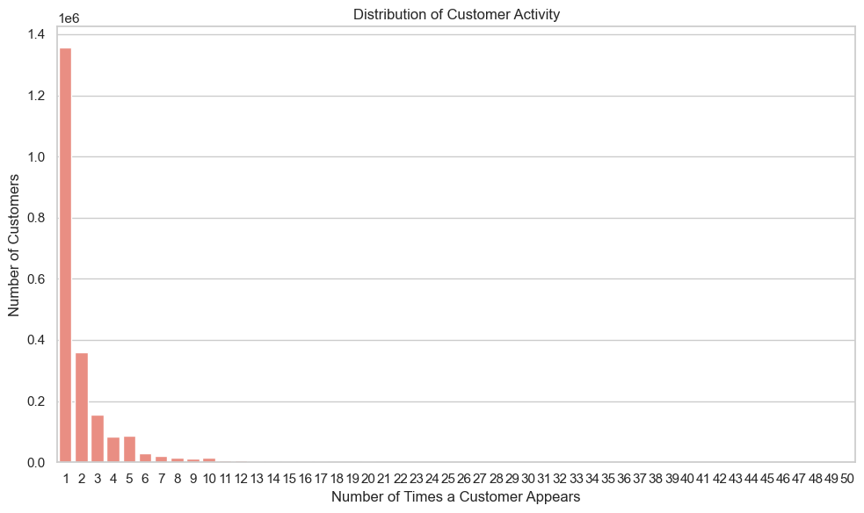
- System Overview / Methodology

5.1 Proposed System Architecture

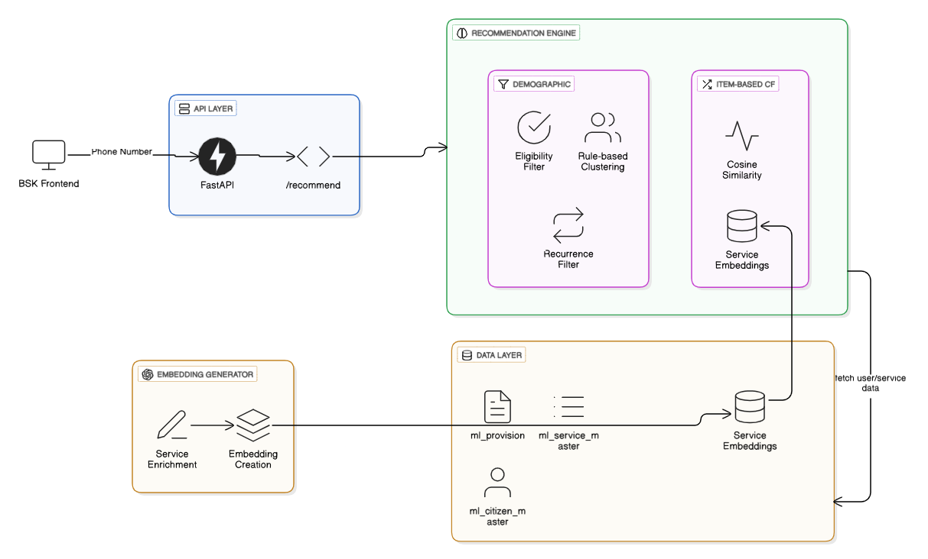
5.2 Process Flow Diagram

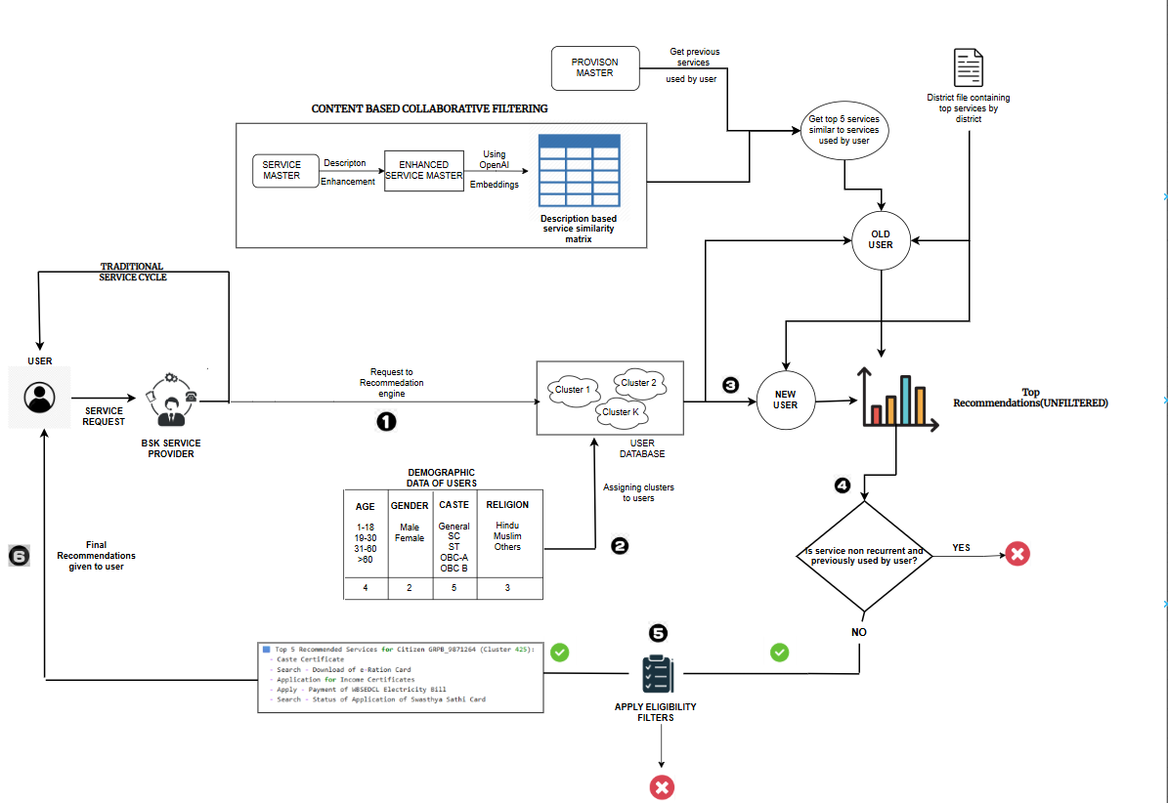

5.3 Technologies / Tools / Frameworks Used
The project involved a combination of web frameworks, data processing libraries, database systems, and machine learning tools. The key technologies used are listed below:
Frontend Framework:(IN DEVELOPMENT)
- Streamlit is being used for building the interactive web interface.
Backend Framework:(IN DEVELOPMENT PHASE)
- FastAPI will be used to develop the backend service that handles data loading, processing, model inference, and API responses.
Database & Data Management:
- PostgreSQL was used as the primary database system.
- Data processing was done using Pandas, NumPy, and CuPy (for GPU-accelerated computation).
Clustering & Model Building:
- Scikit-learn was used for demographic and categorical clustering.
NLP & Recommendation Engine:
- OpenAI API was used to enrich and embed service descriptions using the text-embedding-3-large model.
- Cosine similarity was computed using sklearn.metrics.pairwise.cosine_similarity.

5.4 Detailed Explanation of Chosen AI/ML Models and Components
We had access to real citizen-service interaction data from BSK, which included around 2.5 million users and 5.1 million service usage records. That’s a sizable dataset, but in terms of interaction depth, but the median usage per user was about 1-2 . Many of those were repeat interactions with the same service.
This meant our data was extremely sparse. For recommendation systems, especially collaborative ones, sparsity can be a serious limitation. A user-user similarity model (where we recommend based on what similar users have used) would struggle:
- The sparse vectors wouldn’t carry enough signal to match users meaningfully
- Comparing millions of user profiles would slow things down drastically
- The results wouldn’t be consistent or explainable enough
So instead, we went with a two-part strategy:
- A rule-based model for cold-start users
- An item-based collaborative filtering model for users who had at least one known service interaction

A. Cold-Start Recommendation: Rule-Based Demographic Clustering
For users who had no service history, we needed a way to make reasonable predictions using only available demographic details.
We used fields like:
- Age group
- Gender
- Caste
- Religion
By grouping users into categorical clusters based on these fields, we could identify which services were most commonly used within each group. These became the recommendations for new users.
To ensure we weren't recommending irrelevant services, we added two filters:
- Eligibility filter: Checked age, gender, caste, and religion constraints based on actual service rules
- Recurrence filter: Prevented re-recommending services that are meant to be availed only once
This cold-start model was fast, interpretable, and produced relevant outputs based on population-level trends.

B. Collaborative Filtering: Content-Based Using Embeddings
For users with existing service usage, we took a different approach — one based on identifying services similar to the ones they had already used.
Here’s how it worked:
First, we enriched each service’s description using a language model. This made the text more complete and uniform, especially for services that had limited or vague original descriptions.
Next, we converted these descriptions into embeddings — dense vectors representing each service semantically.
We then used cosine similarity to find which services were most similar to the ones a user had already used.
This let us build a service-to-service similarity matrix, which we could use for recommendations. For example, if someone had used a student scholarship service, we might recommend related education benefits or exam subsidies.
C. Embedding Model Evaluation and Selection
We manually tested service similarity outputs from each model. The large model (text-embedding-3-large) consistently returned more meaningful, domain-aware results — so it was selected as the final embedding model.
Since services don’t change often, these embeddings are generated once and reused unless new services are added. This keeps the system efficient and scalable.

5.5 Deployment Plan

As of now, the recommendation system is still in development. However, we have a clear plan in place for how the final deployment will work.

Planned Backend: FastAPI-Based Inference Service

We plan to build the core backend using FastAPI. This Python-based web framework is lightweight, fast, and supports asynchronous operations, making it well-suited for deploying machine learning inference pipelines.

Once deployed, the FastAPI backend will:

Connect to the official BSK PostgreSQL database

Pull required citizen and service data

Run the preprocessing and feature engineering pipeline (as a cron-job run daily)

Apply rule-based filters (eligibility and recurrence)

Trigger the appropriate recommendation model (rule-based, clustering, or item-similarity)

Return final recommendations to the front-end or any external system via API

This backend will integrate into existing BSK infrastructure. It can either serve real-time requests (as users arrive) or perform daily batch processing for scheduled inference.This FastAPI server can be hosted in Render(serverless).

Planned Frontend: Streamlit for Prototyping

Currently, a basic prototype has been built using Streamlit. While this is not intended for large-scale use, it has been useful during development for:

Running test scenarios

Viewing recommendations for sample citizens from the current citizen data

Toggling between different models’ outputs

In the future, the front-end component may be integrated with an existing BSK user interface . Presently, it can be hosted via Streamlit Cloud.

  - Estimation of API Cost

As part of the item-based collaborative model, we use OpenAI’s APIs to generate enriched text and embeddings for each service.

This only needs to be done when a new service is added — meaning it's a one-time cost per service, not a daily or recurring load.

Breakdown of Steps and Cost (per service):

Enrich the service description using a large language model (LLM)

Generate the service embedding using OpenAI's text-embedding-3-large model

Save the embedding for reuse during similarity calculations

Token and Cost Estimation (INR)

Step | Approx. Tokens | OpenAI Rate (per 1K tokens) | Estimated INR per Call
Description Enrichment | ~2000 tokens | ₹0.17 (input) + ₹0.67 (output) | ₹0.34 + ₹1.34 = ₹1.68
Embedding Generation | ~1000 tokens | ₹0.011 per 1K tokens | ₹0.011
Total | — | — | ~₹1.69 per service

These costs are negligible in the bigger picture, especially since services don’t change often. Once the embeddings are created and stored, they can be reused repeatedly without triggering additional API calls.

- Results & Discussion

  - Model Evaluation Strategy

To evaluate the effectiveness of the three recommendation models — demographic clustering-based, district-based popularity, and item-based collaborative filtering — we adopt both offline metrics and a proposed usage-based validation approach for future production settings.

Coverage
Coverage measures the extent to which the recommended services are relevant to the services previously used by the citizen. It is computed based on the similarity between recommended and used services, using a predefined similarity threshold. This metric reflects how well the recommendations align with the user's historical service usage in a meaningful way.
6.2 Evaluation Results
The recommendation system is intended to be evaluated using the coverage metric, which quantifies the relevance of recommended services based on their similarity to previously used services.
This evaluation is yet to be conducted and will be completed in the later phases of the project. Final coverage scores will be reported after thorough testing on representative user data across diverse service usage patterns.
7. Limitations
  - Identified Limitations of the Model/System

Sparse Interaction Matrix
The user-service interaction matrix was highly sparse, with most users availing only one or two services. This limited the effectiveness of user-based collaborative filtering approaches and made item-based strategies more favorable.

Cold Start for New Services
While cold-start strategies were implemented for new users, the system struggles when new services are introduced. Since the categorical clustering model relies on the historical popularity of services, new services with no prior usage data are less likely to be recommended effectively.

Hard-Coded Filters
Both eligibility and recurrence checks are currently implemented through rule-based filters. These filters require manual updates and reconfiguration whenever service policies or eligibility criteria are changed at the administrative level.

Dependency on Structured Demographics
The rule-based recommendation logic is strongly dependent on structured demographic fields such as age, caste, religion, and gender. If any of these fields are missing, inconsistent, or incorrect, the clustering and eligibility logic can be negatively affected, resulting in inaccurate or incomplete recommendations.

Proxy Service Usage (Family-Level Bias)
In many cases, a user (e.g., the head of a family) avails themselves of services on behalf of multiple family members using a single identity. This leads to distorted demographic-service associations and introduces noise into both clustering and service usage patterns, reducing the personalization accuracy of the system.

  - Possible Risks or Failures

Data Quality and Completeness Issues
The system relies heavily on demographic and service usage data. Inaccurate, outdated, or missing data (e.g., age, caste, religion) can lead to poor clustering and irrelevant service recommendations, especially in cold-start scenarios.

Lack of Updation of service data and district data
The system has been built on a service similarity matrix as well as a district top services file based on the data of the past few months. Introduction of new services need updation of the service to service similarity matrix. Also the top services of a district may change over time and thus the system requires the files to be updated every few months or as and when new services are introduced. Failure to do so may result in faulty results.

- Future Scope

8.1 Potential Improvements

In a real-world BSK deployment environment, validation will be conducted through usage-based feedback:
- The deployed system offers three recommendation models: demographic, district-based, and item-based.
- Operators will have the option to select which model to use via a checkbox interface.
- The system will log the model chosen and the services availed by the citizen.
- Over time, this will allow us to track actual follow-through usage per model, similar to an A/B testing framework.
- Using this post-deployment data, we will identify which model has the highest engagement and service uptake, guiding further optimization.
- This feedback-driven strategy will ensure that recommendation logic evolves based on real-world behavior, user satisfaction, and operational effect.

- Conclusion
This initiative demonstrates an innovative method to fundamentally enhance citizen services in Bangla Sahayata Kendras (BSKs) using AI & ML. By creating a personalized recommendation system, based on individual demographic profiles and service history, we hope to fill the information gap to increase the use of services. The proposed intervention will improve citizen experience and operational efficiency at the BSKs. With a scalable architecture and real-time integration, it can become a basis for data-driven governance in West Bengal.
- References
- OpenAI. (2024). Text embedding models documentation. Retrieved from https://platform.openai.com/docs/guides/embeddings
- FastAPI. (2024). FastAPI: High performance, easy to learn, fast to code. Retrieved from https://fastapi.tiangolo.com/
- Government of West Bengal. (2023). Bangla Sahayata Kendra (BSK) Portal. Retrieved from https://bsk.wb.gov.in
- Ricci, F., Rokach, L., & Shapira, B. (2015). Recommender Systems Handbook. Springer.



