Problem Statement:

Pizza Cabin Inc. needed WFM System data for existing internal application. These applications are already placed and looking to utilize schedule data managed by WFM System.

As per analysis here we are creating a service which able to access WFM System Api and get scheduling data for other internal applications.

Implementation:

* This is a timer-based service, which get data in JSON format from Api.
* Once it gets schedule data it checks database if schedule already exist or not.
* If schedule does not exist in Database, it will create a new resource in Data table for other application. Other wise overlook the duplicate schedule data.

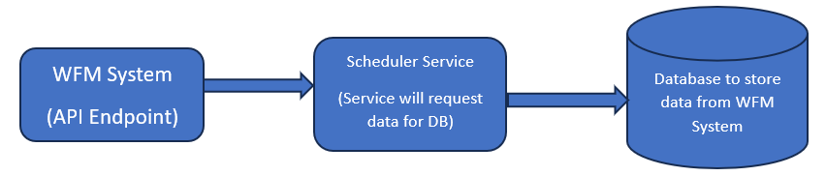

1. .Net core console application, Entity Framework Core 6.0, MS Test
2. **Host Builder:** This could be used in a console application that needs to run background processing tasks, perhaps handling messages on a queue example.
   1. Microsoft.Extensions.Hosting
   2. Microsoft.Extensions.Hosting.Abstractions
3. Quartz: used to schedule jobs to run.
   1. Quartz
   2. Quartz.Extensions.Hosting
4. Configure time interval for scheduler.

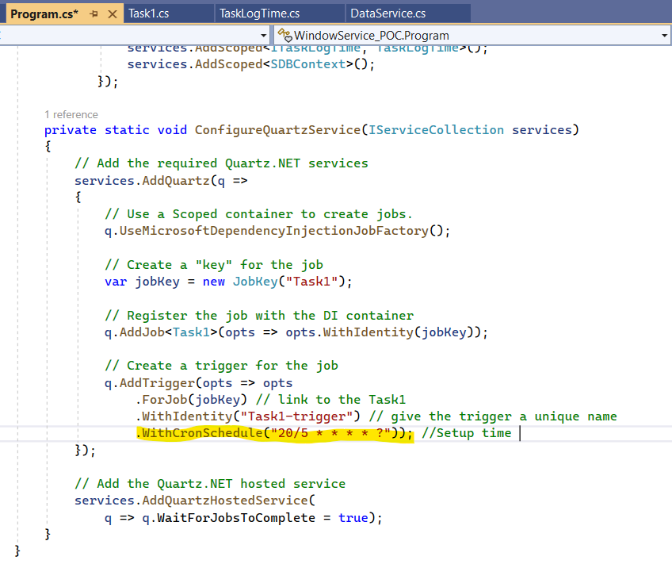

**Database:**

