**Simulation process**

We can use randomness to simulate a game. In python, we can use random package, a sub-package of numpy.

The below code given distribution of tails for a coin flipped 10 times and process is repeated 10000 times

import numpy as np

import matplotlib.pyplot as plt

np.random.seed(123)

final_tails=[]

for x in range(10000):

tails = [0]

for x in range(10):

coin=np.random.randint(0,2)

tails.append(tails[x] + coin)

final_tails.append(tails[-1])

plt.hist(final_tails, bins= 10)

plt.show()

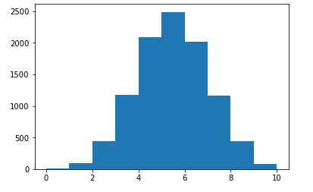

   # *we use randint(), also a function of the random package, to generate integers randomly. Here 0 is head and # tail is one. Note that*

*in the code below 0 is included and 2 is not.*

# In the below problem, I have tried to figure out what are the odds that one reaches 80 steps high on the State Building with each step is based on the result of a dice. Instructions (if dice <=2 , step -1, else if dice <= 5.  step +1, else throw dice again)  Approach- To get an idea about how big our chances are reaching 80 steps, we can repeatedly simulate the random walk and collect the results.

**# What are the odds that one reach 60 steps high on the State Building**

# if dice <=2 , step -1, elseif dice <= 5. step +1, else throw dice again

import matplotlib.pyplot as plt

import numpy as np

np.random.seed(1)

all_walks = []

for i in range(10) :

random_walk = [0]

for x in range(100) :

step = random_walk[-1]

dice = np.random.randint(1,7)

if dice <= 2:

step = max(0, step - 1)

elif dice <= 5:

step = step + 1

else:

step = step + np.random.randint(1,7)

random_walk.append(step)

all_walks.append(random_walk)

# Convert all_walks to Numpy array: np_aw

np_aw=np.array(all_walks)

# Plot np_aw and show

plt.plot(np_aw)

plt.show()

# Clear the figure

plt.clf()

# Transpose np_aw: np_aw_t

np_aw_t = np.transpose(np_aw)

# Plot np_aw_t and show

plt.plot(np_aw_t)

plt.show()

# look -How important is to transpose numpy array

# Select last row from np_aw_t: ends

ends =np_aw_t[-1]

# Plot histogram of ends, display plot

plt.hist(ends)

plt.show()

print(ends)

np.mean(ends >60)

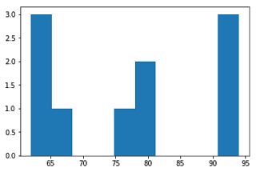

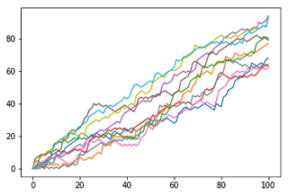

[68 77 80 63 94 79 62 64 93 93]

Out[11]:

1.0