Aws

Iam set up – user , group , policy

Ec2

S3

Putty set up

<https://www.youtube.com/watch?v=bIDDjfRYGU0>

[Prasad Domala](https://www.youtube.com/channel/UCE5IQGVqkhc7G1HuXo3txkg)

Sudo apt-get install

Sudo apt install nodejs

<https://github.com/in28minutes/deploy-spring-boot-aws-eb>

Yum or apt ------ kind of same vary machine to machine

<https://stackoverflow.com/questions/24588742/java-8-application-on-ec2>

java -version

sudo yum install java-1.8.0

sudo alternatives --config java

<https://www.youtube.com/watch?v=R5B0PLrCT4I&list=PL_OdF9Z6GmVZCwyfd8n6_50jcE_Xlz1je&index=13>

basic aws training

<https://www.youtube.com/watch?v=6RrqytT0-I8&t=792s>

spring boot + s3 + deploy

download file to ec2 instance

wget filename

wget <https://amitkr2027-aws-test.s3.us-east-2.amazonaws.com/test-springboot-app-0.0.1-SNAPSHOT.jar>

run jar file in ec2 instance

java –jar [test-springboot-app-0.0.1-SNAPSHOT.jar](https://amitkr2027-aws-test.s3.us-east-2.amazonaws.com/test-springboot-app-0.0.1-SNAPSHOT.jar)

<https://stackoverflow.com/questions/42218237/java-lang-illegalargumentexception-invalid-character-found-in-method-name-http>

This exception can occur when you try to execute [HTTPS](https://wikipedia.org/wiki/HTTPS) request from client on endpoint which isn't HTTPS enabled. Client will encrypt request data when server is expecting raw data.

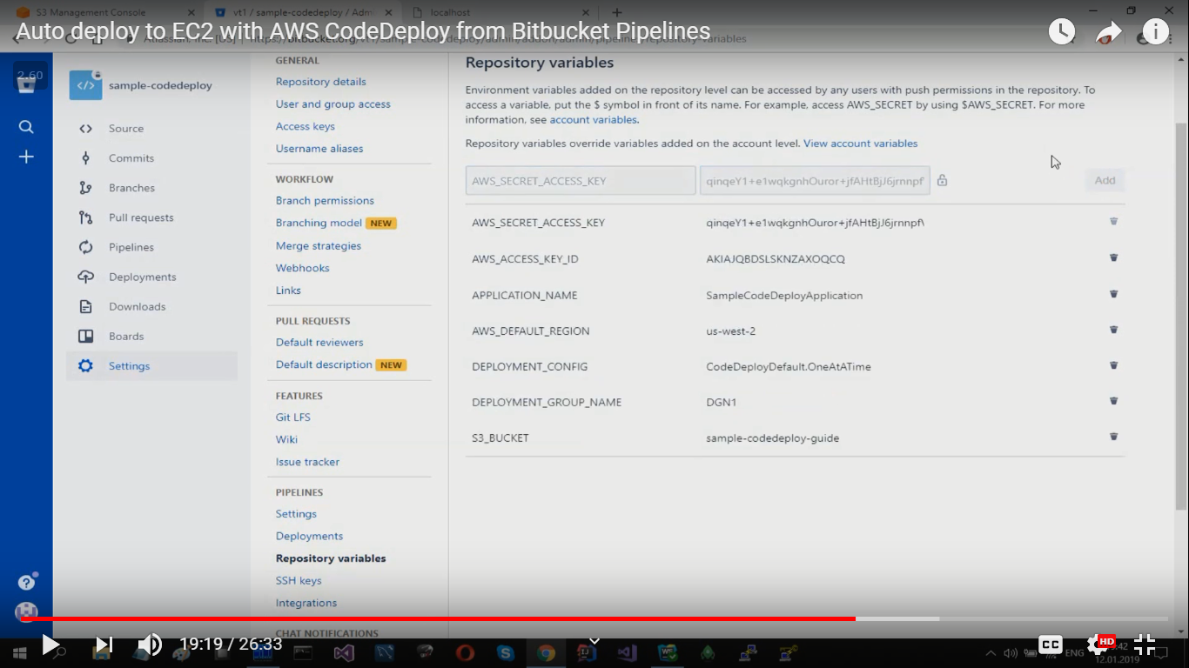

<https://www.youtube.com/watch?v=K8J6ngMekx4&t=1141s>

follow

<https://www.youtube.com/watch?v=gggWnCFEixU&t=1419s>

Future

<https://www.youtube.com/watch?v=bIDDjfRYGU0> aws – load balancer and all

java – 8

<https://www.youtube.com/watch?v=Tm2BpKlv1rU&list=PLd3UqWTnYXOlrKZWFTbgguqNRA_uVyeBl>

Angular app deploy ec2 bit pipeline

<https://www.youtube.com/watch?v=0cwcvJoO0Ec>

project full architecture stock

<https://www.youtube.com/watch?v=rlS9eH5tEnY>

<https://www.youtube.com/watch?v=ifBFwH59gGA>

Netflix

<https://www.youtube.com/watch?v=dZ8Z5DpcdrM>

<https://www.youtube.com/watch?v=SjU3AsSATvI>