Amit_Lab8 - Day 5 & 6 Assignment
C Programming - Functions, Structures & Pointers
Question 1: Find the Maximum of Two Numbers
#include <stdio.h>

int main() {
int a, b;

printf("Enter two numbers: ");
scanf("%d %d", &a, &b);

if (a > b)
printf("Maximum = %d\n", a);
else
printf("Maximum = %d\n", b);

return 0;
}
Output:
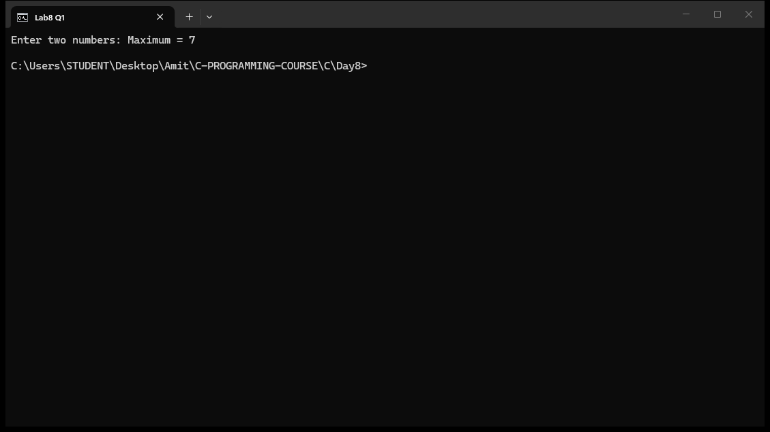

Question 2: Check Prime Number (Write a function isPrime() that returns 1 if a number is prime, otherwise 0)
#include <stdio.h>

int isPrime(int n);

int main() {
int num;

printf("Enter a number: ");
scanf("%d", &num);

if (isPrime(num))
printf("%d is a Prime Number\n", num);
else
printf("%d is not a Prime Number\n", num);

return 0;
}

int isPrime(int n) {
int i;

if (n <= 1)
return 0;

for (i = 2; i * i <= n; i++) {
if (n % i == 0)
return 0;
}

return 1;
}
Output:
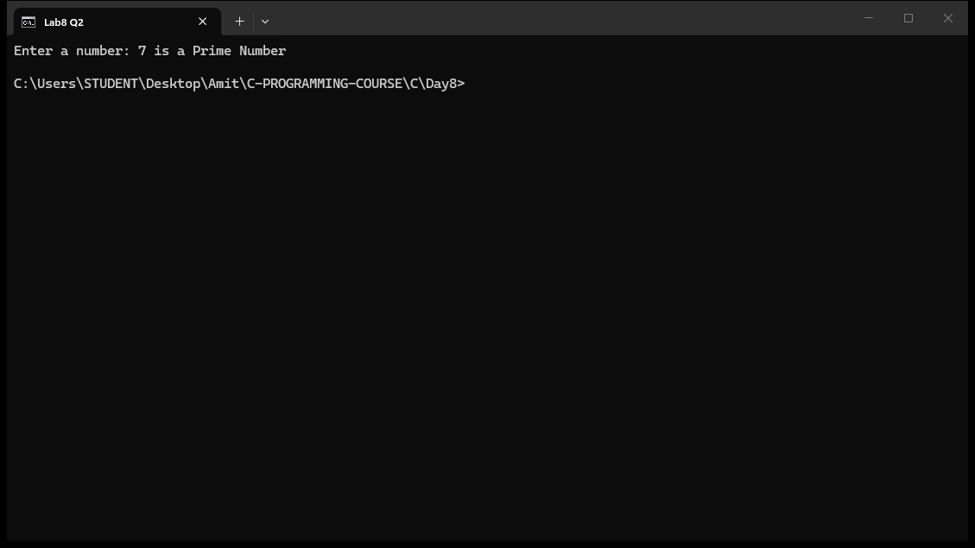

Question 3: Reverse a Number - Write a function that returns the reverse of a given integer
#include <stdio.h>

int reverseNum(int n);

int main() {
int num;

printf("Enter a number: ");
scanf("%d", &num);

printf("Reversed = %d\n", reverseNum(num));

return 0;
}

int reverseNum(int n) {
int rev = 0;

while (n != 0) {
rev = rev * 10 + n % 10;
n = n / 10;
}

return rev;
}
Output:
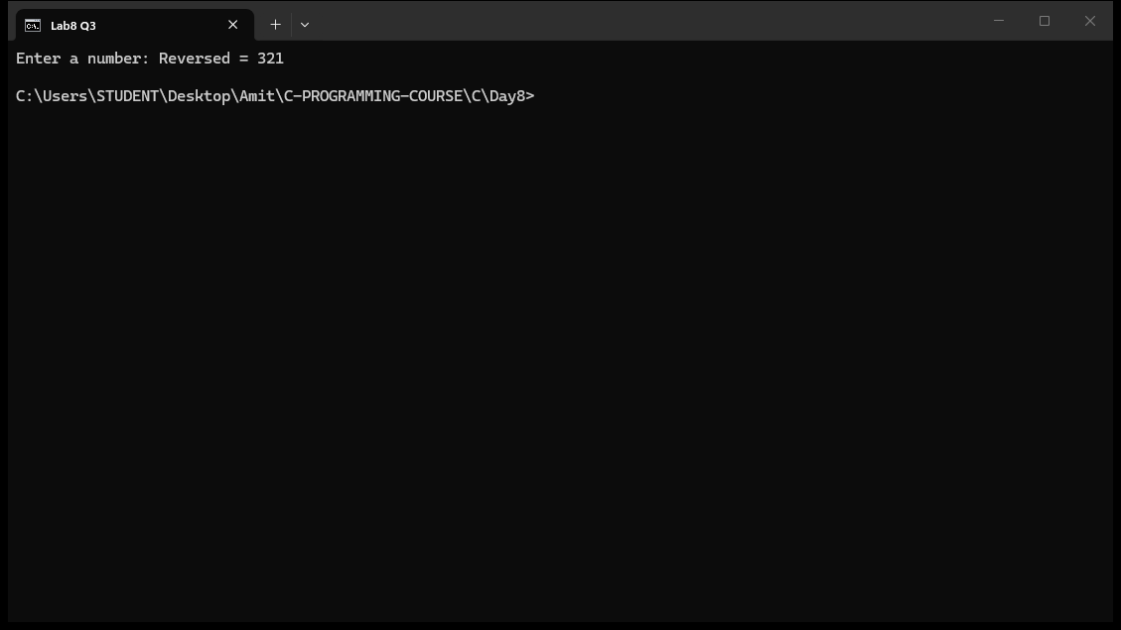

Question 4: Calculate the Factorial of a number Using Function
#include <stdio.h>

long factorial(int n);

int main() {
int num;

printf("Enter a number: ");
scanf("%d", &num);

printf("Factorial = %ld\n", factorial(num));

return 0;
}

long factorial(int n) {
int i;
long f = 1;

for (i = 1; i <= n; i++)
f = f * i;

return f;
}
Output:
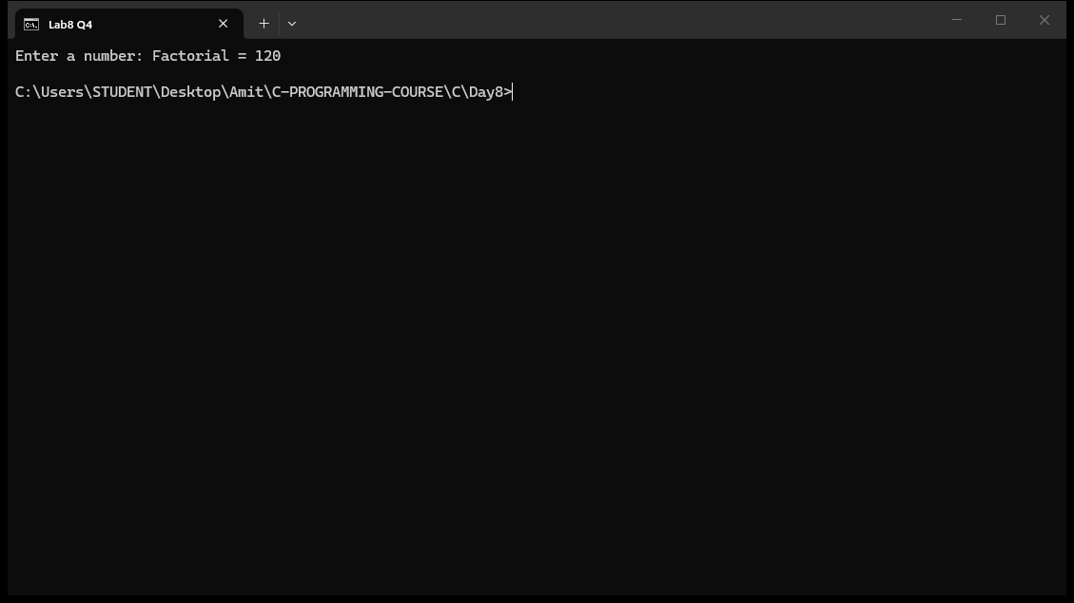

Question 5: Print the first n Fibonacci numbers
#include <stdio.h>

int main() {
int n, i, a = 0, b = 1, c;

printf("Enter how many Fibonacci numbers: ");
scanf("%d", &n);

printf("Fibonacci series: ");

for (i = 0; i < n; i++) {
printf("%d ", a);
c = a + b;
a = b;
b = c;
}

printf("\n");

return 0;
}
Output:
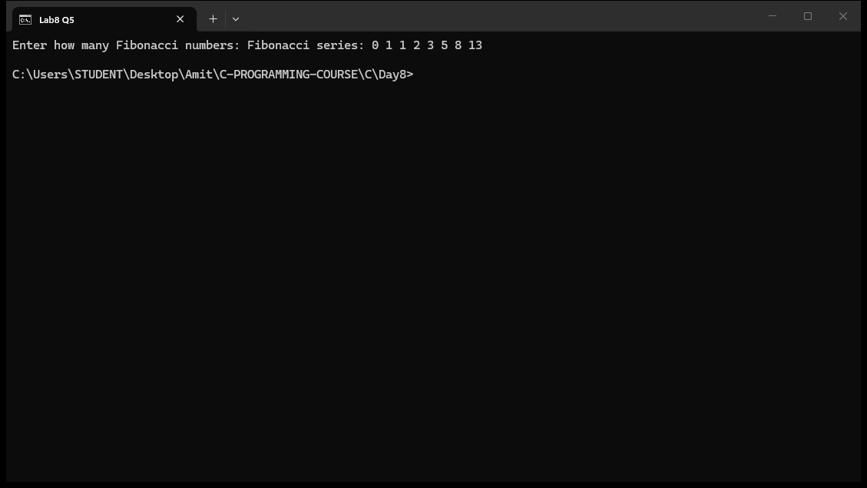

Question 6: Swap Two Numbers using call by value and call by reference, compare outputs
#include <stdio.h>

void swapByValue(int a, int b);
void swapByReference(int *a, int *b);

int main() {
int x, y;

printf("Enter two numbers: ");
scanf("%d %d", &x, &y);

printf("\nOriginal: x = %d, y = %d\n", x, y);

swapByValue(x, y);
printf("After swapByValue: x = %d, y = %d (no change)\n", x, y);

swapByReference(&x, &y);
printf("After swapByReference: x = %d, y = %d (swapped!)\n", x, y);

return 0;
}

void swapByValue(int a, int b) {
int temp = a;
a = b;
b = temp;
}

void swapByReference(int *a, int *b) {
int temp = *a;
*a = *b;
*b = temp;
}
Output:
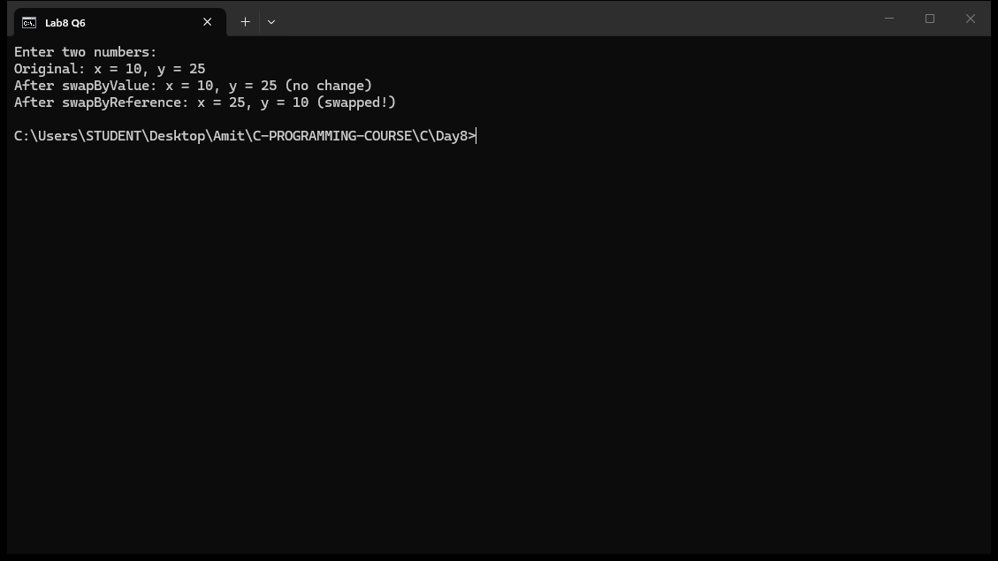

Question 7: struct Student with roll_no, name, marks[5] - find student with highest total marks
#include <stdio.h>

struct Student {
int roll_no;
char name[50];
float marks[5];
};

int main() {
struct Student s[5];
int i, j, topper = 0;
float total, maxTotal = 0;

for (i = 0; i < 5; i++) {
printf("Enter details of student %d:\n", i + 1);
printf("Roll No: ");
scanf("%d", &s[i].roll_no);
printf("Name: ");
scanf("%s", s[i].name);
total = 0;
for (j = 0; j < 5; j++) {
printf("Marks in subject %d: ", j + 1);
scanf("%f", &s[i].marks[j]);
total = total + s[i].marks[j];
}
if (total > maxTotal) {
maxTotal = total;
topper = i;
}
}

printf("\nStudent with highest total marks:\n");
printf("Roll No: %d\n", s[topper].roll_no);
printf("Name: %s\n", s[topper].name);
printf("Total Marks: %.2f\n", maxTotal);

return 0;
}
Output:
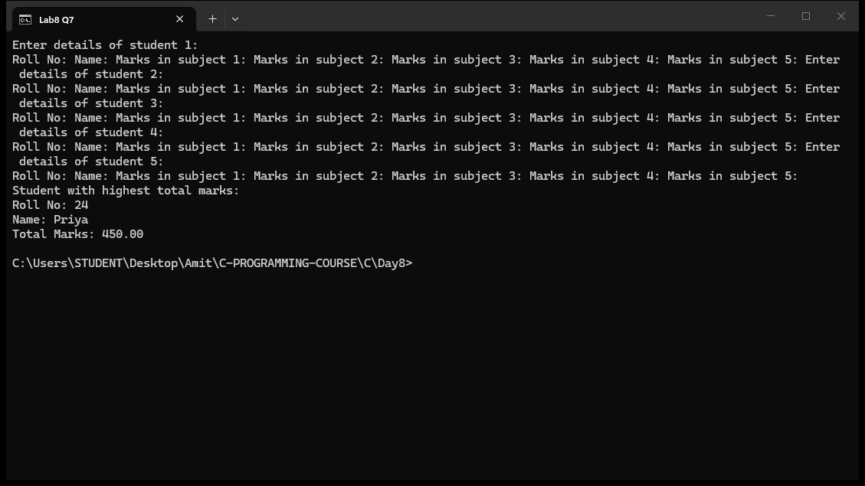

Question 8: Employee struct (ID, Name, Salary) - find employee with highest salary
#include <stdio.h>

struct Employee {
int id;
char name[50];
float salary;
};

int main() {
struct Employee emp[5];
int i, highest = 0;

for (i = 0; i < 5; i++) {
printf("Enter details of employee %d:\n", i + 1);
printf("ID: ");
scanf("%d", &emp[i].id);
printf("Name: ");
scanf("%s", emp[i].name);
printf("Salary: ");
scanf("%f", &emp[i].salary);
if (emp[i].salary > emp[highest].salary)
highest = i;
}

printf("\nEmployee with highest salary:\n");
printf("ID: %d\n", emp[highest].id);
printf("Name: %s\n", emp[highest].name);
printf("Salary: %.2f\n", emp[highest].salary);

return 0;
}
Output:
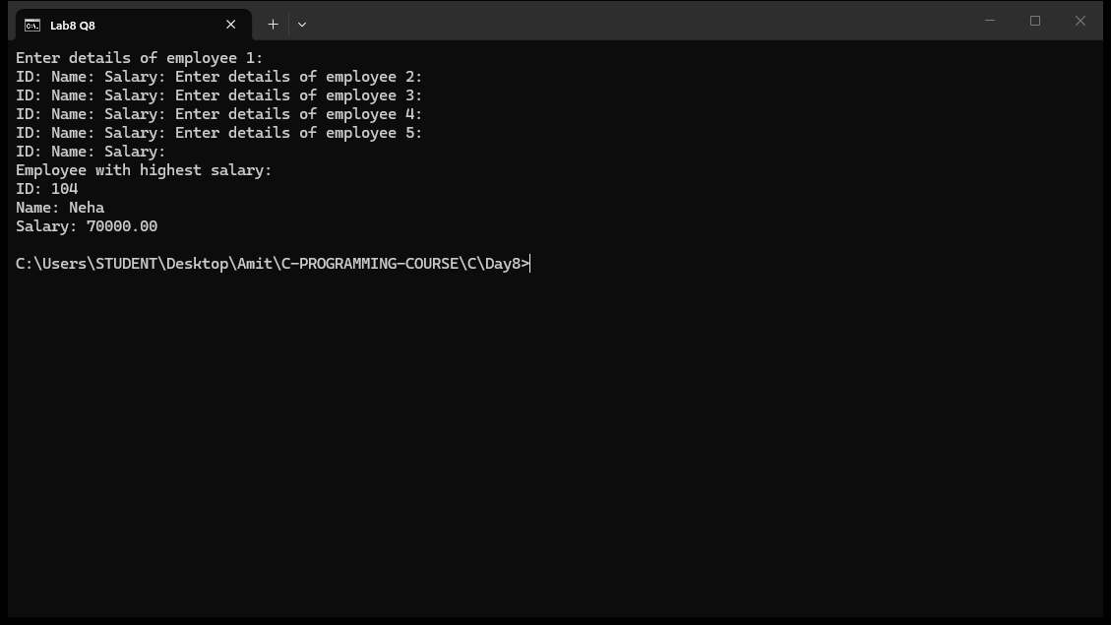

Question 9: Nested struct Date in Employee - print employees who joined before a given year
#include <stdio.h>

struct Date {
int d, m, y;
};

struct Employee {
int id;
char name[50];
struct Date joinDate;
};

int main() {
struct Employee emp[3];
int i, year;
int found = 0;

for (i = 0; i < 3; i++) {
printf("Enter details of employee %d:\n", i + 1);
printf("ID: ");
scanf("%d", &emp[i].id);
printf("Name: ");
scanf("%s", emp[i].name);
printf("Date of joining (dd mm yyyy): ");
scanf("%d %d %d", &emp[i].joinDate.d, &emp[i].joinDate.m, &emp[i].joinDate.y);
}

printf("\nEnter year to check: ");
scanf("%d", &year);

printf("\nEmployees who joined before %d:\n", year);
for (i = 0; i < 3; i++) {
if (emp[i].joinDate.y < year) {
printf("ID: %d, Name: %s, Joined: %d/%d/%d\n",
emp[i].id, emp[i].name,
emp[i].joinDate.d, emp[i].joinDate.m, emp[i].joinDate.y);
found = 1;
}
}

if (!found)
printf("No employees found.\n");

return 0;
}
Output:
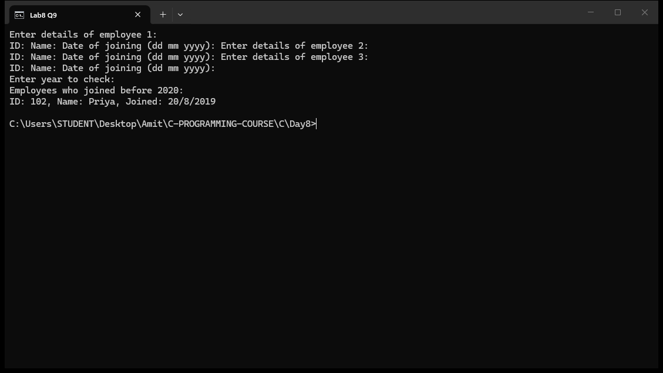

Question 10: Library management with array of structs - add/search/display functions
#include <stdio.h>
#include <string.h>

struct Book {
char title[50];
char author[50];
int issued;
};

void addBook(struct Book *b);
void displayBooks(struct Book *b, int count);
void searchBook(struct Book *b, int count, char *title);

int main() {
struct Book books[20];
int count = 0;
int choice;
char search[50];

do {
printf("\n---LIBRARY MANAGEMENT----\n");
printf("1. Add Book\n");
printf("2. Display Books\n");
printf("3. Search Book\n");
printf("4. Exit\n");
printf("Enter choice: ");
scanf("%d", &choice);

switch (choice) {
case 1:
addBook(&books[count]);
count++;
break;
case 2:
displayBooks(books, count);
break;
case 3:
printf("Enter title to search: ");
scanf("%s", search);
searchBook(books, count, search);
break;
case 4:
printf("Exiting...\n");
break;
default:
printf("Invalid choice!\n");
}
} while (choice != 4);

return 0;
}

void addBook(struct Book *b) {
printf("Enter title: ");
scanf("%s", b->title);
printf("Enter author: ");
scanf("%s", b->author);
b->issued = 0;
printf("Book added.\n");
}

void displayBooks(struct Book *b, int count) {
int i;

if (count == 0) {
printf("No books found.\n");
return;
}

for (i = 0; i < count; i++) {
printf("Title: %s, Author: %s, Issued: %s\n",
b[i].title, b[i].author, b[i].issued ? "Yes" : "No");
}
}

void searchBook(struct Book *b, int count, char *title) {
int i;

for (i = 0; i < count; i++) {
if (strcmp(b[i].title, title) == 0) {
printf("Book Found!\n");
printf("Title: %s, Author: %s\n", b[i].title, b[i].author);
return;
}
}

printf("Book not found.\n");
}
Output:
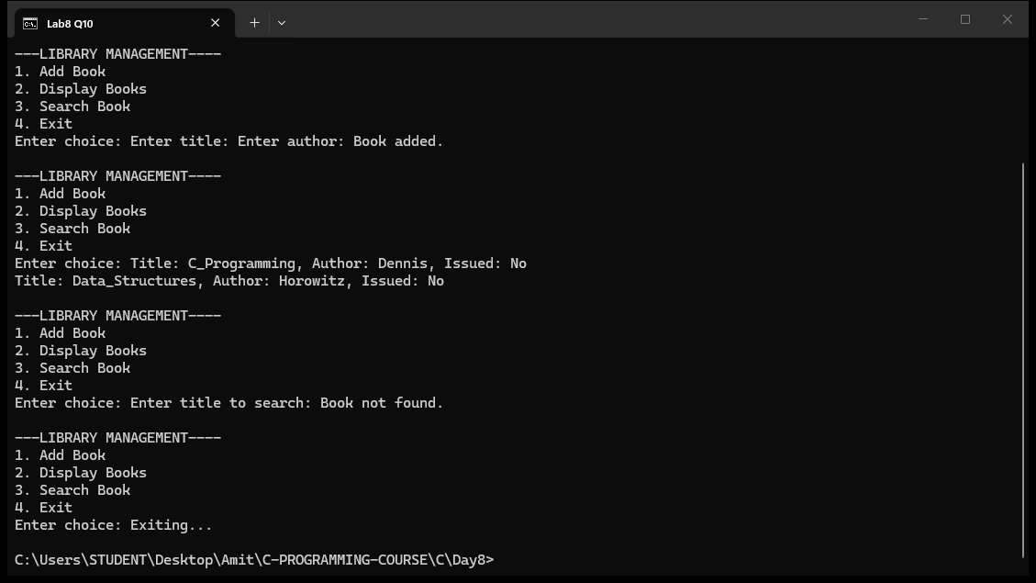

Question 11: Pointer basics - declare variable, print address, value, and access via pointer
#include <stdio.h>

int main() {
int num = 10;
int *ptr;

ptr = &num;

printf("Value of num: %d\n", num);
printf("Address of num (&num): %p\n", &num);
printf("Value stored in ptr: %p\n", ptr);
printf("Value via pointer (*ptr): %d\n", *ptr);

return 0;
}
Output:
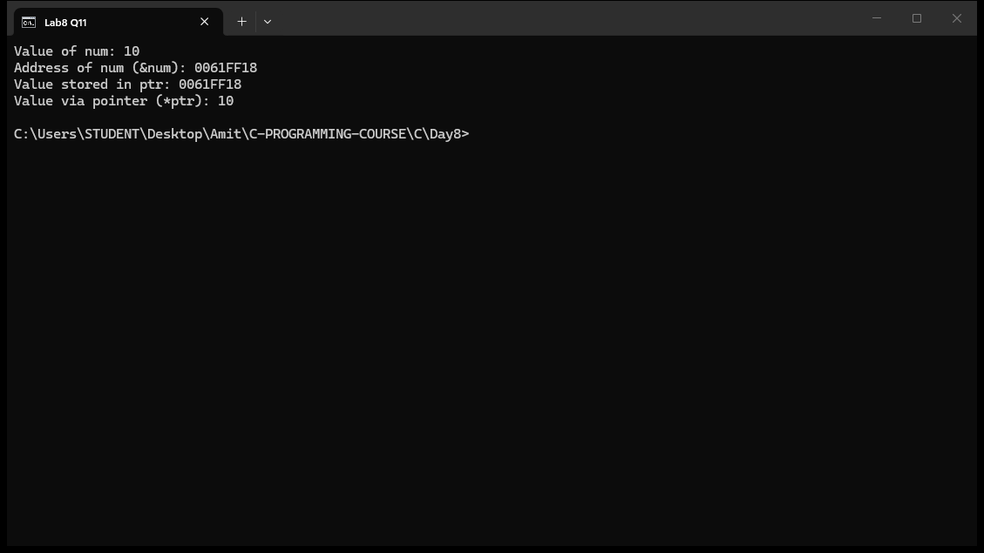

Question 12: Use pointer arithmetic to traverse and print all elements of an array
#include <stdio.h>

int main() {
int arr[10] = {1, 2, 3, 4, 5, 6, 7, 8, 9, 10};
int *ptr;
int i;

ptr = arr;

printf("Array elements using pointer arithmetic:\n");
for (i = 0; i < 10; i++) {
printf("%d ", *(ptr + i));
}
printf("\n");

return 0;
}
Output:
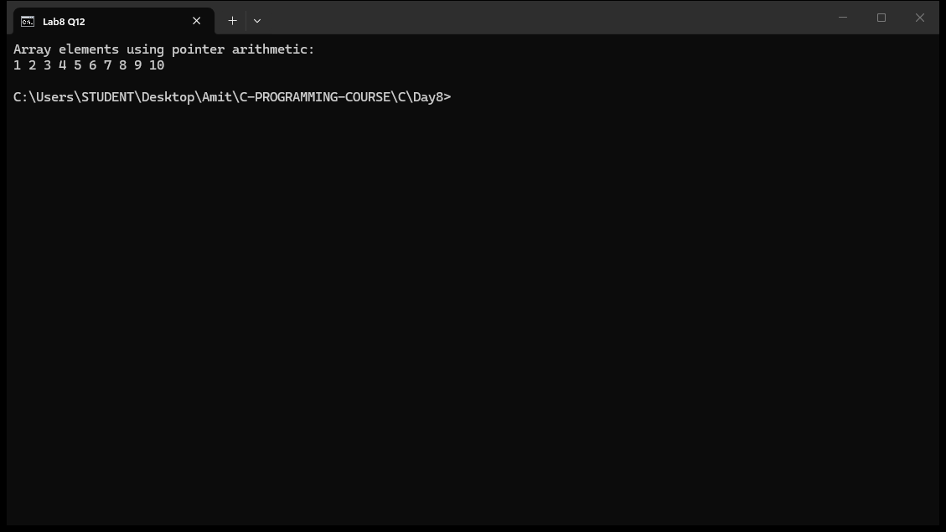

Question 13: Swap Two Numbers Using Pointers
#include <stdio.h>

void swap(int *a, int *b);

int main() {
int x, y;

printf("Enter two numbers: ");
scanf("%d %d", &x, &y);

printf("Before swap: x = %d, y = %d\n", x, y);

swap(&x, &y);

printf("After swap: x = %d, y = %d\n", x, y);

return 0;
}

void swap(int *a, int *b) {
int temp = *a;
*a = *b;
*b = temp;
}
Output:
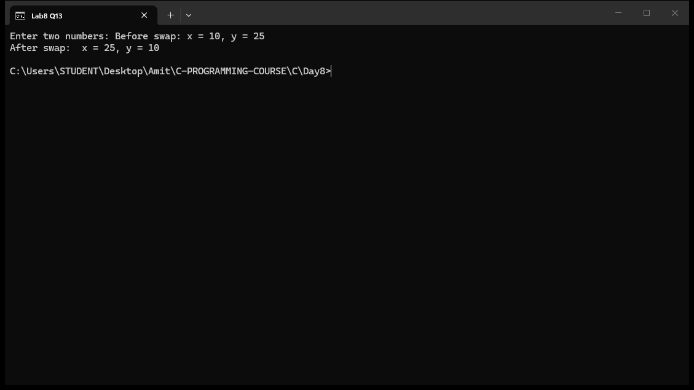

Question 14: Find the Largest Element in an Array Using Pointers
#include <stdio.h>

int main() {
int arr[5] = {23, 45, 67, 12, 89};
int *ptr;
int i, max;

ptr = arr;
max = *ptr;

for (i = 1; i < 5; i++) {
ptr++;
if (*ptr > max)
max = *ptr;
}

printf("Array: ");
for (i = 0; i < 5; i++)
printf("%d ", arr[i]);

printf("\nLargest element = %d\n", max);

return 0;
}
Output:
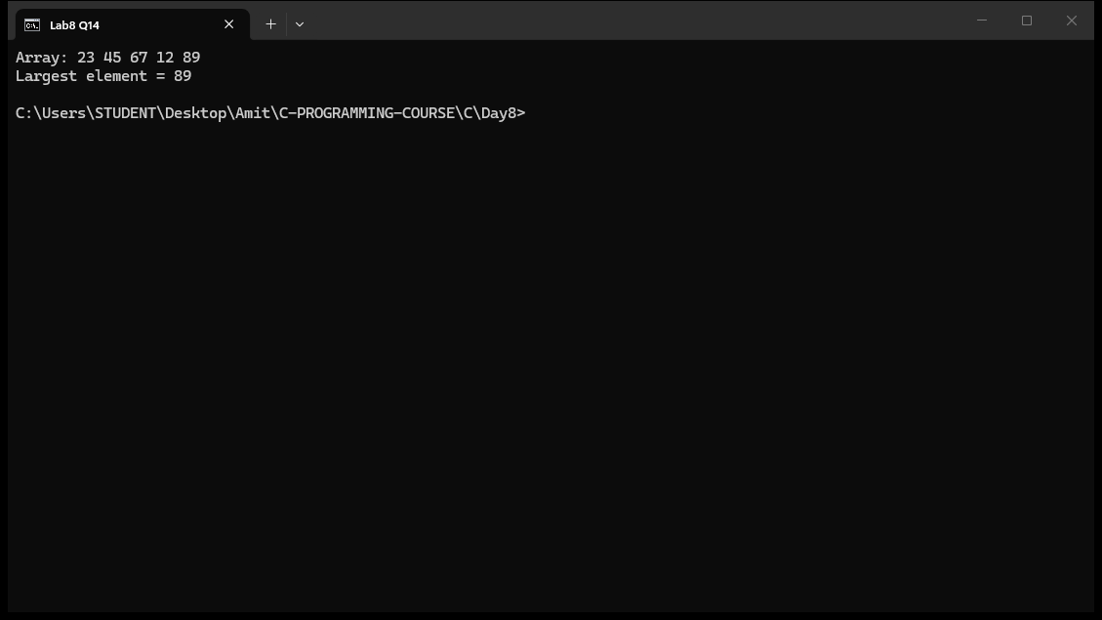

Question 15: Sum of Array Elements Using Pointer Arithmetic
#include <stdio.h>

int main() {
int arr[5] = {10, 20, 30, 40, 50};
int *ptr;
int i;
int sum = 0;
float average;

ptr = arr;

for (i = 0; i < 5; i++) {
sum = sum + *ptr;
ptr++;
}

average = (float)sum / 5;

printf("Array elements: ");
ptr = arr;
for (i = 0; i < 5; i++) {
printf("%d ", *ptr);
ptr++;
}

printf("\nSum = %d\n", sum);
printf("Average = %.2f\n", average);

return 0;
}
Output:
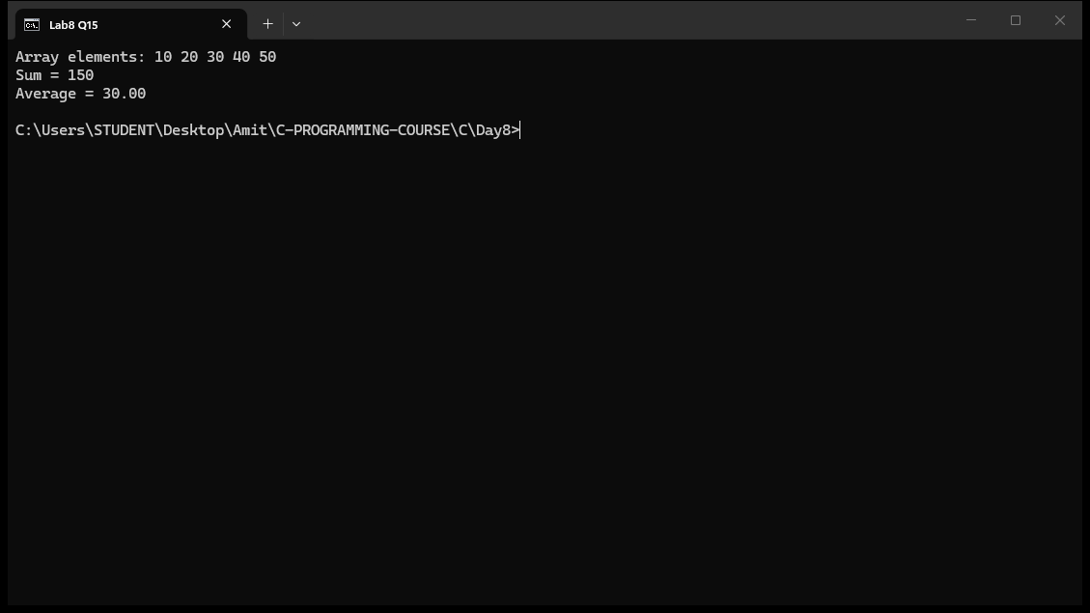

Question 16: Reverse an Array Using Pointers
#include <stdio.h>

int main() {
int arr[7] = {1, 2, 3, 4, 5, 6, 7};
int *left, *right;
int temp;
int i;

printf("Original array: ");
for (i = 0; i < 7; i++)
printf("%d ", arr[i]);
printf("\n");

left = arr;
right = arr + 6;

while (left < right) {
temp = *left;
*left = *right;
*right = temp;
left++;
right--;
}

printf("Reversed array: ");
for (i = 0; i < 7; i++)
printf("%d ", arr[i]);
printf("\n");

return 0;
}
Output:
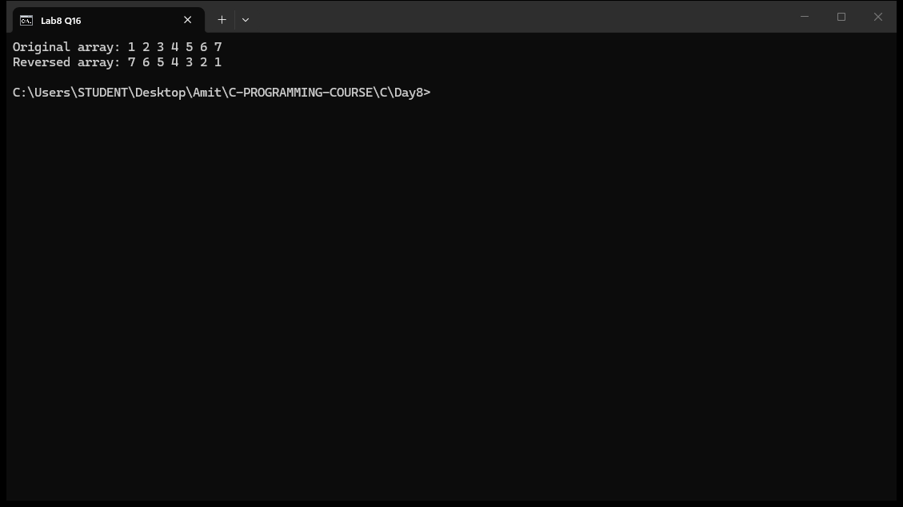

Question 17: Declare int, pointer, double pointer - display all values and addresses
#include <stdio.h>

int main() {
int num = 42;
int *ptr = &num;
int **pptr = &ptr;

printf("Value of the variable: %d\n", num);
printf("Address of the variable (&num): %p\n", &num);
printf("Value stored in the pointer (ptr): %p\n", ptr);
printf("Address of the pointer (&ptr): %p\n", &ptr);
printf("Value stored in the double pointer (*pptr): %p\n", *pptr);
printf("Address of the double pointer (&pptr): %p\n", &pptr);

return 0;
}
Output:
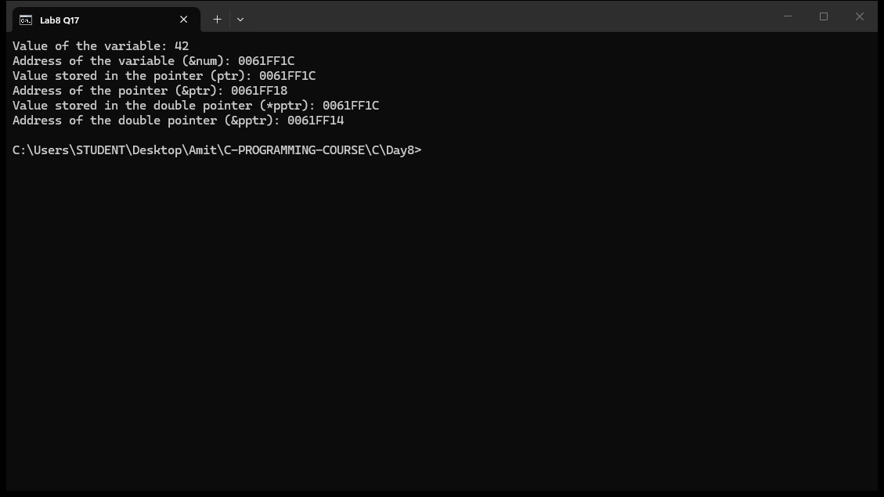

Question 18: Change the value of an integer using only a double pointer
#include <stdio.h>

int main() {
int num = 10;
int *ptr = &num;
int **pptr = &ptr;

printf("Original value: %d\n", num);

**pptr = 50;

printf("Value changed using double pointer: %d\n", num);

return 0;
}
Output:
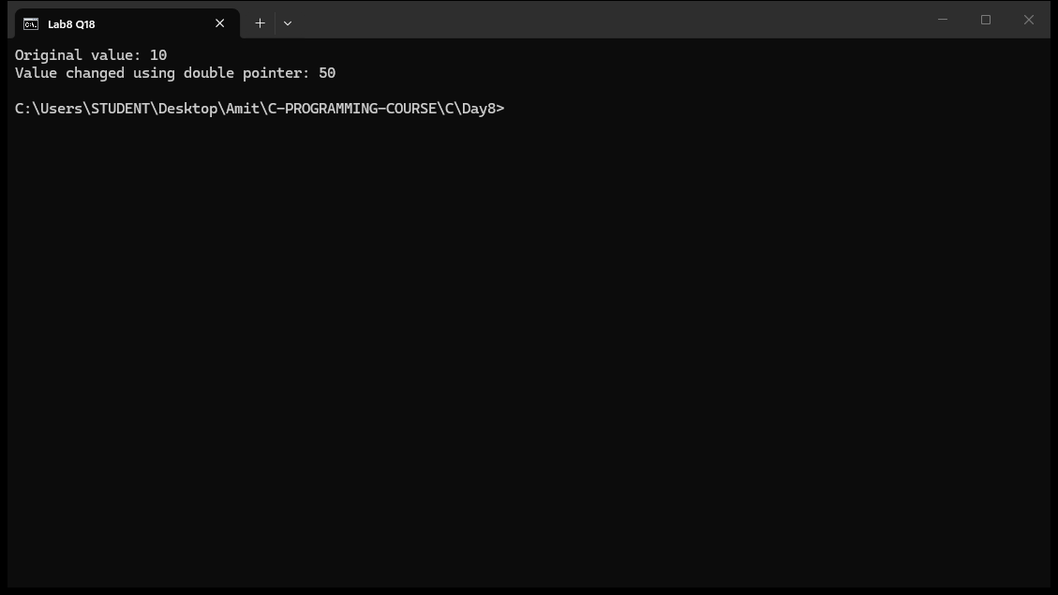

Question 19: Use pointer to iterate array and count even/odd elements
#include <stdio.h>

int main() {
int arr[10] = {12, 5, 8, 7, 10, 3, 6, 9, 14, 1};
int *ptr;
int even = 0, odd = 0;
int i;

ptr = arr;

for (i = 0; i < 10; i++) {
if (*ptr % 2 == 0)
even++;
else
odd++;
ptr++;
}

printf("Array elements: ");
ptr = arr;
for (i = 0; i < 10; i++) {
printf("%d ", *ptr);
ptr++;
}

printf("\nEven numbers: %d\n", even);
printf("Odd numbers: %d\n", odd);

return 0;
}
Output:
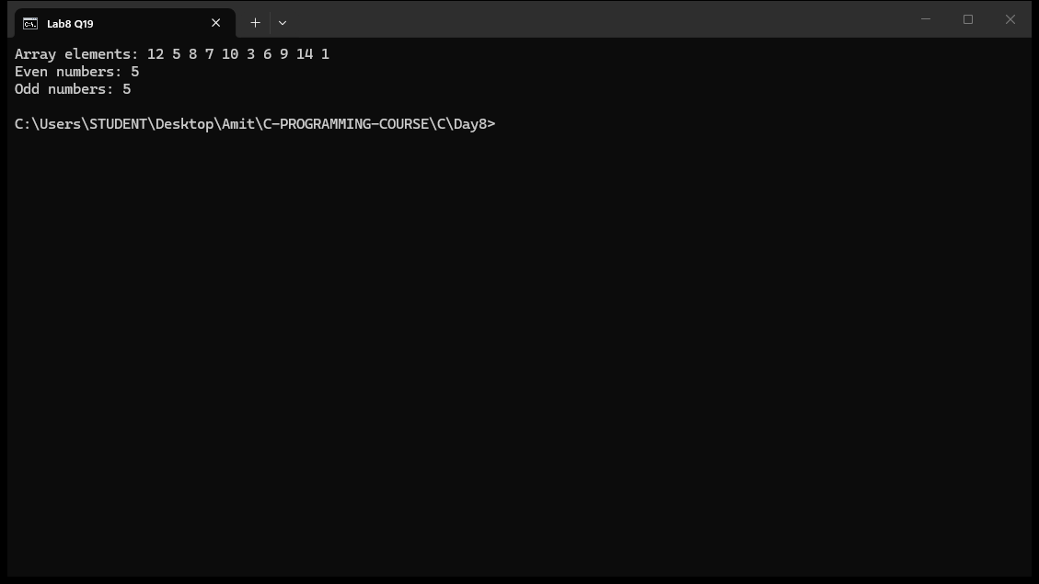

Question 20: Use pointer to find sum and average of all elements in integer array
#include <stdio.h>

int main() {
int arr[5] = {10, 20, 30, 40, 50};
int *ptr;
int i;
int sum = 0;
float average;

ptr = arr;

for (i = 0; i < 5; i++) {
sum = sum + *ptr;
ptr++;
}

average = (float)sum / 5;

printf("Array: ");
ptr = arr;
for (i = 0; i < 5; i++) {
printf("%d ", *ptr);
ptr++;
}

printf("\nSum = %d\n", sum);
printf("Average = %.2f\n", average);

return 0;
}
Output:
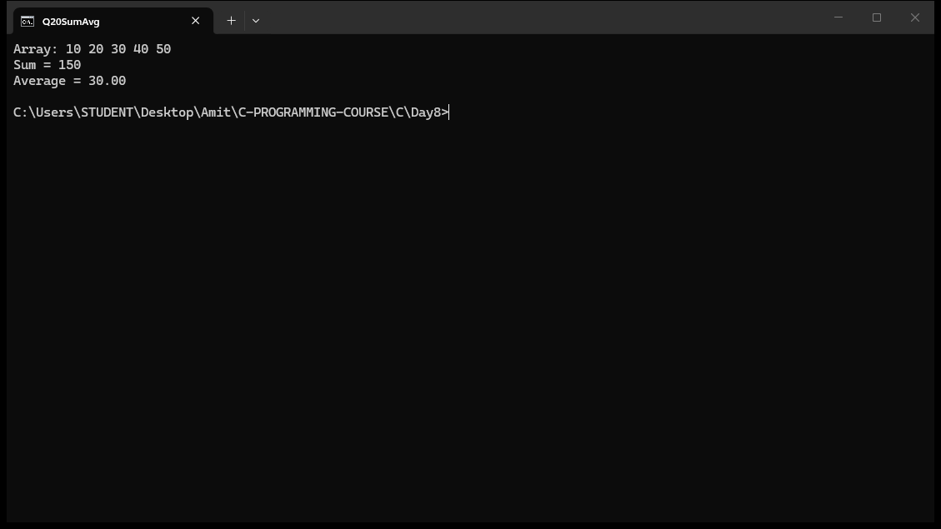

MCQ Questions: Answers
Q | Answer
1 | A) 6 6
2 | B) 40
3 | C) 30
4 | C) s.marks
5 | C) static
6 | C) 1 2 3
7 | A) 80
8 | B) 20
9 | C) 10 20
10 | A) 5
Explain
1. Differentiate between call by value and call by reference in C. Give suitable examples and mention when each is preferred.
In call by value, a copy of the argument is passed to the function, so changes inside do not affect the original. In call by reference, the address of the argument is passed, so the function can modify the original variable. For example swapByValue(x, y) copies x and y and swaps only the copies, while swapByReference(&x, &y) passes addresses and swaps the originals. Call by value is preferred when the function should not change the caller's data, while call by reference is needed when the function must modify caller variables or pass large structures efficiently.
2. What is recursion? Explain its advantages, disadvantages, and give one example where recursion is preferred over iteration.
Recursion is when a function calls itself to solve a problem by breaking it into smaller sub-problems. Advantages: code is simpler and more readable for problems with a recursive structure like tree traversal. Disadvantages: uses extra stack memory, slower than iteration, and may cause stack overflow for very deep recursion. Recursion is preferred for problems like factorial, Fibonacci, Tower of Hanoi and binary tree traversal where the recursive definition naturally matches the algorithm.
3. What is a pointer? Explain the purpose of pointers in C. How do pointers improve the efficiency of programs?
A pointer is a variable that stores the memory address of another variable. Pointers are used for dynamic memory allocation, passing arrays and structures efficiently to functions, implementing data structures like linked lists and trees, and allowing functions to modify caller variables. They improve efficiency by avoiding copying large data structures, enabling direct memory access, and allowing in-place modification of data without returning copies.
4. Explain pointer arithmetic in C. Which arithmetic operations are valid on pointers, and why?
Pointer arithmetic works in units of the pointed-to type. For an int pointer p pointing to arr[0], p+1 points to arr[1] (4 bytes ahead), p+2 to arr[2], etc. Valid operations: addition/subtraction of an integer, subtraction of two pointers of the same type. Invalid operations: multiplication, division, addition of two pointers. Subtraction of two pointers gives the number of elements between them. Pointer arithmetic is safe because it respects the size of the underlying type.
5. What is a double pointer (**)? Explain its syntax, purpose, and one practical application with an example.
A double pointer is a pointer to a pointer - it stores the address of another pointer variable. Syntax: int **pptr = &ptr; where ptr itself is int *. The value is accessed as **pptr which dereferences twice to reach the original integer. Purpose: used for dynamic 2D arrays, modifying pointer parameters in functions, and in some data structures. For example in q18, **pptr = 50; changes the original integer variable through two levels of indirection.
6. Differentiate between structures and arrays in C with suitable examples.
An array stores elements of the same data type in contiguous memory, accessed by index, e.g. int marks[5];. A structure groups different data types under one name, accessed by member name, e.g. struct Student{int id; float marks;};. Arrays are homogenous (all same type), structures are heterogenous (mixed types). Arrays use indexing marks[0], structures use dot operator s.marks. Arrays are useful for lists of the same data; structures are useful for grouping related but different fields like student records.
7. Explain the different ways of passing a structure to a function. Compare passing by value and by pointer.
A structure can be passed by value (e.g. void display(struct Student s)) which creates a copy of all members, or by pointer (e.g. void update(struct Student *s)) which passes the address. By value: safe (original not modified), but slower for large structs due to copying. By pointer: faster (only address copied), allows the function to modify the original struct, but the original can be changed unintentionally. The program in q7 demonstrates call by value where update(s) changes only the local copy, so the original remains unchanged.
8. Explain the four storage classes in C: auto, register, static, extern.
auto: default for local variables, stored in stack, lifetime is within the block, default value is garbage. register: stored in CPU register (hint to compiler), faster access, same scope/lifetime as auto, cannot use & operator. static: persists between function calls, initialized only once, default value is 0, scope is local to block. extern: declared outside any function, shares variable across files, lifetime is program duration, default value is 0. The static variable in q6 (fun) retains its value across calls, printing 1 2 3 instead of 1 1 1.
9. Explain the difference between struct and typedef struct in C. Why is typedef commonly used with structures?
Without typedef, you must write struct Student s; every time you declare a variable. With typedef struct{...} Student; you create an alias so you can write Student s; directly, making code shorter and cleaner. typedef is commonly used because it reduces repetition, especially when the same struct is used in many places. Both are equivalent in functionality, but typedef is preferred for readability and convenience.
10. Why is a structure assignment allowed in C, but an array assignment is not?
In C, the assignment operator (=) works on structures because the compiler copies all members of one struct to another in a single operation (e.g. s2 = s1;). Arrays are not allowed to be assigned with = because C treats array names as constant pointers to the first element, and you cannot assign to an array name. To copy arrays, you must use a loop or memcpy(). Structures support direct assignment, but arrays do not - this is a fundamental difference in how C handles these two aggregate types.

