Amit_Lab3 - Day 3 Assignment
C Programming - Arrays

Question 1: Insert an element at a specified position
/* Question: Insert an element at a specified position in an array. */
#include <stdio.h>

int main()
{
int arr[9];
int n, i, element, position;
printf("Enter number of elements: ");
scanf("%d", &n);
printf("Enter array elements:\n");

for (i = 0; i < n; i++)
{
scanf("%d", &arr[i]);
}

printf("Enter element to insert: ");
scanf("%d", &element);

printf("Enter position: ");
scanf("%d", &position);

for (i = n; i >= position; i--)
{
arr[i] = arr[i - 1];
}

arr[position - 1] = element;

n++;

printf("Array after insertion:\n");

for (i = 0; i < n; i++)
{
printf("%d ", arr[i]);
}

return 0;
}

Output:
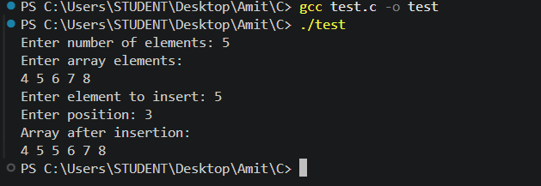

Question 2: Linear search for a value in an array
/*
* Question: Search for a given value in an array using linear search;
* print its index or "Not found."
*/
#include <stdio.h>

int main()
{
int arr[100];
int n, i, value;
int found = 0;
printf("Enter number of elements: ");
scanf("%d", &n);
printf("Enter array elements:\n");

for (i = 0; i < n; i++)
{
scanf("%d", &arr[i]);
}

printf("Enter value to search: ");
scanf("%d", &value);

for (i = 0; i < n; i++)
{
if (arr[i] == value)
{
printf("Element found at index %d\n", i);
found = 1;
break;
}
}

if (found == 0)
{
printf("Element not found\n");
}

return 0;
}

Output:
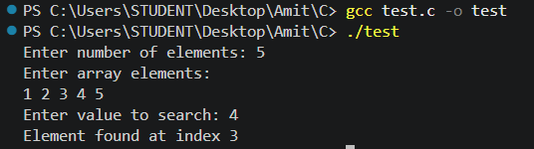

Question 3: Find the largest element in an array
/*
* Question: Find the largest element in an array.
*/
#include <stdio.h>

int main()
{
int arr[100];
int n, i, largest;
printf("Enter number of elements: ");
scanf("%d", &n);
printf("Enter array elements:\n");

for (i = 0; i < n; i++)
{
scanf("%d", &arr[i]);
}

largest = arr[0];

for (i = 1; i < n; i++)
{
if (arr[i] > largest)
{
largest = arr[i];
}
}

printf("Largest element = %d\n", largest);

return 0;
}

Output:
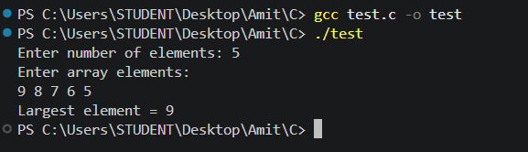

Question 4: Count even and odd numbers in an array
/*
* Question: Count how many even and how many odd numbers are in an array.
*/
#include <stdio.h>

int main()
{
int arr[100];
int n, i;
int even = 0, odd = 0;
printf("Enter number of elements: ");
scanf("%d", &n);
printf("Enter array elements:\n");

for (i = 0; i < n; i++)
{
scanf("%d", &arr[i]);
}

for (i = 0; i < n; i++)
{
if (arr[i] % 2 == 0)
{
even++;
}
else
{
odd++;
}
}

printf("Total even elements = %d\n", even);
printf("Total odd elements = %d\n", odd);

return 0;
}

Output:
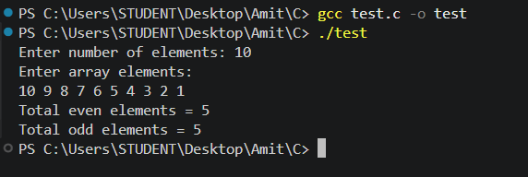

Question 5: Reverse an array
/*
* Question: Reverse an array.
*/
#include <stdio.h>

int main()
{
int arr[100];
int n, i;
printf("Enter number of elements: ");
scanf("%d", &n);
printf("Enter array elements:\n");

for (i = 0; i < n; i++)
{
scanf("%d", &arr[i]);
}

printf("Reverse array:\n");

for (i = n - 1; i >= 0; i--)
{
printf("%d ", arr[i]);
}

return 0;
}

Output:
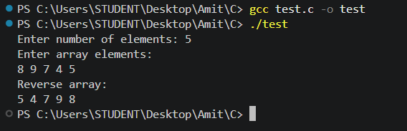

Question 6: Delete a given value from an array
/*
* Question: Delete a given value from an array.
*/
#include <stdio.h>

int main()
{
int arr[100];
int n, i, value, position = -1;
printf("Enter number of elements: ");
scanf("%d", &n);
printf("Enter array elements:\n");

for (i = 0; i < n; i++)
{
scanf("%d", &arr[i]);
}
printf("Enter value to delete: ");
scanf("%d", &value);
for (i = 0; i < n; i++)
{
if (arr[i] == value)
{
position = i;
break;
}
}

if (position != -1)
{
for (i = position; i < n - 1; i++)
{
arr[i] = arr[i + 1];
}

n--;

printf("Array after deletion:\n");

for (i = 0; i < n; i++)
{
printf("%d ", arr[i]);
}
}
else
{
printf("Value not found in array\n");
}

return 0;
}

Output:
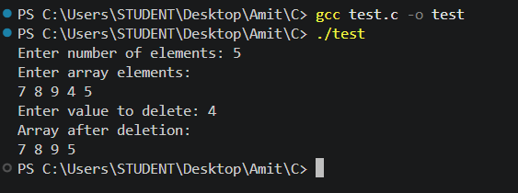

Question 7: Swap first and last elements in an array
/*
* Question: Swap First and Last Elements in an array by getting user input.
*/
#include <stdio.h>
int main()
{
int arr[100], n, i, temp;
printf("Enter number of elements: ");
scanf("%d", &n);

printf("Enter %d elements:\n", n);
for (i = 0; i < n; i++)
scanf("%d", &arr[i]);

printf("Original array:\n");
for (i = 0; i < n; i++)
printf("%d ", arr[i]);
printf("\n");

temp = arr[0];
arr[0] = arr[n - 1];
arr[n - 1] = temp;

printf("Array after swapping first and last elements:\n");
for (i = 0; i < n; i++)
printf("%d ", arr[i]);
printf("\n");

return 0;
}
Output:
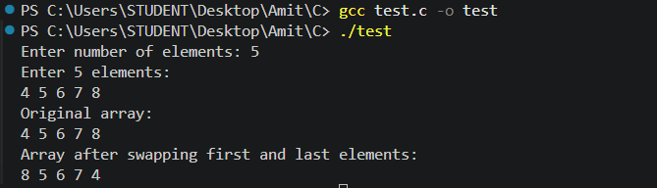

Question 8: Check whether two arrays are identical
/*
* Question: Input two arrays and check whether they are identical.
*/
#include <stdio.h>

int main()
{
int a[100], b[100], n, i, identical = 1;
printf("Enter number of elements: ");
scanf("%d", &n);
printf("Enter %d elements of first array:\n", n);

for (i = 0; i < n; i++)
scanf("%d", &a[i]);

printf("Enter %d elements of second array:\n", n);
for (i = 0; i < n; i++)
scanf("%d", &b[i]);

for (i = 0; i < n; i++)
{
if (a[i] != b[i])
{
identical = 0;
break;
}
}

if (identical == 1)
printf("The arrays are identical\n");
else
printf("The arrays are not identical\n");

return 0;
}
Output:
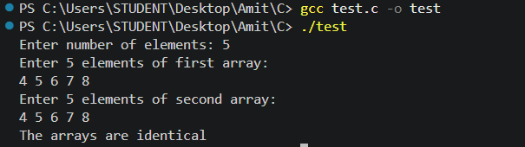

Question 9: Copy all elements of one array into another
/*
* Question: Copy all elements of one array into another array.
*/
#include <stdio.h>

int main()
{
int source[100], copy[100], n, i;
printf("Enter number of elements: ");
scanf("%d", &n);
printf("Enter %d elements:\n", n);
for (i = 0; i < n; i++)
scanf("%d", &source[i]);

for (i = 0; i < n; i++)
copy[i] = source[i];

printf("Elements of the copied array:\n");
for (i = 0; i < n; i++)
printf("%d ", copy[i]);
printf("\n");

return 0;
}
Output:
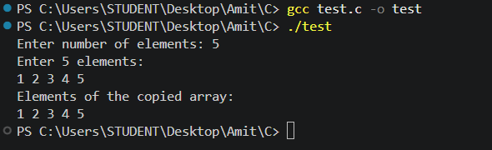

Question 10: Replace every negative number in an array with 0
/*
* Question: Replace every negative number in an array with 0 and display
* the updated array.
*/
#include <stdio.h>

int main()
{
int arr[100], n, i;
printf("Enter number of elements: ");
scanf("%d", &n);
printf("Enter %d elements:\n", n);
for (i = 0; i < n; i++)
scanf("%d", &arr[i]);
printf("Original array:\n");
for (i = 0; i < n; i++)
printf("%d ", arr[i]);
printf("\n");
for (i = 0; i < n; i++)
{
if (arr[i] < 0)
arr[i] = 0;
}
printf("Array after replacing negatives with 0:\n");
for (i = 0; i < n; i++)
printf("%d ", arr[i]);
printf("\n");
return 0;
}
Output:
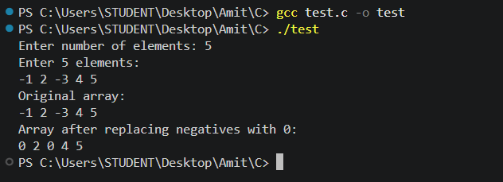

MCQ Questions: Answers
Q | Answer | Explanation
1 | c) 0 | arr has 5 elements but only 3 are initialized; when an array is partially initialized in C, all remaining elements are automatically set to 0, so arr[4] is 0.
2 | c) sizeof(arr) / sizeof(arr[0]) | sizeof(arr) gives the total bytes used by the whole array; dividing by the size of one element gives the element count. This only works while arr is still a real array, not a decayed pointer.
3 | b) 6 | arr[2] is the row {5, 6}, so arr[2][1] is 6.
4 | c) Garbage (indeterminate) values | Local arrays declared without initialization are not auto-cleared; they hold whatever values were already in that memory.
5 | b) 50 40 30 20 10 | The loop starts at index 4 and goes down to 0, printing the array back-to-front.
6 | b) for(int i = 2; i < size-1; i++) arr[i] = arr[i+1]; size--; | Deleting from an array means shifting every element after the target index one position left, then reducing the logical size.
7 | b) 30 | sum accumulates 5 + 10 + 15 = 30, and the loop breaks right after i == 2, before arr[3] is added.
8 | b) 0 0 0 | Rows given fewer values than declared are zero-filled, so arr[0][2], arr[1][1], and arr[1][2] are all 0.
9 | b) 5 3 5 | Each arr[i] is overwritten with the current arr[4-i] one step at a time, so the update at i=3 and i=4 reads values that were already modified earlier in the same loop, giving 5 4 3 4 5.
10 | b) 6 | For a 3D array stored in row-major order, arr[1][0][1] maps to flat index 1*4 + 0*2 + 1 = 5, and the 6th value (index 5) in the initializer list is 6.

Explain
1. Differentiate between compile-time initialization and run-time initialization of arrays, with examples of each.
Compile-time initialization assigns values to an array at the point of declaration; the values are fixed in the source code and become part of the program before it ever runs. Run-time initialization assigns values while the program is executing, typically through user input or computed values, so the contents can differ on every run.
/* Compile-time initialization */
int arr[5] = {1, 2, 3, 4, 5};

/* Run-time initialization */
int arr[5], i;
for(i = 0; i < 5; i++)
{
scanf("%d", &arr[i]);
}
2. How is the length of an array calculated in C, given that C has no built-in length function? Explain with the underlying logic.
C computes the element count using sizeof(arr) / sizeof(arr[0]). sizeof(arr) returns the total number of bytes occupied by the entire array, and sizeof(arr[0]) returns the number of bytes occupied by a single element. Dividing the two gives the number of elements. This trick only works on the original array variable, in the scope where it was declared - once an array is passed to a function it decays to a pointer, and sizeof on that pointer would return the pointer's size instead.
3. Explain how a 2D array is stored in memory, and how the compiler computes the address of a specific element arr[i][j].
A 2D array is stored in a single contiguous block of memory in row-major order, meaning the entire first row is stored first, followed immediately by the second row, and so on. To find the address of arr[i][j], the compiler uses the formula: base_address + (i * number_of_columns + j) * size_of_one_element. This flattens the two-dimensional index into a single offset into that contiguous memory block.
4. Write the syntax for declaring and initializing the following:
(a) 1D array, (b) 2D array, (c) 3D array:
/* (a) 1D array */
int a[5] = {1, 2, 3, 4, 5};

/* (b) 2D array */
int b[2][3] = {{1, 2, 3}, {4, 5, 6}};

/* (c) 3D array */
int c[2][2][2] = {
{{1, 2}, {3, 4}},
{{5, 6}, {7, 8}}
};
5. Write the output of the following programs:
(a) 1D Array: int a[] = {10, 20, 30, 40}; printf("%d %d", a[1], a[3]); -> Output: 20 40
(b) 2D Array: int a[2][2] = {{1, 2}, {3, 4}}; printf("%d %d", a[0][1], a[1][0]); -> Output: 2 3
(c) 3D Array: a[2][2][2] = {{{1,2},{3,4}},{{5,6},{7,8}}}; printf("%d %d", a[0][1][1], a[1][0][0]); -> Output: 4 5
6. What happens if you try to access an element outside the array bounds?
C does not perform automatic bounds checking, so accessing an out-of-range index is undefined behavior. The program may read or write to unrelated memory, which can silently return a garbage value, corrupt other variables, or crash the program (a segmentation fault), depending on what happens to occupy that memory location.
7. Find the Error
1. Yes, there is a bug in this program - it accesses a[3], which is outside the valid range for a 3-element array. 2. It occurs because the valid indices for int a[3] are only 0, 1, and 2; index 3 refers to memory just past the end of the array, so the value read is undefined/garbage rather than a compile-time error. 3. Corrected statement: printf("%d", a[2]); (or enlarge the array to int a[4] if a fourth element was actually intended).
#include <stdio.h>
int main()
{
int a[3] = {10, 20, 30};
printf("%d", a[2]); /* corrected: last valid index is 2 */
return 0;
}
8. What is wrong with this program?
Mistake: the loop condition is i <= 5, which lets i reach 5, but a valid index for int a[5] only goes up to 4. During execution, the sixth scanf call writes to a[5], which lies outside the array's allocated memory - this is a buffer overflow and results in undefined behavior (it may corrupt an adjacent variable or crash the program). Correction: change the condition to i < 5 so the loop only visits valid indices 0 through 4.
int a[5];
for(int i = 0; i < 5; i++) /* corrected condition */
{
scanf("%d", &a[i]);
}
9. Find the Output
int a[] = {2,4,6,8,10}; the loop prints a[i] only when i is even (i = 0, 2, 4), which correspond to values 2, 6, 10.
Output: 2 6 10
10. What is the Output?
int a[] = {1,2,3,4,5}; every element is doubled in place, so a[3] (originally 4) becomes 8.
Output: 8

