Amit_Lab4 - Day 4 Assignment
C Programming - Strings

Question 1: String length using strlen()
/*
* Question: Read a string from the user and display its length using strlen().
*/
#include <stdio.h>
#include <string.h>

int main()
{
char str[100];
printf("Enter a string: ");
fgets(str, sizeof(str), stdin);
str[strcspn(str, "\n")] = '\0';
printf("The string is: %s\n", str);
printf("Length of the string = %d\n", (int)strlen(str));

return 0;
}
Output:
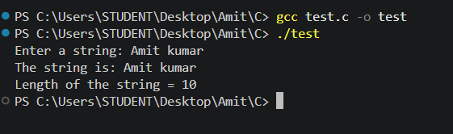

Question 2: Copy a string using strcpy()
/*
* Question: Input a string and copy it into another string using strcpy().
* Display both the original and copied strings.
*/
#include <stdio.h>
#include <string.h>

int main()
{
char original[100];
char copied[100];

printf("Enter a string: ");
scanf("%s", original);
strcpy(copied, original);
printf("Original string = %s\n", original);
printf("Copied string = %s\n", copied);

return 0;
}
Output:
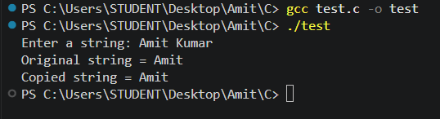

Question 3: Compare two strings using strcmp()
/*
* Question: Input two strings and compare them using strcmp().
* Display whether they are equal or not.
*/
#include <stdio.h>
#include <string.h>

int main()
{
char str1[100], str2[100];

printf("Enter first string: ");
scanf("%s", str1);
printf("Enter second string: ");
scanf("%s", str2);
if(strcmp(str1, str2) == 0)
{
printf("Strings are equal\n");
}
else
{
printf("Strings are not equal\n");
}

return 0;
}
Output:
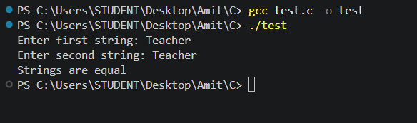

Question 4: Join two strings using strcat()
/*
* Question: Input two strings and join them using strcat().
* Display the resulting string.
*/
#include <stdio.h>
#include <string.h>

int main()
{
char str1[200], str2[100];
printf("Enter first string: ");
scanf("%s", str1);
printf("Enter second string: ");
scanf("%s", str2);
strcat(str1, str2);
printf("Result = %s\n", str1);

return 0;
}
Output:
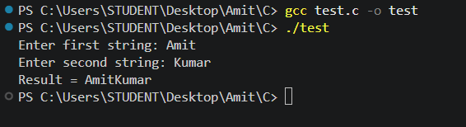

Question 5: Display the longer of two strings using strlen()
/*
* Question: Input two strings. Compare their lengths using strlen()
* and display the longer string.
*/
#include <stdio.h>
#include <string.h>

int main()
{
char str1[100], str2[100];
printf("Enter first string: ");
scanf("%s", str1);
printf("Enter second string: ");
scanf("%s", str2);

if(strlen(str1) > strlen(str2))
{
printf("Longer string = %s\n", str1);
}
else if(strlen(str2) > strlen(str1))
{
printf("Longer string = %s\n", str2);
}
else
{
printf("Both strings have equal length\n");
}

return 0;
}
Output:
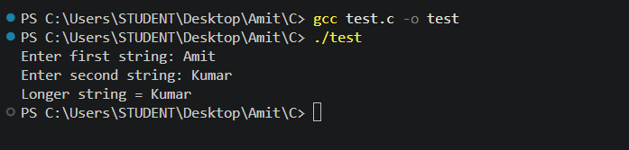

Question 6: Password check using strcmp()
/*
* Question: Assume the correct password is "admin123". Read a password
* from the user and compare it using strcmp().
* Display "Access Granted" or "Access Denied".
*/
#include <stdio.h>
#include <string.h>

int main()
{
char password[100];
printf("Enter password: ");
scanf("%s", password);

if(strcmp(password, "admin123") == 0)
{
printf("Access Granted\n");
}
else
{
printf("Access Denied\n");
}

return 0;
}
Output:
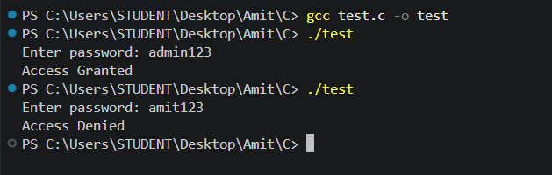

Question 7: Append .txt extension to a filename using strcat()
/*
* Question: Input a filename and append the extension .txt using strcat().
*/
#include <stdio.h>
#include <string.h>

int main()
{
char filename[200];
printf("Enter filename: ");
scanf("%s", filename);
strcat(filename, ".txt");
printf("Filename = %s\n", filename);

return 0;
}
Output:
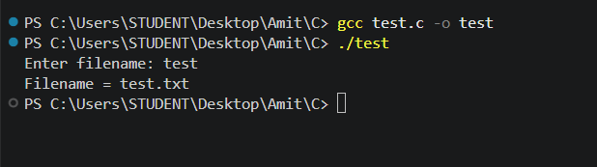

Question 8: Concatenate two strings and display total character count
/*
* Question: Input two strings, concatenate them using strcat(), and display
* the concatenated string and the total number of characters
* using strlen().
*/
#include <stdio.h>
#include <string.h>

int main()
{
char str1[200], str2[100];
printf("Enter first string: ");
scanf("%s", str1);
printf("Enter second string: ");
scanf("%s", str2);

strcat(str1, str2);

printf("Concatenated string = %s\n", str1);
printf("Total characters = %lu\n", strlen(str1));

return 0;
}
Output:
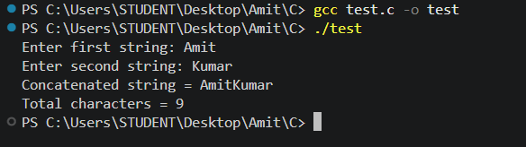

Question 9: Print all vowels present in a string
/*
* Question: Accept a string, define a vowel array (both cases), iterate
* through the input string, and print each character that
* is a vowel, followed by a space.
*/
#include <stdio.h>
#include<string.h>

int main()
{
char str[50];
char vowel[]={'A', 'E', 'I', 'O', 'U', 'a', 'e','i', 'o', 'u'};
printf("Enter a string: ");
scanf("%[^\n]", str);
printf("Vowels in the string: ");

for(int i=0; str[i]!='\0'; i++){
for(int j=0; j<10; j++){
if(str[i]==vowel[j]){
printf("%c", str[i]);
break;
}
}
}
printf("\n");
return 0;
}
Output:
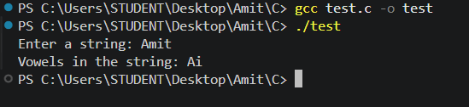

Question 10: Identify each character as lowercase, uppercase, digit, or special character
/*
* Question: Accept a string, then print each character one by one while
* identifying whether it's a lowercase letter, an uppercase
* letter, a digit, or a special character.
*/
#include <stdio.h>
#include <ctype.h>
#include <string.h>

int main()
{
char str[100];

printf("Enter a string: ");
scanf("%99[^\n]", str);

printf("\nAnalysing each character:\n");

for(int i = 0; i < strlen(str); i++)
{
char ch = str[i];

printf("Character %c is ", ch);

if(isupper(ch))
{
printf("Uppercase\n");
}
else if(islower(ch))
{
printf("Lowercase\n");
}
else if(isdigit(ch))
{
printf("Digit\n");
}
else if(strchr("@#$%^&*()_+-=[]{};:|<,>.?/\\", ch) != NULL)
{
printf("Special\n");
}
else
{
printf("Space/Other\n");
}
}

return 0;
}
Output:
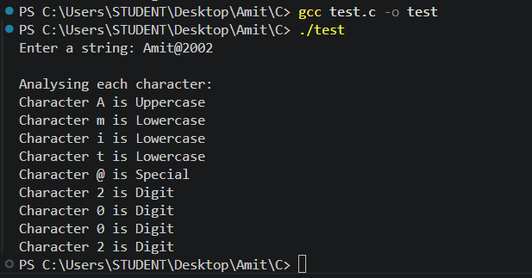

Question 11: Simple C Login System
/*
* Question: Simulate a basic user login system. Register a username and
* password, then log in and validate the entered credentials
* against the stored ones.
*/
#include <stdio.h>
#include <string.h>

int main()
{
char regUser[50], regPass[50];
char loginUser[50], loginPass[50];

printf("--- Registration ---\n");
printf("Enter username: ");
scanf("%49s", regUser);
printf("Enter password: ");
scanf("%49s", regPass);

printf("\n--- Login ---\n");
printf("Enter username: ");
scanf("%49s", loginUser);
printf("Enter password: ");
scanf("%49s", loginPass);

if (strcmp(regUser, loginUser) == 0 && strcmp(regPass, loginPass) == 0)
printf("\nLogin successful! Welcome, %s.\n", loginUser);
else
printf("\nLogin failed! Invalid username or password.\n");

return 0;
}
Output:
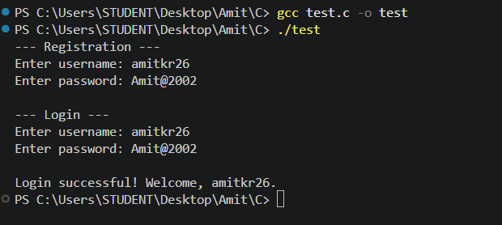

Question 12: Secure Password Creator
/*
* Question: Repeatedly prompt for a new password until it is at least 8
* characters long and contains an uppercase letter, a lowercase
* letter, a digit, and a special character. Give specific
* feedback on each failed attempt.
*/
#include <stdio.h>
#include <string.h>
#include <ctype.h>

int main()
{
char password[50];
int has_upper, has_lower, has_digit, has_special;

while(1)
{
has_upper = has_lower = has_digit = has_special = 0;

printf("Enter password: ");
scanf("%s", password);

int length = strlen(password);

for(int i = 0; i < length; i++)
{
if(isupper(password[i]))
{
has_upper = 1;
}
else if(islower(password[i]))
{
has_lower = 1;
}
else if(isdigit(password[i]))
{
has_digit = 1;
}
else if(strchr("@#$^&*()-=+{}[]|<,>./", password[i])!=NULL)
{
has_special = 1;
}
}

if(length < 8)
{
printf("Error: too short.\n");
}

if(!has_digit)
{
printf("Error: needs digit.\n");
}

if(!has_lower)
{
printf("Error: needs lower.\n");
}

if(!has_upper)
{
printf("Error: needs upper.\n");
}

if(!has_special)
{
printf("Error: needs special.\n");
}

if(length > 8 && has_digit && has_lower && has_upper && has_special)
{
printf("Password is valid!\n");
break;
}
else
{
printf("Invalid password. Try again.\n\n");
}
}

return 0;
}
Output:
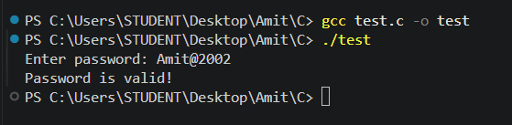

Question 13: Secure User Authentication (registration + login)
/*
* Question: Implement a simple user authentication system: register a
* username and a password meeting security criteria, then log
* in and validate the entered credentials against the stored
* registration data.
*/
#include <stdio.h>
#include <string.h>
#include <ctype.h>

int checkPassword(char p[])
{
char special[] = "!@#$%^&*()_+-=[]{};:'\",.<>/?";
int len = strlen(p);
int hasUpper = 0, hasLower = 0, hasDigit = 0, hasSpecial = 0;
int fail = 0, i, j;

if (len < 8)
{
printf(" - At least 8 characters are required.\n");
fail = 1;
}

for (i = 0; p[i] != '\0'; i++)
{
if (isupper(p[i]))
hasUpper = 1;
else if (islower(p[i]))
hasLower = 1;
else if (isdigit(p[i]))
hasDigit = 1;
else
{
for (j = 0; special[j] != '\0'; j++)
{
if (p[i] == special[j])
hasSpecial = 1;
}
}
}

if (!hasUpper)
{
printf(" - At least one uppercase letter (A-Z) is required.\n");
fail = 1;
}
if (!hasLower)
{
printf(" - At least one lowercase letter (a-z) is required.\n");
fail = 1;
}
if (!hasDigit)
{
printf(" - At least one digit (0-9) is required.\n");
fail = 1;
}
if (!hasSpecial)
{
printf(" - At least one special character is required.\n");
fail = 1;
}

return fail;
}

int main()
{
char username[50], password[50];
char loginUser[50], loginPass[50];
char ch;
int retry;

printf("--- Registration ---\n");
printf("Enter username: ");
scanf("%49s", username);
while ((ch = getchar()) != '\n' && ch != EOF)
;

do
{
printf("Enter a password (8+ chars, A-Z, a-z, 0-9, special): ");
fgets(password, sizeof(password), stdin);
password[strcspn(password, "\n")] = '\0';

retry = checkPassword(password);
if (retry != 0)
printf(" Please try again.\n");
} while (retry != 0);

printf("Registration successful.\n");

printf("\n--- Login ---\n");
printf("Enter username: ");
scanf("%49s", loginUser);
printf("Enter password: ");
scanf("%49s", loginPass);

if (strcmp(username, loginUser) == 0 && strcmp(password, loginPass) == 0)
printf("\nLogin successful! Welcome, %s.\n", loginUser);
else
printf("\nLogin failed! Invalid username or password.\n");

return 0;
}
Output:
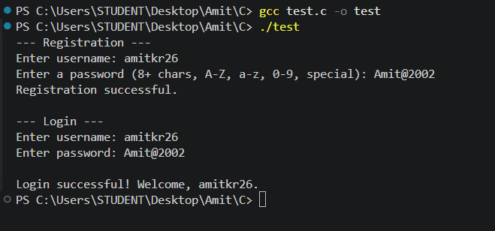

MCQ Questions: Answers
Q | Answer
1 | B) 8
2 | C) GoodDay
3 | C) 0
4 | B) e
5 | C) char str[] = "Hello";
6 | B) There
7 | B) Mango
8 | n
9 | C) John
10 | A) ProgrammingLanguage / Programming

Explain
1. Why is the null character ('\0') important in a string? Explain with an example.
In C, a string is just a character array with no separate length field, so the null character marks where the actual text ends. Every string-handling function (strlen, strcpy, strcmp, strcat, printf with %s, and so on) scans forward until it hits '\0' and treats everything before that as the string's content; without it, these functions would keep reading past the intended data into whatever memory happens to follow, producing garbage output or a crash.
char str[6] = "Hello"; // stored as 'H','e','l','l','o','\0'
printf("%s", str); // stops printing right before the '\0'
2. Differentiate between the following string functions with suitable examples and how it works: strlen(), strcpy(), strcmp(), strcat()
strlen(str) walks the string one character at a time and counts how many characters appear before the terminating '\0', returning that count. it does not include the null character itself.
strcpy(dest, src) copies the characters of src into dest one by one, including the terminating '\0', overwriting whatever was previously in dest. The destination array must be large enough to hold the source string.
strcmp(str1, str2) compares two strings character by character based on their ASCII values. It returns 0 if they are identical, a negative value if str1 comes before str2 alphabetically, and a positive value if str1 comes after str2.
strcat(dest, src) appends a copy of src onto the end of dest, starting at dest's existing null terminator, and adds a new '\0' after the combined content. dest must have enough spare space to hold both strings.
char a[20] = "Hello";
char b[] = "World";

printf("%lu\n", strlen(a)); /* 5 */
strcpy(a, b); /* a becomes "World" */
printf("%d\n", strcmp(a, b)); /* 0, since a and b are now equal */
strcat(a, "!!"); /* a becomes "World!!" */
3. Explain the difference between comparing two strings using the == operator and using the strcmp() function.
When applied to two arrays (or char pointers), the == operator compares their memory addresses, not their contents - it only returns true if both names refer to the exact same block of memory, which is almost never the case for two separately declared strings even when their text is identical. strcmp(), by contrast, walks through both strings character by character and compares the actual content, returning 0 when the text matches regardless of where each string lives in memory. For this reason, strcmp() (or an equivalent content comparison) is the correct way to check whether two C strings hold the same text.
4. What is a two-dimensional character array (array of strings)? Explain its declaration and initialization with an example.
A two-dimensional character array is a block of memory organized as a fixed number of rows, where each row is itself a character array capable of holding one string (including its terminating '\0'). It is a simple way to store a list of strings of similar maximum length using a single variable, and each row can be accessed and manipulated independently with the standard string functions.
char names[3][10] = {"Amit", "Rohan", "Priya"};

printf("%s\n", names[0]); /* Amit */
printf("%s\n", names[1]); /* Rohan */
printf("%c\n", names[2][1]); /* 'r' - second character of "Priya" */
5. Explain How Strings are Stored in a Two-Dimensional Character Array:
char cities[3][10] = {"Delhi", "Mumbai", "Chennai"};
What happens if a string longer than 9 characters is stored in one of the rows?
Here cities are laid out as three separate rows placed back-to-back in memory, each reserved for exactly 10 bytes. "Delhi" occupies cities[0] (5 characters plus a null terminator, with unused bytes left over), "Mumbai" occupies cities[1], and "Chennai" occupies cities[2], each null-terminated within its own row.
Each row can safely hold at most 9 visible characters plus the null terminator, since the row size is 10. If a string longer than that is written into one row - for example, using strcpy(cities[0], "Constantinople") - the extra characters spill past the end of that row's 10 bytes and overwrite the beginning of the next row (or whatever memory follows). This is a buffer overflow: it is undefined behavior in C, and it can silently corrupt the next string in the array or other nearby data.

