1. Check if a number is positive or negative
#include<stdio.h>
int main()
{
int num;
printf("Enter a number ");
scanf("%d", &num);

if(num>0)
{
printf("%d is positive\n", num);
}
else if(num==0)
{
printf("%d is zero\n", num);
}
else{
printf("%d is negative\n", num);
}
return 0;
}
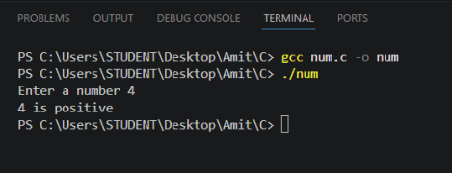2. Check if a number is even or odd.
#include <stdio.h>
int main()
{
int num;
printf("Enter a number: ");
scanf("%d", &num);
if(num % 2 == 0)
{
printf("%d is Even\n", num);
}
else
{
printf("%d is Odd\n", num);
}
return 0;
}
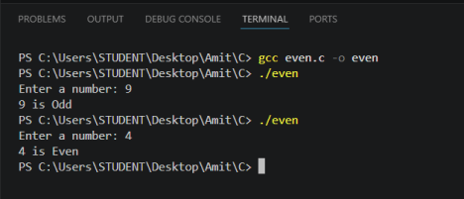3. Check if a person is adult or minor.
#include <stdio.h>
int main()
{
int num;
printf("Enter a number: ");
scanf("%d", &num);
if(num>18)
{
printf("%d is Adult\n", num);
}
else
{
printf("%d is Minor\n", num);
}
return 0;
}
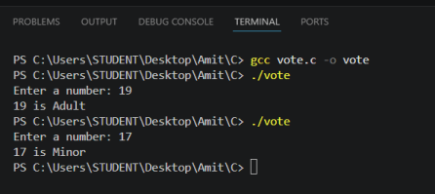4. Check if temperature is hot or cold.
#include <stdio.h>
int main()
{
int num;
printf("Enter a number: ");
scanf("%d", &num);
if(num>30)
{
printf("%d is hot\n", num);
}
else
{
printf("%d is cold\n", num);
}
return 0;
}
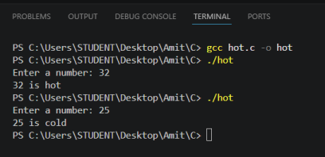5. Check if a number is divisible by 5.
#include <stdio.h>
int main()
{
int num;
printf("Enter a number: ");
scanf("%d", &num);
if(num % 5 == 0)
{
printf("%d is divisible\n",num);
}
else
{
printf("%d is not divisible by 5\n",num); }
return 0;
}
