1. Write a C program to read an array of 10 integers and count the total number of even and odd elements. Sample Output: Enter 10 integers: 1 2 3 4 5 6 7 8 9 10 Total even numbers: 5 Total odd numbers: 5
#include <stdio.h>
int main()
{
int arr[10];
int i;
int even = 0, odd = 0;
printf("Enter 10 integers: ");
for (i = 0; i < 10; i++)
{
scanf("%d", &arr[i]);
}
for (i = 0; i < 10; i++)
{
if (arr[i] % 2 == 0)
{
even++;
}
else
{
odd++;
}
}
printf("Total even numbers: %d\n", even);
printf("Total odd numbers: %d\n", odd);
return 0;
}
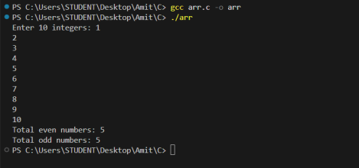
2. WAP that reads two arrays, calculates the sum of corresponding elements, and stores the result in a third array. Sample Output: Enter 5 elements for the first array: 1 2 3 4 5 Enter 5 elements for the second array: 6 7 8 9 10 Sum of the arrays: 7 9 11 13 15
#include <stdio.h>
int main()
{
int arr1[5], arr2[5], sum[5];
int i;
printf("Enter 5 elements for the first array: ");
for (i = 0; i < 5; i++)
{
scanf("%d", &arr1[i]);
}
printf("Enter 5 elements for the second array: ");
for (i = 0; i < 5; i++)
{
scanf("%d", &arr2[i]);
}
for (i = 0; i < 5; i++)
{
sum[i] = arr1[i] + arr2[i];
}
printf("Sum of the arrays: ");
for (i = 0; i < 5; i++)
{
printf("%d ", sum[i]);
}
return 0;
}
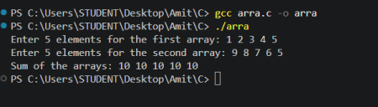#include <stdio.h>
int main()
{
int n;
printf("Enter size of array: ");
scanf("%d", &n);
int arr[n];
printf("Enter %d elements:\n", n);
for (int i = 0; i < n; i++)
{
scanf("%d", &arr[i]);
}
printf("Original array:\n");
for (int i = 0; i < n; i++)
{
printf("%d ", arr[i]);
}
printf("\nReverse array:\n");
for (int i = n - 1; i >= 0; i--)
{
printf("%d ", arr[i]);
}
return 0;
}
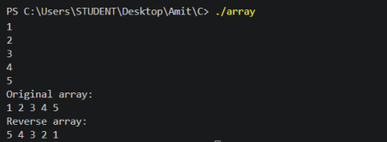#include <stdio.h>
int main()
{
int marks[5];
int total = 0;
float average;
printf("Enter marks of 5 subjects:\n");
for(int i = 0; i < 5; i++)
{
scanf("%d", &marks[i]);
}
for(int i = 0; i < 5; i++)
{
total = total + marks[i];
}
average = (float)total / 5;
printf("Total = %d\n", total);
printf("Average = %.2f\n", average);
return 0;
}
