Amit_Lab2 - Day 2 Assignment C Programming - Lab 2
Question 1: Check if a number is positive or negative
#include<stdio.h>
int main()
{
int num;
printf("Enter a number ");
scanf("%d", &num);

if(num>0)
{
printf("%d is positive\n", num);
}
else if(num==0)
{
printf("%d is zero\n", num);
}
else{
printf("%d is negative\n", num);
}
return 0;
}

Output:
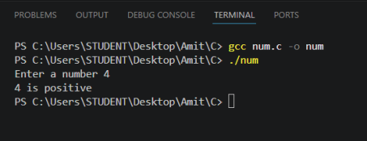

Question 2: Check if a number is even or odd
#include <stdio.h>
int main()
{
int num;
printf("Enter a number: ");
scanf("%d", &num);
if(num % 2 == 0)
{
printf("%d is Even\n", num);
}
else
{
printf("%d is Odd\n", num);
}
return 0;
}

Output:
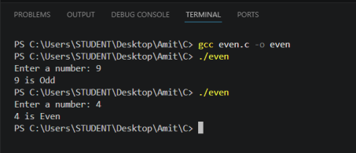Question 3: Check if a person is an adult or minor (18 years)
#include <stdio.h>
int main()
{
int num;
printf("Enter a number: ");
scanf("%d", &num);
if(num>18)
{
printf("%d is Adult\n", num);
}
else
{
printf("%d is Minor\n", num);
}
return 0;
}

Output:
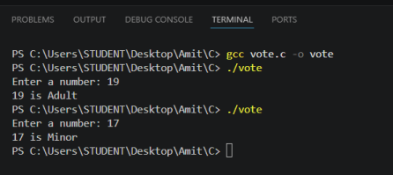

Question 4: Check if temperature is hot or cold (30°C or above is Hot)
#include <stdio.h>

int main()
{
int num;
printf("Enter a number: ");
scanf("%d", &num);
if(num>30)
{
printf("%d is hot\n", num);
}
else
{
printf("%d is cold\n", num);
}
return 0;
}

Output:
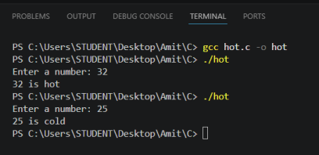
Question 5: Check if a number is divisible by 5
#include <stdio.h>
int main()
{

int num;
printf("Enter a number: ");
scanf("%d", &num);
if(num % 5 == 0)
{
printf("%d is divisible\n",num);
}
else
{
printf("%d is not divisible by 5\n",num);
}
return 0;
}

Output:
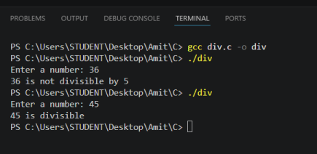
Question 6: Maximum of three numbers using Nested-if
#include <stdio.h>
int main()
{
int a, b, c;

printf("Enter three numbers: ");
scanf("%d %d %d", &a, &b, &c);
if(a > b)
{
if(a > c)
{
printf("Maximum = %d\n", a);
}
else
{
printf("Maximum = %d\n", c);
}
}
else
{
if(b > c)
{
printf("Maximum = %d\n", b);
}
else
{
printf("Maximum = %d\n", c);
}
}
return 0;
}

Output:
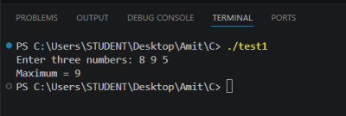

Question 7: Leap Year using Nested-if
#include <stdio.h>
int main()
{
int year;
printf("Enter year: ");
scanf("%d", &year);
if((year % 400 == 0) || (year % 4 == 0 && year % 100 != 0)) {
printf("%d is a leap year\n", year);
}
else
{
printf("%d is not a leap year\n", year);
}
return 0;
}

Output:
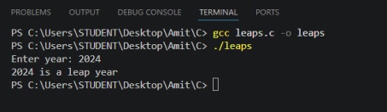

Question 8: Calculator using switch-case
/*
* Question: Take two numbers and an operator (+, -, *, /) from the user and * perform the operation using a switch-case statement.
*/

#include <stdio.h>
int main()
{
int a, b;
char op;
printf("Enter first number: ");
scanf("%d", &a);
printf("Enter operator (+, -, *, /): "); scanf(" %c", &op);
printf("Enter second number: ");
scanf("%d", &b);
switch(op)
{
case '+':
printf("Result = %d\n", a+b); break;
case '-':
printf("Result = %d\n", a-b); break;
case '*':
printf("Result = %d\n", a*b); break;
case '/':
printf("Result = %d\n", a/b); break;
default:
printf("Enter a valid operator\n"); }
return 0;
}
Output:
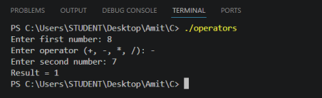

Question 9: Vowel or Consonant
/*
* Question: Check whether a given character is a vowel or a consonant.
*/
#include <stdio.h>
int main()
{
char ch;
printf("Enter a character: ");
scanf(" %c", &ch);
switch(ch)
{
case 'a':
printf("%c is a vowel\n", ch);
break;
case 'e':
printf("%c is a vowel\n", ch);
break;
case 'i':
printf("%c is a vowel\n", ch);
break;
case 'o':
printf("%c is a vowel\n", ch);
break;
case 'u':
printf("%c is a vowel\n", ch);
break;

default:
printf("%c is a consonant\n", ch);
}
return 0;
}

Output:
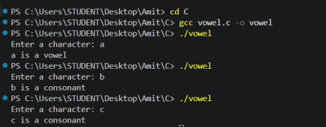

Question 10: Print numbers from 1 to 10
/*
* Question: Print numbers from 1 to 10.
*/
#include <stdio.h>
int main()
{
int i;
for(i = 1; i <= 10; i++)
{
printf("%d ", i);
}
printf("\n");
return 0;
}

Output:
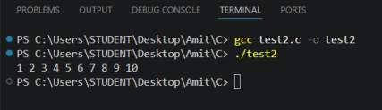

Question 11: Multiplication table
/*
* Question: Print the multiplication table of a number.
*/
#include <stdio.h>
int main()
{
int i, num;
printf("Enter the number: ");
scanf("%d", &num);
for(i = 1; i <= 10; i++)
{
printf("%d x %d = %d\n", num, i, num * i);
}
return 0;
}

Output:
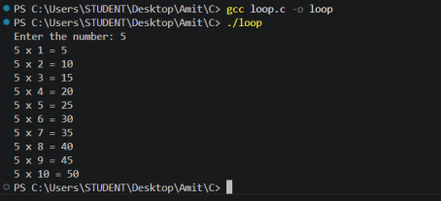

Question 12: Print even numbers between 1 and 50
#include <stdio.h>
int main()
{
int i;
for(i = 2; i <= 50; i = i + 2)
{
printf("%d\n", i);
}
return 0;
}
Output:
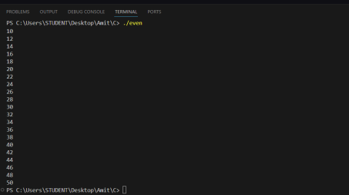

Question 13: Numbers divisible by both 3 and 5 (1 to 100)
/*
* Question: Print only numbers divisible by both 3 and 5 between 1 and 100. */
#include <stdio.h>
int main()
{
int i;
for(i = 1; i <= 100; i++)
{
if(i % 3 == 0 && i % 5 == 0)
{
printf("%d\n", i);
}
}
return 0;
}

Output:
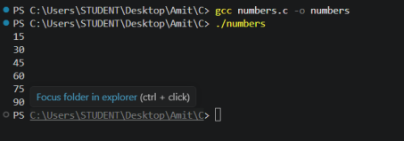

Question 14: Sum only odd numbers up to N
/*
* Question: Sum only odd numbers up to N.
*/
#include <stdio.h>
int main()
{
int i;
int N, sum = 0;
printf("Enter the number: ");
scanf("%d", &N);
for(i = 1; i <= N; i++)
{
if(i % 2 != 0)
{
sum = sum + i;
}
}
printf("Sum = %d\n", sum);
return 0;
}

Output:
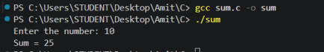

Question 15: Print alphabets from a to z using for loop
/*
* Question: Print alphabets from a to z using a for loop.
*/
#include <stdio.h>
int main()
{
char ch;
for(ch = 'a'; ch <= 'z'; ch++)
{
printf("%c ", ch);
}
return 0;
}

Output:
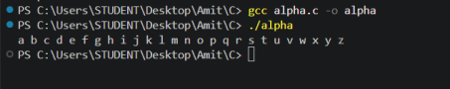

Question 16: Print 5 stars in a row using for loop
/*
* Question: Print 5 stars (*) in a row using a for loop.
*/
#include <stdio.h>
int main()

{
int i;
char ch = '*';
for(i=1; i<=5; i++)
{
printf("%c", ch);
}
return 0;
}

Output:

Question 17: Square star pattern of N rows
/*
* Question: Print a square star (*) pattern of N rows using a for loop. */
#include <stdio.h>
int main()
{
int i,j,n;
char ch = '*';
printf("Enter no. of rows: ");
scanf("%d", &n);
for(i=1; i<=n; i++)
{
for(j=1;j<=n;j++)
{
printf("%c", ch);
}
printf("\n");

}
return 0;
}

Output:

Question 18: Right triangle star pattern
/*
* Question: Print a right triangle star pattern series using a for loop. */
#include <stdio.h>
int main()
{
int n, i, j;
char ch = '*';
printf("Enter number of rows: ");
scanf("%d", &n);
for (i = 1; i <= n; i++)
{
for (j = 1; j <= i; j++)
{
printf("%c", ch);
}
printf("\n");
}
return 0;
}

Output:

Question 19: Print stars in a row using while loop (user input)
/*
* Question: Print stars (*) in a row by getting user input using a while loop. */
#include <stdio.h>
int main()
{
int n, i = 1;
char ch = '*';
printf("Enter number of stars: ");
scanf("%d", &n);
while(i<n)
{
printf("%c", ch);
i++;
}
return 0;
}

Output:

Question 20: Print stars in a row using do while loop (user input)
/*
* Question: Print stars (*) in a row by getting user input using a do while loop. */
#include <stdio.h>
int main()
{
int n, i = 1;
char ch = '*';
printf("Enter number of stars: ");
scanf("%d", &n);
do
{
printf("%c", ch);
i++;
}
while(i<=n);
return 0;
}

Output:

Question Bank: Answers
Q | Answer | Explanation
1 | A. Greater than 5 | 10 > 5 is true
2 | A. 5 4 3 2 1 | i decrements from 5 to 1
3 | B. 0 1 2 4 | continue at i==3 skips printing 3
4 | B. 0 1 2 | break at i==3 exits the loop
5 | C. 1 2 3 | goto loops until i becomes 4

Q | Answer | Explanation
6 | b. Two | first else if matches; second else if(x==2) is never reached
7 | B. 0 1 | after i==2, flag stays 1, so continue skips 2, 3, 4
8 | B. 1 2 4 5 | post-increment count++; continue at count==3

Question Bank: Grade Program
#include<stdio.h>
int main()
{
int marks;
printf("Enter marks: ");
scanf("%d", &marks);
if(marks>=90)
{
printf("Grade is : A");
}
else if(marks>=75){
printf("Grade is : B");
}
else if(marks>=50){
printf("Grade is : C");
}
else if(marks>=35){
printf("Grade is : D");
}
else{
printf("Fail");
}
return 0;
}

Output:

Bonus: Simple ATM Machine (if...else only)
/*
* Question: Simulate a simple ATM machine using only if...else statements. * - Ask for a 4-digit PIN (correct PIN: 1234) -> show menu.
* - Wrong PIN -> "Access Denied" and end.
* - Menu: 1. Check Balance 2. Withdraw Money 3. Deposit Money
* - Any other choice -> "Invalid choice".
* - Print a thank-you message before ending.
*/
#include<stdio.h>
int main()
{
int pin=1234;
int currentbalance=5000;
int choice, withdraw, balance, deposit, newbalance;
printf("Enter your pin: ");
scanf("%d", &pin);
if(pin==1234)
{
printf("1. Check Balance\n");
printf("2. Withdraw Money\n");
printf("3. Deposit Money\n");
printf("Select your choice: ");
scanf("%d", &choice);
if(choice==1)
{
printf("Your current balance is: %d", currentbalance); }
else if(choice==2)
{

printf("Enter the amount you want to withdraw :"); scanf("%d", &withdraw);
if(withdraw<=currentbalance)
{
balance = currentbalance - withdraw;
printf("Your withdrawl is successful\n ");
printf("Your available balance is %d", balance); }
else{
printf("Available is not enough");
}
}
else if(choice==3)
{
printf("How much you want to deposit: ");
scanf("%d", &deposit);
newbalance = currentbalance + deposit;
printf("Your available balance is:%d",newbalance); }
else{
printf("Invalid choice");
}
}
else{
printf("Access Denied");
}
return 0;
}

Output (withdraw):

Conceptual Questions
1. Which loop should be used when the number of iterations is known in advance? Why? The for loop. Because when the number of iterations is known, everything can be written in one line: the initialization, the condition, and the increment, e.g. for(i = 1; i <= 10; i++).
2. Which loop is suitable when the number of iterations is not known in advance? Explain with an example. The while loop. It checks the condition before running the body, so it is used when the loop depends on conditions that change at runtime. Example: keep reading numbers until the user enters -1.
int num;
printf("Enter numbers (-1 to stop): ");

scanf("%d", &num);
while(num != -1)
{
printf("%d\n", num);
scanf("%d", &num);
}

3. Which loop guarantees that its body executes at least once? Why?
The do-while loop. Because it checks the condition at the end, after the body has already run once. 4. What is the difference between entry-controlled and exit-controlled loops?
Entry-controlled loops (for, while) test the condition before entering the body, so the body may execute zero times. Exit-controlled loops (do-while) test the condition after the body, so the body executes at least once.
5. Why is a semicolon required after the condition in a do-while loop?
The semicolon terminates the while(condition); statement. It is part of the do-while syntax that tells the compiler where the loop ends.
6. What is the difference between break and continue in C?
break immediately exits the loop (or switch) entirely and continues after it. continue skips the rest of the current iteration and jumps to the next iteration of the loop.
7. Can a switch statement completely replace an if-else statement in every situation? Explain. No. switch can only compare a value for equality against constant integer/character values. It cannot handle ranges, relational conditions, floating-point values, or compound boolean conditions. if-else is more flexible and can replace switch, but not the other way around.
8. What types of values can generally be used with case labels?
Case labels must be constant expressions of integer type: int, char, or enum values. Floating-point values, variables, and strings are not allowed.
9. What is the purpose of the sizeof operator in C? Does sizeof return the size in bits or bytes? sizeof returns the memory size of a type or variable in bytes (not bits). Example: sizeof(int) usually returns 4 on most systems.
10. How many times will the inner statement execute?
12 times. The outer loop runs 3 times and the inner loop runs 4 times each time: 3 x 4 = 12.
for(i = 1; i <= 3; i++)
{
for(j = 1; j <= 4; j++)
{
printf("*");
}
}

