Amit_Lab3 - Day 3 Assignment C Programming - Arrays
Question 1: Insert an element at a specified position
/* Question: Insert an element at a specified position in an array. */
#include <stdio.h>
int main()
{
int arr[9];
int n, i, element, position;
printf("Enter number of elements: ");
scanf("%d", &n);
printf("Enter array elements:\n");
for (i = 0; i < n; i++)
{
scanf("%d", &arr[i]);
}

printf("Enter element to insert: ");
scanf("%d", &element);
printf("Enter position: ");
scanf("%d", &position);
for (i = n; i >= position; i--)
{
arr[i] = arr[i - 1];
}
arr[position - 1] = element;
n++;
printf("Array after insertion:\n");
for (i = 0; i < n; i++)
{

printf("%d ", arr[i]);
}
return 0;
}

Output:
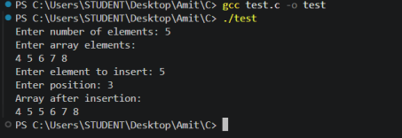

Question 2: Linear search for a value in an array
/*
* Question: Search for a given value in an array using linear search;
* print its index or "Not found."
*/
#include <stdio.h>
int main()
{
int arr[100];
int n, i, value;
int found = 0;
printf("Enter number of elements: ");
scanf("%d", &n);
printf("Enter array elements:\n");
for (i = 0; i < n; i++)
{
scanf("%d", &arr[i]);
}

printf("Enter value to search: ");
scanf("%d", &value);
for (i = 0; i < n; i++)
{
if (arr[i] == value)
{
printf("Element found at index %d\n", i);
found = 1;
break;
}
}
if (found == 0)
{
printf("Element not found\n");
}
return 0;
}

Output:
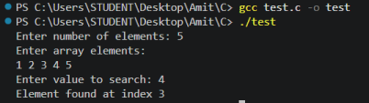

Question 3: Find the largest element in an array
/*
* Question: Find the largest element in an array.
*/
#include <stdio.h>
int main()
{

int arr[100];
int n, i, largest;
printf("Enter number of elements: ");
scanf("%d", &n);
printf("Enter array elements:\n");
for (i = 0; i < n; i++)
{
scanf("%d", &arr[i]);
}
largest = arr[0];
for (i = 1; i < n; i++)
{
if (arr[i] > largest)
{
largest = arr[i];
}
}
printf("Largest element = %d\n", largest);
return 0;
}

Output:
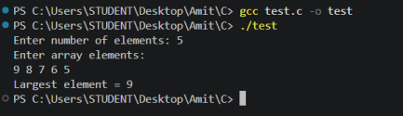

Question 4: Count even and odd numbers in an array
/*

* Question: Count how many even and how many odd numbers are in an array. */
#include <stdio.h>
int main()
{
int arr[100];
int n, i;
int even = 0, odd = 0;
printf("Enter number of elements: ");
scanf("%d", &n);
printf("Enter array elements:\n");
for (i = 0; i < n; i++)
{
scanf("%d", &arr[i]);
}
for (i = 0; i < n; i++)
{
if (arr[i] % 2 == 0)
{
even++;
}
else
{
odd++;
}
}
printf("Total even elements = %d\n", even);
printf("Total odd elements = %d\n", odd);
return 0;
}

Output:
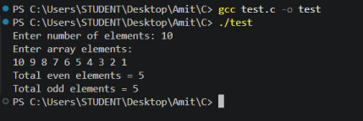

Question 5: Reverse an array
/*
* Question: Reverse an array.
*/
#include <stdio.h>
int main()
{
int arr[100];
int n, i;
printf("Enter number of elements: ");
scanf("%d", &n);
printf("Enter array elements:\n");
for (i = 0; i < n; i++)
{
scanf("%d", &arr[i]);
}
printf("Reverse array:\n");
for (i = n - 1; i >= 0; i--)
{
printf("%d ", arr[i]);
}
return 0;
}

Output:
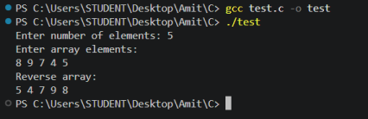

Question 6: Delete a given value from an array
/*
* Question: Delete a given value from an array.
*/
#include <stdio.h>
int main()
{
int arr[100];
int n, i, value, position = -1;
printf("Enter number of elements: ");
scanf("%d", &n);
printf("Enter array elements:\n");
for (i = 0; i < n; i++)
{
scanf("%d", &arr[i]);
}
printf("Enter value to delete: ");
scanf("%d", &value);
for (i = 0; i < n; i++)
{
if (arr[i] == value)
{
position = i;
break;
}
}

if (position != -1)
{
for (i = position; i < n - 1; i++)
{
arr[i] = arr[i + 1];
}
n--;
printf("Array after deletion:\n");
for (i = 0; i < n; i++)
{
printf("%d ", arr[i]);
}
}
else
{
printf("Value not found in array\n");
}
return 0;
}

Output:
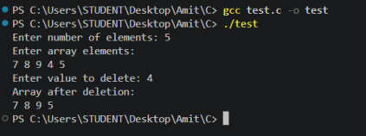

Question 7: Swap first and last elements in an array
/*

* Question: Swap First and Last Elements in an array by getting user input. */
#include <stdio.h>
int main()
{
int arr[100], n, i, temp;
printf("Enter number of elements: ");
scanf("%d", &n);
printf("Enter %d elements:\n", n);
for (i = 0; i < n; i++)
scanf("%d", &arr[i]);
printf("Original array:\n");
for (i = 0; i < n; i++)
printf("%d ", arr[i]);
printf("\n");
temp = arr[0];
arr[0] = arr[n - 1];
arr[n - 1] = temp;
printf("Array after swapping first and last elements:\n"); for (i = 0; i < n; i++)
printf("%d ", arr[i]);
printf("\n");
return 0;
}

Output:
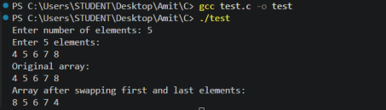

Question 8: Check whether two arrays are identical
/*
* Question: Input two arrays and check whether they are identical.
*/
#include <stdio.h>
int main()
{
int a[100], b[100], n, i, identical = 1;
printf("Enter number of elements: ");
scanf("%d", &n);
printf("Enter %d elements of first array:\n", n);

for (i = 0; i < n; i++)
scanf("%d", &a[i]);
printf("Enter %d elements of second array:\n", n);
for (i = 0; i < n; i++)
scanf("%d", &b[i]);
for (i = 0; i < n; i++)
{
if (a[i] != b[i])
{
identical = 0;
break;
}
}
if (identical == 1)
printf("The arrays are identical\n");
else
printf("The arrays are not identical\n");
return 0;
}

Output:
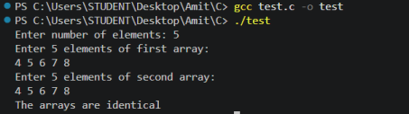

Question 9: Copy all elements of one array into another
/*
* Question: Copy all elements of one array into another array.
*/
#include <stdio.h>
int main()
{
int source[100], copy[100], n, i;
printf("Enter number of elements: ");
scanf("%d", &n);
printf("Enter %d elements:\n", n);
for (i = 0; i < n; i++)
scanf("%d", &source[i]);
for (i = 0; i < n; i++)
copy[i] = source[i];
printf("Elements of the copied array:\n");
for (i = 0; i < n; i++)
printf("%d ", copy[i]);
printf("\n");
return 0;
}

Output:
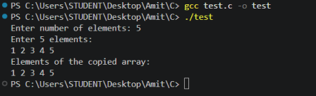

Question 10: Replace every negative number in an array with 0
/*
* Question: Replace every negative number in an array with 0 and display * the updated array.
*/
#include <stdio.h>
int main()
{
int arr[100], n, i;
printf("Enter number of elements: ");
scanf("%d", &n);
printf("Enter %d elements:\n", n);
for (i = 0; i < n; i++)
scanf("%d", &arr[i]);
printf("Original array:\n");
for (i = 0; i < n; i++)
printf("%d ", arr[i]);
printf("\n");
for (i = 0; i < n; i++)
{
if (arr[i] < 0)
arr[i] = 0;
}
printf("Array after replacing negatives with 0:\n");
for (i = 0; i < n; i++)
printf("%d ", arr[i]);
printf("\n");
return 0;
}

Output:
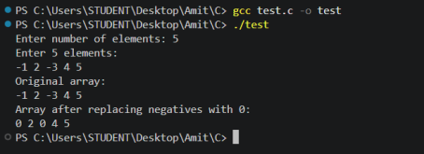

MCQ Questions: Answers
Q | Answer
1 | c) 0
2 | c) sizeof(arr) / sizeof(arr[0])
3 | b) 6
4 | c) Garbage (indeterminate) values
5 | b) 50 40 30 20 10
6 | b) for(int i = 2; i < size-1; i++) arr[i] = arr[i+1]; size--;
7 | b) 30
8 | b) 0 0 0
9 | b) 5 3 5
10 | b) 6

Explain
1. Differentiate between compile-time initialization and run-time initialization of arrays, with examples of each. Compile-time initialization assigns values to an array at the point of declaration; the values are fixed in the source code and become part of the program before it ever runs. Run-time initialization assigns values while the program is executing, typically through user input or computed values, so the contents can differ on every run.
/* Compile-time initialization */
int arr[5] = {1, 2, 3, 4, 5};
/* Run-time initialization */
int arr[5], i;
for(i = 0; i < 5; i++)
{

scanf("%d", &arr[i]);
}

2. How is the length of an array calculated in C, given that C has no built-in length function? Explain with the underlying logic.
C computes the element count using sizeof(arr) / sizeof(arr[0]). sizeof(arr) returns the total number of bytes occupied by the entire array, and sizeof(arr[0]) returns the number of bytes occupied by a single element. Dividing the two gives the number of elements. This trick only works on the original array variable, in the scope where it was declared - once an array is passed to a function it decays to a pointer, and sizeof on that pointer would return the pointer's size instead.
3. Explain how a 2D array is stored in memory, and how the compiler computes the address of a specific element arr[i][j]. A 2D array is stored in a single contiguous block of memory in row-major order, meaning the entire first row is stored first, followed immediately by the second row, and so on. To find the address of arr[i][j], the compiler uses the formula: base_address + (i * number_of_columns + j) * size_of_one_element. This flattens the two-dimensional index into a single offset into that contiguous memory block.
4. Write the syntax for declaring and initializing the following:
(a) 1D array, (b) 2D array, (c) 3D array:
/* (a) 1D array */
int a[5] = {1, 2, 3, 4, 5};
/* (b) 2D array */
int b[2][3] = {{1, 2, 3}, {4, 5, 6}};
/* (c) 3D array */
int c[2][2][2] = {
{{1, 2}, {3, 4}},
{{5, 6}, {7, 8}}
};

5. Write the output of the following programs:
(a) 1D Array:
int a[] = {10, 20, 30, 40};
printf("%d %d", a[1], a[3]);
-> Output: 20 40
(b) 2D Array:
int a[2][2] = {{1, 2}, {3, 4}};
printf("%d %d", a[0][1], a[1][0]);
-> Output: 2 3
(c) 3D Array:
a[2][2][2] = {{{1,2},{3,4}},{{5,6},{7,8}}};
printf("%d %d", a[0][1][1], a[1][0][0]);
-> Output: 4 5
6. What happens if you try to access an element outside the array bounds?
C does not perform automatic bounds checking, so accessing an out-of-range index is undefined behavior. The program may read or write to unrelated memory, which can silently return a garbage value, corrupt other
variables, or crash the program (a segmentation fault), depending on what happens to occupy that memory location.
7. Find the Error
1. Yes, there is a bug in this program - it accesses a[3], which is outside the valid range for a 3-element array.
2. It occurs because the valid indices for int a[3] are only 0, 1, and 2; index 3 refers to memory just past the end of the array, so the value read is undefined/garbage rather than a compile-time error.
3. Corrected statement: printf("%d", a[2]); (or enlarge the array to int a[4] if a fourth element was actually intended).
#include <stdio.h>
int main()
{
int a[3] = {10, 20, 30};
printf("%d", a[2]); /* corrected: last valid index is 2 */
return 0;
}

8. What is wrong with this program?
Mistake: the loop condition is i <= 5, which lets i reach 5, but a valid index for int a[5] only goes up to 4.
During execution, the sixth scanf call writes to a[5], which lies outside the array's allocated memory - this is a buffer overflow and results in undefined behavior (it may corrupt an adjacent variable or crash the program). Correction: change the condition to i < 5 so the loop only visits valid indices 0 through 4.
int a[5];
for(int i = 0; i < 5; i++) /* corrected condition */
{
scanf("%d", &a[i]);
}

9. Find the Output
int a[] = {2,4,6,8,10};
the loop prints a[i] only when i is even (i = 0, 2, 4), which correspond to values 2, 6, 10. Output: 2 6 10
10. What is the Output?
int a[] = {1,2,3,4,5};
every element is doubled in place, so a[3] (originally 4) becomes 8.
Output: 8

