Create a C program to manage student marks for multiple departments. The program must use a three-dimensional array to store the data and perform the following tasks:
● Data Structure: The array marks[5][3][5] should be used to store marks for 5 departments, with 3 students per department, each taking 5 subjects. ● User Input: The program must first prompt the user to input marks for every student in every subject across all 5 departments.
● Total and Average Calculation: After data entry is complete, the program should ask the user to select a specific department. For the chosen department, it must then calculate and display the total marks and average marks for each student.
● Indexing: The program should handle the user-friendly input (e.g., department 1, student 1) by correctly converting it to the 0-based indexing required for the C array.
Sample output :
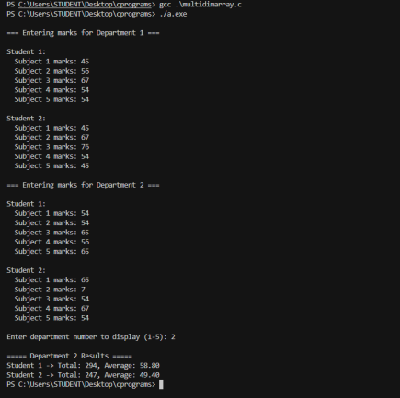For your reference :
#include <stdio.h>
int main() {
int arr[2][3][2]; // arr[x][y][z]
int i, j, k;
// Taking input
printf("Enter values for a 3D array (2 x 3 x 2):\n");
for (i = 0; i < 2; i++) { // First dimension
for (j = 0; j < 3; j++) { // Second dimension
for (k = 0; k < 2; k++) { // Third dimension
printf("Enter value for arr[%d][%d][%d]: ", i, j, k);
scanf("%d", &arr[i][j][k]);
}
}
}
// Displaying output
printf("\nYou entered:\n");
// Printing the first dimension (page index) and its contents for (int i = 0; i < 2; i++) {
printf("--- Page %d ---\n", i); // This prints the page index for (int j = 0; j < 3; j++) {
for (int k = 0; k < 2; k++) {
printf("%d ", arr[i][j][k]);
}
printf("\n");
}
printf("\n");
}
return 0;
}
