C++ Assignment Class and Objects
1. Circle — basic class, computed methods
Create a class Circle with a data member radius (double). Add methods calculateArea() and calculateCircumference() that return values. In main(), create one Circle object, set its radius, and print both results.
Code:
#include <iostream>
using namespace std;

class Circle {
public:
double radius;
const double PI = 3.14;

double calculateArea() {
return PI * radius * radius;
}

double calculateCircumference() {
return 2 * PI * radius;
}
};

int main() {
Circle c;

c.radius = 5;

cout << "Area: " << c.calculateArea() << endl;
cout << "Circumference: " << c.calculateCircumference() << endl;

return 0;
}

Output:
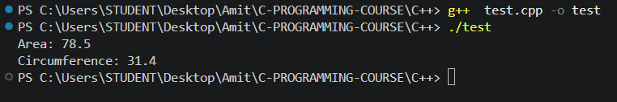
2. Employee — plain class, formatted display
Create a class Employee with name (string), id (int), and salary (double). Add a method displayDetails() that prints all three neatly. In main(), create one Employee object, set its values, and call displayDetails().
#include <iostream>
#include <string>
using namespace std;

class Employee {
public:
string name;
int id;
double salary;

void displayDetails(){
cout<<"Emaployee name: "<<name<<endl;
cout<<"Emaployee id: "<<id<<endl;
cout<<"Emaployee salary: "<<salary<<endl;
}
};

int main() {
Employee e;
e.name = "Amit Kumar";
e.id = 123;
e.salary = 50000;

e.displayDetails();

return 0;
}

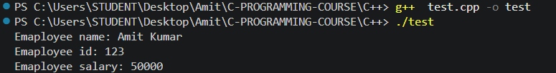
3. Temperature — a method that converts, not just stores
Create a class Temperature with a data member celsius (double). Add a method to Fahrenheit() that returns the Fahrenheit equivalent (formula: (celsius * 9/5) + 32). In main(), create one object, set celsius, and print the converted value.
#include <iostream>
#include <string>
using namespace std;

class Temperature {
public:
double celsius;

double Fahrenheit(){
return celsius * 9/5 + 32;
}
};

int main() {
Temperature t1;
t1.celsius = 27;

cout<<"The converted value:"<<t1.Fahrenheit()<<endl;

return 0;
}

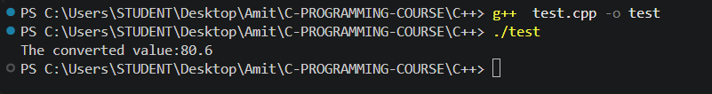
4. Login — private data, validation logic
Create a class Login with a private member password (string), set only through a method setPassword(pwd). Add a method checkPassword(pwd) that returns true only if pwd matches the stored password — main() should never be able to read or guess the password directly. In main(), set a password, then test checkPassword() with one wrong guess and one correct guess, printing the result of each.
#include <iostream>
#include <string>
using namespace std;

class Login {
private:
string password;

public:
void setPassword(string pwd) {
password = pwd;
}

bool checkPassword(string pwd) {
return pwd == password;
}
};

int main() {
Login t1;

t1.setPassword("27272");

cout << "Wrong: "
<< t1.checkPassword("123") << endl;

cout << "Correct: "
<< t1.checkPassword("27272") << endl;

return 0;
}

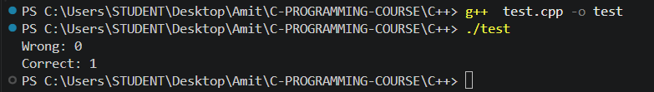
5. Volume — private data with a valid range
Create a class SpeakerVolume with a private member level (int). Add a method setLevel(vol) that only updates level if it's between 0 and 100 (inclusive) — otherwise print an error and leave it unchanged. Add getLevel() to return the current value. In main(), create one object, call setLevel() once with an out-of-range value, then once with a valid value, printing the level after each attempt.
#include <iostream>
using namespace std;

class SpeakerVolume {
private:
int level = 0;

public:
void setLevel(int vol) {
if (vol >= 0 && vol <= 100) {
level = vol;
}
else {
cout << "Error: Volume must be between 0 and 100." << endl;
}
}

int getLevel() {
return level;
}
};

int main() {
SpeakerVolume s;

s.setLevel(123);
cout << "Current level: " << s.getLevel() << endl;

s.setLevel(23);
cout << "Current level: " << s.getLevel() << endl;

return 0;
}

