C++ Day1 Assignment
- Create a namespace College containing a nested namespace CSE, which contains a class Student with a name and rollNo. Access an object of this class from main() using the fully qualified name College::CSE::Student.
- Define two namespaces, VendorA and VendorB, each with a function void printInfo() that prints a different message. In main(), use a namespace alias for one of them and call both functions without ambiguity errors.
- Design a class Account inside a namespace Bank, with members accNo and balance. Implement:
  - a default constructor
  - a parameterized constructor
  - a copy constructor (custom, with a printed message)
  - an explicit single-argument constructor that takes only accNo and sets a default balance of 0
  - In main(), create objects using all four constructor types and print each object's details to show which constructor was invoked.
- Create a class Laptop with:
  - Brand
  - RAM
  - Price
  - Initialize one object using a parameterized constructor.
  - Create another object using the copy constructor.
  - Display both objects.
- Create a C++ program using a class Calculator that demonstrates different function concepts:
  - Create an inline function square(int n) that returns the square of a number.
  - Create overloaded functions named add():
    - add(int, int) → adds two integers.
    - add(double, double) → adds two decimal numbers.
  - Create a function swapValue(int a, int b) using call by value and demonstrate that the original values in main() do not change.
  - Create a function swapReference(int &a, int &b) using call by reference and demonstrate that the original values in main() are changed.
  - Call all the functions from main() and clearly display the results.

MCQs
1. Consider:
class Distance {
public:
explicit Distance(int m) {
}
};
int main() {
Distance d = 100;
}
What happens?
A. Object is created successfully
B. Compilation error because implicit conversion is prevented
C. Runtime error
D. 100 is automatically converted to Distance
Answer:

2. Which of the following is a valid example of function overloading?
A.
int add(int a, int b);
int add(int x, int y);
B.
int add(int a, int b);
double add(double a, double b);
C.
int add(int a, int b);
int add(int a, int b);
D.
int add(int a, int b);
void add(int a, int b);
Answer:

3. What will be the output?
void change(int x) {
x = 100;
}
int main() {
int a = 10;
change(a);
cout << a;}
A. 10
B. 100
C. 0
D. Compilation error
Answer:

4. What will be the output?
void change(int &x) {
x = 100;
}
int main() {
int a = 10;
change(a);
cout << a;
}
A. 10
B. 100
C. Address of a
D. Compilation error
Answer:

5. What is the output?
class Test {
public:
Test() {
cout << "D ";
}
Test(const Test &t) {
cout << "C ";
}
};
void display(Test t) {
cout << "F ";
}
int main() {
Test t1;
display(t1);
}
A. D F
B. D C F
C. C D F
D. D C
Answer:

6. What is the output?
class Demo {
public:
Demo() {
cout << "A ";
}
Demo(int x) {
cout << "B ";
}
Demo(const Demo &d) {
cout << "C ";
}
};
int main() {
Demo d1;
Demo d2(10);
Demo d3 = d1;
}
A. A B C
B. A B A
C. A C B
D. B A C
Answer:

Explain:
- Differentiate between using using namespace std; at the top of a file versus using std:: before each standard library element. Discuss the trade-offs of each approach in terms of readability and naming conflicts.
- Explain the concept of "class" and "object" in C++ with the analogy of a blueprint and a building. What are data members and member functions, and how does access specifier (private/public) control their visibility?
- What is a constructor in C++? List its key properties and explain why a class can have more than one constructor.
- What happens if a class defines no constructor at all — does the compiler still create one?
- Explain the copy constructor. Why does its parameter need to be a const reference (const ClassName&) rather than a plain object or pointer?
- What does the explicit keyword do when applied to a single-argument constructor?
- What is an inline function? Why are inline functions generally useful for small functions? Is inline a guarantee that the compiler will replace the function call with the function body? Explain.
- What is function overloading? Explain how C++ determines which overloaded function should be called. Can functions be overloaded only by changing their return type? Why or why not?

C++ Day1 Assignment
- Create a namespace College containing a nested namespace CSE, which contains a class Student with a name and rollNo. Access an object of this class from main() using the fully qualified name College::CSE::Student.

A - Code:

#include <iostream>
using namespace std;

namespace College
{
namespace CSE
{
class Student
{
public:
string name;
int rollNo;
};
}
}

int main()
{
College::CSE::Student s;
s.name = "Amit Kumar";
s.rollNo = 28;

cout << "Name: " << s.name << endl;
cout << "Roll No: " << s.rollNo << endl;

return 0;
}

Output:

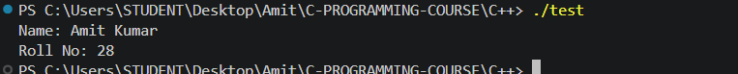

- Define two namespaces, VendorA and VendorB, each with a function void printInfo() that prints a different message. In main(), use a namespace alias for one of them and call both functions without ambiguity errors.

A - Code:

#include <iostream>
using namespace std;

namespace VendorA
{
void printInfo()
{
cout << "VendorA: Supplying hardware components." << endl;
}
}

namespace VendorB
{
void printInfo()
{
cout << "VendorB: Supplying software licenses." << endl;
}
}

int main()
{
namespace VA = VendorA;

VA::printInfo();
VendorB::printInfo();

return 0;
}

Output:



- Design a class Account inside a namespace Bank, with members accNo and balance. Implement:
  - a default constructor
  - a parameterized constructor
  - a copy constructor (custom, with a printed message)
  - an explicit single-argument constructor that takes only accNo and sets a default balance of 0
  - In main(), create objects using all four constructor types and print each object's details to show which constructor was invoked.

A - Code:
#include <iostream>
using namespace std;

namespace Bank
{
class Account
{
public:
int accNo;
double balance;

// default constructor
Account()
{
accNo = 0;
balance = 0.0;
cout << "Default constructor called." << endl;
}

// parameterized constructor
Account(int no, double bal)
{
accNo = no;
balance = bal;
cout << "Parameterized constructor called." << endl;
}

// copy constructor
Account(const Account &other)
{
accNo = other.accNo;
balance = other.balance;
cout << "Copy constructor called." << endl;
}

// explicit single-argument constructor
explicit Account(int no)
{
accNo = no;
balance = 0.0;
cout << "Explicit single-argument constructor called." << endl;
}

void showDetails()
{
cout << "Account No: " << accNo << ", Balance: " << balance << endl;
}
};
}

int main()
{
Bank::Account a1; // default
Bank::Account a2(1023, 5400.50); // parameterized
Bank::Account a3(a2); // copy
Bank::Account a4(2050); // explicit single-argument

a1.showDetails();
a2.showDetails();
a3.showDetails();
a4.showDetails();

return 0;
}

Output:

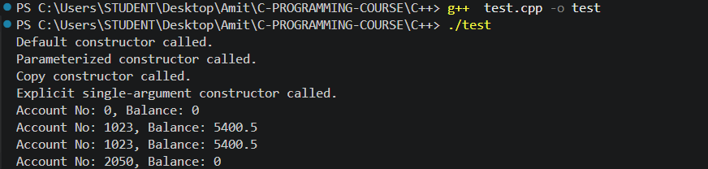

- Create a class Laptop with:
  - Brand
  - RAM
  - Price
  - Initialize one object using a parameterized constructor.
  - Create another object using the copy constructor.
  - Display both objects.

A - Code:
#include <iostream>
using namespace std;

class Laptop
{
public:
string brand;
int ram;
double price;

// parameterized constructor
Laptop(string b, int r, double p)
{
brand = b;
ram = r;
price = p;
}

// copy constructor
Laptop(const Laptop &other)
{
brand = other.brand;
ram = other.ram;
price = other.price;
}

void display()
{
cout << "Brand: " << brand << ", RAM: " << ram << "GB, Price: Rs " << price << endl;
}
};

int main()
{
Laptop l1("Dell", 16, 65000.0);
Laptop l2(l1);

l1.display();
l2.display();

return 0;
}

Output:
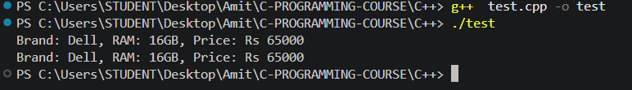

- Create a C++ program using a class Calculator that demonstrates different function concepts:
  - Create an inline function square(int n) that returns the square of a number.
  - Create overloaded functions named add():
    - add(int, int) → adds two integers.
    - add(double, double) → adds two decimal numbers.
  - Create a function swapValue(int a, int b) using call by value and demonstrate that the original values in main() do not change.
  - Create a function swapReference(int &a, int &b) using call by reference and demonstrate that the original values in main() are changed.
  - Call all the functions from main() and clearly display the results.

A - Code:
#include <iostream>
using namespace std;

class Calculator
{
public:
inline int square(int n)
{
return n * n;
}

int add(int a, int b)
{
return a + b;
}

double add(double a, double b)
{
return a + b;
}

void swapValue(int a, int b)
{
int temp = a;
a = b;
b = temp;
cout << "Inside swapValue -> a: " << a << ", b: " << b << endl;
}

void swapReference(int &a, int &b)
{
int temp = a;
a = b;
b = temp;
}
};

int main()
{
Calculator calc;

cout << "Square of 6: " << calc.square(6) << endl;
cout << "add(3, 4): " << calc.add(3, 4) << endl;
cout << "add(3.5, 4.2): " << calc.add(3.5, 4.2) << endl;

int x = 10, y = 20;
cout << "\nBefore swapValue -> x: " << x << ", y: " << y << endl;
calc.swapValue(x, y);
cout << "After swapValue -> x: " << x << ", y: " << y << " (unchanged)" << endl;

cout << "\nBefore swapReference -> x: " << x << ", y: " << y << endl;
calc.swapReference(x, y);
cout << "After swapReference -> x: " << x << ", y: " << y << " (changed)" << endl;

return 0;
}
Output:
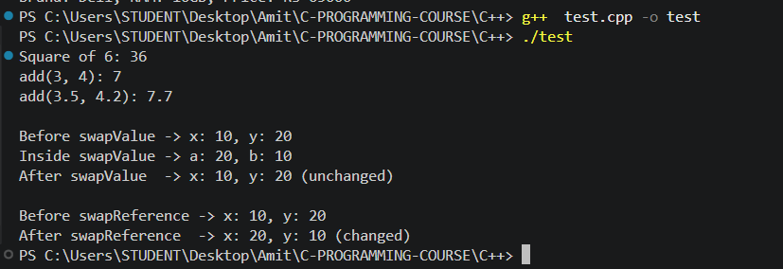

MCQs
1. Consider:
class Distance {
public:
explicit Distance(int m) {
}
};
int main() {
Distance d = 100;
}
What happens?
A. Object is created successfully
B. Compilation error because implicit conversion is prevented
C. Runtime error
D. 100 is automatically converted to Distance
Answer:

B. Compilation error because implicit conversion is prevented

2. Which of the following is a valid example of function overloading?
A.
int add(int a, int b);
int add(int x, int y);
B.
int add(int a, int b);
double add(double a, double b);
C.
int add(int a, int b);
int add(int a, int b);
D.
int add(int a, int b);
void add(int a, int b);
Answer:

B. int add(int a, int b); / double add(double a, double b);

3. What will be the output?
void change(int x) {
x = 100;
}
int main() {
int a = 10;
change(a);
cout << a;}
A. 10
B. 100
C. 0
D. Compilation error
Answer:

A. 10

4. What will be the output?
void change(int &x) {
x = 100;
}
int main() {
int a = 10;
change(a);
cout << a;
}
A. 10
B. 100
C. Address of a
D. Compilation error
Answer:

B. 100

5. What is the output?
class Test {
public:
Test() {
cout << "D ";
}
Test(const Test &t) {
cout << "C ";
}
};
void display(Test t) {
cout << "F ";
}
int main() {
Test t1;
display(t1);
}
A. D F
B. D C F
C. C D F
D. D C
Answer:

B. D C F

6. What is the output?
class Demo {
public:
Demo() {
cout << "A ";
}
Demo(int x) {
cout << "B ";
}
Demo(const Demo &d) {
cout << "C ";
}
};
int main() {
Demo d1;
Demo d2(10);
Demo d3 = d1;
}
A. A B C
B. A B A
C. A C B
D. B A C
Answer:

A. A B C

Explain:
- Differentiate between using namespace std; at the top of a file versus using std:: before each standard library element. Discuss the trade-offs of each approach in terms of readability and naming conflicts.

Answer - Writing using namespace std; once at the top pulls every name from std into the global scope, so afterwards cout, endl, string, and so on can all be used without a prefix. It reads faster and saves typing, but in a large file (or worse, in a header that gets included everywhere) it increases the risk that one of your own names, or a name from another library, collides with something inside std, causing ambiguous-call errors that can be confusing to track down.

Writing std:: before every element instead is more verbose, but it makes it completely explicit where every name is coming from, and it removes any chance of that name silently clashing with something else. This is why using namespace std; is usually fine in a small file or a quick program, but the std:: prefix (or narrower using-declarations for just the names actually needed) is generally the safer habit in bigger projects.

- Explain the concept of "class" and "object" in C++ with the analogy of a blueprint and a building. What are data members and member functions, and how does access specifier (private/public) control their visibility?

Answer - A class is like a blueprint for a building: it lays out what a building of that design will contain and what it will be able to do, but it isn't a building itself. An object is an actual building constructed from that blueprint - you can make several buildings (objects) from the same blueprint (class), each with its own address and its own furniture, even though they all follow the same plan.

Data members are the variables declared inside the class (matching the rooms/fixtures described in the blueprint), and member functions are the operations the class can perform (matching the actions the building supports, like "open the front door"). Access specifiers control who is allowed to reach these from outside the class: a public member can be accessed directly from anywhere the object is visible, while a private member can only be accessed from inside the class's own member functions - so, for example, the outside world can be given a doorbell (a public function) without being handed a key to every room (a private data member).

- What is a constructor in C++? List its key properties and explain why a class can have more than one constructor.

Answer - A constructor is a special member function that runs automatically when an object of a class is created, and it's normally used to set up the object's initial state (assigning starting values to its data members, or doing any other setup the object needs). Its key properties are: it always has the same name as the class, it has no return type (not even void), and it can be overloaded, meaning a class can have several constructors as long as their parameter lists are different from each other.

A class is allowed to have more than one constructor precisely because objects are often created in more than one way - sometimes with no information yet available (a default constructor), sometimes with specific starting values (a parameterized constructor), and sometimes by copying an existing object (a copy constructor). Overloading the constructor lets each of these situations be handled cleanly, with the compiler picking whichever constructor matches the arguments used at the point the object is created.

- What happens if a class defines no constructor at all — does the compiler still create one?

Answer - Yes. If a class defines no constructor of its own, the compiler automatically generates a default constructor behind the scenes so that the class can still be instantiated. This compiler-generated constructor doesn't perform any meaningful initialization of built-in-type members (an int member, for example, is left with an indeterminate value), it simply allows the object to be created. As soon as the class defines any constructor itself, however, this automatic default constructor is no longer generated, and a default constructor has to be written explicitly if one is still needed.

- Explain the copy constructor. Why does its parameter need to be a const reference (const ClassName&) rather than a plain object or pointer?

Answer - A copy constructor is a constructor that initializes a new object as a copy of an existing object of the same class, and it's invoked whenever an object is passed by value, returned by value, or explicitly initialized from another object of the same type.

Its parameter needs to be a const reference, rather than a plain object, because passing by value would itself require making a copy of the argument - which means calling the copy constructor again to make that copy, which would call itself again, and so on forever. Passing by reference avoids this infinite recursion since no copy of the argument is made just to enter the function. It's marked const because the copy constructor's job is only to read from the source object, not modify it, and const also lets the copy constructor accept temporary objects, which cannot bind to a non-const reference.
- What does the explicit keyword do when applied to a single-argument constructor?

Answer - Marking a single-argument constructor explicit stops the compiler from using it for implicit type conversions. Without explicit, a constructor like Distance(int m) would let code such as Distance d = 100; compile by silently converting the integer 100 into a Distance object behind the scenes. With explicit, that same line becomes a compilation error, and object creation must instead use direct-initialization syntax such as Distance d(100);, making the conversion clearly intentional rather than something that happens invisibly.
- What is an inline function? Why are inline functions generally useful for small functions? Is inline a guarantee that the compiler will replace the function call with the function body? Explain.

Answer - An inline function is a function that's marked with the inline keyword to hint that the compiler should try to insert the function's own code directly at each place it's called, rather than performing a normal function call (which involves overhead like jumping to a different part of memory, pushing arguments onto the stack, and returning back). This is generally useful for small functions - such as square(int n) in this assignment - because the overhead of an actual function call can end up being larger than the tiny bit of work the function itself does, so removing that overhead makes the code faster for functions this size.

However, inline is only a request to the compiler, not a guarantee. Modern compilers make their own decision about whether to actually inline a function, and they may choose not to if the function is too large, is recursive, or if inlining it would bloat the resulting program too much - and conversely, compilers often inline small functions automatically for optimization even without the keyword being present at all. So inline is best understood as a hint that guides the compiler's decision rather than a command it must obey.

- What is function overloading? Explain how C++ determines which overloaded function should be called. Can functions be overloaded only by changing their return type? Why or why not?

Answer - Function overloading is defining more than one function with the same name in the same scope, as long as their parameter lists differ from each other in the number of parameters, the types of the parameters, or the order of parameter types.

C++ decides which overloaded function to call at compile time by comparing the arguments provided in the call against the parameter lists of every function sharing that name, and picking the one that matches best (an exact match is preferred, followed by matches that only need standard promotions or conversions); if no single best match exists, the compiler reports an ambiguous call error instead of guessing.

Functions cannot be overloaded by return type alone. The compiler resolves which function to call purely by looking at the function call expression itself - the arguments passed to it - and a call like add(2, 3) gives no information at all about what return type the caller expects, so if two functions differed only in return type, the compiler would have no way to tell which one was meant, especially when the result of the call isn't even assigned to anything.

#include <iostream>

int add(int a, int b, int c=0);
inline int multiply(int a, int b){
return a*b;
}
int factorial(int n){
if(n<+1){
return 1;
}
return n*factorial(n-1);
}

double add(double a, double b){
return a+b;
}
void increment(int &val){
val++;
}

void greet(std::string name, std::string greeting = "Hello"){
std::cout<<greeting<<","<<name<<"!"<<std::endl;
}
int main() {
int x=10;
std::cout<<"add(1,2) with default arg. "<<add(1,2)<<std::endl;
std::cout<<"add(1,2,3) "<<add(1,2,3)<<std::endl;
std::cout<<"multiply(4,5) "<<multiply(4,5)<<std::endl;
std::cout<<"factorial(5) "<<factorial(5)<<std::endl;
std::cout<<"overloaded add(1.5,2.5) "<<add(1.5,2.5)<<std::endl;
std::cout<<"before increament "<<x<<std::endl;
increment(x);
std::cout<<"after increament "<<x<<std::endl;
greet("Alice");
greet("bob", "hi");

return 0;
}

int add(int a, int b, int c){
return a+b+c;
}

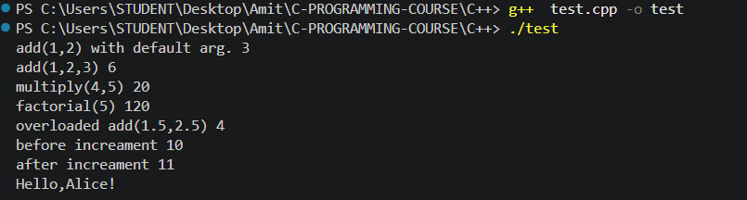

#include <iostream>
#include <string>
using namespace std;

class Complex{
public:
int real;
int imag;

explicit Complex(int r=0, int i=0){
real=r;
imag = i;
}

Complex(const Complex &c){
real=c.real;
imag =c.imag;
}

};
void display(Complex c){
cout<<c.real<<"+"<<c.imag<<"i"<<endl;
}
int main() {
Complex c1;

display(Complex(10));

return 0;
}

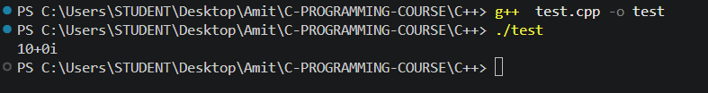

#include <iostream>
using namespace std;

class BankAccount {
private:
int balance;
int accountNumber;

public:

BankAccount() {
balance = 0;
}

BankAccount(int a, int initialBalance) {
balance = initialBalance;
accountNumber = a;
}

BankAccount(const BankAccount &c) {
accountNumber = c.accountNumber;
balance = c.balance;
}

void display() {
cout << "Account Number: " << accountNumber << endl;
cout << "Balance: " << balance << endl;
}
};

int main() {
BankAccount a1(123, 400);
BankAccount a2 = a1;

a1.display();
a2.display();

return 0;
}

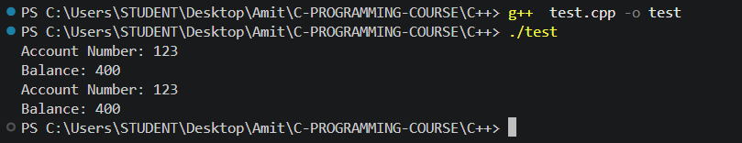

#include <iostream>
#include <string>
using namespace std;
class Car{
public:
string brand;
Car(){
brand = "Unknown";
cout<<"Constructor ran for a car!"<<endl;
}

};
int main() {
cout<<"Before creating Car"<<endl;
Car c1;
cout<<"After creating Car"<<endl;

return 0;
}

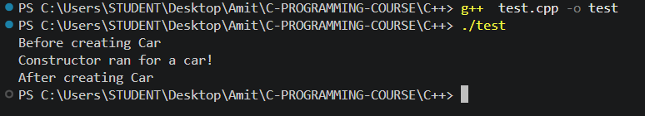

#include <iostream>
#include <string>
using namespace std;

class Complex{
private:
int real;
int imag;

public:
Complex(int r, int i){
real=r;
imag = i;
}

Complex(const Complex &c){
real=c.real;
imag =c.imag;
}

void display(){
cout<<real<<"+"<<imag<<"i"<<endl;
}

};
int main() {
Complex c1(3,4);
Complex c2 = c1;

c1.display();
c2.display();

return 0;
}

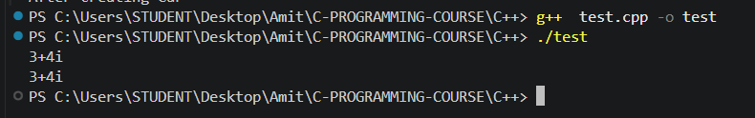
#include <iostream>
#include <string>
using namespace std;

class Complex{
public:
int real;
int imag;

Complex(int r=0, int i=0){
real=r;
imag = i;
}

Complex(const Complex &c){
real=c.real;
imag =c.imag;
}
};
void display(Complex c){
cout<<c.real<<"+"<<c.imag<<"i"<<endl;
}
int main() {
Complex c1;

display(10);

return 0;
}

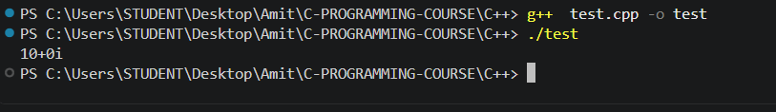
/*Find the maximum of 3 numbers using deafault argument*/
#include <iostream>
using namespace std;

int maxi(int a, int b, int c = 0) {
if (a >= b && a >= c) {
return a;
}
else if (b >= a && b >= c) {
return b;
}
else {
return c;
}
}

int main() {
cout << maxi(50, 4, 40) << endl;
cout << maxi(40, 30) << endl;

return 0;
}
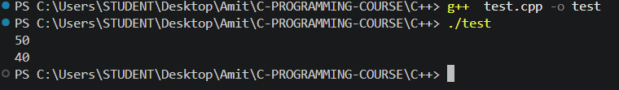
#include <iostream>
using namespace std;

int sum(int a, int b){
return a+b;
}

float sum(float a, float b){
return a+b;
}
int sum(int a, int b, int c){
return a+b+c;
}

int main() {
cout<<sum(10,5)<<endl;
cout<<sum(12.5f, 3.4f)<<endl;
cout<<sum(10,20,3)<<endl;

return 0;
}
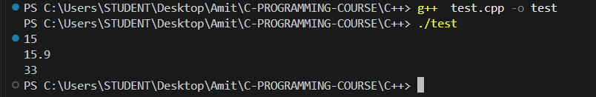
#include <iostream>
using namespace std;

int min(int a, int b) {
if (a < b) {
return a;
}
else {
return b;
}
}

float min(float a, float b) {
if (a < b) {
return a;
}
else {
return b;
}
}

int min(int a, int b, int c) {
if (a <= b && a <= c) {
return a;
}
else if (b <= a && b <= c) {
return b;
}
else {
return c;
}
}

int main() {

cout << min(10, 5) << endl;
cout << min(12.5f, 3.4f) << endl;
cout << min(10, 20, 3) << endl;

return 0;
}
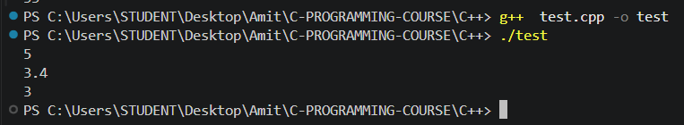

#include <iostream>
using namespace std;

int sum(int a, int b, int c=0) {
return a+b+c;
}

int main() {
cout << sum(10, 20, 3) << endl;
cout << sum(10, 3) << endl;

return 0;
}

