C++ Assignment
- Create a variadic function that accepts a variable number of integers and displays the number of even and odd values.
#include <iostream>
#include <cstdarg>
using namespace std;

void countEvenOdd(int count, ...)
{
va_list args;
va_start(args, count);

int evenCount = 0, oddCount = 0;

for (int i = 0; i < count; i++)
{
int num = va_arg(args, int);
if (num % 2 == 0)
evenCount++;
else
oddCount++;
}

va_end(args);

cout << "Even count: " << evenCount << endl;
cout << "Odd count: " << oddCount << endl;
}

int main()
{
countEvenOdd(6, 4, 7, 10, 3, 8, 15);
return 0;
}

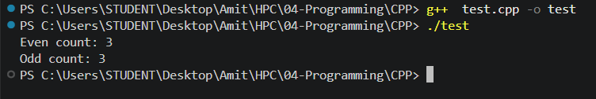
- Create a variadic function that accepts a variable number of integers and counts Positive, Negative and Zero Values.
#include <iostream>
#include <cstdarg>
using namespace std;

void countSign(int count, ...)
{
va_list args;
va_start(args, count);

int pos = 0, neg = 0, zero = 0;

for (int i = 0; i < count; i++)
{
int num = va_arg(args, int);
if (num > 0)
pos++;
else if (num < 0)
neg++;
else
zero++;
}

va_end(args);

cout << "Positive: " << pos << endl;
cout << "Negative: " << neg << endl;
cout << "Zero: " << zero << endl;
}

int main()
{
countSign(7, 5, -3, 0, 8, -1, 0, 12);
return 0;
}

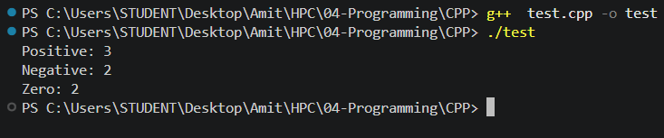
- Write a program that asks an instructor how many students are in their class. Dynamically allocate an array of float on the Heap to store their final grades. Prompt the instructor to enter each grade, print out all grades, and then calculate and display the highest grade. Finally, deallocate the memory properly to prevent leaks.
#include <iostream>
using namespace std;

int main()
{
int n;
cout << "Enter number of students: ";
cin >> n;

float *grades = new float[n];

for (int i = 0; i < n; i++)
{
cout << "Enter grade for student " << (i + 1) << ": ";
cin >> grades[i];
}

cout << "\nAll grades: ";
for (int i = 0; i < n; i++)
cout << grades[i] << " ";
cout << endl;

float highest = grades[0];
for (int i = 1; i < n; i++)
{
if (grades[i] > highest)
highest = grades[i];
}

cout << "Highest grade: " << highest << endl;

delete[] grades;

return 0;
}

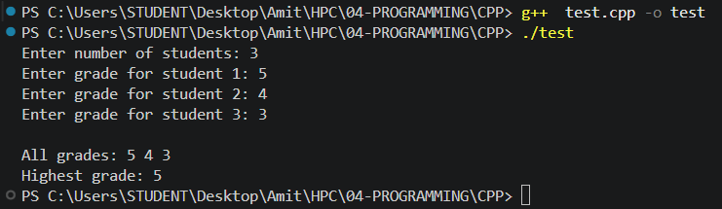
- Write a C++ program to create a class named Student with the following members:
int rollNo
int *marks (allocate memory dynamically)
The class should have:
A parameterized constructor to initialize rollNo and marks.
A display() function to print the roll number, marks, and the memory address of marks.
A setMarks() function to modify the marks.
In the main() function:
Create one object s1.
Create another object s2 by copying s1 using the default copy constructor.
Display both objects. Modify the marks of s2. Display both objects again.
#include <iostream>
using namespace std;

class Student
{
public:
int rollNo;
int *marks;

Student(int roll, int m)
{
rollNo = roll;
marks = new int(m);
}

void display()
{
cout << "Roll No: " << rollNo << ", Marks: " << *marks
<< ", Address of marks: " << marks << endl;
}

void setMarks(int m)
{
*marks = m;
}
};

int main()
{
Student s1(101, 85);
Student s2 = s1;

cout << "Before modifying s2:" << endl;
s1.display();
s2.display();

s2.setMarks(60);

cout << "\nAfter modifying s2's marks:" << endl;
s1.display();
s2.display();

return 0;
}
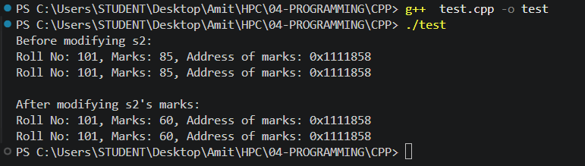
- Modify the previous program by implementing a copy constructor that performs a deep copy.
Requirements
Allocate separate memory for the copied object. Copy the value stored in marks instead of copying the pointer. Display the addresses of both pointers. Verify that changing one object's marks does not affect the other.
#include <iostream>
using namespace std;

class Student
{
public:
int rollNo;
int *marks;

Student(int roll, int m)
{
rollNo = roll;
marks = new int(m);
}

// deep copy constructor
Student(const Student &other)
{
rollNo = other.rollNo;
marks = new int(*other.marks); // allocate separate memory, copy the value
}

void display()
{
cout << "Roll No: " << rollNo << ", Marks: " << *marks
<< ", Address of marks: " << marks << endl;
}

void setMarks(int m)
{
*marks = m;
}
};

int main()
{
Student s1(101, 85);
Student s2 = s1;

cout << "Before modifying s2:" << endl;
s1.display();
s2.display();

s2.setMarks(60);

cout << "\nAfter modifying s2's marks:" << endl;
s1.display();
s2.display();

return 0;
}

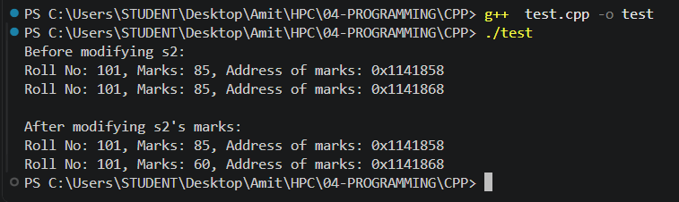
- Write a C++ program to create a class Number having:
int value
int &ref
Requirements:
Initialize the reference member using an initialization list. Display both value and ref. Modify value and verify that ref also changes.
#include <iostream>
using namespace std;

class Number
{
public:
int value;
int &ref;

Number(int v) : value(v), ref(value)
{
}

void display()
{
cout << "value: " << value << ", ref: " << ref << endl;
}
};

int main()
{
Number n(10);

cout << "Initial:" << endl;
n.display();

n.value = 50;

cout << "\nAfter modifying value:" << endl;
n.display();

return 0;
}

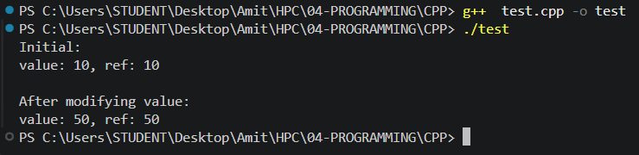
- Write a C++ program that asks the user to enter a single word, then complete the following steps:
Copy: Copy the input word into a new string variable named username.
Concatenate: Create a new string named fullTag by joining username with the suffix "_2026".
Length: Calculate and display the total number of characters in fullTag.
Compare: Check if fullTag is equal to "admin_2026".
If equal, display: "Access: Admin access granted!".
Otherwise, display: "Access: Regular user account created."
#include <iostream>
#include <string>
using namespace std;

int main()
{
string input;
cout << "Enter a single word: ";
cin >> input;

string username = input;
string fullTag = username + "_2026";

cout << "fullTag: " << fullTag << endl;
cout << "Length of fullTag: " << fullTag.length() << endl;

if (fullTag == "admin_2026")
{
cout << "Access: Admin access granted!" << endl;
}
else
{
cout << "Access: Regular user account created." << endl;
}

return 0;
}
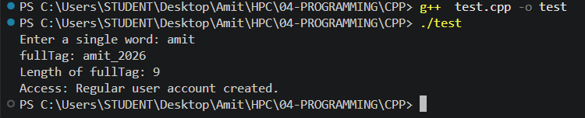
- Create a class Number with two private integers. Use a friend function to find and display the larger number.
#include <iostream>
using namespace std;

class Number
{
private:
int num1, num2;

public:
Number(int a, int b)
{
num1 = a;
num2 = b;
}

friend void showLarger(Number n);
};

void showLarger(Number n)
{
if (n.num1 > n.num2)
cout << "Larger number: " << n.num1 << endl;
else
cout << "Larger number: " << n.num2 << endl;
}

int main()
{
Number n(45, 78);
showLarger(n);

return 0;
}
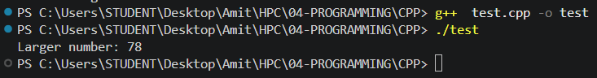
- Create two classes A and B each containing one private integer. Write a friend function to swap their values.
#include <iostream>
using namespace std;

class B;

class A
{
private:
int valueA;

public:
A(int v)
{
valueA = v;
}

void display()
{
cout << "A's value: " << valueA << endl;
}

friend void swapValues(A &a, B &b);
};

class B
{
private:
int valueB;

public:
B(int v)
{
valueB = v;
}

void display()
{
cout << "B's value: " << valueB << endl;
}

friend void swapValues(A &a, B &b);
};

void swapValues(A &a, B &b)
{
int temp = a.valueA;
a.valueA = b.valueB;
b.valueB = temp;
}

int main()
{
A objA(10);
B objB(99);

cout << "Before swap:" << endl;
objA.display();
objB.display();

swapValues(objA, objB);

cout << "\nAfter swap:" << endl;
objA.display();
objB.display();

return 0;
}

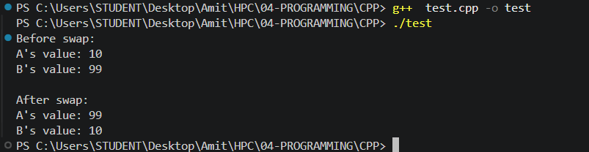
- Write a template function findMax(a, b) that works for int, float, double and char.
#include <iostream>
using namespace std;

template <typename T>
T findMax(T a, T b)
{
return (a > b) ? a : b;
}

int main()
{
cout << "Max of 4, 9 (int): " << findMax(4, 9) << endl;
cout << "Max of 3.5f, 2.1f (float): " << findMax(3.5f, 2.1f) << endl;
cout << "Max of 7.8, 9.6 (double): " << findMax(7.8, 9.6) << endl;
cout << "Max of 'a', 'z' (char): " << findMax('a', 'z') << endl;

return 0;
}

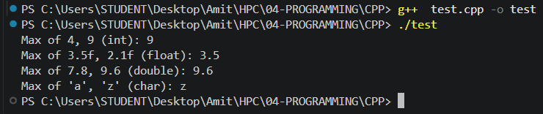
- Create template functions as Generic Calculator for Addition, Subtraction and Multiplication. Test them with integers and floating-point numbers.
#include <iostream>
using namespace std;

template <typename T>
T add(T a, T b)
{
return a + b;
}

template <typename T>
T subtract(T a, T b)
{
return a - b;
}

template <typename T>
T multiply(T a, T b)
{
return a * b;
}

int main()
{
cout << "Integers:" << endl;
cout << "5 + 3 = " << add(5, 3) << endl;
cout << "5 - 3 = " << subtract(5, 3) << endl;
cout << "5 * 3 = " << multiply(5, 3) << endl;

cout << "\nFloating-point:" << endl;
cout << "5.5 + 3.2 = " << add(5.5, 3.2) << endl;
cout << "5.5 - 3.2 = " << subtract(5.5, 3.2) << endl;
cout << "5.5 * 3.2 = " << multiply(5.5, 3.2) << endl;

return 0;
}
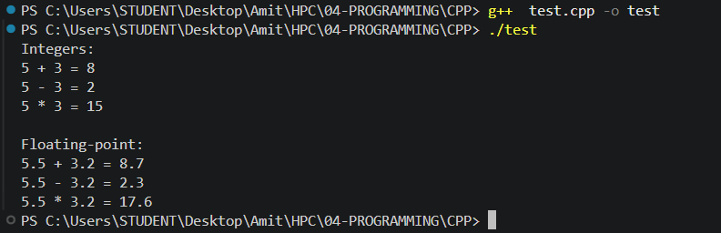
- Create an integer using unique_ptr. Assign value, Display value and Observe automatic deletion.
#include <iostream>
#include <memory>
using namespace std;

int main()
{
unique_ptr<int> ptr(new int(50));

cout << "Value: " << *ptr << endl;

cout << "End of main() reached. The memory will be freed automatically now." << endl;

return 0;
}

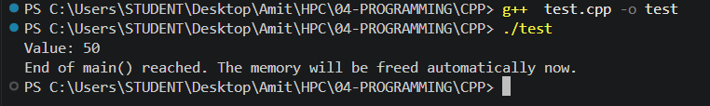
- Create a unique_ptr and transfer ownership using std::move().
#include <iostream>
#include <memory>
using namespace std;

int main()
{
unique_ptr<int> p1(new int(75));

cout << "Before move:" << endl;
cout << "p1 owns the object, value = " << *p1 << endl;
cout << "p2 is empty (owns nothing yet)" << endl;

unique_ptr<int> p2 = move(p1);

cout << "\nAfter move:" << endl;

if (p1 == nullptr)
cout << "p1 no longer owns anything (it is now null)" << endl;

cout << "p2 now owns the object, value = " << *p2 << endl;

return 0;
}
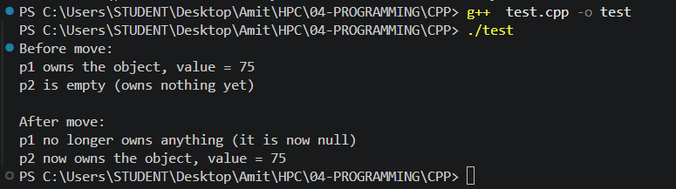
- Display which pointer owns the object before and after moving.
#include <iostream>
#include <memory>
using namespace std;

int main()
{
unique_ptr<int> ptr1 = make_unique<int>(100);

cout << "Before moving:" << endl;

if (ptr1)
cout << "ptr1 owns the object: YES" << endl;
else
cout << "ptr1 owns the object: NO" << endl;

cout << "ptr2 owns the object: NO" << endl;

unique_ptr<int> ptr2 = move(ptr1);

cout << "\nAfter moving:" << endl;

if (ptr1)
cout << "ptr1 owns the object: YES" << endl;
else
cout << "ptr1 owns the object: NO" << endl;

if (ptr2)
cout << "ptr2 owns the object: YES" << endl;
else
cout << "ptr2 owns the object: NO" << endl;

return 0;
}
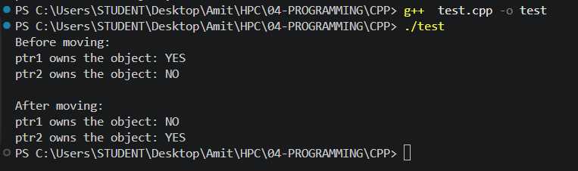
- Create a shared_ptr<int>. Assign it to another shared pointer. Display value and use_count().
#include <iostream>
#include <memory>
using namespace std;

int main()
{
shared_ptr<int> sp1 = make_shared<int>(30);

cout << "sp1 value: " << *sp1 << ", use_count: " << sp1.use_count() << endl;

shared_ptr<int> sp2 = sp1;

cout << "\nAfter assigning sp2 = sp1:" << endl;
cout << "sp1 value: " << *sp1 << ", use_count: " << sp1.use_count() << endl;
cout << "sp2 value: " << *sp2 << ", use_count: " << sp2.use_count() << endl;

return 0;
}
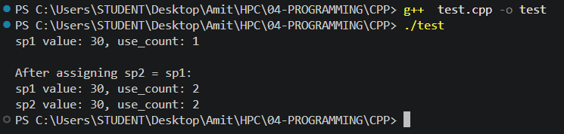
- Input 10 numbers into a vector. Calculate the sum using iterator and range-based loop.
#include <iostream>
#include <vector>
using namespace std;

int main()
{
vector<int> numbers;
int val;

cout << "Enter 10 numbers: ";
for (int i = 0; i < 10; i++)
{
cin >> val;
numbers.push_back(val);
}

int sumIterator = 0;
for (vector<int>::iterator it = numbers.begin(); it != numbers.end(); ++it)
{
sumIterator += *it;
}

int sumRangeBased = 0;
for (int n : numbers)
{
sumRangeBased += n;
}

cout << "Sum using iterator: " << sumIterator << endl;
cout << "Sum using range-based loop: " << sumRangeBased << endl;

return 0;
}
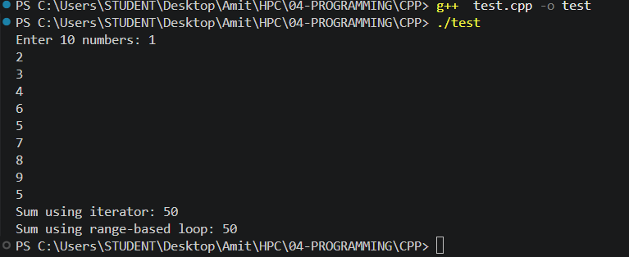
- Create a class Student with private data. Use friend function to calculate average marks vector to store students. Display topper details.
#include <iostream>
#include <vector>
#include <string>
using namespace std;

class Student
{
private:
string name;
int marks[5];

public:
Student(string n, int m[5])
{
name = n;
for (int i = 0; i < 5; i++)
marks[i] = m[i];
}

string getName()
{
return name;
}

friend float averageMarks(Student &s);
};

float averageMarks(Student &s)
{
int total = 0;
for (int i = 0; i < 5; i++)
total += s.marks[i];

return total / 5.0;
}

int main()
{
int m1[5] = {88, 76, 90, 85, 79};
int m2[5] = {95, 92, 89, 97, 91};
int m3[5] = {60, 55, 70, 65, 58};

vector<Student> students;
students.push_back(Student("Rohan", m1));
students.push_back(Student("Ishita", m2));
students.push_back(Student("Karan", m3));

Student *topper = &students[0];
float highestAvg = averageMarks(students[0]);

for (int i = 0; i < students.size(); i++)
{
float avg = averageMarks(students[i]);
cout << students[i].getName() << " - Average: " << avg << endl;

if (avg > highestAvg)
{
highestAvg = avg;
topper = &students[i];
}
}

cout << "\nTopper: " << topper->getName() << " with average " << highestAvg << endl;

return 0;
}
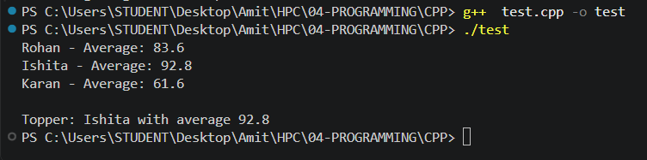
- Create a template function that accepts a vector of any datatype and finds the largest element.
#include <iostream>
#include <vector>
using namespace std;

template <typename T>
T findLargest(vector<T> v)
{
T largest = v[0];
for (int i = 1; i < v.size(); i++)
{
if (v[i] > largest)
largest = v[i];
}
return largest;
}

int main()
{
vector<int> intVec = {12, 45, 7, 89, 33};
vector<double> doubleVec = {3.4, 9.8, 1.2, 6.6};
vector<char> charVec = {'p', 'z', 'a', 'm'};

cout << "Largest in intVec: " << findLargest(intVec) << endl;
cout << "Largest in doubleVec: " << findLargest(doubleVec) << endl;
cout << "Largest in charVec: " << findLargest(charVec) << endl;

return 0;
}
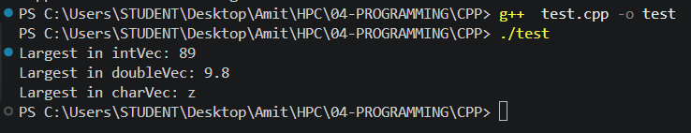
- Create a Student class with the following data members: Roll Number, Name and Marks. Store multiple student records in a vector<Student>. Display all student details and find the student with the highest marks.
#include <iostream>
#include <vector>
#include <string>
using namespace std;

class Student
{
public:
int rollNo;
string name;
float marks;

Student(int r, string n, float m)
{
rollNo = r;
name = n;
marks = m;
}
};

int main()
{
vector<Student> students;
students.push_back(Student(1, "Aman", 78.5));
students.push_back(Student(2, "Divya", 91.0));
students.push_back(Student(3, "Farhan", 84.5));
students.push_back(Student(4, "Neha", 96.5));

cout << "All student records:" << endl;
for (int i = 0; i < students.size(); i++)
{
cout << "Roll No: " << students[i].rollNo
<< ", Name: " << students[i].name
<< ", Marks: " << students[i].marks << endl;
}

int topIndex = 0;
for (int i = 1; i < students.size(); i++)
{
if (students[i].marks > students[topIndex].marks)
topIndex = i;
}

cout << "\nStudent with highest marks: " << students[topIndex].name
<< " (Roll No: " << students[topIndex].rollNo
<< ", Marks: " << students[topIndex].marks << ")" << endl;

return 0;
}
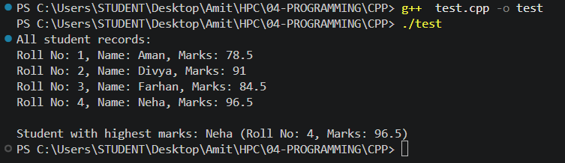
- Write template functions to perform: Addition, Subtraction, Multiplication and Division. Test the program using: int, float, double.
#include <iostream>
using namespace std;

template <typename T>
T add(T a, T b)
{
return a + b;
}

template <typename T>
T subtract(T a, T b)
{
return a - b;
}

template <typename T>
T multiply(T a, T b)
{
return a * b;
}

template <typename T>
T divide(T a, T b)
{
return a / b;
}

int main()
{
cout << "Using int (10, 3):" << endl;
cout << "Add: " << add(10, 3) << endl;
cout << "Subtract: " << subtract(10, 3) << endl;
cout << "Multiply: " << multiply(10, 3) << endl;
cout << "Divide: " << divide(10, 3) << endl;

cout << "\nUsing float (10.0f, 3.0f):" << endl;
cout << "Add: " << add(10.0f, 3.0f) << endl;
cout << "Subtract: " << subtract(10.0f, 3.0f) << endl;
cout << "Multiply: " << multiply(10.0f, 3.0f) << endl;
cout << "Divide: " << divide(10.0f, 3.0f) << endl;

cout << "\nUsing double (10.0, 3.0):" << endl;
cout << "Add: " << add(10.0, 3.0) << endl;
cout << "Subtract: " << subtract(10.0, 3.0) << endl;
cout << "Multiply: " << multiply(10.0, 3.0) << endl;
cout << "Divide: " << divide(10.0, 3.0) << endl;

return 0;
}
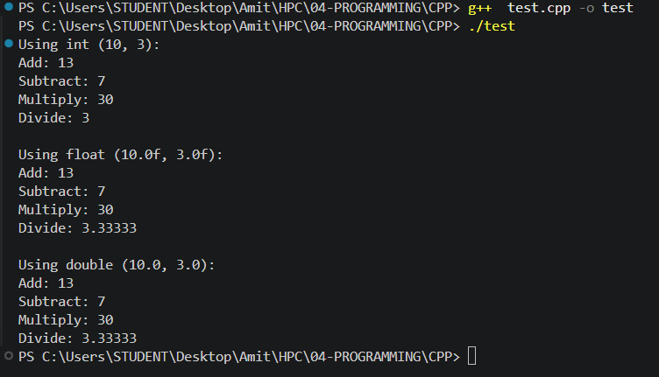

MCQs
1. A friend function can access:
A. Only public members
B. Only protected members
C. Only private members
D. Both private and protected members
Answer: D. Both private and protected members

2. Which header file is required for smart pointers?
A. <memory>
B. <pointer>
C. <smart>
D. <vector>
Answer: A. <memory>

3. Which smart pointer has exclusive ownership of an object?
A. shared_ptr
B. weak_ptr
C. unique_ptr
D. auto_ptr
Answer: C. unique_ptr

4. Ownership of a unique_ptr is transferred using:
A. copy()
B. clone()
C. move()
D. assign()
Answer: C. move()

5. Which function adds an element at the end of a vector?
A. add()
B. insert()
C. append()
D. push_back()
Answer: D. push_back()

Explain
- What is the difference between a member function and a friend function?
Answer - A member function belongs to a class and is called through an object of that class (object.function()), and it automatically has access to that object's private and protected members because it's part of the class itself. A friend function, on the other hand, is a regular standalone function (not a member of the class) that has been explicitly granted permission to access the class's private and protected members, even though it's called normally like any other function rather than through an object. In short: a member function is "inside" the class and always has access, while a friend function is "outside" the class but has been given special access anyway.
- Can a friend function be declared in more than one class?
Answer - Yes. A single function can be declared as a friend inside more than one class (as seen in Question 9, where swapValues() is declared as a friend inside both class A and class B). This is exactly how a friend function is able to reach into the private members of two different classes at once - it needs to be granted friendship by each class individually, since being a friend of one class says nothing about access to any other class.
- Explain the difference between a function template and a normal function.
Answer - A normal function is written for one specific data type, so if the same logic is needed for int, double, and char, separate overloaded versions have to be written by hand for each one. A function template (like the findMax(a, b) in Question 10) is written once using a placeholder type such as typename T, and the compiler automatically generates the correct version of the function for whichever actual type is used at the call site. This means a single function template can work for int, float, double, char, or any other type that supports the operations used inside it, without the programmer duplicating the code for each type.
- What is the difference between unique_ptr and shared_ptr?
Answer - unique_ptr represents exclusive ownership of a dynamically allocated object - only one unique_ptr can own a given object at a time, it cannot be copied (only moved, transferring ownership away from the original), and the object is destroyed as soon as that single owning unique_ptr goes out of scope. shared_ptr, in contrast, allows multiple pointers to share ownership of the same object at once; it keeps an internal reference count (visible through use_count()) that increases every time the object is shared and decreases as each shared_ptr is destroyed, and the underlying object is only deleted once that count reaches zero, i.e. once every owner has let go of it.
- What is the difference between an array and a vector?
Answer - An array has a fixed size that is decided at the time it's declared and cannot be changed afterward, and it doesn't come with any built-in functions to add, remove, or check how many elements it's actually holding - the programmer has to track that separately. A vector, from the Standard Template Library, is a dynamic, resizable array: it can grow or shrink at runtime with functions like push_back(), it keeps track of its own current size with size(), and it manages its own underlying memory automatically rather than requiring the programmer to allocate and free memory manually.
- Explain how iterators are used to traverse a vector.
Answer - An iterator is an object that behaves similarly to a pointer and knows how to move through the elements of a container like a vector one at a time. vec.begin() returns an iterator pointing at the first element, and vec.end() returns an iterator pointing just past the last element (not a valid element itself, just a marker for "one past the end"). A typical traversal loop starts an iterator at begin(), dereferences it with *it to access the current element, and advances it with ++it on each pass, continuing until it reaches end(), at which point every element has been visited exactly once - this is exactly the technique used for the iterator-based sum in Question 16.
- Explain why the following code produces a compilation error:
unique_ptr<int> p1 = make_unique<int>(10);
unique_ptr<int> p2 = p1;
How can it be corrected?
Answer - This code fails to compile because unique_ptr<int> p2 = p1; tries to copy p1 into p2, and unique_ptr has its copy constructor deliberately deleted - copying is not allowed for a type whose entire purpose is guaranteeing that only one pointer ever owns a given object at a time. If copying were allowed, both p1 and p2 would end up believing they owned the same object, and both would eventually try to delete it, causing a double-free error.
It can be corrected by transferring ownership explicitly with std::move() instead of copying, exactly as done in Question 13/14: unique_ptr<int> p2 = std::move(p1); This moves ownership from p1 into p2 rather than copying it, leaving p1 empty (null) afterward and p2 as the sole owner - which is allowed, since move doesn't create a second owner, it just relocates the single ownership from one unique_ptr to another.

- Suppose three pointers need to refer to the same dynamically allocated object. Which smart pointer would you choose? Explain why.
Answer - shared_ptr would be the right choice here, because shared_ptr is specifically designed to let multiple pointers share ownership of the same dynamically allocated object at once, using an internal reference count to keep track of how many owners currently exist. unique_ptr is unsuitable for this situation since it enforces exactly one owner and cannot be copied; if three separate pointers all genuinely need to refer to (and potentially outlive each other while still keeping) the same object, shared_ptr ensures the object is only destroyed once the very last of those three shared_ptrs goes out of scope, rather than being deleted prematurely while another pointer still needs it.
- Explain use_count() in shared_ptr.
Answer - use_count() returns the current number of shared_ptr instances that are jointly managing (own) the same underlying object at that moment. It starts at 1 when the object is first created through a single shared_ptr, and it increases by one every time that shared_ptr is copied into another shared_ptr (as seen in Question 15, where use_count() becomes 2 right after sp2 = sp1;). It decreases by one whenever one of those owning shared_ptrs is destroyed or reset, and once use_count() reaches zero - meaning no shared_ptr owns the object any longer - the object itself is automatically deleted.
- Explain different methods of accessing elements of a vector.
Answer - Elements of a vector can be accessed in several ways: using the subscript operator, like vec[i], which is fast but does not check whether the index is valid; using the at() function, like vec.at(i), which behaves the same way but throws an exception if the index is out of range, making it safer; using iterators, by dereferencing an iterator obtained from begin()/end() as *it while advancing through the container (as shown in Question 16); and using a range-based for loop, like for (int x : vec), which quietly uses iterators behind the scenes to visit every element in order without the programmer having to manage an index or iterator explicitly. front() and back() are also available specifically for reading the first and last elements.

