C++ Day 5 Assignment
Inheritance, Polymorphism, Exception Handling & Operator Overloading
Amit Kumar

Problem 1: Banking hierarchy — base class Account with SavingsAccount and CurrentAccount
Design a basic banking hierarchy consisting of a base class Account and two derived classes: SavingsAccount and CurrentAccount. The base class holds accountNumber and balance, plus deposit(), withdraw(), and displayBalance(). SavingsAccount enforces a minimum balance constraint, and CurrentAccount enforces an overdraft limit constraint.
Code:
#include <iostream>
using namespace std;

class Account
{
protected:
int accountNumber;
double balance;

public:
Account(int accNo, double bal)
{
accountNumber = accNo;
balance = bal;
}

void deposit(double amount)
{
balance += amount;
}

virtual void withdraw(double amount)
{
if (amount <= balance)
balance -= amount;
else
cout << "Withdrawal denied: insufficient balance." << endl;
}

void displayBalance()
{
cout << "Account No: " << accountNumber << ", Balance: " << balance << endl;
}
};

class SavingsAccount : public Account
{
private:
double minBalance;

public:
SavingsAccount(int accNo, double bal, double minBal) : Account(accNo, bal)
{
minBalance = minBal;
}

void withdraw(double amount) override
{
if (balance - amount < minBalance)
cout << "Withdrawal denied: savings account must maintain a minimum balance of "
<< minBalance << endl;
else
balance -= amount;
}
};

class CurrentAccount : public Account
{
private:
double overdraftLimit;

public:
CurrentAccount(int accNo, double bal, double overdraft) : Account(accNo, bal)
{
overdraftLimit = overdraft;
}

void withdraw(double amount) override
{
if (balance - amount < -overdraftLimit)
cout << "Withdrawal denied: exceeds overdraft limit of " << overdraftLimit << endl;
else
balance -= amount;
}
};

int main()
{
SavingsAccount sa(101, 1000, 500);
CurrentAccount ca(201, 1000, 2000);

cout << "-- Savings Account --" << endl;
sa.displayBalance();
sa.withdraw(600);
sa.displayBalance();
sa.withdraw(400);
sa.displayBalance();

cout << "\n-- Current Account --" << endl;
ca.displayBalance();
ca.withdraw(2500);
ca.displayBalance();
ca.withdraw(1000);
ca.displayBalance();

return 0;
}

Output:
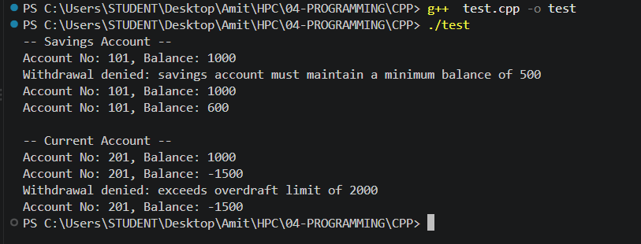

Problem 2: Dynamic polymorphism — Bank interest calculation with SBI, ICICI, HDFC
Demonstrate dynamic polymorphism using a bank interest calculation system: a base class Bank with a virtual interestRate() function, and derived classes SBI, ICICI, and HDFC, each overriding it with their own rate. In main(), create an array of Bank pointers to the derived objects and call interestRate() polymorphically through each one.
Code:
#include <iostream>
using namespace std;

class Bank
{
public:
virtual double interestRate() const
{
return 0.0;
}

virtual string bankName() const
{
return "Generic Bank";
}

virtual ~Bank() {}
};

class SBI : public Bank
{
public:
double interestRate() const override
{
return 6.5;
}

string bankName() const override
{
return "SBI";
}
};

class ICICI : public Bank
{
public:
double interestRate() const override
{
return 7.0;
}

string bankName() const override
{
return "ICICI";
}
};

class HDFC : public Bank
{
public:
double interestRate() const override
{
return 6.8;
}

string bankName() const override
{
return "HDFC";
}
};

int main()
{
Bank *banks[3];

banks[0] = new SBI();
banks[1] = new ICICI();
banks[2] = new HDFC();

for (int i = 0; i < 3; i++)
{
cout << banks[i]->bankName() << " interest rate: " << banks[i]->interestRate() << "%" << endl;
}

for (int i = 0; i < 3; i++)
{
delete banks[i];
}

return 0;
}

Output:
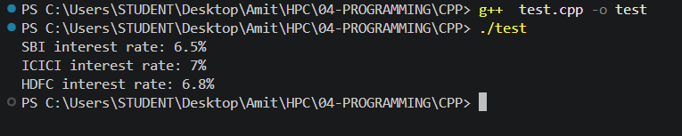

Problem 3: Custom bounds checking for an array using exceptions
Implement custom bounds checking for an array: define a fixed-size integer array, prompt the user for an index, throw an exception (std::out_of_range) if the index is negative or out of bounds, and catch it in a try-catch block so the program displays an error message instead of crashing.
Code:
#include <iostream>
#include <stdexcept>
using namespace std;

int main()
{
const int SIZE = 5;
int arr[SIZE] = {10, 20, 30, 40, 50};
int index;

cout << "Enter an index to retrieve (array size is " << SIZE << "): ";
cin >> index;

try
{
if (index < 0 || index >= SIZE)
{
throw out_of_range("Index out of bounds!");
}

cout << "Element at index " << index << " is " << arr[index] << endl;
}
catch (const out_of_range &e)
{
cout << "Error: " << e.what() << " Valid range is 0 to " << (SIZE - 1) << "." << endl;
}

cout << "Program continues normally after the exception was handled." << endl;

return 0;
}

Output: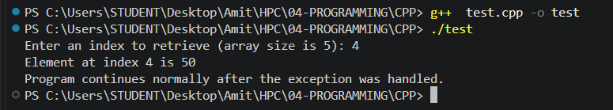

Problem 4: Custom exception class for insufficient funds during withdrawal
Enhance account security with custom exception handling in a withdrawal system: a function withdraw(double balance, double amount) that throws a custom InsufficientFundsException when amount exceeds balance, handled gracefully in the caller by displaying the attempted withdrawal amount and the available balance.
Code:
#include <iostream>
#include <exception>
using namespace std;

class InsufficientFundsException : public exception
{
private:
double attemptedAmount;
double availableBalance;

public:
InsufficientFundsException(double amount, double balance)
{
attemptedAmount = amount;
availableBalance = balance;
}

double getAttemptedAmount() const
{
return attemptedAmount;
}

double getAvailableBalance() const
{
return availableBalance;
}

const char *what() const noexcept override
{
return "Insufficient funds for this withdrawal.";
}
};

double withdraw(double balance, double amount)
{
if (amount > balance)
{
throw InsufficientFundsException(amount, balance);
}

return balance - amount;
}

int main()
{
double balance = 1000.0;

try
{
cout << "Attempting to withdraw 500 from balance of " << balance << endl;
balance = withdraw(balance, 500);
cout << "Success. New balance: " << balance << endl;

cout << "\nAttempting to withdraw 800 from balance of " << balance << endl;
balance = withdraw(balance, 800);
cout << "Success. New balance: " << balance << endl;
}
catch (const InsufficientFundsException &e)
{
cout << e.what() << endl;
cout << "Attempted withdrawal: " << e.getAttemptedAmount() << endl;
cout << "Available balance: " << e.getAvailableBalance() << endl;
}

return 0;
}
Output:
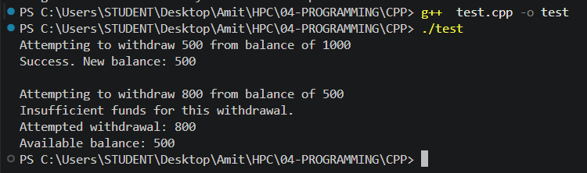

Problem 5: Operator overloading — BankAccount with += and -=
Design a class BankAccount that demonstrates operator overloading using the compound assignment operators for basic banking operations, with full state validation: no negative initial balance, no negative deposit/withdrawal amounts, and no withdrawal that would push the balance below zero.
Code:
#include <iostream>
#include <iomanip>
#include <sstream>
using namespace std;

class BankAccount
{
private:
string accountNumber;
double balance;

string formattedBalance()
{
ostringstream oss;
oss << fixed << setprecision(1) << balance;
return oss.str();
}

public:
BankAccount(string accNo, double initialBalance = 0.0)
{
accountNumber = accNo;
balance = (initialBalance < 0) ? 0.0 : initialBalance;
}

BankAccount &operator+=(double amount)
{
if (amount <= 0)
{
cout << "Error: Deposit amount must be positive." << endl;
return *this;
}

balance += amount;
cout << "Deposited: $" << amount << ". Current Balance: $" << formattedBalance() << endl;
return *this;
}

BankAccount &operator-=(double amount)
{
if (amount <= 0)
{
cout << "Error: Withdrawal amount must be positive." << endl;
return *this;
}

if (amount > balance)
{
cout << "Error: Insufficient funds. Transaction cancelled." << endl;
return *this;
}

balance -= amount;
cout << "Withdrew: $" << amount << ". Current Balance: $" << formattedBalance() << endl;
return *this;
}

void display()
{
cout << "Account: " << accountNumber << " | Balance: $" << formattedBalance() << endl;
}
};

int main()
{
BankAccount acc("ACC-101", 500.0);

acc += 150.0;
acc -= 200.0;
acc -= 600.0;

acc.display();

return 0;
}
Output:
