C++ Programming – Namespace Assignment
1. Fix the collision
A. Two functions both named area() are needed — one for a Circle and one for a Square. Write the code so both can exist in the same file without a redefinition error, using namespaces and the scope resolution operator.
B. Write a program with two namespaces India and USA, each having a function currency(). Call both functions.

A - Code:
#include <iostream>

namespace Circle
{
float area(float r)
{
float pi = 3.14;
float result = pi * r * r;
std::cout << "Area of Circle is: " << result << std::endl;
return result;
}
}

namespace Square
{
float area(float side)
{
float result = side * side;
std::cout << "Area of Square is: " << result << std::endl;
return result;
}
}

int main()
{
Circle::area(5);
Square::area(5);
return 0;
}

Output:
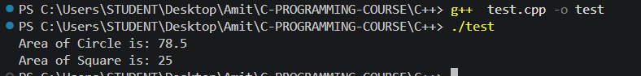

B - Code:
#include <iostream>

namespace India
{
void currency()
{
std::cout << "INR (Indian Rupee)" << std::endl;
}
}

namespace USA
{
void currency()
{
std::cout << "USD (US Dollar)" << std::endl;
}
}

int main()
{
India::currency();
USA::currency();
return 0;
}

Output:
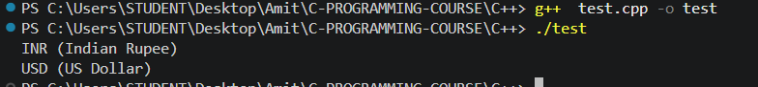

2. Predict the output
#include <iostream>
namespace Shop {
double price = 100.0;
}
namespace Sale {
double price = 75.0;
}
int main() {
std::cout << Shop::price << " " << Sale::price;
}
What does this print, and why doesn't the compiler complain about two variables both called price?

Answer - 100 75

Reason - Shop::price and Sale::price are two completely separate variables that just happen to share the same name. Since each one lives inside its own namespace, the compiler tells them apart using the full qualified name (Shop::price vs Sale::price), so there is no actual naming conflict, only a coincidence in the name itself.

3. Spot the risk
A student writes using namespace std; at the top of a large file, then later adds using namespace MyMathLib;, which also happens to define a function called count(). What problem could this cause, and how would you rewrite the code to avoid it while still keeping things reasonably short to type?

Answer - Once both using namespace std; and using namespace MyMathLib; are active, an unqualified call to count() becomes ambiguous if both namespaces define a function with that name - the compiler won't know which one is meant, and the code may fail to compile, or worse, could end up calling the wrong version if only one of them actually matches the arguments used.

To avoid this while keeping things short to type, the fix is to stop using the blanket using namespace MyMathLib; directive and instead bring in only the specific names that are actually needed with using-declarations, for example using MyMathLib::someFunction; - and call MyMathLib::count() with its full name whenever that particular count() is required. This keeps most of the file just as short as before, but removes the ambiguity since std::count and MyMathLib::count are never both left unqualified at the same time.

4. Write it — using declaration
Using only a using declaration (not a using directive), import just cout and endl from std and write a two-line program that prints "Practicing namespaces". Then explain in one sentence why std::cin would still need its full prefix in this same file.

Code:

#include <iostream>
using std::cout;
using std::endl;

int main()
{
cout << "Practicing namespaces" << endl;
}

Explanation - std::cin still needs its full std:: prefix in this file because the using-declarations only brought cout and endl into scope, not cin, so cin remains reachable only through its fully qualified name.

5. Alias and nest
A. Create a nested namespace Company::HR containing an employee() function and access it from main().

A - Code:
#include <iostream>

namespace Company::HR
{
void employee()
{
std::cout << "Employee added to HR department" << std::endl;
}
}

int main()
{
Company::HR::employee();
return 0;
}

Output:
B. You're given this nested namespace:
namespace College {
namespace Department {
namespace Faculty {
void listCourses() { /* ... */ }
}
}
}
Write two different ways to call listCourses() from main(): (a) using the C++17 nested-namespace shorthand to declare it more concisely, and (b) using a namespace alias to call it more concisely without changing the declaration.

(a) To shorten the declaration itself using C++17, the three nested namespace blocks can be collapsed into one line: namespace College::Department::Faculty { void listCourses() { /* ... */ } }

(b) To shorten the call without touching the original nested declaration, a namespace alias can be created instead: namespace Faculty = College::Department::Faculty; and then the function can be called simply as Faculty::listCourses();

