Amit_Lab6 - Day 6 Assignment
C Programming - Structures
Question 1: Student Management System using Structures - Add, Display and Search student by Roll No
#include <stdio.h>
#define MAX 100

struct student{
int roll;
char name[50];
float marks;
};

int main(){
struct student s[MAX];
int n = 0;
int choice;
int i;
int roll;

do{
printf("\n---STUDENT MANAGEMENT----\n");
printf("1. Add Student\n");
printf("2. Display Students\n");
printf("3. Search Student by Roll No\n");
printf("4. Exit\n");
printf("Enter your choice: ");
scanf("%d", &choice);

switch(choice){
case 1:
printf("Enter Roll No: ");
scanf("%d", &s[n].roll);
printf("Enter Name: ");
scanf("%s", s[n].name);
printf("Enter Marks: ");
scanf("%f", &s[n].marks);
n++;
printf("Student added.\n");
break;

case 2:
if(n == 0){
printf("No students found.\n");
}
else{
for(i=0; i<n; i++){
printf("Roll No: %d\n", s[i].roll);
printf("Name: %s\n", s[i].name);
printf("Marks: %.2f\n", s[i].marks);
printf("--------------\n");
}
}
break;

case 3:
printf("Enter Roll No to search: ");
scanf("%d", &roll);
for(i=0; i<n; i++){
if(s[i].roll == roll){
printf("Student Found!\n");
printf("Roll No: %d\n", s[i].roll);
printf("Name: %s\n", s[i].name);
printf("Marks: %.2f\n", s[i].marks);
break;
}
}
if(i == n){
printf("Student not found.\n");
}
break;

case 4:
printf("Exiting... Thank you!\n");
break;

default:
printf("Invalid choice!\n");
}
}while(choice != 4);

return 0;
}
Output:
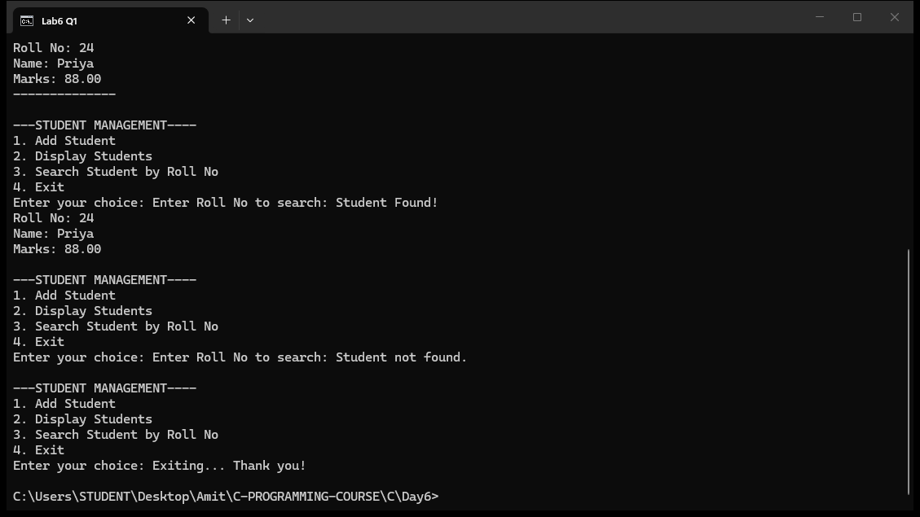

MCQ Questions: Answers
Q | Answer
1 | B) struct student{...};
2 | A) struct student s1;
3 | C) The dot operator (.)
4 | D) struct student s[100];
5 | A) To access members through a pointer
6 | C) s[i].roll
7 | B) struct student s1 = {23, "Amit", 92};
8 | A) 5
9 | D) All of these
10 | C) s.roll and p->roll
Explain
1. What is a structure in C? Why do we need it? Explain with the struct student example.
A structure is a user-defined data type that groups related data items of different types together under one name. In the Student Management System, struct student combines roll (int), name (char array) and marks (float) into one logical unit. Without a structure we would need three separate parallel arrays (int roll[100], char name[100][50], float marks[100]) which are hard to manage. A structure keeps all data of one student together, so the program is easier to read, pass around and search.
2. How do you declare a structure and a structure variable? Show the syntax.
A structure is declared with the struct keyword followed by the tag name and the members inside braces, e.g. struct student{ int roll; char name[50]; float marks; };. Then a variable is declared as struct student s1; and an array of 100 students as struct student s[100];. The declaration only creates the template; the variable declaration actually reserves memory for the members.
3. How do you access the members of a structure? Give examples from this program.
Members are accessed using the dot operator (.) with a variable and the arrow operator (->) with a pointer. In this program s[i].roll, s[i].name and s[i].marks are used inside the for loops to add and display students. The dot operator selects the member of the current element of the array. For example s[i].roll == roll compares the stored roll number with the one typed by the user during search.
4. Why do we use an array of structures in this program instead of a single structure?
A single structure variable can hold only one student, but the system must manage up to MAX (100) students. An array of structures struct student s[MAX] stores many students in memory so the program can add, display and search records in a loop using the index i. The variable n keeps track of how many students are currently stored, which is needed because the array is only partially filled.
5. What happens when the program searches for a roll number that does not exist? Explain the loop logic.
The search loop compares each s[i].roll with the typed roll number. If a match is found, the student details are printed and break stops the loop. If no match exists, the loop runs to the end and i becomes equal to n. The check if(i == n) after the loop is true only when the loop finished without finding a match, so it prints 'Student not found.'. This is a standard sentinel check used with a search loop.

