Amit_Lab7 - Day 7 Assignment
C Programming - Pointers
Question 1: Declare an integer, store its address in a pointer, and print the variable's value three ways - directly, via dereferencing the pointer, and via &variable.
#include <stdio.h>

int main() {
int num = 42;
int *ptr;

ptr = &num;

printf("Value directly: %d\n", num);
printf("Value via pointer dereferencing: %d\n", *ptr);
printf("Address of num (&variable): %p\n", &num);

return 0;
}
Output:
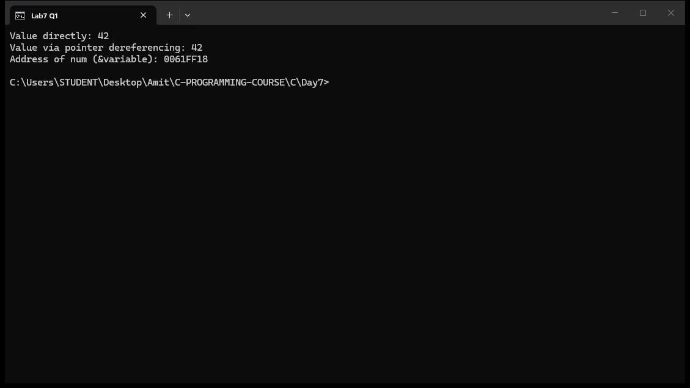

Question 2: Take two integers as input, and using only pointers swap their values. (Write a function swap(int *a, int *b)).
#include <stdio.h>

void swap(int *a, int *b);

int main() {
int x, y;

printf("Enter two integers: ");
scanf("%d %d", &x, &y);

printf("Before swap: x = %d, y = %d\n", x, y);

swap(&x, &y);

printf("After swap: x = %d, y = %d\n", x, y);

return 0;
}

void swap(int *a, int *b) {
int temp;

temp = *a;
*a = *b;
*b = temp;
}
Output:
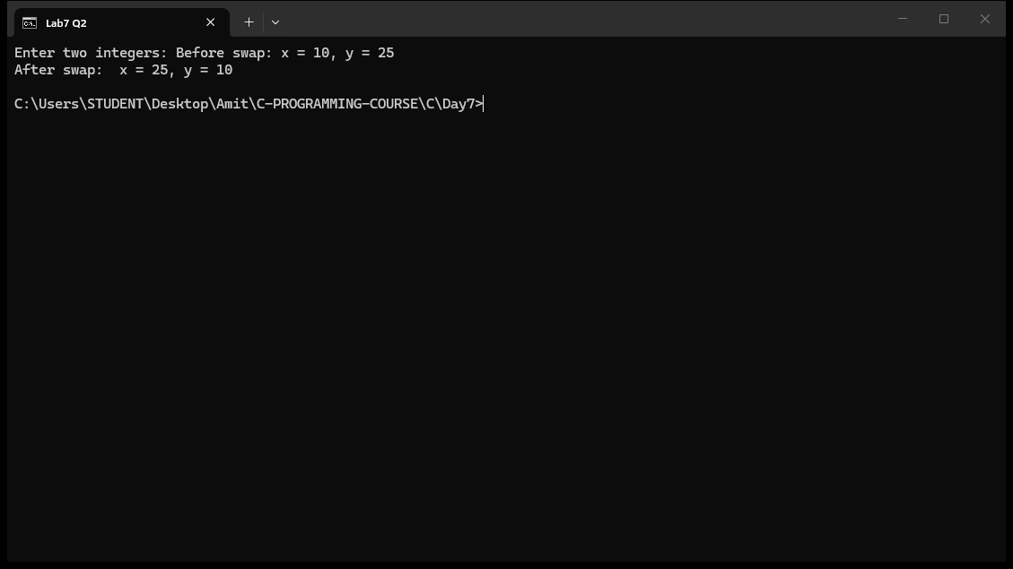

Question 3: Given an array of 10 integers, use a pointer (not indexing) to print every element.
#include <stdio.h>

int main() {
int arr[10] = {10, 20, 30, 40, 50, 60, 70, 80, 90, 100};
int *ptr;
int i;

ptr = arr;

printf("Array elements using pointer:\n");
for (i = 0; i < 10; i++) {
printf("%d ", *ptr);
ptr++;
}
printf("\n");

return 0;
}
Output:
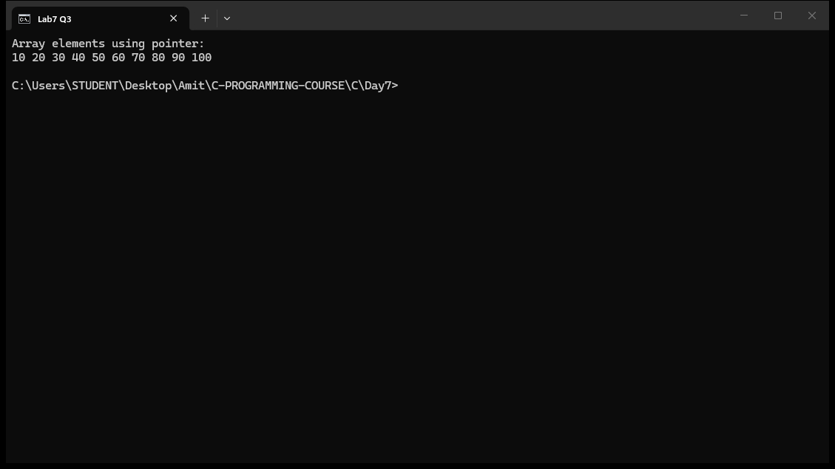

Question 4: Use a pointer to find the sum and average of all elements in an integer array.
#include <stdio.h>

int main() {
int arr[5] = {10, 20, 30, 40, 50};
int *ptr;
int i;
int sum = 0;
float average;

ptr = arr;

for (i = 0; i < 5; i++) {
sum = sum + *ptr;
ptr++;
}

average = (float)sum / 5;

printf("Array elements: ");
ptr = arr;
for (i = 0; i < 5; i++) {
printf("%d ", *ptr);
ptr++;
}

printf("\nSum = %d\n", sum);
printf("Average = %.2f\n", average);

return 0;
}
Output:
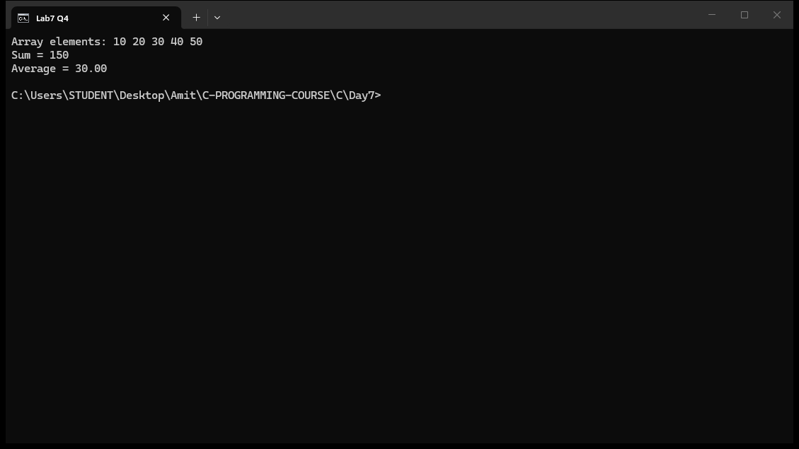

Question 5: Use a pointer to find the maximum and minimum value in an array, without using arr[i] anywhere.
#include <stdio.h>

int main() {
int arr[6] = {45, 12, 78, 34, 99, 8};
int *ptr;
int i;
int max, min;

ptr = arr;

max = *ptr;
min = *ptr;

for (i = 0; i < 6; i++) {
if (*ptr > max) {
max = *ptr;
}
if (*ptr < min) {
min = *ptr;
}
ptr++;
}

printf("Array elements: ");
ptr = arr;
for (i = 0; i < 6; i++) {
printf("%d ", *ptr);
ptr++;
}

printf("\nMaximum value = %d\n", max);
printf("Minimum value = %d\n", min);

return 0;
}
Output:
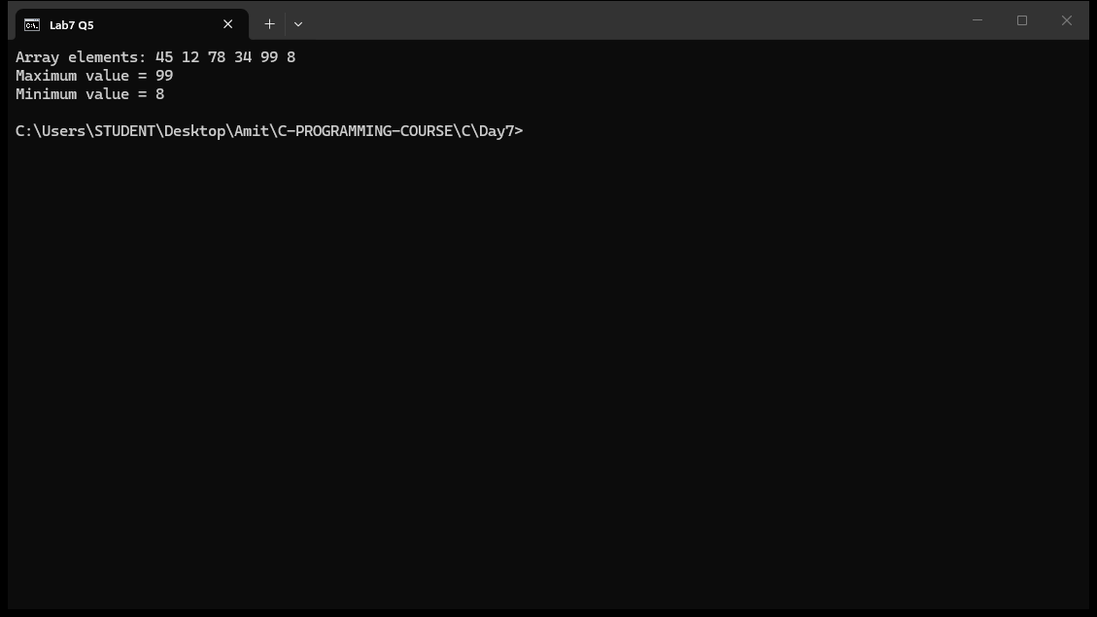

Question 6: Given a pointer p pointing to arr[0] of an int array, predict the address p + 3 will hold, then verify with printf("%p", ...).
#include <stdio.h>

int main() {
int arr[5] = {10, 20, 30, 40, 50};
int *p;

p = &arr[0];

printf("Address of arr[0] (p) = %p\n", (void*)p);
printf("Address of arr[1] (p+1) = %p\n", (void*)(p + 1));
printf("Address of arr[2] (p+2) = %p\n", (void*)(p + 2));
printf("Predicted address of p+3 (arr[3]) = %p\n", (void*)(p + 3));
printf("Verified address of arr[3] using &arr[3] = %p\n", (void*)&arr[3]);

return 0;
}
Output:
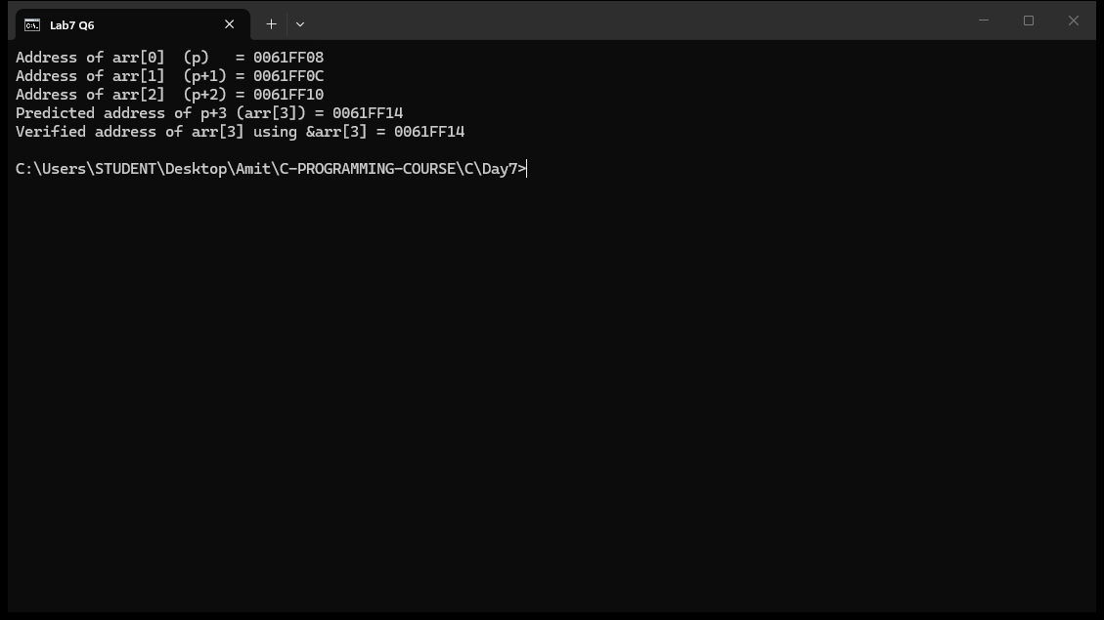

Question 7: Reverse an array in place using two pointers - one starting at the first element, one at the last, swapping and moving inward until they meet.
#include <stdio.h>

int main() {
int arr[7] = {1, 2, 3, 4, 5, 6, 7};
int *left, *right;
int temp;
int i;

printf("Original array: ");
for (i = 0; i < 7; i++) {
printf("%d ", arr[i]);
}
printf("\n");

left = arr;
right = arr + 6;

while (left < right) {
temp = *left;
*left = *right;
*right = temp;
left++;
right--;
}

printf("Reversed array: ");
for (i = 0; i < 7; i++) {
printf("%d ", arr[i]);
}
printf("\n");

return 0;
}
Output:
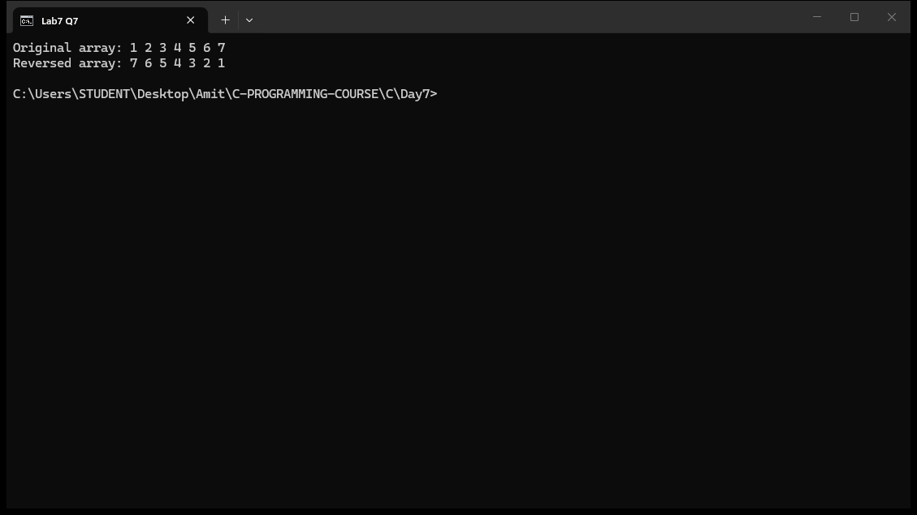

Question 8: Write a program using pointer arithmetic to count how many elements in an array are divisible by 5.
#include <stdio.h>

int main() {
int arr[10] = {5, 12, 15, 20, 23, 25, 30, 35, 42, 50};
int *ptr;
int count = 0;
int i;

ptr = arr;

for (i = 0; i < 10; i++) {
if (*ptr % 5 == 0) {
count++;
}
ptr++;
}

printf("Array elements: ");
ptr = arr;
for (i = 0; i < 10; i++) {
printf("%d ", *ptr);
ptr++;
}

printf("\nElements divisible by 5: %d\n", count);

return 0;
}
Output:
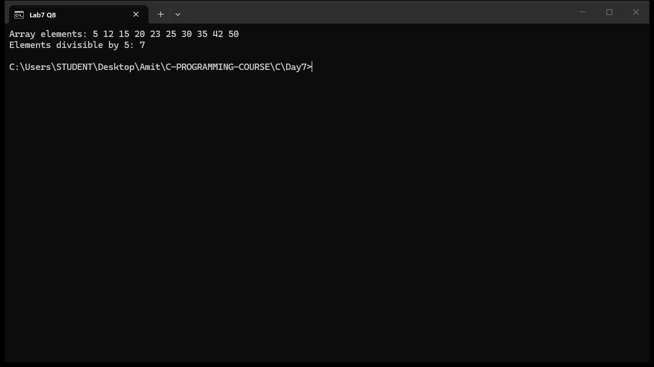

Explain
1. What is a pointer and what does the address-of operator (&) do?
A pointer is a variable that stores the memory address of another variable instead of a value. The address-of operator (&) gives the memory address of a variable, for example &num returns the address where num is stored. In Question 1 the pointer ptr is initialized as ptr = &num; and then *ptr reads the value stored at that address. The value 42 is printed directly, through dereferencing, and from the address in the pointer.
2. How do you declare a pointer and access the value it points to (dereferencing)?
A pointer is declared by putting a * before its name, using the type of the data it points to, for example int *ptr;. The value at the address is accessed with the dereference operator *ptr. In Question 1, *ptr gives 42 which is the same value as num. The * in the declaration means "pointer to", while * in an expression means "value at the address", which confuses many beginners.
3. Why does the swap function need pointer parameters? Why does call by value fail?
In C, function parameters receive a copy of the argument (call by value). If swap took int a and int b, it would swap only the copies and the original x and y in main() would stay unchanged. Passing &x and &y gives swap the actual addresses, and *a and *b access the original variables, so the swap works in main(). This is the standard reason pointers are used to modify caller variables from inside a function.
4. What is pointer arithmetic? How much is p + 3 added in Question 6?
Pointer arithmetic works in units of the pointed-to type, not bytes. For an int array, p + 1 points to the next int element. Since an int is 4 bytes on this system, p + 3 advances the address by 3 * 4 = 12 bytes. The program predicts the address of arr[3] as p + 3 and verifies it with &arr[3], and both print the same address (0061FF14 in the sample run).
5. Explain how the two-pointer reverse loop in Question 7 works.
Two pointers are used: left starts at arr[0] and right starts at arr[6] (the last element). The loop runs while left < right. Each iteration swaps *left and *right, then moves left forward with left++ and right backward with right--. When the two pointers meet in the middle, the whole array is reversed in place without using any extra array. The original 1 2 3 4 5 6 7 becomes 7 6 5 4 3 2 1.

