Study of Transition metal alloy based Thin Films on Flexible Substrate

A report submitted in partial fulfillment of the requirements for the award of the degree of

Master of Science
In
Electronics

Submitted by
Amit Kumar (23251749001)
Under the supervision of Prof. Manoj Kumar (Professor)

Department of Electronic Science University of Delhi, South Campus
Benito Juarez Road, New Delhi-110021, India 2025

CANDIDATE’S DECLARATION
I, Amit Kumar, Roll No: 23251749001, hereby certify that the work presented in the project report entitled Study of Transition metal alloy based Thin Films on Flexible Substrate, in partial fulfillment of the requirements for the award of the Degree of Master of Electronic Science and submitted to the institution, is an authentic record of my own work carried out during the period January 2025 to May 2025 under the supervision of Prof. Manoj Kumar Khanna (Professor).
The content presented in this report has not been submitted elsewhere for the award of any other degree or diploma from any institution.

Date: Signature of the Candidate

DEPARTMENT OF ELECTRONIC SCIENCE

UNIVERSITY OF DELHI SOUTH CAMPUS

Benito Juarez Road, New Delhi-110021, India

CERTIFICATE
I hereby certify that the Project Dissertation titled " Study of Transition metal alloy based Thin Films on Flexible Substrate" which is submitted by Amit Kumar, Roll No. 23251749001 (Dept. of Electronic Science), University of Delhi, South Campus in partial fulfillment of the requirement for the award of the degree of Master of Science in Electronic Science, is a record of the project work carried out by the students during the period Jan 2025 to May 2025 under my supervision. To the best of my knowledge, this work has not been submitted in part or full for any Degree or Diploma to this University or elsewhere.

Prof. Manoj Kumar Khanna
Professor
Department of Electronic Science
UDSC, New Delhi - 110021
Dr. Amit Birwal
(Project Coordinator) Assistant Professor
Department of Electronic Science UDSC, New Delhi - 110021

Prof. Harshupreet Kaur
(Head of the Department)
Department of Electronic Science
UDSC, New Delhi - 110021

ACKNOWLEDGEMENT
I would like to express my sincere gratitude to Prof. Manoj Kumar Khanna, Professor, Department of Electronic Sciences, University of Delhi, South Campus, for his invaluable guidance, encouragement, and for granting me the independence to explore and experiment with my ideas throughout this research.
It is with heartfelt appreciation that I acknowledge Prof. Bijoy Kumar Kuanr, Professor at the Special Centre for Nanoscience, Jawaharlal Nehru University, New Delhi, for generously providing access to laboratory facilities and for his expert guidance during the course of my dissertation. His mentorship, inspiration, and kind blessings were crucial to the successful completion of this work.
I am also deeply thankful to Prof. Harsupreet Kaur, Head of the Department, and to all the esteemed faculty members of the Department of Electronic Science, University of Delhi, South Campus, for their continuous support, insightful suggestions, and academic encouragement.
I am sincerely grateful to project coordinator, Dr. Amit Birwal (Assistant Professor) for providing access to the resource and coordinating helpfully.
I extend my sincere thanks to Dr. Prashant Kumar for his motivation and unwavering encouragement during my research journey.
I am deeply grateful to my parents for their unconditional support, understanding, and love. Their belief in me has been a continuous source of strength and motivation.
Lastly, I wish to thank all my friends and colleagues for their constant encouragement and for uplifting my spirit at every step of this endeavor.

Amit Kumar

CONTENTS
CANDIDATE’S DECLARATION ............................................................... i
CERTIFICATE .................................................................................. ii
ACKNOWLEDGEMENT ..................................................................... iii
CONTENTS .................................................................................... iv
LIST OF FIGURES ........................................................................ v
FREQUENTLY USED ABBREVIATIONS ....................................... vi
ABSTRACT ...................................................................................... vii

CHAPTER 1: INTRODUCTION .......................................................... 1
1.1 Spintronics .................................................................................................. 1
1.1.1 History of Spintronics ................................................................ 2
1.2 Magnetism ................................................................................................. 2
1.2.1 Types of Magnetism ................................................................. 2
1.3 Transition Metals ...................................................................................... 4
1.3.1 Different FeCo Compositions .................................................. 5
1.4 Flexible Substrate ..................................................................................... 5
1.4.1 Different Flexible Substrates .................................................. 6
1.4.2 Copper Tape ............................................................................. 6
1.5 Structure of the Dissertation .................................................................... 9
Chapter 1: Introduction ............................................................... 9
Chapter 2: Thin Film Fabrication Techniques ........................... 9
Chapter 3: Characterizations ....................................................... 9
Chapter 4: Results and Discussion ............................................. 9
Chapter 5: Conclusion and Future Scope ................................... 10

CHAPTER 2: THIN FILM FABRICATION TECHNIQUES ........... 11
2.1 Introduction ............................................................................................... 11
2.2 Different Thin Film Fabrication Methods .......................................... 11
2.2.1 Chemical Vapor Deposition (CVD) ....................................... 12
2.2.2 Physical Vapor Deposition (PVD) ......................................... 13
2.3 Types of PVD Processes ...................................................................... 14
2.3.1 Thermal Evaporation .............................................................. 14
2.3.2 Electron Beam Evaporation .................................................. 15
2.3.3 Pulsed Laser Deposition (PLD) ............................................ 17
2.3.4 Sputtering Process ................................................................. 18
2.4 Fabrication Process of Thin Films ..................................................... 21
2.4.1 Substrate Preparation ............................................................. 21
2.4.2 Target Preparation .................................................................. 21
2.4.3 Deposition via Sputtering ..................................................... 21

CHAPTER 3: CHARACTERIZATIONS .......................................... 23
3.1 Thin Film Characterizations ................................................................. 23
3.2 X-Ray Diffraction (XRD) ....................................................................... 24
3.2.1 Principle of Operation ............................................................ 24
3.2.2 XRD Setup Components ...................................................... 25
3.3 Ferromagnetic Resonance (FMR) ....................................................... 26
3.3.1 Working Principle ................................................................. 27
3.3.2 Experimental Setup ............................................................... 27
3.3.3 Applications of FMR ............................................................ 28
3.4 Vibrating Sample Magnetometry (VSM) ............................................ 28
3.4.1 Working Principle ................................................................. 29
3.4.2 Applications ............................................................................ 30
3.5 Atomic Force Microscopy (AFM) ....................................................... 30
3.5.1 Working Principle ................................................................. 30
3.5.2 AFM Imaging Modes ........................................................... 31
3.5.3 Applications ............................................................................ 31
3.6 Field Emission Scanning Electron Microscopy (FESEM) ............... 32
3.6.1 Working Principle ................................................................. 32
3.6.2 Signal Detection and Imaging ............................................. 33
3.6.3 Advantages ............................................................................. 33
3.6.4 Applications ............................................................................ 34
3.7 Energy Dispersive X-Ray Spectroscopy (EDS) ................................ 34
3.7.1 Working Principle ................................................................. 34
3.7.2 Advantages ............................................................................. 35
3.7.3 Applications ............................................................................ 35

CHAPTER 4: RESULTS AND DISCUSSION ................................. 37
4.1 X-Ray Diffraction (XRD) Analysis ..................................................... 37
4.2 Ferromagnetic Resonance (FMR) Analysis ..................................... 39
4.2.1 Resonance Field and Kittel Analysis .................................... 39
4.2.2 Damping Constant and Linewidth Analysis .......................... 40
4.3 Vibrating Sample Magnetometry (VSM) Analysis ............................ 42

CHAPTER 5: CONCLUSION AND FUTURE WORK ..................... 44
5.1 Conclusion ................................................................................................. 44
5.2 Future Work .............................................................................................. 44

REFERENCES ............................................................................... 46

LIST OF FIGURES
Figure 1: Schematic Representation of Types of Magnetism 13
Figure 2: Schematic of Copper tape 17
Figure 3: Schematic representation of PVD and CVD techniques 22
Figure 4: a) Thermal Evaporation Unit 25
Figure 5: Schematic representation of Electron Beam Evaporation 26
Figure 6: a) PLD Unit at JNU Nanoscience Lab 27
Figure 7: Sputtering and E-beam Evaporation Unit at JNU Nanoscience lab 29
Figure 8: Schematic representation of DC Sputtering 30
Figure 9: Schematic representation of RF Sputtering 30
Figure 10: Schematic representation of Diffraction of X-Rays 35
Figure 11: Schematic representation of XRD Setup 35
Figure 12: Schematic representation of FMR setup 36
Figure 13: VSM working (Source: Uod North Campus, USIC) 38
Figure 14: Schematic representation of VSM 39
Figure 15: Schematic representation of AFM 41
Figure 16: Schematic representation of FESEM 43
Figure 17: Schematic representation of EDS 45
Figure 18: XRD plot for diffraction patterns of a) 6nm b) 15nm 48
Figure 19: FMR plots of sputtering deposited Fe₈₀Co₂₀ at 15nm 51
Figure 20: a) Hr vs Frequency plot of Fe₈₀Co₂₀ thin film on copper tape 51
Figure 21: VSM plots a) Shows the M-H Hysteresis loop b)Coercivity 53

FREQUENTLY USED ABBREVIATIONS

Fe: Iron
Co: Cobalt
PLD: Pulsed Laser Deposition
PVD: Physical Vapor Deposition
E-beam: Electron Beam
RF: Radio Frequency
DC: Direct Current
CVD: Chemical Vapor Deposition
XRD: X-Ray Diffraction
SEM: Scanning Electron Microscopy
TEM: Transmission Electron Microscopy
AFM: Atomic Force Microscopy
EDS: Energy Dispersive X-Ray Spectroscopy
VSM: Vibrating Sample Magnetometry
FMR: Ferromagnetic Resonance
CPW: Coplanar Waveguide
FESEM: Field Emission Scanning Electron Microscopy

ABSTRACT
This dissertation presents the fabrication and thorough characterization of cobalt-iron (FeCo) thin films deposited on flexible substrates, mainly copper tape, via the sputtering technique. We used copper tape with a flexible substrate to fabricate the Fe₈₀Co₂₀ composition. With the ability to alter surface and magnetic properties without sacrificing the mechanical flexibility of the underlying substrate, thin film technology is essential to the development of flexible electronics and spintronic devices. Since sputtering allows for precise control over thickness, composition, and microstructure, as well as the production of uniform, high-quality thin films with exceptional adhesion to flexible substrates, it was selected as the deposition technique. To evaluate the structural, morphological, compositional, and magnetic properties of the generated Fe₈₀Co₂₀ thin films, a number of characterization techniques were used. X-ray diffraction (XRD) was used for structural analysis, which showed that the films were crystalline and gave information about phase purity, lattice spacing, and grain size. Vibrating sample magnetometry (VSM) and ferromagnetic resonance (FMR) were used to study magnetic properties, which are necessary for spintronic applications. While FMR analysis provided information about resonance fields, linewidths, effective magnetization, and damping constants, VSM measurements provided detailed information about the films' Coercivity, saturation magnetization, and magnetic anisotropy. The Gilbert damping constant, which is important in understanding magnetization dynamics in spintronic devices, has been obtained from the frequency dependence of linewidths. According to the findings, copper tape is a very good flexible substrate because it combines excellent mechanical flexibility with superior thermal conductivity. This makes it possible for the stable deposition of Fe₈₀Co₂₀ thin films with desired electrical and magnetic properties. Because of their strong crystallinity, uniform elemental distribution, smooth surface morphology, and desirable magnetic behavior, the Fe₈₀Co₂₀ films are ideal for use in flexible spintronic devices. The potential of Fe₈₀Co₂₀ thin films on flexible metallic substrates for future applications in wearable technology, magnetic sensors, and non-volatile memory devices is demonstrated by these findings, which also add to the growing field of flexible electronics. The study sets the foundation to future Fe₈₀Co₂₀ thin film optimization for use in the flexible and spintronic devices.

CHAPTER 1: INTRODUCTION

This chapter introduces and tell us about some basic concepts that are discussed in next chapters like spintronics, magnetism, transition metal alloys and flexible substrates. This chapter also gives the information about the structure of dissertation.

1.1 Spintronics
Spintronics, which stands for "spin electronics," is a rapidly evolving field that combines physics of matter, materials science, and nanotechnology. Traditional electronics only use the charge of electrons to store and process data. On the other hand, spintronics uses an extra quantum property of electrons which is built in, called "spin." Electron spin can be in one of two basic positions, which are usually called "spin-up" and "spin-down." These positions can be used to store binary information, just like 0s and 1s in regular electronic devices. Spintronic technologies promise to be better than traditional electronics in a number of ways by using both the electron's charge and spin. These include faster data processing speeds, less power use, and a big increase in the amount of data that can be stored in a small space. One of the most interesting things about spintronic devices is that they are inherently non-volatile. This means that information stored through electron spin stays safe even when the power is turned off. This feature makes spintronics very appealing for developing new types of memory, like Magnetic Random Access Memory (MRAM), which is fast, uses relatively little energy, and doesn't lose data when the power goes out. Spintronics opens up new possibilities in fields that are still developing, like quantum computing, where electron spins can act as quantum bits (qubits), and neuromorphic computing, which tries to mimic the brain's neural architecture to process information faster. Adding spintronic principles to flexible and nanoscale devices opens up even more possibilities for new uses in wearable electronics, sensors, and other areas. For this project, investigating into FeCo thin films on flexible substrates fits completely with the goals of spintronics research. Cobalt-iron alloys have great magnetic properties, such as high saturation magnetization and low magnetic damping. These are important for shifting and manipulating spins efficiently. This work aims to create mechanically flexible spintronic parts that can be used in the next generation of flexible and wearable electronics by putting these films on flexible copper tape. By acquiring more about and improving how these films act magnetically on flexible substrates, we can make advancement on flexible spintronic devices that can be used in real-world situations where rigidity is a problem.

1.1.1 History of Spintronics
A 1988 discovery marked the beginning of the development of spintronics as a field of study. The phenomenon of Giant Magnetoresistance (GMR) was independently discovered in this year by Peter Grünberg in Germany and Albert Fert in France. This amazing phenomenon, which was seen in carefully layered magnetic structures, showed a significant change in electrical resistance depending on the relative orientation of magnetization in the layers. The development of extremely sensitive read heads made possible by the discovery of GMR revolutionized hard disk technology and resulted in an exponential rise in data storage densities. In 2007, Fert and Grünberg were duly awarded the Nobel Prize in Physics for their introducing work, which sparked a wave of innovation in the field of spintronics. Tunnel Magnetoresistance (TMR), Spin-Transfer Torque (STT), and other intriguing spin-based effects like the spin Hall Effect and Rashba effect are examples of later innovations. The functional capabilities of spintronic systems have been gradually expanded by each of these developments. These days, spintronics is a key component of both basic quantum science and applied electronics research.

1.2 Magnetism
The behavior of electrons at the quantum level—more especially, their orbital motion around the nucleus and spin angular momentum—is the source of magnetism. Every single unpaired electron functions as a tiny magnetic dipole. Quantum mechanical forces in some materials can cause many of these dipoles to align collectively, creating macroscopic magnetism that can be seen. The exchange interaction is the main mechanism responsible for this alignment. Depending on the atomic structure of the material, this quantum phenomenon favors either parallel or antiparallel spin alignment. Non-magnetic materials are typically those with fully filled electron shells, in which every spin is paired. However, because of these cooperative interactions, materials with unpaired electrons, especially those found in transition metals, frequently exhibit strong magnetic properties [4].

1.2.1 Types of Magnetism
The magnetic behavior observed in materials originates from the orientation and interactions of electron spins. These interactions give rise to various forms of magnetism, each possessing distinct physical characteristics and potential applications in technology.
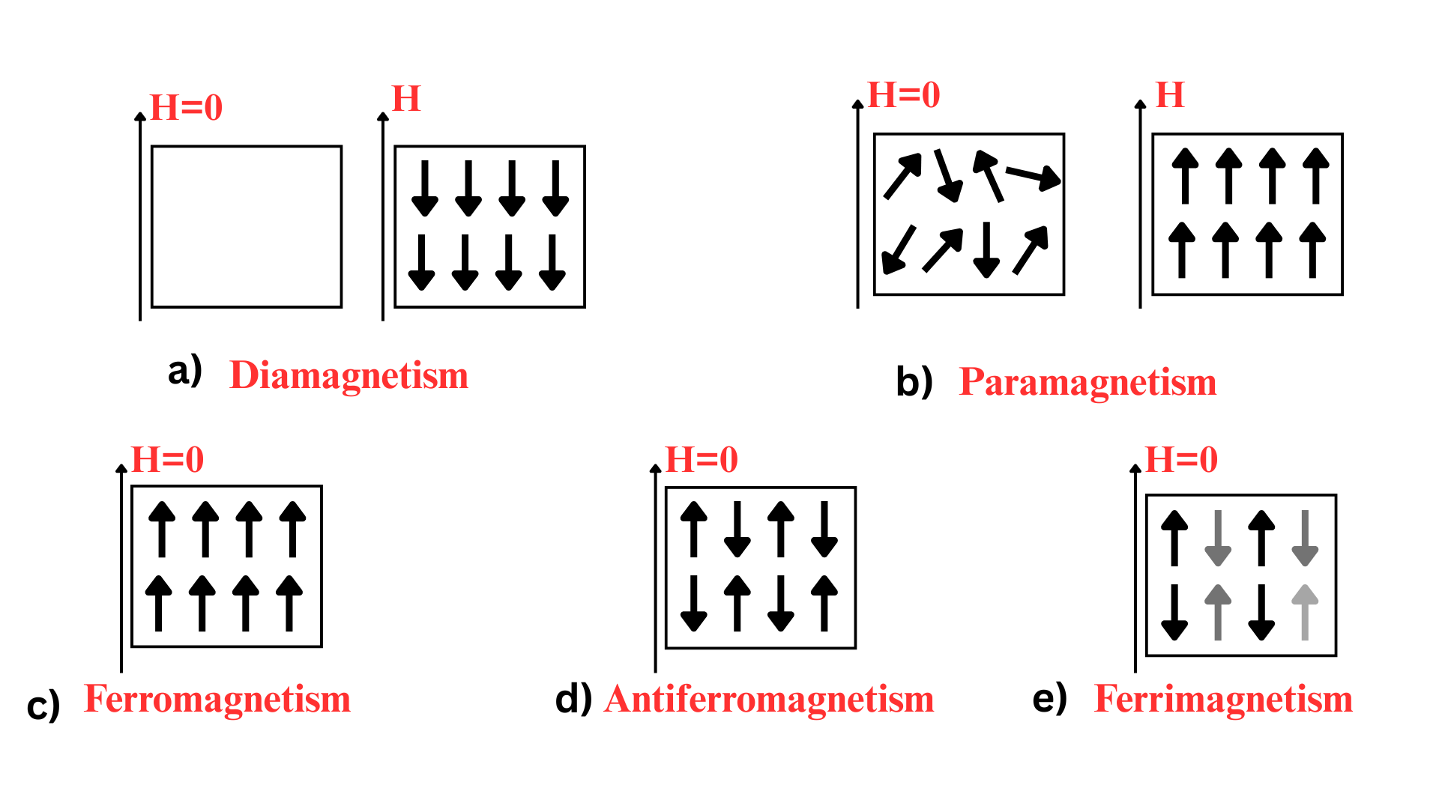
Figure 1: Schematic Representation of Types of Magnetism
- Diamagnetism represents a universal and extremely weak form of magnetism found in all materials. In diamagnetic substances, the electrons are paired, and when subjected to an external magnetic field, they experience a slight repulsion caused by alterations in their orbital motion. This effect is generally negligible and disappears once the external field is removed. Figure 1(a) illustrates the alignment of magnetic poles in a diamagnetic material.
- Paramagnetism occurs in materials that contain unpaired electrons. Such materials exhibit a weak attraction towards external magnetic fields. However, unlike ferromagnetic materials, paramagnetic substances do not retain their magnetization when the external field is removed, as their magnetic moments remain randomly oriented in its absence. Figure 1(b) depicts the arrangement of magnetic poles in a paramagnetic material.
- Ferromagnetism, known for its strength and significance in technological applications such as spintronics, arises in materials like iron, cobalt, and nickel. Here, the electron spins spontaneously align in the same direction due to exchange interactions, resulting in a persistent internal magnetic field. This behavior forms the basis of permanent magnets. Figure 1(c) demonstrates the magnetic pole alignment in a ferromagnetic material.
- Antiferromagnetism, on the other hand, occurs when adjacent atomic magnetic moments align in opposite directions, effectively canceling each other out. As a result, antiferromagnetic materials exhibit no net magnetization under typical conditions. Despite this, they are gaining increasing interest in spintronics for their potential to achieve ultrafast switching and enhanced stability against external magnetic disturbances. Figure 1(d) shows the magnetic pole arrangement in an antiferromagnetic material.
- Ferrimagnetism is similar to antiferromagnetism in that opposing magnetic moments are present; however, these moments differ in magnitude, resulting in a non-zero net magnetization. Magnetite (Fe₃O₄) is an example of a material exhibiting this type of magnetism, which is especially valuable in specific magnetic applications. Figure 1(e) illustrates the alignment of magnetic poles in a ferrimagnetic material.
Understanding these types of magnetism is essential in selecting and engineering materials for various spintronic devices, as the spin behavior of electrons in a material directly influences its suitability for different functions in memory and logic systems.

1.3 Transition Metals
The presence of partially filled d-orbitals gives transition metals, which are found in the d-block of the periodic table, a distinct set of physical and chemical properties. Numerous oxidation states, high electrical conductivity, and noteworthy magnetic behavior are just a few of the amazing qualities that this electronic structure imparts. The ferromagnetic nature of elements like iron (Fe), cobalt (Co), and nickel (Ni) makes them stand out among this group and makes them essential for the advancement and improvement of spintronic technologies. Because of their potent interaction with electron spins, these metals are particularly prized in applications involving magnetic data storage, spin-based logic devices, and sensors. They are essential parts of contemporary electronic and spintronic systems due to their behavior in magnetic fields and compatibility with nanoscale material processing techniques. In spintronics, transition metals are selected for a number of important reasons. Strong magnetic behavior and effective spin polarization are made possible by their unpaired d-electrons, which are important for devices based on GMR and TMR. Reliable thin film growth and operation under a number of conditions are made possible by these elements' high mechanical and thermal stability. Furthermore, their superior conductivity facilitates effective charge transport, and their surface chemistry makes them ideal for thin-film deposition and nanofabrication procedures.

1.3.1 Different FeCo Compositions
Cobalt-iron (FeCo) alloys are extensively researched due to their low Coercivity, high saturation magnetization, and soft magnetic characteristics, particularly for stoichiometries like Fe₈₀Co₂₀. Because of these characteristics, they are great choices for spintronic applications like magnetostrictive devices, MRAM, and sensors. In addition to Fe₈₀Co₂₀, other important compositions are Co₅₀Fe₅₀, which provides a balanced magnetization and is often used in spin-valve structures, and Co₂₅Fe₈₀, another Fe-rich composition of FeCo. Co₆₈Fe₃₂ is a Co-rich FeCo composition. By adjusting the Co:Fe ratio, which influences factors like Coercivity, magnetostriction, and Gilbert damping, the magnetic behavior of FeCo alloys can be precisely adjusted. Fe-rich compositions usually offer higher saturation magnetization, whereas Co-rich compositions tend to show stronger magnetocrystalline anisotropy [7][9].

1.4 Flexible Substrate
In electronic components, particularly modern printed circuit boards (PCBs), a flexible substrate serves as a lightweight, thermally stable base material which is usually made up of polymers like polyimide or polyethylene terephthalate (PET)^{[3][11]}. Its unique mechanical flexibility allows it to be used in small and asymmetrical electronic systems without affecting the functionality of the device. This ability to adapt has become important to the development of modern electronics, such as implantable biomedical devices, bendable screens, and wearable technology. A fundamental change in the design and fabrication of devices has resulted from an increasing demand for flexible and adaptive electronics. Flexible substrates provide a mechanical flexibility that allows devices to bend, twist, or conform to non-planar surfaces, compared with traditional rigid platforms like silicon wafers or glass. They are essential to the push for common and embedded computing because of their flexibility, which makes it easier to integrate them into a variety of environments, including textiles, human skin, and portable electronics. Because of their numerous structural, functional, and processing benefits, flexible substrates are becoming more and more popular. Because they are lightweight, they are perfect for applications like wearable technology and aerospace systems where mass is a constraint. These substrates also have outstanding mechanical endurance, meaning they can withstand repeated deformations like bending and stretching without breaking. Since many of them can be processed at lower temperatures, delicate functional materials like soft magnetic thin films or organic semiconductors can be integrated. From a manufacturing perspective, roll-to-roll (R2R) fabrication techniques, which allow for continuous, scalable, and economical production of large-area electronics, are compatible with flexible substrates. This is especially helpful when making flexible solar cells, sensors, and displays. These substrates have a special benefit in the field of magnetics: they permit controlled mechanical strain, which can be used to customize magnetic characteristics like anisotropy, magnetostriction, and magnetoresistance. An extra tool for adjusting device performance is provided by this strain-induced tunability [5][3].

1.4.1 Different Flexible Substrates
A variety of materials, chosen for their mechanical, chemical, and thermal properties, are frequently employed as flexible substrates:
- Polyimide (Kapton): A high-performance polymer renowned for its superior chemical stability and heat resistance. Because of its resilience to operational and fabrication stresses, it is the most widely used substrate in flexible electronics and spintronics.
- Polyethylene Terephthalate (PET): An inexpensive, optically transparent polymer that works well in applications requiring a moderate amount of flexibility. It is still appropriate for devices made at comparatively low thermal budgets even though it can withstand lower processing temperatures than polyimide.
- When high thermal conductivity and dimensional stability are needed, metal foils—such as those made of titanium or stainless steel—are utilized. Additionally, their inherent robustness and magnetic shielding are provided by their metallic nature.
- Polyethylene Naphthalate (PEN): Suitable for high-frequency and optoelectronic applications, PEN has better moisture and heat barrier qualities than PET.

1.4.2 Copper Tape
A very flexible and adaptable substrate for electronic and magnetic thin-film applications is copper tape. Usually made up of a thin layer of copper foil with a pressure-sensitive adhesive on the back, it offers exceptional mechanical flexibility along with electrical and thermal conductivity. Its dual function as an integrated electrode and substrate streamlines device architecture and improves overall performance. Applications for copper tape are numerous and include everything from the creation of spintronic devices to shielding against electromagnetic interference (EMI) and circuit prototyping.
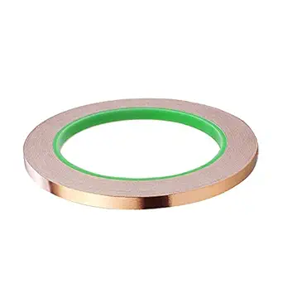
Figure 2: Schematic of Copper tape
Copper tape helps with both electrical and thermal transport in spintronic systems by acting as a conductive channel in addition to offering the thin film physical support. This multipurpose function is especially important in small devices where performance cannot be sacrificed due to space constraints. Copper tape is the perfect material for creating effective, flexible electronic systems because it combines conductive and flexible properties.

1.4.2.1 Functional Advantages of Copper Tape
Copper tape exhibits a combination of properties that make it highly advantageous for next-generation thin-film electronics and magnetics:
- Superior Electrical Conductivity: Copper's high bulk conductivity of roughly 5.8 × 10⁷ S/m makes it possible for spin-polarized currents to be transported efficiently in spintronic devices.
- High thermal conductivity: Copper efficiently dissipates heat produced during device operation or thin-film deposition, improving system stability. Its thermal conductivity is approximately 400 W/m·K.
- Mechanical Flexibility: Thin copper foils are appropriate for wearable and foldable electronics because they retain their structural integrity when bent and folded.
- Smooth Deposition Surface: Its polished and homogeneous surface enables the steady development of superior thin films, which are necessary for applications such as spin valves and magnetic tunnel junctions.
- Vacuum Compatibility: Copper remains stable in high-vacuum settings, and many commercial varieties come with protective coatings that stop oxidation and enhance film adhesion and reproducibility.
- Affordability and Accessibility: Copper tape is perfect for scholarly research, prototyping, and scalable production settings due to its low cost and commercial availability.

1.4.2.2 Role in Spintronic Device Fabrication
Copper tape has two uses in the field of spintronics: it acts as an active conductive layer and provides physical support for thin-film structures. By lowering the number of necessary layers and interconnects, this dual capability expedites the fabrication process and enhances device performance. Large-scale production of flexible magnetic devices is supported by its versatility, which also makes it compatible with roll-to-roll and sheet-based fabrication techniques.
In spintronics, strain engineering is a particularly useful use for copper tape. Researchers can control spin transport and magnetic anisotropy in thin films by mechanically bending or deforming the substrate. This method makes it easier to develop devices with adjustable magnetic properties and allows for a deeper understanding of how materials behave under stress.

1.5 Structure of the Dissertation
Each of the five major chapters that make up this dissertation's systematic organization helps readers comprehend how FeCo thin films are made and characterized after being deposited on flexible substrates. From theoretical ideas to experimental implementation, analysis, and conclusions, the structure is made to flow logically. Every chapter builds on the one before it, providing a concise and well-organized account of the research.

Chapter 1: Introduction
The basic ideas of magnetism, including the different kinds and sources of magnetic behavior, are covered in this chapter along with an outline of the new field of spintronics. It presents transition metals, emphasizing their value in magnetic and spintronic applications with an emphasis on FeCo alloys. The chapter also examines the increasing significance of flexible substrates in contemporary electronic devices and argues for the use of copper tape as a versatile and efficient thin film deposition substrate.

Chapter 2: Thin Film Fabrication Techniques
With a focus on sputtering as the selected physical vapor deposition (PVD) technique, this chapter describes the thin film deposition techniques used in this work. The discussion covers the fundamentals of sputtering as well as the rationale behind its choice for the production of FeCo thin films.

Chapter 3: Characterizations
The structural, morphological, compositional, and magnetic characterization of the FeCo thin films are described in detail in this chapter. Crystallinity, surface topology, and elemental distribution are evaluated using the data from XRD, AFM, FESEM, and EDS. Using VSM and FMR, the magnetic properties are thoroughly examined, providing information on the effects of substrate flexibility and film thickness on the overall magnetic behavior.

Chapter 4: Results and Discussion
The experimental results are covered in detail in this chapter, with a focus on the relationship between the observed structural and magnetic properties and film thickness. It looks at how surface roughness, magnetic response, and crystallinity change with thickness. Understanding magnetization dynamics through FMR analysis and comparing them with static magnetic measurements from VSM are given particular attention. In light of these findings, the impact of employing copper tape, a flexible substrate, is critically investigated.

Chapter 5: Conclusion and Future Scope
The successful deposition and characterization of FeCo thin films on flexible copper substrates are highlighted in the final chapter, which also provides a summary of the research's key findings. It draws attention to how these films might be used in the field of flexible spintronic devices. Future research directions are also suggested in this chapter, such as investigating different substrate materials, applying strain engineering methods, and advancing toward device-level integration.
References
All of the sources and references that have influenced and developed this research project are included in this section of the dissertation. The underlying ideas, approaches, and scientific discoveries that have influenced the research and analysis offered in this study are reflected in the materials cited here. The theoretical framework, experimental design, and result interpretation have all been greatly influenced by each reference.

CHAPTER 2: THIN FILM FABRICATION TECHNIQUES

The various fabrication methods used to create thin films are covered in this chapter. This chapter discusses various physical and chemical vapor deposition techniques.

2.1 Introduction
The process of depositing thin layers of material onto a substrate in order to alter its properties is known as thin film fabrication. Depending on the intended use, these coatings can be created from a variety of materials, such as metals, oxides, and compounds. Controlling the substrate's electrical, optical, mechanical, and chemical properties is largely dependent on the fabrication process. For instance, whereas some thin films offer high transparency, strength, or scratch resistance, others can change electrical conductivity. The production of numerous solid-state, medical, and optoelectronic devices depends on this process. Consumer electronics, semiconductor lasers, fiber lasers, LED screens, optical filters, compound semiconductors, precision optics, microscopy sample slides, and medical implants are among the many applications for thin films. Applications-specific technologies, tools, and equipment are used to optimize the thin film deposition process. High-performance coatings for modern technological applications are guaranteed by precise control over film thickness, composition, and uniformity made possible by advanced deposition techniques.

2.2 Different Thin Film fabrication Methods
Physical Vapor Deposition (PVD) and Chemical Vapor Deposition (CVD) are the two primary categories into which thin film deposition techniques are generally divided. Each technique has unique benefits and is selected according to the requirements of the application and the desired material properties. We focus on sputtering, a popular PVD technique, in this thesis. Sputtering is perfect for producing high-quality thin films because it provides exact control over the film's thickness, homogeneity, and composition. Applications needing improved electrical, magnetic, and optical properties are best suited for this technique. The various deposition methods are depicted in Figure 3.
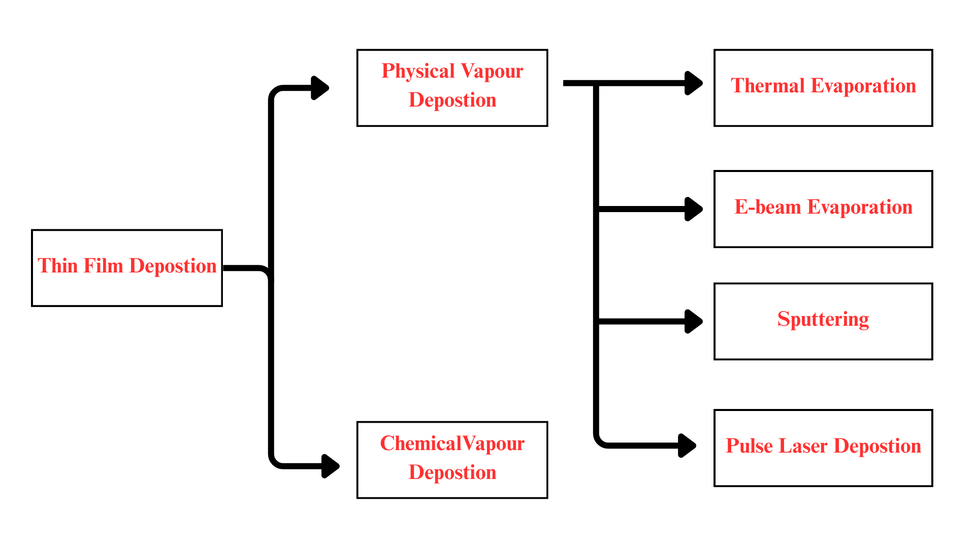
Figure 3: Schematic representation of PVD and CVD techniques

2.2.1 Chemical Vapor Deposition (CVD)
A popular method for thin-film deposition is chemical vapor deposition (CVD), in which solid material is created from gaseous precursors and deposited onto a substrate. In contrast to PVD, which employs solid precursors, CVD uses vapor-phase reactants that undergo chemical reactions to create a thin film. Thermal CVD, laser CVD (LCVD), metal-organic CVD (MOCVD), low-pressure CVD (LPCVD), plasma-enhanced CVD (PECVD), photochemical vapor deposition, and chemical beam epitaxy are some of the techniques that are included in CVD. Among the most popular are PECVD, LCVD, and thermal CVD.
- Thermal CVD: This technique produces film deposition by using heat to break down gaseous precursors when they come into contact with the substrate.
- Plasma-Enhanced CVD (PECVD): By aiding in the breakdown of the precursor gas, plasma improves film adhesion and uniformity and permits deposition at lower temperatures.
- Laser CVD (LCVD): When a laser interacts with a heated substrate surface, the precursor gas is thermally or photochemically broken down.
The ability of CVD to create highly conformal coatings is one of its main advantages, which makes it perfect for intricate, three-dimensional structures. Additionally, it facilitates batch processing, which boosts productivity in large-scale production. In industries where exact control over film composition and thickness is essential, such as semiconductor fabrication, protective coatings, and optical device manufacturing, CVD is widely used.

2.2.2 Physical Vapor Deposition (PVD)
A vacuum-based method called physical vapor deposition (PVD) is used to form coatings and thin films on a range of materials, including metals, glass, ceramics, and polymers. With this technique, a substance is changed from a condensed phase to a vapor phase and back to a thin film phase on the substrate. Because of their high purity, remarkable adhesion, and outstanding performance, PVD coatings are well-suited for use in a variety of industries, including microchips, solar panels, medical devices, protective films, and optical lenses. Atomic-level interactions form the basis of PVD's operation, which enables exact control over the properties of the film. There are three primary phases to the process: The first step is vaporization, in which atoms are ejected or evaporated from the source material using a strong energy source like thermal energy, electron beams, or plasma. In the second step, transport, these vaporized atoms move in the direction of the substrate via a vacuum chamber. The vaporized atoms eventually condense and gather on the substrate during nucleation and growth to form a thin film with a regulated thickness, composition, and microstructure. One of PVD's many benefits is its high purity, which comes from the coatings' generally low levels of contamination and excellent material quality [7].
In order to achieve particular film properties, including thickness, composition, and microstructure, the process also enables precise control over the deposition parameters. Consistent film thickness over wide substrate areas is guaranteed by the process' uniformity. Additionally, a wide range of materials, including metals, semiconductors, oxides, and nitrides, can be deposited using PVD due to its versatility. PVD coatings improve qualities like hardness, lubricity, adhesion, and wear resistance, which makes them ideal for manufacturing, aerospace, automotive, and defense industries. These coatings are perfect for decorative applications that need long-lasting color retention because they also have high resistance to corrosion and tarnish.
Thermal evaporation, electron beam evaporation, sputtering, and pulsed laser deposition are the most widely used PVD processes. The two most commonly used of these are thermal evaporation and sputtering. Both techniques use high vacuum to transform a source material into atomic or molecular plasma, which is subsequently applied to a substrate to produce a thin film.

2.3 Types of PVD Processes:
For the creation of thin films, a variety of physical vapor deposition (PVD) methods are used; each has special benefits and is appropriate for particular material systems and application needs. Four well-known approaches among these are as follows:

- Thermal Evaporation
- Electron Beam Evaporation
- Sputtering
- Pulsed Laser Deposition

2.3.1 Thermal Evaporation
A common Physical Vapor Deposition (PVD) method is thermal evaporation, and it involves evaporating the source material under high vacuum conditions to deposit a thin layer of material onto a substrate. The atoms or molecules in the source material move through the vacuum chamber and condense onto the substrate to form a thin film when it is heated to its evaporation temperature. The process usually holds the source material in either solid bar or powder form using a resistive heating element, like a boat-shaped crucible or coiled filament. The resistive element receives a direct current (DC), which produces enough heat to cause the material to evaporate. A high vacuum (below 10⁻⁴ Pa) is necessary for materials with high melting points in order to promote evaporation and deposition. Since low-melting-point materials need moderate temperatures for efficient evaporation, this method works especially well for them. Thermal evaporation has a number of benefits. It is easy to assemble and use, and it is affordable. Rapid thin-film formation is made possible by the process's high deposition rates. Additionally, a variety of materials, such as metals, oxides, and organic compounds, can be deposited using thermal evaporation due to its versatility. This approach does have certain drawbacks, though. It struggles with resistant metals, so its ability to deposit high-melting-point materials is limited. Adhesion problems can also arise, as thin films may not always stick to some substrates very well. Furthermore, complex geometries may experience shadowing effects, which could result in uneven surfaces with non-uniform thickness. Thermal evaporation is still a popular and adaptable deposition technique in spite of these difficulties, especially for applications that value ease of use and rapid deposition rates. It is a dependable method for a range of applications because it provides exact control over the microstructure, composition, and thickness of the film.
a)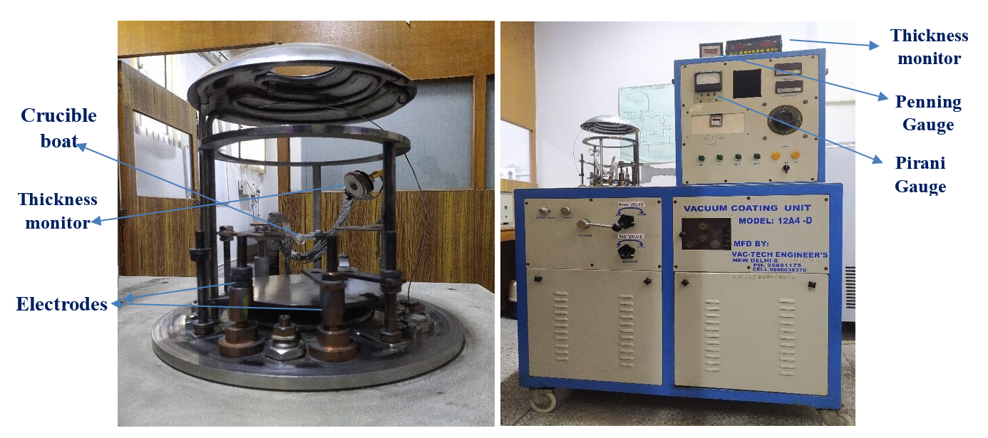
b)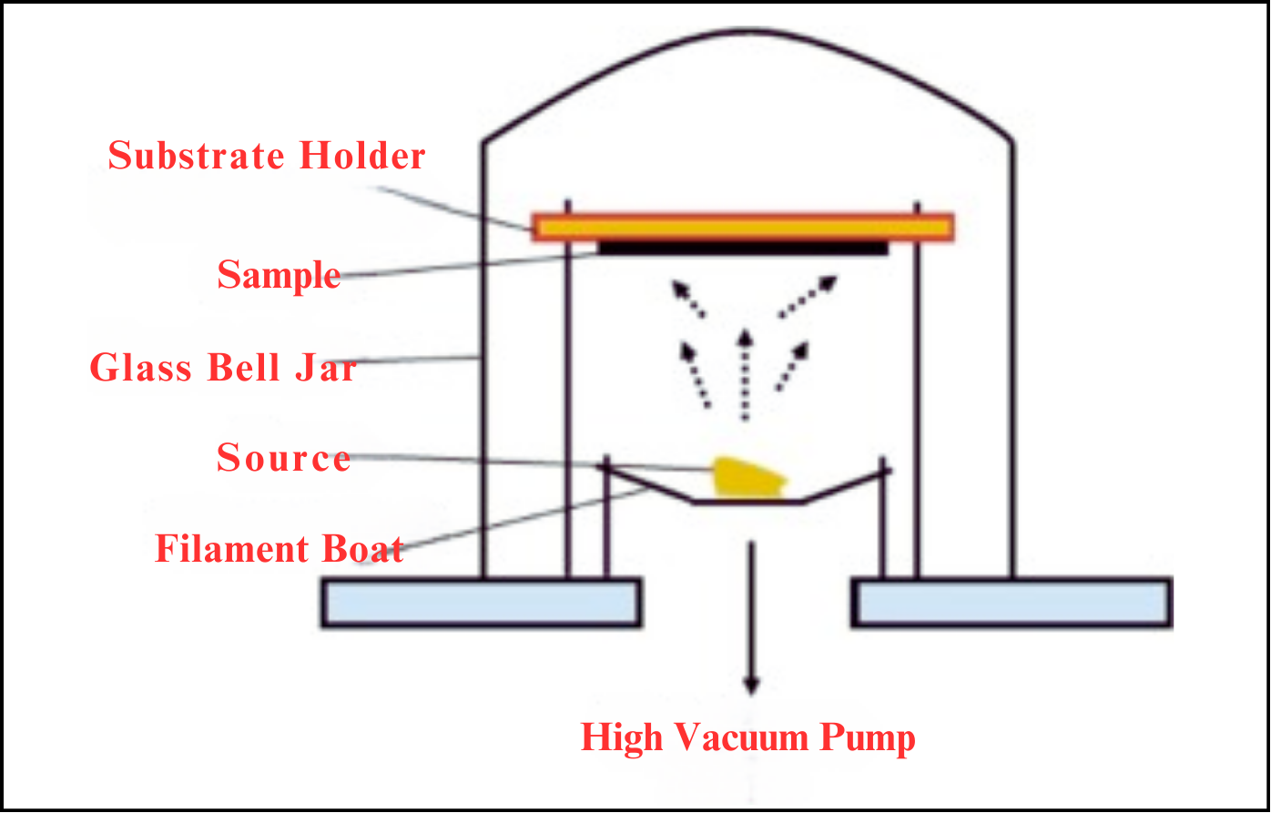
Figure 4: a) Thermal Evaporation Unit DU, South Campus b) Schematic representation of Thermal Evaporation

2.3.2 Electron Beam Evaporation
One Physical Vapor Deposition (PVD) method for producing thin film coatings on a variety of substrates is Electron Beam (E-Beam) Evaporation. The target material is exposed to a high-energy electron beam produced by a charged tungsten filament during this procedure. The material is evaporated by the electron beam's energy, becoming a gas that condenses onto the substrate to form a homogeneous thin film. To prevent contamination and guarantee precise, uniform deposition, this procedure is carried out in a high-vacuum chamber. E-Beam Evaporation has a number of benefits. It works especially well with materials that have a high melting point because the electron beam's direct energy transfer makes it possible for refractory metals to evaporate effectively. fast coating formation is made possible by the technique's support for high deposition rates, which range from 0.1 nm/min to 100 nm/min. High-quality thin films with better substrate adhesion are also produced by the process, which yields dense and adherent films. However, there are some limitations to this technique. Shadowing effects can occur, particularly on complex geometries, leading to non-uniform film thickness. The high-energy electron beams can also increase the substrate temperature, which may affect the properties of the deposited film. Furthermore, while it is highly effective for many materials, some high-melting-point materials may still pose challenges during the evaporation process. Among the various PVD techniques, both sputtering and Electron Beam Evaporation are widely used. However, E-Beam Evaporation is often preferred for applications that require high-melting-point materials and precise control over film properties, making it a valuable technique for such specialized applications.
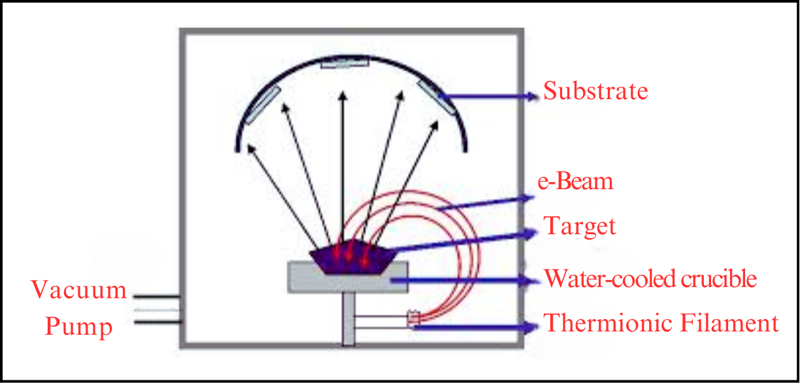
Figure 5: Schematic representation of Electron Beam Evaporation

2.3.3 Pulsed Laser Deposition (PLD)
Pulsed Laser Deposition (PLD) is a widely used physical vapor deposition (PVD) technique for fabricating thin films. In this process, a high-energy laser pulse is directed at a target material within a vacuum chamber. The target is ablation by the laser energy, creating a plasma plume that spreads out and forms a thin film on a substrate. To change the composition and characteristics of the film, PLD can be performed in an ultra-high vacuum or in a controlled gas atmosphere, like oxygen. Although PLD's equipment is similar to that of sputtering, its dynamics are different. The target experiences electronic excitations from the laser pulse, which are then transformed into mechanical, chemical, and thermal energy. As a result, material evaporates and a plasma plume made up of atoms, molecules, ions, and electrons is formed [7].
a)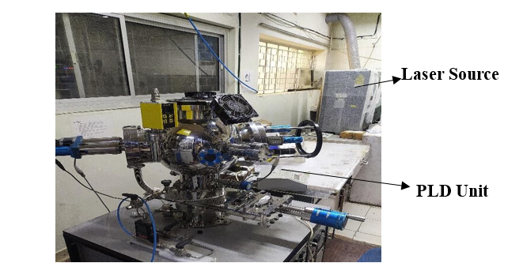
b)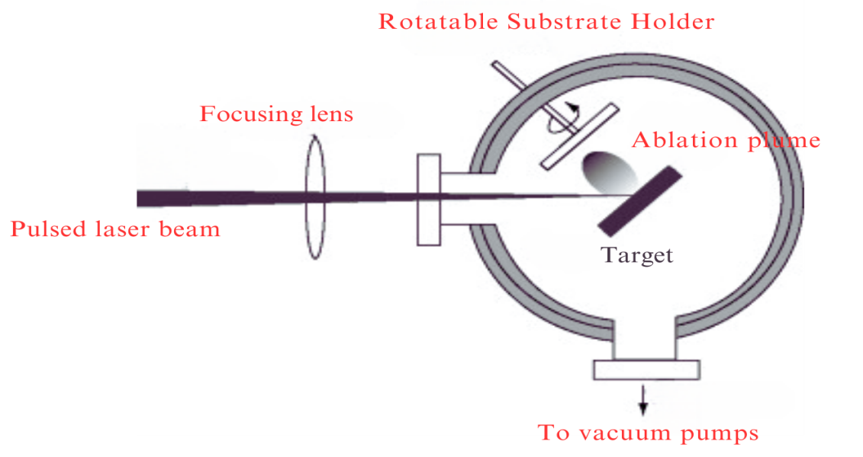
Figure 6: a) PLD Unit at JNU Nanoscience Lab b) Schematic representation of pulse laser deposition
There are multiple steps in the film growth process:
- Laser-Material Interaction & Ablation: The target is quickly heated by the laser energy, leading to vaporization and the creation of plasma.
- Plasma Expansion & Dynamics: A number of factors, including laser fluence and pressure, affect how much the plasma plume expands inside the chamber.
- Deposition on the Substrate: A thin layer is created on the substrate when the vaporized material condenses.
- Film Growth & Crystallization: Depending on the conditions of deposition, the deposited material organizes into an amorphous or crystalline structure.
PLD is perfect for creating complex materials like oxide films, high-temperature superconductors, and functional coatings for optical and electronic applications because it provides exact control over stoichiometry, layer thickness, and film quality.

2.3.4 Sputtering Process
Sputtering is a deposition technique that uses the energy of a partially ionized gas called plasma to remove atoms from a target material and deposit them onto a substrate. Several crucial steps are involved in the process: A plasma of Ar⁺ ions is first produced by ionizing a noble gas, usually argon, using radiofrequency (RF) excitation or a pulsed DC potential. In magnetron sputtering, an electric and magnetic field accelerates these ions in the direction of the target (cathode). The target's atoms receive energy from the Ar⁺ ions' collision, which causes them to be ejected and projected in the direction of the substrate. These expelled atoms form a homogeneous thin film on the substrate after condensing through the vacuum. In order to guarantee a clean deposition environment and reduce contamination from leftover gases, sputtering is typically carried out under high vacuum conditions (10⁻¹ to 10⁻³ mbar). The sputtering process is greatly aided by ion bombardment, where various interactions take place according to the energy and type of ions. The primary mechanism is material ejection (sputtering), where target atoms are removed and deposited onto the substrate. Additionally, reactive ion implantation can occur, where ions integrate with the target material and form chemical compounds in the deposited film. Another possible effect is ion beam deposition, where ions accumulate on the substrate, forming a thin layer. In simpler terms, sputtering can be likened to atomic-scale billiards: The incident Ar⁺ ions transfer energy to the target atoms, triggering a chain reaction of collisions. If an atom near the surface gains enough energy, it escapes from the target and deposits onto the substrate. The sputtering process can be classified into several types based on factors such as power source, material interaction, and deposition technique. Below are key types of sputtering processes:
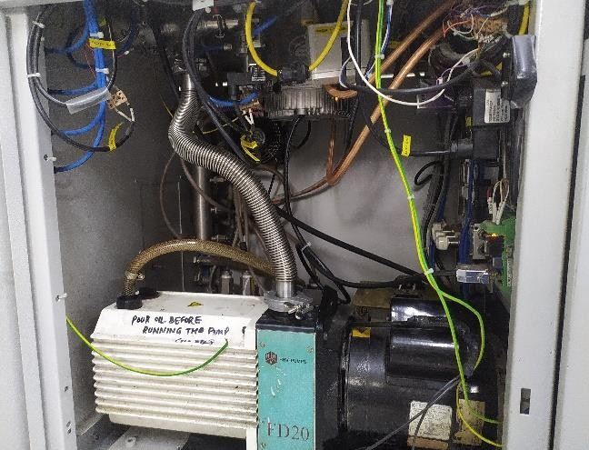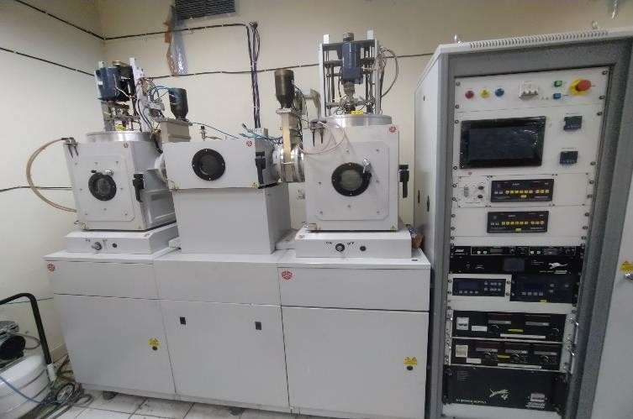
Figure 7: Sputtering and E-beam Evaporation Unit at JNU Nanoscience lab
Turbo pump
Rotary Pump
Sputtering Load
Control Unit
lock
e-beam
Chamber evaporation

2.3.4.1 DC Sputtering
Direct Current (DC) Sputtering is a simple sputtering technique used in Physical Vapor Deposition (PVD), where a DC voltage (500–1000 V) is applied between a target (cathode) and a substrate (anode) in the presence of low-pressure argon (Ar) plasma. The process works by generating plasma, which consists of positively charged Ar⁺ ions.
These ions move in the direction of the target, where they collide with the target material with enough force to remove the atoms. After passing through the vacuum, these atoms condense to form a thin layer on the substrate. DC sputtering does have certain drawbacks, though. Because insulating materials stop the process from proceeding because of the accumulation of positive charge on the target, it is limited to conductive materials. Because there aren't many ions produced in the plasma, the sputtering rate is also rather low. In spite of these difficulties, DC sputtering is frequently utilized for metallic coatings in protective films, optical coatings, and microelectronics.
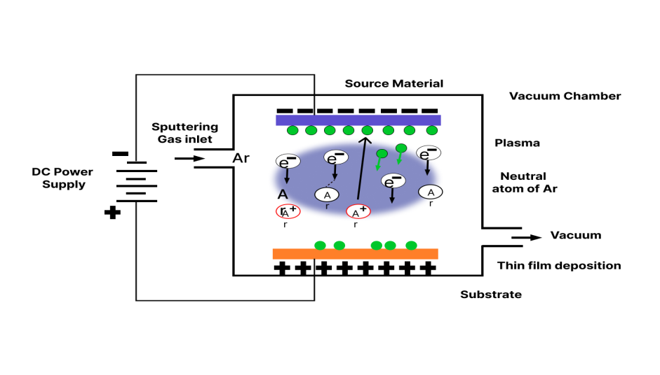
Figure 8: Schematic representation of DC Sputtering

2.3.4.2 RF Sputtering
A PVD method called radio frequency (RF) sputtering can sputter both conductive and non-conductive materials because it employs a high-frequency alternating electric field rather than a DC field. By ionizing the argon gas through oscillating electrons, an RF voltage is applied to the plasma, resulting in a high-density plasma. Because of this, RF sputtering can function at lower pressures while still achieving a higher sputtering rate than DC sputtering.
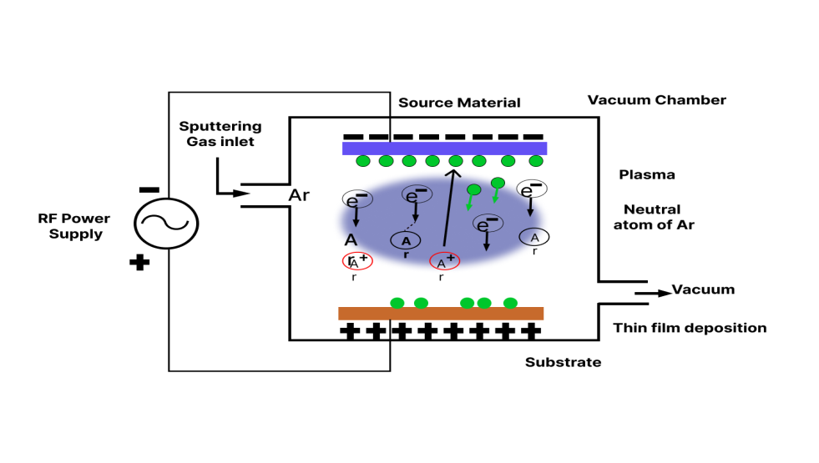
Figure 9: Schematic representation of RF Sputtering
The ability of RF sputtering to deposit thin films on non-conductive materials like semiconductors and insulators (e.g., Al₂O₃, BN) makes it advantageous. Additionally, it causes less heating of the substrate, which is perfect for materials that are sensitive to heat. Furthermore, RF sputtering provides better control over microstructures, enhanced thin film quality, and higher deposition rates (roughly ten times faster than DC sputtering). However, the cost of RF generators makes it more costly, and it may have problems with uniform layer thickness due to uneven plasma distribution across large cathodes.

2.4 Fabrication Process of Thin Films
The fabrication of cobalt-iron (FeCo) thin films on copper tape involves a series of carefully controlled steps designed to produce high-quality films with precise magnetic and structural characteristics.

2.4.1. Substrate Preparation
In order to ensure clean, smooth edges, the copper tape substrate must first be prepared by cutting it to the appropriate size. The substrate is thoroughly cleaned to get rid of impurities like dust, oils, and oxide layers. This entails ultrasonic cleaning in solvents such as acetone and isopropanol, followed by deionized water rinsing and air or nitrogen stream drying. To improve the thin film's adherence and get rid of any remaining oxide layers, extra surface treatments like mild etching or plasma cleaning are occasionally used.

2.4.2 Target Preparation
The FeCo sputtering target, which is usually made of an alloy such as Fe₀.₈Co₀.₂ (Fe₈₀Co₂₀), is prepared in the following step. The target is pre-sputtered inside the vacuum chamber before the actual deposition. By stabilizing the plasma conditions and assisting in the removal of surface impurities from the target material, this process guarantees uniform deposition throughout the sputtering process.

2.4.3 Deposition via Sputtering
The sputtering process starts after the substrate and target are ready. In order to minimize the presence of residual gases and impurities, the deposition chamber is first evacuated to reach high vacuum levels (about 10⁻⁶ Torr). After that, high-purity argon gas is added to keep the plasma environment steady at a regulated pressure, usually 3–5 mTorr. To ensure stable contact during deposition, the cleaned copper tape is carefully placed on the substrate holder and attached with clamps or thermal tape. The sputtering process is started by applying a direct current (DC) power source, usually between 50 and 200 watts, to the FeCo target. To obtain the required film thickness, which is typically between 10 and 100 nanometers, the deposition time is carefully regulated. Depending on the system requirements and the desired properties of the final film, minor heating or cooling adjustments may be made during the deposition process, which is typically carried out at room temperature. To encourage consistent film deposition over the whole surface, the substrate holder may rotate in certain configurations. Atoms are dislodged from the FeCo target's surface by the impact of energetic argon ions during sputtering. A thin FeCo film with the desired magnetic and structural characteristics is progressively formed as these atoms move through the plasma and condense onto the copper tape substrate. We have fabricated different thickness of FeCo like 6nm, 12nm and 15nm on Copper tape using sputtering technique [13].

CHAPTER 3: CHARACTERIZATIONS

The various characterization methods used to obtain various thin-film properties, such as crystal structure and static and dynamic magnetic properties, are covered in this chapter.

3.1 Thin Film Characterizations
Understanding thin films' structural, morphological, chemical, magnetic, and electrical characteristics—all of which have a direct impact on how well they function in a variety of technological applications—requires characterization. A thorough examination of these characteristics directs the creation of novel materials for applications in electronics, spintronics, sensors, and photonic devices and allows for the optimization of fabrication procedures. A variety of sophisticated characterization methods are used to accomplish this, each of which offers distinct and complementary information. The crystallographic structure and phase composition of the films are frequently ascertained using X-ray diffraction (XRD). It provides information on overall crystallinity, grain size, and crystal orientation—all of which are essential for comprehending the internal order of the material. Transmission electron microscopy (TEM) and scanning electron microscopy (SEM) offer high-resolution imaging of cross-sectional and surface morphology. While TEM allows for the observation of the internal microstructure at atomic to nanometer scales, SEM reveals surface features like defects and grain structure. Surface topography is analyzed using atomic force microscopy (AFM), which provides three-dimensional profiles with nanometer resolution, which is crucial for measuring surface roughness and texture. For elemental analysis, energy-dispersive X-ray spectroscopy (EDS) is frequently used in conjunction with electron microscopy to determine the distribution and composition of the elements in the thin film. Ferromagnetic resonance (FMR)[1] and vibrating sample magnetometry (VSM) are used to investigate magnetic behavior. While FMR provides more in-depth information on magnetization dynamics, resonance conditions, and damping behavior, VSM provides parameters such as Coercivity, remanence, and saturation magnetization. The four-point probe method, which measures conductivity and resistivity and helps in determining the film's suitability for electronic applications, is one technique used in electrical characterization. Optical characteristics such as film thickness, refractive index, and dielectric constants—important variables in optoelectronic and photonic devices—are assessed using spectroscopic ellipsometry. When these methods are combined, they provide a thorough understanding of the properties of the thin film. Each technique adds important information. In addition to guaranteeing material quality, thorough and precise characterization helps guide future advancements in deposition techniques and device integration. The theoretical underpinnings and practical implications of each of the primary characterization techniques employed in this investigation are presented in the ensuing sections, which serve as the foundation for the interpretation and discussion of the experimental findings.

3.2 X-Ray Diffraction (XRD)
In materials science, X-Ray Diffraction (XRD) is an essential tool for examining the structural characteristics of crystalline materials. In both thin films and bulk materials, it is frequently used to ascertain phase composition, crystal structure, and orientation. XRD is a precise and non-destructive technique that offers comprehensive information about atomic arrangements, making it useful for both industrial and research applications [14].

3.2.1 Principle of Operation
The basis of XRD is the idea that a monochromatic X-ray beam interacts with a crystal that has an ordered atomic structure, diffracting the X-rays to produce a distinct interference pattern. Bragg's Law, which outlines the prerequisites for constructive interference, is followed by this diffraction pattern:
$$nλ=2dsinθ$$
Where, n is an integer (order of reflection), λ is the wavelength of the incident X-ray beam, d is the interplanar spacing of the crystal and θ is the diffraction angle. Important details about the crystal structure, including phase composition and lattice parameters, are revealed by the diffraction pattern.

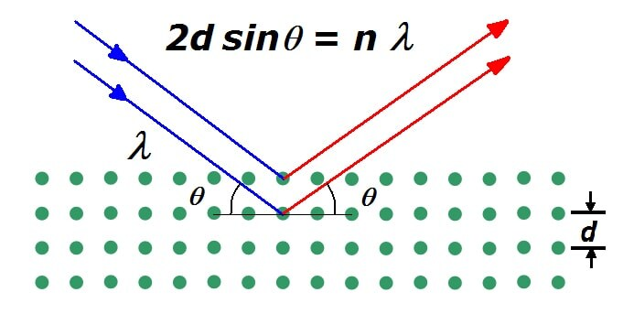
Figure 10: Schematic representation of Diffraction of X-Rays
Crystallite Size Determination
$$D=\frac{kλ}{βcosθ}$$
Where λ is the X-ray wavelength (usually 1.54 Å for Cu Kα radiation), β is the full width at half maximum (FWHM) of the diffraction peak, θ is the diffraction angle, D is the crystallite size, and k is the Scherrer constant (usually 0.98). In the study of nanomaterials, where grain size is a key factor in determining the material's mechanical and electrical properties, this approach is particularly helpful.

3.2.2 XRD Setup Components
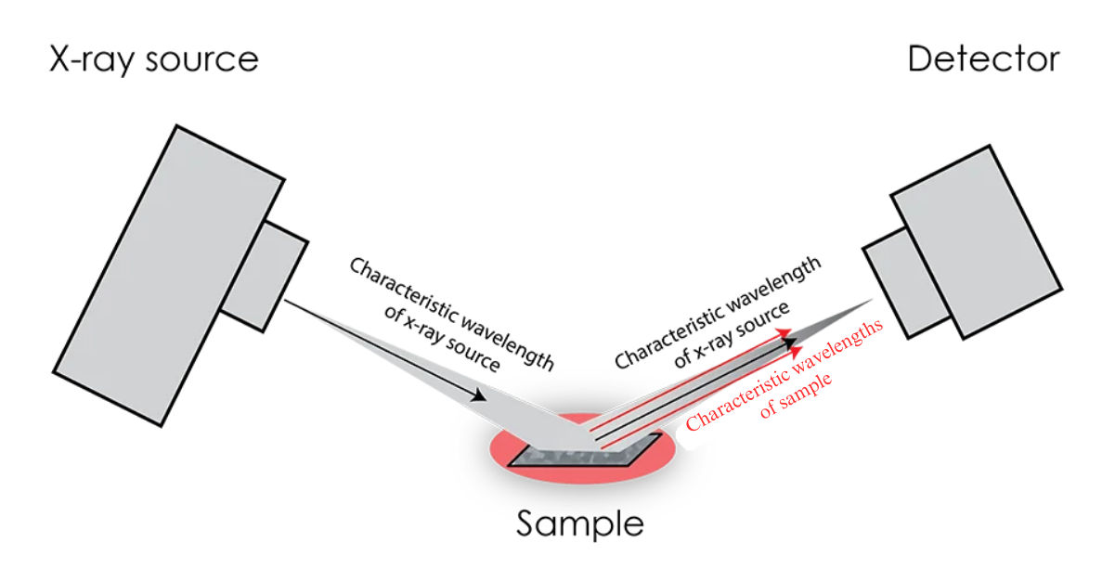
Figure 11: Schematic representation of XRD Setup
Three primary parts make up a typical XRD setup:
- X-ray Tube: The source of X-ray radiation, typically a heated tungsten filament that releases electrons onto a target material to produce distinctive X-rays.
- Sample Holder: The platform that rotates the sample to maximize diffraction angles and guarantee appropriate exposure to the X-ray beam.
- X-ray detector: records the X-rays that have diffracted, interprets the signals, and creates a readable diffraction profile.
X-ray wavelengths are perfect for diffraction studies because they are on the same scale as atomic spacing (1-100 Å). XRD is a vital tool for characterizing thin films, powders, and bulk materials because the diffraction patterns it produces aid in phase identification, strain analysis, and crystallinity evaluation.

3.3 Ferromagnetic Resonance (FMR)
One important method for examining the dynamic magnetic behavior of ferromagnetic materials is Ferromagnetic Resonance (FMR) [1]. These materials' magnetization precesses when exposed to an external magnetic field, and under resonance circumstances, it absorbs microwave energy at a particular frequency. This method offers important insights into magnetic anisotropy, damping, and exchange interactions, making it useful in domains such as spintronics, magnetic storage, and magnetization dynamics[6][2].
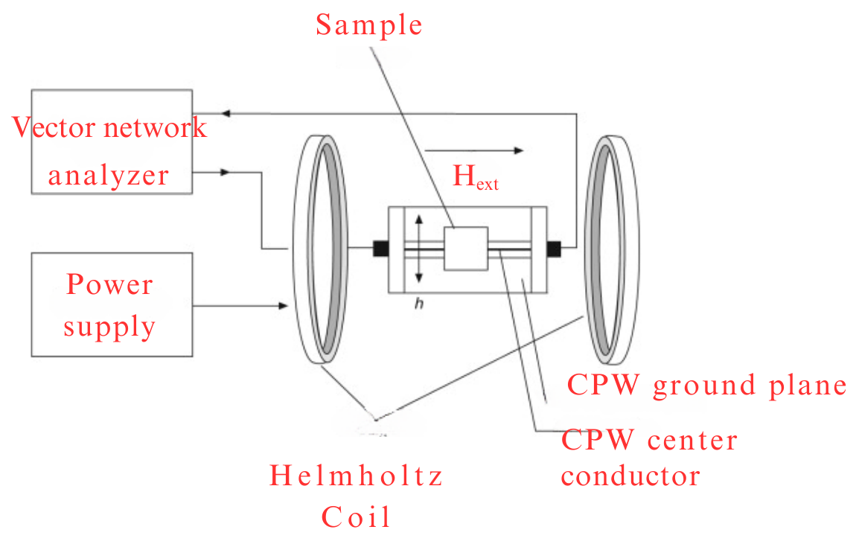
Figure 12: Schematic representation of FMR setup

3.3.1 Working Principle
When a microwave magnetic field is applied perpendicular to a ferromagnetic material's magnetization, FMR takes place. When the microwave field frequency equals the spins' natural precession frequency, resonance is reached and the magnetic moments start to precess. Maximum microwave absorption and a detectable signal drop in transmitted or reflected power result from this resonance. Important magnetic parameters like effective magnetization, anisotropy fields, and damping factors can be ascertained by examining this signal.

3.3.2 Experimental Setup
The sample is placed in a microwave cavity or waveguide in a typical FMR experiment. The sample is excited by a microwave field while a static magnetic field is swept. Among the most important actions are:
- Microwave Excitation: An alternating magnetic field is produced by a microwave source.
- Field Sweeping: A steady external magnetic field is progressively changed.
- Detection: Variations in the transmission, absorption, or reflection of microwaves are noted.
- Data Analysis: Magnetic characteristics like resonance field and linewidth are extracted from the FMR spectra.
Kittel Equation
The resonance condition in FMR is determined by the Kittel equation, which describes the relationship between the resonance frequency and the applied magnetic field. It is expressed as:
$$f=\frac{γ}{2π}\sqrt{\left(H_{r}+H_{k}\right)(H_{r}+H_{k}{+4πM}_{eff})}$$
Where γ is the gyromagnetic ratio, H_{r} is the FMR field, H_{k} is the magnetic anisotropy field induced by stoichiometric ratio, and 4πM_{eff} is the saturation magnetization of ferromagnetic films. H_{k} is the in-plane stress and shape of a corporately induced internal effective magnetic field. The H_{eff} will change when the sample is put under an opposite stress and shape state (tensile or compressive), then the in-plane Hr changes in the opposite trend.

3.3.3 Applications of FMR
FMR is widely used in device engineering and material science:
- Magnetic Characterization: Determines factors such as anisotropy, saturation magnetization, and gyromagnetic ratio.
- Spintronics: Facilitates the study of spin dynamics and helps with the design of devices such as magnetic logic circuits and MRAM.
- Data Storage: By changing anisotropy and damping characteristics, thin films and nanoparticles are optimized for high-density magnetic recording.
All things considered, FMR is an essential tool for investigating magnetic materials and developing data storage and spin-based electronics technologies.

3.4 Vibrating Sample Magnetometry (VSM)
A very sensitive method for determining the magnetic characteristics of both solid and liquid samples is called vibrating sample magnetometry, or VSM. In order to precisely detect magnetic responses, even from materials with incredibly small magnetic moments—as low as 10⁻¹⁰ emu—it vibrates a sample within a uniform magnetic field. This technique works particularly well for examining a variety of materials, such as bulk samples, thin films, and nanoscale structures.
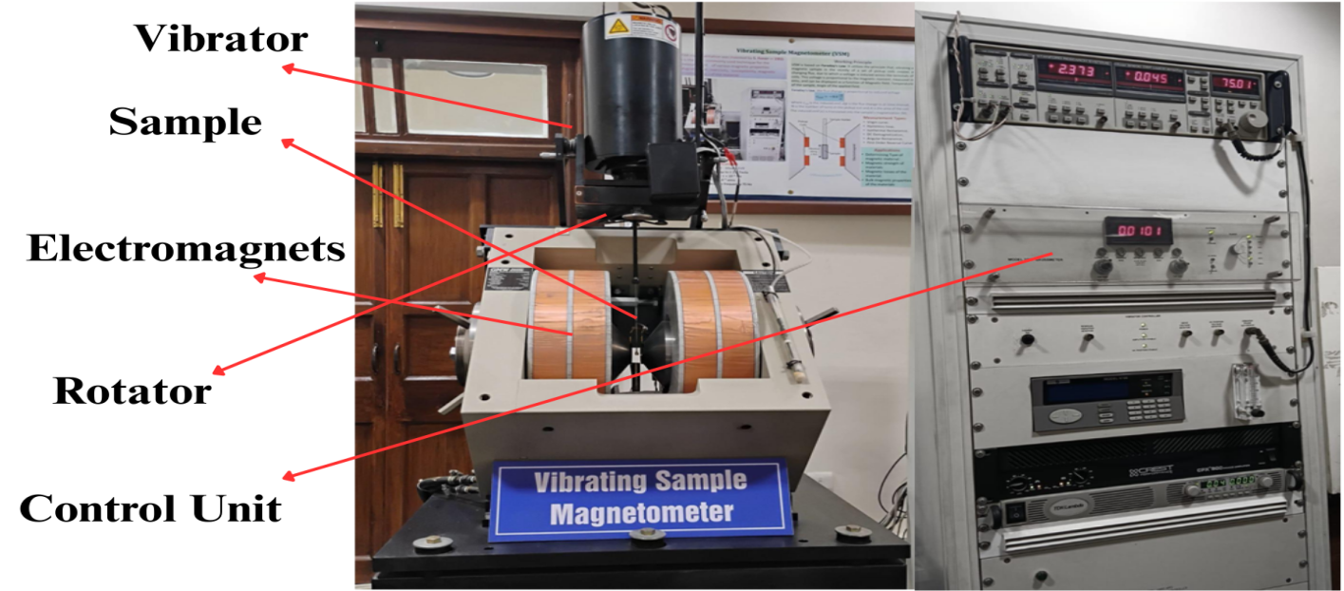
Figure 13: VSM working (Source: Uod North Campus, USIC)

3.4.1 Working Principle
Faraday's Law of Electromagnetic Induction, which states that an electric field is induced in a nearby conductor by a time-varying magnetic field, is the working principle of VSM. The sample is mechanically vibrated in a VSM system while being exposed to a continuous magnetic field, typically at a frequency of 85 Hz. Via adjacent pickup coils, this vibration periodically alters the magnetic flux. These coils produce a voltage as the magnetic flux changes. The sample's magnetic moment directly correlates with the induced voltage's strength. Important magnetic parameters like saturation magnetization (M), Coercivity (H_{C}), and remanent magnetization (M_{r}) can be precisely ascertained by examining this signal.

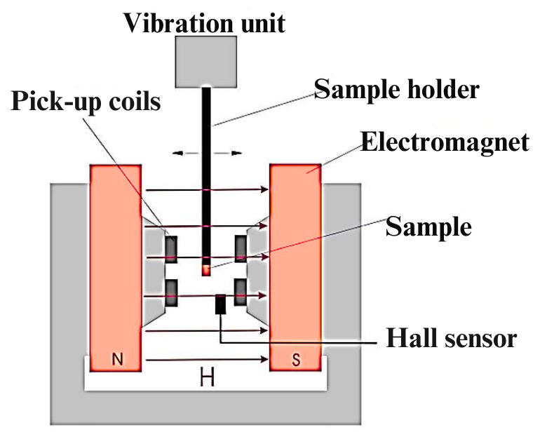
Figure 14: Schematic representation of VSM

3.4.2 Applications
Applications for VSM are numerous in both industry and research. It is widely used to investigate ferromagnetic, ferrimagnetic, and antiferromagnetic systems, among other kinds of magnetic materials. High-performance electronic and spintronic devices depend on the magnetic properties of thin films and nanostructures, which can only be analyzed using VSM in the field of nanotechnology. Additionally, the method makes it easier to analyze hysteresis loops in detail, offering information on coercive force, magnetic anisotropy, and energy loss during magnetization reversal. Additionally, VSM is essential to the creation and evaluation of magnetic materials used in hard drives, magnetic sensors, and data storage devices.

3.5 Atomic Force Microscopy (AFM)
The advanced high-resolution technique referred to as Atomic Force Microscopy (AFM) makes it possible to see and characterize surfaces in great detail at the atomic and nanometer scales. In order to identify different surface characteristics like topography, mechanical stiffness, adhesion, and roughness, it moves a sharp probe across a sample surface. AFM offers true three-dimensional surface imaging without the need for complicated sample preparation or vacuum environments, in contrast to optical and electron microscopy techniques. It is extremely useful in disciplines like biology, materials science, and nanotechnology because of its capacity to resolve features down to the atomic level.

3.5.1 Working Principle
AFM's operation depends on identifying the forces that interact between a material's surface and a sharp probe. The essential part is a flexible cantilever with a very sharp tip, usually made of silicon or silicon nitride, and with a radius of just a few nanometers. Several forces, including van der Waals, electrostatic, and chemical bonding interactions, affect the cantilever's deflection as the sample is scanned beneath the tip. These deflections are precisely recorded by a laser beam that bounces off the cantilever's back and onto a photodetector. Through a feedback mechanism that modifies the tip's vertical position in real time, the system maintains a controlled force between the tip and the sample. A high-resolution three-dimensional surface map is subsequently created from this data.
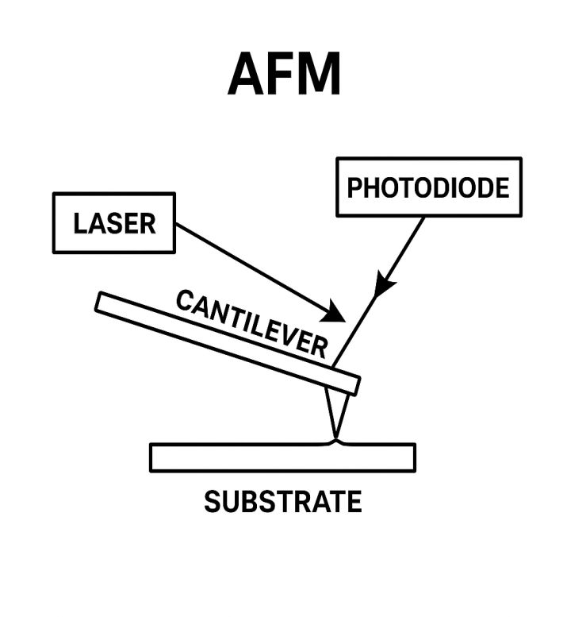
Figure 15: Schematic representation of AFM

3.5.2 AFM Imaging Modes
To accommodate various materials and analysis needs, AFM can function in multiple imaging modes. When the probe is in contact mode, it stays in constant contact with the surface, giving precise topographical data but possibly destroying softer samples. By touching the surface sporadically, the tapping mode reduces sample deformation and provides a balanced alternative. In the non-contact mode, ultra-soft or delicate samples are imaged using long-range forces rather than direct contact. Furthermore, by examining the force-distance curve during tip-sample interaction, the force spectroscopy mode makes it possible to measure mechanical attributes like stiffness, elasticity, and adhesion.

3.5.3 Applications
AFM is a flexible instrument with a broad range of industrial and scientific uses. It contributes significantly to surface characterization by providing nanoscale information on texture, morphology, and roughness that is especially helpful in thin film and coating analysis. AFM helps assess the mechanical and electrical characteristics of nanomaterials like graphene, carbon nanotubes, and magnetic nanoparticles in the fields of nanotechnology and materials science. It makes it easier to image cells and biomolecules in the biological sciences without labeling or destroying samples. The method is also crucial for the semiconductor industry's failure analysis, defect detection, and nanoscale electrical measurements, as well as for polymer research's analysis of surface adhesion and phase separation.

3.6 Field Emission Scanning Electron Microscopy (FESEM)
The advanced imaging method known as Field Emission Scanning Electron Microscopy (FESEM) allows for nanometer-level observations of a material's surface morphology and structural details. In contrast to traditional optical microscopy, which uses visible light, FESEM scans the surface of the sample using an electron beam that is extremely focused. This makes it possible to see features at the nanoscale with a resolution of 1-2 nanometers. FESEM is extensively used in the domains of materials science, nanotechnology, semiconductor research, and biology because of its exceptional imaging capabilities.

3.6.1 Working Principle
The fundamental idea behind FESEM's operation is electron emission in the presence of a powerful electric field. It creates a focused and powerful electron beam using a field emission gun (FEG), usually equipped with a sharp tungsten or lanthanum hexaboride (LaB₆) tip. Electrons with energies usually between 1 and 30 keV are released from the tip and accelerated toward the sample when a strong electric field is applied. This electron beam is rastered in a regulated zigzag pattern across the surface of the sample after being focused into a tiny probe using electromagnetic lenses. The beam produces a variety of signals, including characteristic X-rays, backscattered electrons, and secondary electrons, as it interacts with the atoms in the sample.
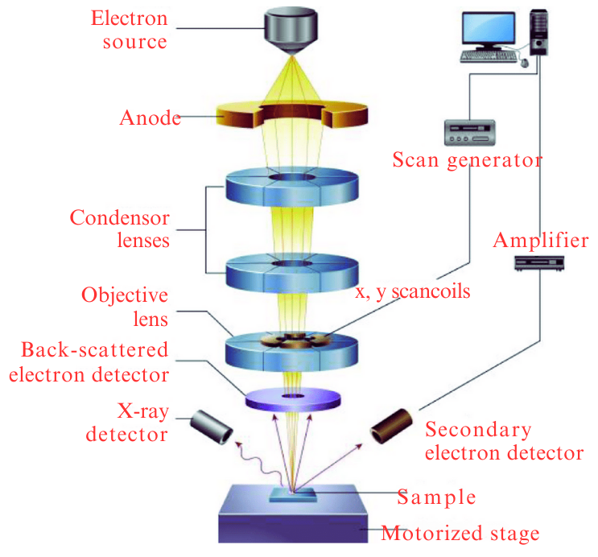
Figure 16: Schematic representation of FESEM

3.6.2 Signal Detection and Imaging
Secondary electron emission, which is extremely sensitive to surface topography, is the most often used signal for imaging in FESEM. Detectors like the Everhart-Thornley detector pick up these electrons, transform them into electrical signals, and then amplify them. A high-resolution grayscale image that depicts the surface morphology is created by processing the resultant signal intensity. This image can be further examined or saved for documentation, and it is shown in real time on a monitor.

3.6.3 Advantages
Compared to traditional Scanning Electron Microscopy (SEM), FESEM has a number of important advantages. By using a field emission source, it provides a significantly higher resolution, making it possible to observe minuscule features. Additionally, the method necessitates little sample preparation, and conductive layer coating is frequently not required. Furthermore, FESEM has a deeper depth of field, which improves the surface structures' three-dimensional appearance and makes it perfect for examining fine surface details and nanostructured materials.

3.6.4 Applications
Applications for FESEM are numerous and span many scientific and industrial domains. It is employed in materials science and nanotechnology to describe the morphology of surface coatings, thin films, and nanomaterials. FESEM helps with the inspection and quality control of microchips, transistors, and MEMS devices in the semiconductor and microelectronics industry. High-resolution imaging of cells and tissues without causing major sample damage is another application for it in biological research. FESEM is useful for examining cracks, fractures, and contaminations at the micro and nanoscale in forensic and failure analysis, and it aids in evaluating surface homogeneity and layer thickness in polymer and coating studies. FESEM is an essential tool for nanoscale research and precise material characterization because it can provide detailed imaging of surfaces at incredibly high resolution with little sample damage.

3.7 Energy Dispersive X-Ray Spectroscopy (EDS)
One important analytical method for determining a material's elemental makeup and chemical structure is energy dispersive X-ray spectroscopy, also known as EDS or EDX. It is most frequently combined with electron microscopy methods like Transmission Electron Microscopy (TEM) and Scanning Electron Microscopy (SEM), which enable researchers to view a sample's morphology and elemental makeup at the same time. Because of its speed, accuracy, and non-destructive nature, EDS has emerged as a vital tool in disciplines like materials science, nanotechnology, geology, biology, and semiconductor research.

3.7.1 Working Principle
The interaction of high-energy particles, such as electron beams or X-rays, with a sample's atoms forms the basis of EDS. An inner-shell electron, typically from the K or L shell, is ejected when the sample is exposed to radiation because the atoms inside it become excited. This makes the atom unstable by leaving an electron vacancy. An X-ray photon is released by the atom as an electron from a higher energy shell descends into the lower shell to restore stability. It is feasible to identify the elements contained in the sample because the energy of the X-ray that is released is characteristic of the particular element in question. High-sensitivity detectors like the Silicon Drift Detector (SDD) or the more traditional Lithium-drifted Silicon Detector (Si(Li)) are used to find the emitted X-rays. These detectors create an energy spectrum by measuring the incoming X-rays' energy and intensity. Both qualitative and quantitative elemental analysis are made possible by the spectrum's display of peak positions (in keV) that correspond to particular elements.
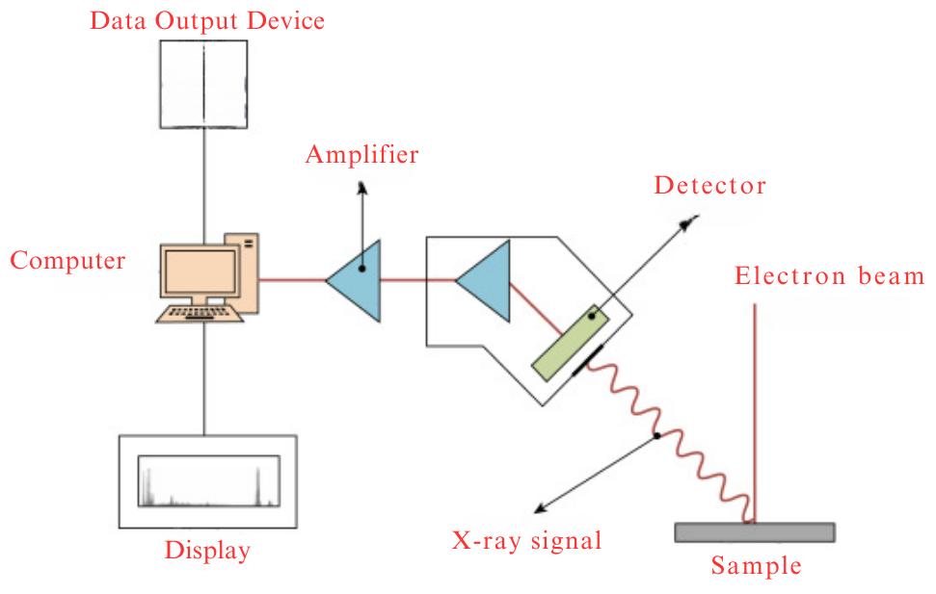
Figure 17: Schematic representation of EDS

3.7.2 Advantages
EDS is a useful technique for modern research and industrial applications because of its many benefits. With little to no sample preparation, it provides quick and simultaneous detection of several elements. Additionally, it is a non-destructive method that protects the integrity of sensitive or valuable samples. Additionally, it enables elemental mapping, which shows the distribution of various elements on a sample surface graphically.

3.7.3 Applications
EDS is used in many different fields because of its adaptability. It is employed in materials science to examine the makeup of composites, thin films, and alloys. EDS helps in determining soil chemistry, contamination levels, and mineral content in geology and environmental science. EDS is used in biological and medical research to examine tissue composition and biomaterials. It helps with the analysis of trace evidence, such as gunshot residue and counterfeit detection, in forensic investigations. EDS is used in the semiconductor industry to ensure the integrity of coatings, nanostructures, and microelectronic components. EDS continues to be a vital tool for accurate material characterization, helping engineers and researchers understand and improve material performance by providing both qualitative and quantitative insights into a sample's elemental composition.

CHAPTER 4: RESULTS AND DISCUSSION

The experimental findings from various characterization methods applied to Fe₈₀Co₂₀ thin films deposited on flexible copper tape substrates are covered in this chapter. Three primary methods are examined: ferromagnetic resonance (FMR), vibrating sample magnetometry (VSM), and X-ray diffraction (XRD). The films crystalline structure, lattice parameters, and crystallite sizes were examined using XRD, which provided insight on their microstructural integrity. Static magnetic properties, such as Coercivity and saturation magnetization, were measured using VSM as a function of film thickness. The dynamic magnetic behavior was investigated using FMR spectroscopy, which provided insights into the resonance field, effective magnetization, and damping properties. A thorough grasp of the Fe₈₀Co₂₀ thin films' structural and magnetic characteristics can be obtained by combining the analysis of these methods.

4.1 X-ray Diffraction (XRD) Analysis
X-ray diffraction (XRD) was used to examine the structural properties of Fe₈₀Co₂₀ thin films that were deposited on flexible copper tape. The diffraction patterns for the films with thicknesses of 6 nm and 15 nm are shown in Figure 17. The crystalline nature of the deposited films was demonstrated by the sharp and clear diffraction peaks that were seen in both situations.
The Debye-Scherrer equation was utilized to determine the crystallite size based on the full width at half maximum (FWHM) of the peaks. A Cu Kα X-ray source with a wavelength of 1.5406 Å and a shape factor K of 0.9 were used for the analysis [14].
$$D=\frac{kλ}{βcosθ}$$
Where λ is the wavelength of Cu Kα radiation (1.5406 Å), β is the FWHM in radians, θ is the Bragg angle, D is the crystallite size, and K is the shape factor (0.9). Furthermore, Bragg's law was used to determine the interplanar spacing d:
$$nλ=2dsinθ$$
All calculated results for interplanar spacing and experimentally determined crystallite sizes are shown in Table 4.1. The film’s nanocrystalline nature is confirmed by the crystallite size values, which are within the nanometer range. Additionally, the fact that the values of the 6 nm and 15 nm samples are similar indicates that the sputtering process creates uniform and consistent grain structures at various thicknesses. The films' good structural integrity is indicated by the d-spacing values, which are in good agreement with the known lattice parameters of the materials involved.
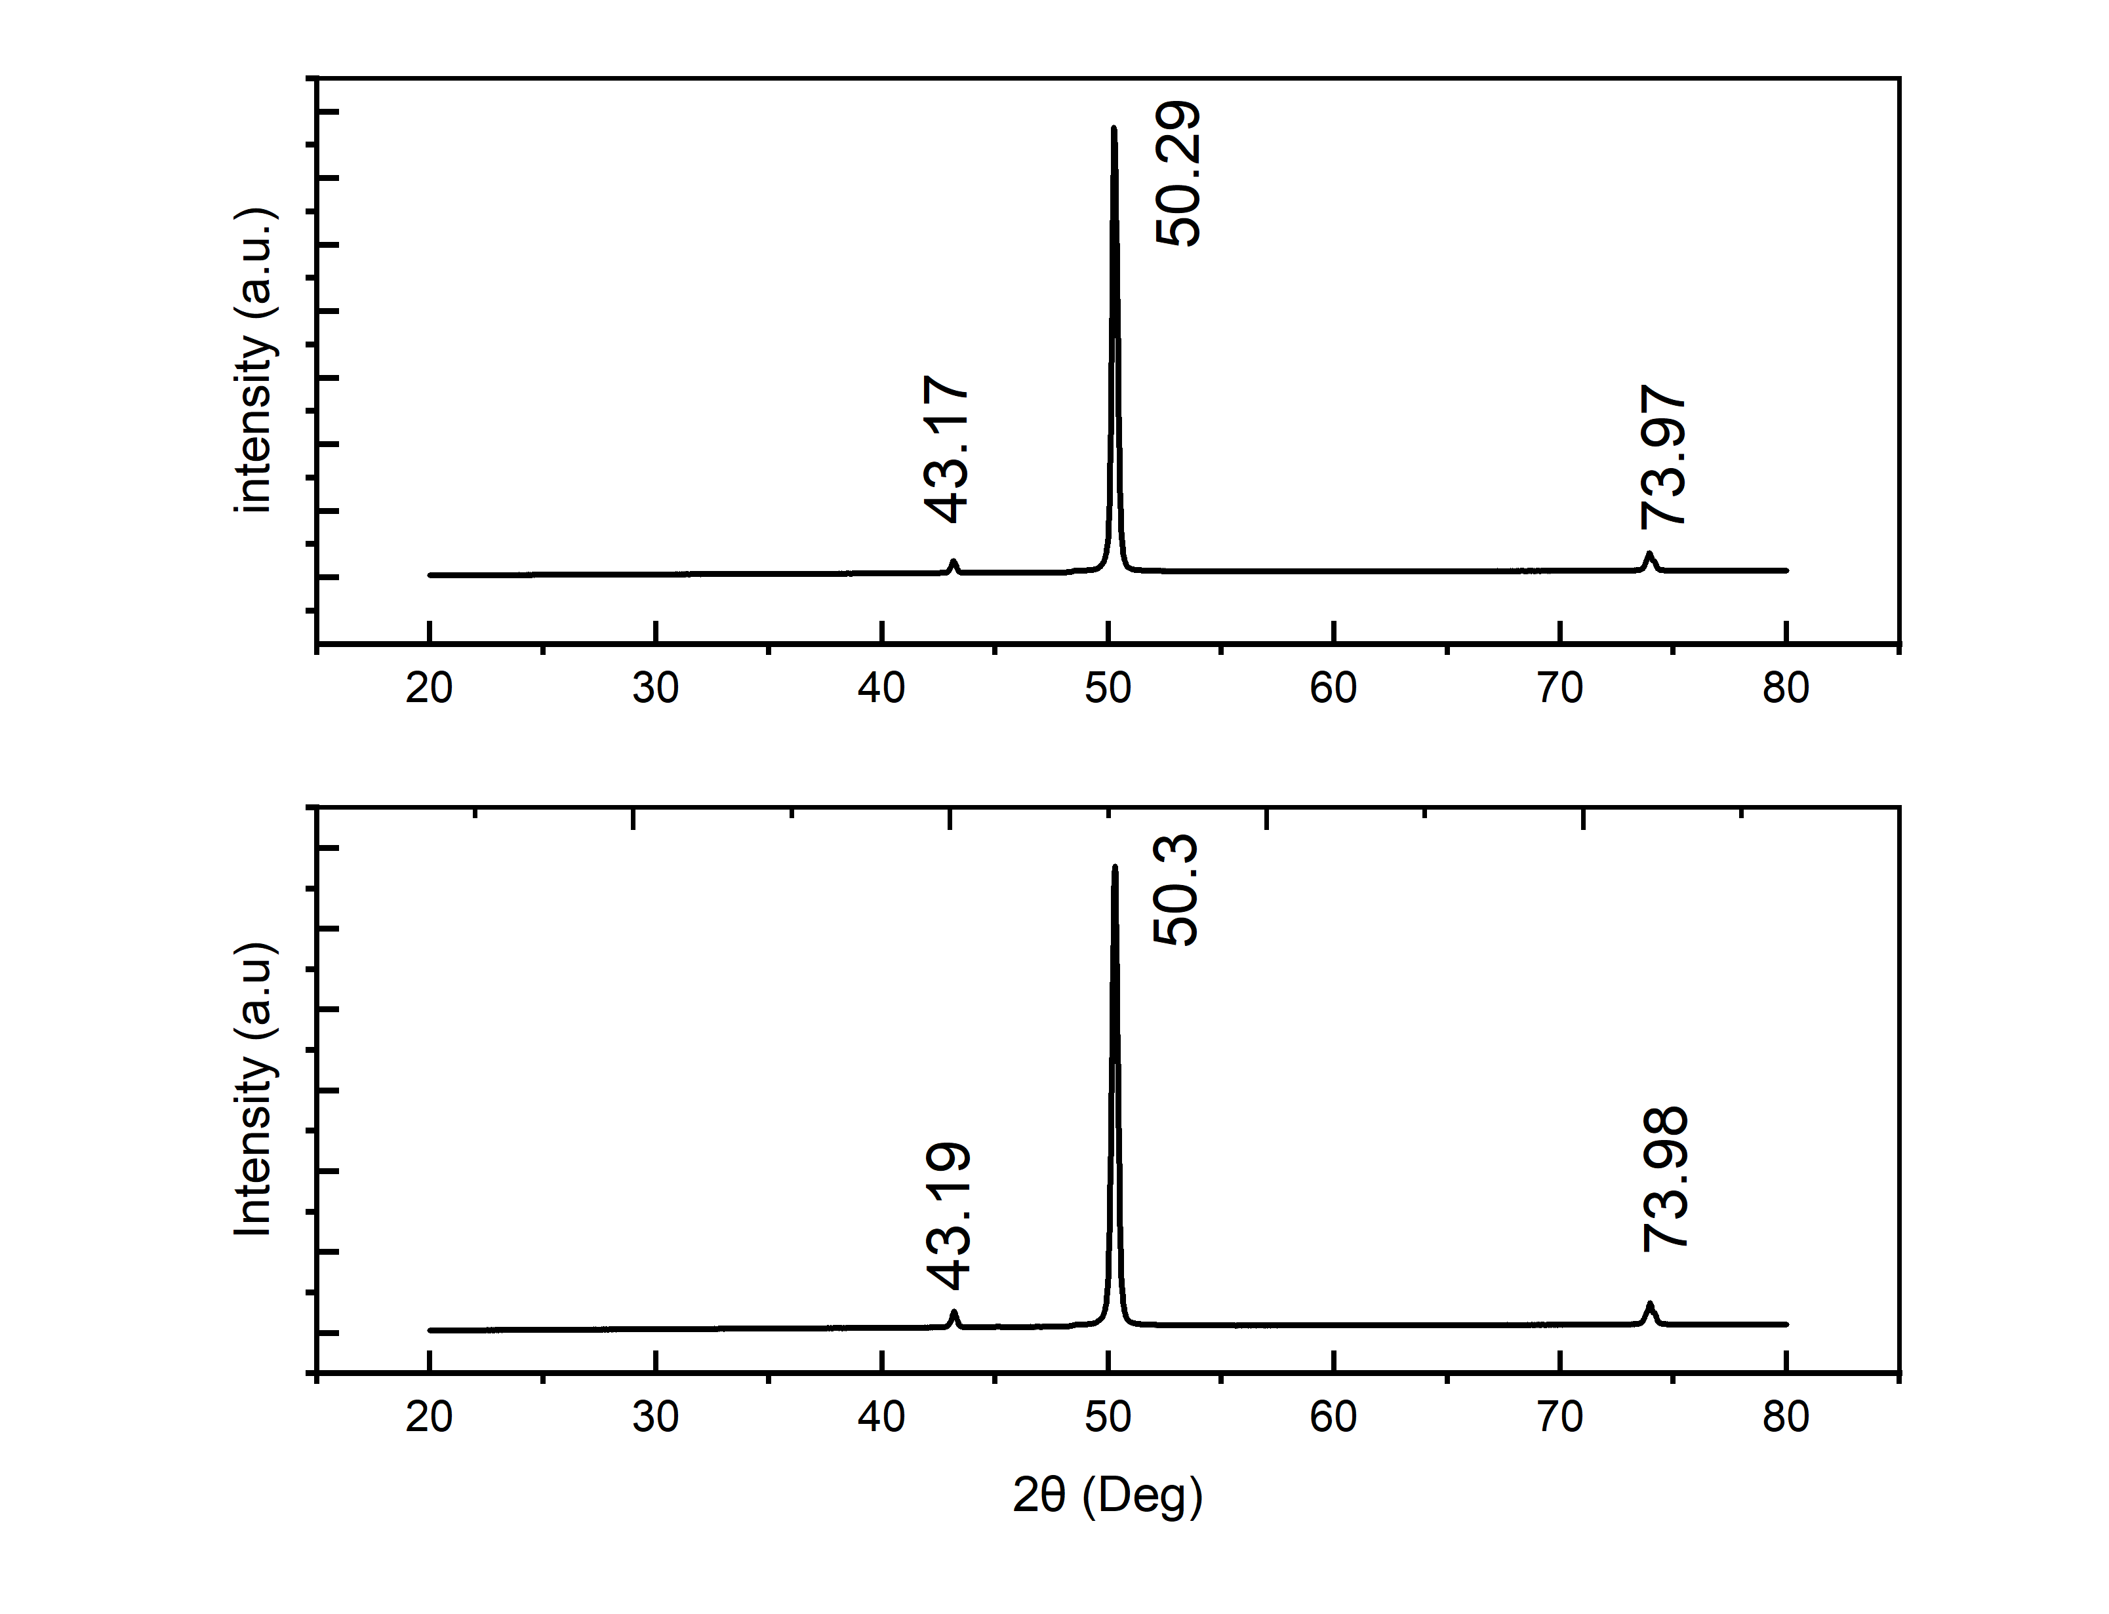
b)
a)
Figure 18: XRD plot for diffraction patterns of (a) 6nm (b) 15nm
Thickness(nm) | 2θ (°) | FWHM (°) | θ (°) | θ (rad) | FWHM (rad) | D (nm) | d (Å)
6 | 50.3 | 3.23E-01 | 25.15 | 0.4389 | 0.00563 | 2.51E+01 | 1.812
6 | 73.98 | 5.22E-01 | 36.99 | 0.6457 | 0.00912 | 1.54E+01 | 1.281
6 | 43.19 | 2.52E-01 | 21.59 | 0.3768 | 0.00441 | 3.14E+01 | 2.087
15 | 50.29 | 2.97E-01 | 25.14 | 0.4387 | 0.00519 | 2.73E+01 | 1.812
15 | 73.97 | 4.83E-01 | 36.98 | 0.6455 | 0.00843 | 1.67E+01 | 1.281
15 | 43.17 | 2.46E-01 | 21.59 | 0.3766 | 0.0043 | 3.22E+01 | 2.087
Table 4. 1: Summarizes the values of 2θ, FWHM, d-spacing and estimated crystallite size for both film thicknesses.

4.2 Ferromagnetic Resonance (FMR) Analysis
Ferromagnetic resonance (FMR) spectroscopy was conducted to explore the dynamic magnetic behavior of Fe₈₀Co₂₀ thin films deposited on flexible copper substrates. The measurements were performed at room temperature using a broadband two-port setup comprising a Keysight Vector Network Analyzer (VNA) coupled to an “S” shaped coplanar waveguide (CPW). The thin films were mounted face-down over the CPW’s signal line to ensure optimal coupling with the RF magnetic field. An external DC magnetic field was applied in-plane via an electromagnet to induce resonance [6] [2].
The experiments were carried out in field-swept mode at fixed microwave frequencies ranging from 6 to 24 GHz. The transmission coefficient (S₂₁) was recorded to monitor the absorption profile. The observed FMR spectra were fitted using a combination of symmetric and antisymmetric Lorentzian line shapes, represented by:
$$S_{21}=A_{sym}\frac{({∆H/2)}^{2}}{{(H-H_{r})}^{2}+({∆H/2)}^{2}}+A_{asym}\frac{(\frac{∆H}{2})\left(H-H_{r}\right)}{{(H-H_{r})}^{2}+({∆H/2)}^{2}}$$
Where, A_{sym} ​& A_{asym} ​denote the symmetric and antisymmetric amplitudes of the resonance, H is the external DC magnetic Field, H_{r}​ is the ferromagnetic resonance field, and ΔH represents resonance linewidth. Figures 18 illustrate the FMR absorption spectra for the 15 nm Fe₈₀Co₂₀ film measured at different frequencies from 10 to 13 GHz. These spectra demonstrate a clear resonance behavior and confirm the reliability of the fitting process used to extract the resonance parameters.

4.2.1 Resonance Field and Kittel Analysis
The variation of the resonance field H_{r} with frequency was analyzed using the Kittel equation for an in-plane FMR configuration:
$$f=\frac{γ}{2π}\sqrt{\left(H_{r}+H_{k}\right)(H_{r}+H_{k}{+M}_{eff})}$$
Where, f is the frequency, γ is the gyromagnetic ratio, and M_{S} is the saturation magnetization. Figure 19 (a) illustrates the relationship between H_{r} and frequency for the Fe₈₀Co₂₀ thin films. The observed trend aligns well with the Kittel equation, confirming the magnetic uniformity of the films and providing insight into their dynamic magnetic properties.

4.2.2 Damping Constant and Linewidth Analysis
The dependence of the FMR linewidth ΔH on frequency was analyzed to estimate the effective Gilbert damping constant α_{eff}​, employing the linear relationship:
$$∆H= ∆H_{0}+\frac{4πf}{γ}α_{eff}$$
Where, ΔH₀ represents the inhomogeneous linewidth broadening due to microstructural imperfections, and f is the microwave frequency. Figure 19 (b) presents the variation of ΔH with frequency, and the slope of the linear fit yields α_{eff}​. Table 4.2 summarizes the extracted values of the effective magnetization (M_{eff}​) and the effective gilbert damping constant (α_{eff}​) for the Fe₈₀Co₂₀ films with thicknesses of 6 nm, 12 nm, and 15 nm. The 6 nm film exhibited the lowest effective magnetization at 3.42 kOe, while the 15 nm film displayed the highest at 9.55 kOe. The effective damping constant was also strongly dependent on film thickness, with the 6 nm film exhibiting a remarkably high value of 72.2 × 10⁻³, which sharply decreased to 17.03 × 10⁻³ for the 12 nm film and then decreased to 3.22 × 10⁻³ at 15 nm [13].
a)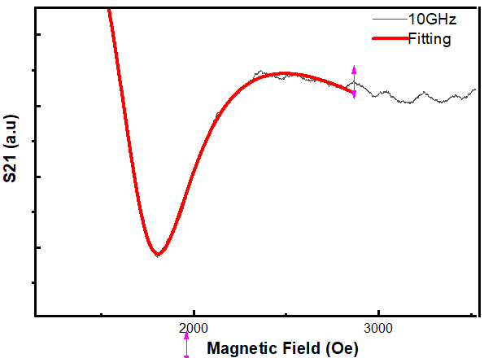b)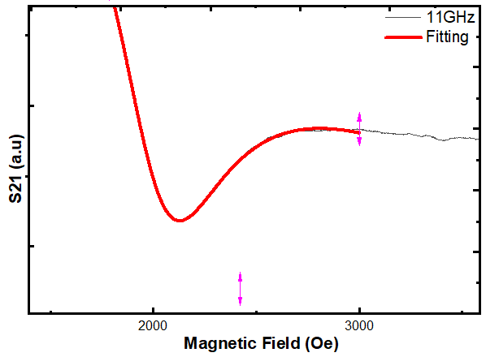
c)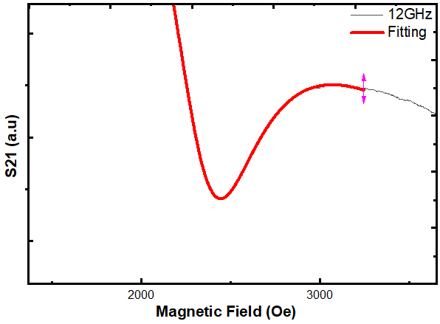d) 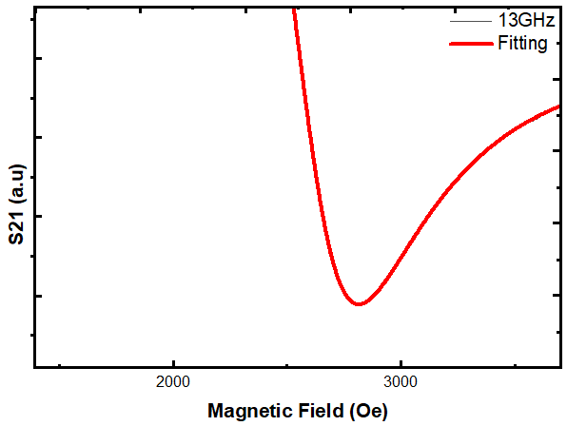
Figure 19: FMR plots of sputtering deposited Fe₈₀Co₂₀ at 15nm
a)10GHz frequency b)11GHz frequency c) 12GHz frequency d) 13GHz frequency
- 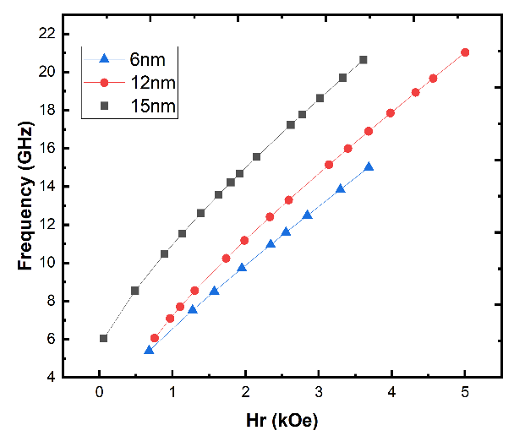 b) 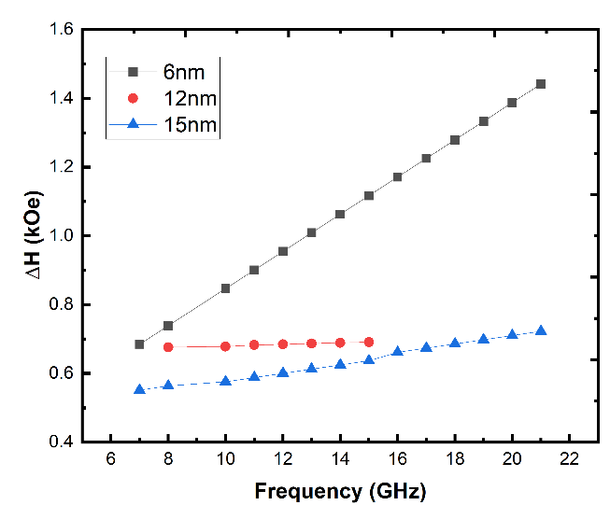
Figure 20: a) H_{r} vs Frequency plot of Fe₈₀Co₂₀ thin film on copper tape
b) Frequency vs ∆H of Fe₈₀Co₂₀ thin film on copper tape
Thickness (nm) | M_{eff} (kOe) | α_{eff} × 10⁻³
6 | 3.42 | 72.2
12 | 6.61 | 17.03
15 | 9.55 | 3.22
Table 4. 2: Summarizes the extracted values of effective magnetization Meff and damping constant αeff for FeCo thin films with different thicknesses.
The variation of M_{eff} and α_{eff} with film thickness can be attributed to factors such as changes in microstructure, interface roughness, and magnetic anisotropy. The high damping observed for the 6 nm film may result from enhanced two-magnon scattering, increased surface-to-volume ratio, or interface imperfections, which introduce additional relaxation channels. The significantly lower damping constant in the 15 nm film suggests a more uniform magnetic structure with reduced inhomogeneities. The subsequent increase in damping for the 15 nm film could be due to the onset of strain relaxation or the formation of structural defects with increased thickness. The sensitivity of dynamic magnetic properties to film thickness is highlighted by these FMR results, which is important for thin-film spintronic device design and optimization.

4.3 Vibrating Sample Magnetometry (VSM) Analysis
VSM spectroscopy is used to find the static magnetic properties of materials. The magnetic characteristics of Fe₈₀Co₂₀ thin films with different thicknesses (6 nm, 12 nm, and 15 nm) exhibit a distinct trend in Table 4.3. The saturation magnetization (M_{S}) increases from 260 emu/cc to 763 emu/cc as the thickness increases, suggesting a greater contribution of magnetic material to the total magnetization. This pattern is explained by thicker films' decreased surface or interface effects and larger ferromagnetic material volume. Concurrently, the Coercivity (H_{C}) drops from 91.09 Oe (6 nm) to 27.98 Oe (15 nm), indicating that thinner films have more pinning sites or magnetic anisotropy, which prevent domain wall movement. The room temperature hysteresis loops demonstrate a constant saturation field of roughly 4–5 kOe for every sample and validate the ferromagnetic nature of the films. The normalized M/M_{S} versus H curves show comparable shapes at all thicknesses, suggesting that the magnetization reversal processes are similar even though the absolute values of Coercivity and magnetization differ. These findings validate the high magnetic quality of the FeCo thin films and show a strong dependence of magnetic behavior on film thickness.
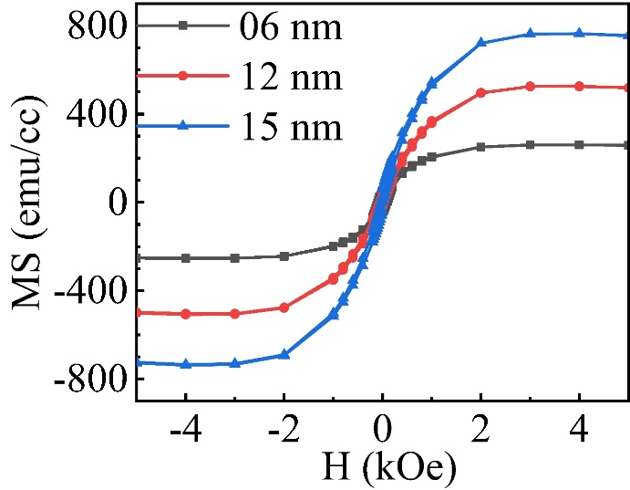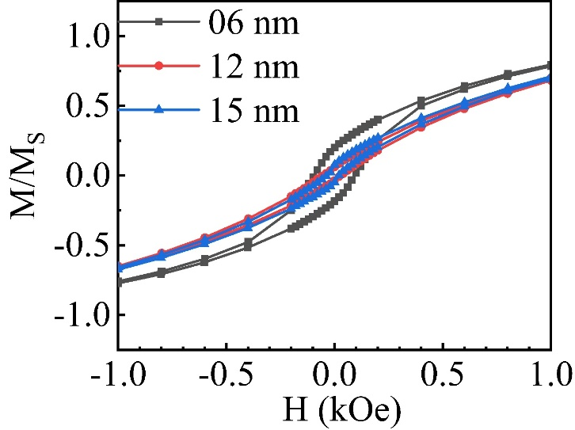
Figure 21: VSM plots a) Shows the M-H Hysteresis loop of FeCo for different thickness b) Shows Coercivity

Thickness  (nm) | Coercivity  (Oe) | Saturation Magnetization  (emu/cc)
6 | 91.09 | 260
12 | 40.71 | 526
15 | 27.98 | 763
Table 4. 3: summarizes the extracted values of saturation magnetization M_{S} and Coercivity H_{C} for Fe₈₀Co₂₀ thin films with different thicknesses.
The Coercivity (H_{C}) and the low squareness ratio (M/M_{S}) observed in the 6 nm FeCo thin film indicate the presence of significant surface defects and poor crystalline ordering, typical of ultra-thin films. As the film thickness increases beyond 6 nm, there is a marked reduction in Coercivity, which reflects a notable decrease in defect densities and an improvement in structural quality. The observed trend of increasing Coercivity in very thin films can be attributed to enhanced surface anisotropy, likely caused by surface roughness effects, as supported by previous studies. Moreover, the squareness ratio (M/M_{S}) increases progressively from the thinner 6 nm film to the thicker 15 nm film, demonstrating the evolution of magnetic domain structure and reduction in pinning sites with increasing thickness.

CHAPTER 5: CONCLUSION AND FUTURE WORK

This chapter of Dissertation presents and discusses the final conclusions and Future work scope for this research.

5.1 Conclusion
Cobalt-iron (FeCo) thin films were successfully fabricated in this study using the sputtering technique on flexible copper tape substrates. The findings show that, even on flexible metallic substrates, physical vapor deposition by sputtering is an effective method to produce uniform, well-adhered thin films with variable thickness and composition. The films consistent grain structure and crystalline nature have been confirmed by structural characterization using X-ray diffraction (XRD). Vibrating sample magnetometry (VSM) and ferromagnetic resonance (FMR) were used to examine the magnetic properties. The results showed a clear dependence on film thickness, with changes in Coercivity, saturation magnetization, effective magnetization, and damping parameters. The research that while intermediate thicknesses offer more consistent magnetic behavior, thinner films typically show higher damping constants, most likely as a result of surface and interface effects. The flexible copper tape substrate proved to be an excellent mechanical support, also contributing to the film’s electrical and thermal stability, which is important for invention of flexible spintronic devices. Overall, the work confirms the feasibility of integrating FeCo thin films on flexible substrates with promising magnetic and structural properties suitable for next-generation wearable electronics, sensors, and spintronic applications.

5.2 Future Work
Although the current research offers valuable insights into FeCo thin films on copper tape, several aspects warrant further exploration to optimize performance and practical applicability. Future work could focus on post-deposition treatments such as annealing to enhance crystallinity, reduce defects, and tailor magnetic anisotropy and damping properties. Expanding the study to include other flexible substrates like polyimide, Kapton, or mica would enable a comparative analysis of substrate effects on film microstructure and magnetic behavior. Another important direction is the integration of these films into functional spintronic devices, including magneto resistive sensors and spin valves, to evaluate their operational stability and performance under bending or mechanical stress. Investigating strain effects and spin transport under dynamic deformation is particularly critical for wearable and flexible electronics applications. Furthermore, exploring multilayer architectures involving magnetic/non-magnetic combinations could unlock additional functionalities and improve device efficiency.
In summary, continued research in these areas will deepen the understanding of flexible FeCo thin films and accelerate their adoption in emerging spintronic and flexible electronics technologies.

REFERENCES

[1] A. Zighem, M. Belmeguenai, and Y. Roussigné, “Ferromagnetic resonance in magnetic thin films and heterostructures,” Journal of Physics: Condensed Matter, vol. 33, no. 23, p. 233002, 2021.
https://doi.org/10.1088/1361-648X/abf5eb
[2] S. S. Kalarickal, P. Krivosik, M. Wu, C. E. Patton, M. L. Schneider, and P. Kabos, Ferromagnetic Resonance: Theory and Applications. Springer, 2008.
[3] Y. Liu, Y. Hou, D. Zhang, et al., “Mechanical Strain‐Tunable Microwave Magnetism in Flexible CuFe₂O₄ Epitaxial Thin Film,” Advanced Functional Materials, vol. 28, no. 10, p. 1705922, 2018.
https://doi.org/10.1002/adfm.201705922
[4] Y. Yang et al., “Advances in Flexible Magnetosensitive Materials and Devices for Wearable Electronics,” Advanced Materials, vol. 36, no. 3, p. 2306251, 2024.
https://doi.org/10.1002/adma.202306251
[5] G. Wang, X. Zhang, et al., “Magneto-transport and damping properties in flexible magnetic thin films,” Scientific Reports, vol. 12, p. 10423, 2022.
https://doi.org/10.1038/s41598-022-14861-z
[6] C. Zhou et al., “Low-damping magnetic thin films studied by ferromagnetic resonance,” Applied Physics Express, vol. 13, no. 4, p. 043001, 2020.
https://doi.org/10.35848/1882-0786/ab7a1d
[7] R. Koinkar and M. Sharma, “Review on PVD techniques for thin film deposition,” Coatings, vol. 8, no. 7, p. 278, 2018.
https://doi.org/10.3390/coatings8070278
[8] J. Huang et al., “Multifunctional La₀.₆₇Sr₀.₃₃MnO₃ Thin Films Integrated on Mica Substrates toward Flexible Electronics,” ACS Applied Materials & Interfaces, vol. 10, no. 9, pp. 7994–8000, 2018.
https://doi.org/10.1021/acsami.7b16718
[9] J. Sheng, “Magnetic and transport properties of FeCoB thin films,” Journal of Semiconductors, vol. 39, no. 1, p. 011006, 2018.
https://doi.org/10.1088/1674-4926/39/1/011006
[10] D. Liu, M. Wu, et al., “Magnetization dynamics of magnetic thin films,” Chinese Physics B, vol. 22, no. 12, p. 127502, 2013.
https://doi.org/10.1088/1674-1056/22/12/127502
[11] M. C. Wanke, “Flexible substrates and their role in wearable electronics,” Latest Advances in Substrates for Flexible Electronics, Elsevier, pp. 1–25, 2021.
[12] M. Wang et al., “Polyimide Films Containing Trifluoromethoxy Groups for High-Performance Flexible Applications,” Polymer, vol. 13, no. 3, p. 341, 2022.
https://doi.org/10.3390/polym13030341
[13] M. M. Hussain and T. Jackson, “Materials and mechanisms for flexible substrates in magnetoelectronics,” Materials Today, vol. 27, pp. 2–9, 2020.
https://doi.org/10.1016/j.mattod.2020.02.006
[14] M. S. Seehra, “X-ray diffraction and Scherrer analysis of FeCo nanostructures,” Surface and Coatings Technology, vol. 400, p. 126202, 2021.
https://doi.org/10.1016/j.surfcoat.2020.126202

