C Program - Day 5 & 6 Assignment
- WAP to find the Maximum of Two Numbers.
- WAP to Check Prime Number(Write a function isPrime() that returns 1 if a number is prime, otherwise 0).
- WAP to Reverse a Number - Write a function that returns the reverse of a given integer.
- WAP to calculate the Factorial of a number Using Function.
- WAP that prints the first n Fibonacci numbers.
- Swap Two Numbers - Write a function to swap two numbers:
using call by value and using call by reference
Compare the outputs.
- Define a struct Student with roll_no, name, marks[5]. Write a program to input data for 5 students and print the one with the highest total marks.
- Define a structure for Employee Details. Store employee information: ID, Name and Salary. Find the employee with the highest salary.
- Define nested structures: struct Date {int d, m, y;} inside struct Employee (date of joining). Print employees who joined before a given year.
- Write a program using an array of structures to manage a simple library — book title, author, and issue status — with add/search/display functions.
- Write a program to demonstrate pointer basics: declare a variable, print its address, value, and access it via a pointer.
- Write a program using pointer arithmetic to traverse and print all elements of an array.
- WAP to Swap Two Numbers Using Pointers.
- Find the Largest Element in an Array Using Pointers
- Sum of Array Elements Using Pointer Arithmetic
- Reverse an Array Using Pointers
- Write a program to declare an integer, a pointer, and a double pointer. Display:
Value of the variable, Address of the variable, Value stored in the pointer, Address of the pointer, Value stored in the double pointer and Address of the double pointer
- Write a program that changes the value of an integer using only a double pointer.
- Write a C program that uses a pointer to iterate through an array of integers and count the number of even and odd elements.
- Use a pointer to find the sum and average of all elements in an integer array.

Amit_Lab5&6 - Day 5 & 6 Assignment
C Programming - Functions, Structures & Pointers

Question 1: Find the Maximum of Two Numbers
#include <stdio.h>
int main()
{
int a, b;
printf("Enter two numbers: ");
scanf("%d %d", &a, &b);
if(a > b)
{
printf("Maximum = %d\n", a);
}
else
{
printf("Maximum = %d\n", b);
}

return 0;
}
Output:
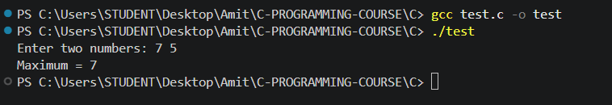

Question 2: Check Prime Number using isPrime()
#include <stdio.h>
int isPrime(int n);
int main()
{
int num;
printf("Enter a number: ");
scanf("%d", &num);
if(isPrime(num))
{
printf("%d is a Prime Number\n", num);
}
else
{
printf("%d is not a Prime Number\n", num);
}
return 0;
}

int isPrime(int n)
{
int i;
if(n <= 1)
{
return 0;
}
for(i = 2; i * i <= n; i++)
{
if(n % i == 0)
{
return 0;
}
}
return 1;
}
Output:
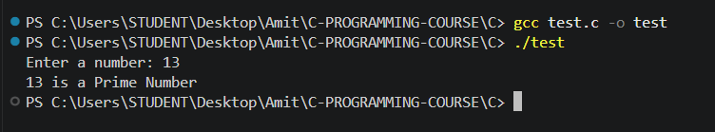

Question 3: Reverse a Number using a function
#include <stdio.h>
int reverseNum(int n);
int main()
{
int num;
printf("Enter a number: ");
scanf("%d", &num);
printf("Reversed = %d\n", reverseNum(num));

return 0;
}
int reverseNum(int n)
{
int rev = 0;
while(n != 0)
{
rev = rev * 10 + n % 10;
n = n / 10;
}
return rev;
}
Output:
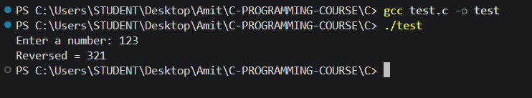

Question 4: Factorial of a number Using Function
#include <stdio.h>
long factorial(int n);
int main()
{
int num;
printf("Enter a number: ");
scanf("%d", &num);
printf("Factorial = %ld\n", factorial(num));

return 0;
}

long factorial(int n)
{
int i;
long f = 1;
for(i = 1; i <= n; i++)
{
f = f * i;
}

return f;
}
Output:
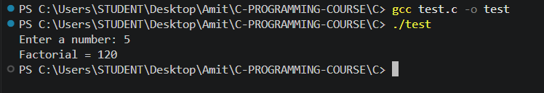

Question 5: Print the first n Fibonacci numbers
#include <stdio.h>

int main()
{
int n, i, a = 0, b = 1, c;
printf("Enter how many Fibonacci numbers: ");
scanf("%d", &n);
printf("Fibonacci series: ");
for(i = 0; i < n; i++)
{
printf("%d ", a);
c = a + b;
a = b;
b = c;
}
printf("\n");

return 0;
}
Output:
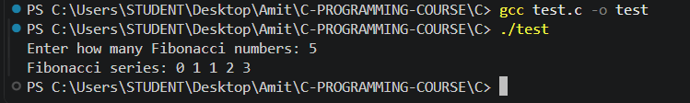

Question 6: Swap Two Numbers - call by value vs call by reference
#include <stdio.h>

void swapByValue(int a, int b);
void swapByReference(int *a, int *b);

int main()
{
int x, y;
printf("Enter two numbers: ");
scanf("%d %d", &x, &y);
printf("\nOriginal: x = %d, y = %d\n", x, y);
swapByValue(x, y);
printf("After swapByValue: x = %d, y = %d (no change)\n", x, y);
swapByReference(&x, &y);
printf("After swapByReference: x = %d, y = %d (swapped!)\n", x, y);

return 0;
}

void swapByValue(int a, int b)
{
int temp = a;
a = b;
b = temp;
}

void swapByReference(int *a, int *b)
{
int temp = *a;
*a = *b;
*b = temp;
}

Output:
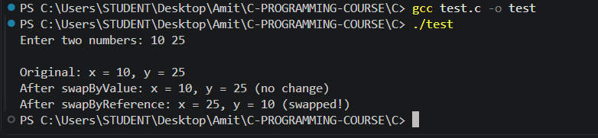

Question 7: struct Student - find student with highest total marks
#include <stdio.h>

struct Student
{
int roll_no;
char name[50];
float marks[5];
};

int main()
{
struct Student s[5];
int i, j, topper = 0;
float total, maxTotal = 0;
for(i = 0; i < 5; i++)
{
printf("Enter details of student %d:\n", i + 1);
printf("Roll No: ");
scanf("%d", &s[i].roll_no);
printf("Name: ");
scanf("%s", s[i].name);
total = 0;
for(j = 0; j < 5; j++)
{
printf("Marks in subject %d: ", j + 1);
scanf("%f", &s[i].marks[j]);
total = total + s[i].marks[j];
}

if(total > maxTotal)
{
maxTotal = total;
topper = i;
}
}

printf("\nStudent with highest total marks:\n");
printf("Roll No: %d\n", s[topper].roll_no);
printf("Name: %s\n", s[topper].name);
printf("Total Marks: %.2f\n", maxTotal);

return 0;
}
Output:
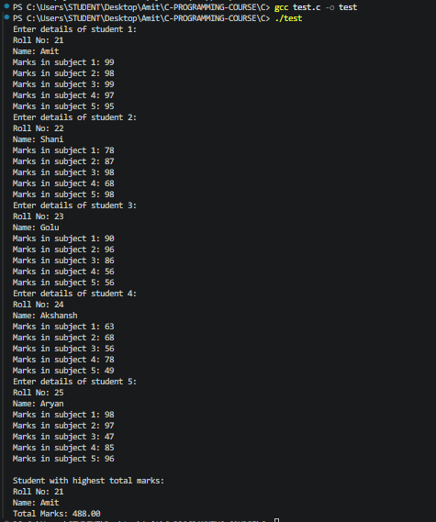

Question 8: Employee struct (ID, Name, Salary) - find highest salary
#include <stdio.h>

struct Employee
{
int id;
char name[50];
float salary;
};

int main()
{
struct Employee emp[5];
int i, highest = 0;
for(i = 0; i < 5; i++)
{
printf("Enter details of employee %d:\n", i + 1);
printf("ID: ");
scanf("%d", &emp[i].id);
printf("Name: ");
scanf("%s", emp[i].name);
printf("Salary: ");
scanf("%f", &emp[i].salary);
if(emp[i].salary > emp[highest].salary)
{
highest = i;
}
}

printf("\nEmployee with highest salary:\n");
printf("ID: %d\n", emp[highest].id);
printf("Name: %s\n", emp[highest].name);
printf("Salary: %.2f\n", emp[highest].salary);

return 0;
}
Output:
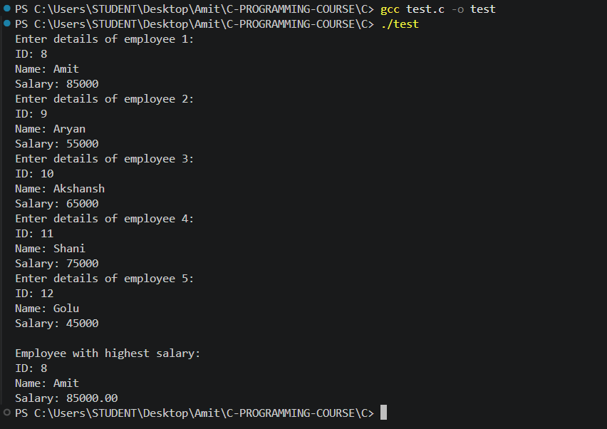

Question 9: Nested struct Date in Employee - joined before a given year
#include <stdio.h>

struct Date
{
int d, m, y;
};

struct Employee
{
int id;
char name[50];
struct Date joinDate;
};

int main()
{
struct Employee emp[3];
int i, year;
int found = 0;
for(i = 0; i < 3; i++)
{
printf("Enter details of employee %d:\n", i + 1);
printf("ID: ");
scanf("%d", &emp[i].id);
printf("Name: ");
scanf("%s", emp[i].name);
printf("Date of joining (dd mm yyyy): ");
scanf("%d %d %d", &emp[i].joinDate.d, &emp[i].joinDate.m, &emp[i].joinDate.y);
}

printf("\nEnter year to check: ");
scanf("%d", &year);
printf("\nEmployees who joined before %d:\n", year);
for(i = 0; i < 3; i++)
{
if(emp[i].joinDate.y < year)
{
printf("ID: %d, Name: %s, Joined: %d/%d/%d\n",
emp[i].id, emp[i].name,
emp[i].joinDate.d, emp[i].joinDate.m, emp[i].joinDate.y);
found = 1;
}
}

if(!found)
{
printf("No employees found.\n");
}

return 0;
}

Output:
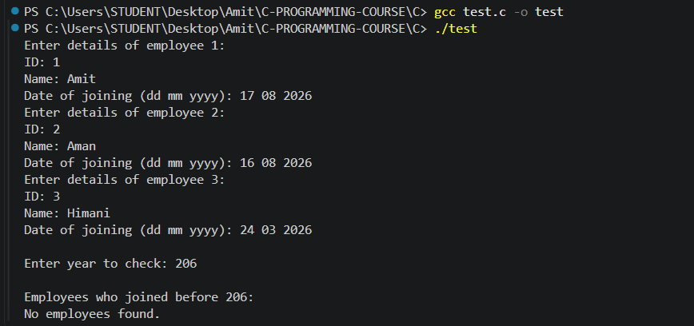
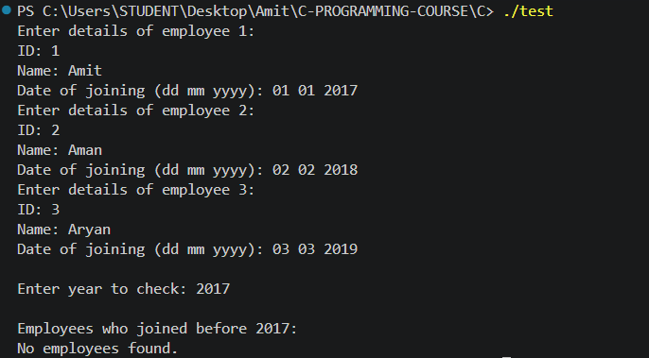

Question 10: Library management using an array of structures
#include <stdio.h>
#include <string.h>

struct Book
{
char title[50];
char author[50];
int issued;
};

void addBook(struct Book *b);
void displayBooks(struct Book *b, int count);
void searchBook(struct Book *b, int count, char *title);

int main()
{
struct Book books[20];
int count = 0;
int choice;
char search[50];

do
{
printf("\n---LIBRARY MANAGEMENT----\n");
printf("1. Add Book\n");
printf("2. Display Books\n");
printf("3. Search Book\n");
printf("4. Exit\n");
printf("Enter choice: ");
scanf("%d", &choice);

switch(choice)
{
case 1:
addBook(&books[count]);
count++;
break;

case 2:
displayBooks(books, count);
break;

case 3:
printf("Enter title to search: ");
scanf("%s", search);
searchBook(books, count, search);
break;

case 4:
printf("Exiting...\n");
break;

default:
printf("Invalid choice!\n");
}

} while(choice != 4);

return 0;
}

void addBook(struct Book *b)
{
printf("Enter title: ");
scanf("%s", b->title);

printf("Enter author: ");
scanf("%s", b->author);

b->issued = 0;
printf("Book added.\n");
}

void displayBooks(struct Book *b, int count)
{
int i;

if(count == 0)
{
printf("No books found.\n");
return;
}

for(i = 0; i < count; i++)
{
printf("Title: %s, Author: %s, Issued: %s\n",
b[i].title, b[i].author, b[i].issued ? "Yes" : "No");
}
}

void searchBook(struct Book *b, int count, char *title)
{
int i;

for(i = 0; i < count; i++)
{
if(strcmp(b[i].title, title) == 0)
{
printf("Book Found!\n");
printf("Title: %s, Author: %s\n", b[i].title, b[i].author);
return;
}
}

printf("Book not found.\n");
}
Output:
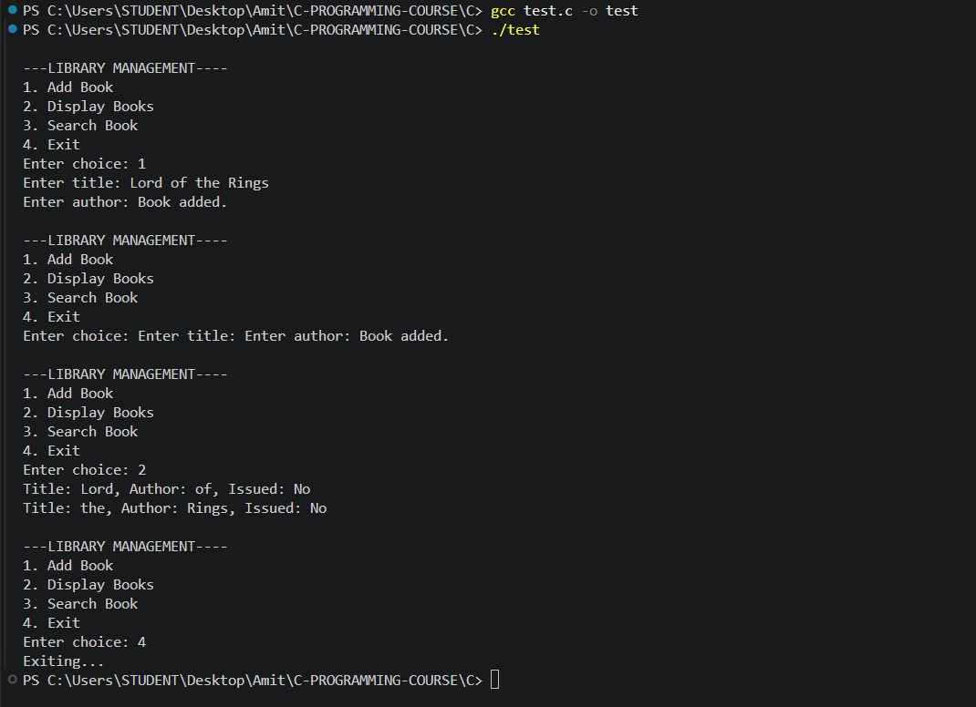

Question 11: Pointer basics - address, value, access via pointer
#include <stdio.h>

int main()
{
int num = 10;
int *ptr;
ptr = &num;
printf("Value of num: %d\n", num);
printf("Address of num (&num): %p\n", &num);
printf("Value stored in ptr: %p\n", ptr);
printf("Value via pointer (*ptr): %d\n", *ptr);

return 0;
}
Output:
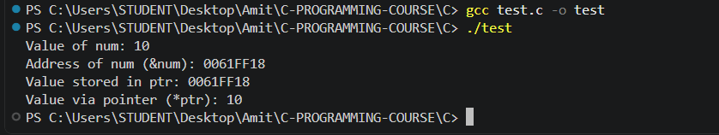

Question 12: Traverse and print an array using pointer arithmetic
#include <stdio.h>

int main()
{
int arr[10] = {1, 2, 3, 4, 5, 6, 7, 8, 9, 10};
int *ptr;
int i;
ptr = arr;
printf("Array elements using pointer arithmetic:\n");
for(i = 0; i < 10; i++)
{
printf("%d ", *(ptr + i));
}
printf("\n");

return 0;
}
Output:
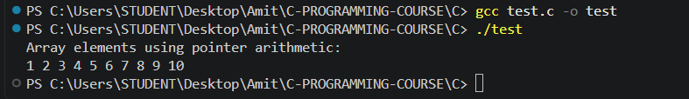

Question 13: Swap Two Numbers Using Pointers
#include <stdio.h>

void swap(int *a, int *b);

int main()
{
int x, y;
printf("Enter two numbers: ");
scanf("%d %d", &x, &y);
printf("Before swap: x = %d, y = %d\n", x, y);
swap(&x, &y);
printf("After swap: x = %d, y = %d\n", x, y);
return 0;
}

void swap(int *a, int *b)
{
int temp = *a;
*a = *b;
*b = temp;
}

Output:
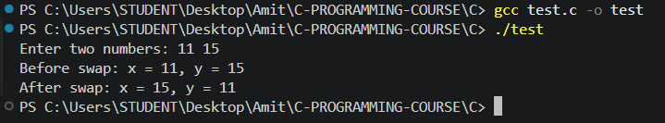

Question 14: Find the Largest Element in an Array Using Pointers
#include <stdio.h>

int main()
{
int arr[5] = {23, 45, 67, 12, 89};
int *ptr;
int i, max;
ptr = arr;
max = *ptr;
for(i = 1; i < 5; i++)
{
ptr++;
if(*ptr > max)
{
max = *ptr;
}
}

printf("Array: ");
for(i = 0; i < 5; i++)
{
printf("%d ", arr[i]);
}
printf("\nLargest element = %d\n", max);

return 0;
}

Output:
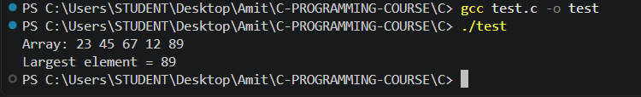

Question 15: Sum of Array Elements Using Pointer Arithmetic
#include <stdio.h>

int main()
{
int arr[5] = {10, 20, 30, 40, 50};
int *ptr;
int i;
int sum = 0;
float average;
ptr = arr;
for(i = 0; i < 5; i++)
{
sum = sum + *ptr;
ptr++;
}
average = (float)sum / 5;

printf("Array elements: ");
ptr = arr;
for(i = 0; i < 5; i++)
{
printf("%d ", *ptr);
ptr++;
}

printf("\nSum = %d\n", sum);
printf("Average = %.2f\n", average);

return 0;
}
Output:
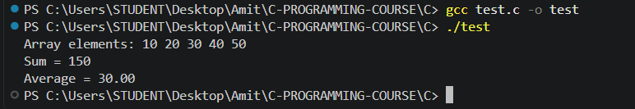

Question 16: Reverse an Array Using Pointers
#include <stdio.h>

int main()
{
int arr[7] = {1, 2, 3, 4, 5, 6, 7};
int *left, *right;
int temp;
int i;
printf("Original array: ");
for(i = 0; i < 7; i++)
{
printf("%d ", arr[i]);
}
printf("\n");
left = arr;
right = arr + 6;
while(left < right)
{
temp = *left;
*left = *right;
*right = temp;
left++;
right--;
}
printf("Reversed array: ");
for(i = 0; i < 7; i++)
{
printf("%d ", arr[i]);
}
printf("\n");

return 0;
}
Output:
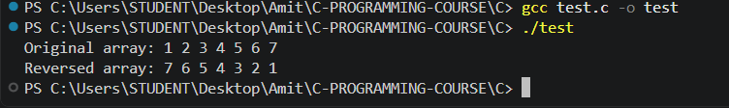

Question 17: Integer, pointer, and double pointer - values and addresses
#include <stdio.h>

int main()
{
int num = 42;
int *ptr = &num;
int **pptr = &ptr;

printf("Value of the variable: %d\n", num);
printf("Address of the variable (&num): %p\n", &num);
printf("Value stored in the pointer (ptr): %p\n", ptr);
printf("Address of the pointer (&ptr): %p\n", &ptr);
printf("Value stored in the double pointer (*pptr): %p\n", *pptr);
printf("Address of the double pointer (&pptr): %p\n", &pptr);

return 0;
}
Output:
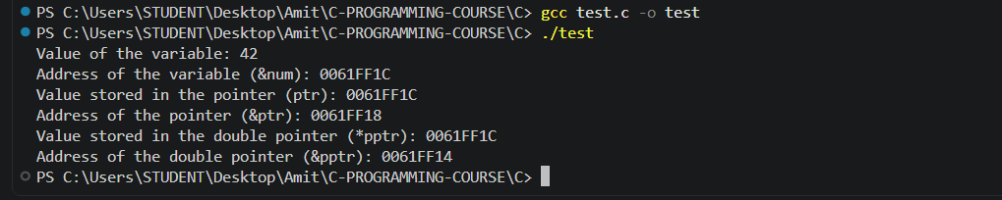

Question 18: Change an integer's value using only a double pointer
#include <stdio.h>

int main()
{
int num = 10;
int *ptr = &num;
int **pptr = &ptr;
printf("Original value: %d\n", num);
**pptr = 50;
printf("Value changed using double pointer: %d\n", num);

return 0;
}
Output:
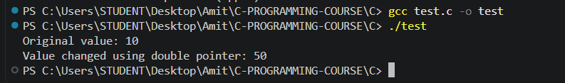

Question 19: Count even and odd elements using a pointer
#include <stdio.h>

int main()
{
int arr[10] = {12, 5, 8, 7, 10, 3, 6, 9, 14, 1};
int *ptr;
int even = 0, odd = 0;
int i;

ptr = arr;
for(i = 0; i < 10; i++)
{
if(*ptr % 2 == 0)
{
even++;
}
else
{
odd++;
}
ptr++;
}

printf("Array elements: ");
ptr = arr;
for(i = 0; i < 10; i++)
{
printf("%d ", *ptr);
ptr++;
}

printf("\nEven numbers: %d\n", even);
printf("Odd numbers: %d\n", odd);

return 0;
}
Output:
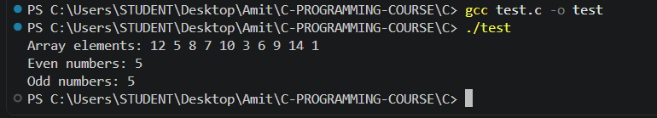

Question 20: Sum and average of array elements using a pointer
#include <stdio.h>

int main()
{
int arr[5] = {10, 20, 30, 40, 50};
int *ptr;
int i;
int sum = 0;
float average;
ptr = arr;
for(i = 0; i < 5; i++)
{
sum = sum + *ptr;
ptr++;
}

average = (float)sum / 5;

printf("Array: ");
ptr = arr;
for(i = 0; i < 5; i++)
{
printf("%d ", *ptr);
ptr++;
}

printf("\nSum = %d\n", sum);
printf("Average = %.2f\n", average);

return 0;
}
Output:
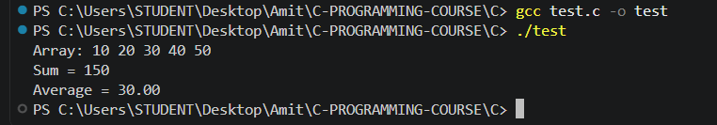

MCQ questions
Q1. What is the output of the following program?
#include <stdio.h>
int fun(int x)
{
return x++;
}
int main()
{
int a = 5;
printf("%d %d", fun(a), a);
return 0;
}
A) 6 6
B) 5 6
C) 5 5
D) 6 5
Answer: C) 5 5

Q2. What is the output?
int a = 20;
int *p = &a;
int **pp = &p;
printf("%d", **pp + *p);
A) 20
B) 40
C) 60
D) Compilation Error
Answer: B) 40

Q3. What does the following statement print?
int arr[] = {10,20,30,40};
printf("%d", *(arr + 2));
A) 10
B) 20
C) 30
D) 40
Answer: C) 30

Q4. Consider:
struct Student
{
int id;
char grade;
float marks;
};
struct Student s;
Which statement correctly accesses marks?
A) s->marks
B) (*s).marks
C) s.marks
D) marks.s
Answer: C) s.marks

Q5. Which storage class preserves the value of a local variable between function calls?
A) auto
B) register
C) static
D) extern
Answer: C) static

Q6. What is the output?
#include <stdio.h>
void fun()
{
static int x = 0;
x++;
printf("%d ", x);
}
int main()
{
fun();
fun();
fun();
}
A) 1 1 1
B) 0 1 2
C) 1 2 3
D) 3 3 3
Answer: C) 1 2 3
Q7. What is the output?
#include <stdio.h>
struct Student
{
int marks;
};
void update(struct Student s)
{
s.marks = 100;
}
int main()
{
struct Student s = {80};
update(s);
printf("%d", s.marks);
}
A) 80
B) 100
C) Garbage Value
D) Compilation Error
Answer: A) 80

Q8. What is the output of the following program?
#include <stdio.h>
int main()
{
int a[] = {10, 20, 30, 40};
int *p = a;
printf("%d", *(p + 3) - *(p + 1));
return 0;
}
A) 10
B) 20
C) 30
D) 40
Answer: B) 20

Q9. What is the output?
#include <stdio.h>
struct Student
{
int id;
};
int main()
{
struct Student s1 = {10};
struct Student s2;
s2 = s1;
s2.id = 20;
printf("%d %d", s1.id, s2.id);
return 0;
}
A) 20 20
B) 10 10
C) 10 20
D) Compilation Error
Answer: C) 10 20

Q10. What is the output?
#include <stdio.h>
int main()
{
int a[] = {5, 10, 15};
int *p = a;
printf("%d", *p++);
return 0;
}
A) 5
B) 10
C) 15
D) Compilation Error
Answer: A) 5

MCQ Questions: Answers
Q | Answer
1 | C) 5 5
2 | B) 40
3 | C) 30
4 | C) s.marks
5 | C) static
6 | C) 1 2 3
7 | A) 80
8 | B) 20
9 | C) 10 20
10 | A) 5

Explain
- Differentiate between call by value and call by reference in C. Give suitable examples and mention when each is preferred.
- What is recursion? Explain its advantages, disadvantages, and give one example where recursion is preferred over iteration.
- What is a pointer? Explain the purpose of pointers in C. How do pointers improve the efficiency of programs?
- Explain pointer arithmetic in C. Which arithmetic operations are valid on pointers, and why?
- What is a double pointer (**)? Explain its syntax, purpose, and one practical application with an example.
- Differentiate between structures and arrays in C with suitable examples.
- Explain the different ways of passing a structure to a function. Compare passing by value and by pointer.
- Explain the four storage classes in C:
auto
register
static
extern
Compare them based on:
Scope
Lifetime
Storage location
Default initial value
- Explain the difference between struct and typedef struct in C. Why is typedef commonly used with structures? Illustrate with an example.
- Why is a structure assignment allowed in C, but an array assignment is not?

Explain
1. Differentiate between call by value and call by reference in C. Give suitable examples and mention when each is preferred.
In call by value, a copy of the argument is passed to the function, so changes inside the function do not affect the original variable.
In call by reference, the address of the argument is passed, so the function can modify the original variable through that address.
For example, swapByValue(x, y) copies x and y and swaps only the copies, while swapByReference(&x, &y) passes addresses and swaps the originals.
Call by value is preferred when the function should not change the caller's data;
call by reference is needed when the function must modify caller variables, or when passing large structures where copying would be expensive.
2. What is recursion? Explain its advantages, disadvantages, and give one example where recursion is preferred over iteration.
Recursion is when a function calls itself to solve a problem by breaking it down into smaller sub-problems of the same kind, until a base case is reached.
Advantages: the code is often simpler and more readable for problems with a naturally recursive structure, such as tree traversal.
Disadvantages: it uses extra stack memory for each call, tends to be slower than an equivalent loop, and can cause a stack overflow if the recursion goes too deep.
Recursion is generally preferred for problems like factorial, Fibonacci, Tower of Hanoi, and binary tree traversal, where the recursive definition matches the structure of the problem far more naturally than an iterative version would.
3. What is a pointer? Explain the purpose of pointers in C. How do pointers improve the efficiency of programs?
A pointer is a variable that stores the memory address of another variable rather than a data value itself. Pointers are used for dynamic memory allocation, passing arrays and large structures to functions efficiently, implementing data structures such as linked lists and trees, and allowing a function to modify a variable that belongs to its caller.
They improve efficiency by avoiding the cost of copying large blocks of data - only the address is passed or stored - and by giving direct access to memory, which enables in-place modification of data without needing to return and reassign a copy.
4. Explain pointer arithmetic in C. Which arithmetic operations are valid on pointers, and why?
Pointer arithmetic in C works in units of the pointed-to type rather than raw bytes. For an int pointer p pointing at arr[0], the expression p + 1 points to arr[1] (which is 4 bytes ahead on a typical system), p + 2 points to arr[2], and so on - the compiler automatically scales the offset by sizeof(int). Valid operations are: adding or subtracting an integer to or from a pointer, and subtracting one pointer from another pointer of the same type (which yields the number of elements between them). Multiplying two pointers, dividing a pointer, or adding two pointers together are all invalid, since none of those operations correspond to a meaningful memory address. Because pointer arithmetic always respects the size of the underlying type, it stays safe and predictable when moving between consecutive array elements.
5. What is a double pointer (**)? Explain its syntax, purpose, and one practical application with an example.
A double pointer is a pointer that stores the address of another pointer variable, rather than the address of an ordinary data variable. The syntax int **pptr = &ptr; declares pptr as a pointer to an int pointer, where ptr itself is declared as int *ptr. The value that pptr ultimately points to is reached by dereferencing twice: **pptr. Double pointers are used for dynamically allocating 2D arrays, for modifying a pointer parameter inside a function (since a plain pointer parameter would only let you modify what it points to, not the pointer itself), and in certain data structures. In Question 18 above, **pptr = 50; changes the original integer variable num through two levels of indirection, without num being referenced directly at that point in the code.
int num = 10;
int *ptr = &num;
int **pptr = &ptr;

**pptr = 50; /* changes num to 50, through two levels of indirection */
6. Differentiate between structures and arrays in C with suitable examples.
An array stores multiple elements of the same data type in contiguous memory, and each element is accessed by a numeric index, e.g. int marks[5];. A structure groups together variables of different data types under a single name, and each member is accessed by name using the dot operator, e.g. struct Student { int id; float marks; };. Arrays are homogeneous - every element must be the same type - while structures are heterogeneous, allowing a mix of types in one unit. An array element is accessed as marks[0], while a structure member is accessed as s.marks. Arrays are best suited for a list of similar data, while structures are best suited for grouping related but different fields, such as the fields that together describe one student or employee record.
7. Explain the different ways of passing a structure to a function. Compare passing by value and by pointer.
A structure can be passed to a function by value (e.g. void display(struct Student s)), which creates a full copy of every member inside the function, or by pointer (e.g. void update(struct Student *s)), which passes only the address of the original structure. Passing by value is safer, since the original structure can never be modified by the function, but it is slower for large structures because every member has to be copied. Passing by pointer is faster, since only the address is copied regardless of how large the structure is, and it allows the function to modify the caller's original data - which is useful, but also means the original can be changed unintentionally if that isn't the goal. Question 7 demonstrates call by value in the update() example: because the struct is passed by value, changing s.marks inside update() only affects the local copy, and the original struct in main() remains unchanged.
8. Explain the four storage classes in C: auto, register, static, extern. Compare them based on scope, lifetime, storage location, and default initial value.
auto is the default storage class for local variables; it has block scope, a lifetime limited to the block in which it is declared, is stored on the stack, and has an indeterminate (garbage) default value.
register is a hint to the compiler to store the variable in a CPU register instead of memory for faster access; it has the same scope and lifetime as auto, cannot have its address taken with the & operator, and also has a garbage default value.
static gives a local variable a lifetime that spans the entire program - it is initialized only once and retains its value between function calls - while its scope remains limited to the block where it's declared; its default value is 0.
extern declares a variable that is defined elsewhere (often in another file), letting multiple files share the same variable; it has program-wide (external) scope, a lifetime equal to the whole program's execution, and a default value of 0.

9. Explain the difference between struct and typedef struct in C. Why is typedef commonly used with structures?
Without typedef, every variable declaration of a given structure requires the struct keyword, e.g. struct Student s;. With typedef struct { ... } Student;, an alias is created so a variable can be declared simply as Student s; without repeating struct each time. typedef is commonly used with structures because it shortens declarations and improves readability, which matters especially when the same structure type is used in many places throughout a program - function parameters, return types, array declarations, and so on. Functionally, both approaches define the same type; typedef is purely a readability and convenience improvement, not a different kind of structure.
/* Without typedef */
struct Student
{
int id;
};
struct Student s1;

/* With typedef */
typedef struct
{
int id;
} Student;
Student s2; /* no need to write "struct" here */
10. Why is a structure assignment allowed in C, but an array assignment is not?
In C, the assignment operator (=) works directly on structures because the compiler copies every member of one structure into the corresponding member of another in a single operation, e.g. s2 = s1; copies all fields of s1 into s2 at once. Arrays cannot be assigned this way because an array name in C is treated as a constant reference to the address of its first element - it is not a modifiable value that can appear on the left of =. To copy the contents of one array into another, a loop or a function like memcpy() must be used instead. This is a fundamental difference in how C treats these two aggregate types: structures support direct, whole-object assignment, while arrays only support element-by-element copying.

