2425-MS5128 DECISION THEORY, AI AND ANALYTICS

Silent Shoppers: Who are the customers who shop infrequently but spend large amounts per visit? How can we encourage more frequent engagement from this group?

Approach

Data Sources:
- Transactional Data: Included basket details (Basket ID, Barcode, Total Spend, Total Units, Card ID).
- Product categories and subcategories mapped through barcodes.
Key Metrics:
- Total revenue from all transactions: €554,781.48.
- Total revenue from high-value infrequent customers: €199,770.72 (36% of total revenue).
Analysis Methodology:
- Customers were segmented into "high-value infrequent customers" based on their:
- Visit frequency (bottom 25% of customers by total visits).
- Basket value (top 25% by average spend per transaction).

Results and Insights

Comparison of ALL v/s High-Value Infrequent Customers:

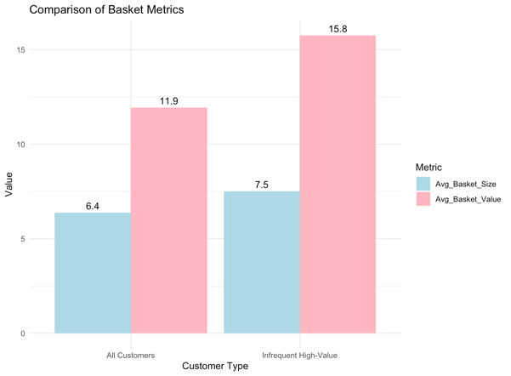
- High-Value Infrequent Customers represent 36% of total revenue (€199,770.72).
- Have an average basket size of 7.5 items per transaction (compared to 6.4 for all customers).
- Exhibit an average basket value of €15.8 per transaction (compared to €11.9 for all customers).

Product Preferences:

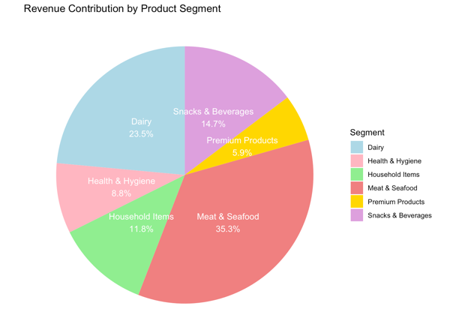
Segment-Wise Revenue Contribution:
- Meat & Seafood: Contributes the largest share at 35.3% of revenue.
- Dairy: Significant contributor with 23.5%.
- Snacks & Beverages: Captures 14.7%, appealing to convenience-oriented customers.
- Household Items (11.8%) and Health & Hygiene (8.8%) maintain steady demand.
- Premium High-value infrequent customers prioritize fresh products, particularly Meat & Seafood and Dairy.

Demographic Analysis:

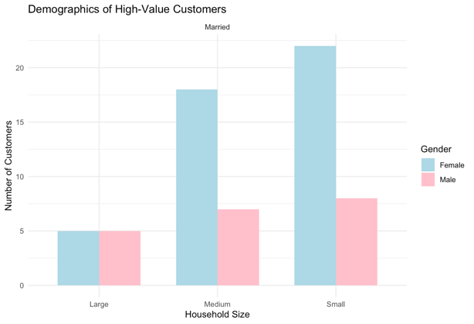

Household Size:
- Small households have the highest average basket value, indicating focused purchasing of premium items.
- Medium-sized households show balanced spending patterns.
- Large households exhibit moderate spending but more diverse purchasing habits.
- Gender: Female customers dominate, making up the majority of high-value infrequent customers.
- Marital Status: All high-value infrequent customers are married, reflecting family-oriented spending behaviour.

Recommended Business Action

Loyalty and Reward Programs:
- Incentivize repeat visits by offering targeted & loyalty rewards, particularly on high-margin products like Meat & Seafood and Premium Products.
Exclusive Product Bundling:
- Combine complementary products (e.g., Snacks & Beverages with Premium Products or Household Items) to increase basket size and value.
Personalized Marketing Campaigns:
- Focus on married couples in small and medium households with tailored promotions, emphasizing the freshness and quality of products like Dairy and Meat & Seafood.
Upselling Strategies:
- Encourage upselling of premium products by promoting limited-time offers and seasonal bundles.
Convenience-Based Engagement:
- Create subscription packages for Household Items and Health & Hygiene to ensure consistent engagement.

