**Why Use Docker:**

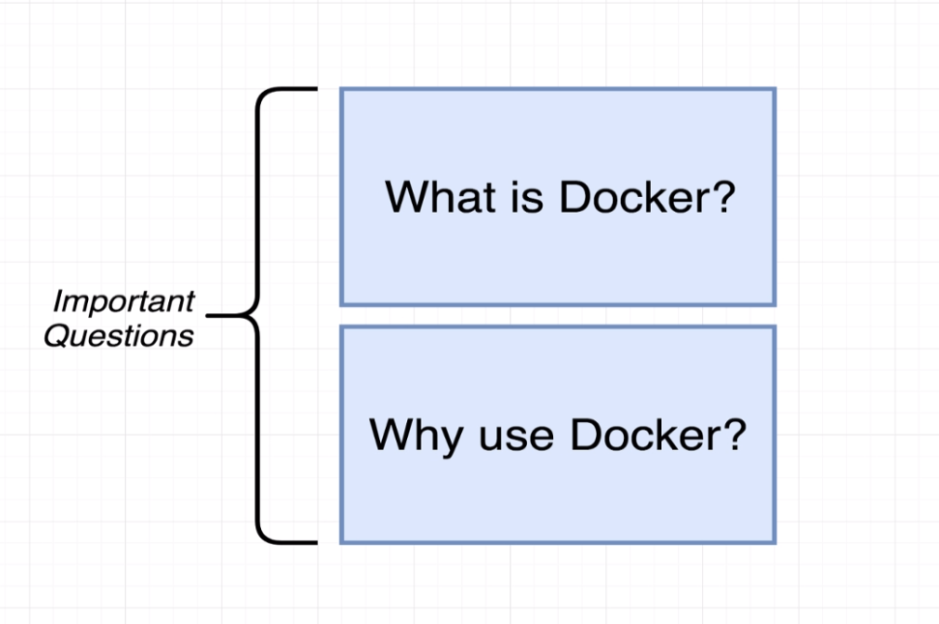

Flow for installing software in your personal computer:

Example: to install a software “Redis”:

Endless cycle of troubleshooting.

If we use docker, need to run one single command and instance of software will be installed in our computer:



