Pwd : print name of current/working directory

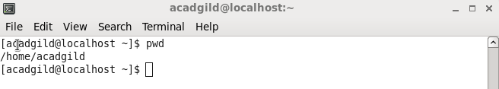

Vi: If the file named filename exists, then the first page (or screen) of the file will be displayed; if the file does not exist, then an empty file and screen are created into which you may enter text. 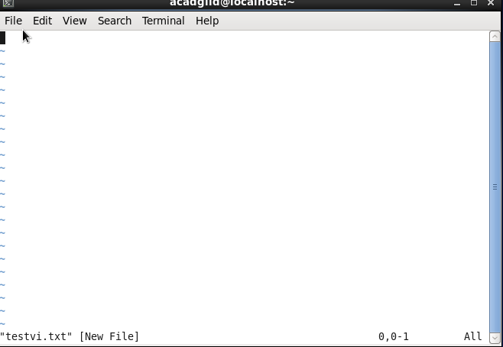

Touch : The touch command is the easiest way to create new, empty files.

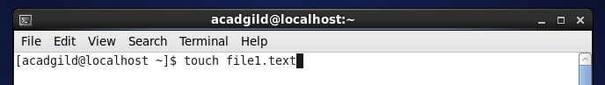

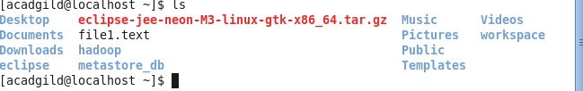

mkdir: Create a new directory called session_test in the current directory.

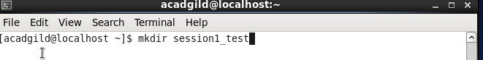

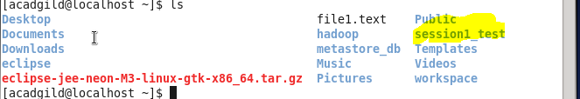

Ls: show the list of the files present directory .

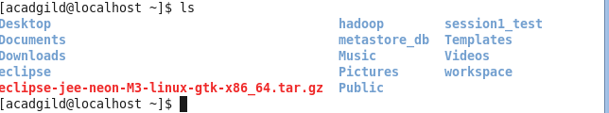

Echo: print the string on screen

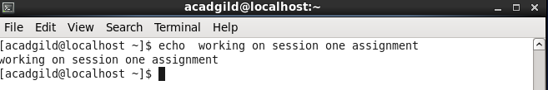

Rm: remove the file from present directory .

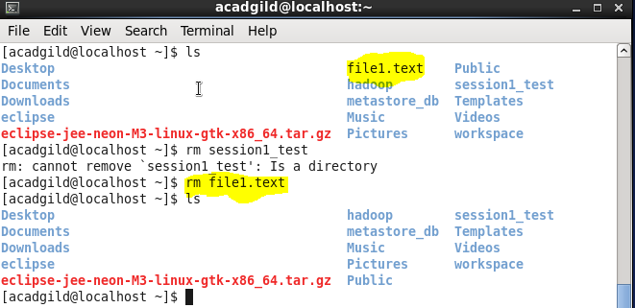

Cat: to show the content for file

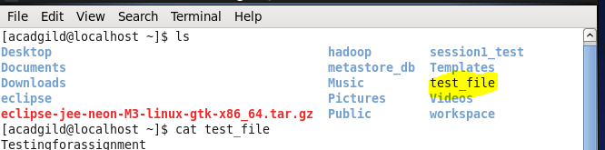

Who:display who is on system

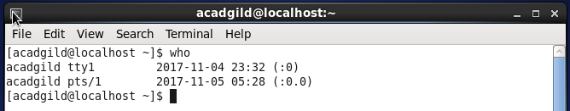

Cd :this command is to change the current directory to specified directory.

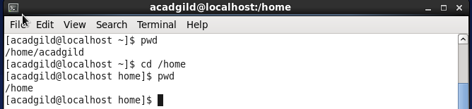

Date : show the current date and time

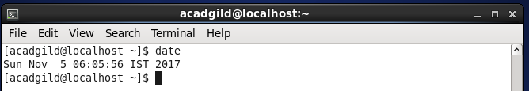

Cal: show the calendar

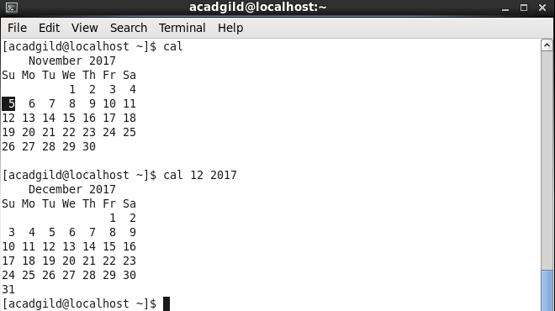

Mv: move the given file name to specified location .

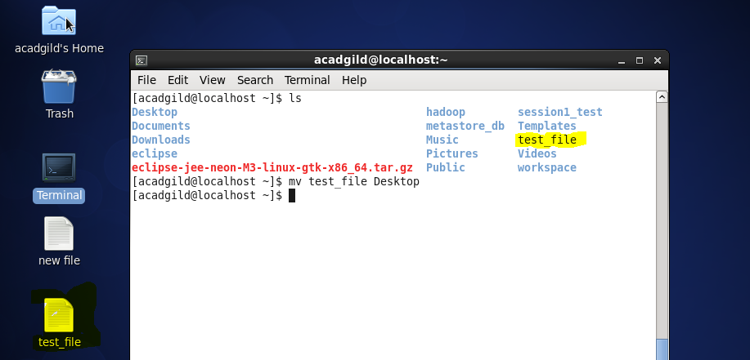

Cp: *cp* is a Linux shell command to *copy* files and directories.

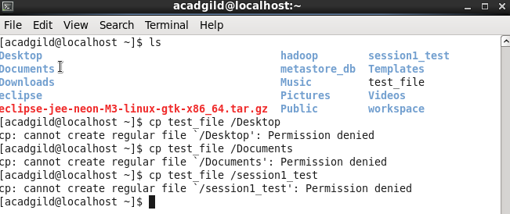

Which :command gives option “-a” that displays all paths of executable matching to argument

