File created on desktop local fs

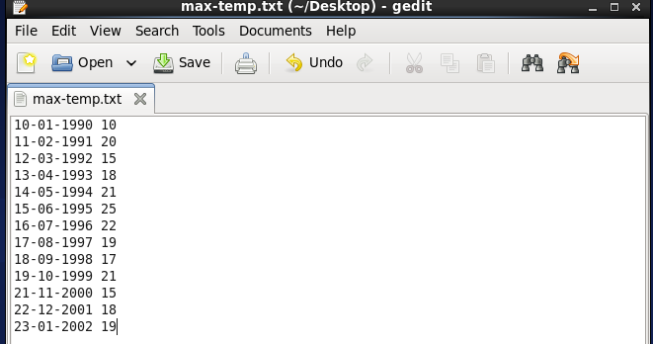

Then put this file on HDFS /user/acadgild/hadoop

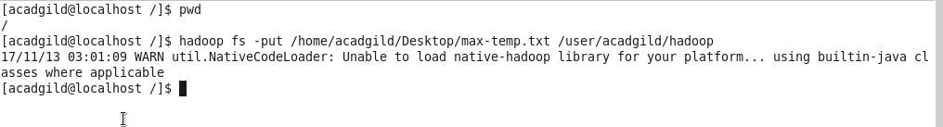

Now list down all the files from /user/acadgild/hadoop

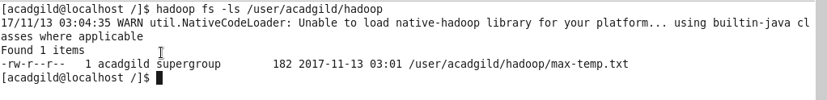

So file has been copied

Now reading the file content

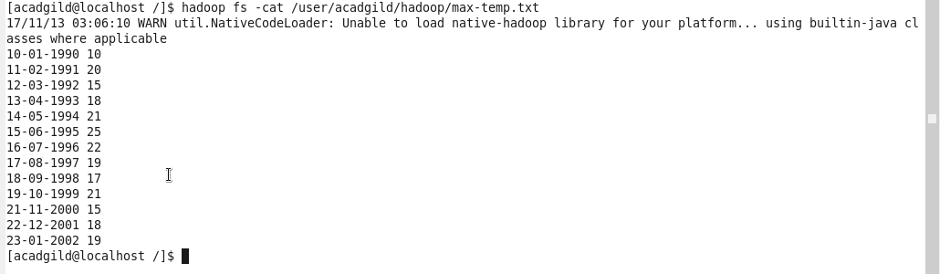

Default permission of the file

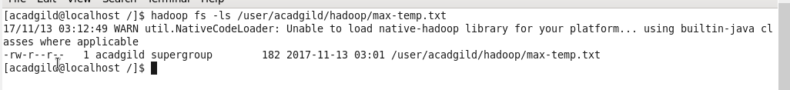

Now changing the file permission to 600

